Jordan Bone and Rachel Wofford

CS 273

17 May 2018

Final Summary

Using our simulation, we calculated the average patient visit time for a patient arrival rate of 5 patients per hour for a varying number of doctors and nurses. With one 1 doctor and 1 nurse, the average patient visit time was around 30 minutes, and sometimes even higher. With 1 doctor and 2 nurses the average was between 21 and 23 minutes and with 2 doctors and 1 nurse the average was around 20 minutes. This data agreed with our hypothesis that as the number of doctors and nurses in the simulation increased, our average patient visit time would decrease because there would be more available caregivers to treat patients. We did find it interesting that the average was so close between 1 doctor and 2 nurses and 2 doctors and 1 nurse because we thought having an extra doctor would make a bigger difference since doctors can treat patients of any priority level. However, it does make sense that having an extra doctor produces a lower average visit time than having an extra nurse.

For a combination of 5 doctors and 5 nurses, we graphed the average visit time for patient arrival rate from 5 patients/hour to 55 patients/hour, incrementing the arrival rates by 5 patients/hour. The graph can be seen below.

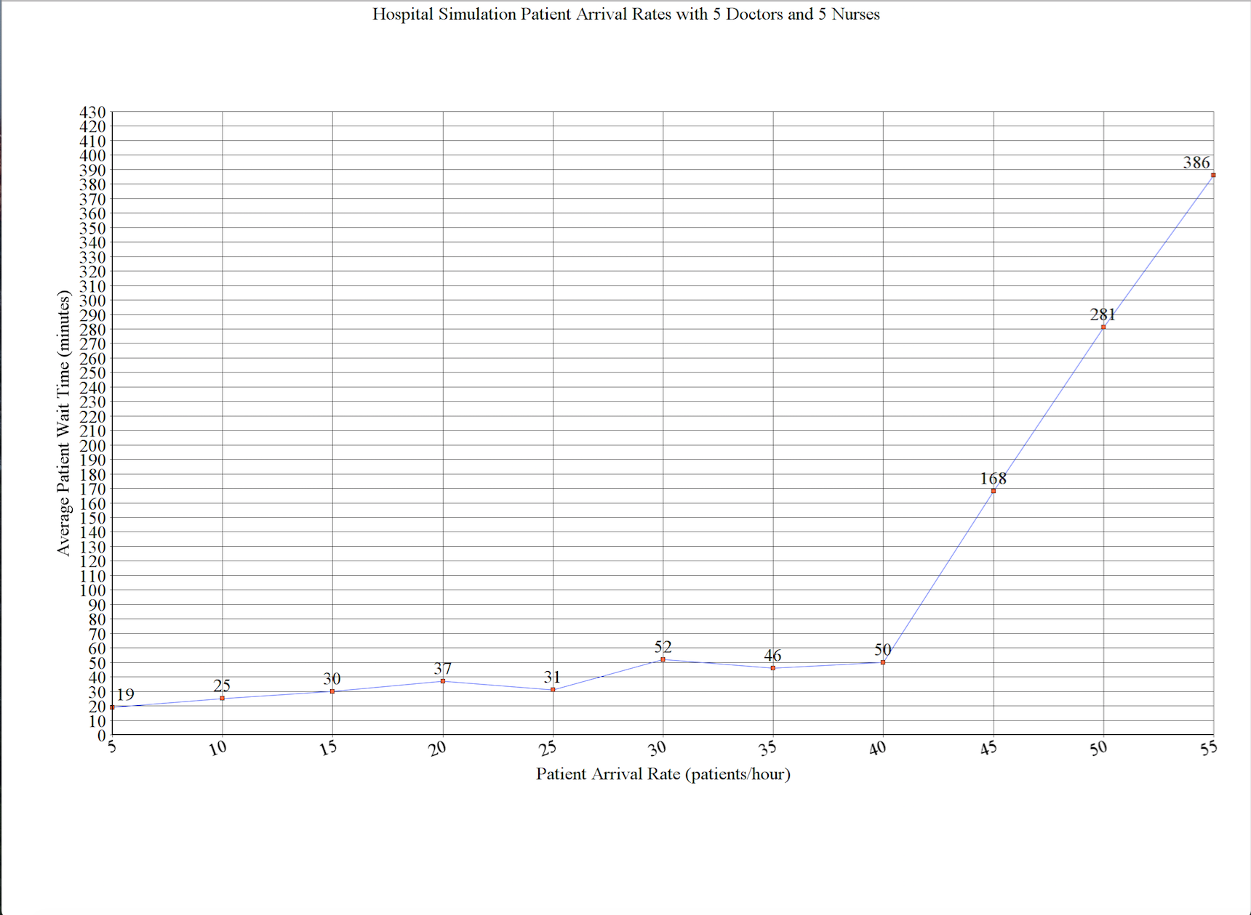

The average patient wait time displayed on this graph is not exact, we just used the most common values that appeared when we ran the simulation several times with each set of numbers. One interesting thing to note is that the simulation usually gave us average patient visit times similar to those seen in the graph, but occasionally would give us incredibly high average patient wait times, sometimes in the thousands of minutes range. We think this may be because the patient priority numbers are randomly generated and only doctors can treat patients with priority 10-20. So, if a lot of patients with high priority numbers are generated, it is almost like the nurses are not there and the doctors have to do twice as much work so the patients must wait longer. This would be an explanation for the very large average patient wait times. Additionally, the data for this graph agreed with our hypothesis. We expected that as the average hourly patient arrival rate increased while the number of doctors and nurses stayed the same, the average patient wait time would increase substantially.

Quite a bit was changed from our initial design to our final implementation. Our class hierarchy and relationships stayed the same, but the purposed of several classes changed. Originally, we had our Simulation class storing most of our data regarding patients, wait time, and number of patients served. All of that information got moved to other classes, mostly to the Patient class, and now Simulation only keeps track of clock and the number of doctors and nurses. Similar changes were made in our EmergencyRoom class. We originally planned to have information about the Doctor and Nurse service times and clearance levels in EmergencyRoom, but all of that information was moved to Caregivers and is now accessed using polymorphism. The functions in Discharge are the same as we planned, but they do more than we were anticipating them needing to do. They are the main way of storing the information that the menu outputs, and they contain the multiset that stores that Patient’s name, number of hospital visits, and priority numbers. This information is then accessed in Simulator from Discharge. We added a function in the Caregiver class to retrieve the Doctor or Nurse’s clearance level. We also implemented functions to determine whether or not a Doctor or Nurse is available to treat a patient. In Patient, we added several accessor and mutator functions to retrieve Patient information in other classes. Most importantly, we added a function to generate the vector of Patient’s names and assign those names to a Patient.

Our implementation was successful, except for one small aspect. We were unable to output the Patient’s priority levels for each of the visits to the hospital. We were confused about this part because we were able to access the number of times each Patient went to the hospital, but not the corresponding priority numbers. We attempted to do this using multisets, but were unsuccessful.