QrGate showcase
Developed by avocloud.net

Shop
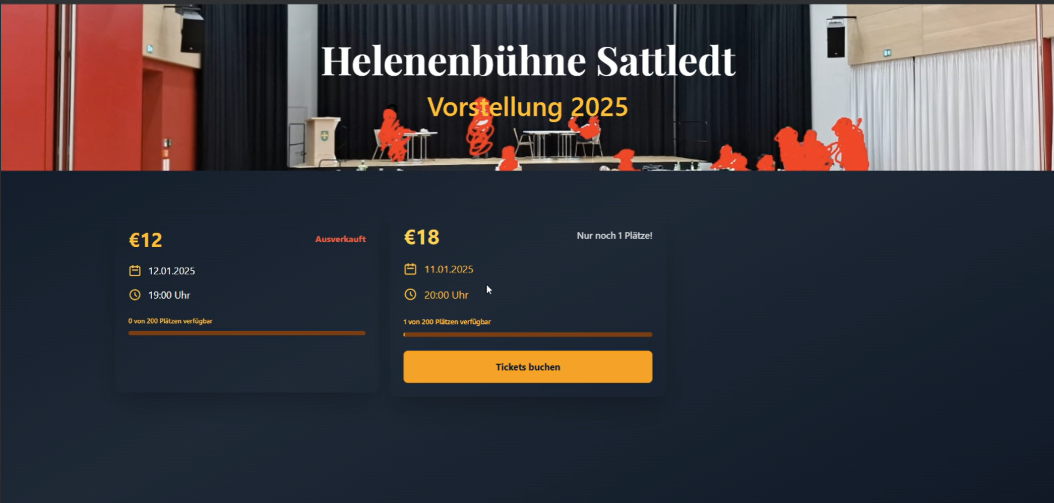

With the help of the online store, visitors can book tickets or buy one or more tickets via paypal (paypal, credit card, ...). Everything that can be seen there can be set via the admin dashboard. If a day/time is fully booked, this will be displayed there and blocked accordingly.

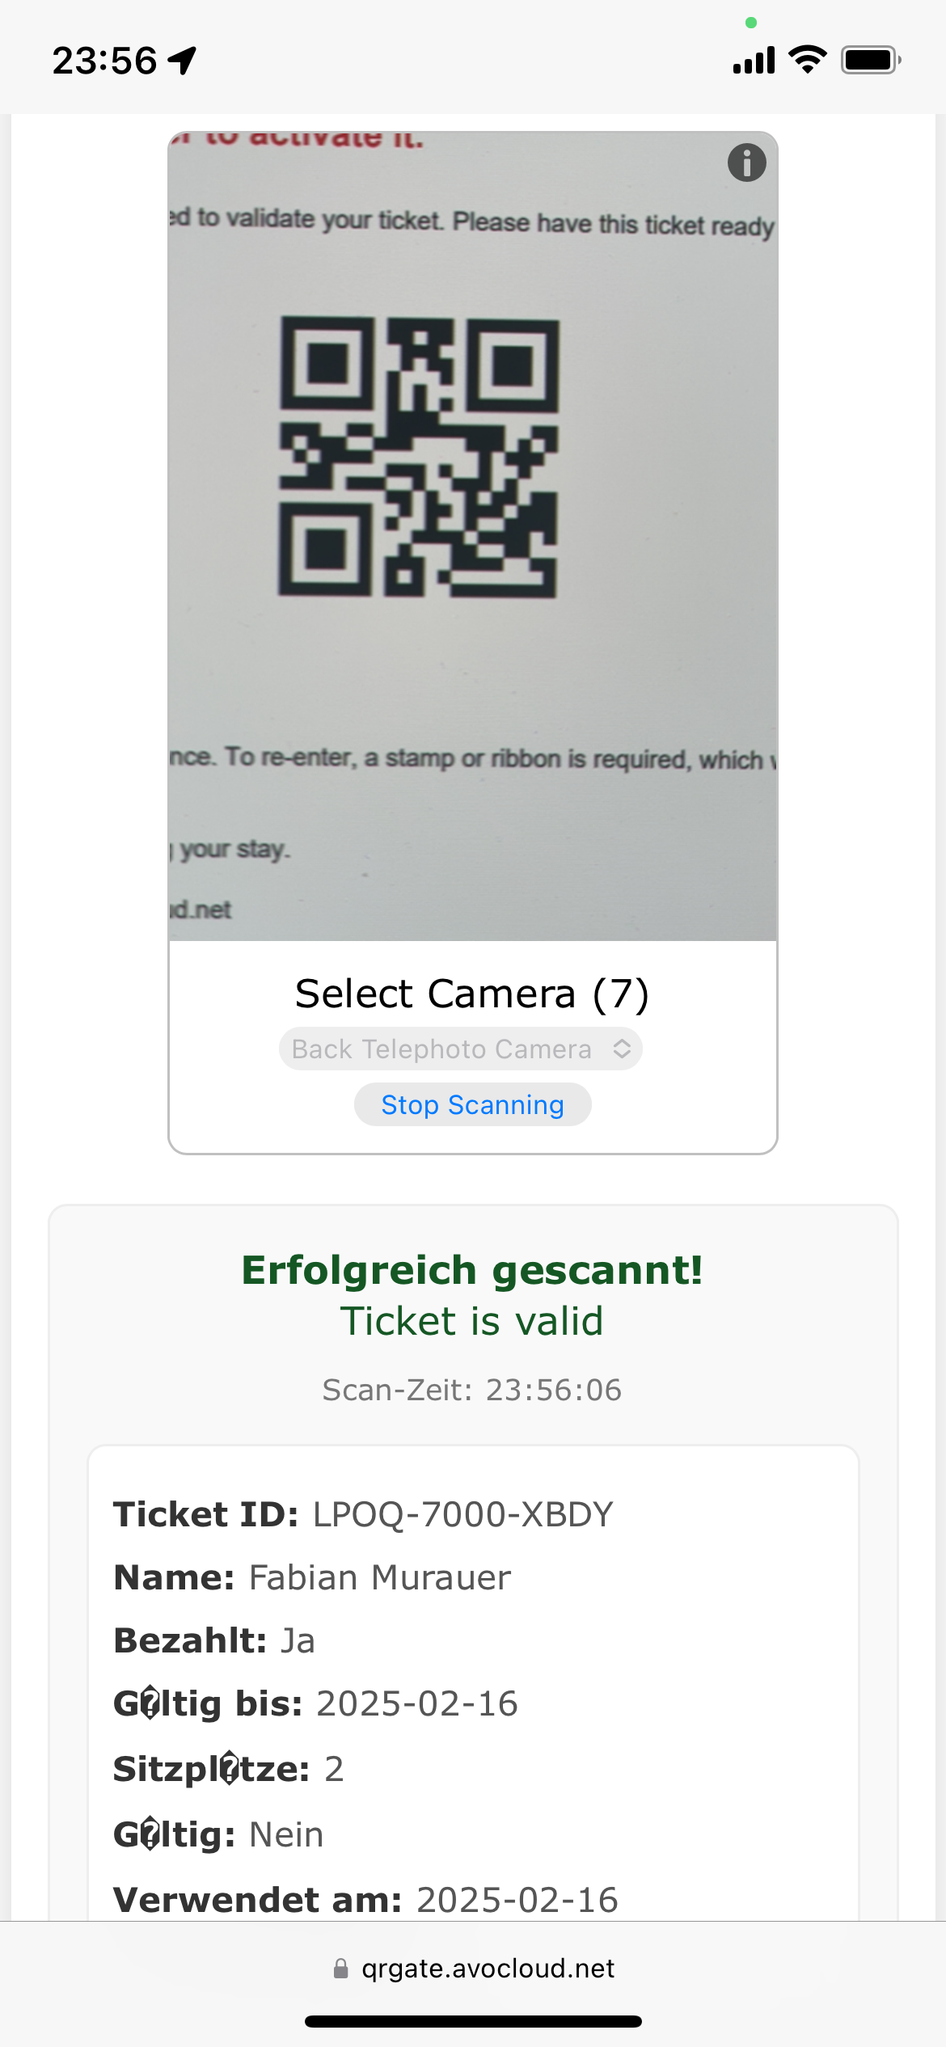
Handheld
The web app for the so-called handhelds is used to validate tickets quickly and easily. Using any smartphone (old or new), it is possible to capture and validate the QR codes on the tickets. The design makes it easy to see whether a ticket is valid or invalid.

Admin
[IMAGE NOT AVAILABLE]
The admin dashboard allows the administrators of the event to change the content of the store. This includes performances (date, time, available seats, ...). Statistics can also be called up there.

