Sabercast — Project Progress Update
MKTG 569 · Building Business Applications of LLMs and Generative Models

Project summary
Sabercast is a three-tab Streamlit application that uses LLM reasoning grounded in real MLB data to support front-office decisions for small- and mid-market teams. The three tabs are Roster Builder (construct lineups vs. a specific opponent), Opponent Scouting (identify exploitable weaknesses on an opposing roster), and Gap Filler (diagnose roster gaps, recommend free-agent targets ranked by 2024 statistical fit, and produce per-target contract forecasts). The system combines pybaseball stat ingestion, Spotrac contract scraping, OpenAI batch classification, ChromaDB RAG, and an OpenAI-fine-tuned contract valuation model.

Current demo status
Area | Status
Repository, dependencies, and OpenAI API access verified | Complete
2024 batting + pitching ingest via pybaseball (Baseball Reference endpoint, with documented FanGraphs fallback) | Complete
115 MLB contracts in dataset: 100 scraped from Spotrac plus 15 manually curated additions at thin positions (catcher, reliever, second base) | Complete
Gap Filler tab with team dropdown (all 30 MLB teams), editable payroll input, gap diagnosis, per-target acquisition-cost forecasts, and pricing comparables | Complete
Opponent Scouting tab with team dropdown, top hitter/pitcher tables, LLM-generated narrative, three top threats, three exploitable weaknesses, and recommended pitching strategy + hitting approach | Complete
Session-scoped result caching for repeat queries | Complete
Comparable filtering enforces no look-ahead: only contracts signed on or before the evaluation year are eligible as targets or pricing comparables | Complete
Multi-year historical batting and pitching ingest (2019–2023) | In work
Statcast defensive metrics ingest (per-position OAA, sprint speed) | In work
ChromaDB vectorstore for embedding-based player matching | In work
Fine-tuned contract valuation model (prompt-based fallback in place) | In work
Roster Builder tab end-to-end | In work
Streamlit Community Cloud deployment | In work
Five-year correlation evaluation (gap score versus next-year wins) | In work

Screenshots
Six screenshots captured from a live run of the deployed Streamlit app. The Gap Filler tab is scouted as of the end of the 2024 season for the Seattle Mariners; the Opponent Scouting tab is scouted for the Houston Astros.
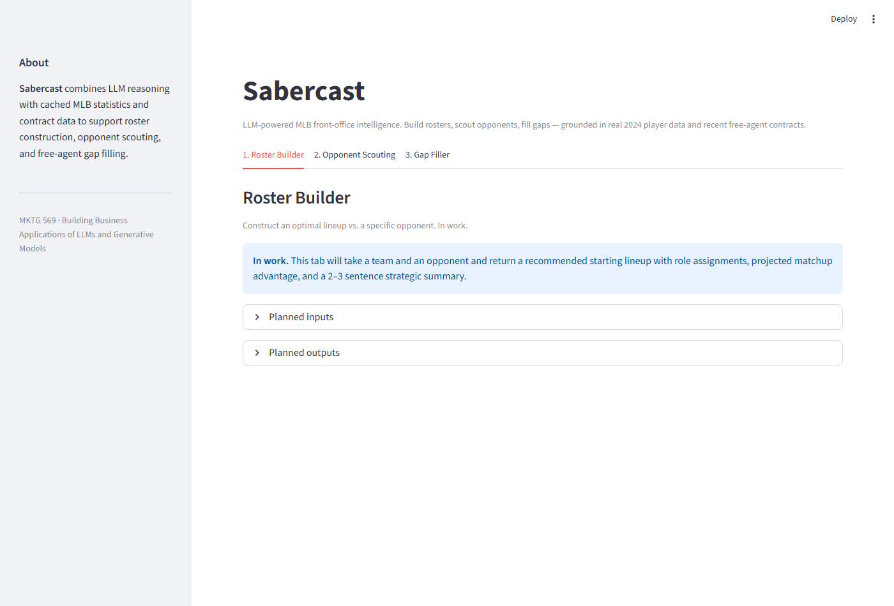
Figure 1. Landing page. All three tabs visible. The default tab (Roster Builder) currently renders an in-work placeholder listing the planned inputs and outputs.
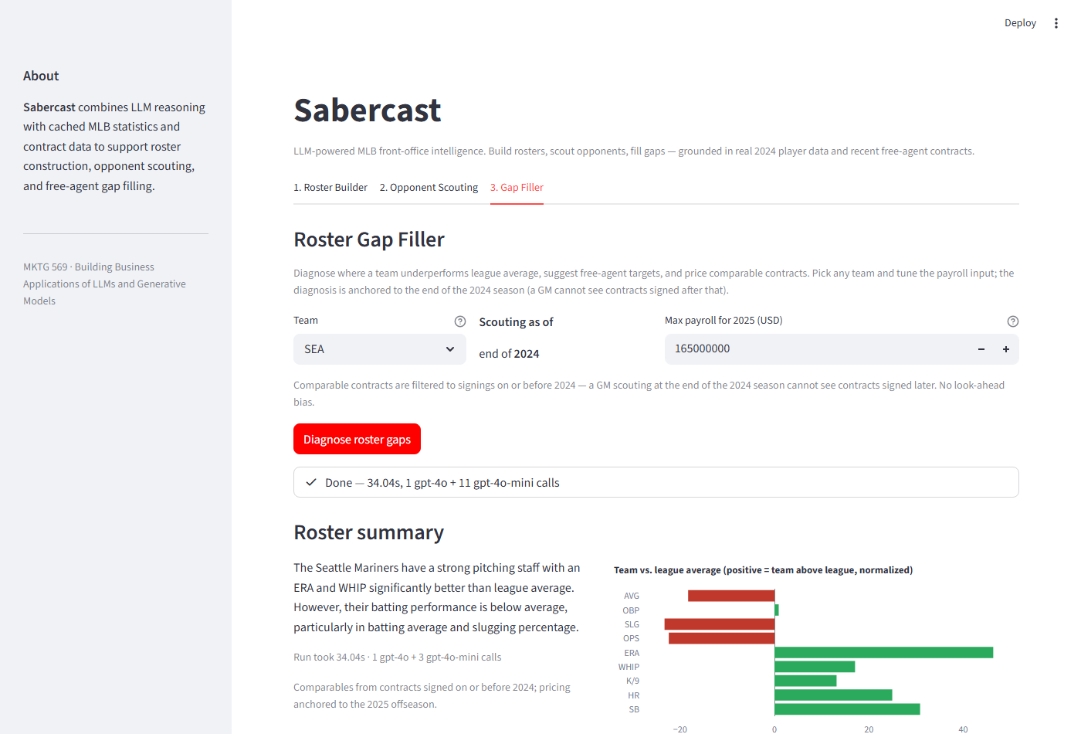
Figure 2. Gap Filler tab after running the diagnosis. The team dropdown holds all 30 MLB teams; the max-payroll input is pre-filled with the selected team's 2025 default (SEA: $165M). Status widget shows the completed run (1 gpt-4o call + 11 gpt-4o-mini calls). The Plotly delta chart visualizes team-vs-league averages — red bars on AVG/OBP/SLG/OPS, green bars on ERA/WHIP/K/9 and the team's HR/SB counting totals.
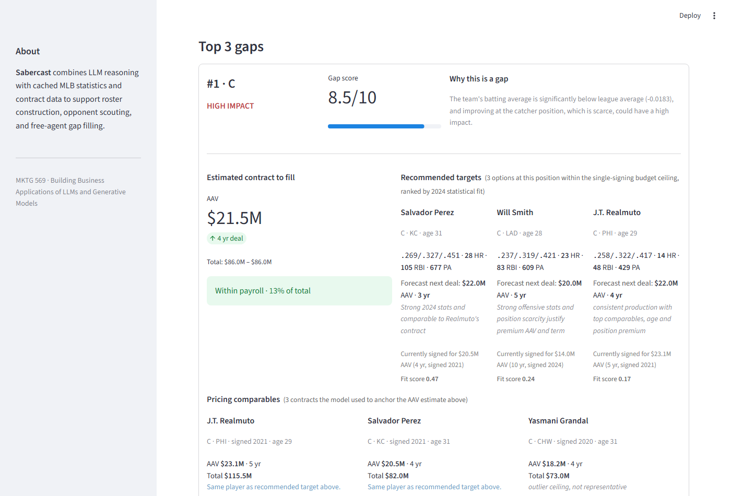
Figure 3. Top gap card for the Mariners. Catcher diagnosed as the highest-impact gap (8.5/10, $21.0M AAV estimated to fill). The Recommended targets section ranks Salvador Perez, Will Smith, and J.T. Realmuto by 2024 statistical fit, with each player's 2024 line, per-target forecast next deal, and current contract for context. The Pricing comparables section below lays out the three contracts the LLM used to anchor the AAV estimate, with a short rationale for each.
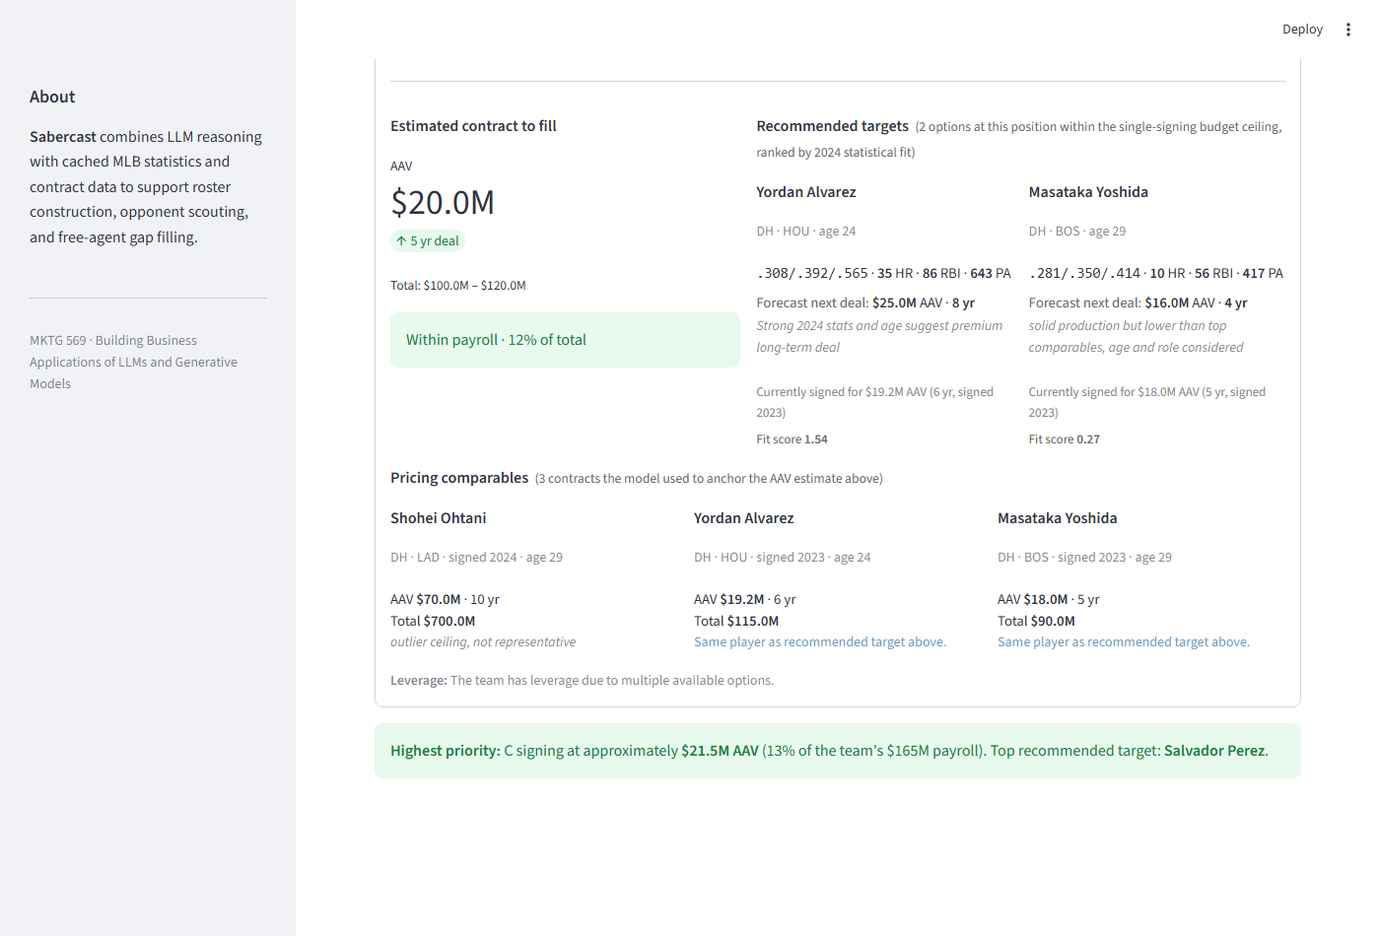
Figure 4. Bottom of the Gap Filler results. Contract estimate for the DH gap ($20.0M AAV / 5 yr) with two recommended targets, each with a per-target forecast. The Pricing comparables section includes Shohei Ohtani ($70M AAV) with the LLM rationale "outlier ceiling, not representative" — Ohtani's contract anchors pricing but his AAV exceeds the 30% single-signing ceiling, so he is not a target. Final summary banner identifies the highest-priority signing and the top recommended target.
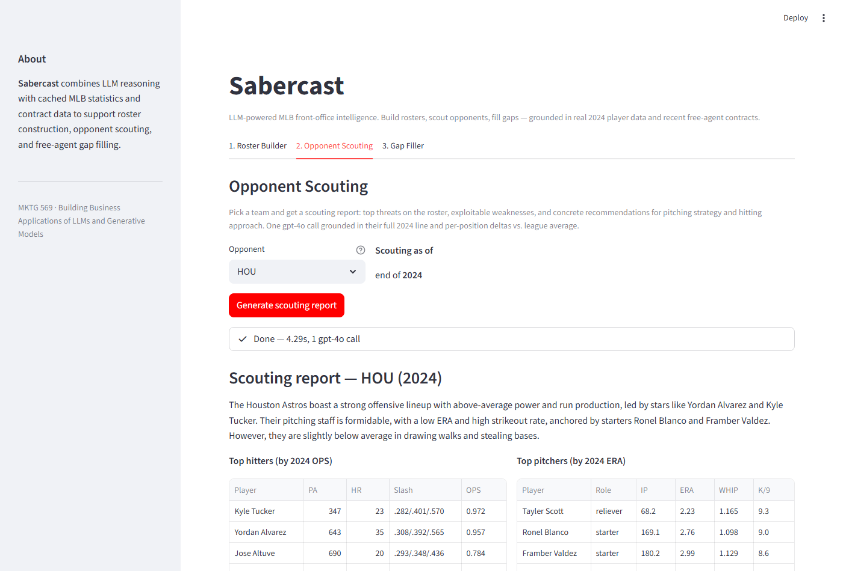
Figure 5. Opponent Scouting tab with the Astros selected. After one gpt-4o call (approximately 5 seconds) the tab renders the LLM-generated narrative plus two data tables: top hitters by 2024 OPS (Kyle Tucker .972, Yordan Alvarez .957, Jose Altuve .784, ...) and top pitchers by 2024 ERA (Tayler Scott 2.23, Ronel Blanco 2.76, Framber Valdez 2.99, ...). The raw stats are shown directly alongside the narrative.
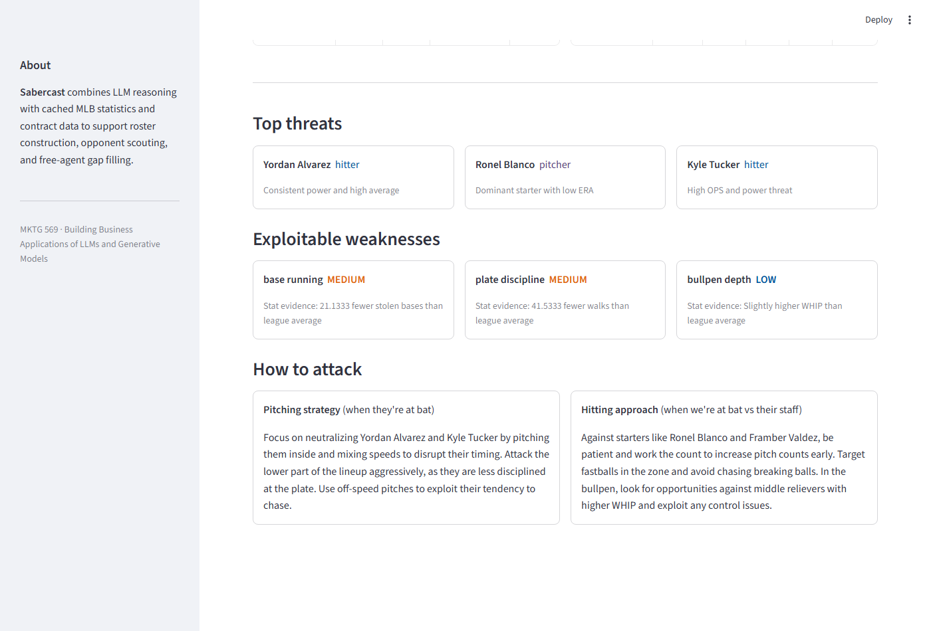
Figure 6. Bottom of the Opponent Scouting tab. Three top-threat cards (Yordan Alvarez, Ronel Blanco, Kyle Tucker), three exploitable-weakness cards with stat-evidence captions and impact chips, and two strategy cards with the recommended pitching strategy (when the opponent is at bat) and hitting approach (when our team is at bat versus their staff).

Known limitations
- Catcher framing data is not produced by the working pybaseball Statcast endpoint; catcher OAA serves as the proxy in the planned defensive ingest.
- Contract data does not include no-trade clauses or opt-out cascades. Spotrac's main contracts table does not expose this information without per-player page fetches.
- Contract pool is a 115-player subset (top-100 by AAV from Spotrac plus 15 hand-curated additions at thin positions). The full build will sweep Spotrac's per-team pages for broader coverage.
- Fielding metrics are not yet integrated into the gap diagnostic. The Pipeline 01 expansion in progress will add per-position Statcast OAA and sprint speed.

Deployment
The app runs locally via streamlit run app/streamlit_app.py after a one-line OpenAI key setup (key in OpenAIKey.txt or OPENAI_API_KEY environment variable). Streamlit Community Cloud deployment is in work.

