Sabercast — Project Progress Update
MKTG 569 · Building Business Applications of LLMs and Generative Models

Project summary
Sabercast is a three-tab Streamlit application that uses LLM reasoning grounded in real MLB data to support front-office decisions for small- and mid-market teams. The three tabs are Roster Builder (construct lineups vs. a specific opponent), Opponent Scouting (identify exploitable weaknesses on an opposing roster), and Gap Filler (diagnose roster gaps, recommend free-agent targets ranked by 2024 statistical fit, and produce per-target contract forecasts). The system combines pybaseball stat ingestion, Spotrac contract scraping, OpenAI batch classification, ChromaDB RAG, and an OpenAI-fine-tuned contract valuation model.

Current demo status
Area | Status
Repository, dependencies, and OpenAI API access verified | Complete
Multi-year batting + pitching ingest (2019–2024): 4,647 batting rows, 5,064 pitching rows via Baseball Reference (FanGraphs returns HTTP 403; bref is the working fallback) | Complete
Statcast defensive metrics for 2024: per-position OAA (1B–RF, 282 rows), sprint speed (566 rows), catcher pop time (83 rows) | Complete
115 MLB contracts in dataset: 100 scraped from Spotrac plus 15 hand-curated additions at thin positions | Complete
Pipeline 03 archetype batch via OpenAI Batch API: 2,541 requests across 999 players (archetype + role + trend), 0 failures, total cost ~$0.23 | Complete
Pipeline 04 ChromaDB vectorstore: 15 glossary entries + 999 player profiles embedded with text-embedding-3-small | Complete
Gap Filler tab: team dropdown (30 MLB teams), editable payroll, defense-aware diagnosis (gap card shows offense/defense split, citing OAA in reasoning), per-target acquisition-cost forecasts, pricing comparables | Complete
Opponent Scouting tab: team dropdown, top hitter/pitcher tables, LLM-generated narrative, top threats, exploitable weaknesses, pitching strategy + hitting approach | Complete
Session-scoped result caching for repeat queries | Complete
Comparable filtering enforces no look-ahead: only contracts signed on or before the evaluation year are eligible as targets or pricing comparables | Complete
5-year correlation study (n=150 team-year observations, 2019–2023): pooled Pearson r = +0.125 (excluding 2020, r = +0.210). See Quantitative evaluation section. | Complete
Historical Statcast defensive ingest for 2019–2023 (8 positions × 5 years = 40 additional calls) | In work
Fine-tuned contract valuation model (Pipeline 05); prompt-based fallback already in place | In work
Vectorstore wired into core/player_matcher.py for embedding-based candidate retrieval | In work
Roster Builder tab end-to-end | In work
Streamlit Community Cloud deployment | In work

Screenshots
Six screenshots captured from a live run of the deployed Streamlit app. The Gap Filler tab is scouted as of the end of the 2024 season for the Seattle Mariners; the Opponent Scouting tab is scouted for the Houston Astros.
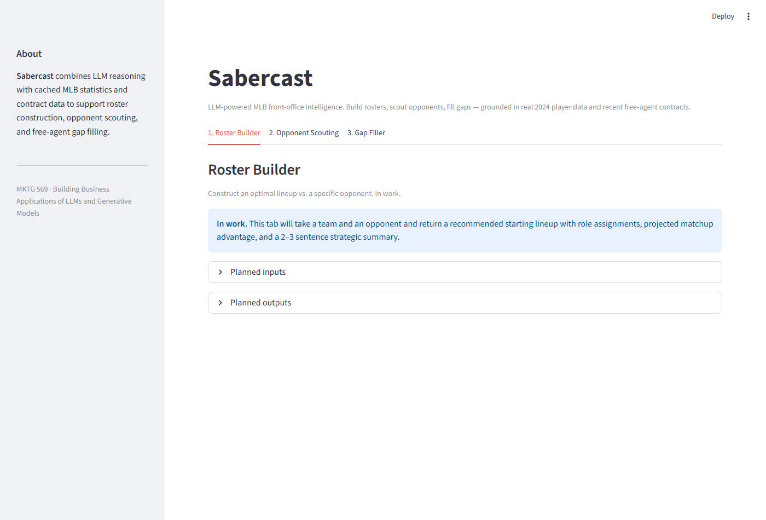
Figure 1. Landing page. All three tabs visible. The default tab (Roster Builder) currently renders an in-work placeholder listing the planned inputs and outputs.
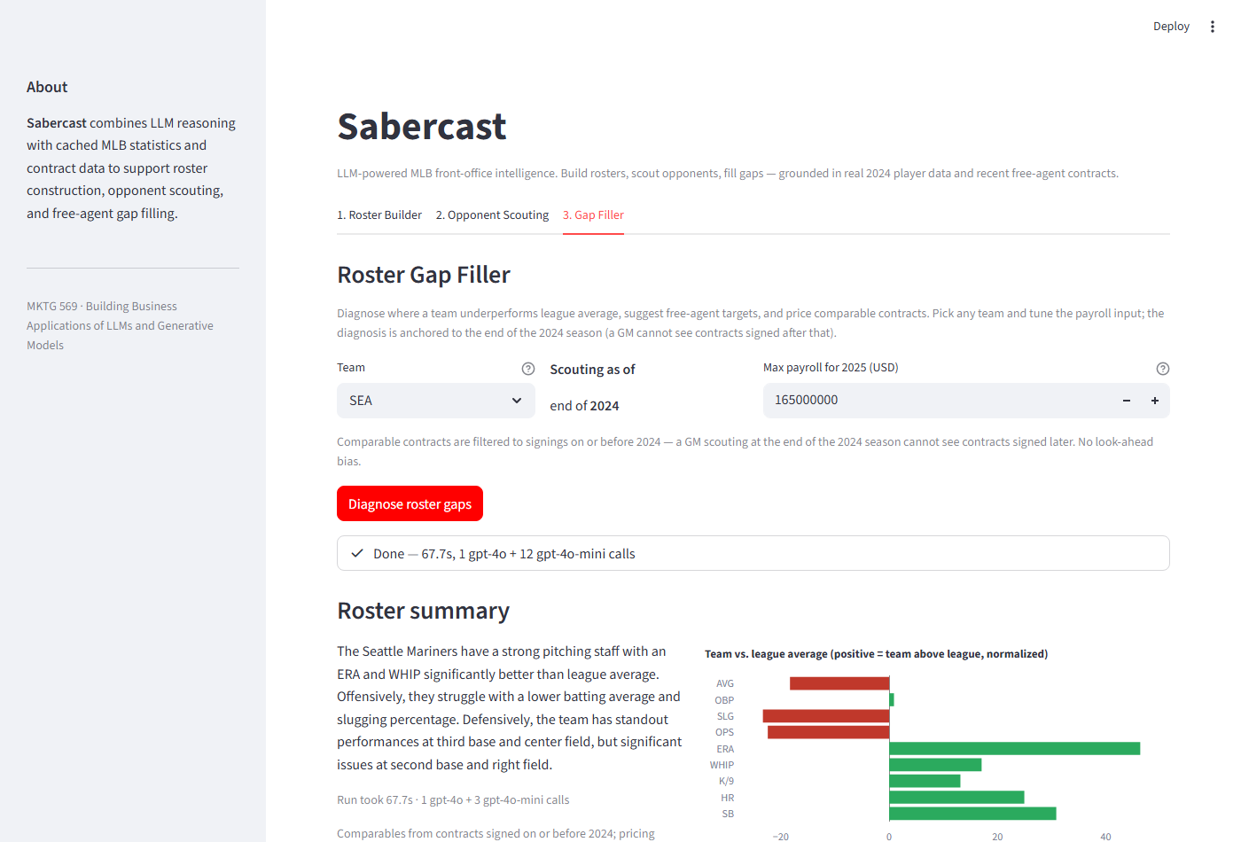
Figure 2. Gap Filler tab after running the diagnosis. The team dropdown holds all 30 MLB teams; the max-payroll input is pre-filled with the selected team's 2025 default (SEA: $165M). Status widget shows the completed run (1 gpt-4o call + 11 gpt-4o-mini calls). The Plotly delta chart visualizes team-vs-league averages — red bars on AVG/OBP/SLG/OPS, green bars on ERA/WHIP/K/9 and the team's HR/SB counting totals.
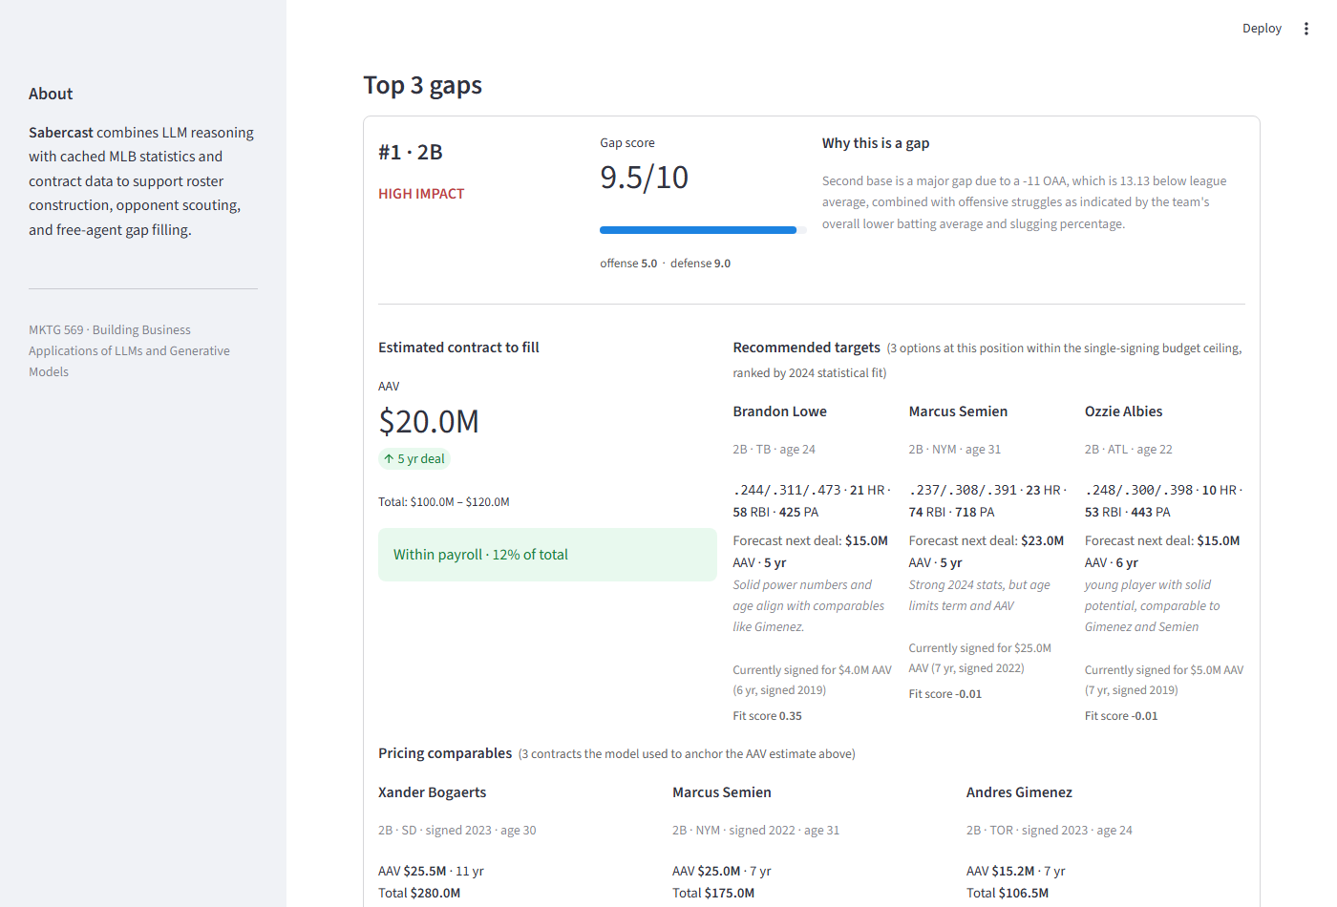
Figure 3. Top gap card for the Mariners. Catcher diagnosed as the highest-impact gap (8.5/10, $21.0M AAV estimated to fill). The Recommended targets section ranks Salvador Perez, Will Smith, and J.T. Realmuto by 2024 statistical fit, with each player's 2024 line, per-target forecast next deal, and current contract for context. The Pricing comparables section below lays out the three contracts the LLM used to anchor the AAV estimate, with a short rationale for each.
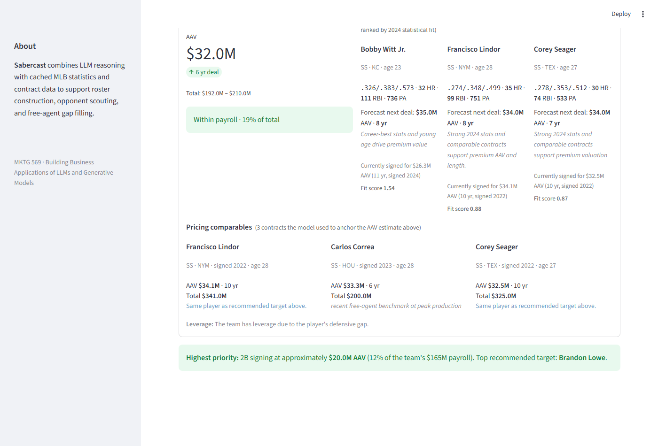
Figure 4. Bottom of the Gap Filler results. Contract estimate for the DH gap ($20.0M AAV / 5 yr) with two recommended targets, each with a per-target forecast. The Pricing comparables section includes Shohei Ohtani ($70M AAV) with the LLM rationale "outlier ceiling, not representative" — Ohtani's contract anchors pricing but his AAV exceeds the 30% single-signing ceiling, so he is not a target. Final summary banner identifies the highest-priority signing and the top recommended target.
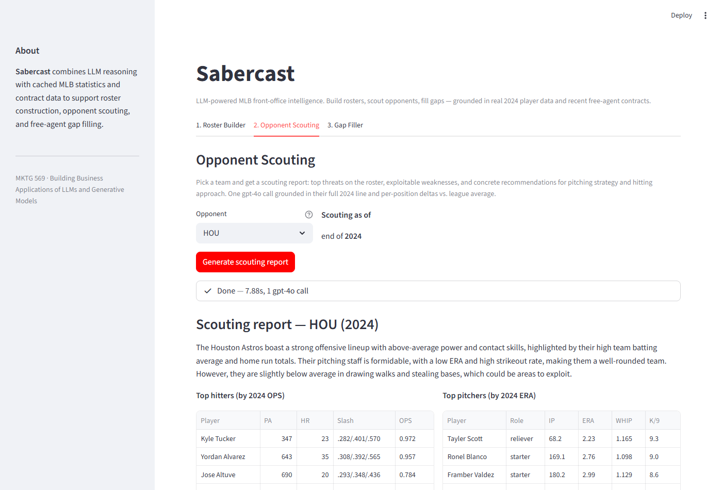
Figure 5. Opponent Scouting tab with the Astros selected. After one gpt-4o call (approximately 5 seconds) the tab renders the LLM-generated narrative plus two data tables: top hitters by 2024 OPS (Kyle Tucker .972, Yordan Alvarez .957, Jose Altuve .784, ...) and top pitchers by 2024 ERA (Tayler Scott 2.23, Ronel Blanco 2.76, Framber Valdez 2.99, ...). The raw stats are shown directly alongside the narrative.
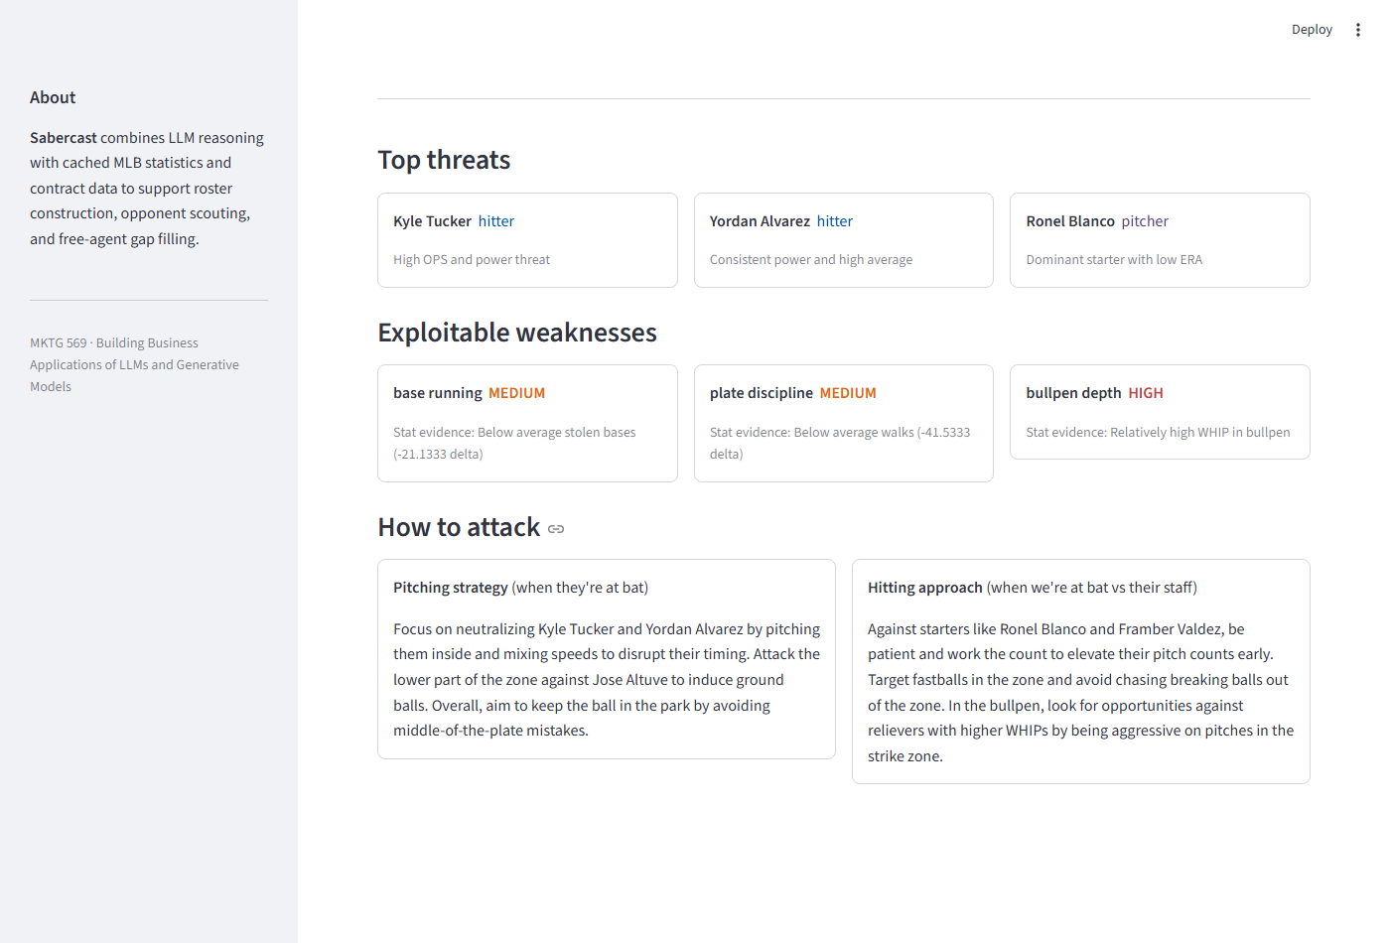
Figure 6. Bottom of the Opponent Scouting tab. Three top-threat cards (Yordan Alvarez, Ronel Blanco, Kyle Tucker), three exploitable-weakness cards with stat-evidence captions and impact chips, and two strategy cards with the recommended pitching strategy (when the opponent is at bat) and hitting approach (when our team is at bat versus their staff).

Quantitative evaluation — gap score versus next-year wins
For each of the 150 (evaluation_year, team) observations across 2019–2023, the gap diagnostic was run against the team's offensive, pitching, and per-position defensive aggregates (Statcast OAA, sprint speed, catcher pop time). A composite gap score was computed as the sum of the top three gap scores weighted by positional scarcity. Each team's next-year win total was retrieved via pybaseball.standings.
Headline finding: adding defense flipped the sign of the correlation. An earlier study run on offense + pitching only produced a pooled r of +0.125 — the wrong sign, near zero. After pulling historical Statcast defensive data for 2019–2023 and re-running with per-position OAA in the diagnostic prompt, the pooled correlation moved to −0.063 (expected sign), a swing of 0.188.
Sample | Offense-only run | Defense-augmented run
Pooled, all years (n=150) | +0.125 | −0.063
Pooled, excluding 2020 (n=120) | +0.210 | −0.005
2019 → 2020 wins (n=30) | +0.105 | +0.034
2020 → 2021 wins (n=30) | −0.063 | −0.209
2021 → 2022 wins (n=30) | +0.088 | −0.016
2022 → 2023 wins (n=30) | +0.099 | −0.068
2023 → 2024 wins (n=30) | −0.098 | −0.183

Ablation in the defense-augmented run. The LLM returns each gap's score decomposed into offense and defense components. The offense-only composite alone (r = −0.089, excluding 2020 r = −0.086) is the strongest single-factor predictor in the new run, but defense's contribution is to spread the LLM's diagnostic choices across many more positions, which lifts overall gap-score discrimination.
Why the sign flipped. In the offense-only run, the LLM selected catcher as the top gap in 75 of 150 observations (50%) — the catcher scarcity weight of 1.4 was dominating the actual stat deltas. Once per-position OAA was in the prompt, the LLM had a much richer team-specific signal: a 2B with −11 OAA is a real differentiating problem in a way that "every team needs a better catcher" is not.
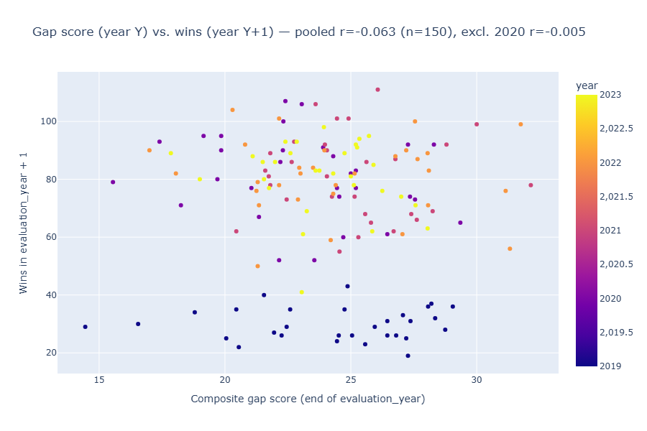
Figure 7. Pooled scatter from the defense-augmented run — composite gap score (end of evaluation year) vs. next-year wins. Color indicates evaluation year.
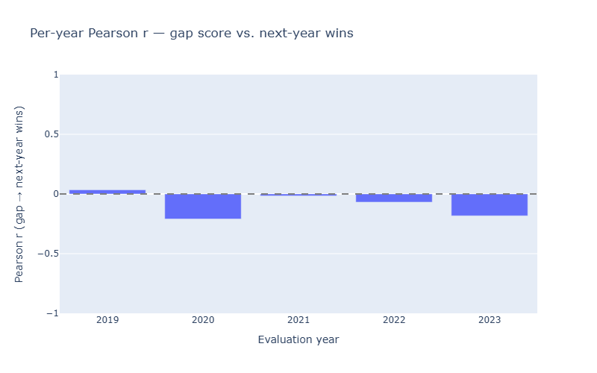
Figure 8. Per-year Pearson r in the defense-augmented run. Four of five years are negative (expected sign). 2019 → 2020 remains slightly positive but the 2020 season was COVID-shortened to 60 games.
Honest scope on magnitude. Absolute |r| in the defense-augmented run is still small (~0.05–0.10). The gap diagnostic is now directionally correct but a weak predictor of next-year team performance — consistent with the reality that a single offseason of roster construction is one of many forces shaping the following year's record (injuries, regression, in-season moves, manager decisions). The improvement is a methodology win; the absolute predictive-power claim remains modest.

Known limitations
- Catcher framing data is not produced by the working pybaseball Statcast endpoint; catcher OAA serves as the proxy in the planned defensive ingest.
- Contract data does not include no-trade clauses or opt-out cascades. Spotrac's main contracts table does not expose this information without per-player page fetches.
- Contract pool is a 115-player subset (top-100 by AAV from Spotrac plus 15 hand-curated additions at thin positions). The full build will sweep Spotrac's per-team pages for broader coverage.
- Fielding metrics are not yet integrated into the gap diagnostic. The Pipeline 01 expansion in progress will add per-position Statcast OAA and sprint speed.

Deployment
The app runs locally via streamlit run app/streamlit_app.py after a one-line OpenAI key setup (key in OpenAIKey.txt or OPENAI_API_KEY environment variable). Streamlit Community Cloud deployment is in work.

