NI Lock-In Amplifier
Start-Up Kit
User Manual

Introduction 4
How it works 4
Front Panel 6
1. Reference Section 6
Error Indicator 7
Type Control 7
PLL Filter TC (s) Control and Indicator 7
Phase Shift Control 8
Phase Autozero Control 8
Order Multiplier Control 8
Switch Signal/Reference Control 8
2. Filter Section 8
Type Control 8
TC (s) Control 9
Filter Roll-off Control 10
Settle Time(s) Indicator 10
Timer(s) Indicator 10
Reset Button 10
APPLY Button Control 10
3. Signal Generator Section 10
Signal Generator Selector 10
Ref Amp Control 10
Sig Amp Control 10
Frequency Control 11
Ref Shape Control 11
Reference Noise (V) Control 11
4. Graphical Display Section 11
Graph Indicator 11
Plot Control 11
Backlog Bar 11
DEMO Control 11
START Control 12
5. Digital Display Section 12
Display Selection Control 12
RESET MAX/MIN Button 12
STOP Button 12
SI Notation Switches 12
Display Mode Control 12
Digital Display Controls 12
Display Enable Control 13
6. Configuration Section 13
AI Configuration Control 13
Greeting Message Control 14
Lock-in Engine VI 15
LockinCheckLicense.vi 15
Description 15
Controls 15
Indicators 15
LockinPLL.vi 15
Description 15
Controls 16
Indicators 17
LockinDemodulatorSettings.vi 18
Description 18
Controls 18
Indicators 18
LockinDemodulator.vi 19
Description 19
Controls 19
Indicators 20

Introduction

National Instruments new Lock-In Amplifier Start-Up Kit provides virtual instrumentation for the precise measurement of AC signals that are partially or completely buried in noise. The start-up kit extends the power of LabVIEW to measure signals that you could not measure before, such as very small signals buried 100 dB deep in noise. An example of this includes extracting a 50 mV sine wave from a white noise signal with 5 V amplitude.

How it works

A lock-in amplifier is intended for precise measurement of AC signals. The noise is removed by performing a Fourier transform on the input signal at the frequency and phase carried by the reference signal. A lock-in amplifier acts as a narrow band-pass filter (as narrow as 1 mHz) around the reference signal frequency.
Gain

PLL
Signal
Ref
X
Acos(ω_{S}t +θ - ω_{R}t) +
Acos(ω_{S}t +θ +ω_{R}t)
Low-pass
Filter
TC (s)
Asin(ω_{S}t+θ)
For ω_{S} = ω_{R}
Acos(θ) + ½Acos(2ω_{S}t + θ)
X = Acos(θ)
2sinω_{R}t
Y= Asin(θ)
A = R = (X ² +Y ²)^{1/2}
θ = tan⁻¹(Y/X)
2cosω_{R}t
X
Asin(ω_{S}t +θ - ω_{R}t) +
Asin(ω_{S}t +θ +ω_{R}t)
Low-pass
Filter
TC (s)

Simplified Lock-In Block Diagram

The reference signal is fed into an internal reference synthesizer that extracts frequency and phase information from the reference signal and generates a pure sine wave. That sine wave is then mixed with the amplified signal (amplification is optional). For each frequency component in the input signal, the mixer generates two output components: one with the frequency equal to the difference between the frequencies of the internal reference and the signal component (ω_{R} - ω_{S}) and one equal to the sum of the two frequencies (ω_{R} + ω_{S}). For the component of the input signal with the frequency equal to that of the internal reference (ω_{S} = ω_{R}), the first mixer component will have frequency equal to 0 (a DC signal) and the second mixer component will have frequency equal to twice the reference frequency (2ω_{R}). A low-pass filter that follows the mixer should ideally reject everything but the DC component, which is proportional to the amplitude of the signal component at the ω_{R} and the cosine of its phase relative to the phase of the internal reference (A•cos(θ)). This quantity is referred to as “X.” If the same process, mixing and filtering, is applied using a pure cosine wave at ω_{R}, quantity “Y” will be generated. Y is proportional to the amplitude of the signal component times the sine of the phase shift (A•sin(θ)). From these two quantities, the amplitude (A) and relative phase (R) of the input signal can be determined.
In practice, however, the low-pass filter will reject only frequencies that are outside of its cutoff frequency range. Consequently, all noise in the range (ω_{R} ± filter cut-off frequency) will pass through the filter and adversely affect the measurement. That is why the characteristics of the output filter are of crucial importance to making fast and precise measurements.
When speaking about lock-in amplifiers, filter bandwidth is expressed in seconds (time-constant or TC) instead of in frequency. This is because TC is directly proportional to the filter settling time. If we define the cutoff frequency as the frequency at which the signal is attenuated 3 dB (multiplied by the filter order for higher order filters), the IIR filter used in the National Instruments lock-in engine has a cut-off frequency equal to 1/(2π TC) Hz. The TC is the filter time constant expressed in seconds. For the FIR filter that frequency is approximately 0.35/TC Hz.

Front Panel
The Lock-In DEMO VI front panel consists of the following sections:
- Reference
- Filter
- Signal Generator
- Graphical Display
- Digital Display
- Configuration

What follows is a brief description of controls and indicators in each section.

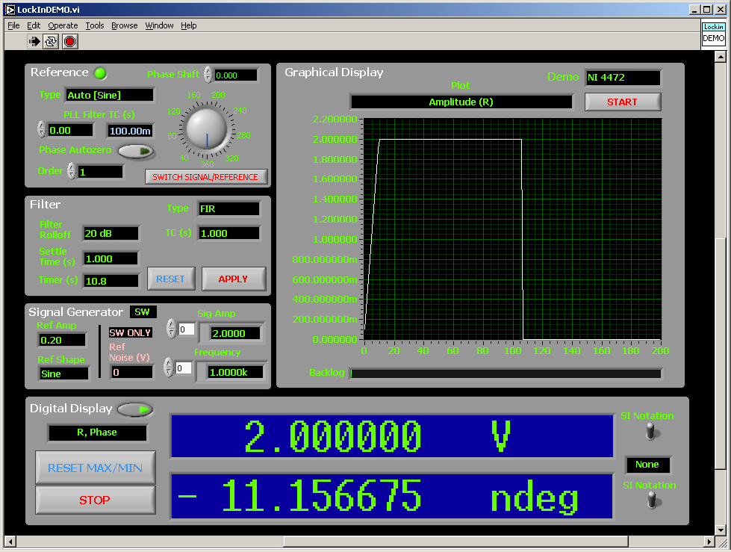

Lock-In DEMO VI Front Panel

1. Reference Section
Controls and indicators in this section affect how the external reference is converted into internal reference waves mixed with the input signal to extract the amplitude and phase of the desired frequency component.

Error Indicator
The unnamed LED located immediately to the right of the “Reference” text will turn RED if an error has been detected while extracting frequency and phase information. Otherwise it is green.

Type Control
This control is used to select the frequency range and shape of the reference signal. The information is used internally to determine the optimal algorithm for extraction of the reference signal frequency and phase. Auto signifies that the lock-in will detect any frequency within its range.
The main difference between Auto [Sine] and Auto [Sine-Sync] is how often the reference frequency is updated. If the Auto [Sine] option is selected, the reference frequency is updated for each block of data retrieved from the device analog input buffer. For example, if the sampling rate is 200 kHz and the data block size is set to 20,000 (see Configuration Section), the reference frequency will be updated 10 times each second. If the Auto [Sine-Sync] is selected, the reference frequency will be updated only for data blocks in which a threshold crossing with positive slope has been detected.
If the reference frequency is 1 Hz, its value is updated once every second even though 10 data blocks have been processed during the same time interval.
Please note that if the number of data blocks processed each second is smaller than the reference frequency, the processing rate determines the update rate. For instance, if the sampling rate is 200 kHz, the data block size is 400,000 points, and the reference frequency is 1 Hz, updates occur only once every two seconds. Consequently, the two options become identical when the reference frequency is large enough for each data block to contain at least one full cycle. The main reason for the synchronous option is to reduce the processor load, which may allow for the increase in the acquisition rate or a reduction in the data block size.
The frequency of the square waves is always updated in a synchronous fashion since the exact frequency can be determined only once a positive slope edge has been detected.
The VI will automatically handle reference signals that are not symmetric around the zero as long as the value of the offset does not change significantly throughout the measurement. A TTL signal is an example of such a signal.

PLL Filter TC (s) Control and Indicator
This Control/Indicator determines the amount of data used to extract the reference signal frequency and phase. For all sinusoidal references, and square references with frequencies larger than 5 Hz, at least three cycles of the signal are required for information extraction. For all other square references, only one cycle is required. This option can be very useful when the reference signal is noisy.
The lock-in engine algorithm will automatically choose the time closest to the time entered into the control that is displayed in the blue colored indicator. For example, if TC of 0 is requested, only three cycles will be used to extract the necessary information, regardless of the reference frequency. Please note that as TC increases, more computation is required and buffer overflows may occur on slower computers.

Phase Shift Control
This control can be used to insert phase lag into the internal reference signals. Phase lag may be necessary to maximize the X or Y components when the signal arriving at the lock-in is phase shifted with respect to the reference signal. One can either use the dial or type the phase-shift directly into the dial’s digital display.
The shift should be entered in degrees.

Phase Autozero Control
When autozero is turned on, the value of the current phase shift is written into the Phase Shift control so that the X component is maximized. The control will be automatically deselected once the value has been written.

Order Multiplier Control
This multiplier can be used to modify the reference frequency that the lock-in is locking onto. By entering integer values 2, 3, 4, and others, one can lock onto the 2nd, 3rd, 4th, etc., harmonic of the original reference frequency.
There is no protection from entering a multiple that will cause the reference frequency to go above half of the sampling frequency, so be careful when selecting values.

Switch Signal/Reference Control
When the Switch Signal/Reference Control has been pressed, the paths of the reference and input signal will be swapped. This can be used to remove phase shift errors due to noise in the reference and the underlying algorithm when precise phase shift measurements are required. Phase shift inherent in the two signals will change sign when the two paths are changed, whereas other shifts caused by the noise in the reference and algorithm will not. Note that if the signal is buried in noise, switching paths will not work. Also, if the signal is very noisy compared to the reference, increasing the reference filter TC will be required.

2. Filter Section
This section describes controls and indicators associated with the output low-pass filter.

Type Control
Several types of low-pass filters that are various incarnations of either 10th order IIR or 10th order FIR filter can be selected. Since the filters are 10th order, they can have roll-offs ranging from 20 to 200 dB/decade. There are no constraints on the time constants regardless of the type of the filter used.

Description of filter types:

- IIR (2-dig)
Selects a 10th order IIR filter and displays the time it takes filter to settle to 99 percent of its final value. Numerically, the IIR filter is less expensive than its FIR counterpart, so it can be used to speed-up calculation when time constants smaller than 10,000 x conversion interval are required. It can also be used to reduce filtering overhead when the conversion rate has to be increased. For example, if the conversion rate is 100 kHz, selecting the IIR filter option may allow the application to run on slower computers when filter time constants of 10 ms or less are required.
- IIR (5-dig)
This filter setting is the same as the IIR (2-dig) setting except that the time required for the filter to settle to 99.999 percent of its final value is displayed.
- FIR
Selects 10th order FIR filter. As mentioned previously, this type of filter is more time-consuming than the IIR version for time constants smaller than 10,000 x sampling frequency.
- FIR (ENBW)
This filter setting is the same as the FIR, except that the time constant of the FIR filter is internally modified so that the Equivalent Noise Bandwidth (ENBW) becomes equal to that of the IIR filter with the time constant specified in the TC (s) control. To match the lower noise bandwidth of the IIR filter, the time constant must be increased, resulting in an increased settling time. Although increased, the settling time will still be shorter than the settling time of the IIR filter if five digits of precision are required.
- FIR (Sync)
This filter setting is the same as FIR except that the time constant entered into the TC (s) control is coerced to the closest integer multiple of the reference frequency inverse. This is especially useful for smaller reference frequencies where the (ω_{R} + ω_{S}) frequency component generated by the mixer can be very close to the DC component. For example, if the reference frequency is f_{R} = 0.1 Hz, the mixer will produce the desired DC signal as well as an unwanted frequency component at 2f_{R} = 0.2 Hz. It is the task of the low-pass filter to remove the unwanted frequency component. To attenuate this component by 60 dB, using a 4th order IIR filter would require at least 50 or 90 seconds to settle to five digits. The FIR filter, however, has poles located at the integer multiples of 1/TC Hz and accomplishes this much faster. For example, a 3rd order sync-FIR filter will attenuate the 2f_{R} component to more than 60 dB and completely settle in 30 seconds if its time constants are within 0.9 to 1.1 of the 1/(2 f_{R}). If the sync window can be calculated more precisely this time can be reduced to 20 seconds or less.

Changing the type control will not go into effect until the APPLY button has been pressed. However, the Settling Time indicator will change to show what the filter settling time will be with the new option.

TC (s) Control
Time constant of the low-pass filter in seconds. If the “FIR (ENWB)” option is selected as a filter type, this is not the actual time constant of the FIR filter, but is the time constant of the IIR filter whose equivalent noise bandwidth we want to match. For an IIR filter, a cutoff frequency (frequency attenuated by at least 3 dB with a first-order filter) is equal to 1/(2 π TC) Hz whereas for the FIR filter that frequency is about 0.35/TC Hz.
Changing this option will not go into effect until APPLY button has been pressed. However, the Settling Time indicator will change to show what the filter settling time will be with the new option.

Filter Roll-off Control
Selects order of the filter. Changing this option immediately affects the filter output since all stages of the filter are evaluated simultaneously. Please note that the higher order filter outputs will take longer to settle. The Settling Time indicator will change to show what the filter settling time is.

Settle Time(s) Indicator
Shows the time in seconds required for the filter to settle its output. This value changes immediately when filter type, time constant, and roll-off are modified.

Timer(s) Indicator
Shows the time in the seconds expired from the last time the APPLY button has been pressed. When compared with the Settle Time(s) indicator, it can be used to determine if the filter has settled or not. The timer does not restart if significant changes in the reference frequency or input amplitude are detected. The counter can be zeroed by pressing the APPLY button. Note that by pressing APPLY button you will also reset the filter internals.

Reset Button
This button resets the timer.

APPLY Button Control
When pressed, any changes to the filter type and the TC(s) controls take effect. Pushing this button also clears the filter stages and resets the filter timer.

3. Signal Generator Section
This section can be used to control generation of limited set of waveforms in SW (simulation). This option can be used to demonstrate filter behavior using simulated signals.

Signal Generator Selector
The pull-down menu selector is located immediately right from the “Signal Generator” text. It can be used to turn the signal generation from OFF to SW. Simulation (SW) mode requires no HW.

Ref Amp Control
Determines amplitude of the wave generated on the reference output.

Sig Amp Control
Determines amplitude of the wave generated on the signal output. The amplitudes are matched with the corresponding entries in the Frequency control to allow generation of multiple frequency components.

Frequency Control
Determines the frequency of generated signals. The frequencies are matched with the corresponding entries in the Sig Amp control to allow the generation of multiple frequency components on the signal output.

Ref Shape Control
Determines the shape of the generated reference signal.

Reference Noise (V) Control
If different from 0, a gaussian noise pattern with standard deviation specified by the control will be added to the sinusoidal reference wave.

4. Graphical Display Section

Graph Indicator
Displays various plots selected by the Plot control

Plot Control
Selects what is to be displayed on the Graph. These options are also self explanatory and will not be discussed in detail.
The graph is updated at a rate equal to the sampling frequency divided by the size of the data block that is processed at a time (see Configuration section).
All options labeled “(Scope Mode)” display data acquired at the full sampling rate and can slow down the application significantly. This is because in each update all points acquired in the mean time must be plotted. A partial speed increase may be achieved by limiting the number of points visible on the graph.
Other options display the last 200 points worth of history and a new point is added at the display update rate. For example, for a sampling rate of 100 kHz and a block size of 10,000, the two digital displays and the graph will be updated once every 100 ms, which translates to 20 seconds worth of data in the history buffer.
“Signal, Reference, Internal Ref (Scope Mode)” option displays three curves on the graph using white, red, and green colors, respectively. “Internal Ref” curve can be used to show how well the reference section locked onto the reference signal.
To free-up processor time used for graph updating, the “Off” option should be selected.

Backlog Bar
Displays amount of data backlogged in the AI buffer. It indicates that the processor cannot keep up with the incoming data if the bar grows continually. Remedies include, but are not limited to, using faster computer, increasing size of the data block, reducing acquisition speed (can cause problems due to aliasing), disabling plotting altogether (or not plotting scope mode data), choosing IIR filter for smaller time-constants, etc.

DEMO Control
In combination with information in the Configuration section, this control can be used to pick one of the predefined AI configurations.

START Control
The VI displays the welcome message until the START button is pressed. If the START button has not been pressed, the STOP button cannot be used to stop the execution of the VI.

5. Digital Display Section
Controls what data is displayed in the two digital displays and how it is formatted.

Display Selection Control
The Display Selection control is an unnamed pull-down menu located on the left side of the two digital displays. The control is used to choose what gets displayed in the digital displays. The first variable is displayed in the upper display and the second variable is displayed in the lower display. The settings are self explanatory but the abbreviations may not be clear. They are shown below:
X, Y – standard lock-in notation (please see introduction)
R or Amplitude – standard lock-in notation (please see introduction)
θ or Phase - standard lock-in notation (please see introduction)
f_{ref} – reference frequency
(Max, Min) – maximum and minimum values of a given variable since the last time RESET MAX/MIN button has been pressed.

RESET MAX/MIN Button
This button will restart the tracking of the minimum and maximum values for all variables.

STOP Button
This button will stop the execution of the VI.

SI Notation Switches
Switching these on will set the display mode of the corresponding digital display from a floating-point (eleven digits + sign + decimal point) to SI notation (one to three digits before the decimal point and six digits after the decimal point).

Display Mode Control
Display Mode control is an unnamed pull-down menu located on the right side of the two digital displays. This control determines whether quantities in both digital displays will be shown as amplitudes, RMS values, or peak-to-peak values. This option does not affect quantities for which it does not make sense, such as Hz, degrees, etc.

Digital Display Controls
Digital displays are updated at a rate equal to the sampling frequency divided by the size of the data block that is processed at a time (see Configuration section).

Display Enable Control
Display enable control is a button located on the right hand side of the “Digital Display” text. If the button is turned OFF, the lock-in VI will stop updating the Graph (see Graphical Display Section) and the two digital displays, and stop keeping track of Min and Max values. This should free some computer resources for other tasks. To disable the digital displays without affecting the tracking of Min and Max values, use the “Off” option in the Display Selection control.

6. Configuration Section
This section, shown below, is located on the left side of the lock-in front panel and should be hidden from the view.

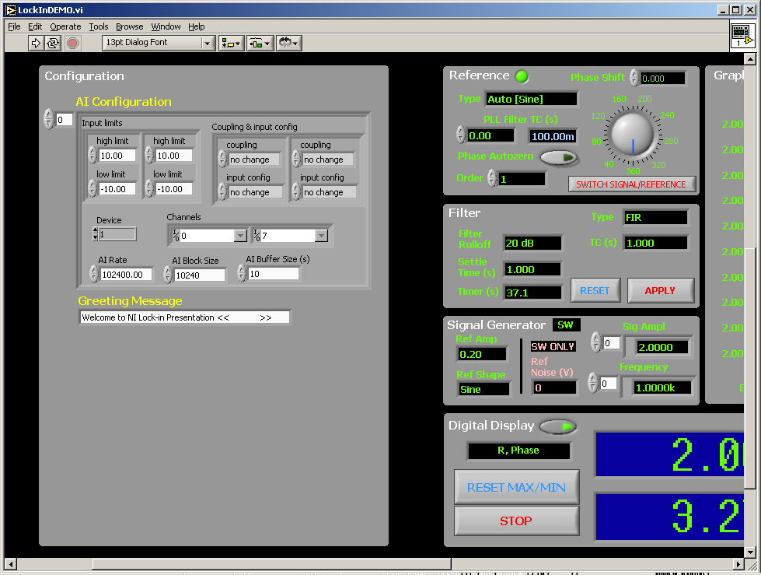

Lock-In DEMO VI Front Panel (Hidden Configuration Section)

AI Configuration Control
This array control can be used to define multiple configurations of the HW front end (device, AI channels, gains, coupling, acquisition speed, data block size, acquisition buffer size). The predefined configurations can be later selected via DEMO Control described previously. The first channel in the channel list should be used for the signal and the second channel in the list should be used as the reference input.

Greeting Message Control
A message to be scrolled in the upper digital display once the VI is started (also see Graphical Display section).

Lock-in Engine VI

The lock-in engine consists of four VIs:
- LockinCheckLicense.vi
- LockinPLL.vi
- LockinDemodulatorSettings.vi
- LockinDemodulator.vi.

The controls, indicators, and functionality of these VIs are discussed below. When using the VIs, you may also find it helpful to use the Context Help Window by navigating to Help>>Show Context Help (Ctrl-H). The documentation below is available there as well.

LockinCheckLicense.vi

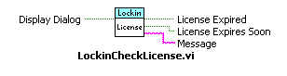Description
The VIs included in the NI Lock-In Start-Up Kit will stop working once their license expires. This VI may be used to display a warning that the license will expire within the month or that it has already expired.

Controls
Display Dialog If set to true, the VI displays warning dialog
Default value: True.

Indicators
License Expired Set to True if the license expired.

License Expires Soon Set to True if the license will expire within a month.
Message Message that is displayed in the warning dialog if enabled. This message is set regardless of the state of the Display Dialog flag.

LockinPLL.vi

Description
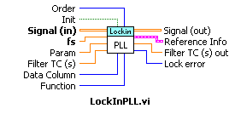The LockInPLL.vi is a software implementation of a PLL algorithm (phase locked loop) whose main purpose is to measure the frequency and phase of the reference signal. This information may then be used to generate internal sine and cosine reference signals that are mixed with the input signal(s). The reference signal can have a frequency ranging from mHz to MHz and can be either a sine or a square wave.

Controls
Signal(In) A 2D-array. The Data Column control is used to specify which column of the matrix contains the reference signal data.
Default value: none (input value required)

fs The frequency at which the data has been sampled.
Default value: none (input value required)

Param For the current version of the LockInPLL.vi to function properly, the reference signal must be symmetric around 0. This parameter may be used to offset the reference signal if that is not the case. For example, if a TTL signal is to be used as a reference signal and its levels are between 0.5 and 4.8 V, then the value of the parameter should be about
(4.8 – 0.5) / 2 ~ 2.2 V
Default value: 0

Filter TC(s) The PLL algorithm operates on blocks of reference signal data to extract the required information. The larger the block size, the better the estimate. The size of the block is determined as follows.
By default, the algorithm uses three cycles worth of data unless the chunk of data passed to the VI is larger. In the later case, the whole chunk will be used to extract the relevant information. In the former case, the VI automatically accumulates the required amount of data. For example, if the sampling frequency fs is 102.4 kHz, the length of the input data is 10,240 samples, and the reference signal frequency is 1 kHz, the output of the PLL will represent the average over 100 reference cycles.
If, on the other hand, the reference frequency is 10 Hz, the VI will use stored data from the last three calls to obtain the frequency and phase. The amount of data to average over can be increased via this control. For example, to average a 10 Hz reference signal over five cycles, one should select the time constant (TC) to be 0.5 s. The actual TC used is displayed in the Filter TC(s) out indicator (see the Indicators section). Note that the default value of three cycles can be selected by typing 0 in the control and also represents the minimum TC. Finally, note that the TC can only be a multiple of the reference signal period and that other values will be rounded off to the nearest integer multiple.
Default value: 1 second

Data Column Specifies which column in the input 2-D matrix contains the reference signal data.
Default value: 1

Function Selects the shape of the reference signal. The Sine (sync) option is a special case of the Sine option where the output of the VI will change only if a positive slope zero crossing has been detected in the latest block of input data. The Square option is always synchronous. This behavior may be useful for lower reference frequencies.
Default value: Sine

Init When set to true, this Boolean control initializes the internal data structures of the VI. It is recommended that this parameter be set to True at the beginning of a new experimental run to clear the VI’s history buffer.
Default value: False

Order Selects which harmonic of the reference frequency to lock onto. Acceptable values are integers between 1 and n where n * reference frequency is smaller than ½ of the sampling frequency fs. For example, for fs = 102.4 kHz, and a reference frequency of 300 Hz, the maximum value of n is
n_{max} = |_ ½ * 102400 / 300_| = |_170.67_| = 170
If requested order n is not within allowed range, i.e., 1 ≤ n ≤ n_{max}, it will be coerced to one of the limit values and error (-3) will be reported via the Lock Error indicator (see the Indicators section).
Default value: 1

Indicators
Signal (out) Feeds through the 2D-Array of sampled data that was passed to the Signal (in) control (see the Controls section).

Reference Info This structure is used to pass information back to the caller. The cluster consists of the following members:
fr Measured reference frequency
Phase Measured reference phase with respect to the beginning of the data block
Order Coerced value (if necessary) of the Order control (see the Controls section)
Updated True if reference data has been updated in this call (see the Function and Filter TC (s) controls in the Controls section)
Block Size Size of the data block passed to the VI via the Signal (in) control (see the Controls section)
fs Sampling frequency passed to the VI through the fs control (see the Controls section)

Filter TC(s) out Actual filter time constants used.

Lock Error If non-zero, an error has occurred while trying to PLL to the reference signal.

Currently supported warnign codes:
License about to expire (1)
The NI Lock-In Start-Up Kit License will expire within a month.

Currently supported error codes:
Range Error (-1)
A reference frequency out of range has been detected.
Sampling rate error (-2)
Sampling rate is less than 50 kHz.
Order overflow error (-3)
Selected order does not satisfy ceiling requirement discussed previously (see the Order control in the Controls section).
License Expired Error (-4)
The NI Lock-In Start-Up Kit License has expired.

LockinDemodulatorSettings.vi

Description
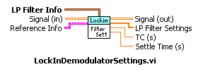This VI calculates some of the internally used settings for the mixer and low-pass filter blocks in the demodulator VI as well as the actual low-pass filter time constant and settling time.

Controls
Reference Info A cluster populated by the LockInPLL.vi. The cluster contains information necessary to generate mixer and low-pass filter parameters.
Default value: none (input value required)

LP Filter Info Time constant (TC), rolloff (Rolloff), and type (Type) of the low-pass filter. For a more in-depth discussion about the filter and its options, please see the Filter section.
Default value: none (input value required)

Indicators
LP Filter Settings Lock-In Engine private filter settings

TC(s) Actual time constant (TC) of the low-pass filter. For a more in-depth discussion about the filter and its options, please see the Filter section.

Settle Time (s) Time in seconds that will be required for the low-pass filter to settle if the current filter settings are applied to the low-pass filter. For a more in-depth discussion about the filter and its options, please see the Filter section.

LockinDemodulator.vi

Description
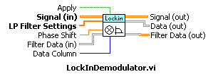This VI extracts a frequency component from the input signal whose frequency and phase are specified by the reference signal.

Controls
Signal (In) A 2D-array of doubles. The Data Column control is used to specify which column of the matrix contains the input signal data.
Default value: none (input value required)

LP Filter Settings Filter settings generated by the LockinDemodulatorSettings.vi.
Default value: none (input value required)

Phase Shift Inserts phase lag (in degrees) into the internal reference signal. Phase lag may be necessary to maximize the X or Y components when the signal arriving at the lock-in is phase shifted with respect to the reference signal. For more information see the Introduction and Reference sections.
Default value: 0

Filter Data (in) This control may be used for passing a pre-allocated array of double floating-point numbers which array may contain, upon return (via the Filter Data (out) indicator), the following data: the internal sinusoidal reference that has been mixed with the signal if the number of columns in the matrix is one or three; and outputs of the X and Y component low-pass filters for each point passed in the Signal (in) parameter if the number of columns in the matrix is two or three. The X and Y component information is always returned in columns zero and one and the reference information is returned in column zero or column two, respectively. The sine wave is of unit amplitude. The data will be generated only if the number of rows of the 2-D array is equal to the number of rows of the input 2-D array (see the Signal (in) control).
Default value: empty array

Apply Changes in the low-pass filter time constant and type do not become effective immediately even though the Settle Time (s) and TC (s) indicators of the LockinDemodulatorSettings.vi follow the changes. Instead, the changes become effective only after this Boolean control has been set to true. The flag causes filter internals to be re-initialized so it should be set to true for one call only. For a more in-depth discussion about the topic, please see the Filter.
Default value: False

Data Column Specifies which column in the input 2-D matrix (see the Signal (In) control description) contains the reference signal data.
Default value: 0

Indicators
Signal (out) Feeds through the 2D-Array of sampled data that was passed in via the Signal (in) control (see Controls section)

Filter Data (out) Internal filter data if requested (see description of the Filter Data (in) control in the Controls section).

Data (out) A 2-D array containing X and Y components of the input signal at the frequency of the reference signal for all filter roll-off values (one per column). Note that all filter stages necessary to obtain different roll-offs are calculated in parallel so that one can pick the output of any stage without paying a “re-settling time” penalty. For more about the topic, please see the Filter.

