## CS 639 – Mobile Application Development Week 1a

RW Taggart  
2015.5.26  
M.S. Computer Science

## Part 3:

GitHub is a web-based tool that incorporates the version control system “git” and a few other features. It provides wiki’s, project management, bug tracking, and feature requests. It is the most common place for software developers to host open source repositories for communities to access. It was founded by Tom Preston-Werner and PJ Hyett between late 2007 and early 2008. There are several alternatives, both commercial and open source, to GitHub. Some of them include IBM Rationale, Bit Bucket, and Microsoft Team Foundation Server. Storing source code in a publicly available location is convenient for open source projects. Anyone can pull source code from the repository, and anyone can also easily contribute to that repository, as long as they have an account with GitHub.

## Part 4:

I wasn’t sure how to include the work from this tutorial, so I provided some screen shots including the “final badge.”

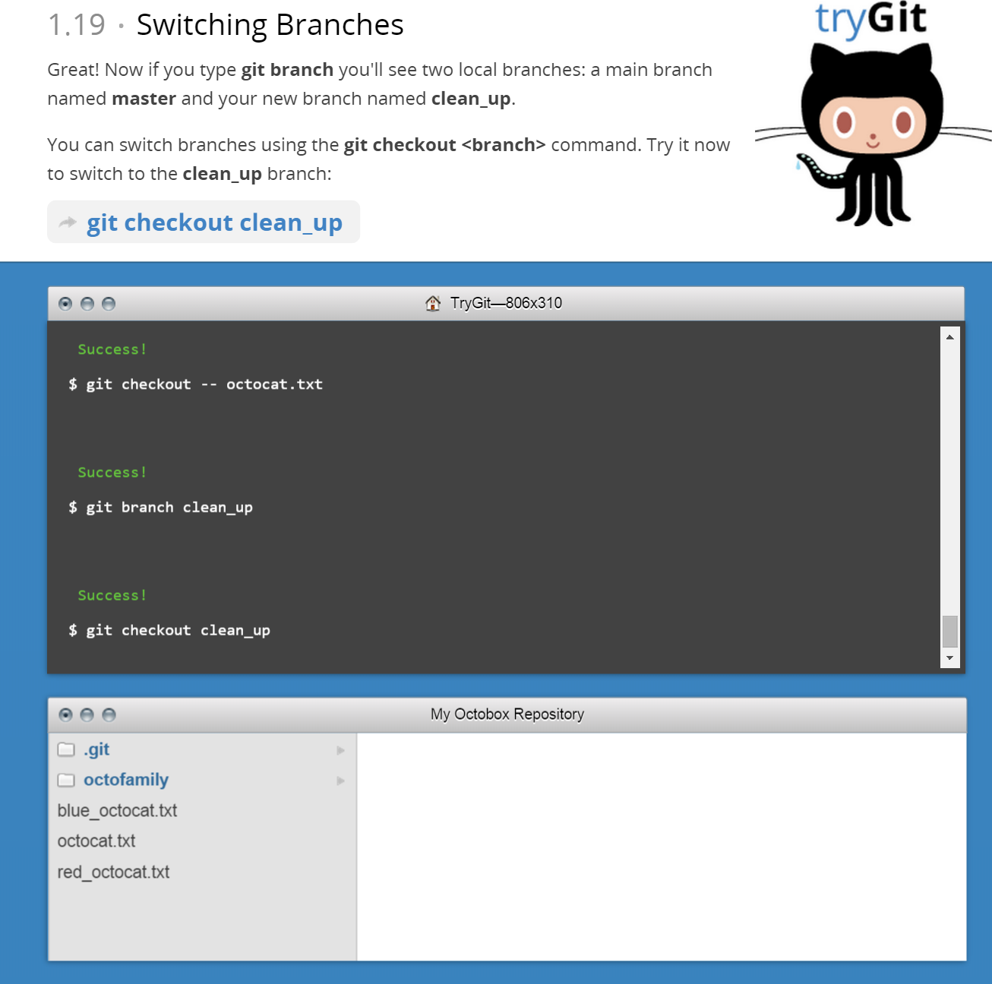

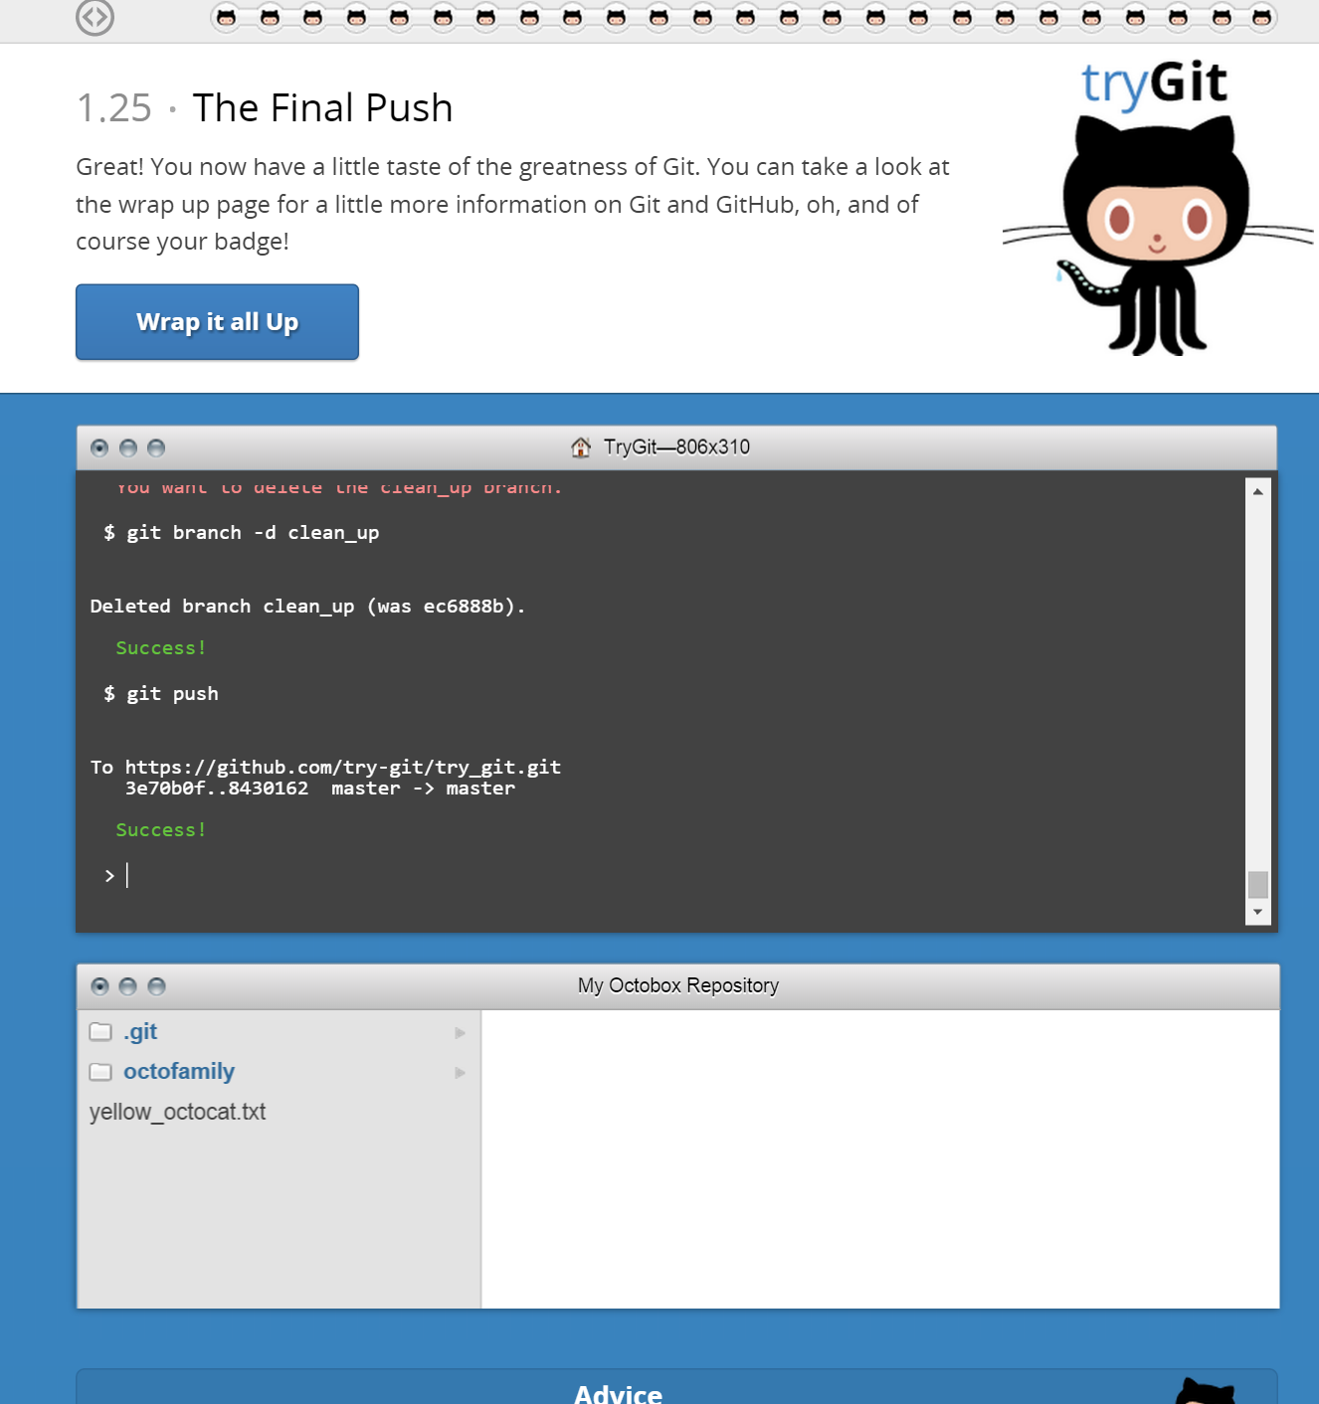

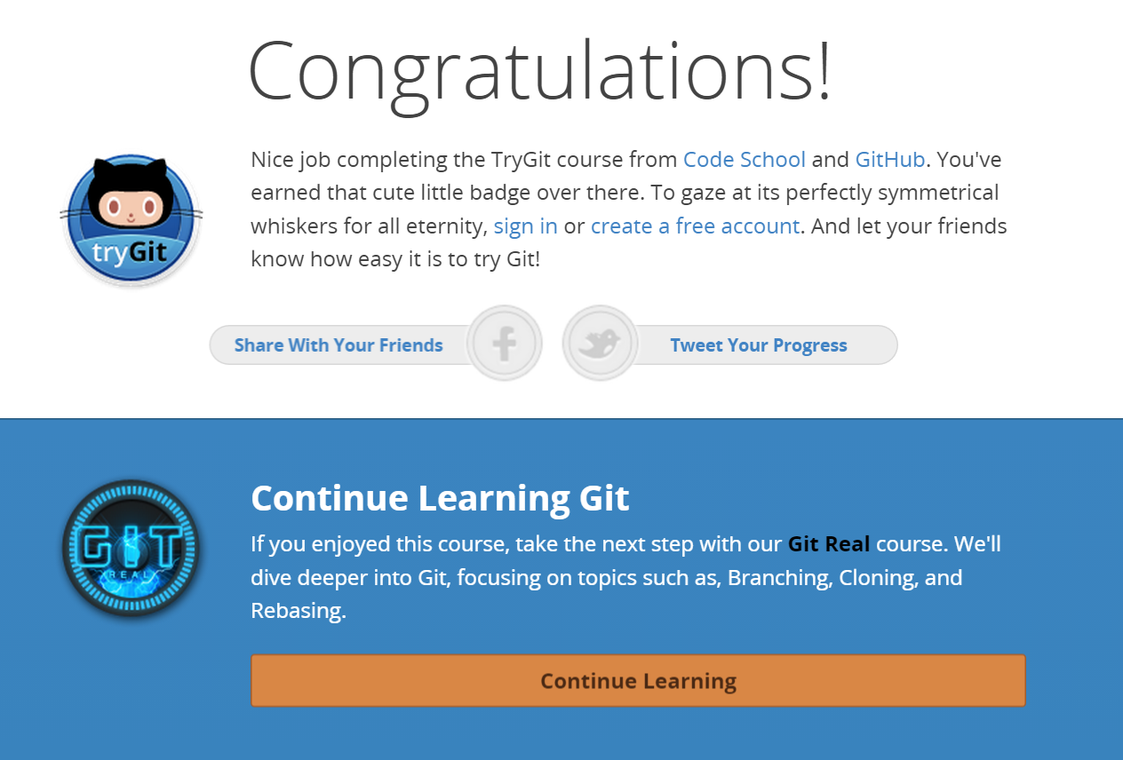

## Part5:

A **repository** is a space where code can be version controlled and managed. There are many repository management systems that exist like: SVN, CVS, and Git. Unlike CVS and SVN, which require central servers to manage the repositories, Git “working copies” contain the entire repository.

A **commit** is when a developer instructs Git to save the changes that they have made to their working copy of the source code. A **push** will update a remote repository with changes in a local one.

A **branch** is a side working copy of the repository. It allows a developer to make and save changes which are version controlled without impacting normal development in the pipeline.

A **fork** is the process of creating new branch from the trunk or active branch of the repo.

A **merge** will incorporate changes and highlight differences between the active branch and a side branch in the repository.

A **clone** will create a new working directory based on a previous repository. It will also fork a branch from the repo’s current active branch.

A **pull** is the inverse of a push. It will incorporate the changes from a remote repository into a local one. Similarly, a **request pull** will show which resources will be updated upon a pull, and also where those resources will come from.