[Name of Customer Agency]

Human Resources / staffing plan

[Program Name]

Version 1.0

[Day, Month, Year]

Document History

|  |  |  |  |
| --- | --- | --- | --- |
| Release No. | Date | Author | Revision Description |
| 1.0 |  |  | Initial Draft Version |
|  |  |  |  |
|  |  |  |  |
|  |  |  |  |
|  |  |  |  |
|  |  |  |  |
|  |  |  |  |

I have carefully assessed the Human Resources/Staffing Planforthe *<<INSERT NAME OF PROGRAM>>.* This document has been completed in accordance with the requirements of the USSM Guidance.

MANAGEMENT CERTIFICATION - Please check the appropriate statement.

______ The document is accepted.

______ The document is accepted pending the changes noted.

______ The document is not accepted.

We fully accept the content within this project artifact and associated tasks.

_______________________________ _____________________

*<<Insert Name>> <<Insert Date>>*

*<<Insert Title>>*

_______________________________ _____________________

*<<Insert Name>> <<Insert Date>>*

*<<Insert Title>>*

# Contents

1. Purpose of Plan 5

2. Plan Audience 6

3. Resource Management Strategy 7

4. Onboarding and Attrition Management 8

5. Organizational Structure 9

6. PMO Roles and Responsibilities Overview 10

7. Approvals 13

Appendix A: Key References 14

Appendix B: Key Terms 14

# Purpose of Plan

<<This document should be reviewed and approved by both the Provider and the Customer Program Manager.

*This Human Resources/Staffing Plan is intended to accomplish the following:*

* Establish a clearly defined resource management strategy;
* Establish a clearly defined organizational structure and leadership team;
* Establish clearly defined program and project positions’ roles and responsibilities and their requisite skills and experience levels;
* Establish a clearly defined support staff positions and associated identification of the personnel; and
* Establish a clearly defined onboarding and attrition/turnover plan.>>

# Plan Audience

*<<The project leadership team, team members from both the provider and customer agencies, as well as any other impacted and/or supporting stakeholders should understand The Human Resources/Staffing Plan.>>*

# Resource Management Strategy

*<<Provide an overview of the resource management strategy of the project, to include how staff will be detailed from the organization, the life-cycle management of resources, and sources of project staff (including contractors).*

*Provide an overview of how contractors will be used in conjunction with Federal staff.>>*

# Onboarding and Attrition Management

*<<Provide an overview of how new project team members will be onboarded to the project team, including the information that they will be provided with, onboarding procedures that must be followed, and expectations for their onboarding experience.*

*Provide an approach for managing project team attrition, including staff retention strategies, Human Resources performance management processes, and procedures that must be followed when a project team member transitions off a project.>>*

# Organizational Structure

*<<Provide an overview of the project organizational structure. Below is an example organizational and reporting structure that can be replicated for migration Project Management Offices (PMOs).>>*

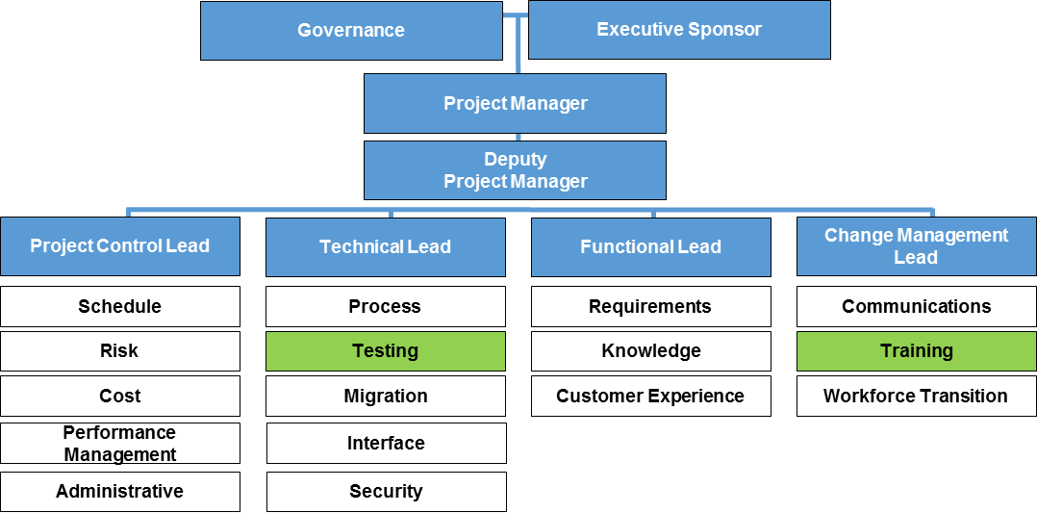

# PMO Roles and Responsibilities Overview

*<<For Phase 1, leverage the****PMO Role and Responsibilities****table below for planning purposes. For subsequent phases, update the organizational chart with names of personnel.*

* Program leadership team: For each role on the project leadership team, include a list of the high-level role responsibilities and a summary of the requisite experience and qualifications. If an employee must develop skills, identify a skills training plan.
* Sub-parts and position background information: Provide an overview of each of the sub-parts of the PMO organization, such as Project Control, Functional, Technical, and Change Management. Identify the number of FTEs required for each area of the PMO, and provide a breakdown of full-time Federal vs. Contractor personnel.
* Lead and support staff listing details for each sub-part: Indicate lead and support staff positions for each of the PMO sub-parts; support staff include resources assigned to the project, as well as Subject Matter Experts who support project design and execution within specific specialty areas. Provide a position description for each lead and support staff position, indicating the following:
  + Job title/position description
  + Whether the role is filled by acting or permanent personnel, or vacant
  + Personnel name (if known)
  + Whether the employee is lead or support staff
  + The specialty area and whether the employee is a SME (for support staff only)
  + Major responsibilities
  + Requisite experience/skills
  + Whether the role requires Federal resources or can be Federal or Contractor resources
  + The Federal lead (for Contractor workstreams or roles only)
  + The number of resources and time commitment required
  + Whether the resources have been acquired
  + Any resource/skills gaps and target date to fill the resource gap or training date to fill the skills gap

*Replicate the table below as necessary to account for additional areas of the PMO structure.>>*

| Job Title/  Position Description | Filled (Acting/ Permanent Personnel) or Vacant | Personnel Name (if known) | Lead or Support Staff | Specialty Area & SME Status (for Support Staff Only) | Major Responsibilities | Required Experience/  Skills | Federal/ Contractor Personnel? | Federal Lead (for Contractor Workstreams/Roles Only) | Number of Resources & Commitment Required | Have Resources Been Acquired for the Role? | Resource/Skills Gaps & Target Dates to Fill Gaps |
| --- | --- | --- | --- | --- | --- | --- | --- | --- | --- | --- | --- |
|  | **Overall Program Leadership Team** | | | | | | | | | | |
| *Executive Sponsor* | *Indicate whether the role is filled by acting or permanent personnel, or vacant* | *Provide personnel name if known* | *N/A* | *N/A* | *List chief responsibilities* | *List specific skills or experience required to effectively fill the role, or identify a skill training plan* | *Indicate Federal or Contractor personnel* | *For Contractor workstreams/ roles only, identify Federal leads* | *Indicate percent time commitment to the project* | *Indicate if resources have been acquired to fill the role, and if so, provide the percent time commitment* | *Indicate resource/skills gaps and target date to fill the resource gap or training date to fill the skills gap* |
| *Project Manager* |  |  | *N/A* | *N/A* |  |  |  |  |  |  |  |
| *Deputy Project Manager* |  |  | *N/A* | *N/A* |  |  |  |  |  |  |  |
|  | *Project Control – <<Insert Total Number of FTEs, Number of Federal vs. Contractor Personnel>>* | | | | | | | | | | |
| *Provide the Title of the Role* | *Indicate whether the role is filled by acting or permanent personnel, or vacant* | *Provide personnel name if known* | *Indicate if the employee is lead or support staff* | *For support staff only, indicate support area and if the employee is a SME* | *List chief responsibilities* | *List specific skills or experience required to effectively fill the role, or identify a skill training plan* | *Indicate Federal or Contractor personnel* | *For Contractor workstreams/ roles only, identify Federal leads* | *Indicate percent time commitment to the project* | *Indicate if resources have been acquired to fill the role, and if so, provide the percent time commitment* | *Indicate resource/skills gaps and target date to fill the resource gap or training date to fill the skills gap* |
|  |  |  |  |  |  |  |  |  |  |  |  |
|  |  |  |  |  |  |  |  |  |  |  |  |
|  | *Functional – <<Insert Total Number of FTEs, Number of Federal vs. Contractor Personnel>>* | | | | | | | | | | |
|  |  |  |  |  |  |  |  |  |  |  |  |
|  |  |  |  |  |  |  |  |  |  |  |  |
|  |  |  |  |  |  |  |  |  |  |  |  |
|  | *Technical – <<Insert Total Number of FTEs, Number of Federal vs. Contractor Personnel>>* | | | | | | | | | | |
|  |  |  |  |  |  |  |  |  |  |  |  |
|  |  |  |  |  |  |  |  |  |  |  |  |
|  |  |  |  |  |  |  |  |  |  |  |  |
|  | *Change Management – <<Insert Total Number of FTEs, Number of Federal vs. Contractor Personnel>>* | | | | | | | | | | |
|  |  |  |  |  |  |  |  |  |  |  |  |
|  |  |  |  |  |  |  |  |  |  |  |  |
|  |  |  |  |  |  |  |  |  |  |  |  |

**Table 1: PMO Roles and Responsibilities**

# Approvals

*<<Identify the required signatures or approvals for the Human Resources/Staffing Plan below.>>*

# Appendix A: Key References

*<<Insert the name, version number, description, and physical location of any documents referenced in this document. Add rows to the table as necessary.>>*

Table below summarizes the documents referenced in this document.

|  |  |  |
| --- | --- | --- |
| Document Name | Description | Location |
| *<<Document Name and Version Number>>* | *<<Document description>>* | *<<URL to where document is located>>* |
|  |  |  |
|  |  |  |

**Table 2: Key References**

# Appendix B: Key Terms

Table below provides definitions and explanations for terms and acronyms relevant to the content presented within this document.

|  |  |
| --- | --- |
| Term | Definition |
| *<<Insert Term>>* | *<<Provide definition of term and acronyms used in this document>>* |
|  |  |
|  |  |

**Table 3: Key Terms**