**GEMASTIK XVII  
FORENSIC: QR_CODE**

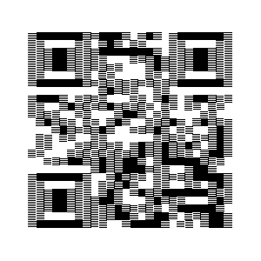

|  |
| --- |
| #!/bin/bash  input_image="/home/kali/gemastik_5.png"  output_image="/home/kali/hasil.png"  width=$(identify -format "%w" "$input_image")  height=$(identify -format "%h" "$input_image")  temp_image=$(mktemp).png  for ((i = 0; i < height; i++)); do  if ((i % 2 == 0)); then  convert "$input_image" -crop "${width}x1+3s+$i" +repage "$temp_image"  else  convert "$input_image" -crop "${width}x1+3+$i" +repage -flop "$temp_image"  fi  if ((i == 0)); then  cp "$temp_image" "$output_image"  else  convert "$output_image" "$temp_image" -append "$output_image"  fi  done  rm "$temp_image"  echo "Gambar hasil pemrosesan disimpan di: $output_image" |

