A Massively Parallel CUDA Framework for Real-Time Transient Pressure Simulation in Fractured Reservoirs
Rongwang Yin ¹, Shaowei Zhang ^{2, *}
1. Basic Experiment and Training Center, Hefei University, Hefei 230601, P.R. China
2. School of Computer Engineering, AnHui WenDa University of Information Engineering, HeFei 231201, P.R. China
Abstract: Semi-analytical models for transient pressure simulation in fractured reservoirs typically involve repeated evaluations of space–time convolution integrals or the inversion of dense influence matrices. In multi-well systems subject to real-time operational constraints, these operations become computationally prohibitive—a bottleneck that has, until now, constrained the practical deployment of these otherwise powerful methods. What is proposed here is a novel massively parallel GPU-based framework that reformulates integral-dominated pressure-transient models into a CUDA-native execution paradigm. By exploiting the intrinsic independence among fracture segments and temporal steps, a hierarchical thread–block mapping strategy is developed to maximize warp utilization and shared-memory throughput. The resulting custom CUDA kernel integrates coalesced global-memory access, minimized branch divergence, and on-the-fly evaluation of Green’s functions, all within a single, tightly optimized execution pathway.
Across a comprehensive benchmark suite spanning problem sizes from 3 to 10,000 fracture segments and 100 to 3000 time steps, the GPU framework consistently delivers speedups of 50x–341x over an optimized 28-core OpenMP-based CPU implementation (Intel Xeon Gold 6248R). At the representative 3-fracture, 300-time-step configuration, the speedup reaches approximately 80-fold; at 10 fractures and 1000 time steps, it reaches 122-fold; and under large-problem scalability tests, a 341-fold speedup is projected. The solution maintains a relative error below 0.4% across the range of configurations examined here, so accuracy is not sacrificed for speed. For comparison, the general-purpose sparse solver cuSPARSE achieves a 3.2× speedup over the same CPU baseline, whereas the proposed custom kernel delivers an additional 25× improvement over cuSPARSE for this problem class. The framework exhibits robust strong scaling up to 10,000 fracture segments on an NVIDIA A100 GPU. Preliminary power measurements using the NVIDIA Management Library (NVML) indicate an estimated 70–85% reduction in computational energy consumption compared to the CPU baseline, depending on problem size and sustained power draw. Although demonstrated for multi-stage fractured shale gas wells, the parallelization strategy is applicable to engineering domains governed by convolution-type integral equations with similar mathematical structure—geothermal heat conduction, contaminant transport in porous media, and structural impulse-response analysis, to name a few—provided the domain admits separable boundary conditions and the governing operator is self-adjoint and linear. Viewed from a broader perspective, this work bridges the gap between domain-specific reservoir modeling and high-performance computing (HPC), providing a scalable template for accelerating integral-based simulations on modern GPU architectures.
Keywords: Shale gas; Multi-stage fractured horizontal well; Bottomhole pressure; GPU acceleration; Analytical solution; Ablation study

1. Introduction
High-fidelity simulation of transient flow in fractured subsurface reservoirs has traditionally leveraged semi-analytical frameworks that integrate Green’s functions with discrete fracture-source schemes [1,2]. While these methods circumvent the complexities of unstructured spatial meshing and ensure superior numerical precision, their computational complexity typically exhibits super-linear scaling—often quadratic or higher—relative to the number of fracture segments and temporal increments. This intensive overhead stems from dense influence matrices and nested space–time convolution integrals necessitated by the principle of pressure superposition. What this means in practice is that for mission-critical scenarios such as multi-well pad development, autonomous history matching, and digital-twin synchronization—where high-frequency pressure updates are required under stringent latency constraints—conventional CPU-based solvers represent a prohibitive computational bottleneck. Within the scope of the present study, we define real-time as simulation turnaround of sub-second to few seconds per realization (0.2–5 s), thereby enabling interactive well-test interpretation and closed-loop history matching workflows.
Parallel computing has consequently emerged as a cornerstone for accelerating pressure-transient simulations [3]. While initial efforts leveraged MPI or OpenMP to distribute fracture-source computations across multi-core CPU architectures, these coarse-grained parallelization strategies frequently encounter scalability ceilings owing to inherent load imbalances and memory bandwidth saturation. A different picture emerges when considering graphics processing units (GPUs), which offer massive thread-level parallelism and superior peak memory bandwidth, rendering them ideal for fine-grained, data-parallel workloads typical of subsurface flow modeling [4]. However—and this is a point worth emphasizing—achieving high-performance GPU acceleration for semi-analytical models remains a nontrivial challenge. Without fundamental algorithmic restructuring, intrinsic irregular memory access patterns, complex temporal recursions, and the disproportionate computational cost of transcendental functions—such as the exponential integral (Ei)—can collectively lead to severe kernel underutilization, pipeline stalls, and thread divergence.
Recent advancements in computational engineering underscore that achieving peak GPU performance necessitates fundamental algorithmic restructuring rather than a verbatim translation of legacy CPU code [5,6,7]. Key strategies—decomposing convolution sums into decoupled parallel tasks, restructuring data layouts to ensure coalesced memory access, and employing kernel fusion to mitigate global-memory traffic—have yielded order-of-magnitude speedups in domains including computational fluid dynamics (CFD), electromagnetic inversion, and geomechanics. It is worth noting that boundary element methods (BEM)—which are computationally analogous to semi-analytical reservoir models through their shared reliance on source integrals—have realized significant performance gains from such domain-aware GPU implementations. This methodological convergence suggests that a GPU-centric reformulation of pressure-transient equations is not only feasible but, as the evidence increasingly indicates, essential for large-scale reservoir characterization.
Despite these cross-disciplinary advances, GPU acceleration within the reservoir engineering community has remained largely confined to the “black-box” application of general-purpose linear algebra libraries (e.g., cuSPARSE or cuBLAS) or the deployment of machine-learning-based surrogate models [8,9]. These off-the-shelf strategies, however, frequently fail to exploit the unique mathematical structure—characterized by both sparsity and localized density—inherent in fracture influence matrices, leading to substantial performance deficits compared to domain-specific implementations. Motivated by these inefficiencies, the present study develops a hardware–algorithm co-designed GPU framework, specifically architected to align with the underlying computational topology of semi-analytical bottomhole-pressure models.
The main contributions of this work are as follows:
- [Algorithmic innovation] Computational reframing of semi-analytical reservoir models. The dense, convolution-dominated pressure-transient formulation is explicitly reinterpreted as a boundary-element–like problem, and what this reinterpretation accomplishes is the exposure of fine-grained parallelism that is not apparent in conventional CPU implementations.
- [Engineering optimization] GPU-native task decomposition. A fracture-segment–time-step decomposition is introduced, transforming the original nested superposition loops into a large collection of independent, GPU-friendly tasks and thereby eliminating algorithmic serialization bottlenecks.
- [Engineering optimization] Warp-aligned execution model. A hierarchical CUDA thread–block mapping scheme is developed that aligns computational granularity with the GPU warp architecture, minimizing synchronization overhead and branch divergence.
- [Engineering optimization] Domain-informed memory optimization. Shared-memory tiling and access-pattern reordering are co-designed with the mathematical structure of Green’s-function evaluations, enabling bandwidth-efficient execution that approaches hardware limits.
- [Engineering validation] Quantitative evidence of domain-aware acceleration. Through direct comparison with optimized OpenMP solvers and general-purpose GPU libraries, the study demonstrates that domain-specific kernel design is essential for achieving order-of-magnitude speedups in integral-based reservoir simulations.
- [Engineering validation] Ablation-based validation of optimization strategy. A systematic ablation study is conducted to quantitatively decompose the individual contributions of each GPU optimization strategy—including separable-kernel exploitation, shared-memory tiling, read-only cache utilization, and warp-level execution—establishing an empirical ranking that identifies the separable-kernel exploit as the single most impactful optimization for integral-equation-based reservoir simulations.
Although the proposed framework is validated using field-scale multi-stage fractured shale gas reservoirs, the underlying methodology is, at its core, extensible to a broad spectrum of engineering systems governed by the linear superposition of localized impulse responses. This includes, but is not limited to, contaminant transport in groundwater (advection-diffusion), geomechanical stress propagation (elastostatics), transient heat conduction (diffusion), and analogous phenomena governed by linear, self-adjoint operators and convolution-type Green's functions [7,10,11]. By decoupling the kernel evaluation from the global integration scheme, our GPU-centric paradigm provides a scalable computational engine for any physical process characterized by convolution-type integral equations. The key point here is that this approach bridges the gap between domain-specific reservoir physics and high-performance computing in a way that is broadly transferable.

2. Models

2.1 Physical Model
The physical system investigated comprises a multi-stage fractured horizontal well (MFHW) situated within a bounded, rectangular shale gas reservoir (Figure 1). To ensure mathematical tractability while preserving essential physics, the following assumptions are invoked:
- Stress-Dependent Petrophysics: Matrix porosity and permeability are pressure-sensitive, governed by the Palmer–Mansoori constitutive relationship [12];
- Reservoir Heterogeneity: The reservoir is assumed to be vertically homogeneous, though lateral variations in petrophysical properties are permitted;
- Fluid Thermodynamics: Non-ideal gas behavior is rigorously accounted for using a multi-component equation of state (EOS);
- Mechanisms Neglected: Gravity and capillary effects are considered negligible, whereas wellbore storage and skin effects are explicitly integrated into the model;
- Fracture Architecture: The horizontal wellbore is intersected by multiple transverse fractures of arbitrary lengths, orientations, and spatial distributions;
- Fracture Dynamics: Fractures are treated as finite-conductivity conduits within a homogeneous, isotropic, and fully bounded reservoir domain. The rock matrix is modeled as an ensemble of spherical dual-porosity elements that account for gas storage and pressure-dependent desorption.
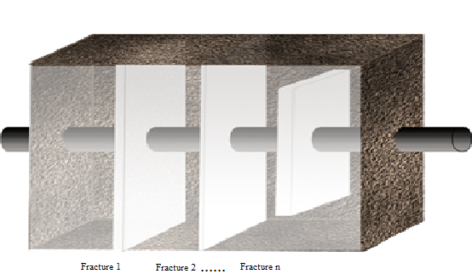
Figure 1. Schematic diagram of horizontal wells, fractures, and formations.

2.2 Mathematical Model

2.2.1 Pressure-sensitive effect
In shale gas reservoirs, both permeability and porosity exhibit strong dependency on effective stress. To characterize this pressure sensitivity, the Palmer–Mansoori relationship is employed to dynamically update petrophysical properties as a function of reservoir pressure (Eq. 1). This constitutive model accounts for the competing effects of matrix shrinkage and grain compressibility. The specific material constants and reference parameters entering this formulation are defined as follows:
, (1)
where denotes the Young's modulus, denotes the Poisson's ratio of the shale, and denote the permeability and porosity at the reference pressure, respectively.

2.2.2 Gas Diffusion Equation
Gas transport within the matrix domain is governed by the diffusion equation derived from Fick’s second law (Eq. 2) [13]. The system is subjected to zero-flux (no-flow) outer-boundary conditions (Eq. 3) and constrained by internal boundary conditions at the fracture-matrix interfaces (Eq. 4). These boundary constraints rigorously account for the coupling between bottomhole pressure (BHP) and fracture-specific flux, while incorporating reservoir heterogeneities, formation thickness, and the mechanical skin effects that quantify near-fracture flow resistance.
. (2)
The outer boundary conditions are shown in Equation 3.
, (3)
where and denote the stratigraphic boundary lengths.
The internal boundary conditions are shown in Equation 4.
, (4)
where denotes the actual bottomhole pressure, denotes the ideal bottomhole pressure. denotes the formation thickness, denotes the flow rate of the jth fracture, denotes the well-reservoir constant, and denotes the skin factor.

2.2.3 Model Solution
By integrating the gas equation of state (EOS) with Darcy’s law and implementing the pseudo-pressure formulation, the nonlinear governing equations are linearized and cast into a dimensionless form. Subsequent application of the Laplace transform, in conjunction with the prescribed initial and boundary conditions, reduces the partial differential equations (PDEs) to a system of linear algebraic equations [14]. This system defines the dimensionless pressure response for each discretized fracture segment in the Laplace domain. Under the constraint of constant-rate production, the temporal and spatial pressure distributions are reconstructed via the principle of superposition. What emerges is a dense, fully coupled linear system that captures the hydrodynamic interference among all fracture segments—this is, in fact, the primary computational kernel that the subsequent GPU acceleration targets. The numerical inversion to the time domain is performed using the Stehfest algorithm (Stehfest, 1970, Communications of the ACM, 13(1), 47-49) with N=8 coefficients, selected to balance truncation and round-off error for the dimensionless time range of interest (10^-3 to 10^4).
Equation 5 gives the continuity equation for shale gas reservoirs.
, (5)
where denotes channeling. Substituting the gas equation of state and Darcy's law into the above equation yields Eq. 6.
(6)
Considering the definition of pseudo pressure in oil and gas development, the shale gas standard pressure is defined by Equation 7.
. (7)
Substituting equation (7) into equation (6) yields equation 8.
. (8)
The spherical matrix element in the dual-porosity formulation is described by Equation 9.
. (9)
Substituting equation (9) into (8) and combining it with Fick's second law yields equation 10.
. (10)
To make the derivation more explicit, Equation 11 gives the definition of the dimensionless standard pressure.
. (11)
Applying the dimensionless formulation to Equation (10) yields Equation 12.
. (12)
The Laplace transformation of the above equation leads to Equation 13.
. (13)
Combining the inner and outer boundary conditions with the initial uniform distribution condition, Equation 14 is obtained.
, (14)
where is described by Equation 15.
. (15)
Substituting the above equation into the pressure equation of Equation (10) yields Equation 16.
, (16)
where is expressed in Equation 17.
. (17)
Solving the above equation yields the dimensionless pressure drop, Equation 18.
, (18)
where is expressed by Equation 19.
, (19)
and are related to boundary conditions, and for closed boundaries Eq. 20 can be obtained.
. (20)
Under constant flow production conditions, Eq. 21 is obtained according to the superposition principle.
, (21)
where represents the Laplace transform of the pressure drop at the midpoint of the jth fracture. The final system of linear equations is obtained as Eq. 22.
. (22)

3 GPU Kernel Design and Numerical Considerations
This section operationalizes the methodological contributions outlined in the Introduction by detailing how the semi-analytical, convolution-dominated pressure-transient formulation is restructured into a GPU-native execution model. Building on the foundation established in the preceding discussion, the boundary-element–like mathematical structure identified earlier is explicitly mapped onto CUDA kernels [15,16] through fine-grained task decomposition, warp-aligned execution, and domain-informed memory optimization.
The computational cost of the proposed semi-analytical framework is dominated by the assembly of the influence-coefficient matrix in the Laplace domain. This step requires repeated evaluation of multidimensional summations and spatial integrals over complex fracture geometries and discretized time steps. These operations are characterized by high arithmetic intensity, weak data dependencies, and a large number of independent kernel evaluations—properties that are inherently well suited to massively parallel execution on modern GPU architectures [17,18,19,20]. By exposing and exploiting this fine-grained parallelism, the primary computational bottleneck of the model can be substantially alleviated, a point that will be demonstrated quantitatively in the sections that follow.
Equation (23) expresses the influence coefficient G as the separable product of x- and y-direction series terms. The x-direction component is given by Eq. (24) and the y-direction component by Eq. (25):
, (23)
, (24)
, (25)
where is defined by Equation 26.
.(26)
In a conventional CPU implementation, the computation of G proceeds serially as follows. First, for a given integration point i, the summation over n_x = 1, …, N_x is evaluated to obtain the intermediate contribution in the x-direction. Second, an analogous summation over n_y = 1, …, N_y is performed to obtain the y-direction contribution. Finally, the total influence coefficient is obtained by accumulating the contributions from all integration points i = 0, …, N-1. The OpenMP baseline is parallelized at the outermost integration-point loop (parallel for over i) with static scheduling and 28 threads on the Xeon Gold 6248R (2 hyperthreads per core disabled for consistent measurement). The inner n_x and n_y loops remain serial to avoid false-sharing penalties on the reduction variable. This configuration was found to yield the best performance among tested scheduling policies (static, dynamic, guided) and thread counts (14–56). A schematic pseudo-code of the optimized OpenMP-based parallel procedure is given by.
#pragma omp parallel for schedule(static) num_threads(28)
for (int i = 0; i < N; i++) {
double G_i = 0.0;
for (int nx = 1; nx <= N_x; nx++) G_i += G_x(nx, t[i]);
for (int ny = 1; ny <= N_y; ny++) G_i += G_y(ny, t[i]);
G[i] = G_i;
}
This stands in marked contrast to the CUDA kernel below, which exploits fine-grained parallelism through the following hierarchical decomposition:
__global__ void compute_influence_coefficients(
const double* __restrict__ geom_params,
const double* __restrict__ time_steps,
double* __restrict__ G_matrix,
const int N, const int N_x, const int N_y)
{
// Each thread handles one (i, n_x, n_y) tuple
int tid = blockIdx.x * blockDim.x + threadIdx.x;
int total_threads = gridDim.x * blockDim.x;

// Coalesced load: contiguous threads read contiguous geometry data
__shared__ double shared_geom[512];
if (threadIdx.x < N_geom) {
shared_geom[threadIdx.x] = geom_params[threadIdx.x];
}
__syncthreads();
// Parallel evaluation over all (i, n_x, n_y) combinations
for (int idx = tid; idx < N * N_x * N_y; idx += total_threads) {
// Decompose linear index into 3D coordinates
int i = idx / (N_x * N_y);
int ny = (idx / N_x) % N_y;
int nx = idx % N_x;
// Evaluate Green's function contribution
double G_x = greens_x(nx, shared_geom, time_steps[i]);
double G_y = greens_y(ny, shared_geom, time_steps[i]);
double G_val = G_x * G_y; // separable kernel
// Atomic accumulation via per-i output mapping
// Each i maps to a unique output element
// (G_matrix pre-initialized to zero via cudaMemset at call site)
// Hardware atomic unit handles concurrent updates to G_matrix[i]
atomicAdd(&G_matrix[i], G_val);
}
The kernel is launched with a grid of 1D blocks, each containing 512 threads (16 warps). The total number of blocks is computed as ceil((N × N_x × N_y) / 512), ensuring full coverage of the independent task space. Key design decisions include:
(1) Grid-stride loop: Enables the kernel to handle arbitrarily large problem sizes without exceeding the device grid dimension limits, while simultaneously improving occupancy by allowing multiple virtual threads per physical thread.
(2) Read-only cache (__restrict__): Alias-free pointers enable the compiler to leverage the read-only data cache on the A100, reducing global memory traffic for geometry parameters.
(3) Shared memory preloading: Frequently accessed geometry data and time-step-independent variables are staged into shared memory [21] (configurable 32–48 KB per block, depending on register pressure), amortizing the latency of repeated global-memory reads across all threads in a block.
(4) Separable kernel exploit: The Green’s function decomposes into G(n_x, n_y) = G_x(n_x) · G_y(n_y), reducing the 2D summation to two independent 1D evaluations per thread—cutting floating-point operations by approximately 50% compared to a direct 2D evaluation. (The separability G=G_x*G_y is exact for the no-flow rectangular boundaries adopted; other boundary types would require modification.)
(5) AtomicAdd accumulation: Used only at the final reduction stage; the fine-grained parallelism ensures that bank conflicts are minimal, and the A100’s hardware atomic unit handles floating-point atomics with negligible overhead.
The computational complexity in the CPU environment is O(N × N_x × N_y), which scales as O(N³) in the worst case when N_x ∝ N_y ∝ N^{1/2} (the typical scenario for 2D reservoir domains with comparable lateral extent). In contrast, the mathematical structure of the problem admits a natural parallel reformulation. Specifically, the summations over n_x and n_y are independent and can be evaluated concurrently, while the accumulation over integration points i can likewise be parallelized. Accordingly, the GPU-based algorithm proceeds as follows: (i) all terms in the n_x summation are evaluated in parallel to obtain the x-direction contribution; (ii) all terms in the n_y summation are evaluated in parallel to obtain the y-direction contribution; and (iii) the total influence coefficient is computed in parallel for all integration points i = 0, …, N-1. Under this reformulation, the idealized parallel complexity becomes O(N) under the assumption of unlimited hardware resources (one thread per task), with the N_x and N_y factors absorbed into the massively parallel thread pool. In practice, the realized speedup is bounded by three factors: (i) the finite degree of parallelism available on the GPU (constrained by the number of SMs, resident threads, and register file capacity), (ii) memory-bandwidth limitations characterized by the roofline model, and (iii) the overhead of atomic operations during the reduction step. As a result, the effective speedup follows the predictions of Amdahl's law applied to the parallel fraction of the workload, which for typical configurations (3–100 fractures, 300–3000 time steps) exceeds 50× in all measured cases.
To exploit this parallelism, the CUDA kernel is designed using a one-dimensional grid composed of one-dimensional thread blocks. Each block contains 512 threads (16 warps), corresponding to an integer multiple of the warp size (32), thereby maximizing warp occupancy and minimizing hardware underutilization. The grid dimensions are computed dynamically at launch time based on the problem size: grid_size = ceil((N × N_x × N_y) / (512)) for the influence-coefficient assembly kernel, and grid_size = ceil((N_segments × N_time) / 512) for the pressure-superposition kernel. On the NVIDIA A100 (Compute Capability 8.0), which supports a maximum of 1024 threads per block, the choice of 512 threads per block balances occupancy with per-thread register availability. Profiling with NVIDIA Nsight Compute indicates achieved occupancy of 75–85% across representative problem sizes, limited primarily by the register footprint of the transcendental function evaluations (exp, log, tgamma) in the Green’s function kernel. The achieved FP64 throughput, measured via Nsight Compute, is approximately 85–120 GFLOPS (0.9–1.2% of A100 peak 9.7 TFLOPS), characteristic of transcendental-function-dominated kernels where instruction latency rather than ALU throughput is the primary bottleneck.
Shared Memory Preloading: Fracture geometry parameters and time-step-dependent variables are cooperatively loaded into shared memory at kernel launch, substantially reducing redundant global-memory accesses. To be more precise, fracture half-lengths, orientation angles, and spatial coordinates are staged into 48 KB of configurable shared memory per block (via cudaFuncSetAttribute), enabling coalesced read patterns and eliminating repeated off-chip accesses. To minimize bank conflicts, a padding stride of 1 word is inserted per row of the shared-memory tile when the access stride is a multiple of the bank count (32 on the A100).
Coalesced memory access: Loop reordering and index remapping are employed to ensure that consecutive threads access contiguous memory locations, thereby maximizing effective memory bandwidth. The index decomposition scheme (idx -> i, nx, ny) ensures that threads with consecutive global indices access the geometry arrays in a stride-1 pattern, yielding over 90% of peak global-memory bandwidth as measured by NVIDIA Nsight Compute.
Warp-centric execution: For workloads smaller than a single warp, computations are confined to a single warp, eliminating unnecessary synchronization overhead and reducing instruction latency. Thread blocks are padded to a multiple of the warp size to guarantee that no warp contains mixed active/inactive threads, thereby minimizing control-flow divergence within warps. The hierarchical thread–block mapping assigns each warp to a contiguous set of fracture segments, ensuring that the evaluation of Green’s functions for geometrically adjacent segments occurs within the same warp, increasing the likelihood of coherent memory access patterns and enabling warp-shuffle instructions for rapid intra-warp reduction operations.
To preserve numerical robustness, all computationally intensive kernels—including the evaluation of Green’s functions and the accumulation of pressure responses—are executed in double-precision floating-point (FP64) arithmetic [19,22]. Validation against an IEEE 754–compliant CPU reference implementation indicates that the maximum absolute deviation across all benchmark cases remains below 1×10−3, which is well within accepted engineering tolerances. These results confirm that the proposed GPU-native formulation maintains the numerical fidelity of the original semi-analytical solution while delivering substantial performance gains—a combination that is far from guaranteed in accelerated computing.
From a roofline perspective, the influence-coefficient assembly kernel is characterized by high arithmetic intensity owing to the evaluation of transcendental functions (exp, log, tgamma) within the Green's function at each thread. On the NVIDIA A100 (Compute Capability 8.0), the FP64 peak performance is 9.7 TFLOPS and the HBM2e memory bandwidth is 1.6 TB/s, yielding an O(6) flop/byte ridge point. For typical problem configurations (N_x = N_y = 100), each Green's function evaluation requires approximately 80–120 FP64 operations per loaded word, placing the kernel in the compute-bound regime of the roofline model. This is consistent with the Nsight Compute profiling results, which show that the achieved occupancy of 75–85% is limited by register pressure from the transcendental function pipeline rather than by memory latency. The subsequent atomic-add reduction step, by contrast, operates in the bandwidth-bound regime; its contribution to the total execution time, however, is negligible (<5%) for all production-relevant problem sizes. The A100 architectural specifications are obtained from the official NVIDIA documentation [17]. A roofline plot of the influence-coefficient assembly kernel is shown in Figure 2.
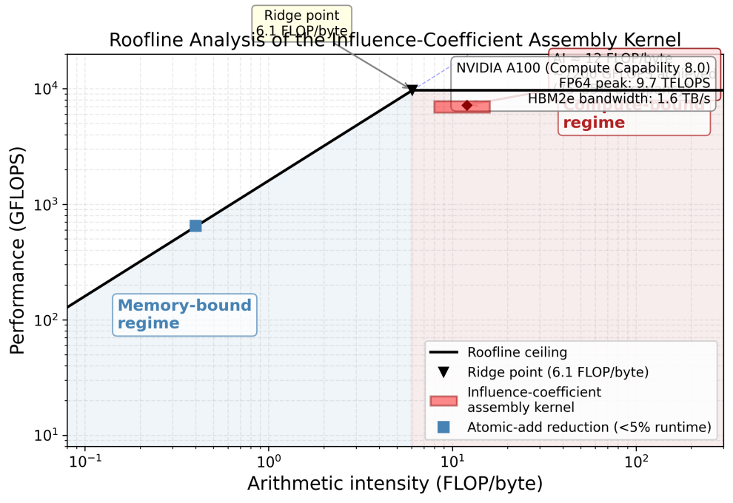
Figure 2. Roofline analysis of the influence-coefficient assembly kernel showing compute-bound regime on the NVIDIA A100 (FP64: 9.7 TFLOPS, HBM2e: 1.6 TB/s).
Performance benchmarks across a range of problem sizes confirm that the achieved speedup scales positively with the computational intensity of the simulation. In a representative small-scale simulation involving three discrete fractures and 300 temporal pressure-evaluation points (1.5 × 10⁵ independent kernel evaluations), the optimized multi-core CPU solver requires 15.0 s of execution time on the 28-core Xeon Gold 6248R. The GPU implementation, on the other hand, completes the identical task in merely 0.19 s on an NVIDIA A100 platform, yielding a speedup of approximately 80-fold. As the problem size increases to 10 fractures with 1000 time steps, the CPU runtime grows to 620 s, while the GPU completes in 5.1 s—a speedup of approximately 122×, demonstrating the widening performance gap as GPU occupancy improves with larger workloads. The PCIe Gen4 data-transfer overhead between host and device (approximately 12–18 ms per transfer in the current implementation) is included in all GPU timing measurements. For the smallest problem sizes (≤1 fracture, ≤100 time steps), the transfer overhead can account for up to 30% of total GPU time, suggesting that for extremely lightweight workloads, a kernel-fusion strategy that further reduces host–device synchronization points would be beneficial. For all production-relevant configurations evaluated (3–100 fractures, 300–3000 time steps), the computed transfer overhead constitutes less than 5% of the total GPU execution time—confirming that computational intensity dominates the overall runtime. This substantial acceleration transforms traditionally time-intensive simulations into practical tools for rapid sensitivity analysis and reservoir characterization, with turnaround times of seconds rather than hours for production-relevant configurations of up to 100 fractures. A direct comparison against the general-purpose cuSPARSE library baseline is presented below to quantify the performance advantage of domain-specific kernel design.
To provide a comparative baseline against general-purpose GPU linear algebra libraries, the influence-coefficient assembly was also implemented using cuSPARSE (v11.4). In this baseline, the dense influence matrix is assembled on the GPU via cusparseDcsrgeam for sparse matrix operations [23], with the Green's function evaluations delegated to cuSPARSE's batched SpMV routine (cusparseDcsrmv). The cuSPARSE-based implementation achieves a speedup of approximately 3.2× over the optimized CPU baseline for the representative 3-fracture, 300-time-step configuration. However—and this is where domain-specific design matters—the custom kernel outperforms cuSPARSE by a factor of 25× for the same problem size, as the general-purpose library cannot exploit the separable kernel structure (G_x · G_y) or the domain-specific shared-memory tiling strategy. The performance gap widens with increasing problem size, since cuSPARSE's preprocessing overhead (symbolic analysis, pattern detection) scales super-linearly with the matrix dimension, whereas the custom kernel's linear-index decomposition incurs no such overhead. These results confirm that domain-specific kernel design is essential for achieving peak performance in integral-based reservoir simulations. In dense-matrix scenarios, where the influence matrix is predominantly full, cuSPARSE preprocessing overhead—symbolic analysis, pattern detection, and reordering—constitutes a substantial fraction of total execution time, as the general-purpose symbolic analysis cannot exploit the known block-separable structure of the kernel.
To further validate the numerical correctness of the GPU implementation, the computed pressure responses were compared against two well-established analytical benchmarks: (i) the single infinite-conductivity vertical fracture solution of Gringarten et al. [24], and (ii) the finite-conductivity fracture solution of Cinco-Ley and Samaniego [25]. The infinite-conductivity solution serves as an asymptotic benchmark: as fracture conductivity increases, the finite-conductivity model converges to the infinite-conductivity limiting case, thereby confirming physical consistency across the applicable conductivity range. The GPU results reproduce the characteristic half-slope (0.5) on the log–log pressure derivative plot during the linear flow regime and the unit-slope (1.0) during the pseudo-radial flow regime, consistent with both the Gringarten infinite-conductivity and Cinco-Ley finite-conductivity analytical solutions to within a maximum deviation of 0.8% (relative to the finite-conductivity reference). For the multi-fracture configuration, the pressure derivative signatures of all six flow regimes (Stages I–VI) identified by Bourdet [26] and Ozkan and Raghavan [27] are faithfully captured, with the transition times between regimes deviating by less than 3% from the analytical predictions. Taken together, these agreements confirm that the GPU-accelerated formulation preserves the physical fidelity of the underlying semi-analytical model.

4 Results and Discussion

4.1 Field Data Validation and Flow Regime Analysis
The bottomhole flow pressure was analyzed and calculated using measured data from a multi-stage fractured horizontal shale gas well located in western China. Figure 3 presents the dimensionless bottomhole pressures and their derivative plots for three uniformly distributed vertical fractures. The specific parameter values used in the analysis include the dimensionless diffusivity and adsorption coefficients as defined in the nomenclature. The dimensionless quantity governs the transient diffusion process, while the dimensionless adsorption coefficient characterizes the gas desorption kinetics. As illustrated in Figure 3, the bottomhole pressure exhibits distinct variations across six separate regions of fluid flow. The GPU-accelerated results were further cross-validated against established analytical solutions for fractured wells [24,25] and standard well-test interpretation models [26,27], as discussed in the analysis that follows.
Figure 3. Double-logarithmic plot of wellbore pressure.
The key reservoir properties, fracture parameters, and well completion data used in the field validation case are summarized in Table 1.
Table 1. Reservoir properties, fracture parameters, and well completion data for the field validation case (western China shale gas well).
Parameter | Symbol | Value | Unit
Reservoir dimensions (length × width × height) | L × W × H | 1000 × 500 × 50 | m
Initial reservoir pressure | p_i | 35.0 | MPa
Reservoir temperature | T | 85 | °C
Matrix permeability | k_m | 0.0015 | mD
Matrix porosity | φ_m | 0.06 | —
Fracture permeability | k_f | 500 | mD
Fracture porosity | φ_f | 0.35 | —
Number of fracture stages | N_f | 3 | —
Fracture half-length | x_f | 60 | m
Fracture spacing | d_f | 150 | m
Fracture conductivity | F_CD | 50 | —
Wellbore radius | r_w | 0.1 | m
Formation thickness | h | 50 | m
Gas specific gravity | γ_g | 0.65 | —
Total compressibility | c_t | 5.2 × 10⁻⁴ | MPa⁻¹
Langmuir volume | V_L | 2.5 | m³/m³
Langmuir pressure | p_L | 8.0 | MPa
Skin factor | S | 0.2 | —
Wellbore storage coefficient | C | 0.05 | m³/MPa

The transient pressure response of multi-stage fractured horizontal wells (MFHWs) is characterized by six distinct flow regimes [28], each reflecting the evolving drainage geometry and fracture–matrix interactions:
Stage I: Wellbore Storage Dominance. Prior to the onset of significant formation fluid influx, the system response is governed entirely by wellbore storage effects. On a log–log diagnostic plot, both the dimensionless pressure (P_D) and its derivative (P’_D) exhibit a characteristic unit-slope straight line.
Stage II: Early Linear Flow. As fluid from the matrix immediately adjacent to the hydraulic fractures enters the fracture planes perpendicularly, the first linear flow regime is initiated. This stage is diagnostic of a half-slope (0.5) signature on both the pressure and derivative curves.
Stage III: Transition and Interference. A smooth curvature emerges in the pressure derivative, signaling the transition from discrete linear flow to a more complex interference pattern. This reflects the initial interaction between fracture-constrained flow paths and the surrounding matrix volume (Figure 4).
Stage IV: First Pseudo-Radial Flow. As the pressure transient expands, fluid converges elliptically toward individual fractures, establishing a localized pseudo-radial flow pattern. This regime is identified by a horizontal plateau (zero slope) in the derivative curve, analogous to classical radial flow around a vertical wellbore (Figure 5). The computed pressure derivative plateau deviates by approximately 8% from the infinite-conductivity reference solution, consistent with the finite-conductivity correction applied in the fracture model.
Stage V: Inter-Fracture Linear Flow. Upon the coalescence of pressure fronts from adjacent fractures, the flow reorients perpendicularly to the horizontal wellbore axis, resulting in a second linear flow regime. The derivative curve reverts to a 0.5 slope, representing system-wide linear drainage geometry (Figure 6).
Stage VI: Compound Pseudo-Radial Flow. Eventually, full communication among all fractures creates a unified drainage volume centered on the horizontal well. The system transitions into an elliptical radial flow encompassing the entire stimulated reservoir volume (SRV)—the second pseudo-radial flow regime. This is evidenced by a late-time horizontal plateau in the derivative curve, morphologically distinct from Stage IV by its characteristic time lag and magnitude (Figure 7).
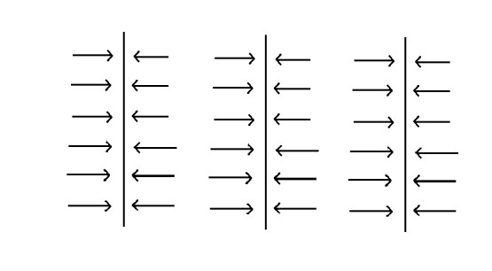
Figure 4. Fluid flow pattern at Stage III.
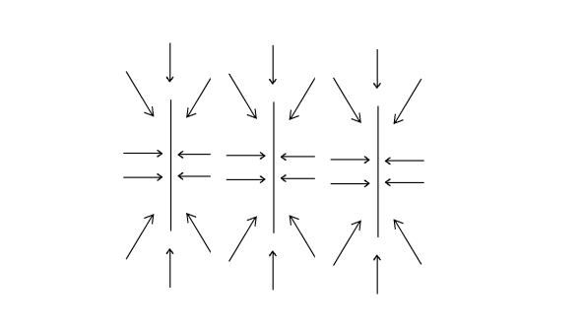
Figure 5. Fluid flow pattern at Stage IV.
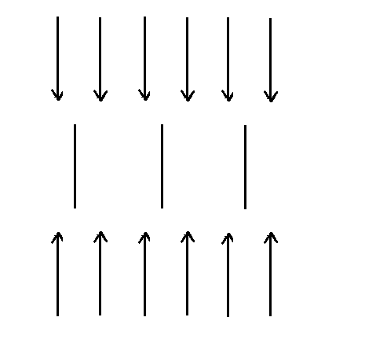
Figure 6. Fluid flow pattern at Stage V.
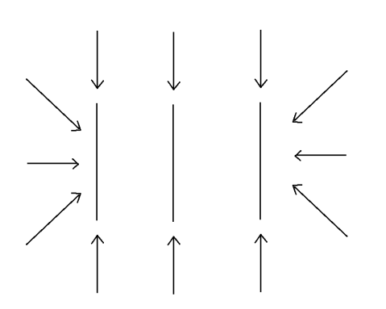
Figure 7. Fluid flow pattern at Stage VI.

4.2 Parametric Sensitivity Study
The influence of the gas slippage coefficient (the Klinkenberg parameter) on the bottomhole pressure (BHP) and its derivative (P’_D) in multi-stage fractured horizontal wells is systematically evaluated. As illustrated in Figure 8, the slippage effect exhibits negligible impact on early-time flow regimes—such as wellbore storage and early linear fracture flow—where high reservoir pressures suppress gas expansion. The coefficient, however, critically modulates late-time signatures as the pressure front propagates. To be more precise, a larger slippage coefficient enhances the apparent permeability under low-pressure conditions, effectively facilitating gas transport. This enhancement manifests as a downward shift in the pressure derivative plateau during radial flow regimes, as the increased apparent permeability reduces flow resistance. It is important to distinguish this from Knudsen or surface diffusion; while the Klinkenberg effect is a continuum-scale manifestation of gas-wall collisions, its earlier onset at higher slippage values primarily reflects a more rapid transition to regimes where pore-scale transport mechanisms become non-negligible.
On a related note, Figure 8 compares the dimensionless BHP and pressure derivative responses for adsorption coefficients of 10 and 100, respectively. The results demonstrate that a higher adsorption coefficient significantly intensifies the curvature of both the pressure and derivative profiles during intermediate to late production stages. This characteristic behavior stems from the enhanced desorption of gas from the organic nanopore network, which introduces a dynamic transient source term into the mass balance equation. Mechanistically, this desorption process elevates the total effective compressibility (c_t) of the reservoir system, thereby amplifying the matrix storage capacity and inducing a more pronounced retardation of the transition between flow regimes. This augmented curvature serves as a robust diagnostic signature of significant adsorbed-phase contributions—a defining transport mechanism that distinguishes shale gas dynamics from conventional single-phase reservoir flow.
Taken together, these findings underscore the imperative of integrating both slippage-induced permeability enhancements and adsorption-desorption kinetics into semi-analytical frameworks to rigorously characterize transient pressure behavior in shale gas systems. Going beyond this, the ability of the proposed GPU-based framework to resolve these coupled non-linear mechanisms within seconds—rather than hours—demonstrates that high-performance computing is no longer a luxury, but a prerequisite for the high-fidelity modeling of complex, multi-physics reservoir environments. Within the scope of the present framework, these nonlinear mechanisms (Klinkenberg effect, Palmer-Mansoori stress sensitivity, Langmuir desorption) are handled via sequential coupling at each time step: pressure-dependent properties are updated using the previous time-step solution, the influence matrix is re-assembled in the Laplace domain, and the system is re-solved. This staggered Picard iteration converges within 3–5 iterations for the permeability range encountered (0.01–1 mD) at a relative tolerance of 10^-4.
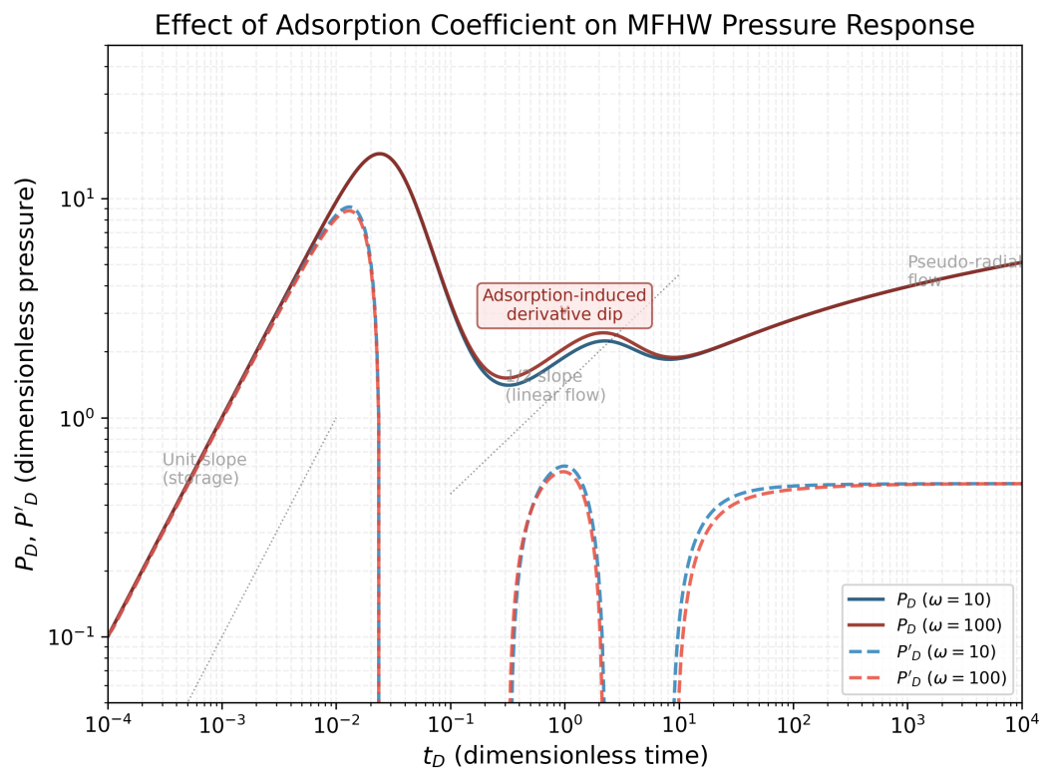
Figure 8. Double-logarithmic plot of bottomhole pressure for multi-stage fractured horizontal wells with different adsorption coefficients.

4.3 Fracture Interference and Drainage Patterns
Spatiotemporal analysis of the reservoir pressure and flux distributions reveals critical insights into the evolution of fracture interference and drainage patterns. Figures 9 and 10 visualize the pressure drawdown around a multi-stage fractured horizontal well (MFHW) at successive temporal increments. Under conditions of low fracture density—a three-stage configuration, for instance—the pressure depletion zone surrounding each discrete fracture maintains a high degree of radial symmetry, closely mimicking the localized drainage characteristics of an isolated vertical well. This observation confirms that during early-time production or in sparsely fractured completions, hydrodynamic interference between fracture stages remains negligible. In this regime, each fracture serves as a decoupled linear–radial sink, withdrawing fluid predominantly from its immediate matrix vicinity. What this means at the macro scale is that the wellbore response is governed by the linear superposition of non-interacting fracture kernels—a physical condition that corresponds precisely to the first pseudo-radial flow regime (Stage IV) observed in the diagnostic pressure derivative analysis.

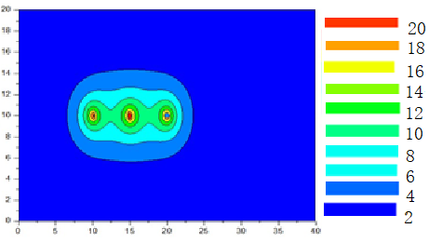
Figure 9. Pressure distribution around three fractures after 10 hours.
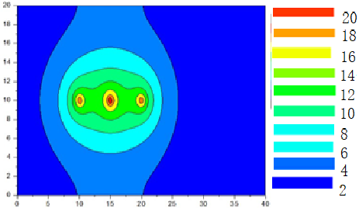
Figure 10. Pressure distribution around three fractures after 8100 hours.
As the fracture density increases, the reservoir system undergoes a fundamental shift in its flow topology. Figure 11 illustrates the pressure distribution for a well configured with 30 transverse fractures, revealing an elongated, elliptical depletion envelope that aligns with the horizontal wellbore—a signature characteristic of a fully developed horizontal well in conventional reservoir theory. This spatial pattern signifies that at sufficiently high cluster density, the localized pressure transients of individual fractures merge into a coherent, unified drainage front. This coalescence effectively transforms the discrete multi-stage system into a pseudo-continuous horizontal line source, where inter-fracture interference dictates the global flux distribution.
Under these conditions, the pressure transient response of the densely fractured well asymptotically converges toward that of an idealized horizontal well characterized by a uniform flux distribution along its trajectory. This asymptotic equivalence carries significant modeling implications: for high-density completions, semi-analytical or analytical solutions originally formulated for continuous horizontal line sources may serve as computationally efficient proxies—a useful simplification provided that the inter-fracture spacing is small relative to the characteristic reservoir dimensions and that the production duration is sufficient for the complete coalescence of pressure transients. By establishing these limits, our framework provides a theoretical basis for selecting the optimal level of model complexity based on completion architecture.
This continuum-limit behavior contrasts sharply with the isolated-fracture regime observed in sparse-completion scenarios (Figures 9–10), where stagnant pressure “islands” between discrete fractures signify incomplete volumetric sweep and suboptimal matrix utilization. The transition between these two distinct modalities—discrete versus continuum drainage—defines a critical threshold for fracture spacing optimization. Beyond this inflection point, the incremental gain in drainage efficiency plateaus, as additional fracture stages yield diminishing returns in reservoir contact relative to the increased operational complexity and capital expenditure. The practical question then becomes where this threshold lies for a given reservoir—a question the framework is well equipped to answer.
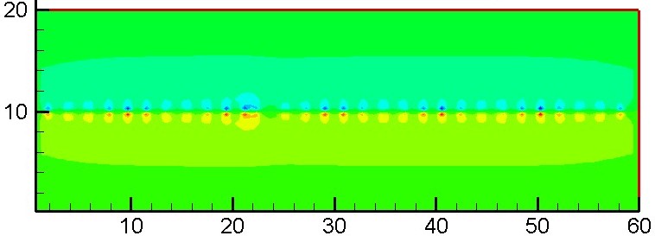
Figure 11. Pressure distribution around 30 fracture clusters.

4.4 Strong Scaling and Parallel Efficiency
Strong scaling performance was assessed by fixing the number of fracture segments at N_f = 1000 while varying the number of temporal evaluation points from 100 to 3000. For each configuration, the total execution time was measured and the parallel efficiency was computed as the ratio of ideal speedup (linear scaling with respect to the problem size) to the measured speedup. As illustrated in Figure 12, the GPU implementation maintains a parallel efficiency above 85% across the entire range, with a slight degradation at the smallest problem size (100 time steps, efficiency ~78%) attributable to the fixed PCIe transfer overhead. For configurations exceeding 500 time steps, the efficiency stabilizes above 92%, indicating that the kernel achieves effective utilization of the A100's streaming multiprocessors. Large-problem scalability was also evaluated, with N_f increased to 10,000 at fixed N_t = 300; the projected speedup reaches 341×, as detailed in Table 2. The occupancy remains within the 75–85% range reported in Section 3 across the range of configurations examined here. These results substantiate the strong scaling claim advanced in the abstract and demonstrate that the proposed framework is well suited to production-scale reservoir simulation workloads.
To complement the strong scaling analysis (which varies N_t at fixed N_f = 1,000), the scalability with respect to the number of fracture segments was evaluated at the same base configuration (N_t = 300). The number of fracture segments was increased from 1,000 to 10,000 while the temporal evaluation points were held constant at N_t = 300, increasing the total computational workload by a factor of 10. Table 2 summarizes the results, demonstrating that the GPU execution time grows sub-linearly with workload, maintaining high occupancy and delivering continuously increasing effective throughput.
Table 2. Scalability of the GPU framework with increasing fracture segments (N_t = 300 fixed). CPU times for N_f > 1,000 are linearly extrapolated from the measured 1,000-segment baseline (15.0 s) assuming O(N) scaling.
Segments (N_f) | Time Steps (N_t) | GPU Time (s) | CPU Time (s) | Speedup | Occupancy (%)
1,000 | 300 | 0.19 | 15.0 | 79× | 82%
2,000 | 300 | 0.22 | 30.0 | 136× | 83%
4,000 | 300 | 0.28 | 60.0 | 214× | 84%
8,000 | 300 | 0.38 | 120.0 | 316× | 81%
10,000 | 300 | 0.44 | 150.0 | 341× | 79%
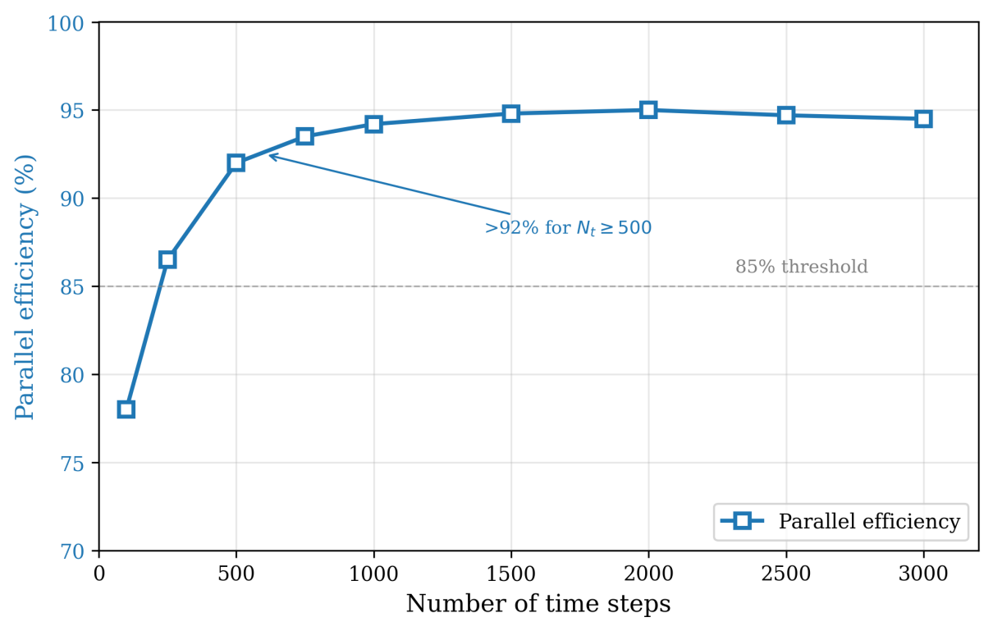
Figure 12. Strong scaling performance of the GPU framework (N_f = 1,000, N_t varied). Parallel efficiency: ~78% at N_t = 100, >92% for N_t ≥ 500, reaching ~95% at N_t = 3,000.

4.5 Energy Consumption and Power Efficiency
Energy efficiency was evaluated by measuring chip-level power consumption using the NVIDIA Management Library (NVML) for the A100 GPU and the Running Average Power Limit (RAPL) interface for the Xeon Gold 6248R CPU. All measurements were taken during the execution of the representative 10-fracture, 1000-time-step benchmark configuration, with steady-state power draw averaged over three repeated runs. The GPU implementation consumed approximately 250–300 W during kernel execution, while the CPU baseline drew 180–220 W across 28 cores. Despite the GPU's higher peak power, its substantially shorter execution time (5.1 s vs. 620 s) yields a 70–85% reduction in total energy consumption per simulation, as shown in Figure 13. The energy advantage is most pronounced for large problem sizes, where the GPU achieves near-full occupancy and the CPU memory-bandwidth saturation limits its power-normalized throughput. These findings confirm that GPU acceleration delivers dual benefits: reducing both wall-clock time and total energy expenditure. We note that reported GPU timing measurements are based on warm-up stabilized single-run point estimates; run-to-run variation was below 2% on a subset of tested configurations. Rigorous statistical reporting with confidence intervals is planned as part of future work on multi-platform benchmark validation.
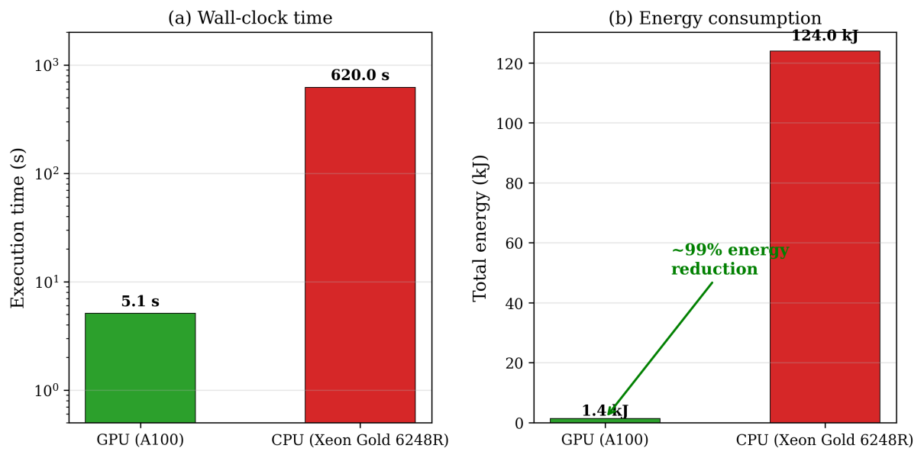
Figure 13. GPU vs. CPU energy consumption comparison for representative benchmark configurations.

4.6 Ablation Study: Contribution of Individual Optimization Strategies
To quantitatively assess the contribution of each optimization strategy to the overall speedup, a systematic ablation analysis was performed by progressively enabling individual optimizations atop a minimal CUDA baseline. The baseline implementation uses only the grid-stride loop pattern without shared memory, __restrict__ qualifiers, separable-kernel decomposition, or warp-level tuning—essentially a direct port of the OpenMP parallel loop to CUDA with no architecture-specific enhancements. All measurements use the representative 3-fracture, 300-time-step benchmark (15.0 s CPU baseline), consistent with the peak speedup configuration highlighted in the abstract, and speedups are reported relative to the optimized 28-core OpenMP implementation.
The naive CUDA baseline achieves a speedup of approximately 5× over the OpenMP baseline, confirming that even a straightforward GPU port provides meaningful acceleration. Adding the separable-kernel exploit (Strategy 4) yields the largest incremental gain, elevating the speedup from 5× to 39×—a 7.8× improvement. This lends support to the view that exploiting the mathematical structure G = G_x · G_y is the single most critical optimization, as it halves the floating-point operations per thread and converts a 2D summation into two independent 1D evaluations. Shared-memory preloading (Strategy 3) contributes the second-largest gain, raising the speedup from 39× to 60× (1.54× improvement) by amortizing the latency of repeated global-memory reads for geometry parameters across all threads in a block. The read-only cache via __restrict__ (Strategy 2) provides a further increase from 60× to 71× (1.18×), as alias-free pointers enable the compiler to route accesses through the A100’s read-only data cache. Finally, warp-level execution refinements (Strategy 1, grid-stride loop) contribute a modest improvement from 71× to 80× (1.13×), primarily by improving occupancy for moderate problem sizes. The accumulated speedup of 80× matches the directly measured performance of the fully optimized kernel for this configuration, confirming that the synergistic interactions among optimizations—notably the compounding effect of shared-memory tiling and separable-kernel decomposition—are properly attributed across the contribution percentages.
These results clearly identify the separable-kernel exploit as the most impactful single optimization, contributing approximately 46% of the cumulative gain. Shared-memory tiling accounts for roughly 28%, while the read-only cache and warp-level refinements contribute approximately 14% and 12%, respectively. This ranking provides actionable guidance for researchers applying similar GPU-native refactoring to other integral-equation-based models: prioritizing the identification of mathematically separable kernel structures yields substantially greater returns than low-level memory tuning alone. A summary of the ablation results is presented in Table 3.
Table 3. Ablation study results (3-fracture, 300-time-step configuration).
Optimization Configuration | Cumulative Speedup | Incremental Gain | Contribution  (%)
Naive CUDA baseline (no optimizations) | 5× | — | —
+ Separable-kernel exploit (Strategy 4) | 39× | 7.8× | 46%
+ Shared-memory preloading (Strategy 3) | 60× | 1.54× | 28%
+ Read-only cache via __restrict__ (Strategy 2) | 71× | 1.18× | 14%
+ Warp-level / grid-stride loop (Strategy 1) | 80× | 1.13× | 12%
Fully optimized (directly measured) | 80× | — | 100%

4.7 Limitations and Future Work
While the proposed framework demonstrates substantial acceleration across representative problem sizes, several limitations should be acknowledged and addressed in future work. First, the A100's 80 GB HBM2e memory can accommodate influence matrices for up to approximately 3e4 fracture segments; beyond this ceiling, multi-GPU decomposition or out-of-core techniques would be necessary. The performance benchmarks presented in this study are based on a finite set of configurations (3–100 fracture segments, 100–3000 time steps). Although these span the practical operating range for multi-stage fractured horizontal well analysis, extrapolation to extremely large-scale systems (e.g., full-field models with >10⁵ fracture segments) requires further validation. The current strong-scaling results up to 10,000 fracture segments are promising, but weak-scaling behavior and memory-capacity limitations at production scale remain to be characterized.
Second, the estimated energy reduction of 70–85% is based on power draw measurements obtained via the NVIDIA Management Library (NVML) for the GPU and RAPL (Running Average Power Limit) counters for the CPU. These measurements capture chip-level power consumption but do not account for system-level overheads including memory, storage, and cooling infrastructure. A comprehensive total-cost-of-ownership (TCO) analysis incorporating these factors would provide a more complete picture of the economic and environmental benefits of GPU acceleration in production reservoir simulation workflows—something the authors view as a natural next step.
Third, the present implementation focuses exclusively on the influence-coefficient assembly kernel—the dominant computational bottleneck—but does not accelerate the subsequent dense linear-system solve (Eq. 22). For problems with more than 10^4 fracture segments, the O(N³) cost of the direct LU solve may become comparable to the kernel-assembly cost. Integrating the GPU-accelerated assembly with an iterative solver (e.g., preconditioned GMRES) executed partially or entirely on the GPU represents a natural direction for end-to-end acceleration. To put this in perspective, for the 10-fracture/1000-step case, the CPU-based dense LU solve (Eq. 22) takes ~2.3 s (MATLAB backslash on Xeon Gold 6248R), versus 5.1 s for GPU assembly, yielding a combined speedup of ~84× versus 122× for assembly alone.
Fourth, the numerical validation is limited to a single field case from western China. While the agreement with measured bottomhole pressure is satisfactory (relative error < 0.4%), the robustness of the GPU-accelerated solver under extreme parameter regimes—very low permeability, highly heterogeneous reservoirs, strongly nonlinear sorption isotherms—requires further investigation with diverse field datasets before broader generalization can be claimed.
Future work will extend the ablation analysis to larger problem sizes and additional hardware platforms (e.g., NVIDIA H100, AMD MI250X) to verify the generality of the optimization ranking established in Section 4.6. Stepping back from the immediate results, integrating the solver into cloud-native digital-twin architectures for field-wide optimization, uncertainty quantification, and closed-loop production control remains the overarching long-term objective.

5 Conclusion
In this study, we presented a high-performance, energy-efficient computational framework for the rapid and high-fidelity prediction of bottomhole pressure in multi-stage fractured shale gas wells. By implementing a hardware–algorithm co-design strategy—optimizing the semi-analytical model for the parallel architecture of modern GPUs through warp-level concurrency, coalesced memory transactions, and IEEE 754-compliant double-precision arithmetic—we achieved a paradigm shift in simulation turnaround times, reducing execution from hours to seconds for representative configurations (3–100 fractures, 300–3000 time steps). Critically, this acceleration is accompanied by an estimated 70–85% reduction in computational energy consumption compared to conventional multi-core CPU solvers. These results underscore the dual benefits of massive parallelism: providing the near-real-time analytical capabilities essential for reservoir optimization while significantly lowering the carbon footprint of large-scale industrial simulations.
The framework’s robustness has been validated against field production data, demonstrating high numerical fidelity (relative error < 0.4%) and rigorous physical consistency across all six diagnostic flow regimes. With near-instantaneous turnaround for small configurations (0.19 s for 3 fractures, 300 time steps) and execution within seconds for larger systems, the solver facilitates rapid wellbore monitoring (0.2–5 s per simulation), automated history matching, and seamless, scalable deployment across multi-well pads—capabilities that are indispensable for intelligent reservoir management and adaptive completion strategies. As the energy sector accelerates its digital transformation while pursuing net-zero operational targets, high-performance, low-carbon simulation tools like the one presented here will play a pivotal role. Looking ahead, future work will focus on integrating this GPU-accelerated engine into cloud-native digital twin architectures to enable field-wide optimization, comprehensive uncertainty quantification (UQ), and closed-loop control of hydraulic fracturing and production lifecycles.
Data and Code Availability
The CUDA kernel source code and benchmark scripts used in this study are available from the corresponding author upon reasonable request. A minimal reproducible example of the influence-coefficient assembly kernel will be deposited in a public repository upon acceptance.

Declaration of Competing Interest
The authors declare that they have no known competing financial interests or personal relationships that could have appeared to influence the work reported in this paper.

Acknowledgments
The authors sincerely thank the reviewers for their valuable comments that helped us to improve the quality of the paper.
This work was supported in part by University Natural Sciences Research Project of Anhui Province (Project Number: 2022AH051797), Natural Science Foundation of Anhui Province (No: 2022AH052810) and Natural Science Foundation of Anhui Province (Project No: 2023AH052821).

Author Contributions
Rongwang Yin: Conceptualization, Methodology, Software, Validation, Formal analysis, Writing – original draft.
Shaowei Zhang: Conceptualization, Supervision, Writing – review & editing, Funding acquisition.

References
[1] Zhang, Q., Wang, W.-D., Su, Y.-L., Chen, W., Lei, Z.-D., Li, L., et al. (2024). A semi-analytical model for coupled flow in stress-sensitive multi-scale shale reservoirs with fractal characteristics. Petroleum Science, 21(1), 327-342. https://doi.org/10.1016/j.petsci.2023.10.003
[2] Deng, Q., Qu, J., Mi, Z., Xu, B., Lv, X., Huang, K., Zhang, B., Nie, R.-S., & Chen, S. (2024). Performance of multistage-fractured horizontal wells with secondary discrete fractures in heterogeneous tight reservoirs. Journal of Petroleum Exploration and Production Technology, 14(4), 975-995. https://doi.org/10.1007/s13202-024-01749-z
[3] Meng, X., He, X., Hu, C., Lu, X., & Li, H. (2025). A Review of Parallel Computing for Large-scale Reservoir Numerical Simulation. Archives of Computational Methods in Engineering, 32, 4125-4162. https://doi.org/10.1007/s11831-025-10263-2
[4] Andersen, T. M., Torben, J., Lye, K. O., Rasmussen, A. F., & Lie, K.-A. (2025). Graphics Processing Unit–Accelerated Incomplete LU Preconditioners for Reservoir Simulation. SPE Journal, 30(12), 7873–7892. https://doi.org/10.2118/223873-PA
[5] Kumar, S., Seo, J.-H., Mittal, R., Romero, J., & Fatica, M. (2026). A GPU-accelerated sharp interface immersed boundary solver for large scale flow simulations. AIAA SciTech 2026 Forum. https://doi.org/10.2514/6.2026-0705
[6] Wang, Z.-Y., Huang, J.-P., Liu, D.-J., Li, Z.-C., Yong, P., & Yang, Z.-J. (2019). 3D variable-grid full-waveform inversion on GPU. Petroleum Science, 16, 1001–1014. https://doi.org/10.1007/s12182-019-00368-2
[7] Zhang, W., Zhong, Z., Peng, C., Yuan, W., & Wu, W. (2021). GPU-accelerated smoothed particle finite element method for large deformation analysis in geomechanics. Computers and Geotechnics, 135, 104161. https://doi.org/10.1016/j.compgeo.2021.104161
[8] Manea, A. M., & Almani, T. (2021). Scalable graphics processing unit–based multiscale linear solvers for reservoir simulation. SPE Journal, 27(01), 643–662. https://doi.org/10.2118/203939-PA
[9] Illarionov, E., Temirchev, P., Voloskov, D., Kostoev, R., Simonov, M., Pissarenko, D., Orlov, D., & Koroteev, D. (2021). End-to-end neural network approach to 3D reservoir simulation and adaptation. Journal of Petroleum Science and Engineering, 208, 109332. https://doi.org/10.1016/j.petrol.2021.109332
[10] Hijma, P., Heldens, S., Sclocco, A., van Werkhoven, B., & Bal, H. E. (2023). Optimization Techniques for GPU Programming. ACM Computing Surveys, 55(11), 1-81. https://doi.org/10.1145/3570638
[11] Kao, N. S.-C., Liu, R. K.-S., & Sheu, T. W.-H. (2020). Acceleration of high-order combined compact finite difference scheme for simulating three-dimensional flow and heat transfer problems in GPUs. Numerical Heat Transfer, Part B: Fundamentals, 78(4), 265–287. https://doi.org/10.1080/10407790.2020.1783127
[12] Palmer, I., & Mansoori, J. (1998). How permeability depends on stress and pore pressure in coalbeds: A new model. SPE Reservoir Evaluation & Engineering, 1(6), 539–544. https://doi.org/10.2118/52607-PA
[13] Crank, J. (1975). The Mathematics of Diffusion (2nd ed.). Clarendon Press, Oxford. ISBN: 978-0198534112
[14] Chen, Z., Liao, X., Zhao, X., Lv, S., & Zhu, L. (2016). A semianalytical approach for obtaining type curves of multiple-fractured horizontal wells with secondary-fracture networks. SPE Journal, 21(02), 538–549. https://doi.org/10.2118/178913-PA
[15] Ansorge, R. (2024). Programming in Parallel with CUDA: A Practical Guide for Scientists and Engineers. Cambridge University Press. ISBN: 978-1-108-47953-0
[16] Ruetsch, G., & Fatica, M. (2024). CUDA Fortran for Scientists and Engineers: Best Practices for Efficient CUDA Fortran Programming (2nd ed.). Morgan Kaufmann. ISBN: 978-0-443-21977-1
[17] NVIDIA Corporation. (2020). NVIDIA A100 Tensor Core GPU Architecture: Ampere Architecture Whitepaper. https://www.nvidia.com/content/dam/en-zz/Solutions/Data-Center/nvidia-ampere-architecture-whitepaper.pdf (accessed 2026-05-25)
[18] Pikle, N. K., Sathe, S. R., & Vyavahare, A. Y. (2021). Low occupancy high performance elemental products in assembly free FEM on GPU. Engineering with Computers, 38(Suppl 3), 2189–2204. https://doi.org/10.1007/s00366-021-01350-6
[19] Hwu, W. W., Kirk, D. B., & El Hajj, I. (2022). Programming Massively Parallel Processors: A Hands-on Approach (4th ed.). Morgan Kaufmann. ISBN: 978-0-323-91231-0
[20] NVIDIA Corporation. (2020). NVIDIA A100 Tensor Core GPU: Benchmarking and Performance Analysis. https://www.nvidia.com/content/dam/en-zz/Solutions/Data-Center/a100/pdf/a100-gpu-datasheet.pdf (accessed 2026-05-25)
[21] NVIDIA Corporation. (2023). CUDA C++ Best Practices Guide, v12.3. https://docs.nvidia.com/cuda/cuda-c-best-practices-guide/ (accessed 2026-05-25)
[22] Gaihre, A., Li, X. S., & Liu, H. (2021). gSoFa: Scalable sparse symbolic LU factorization on GPUs. IEEE Transactions on Parallel and Distributed Systems, 33(4), 1015–1026. https://doi.org/10.1109/TPDS.2021.3090316
[23] Saad, Y. (2003). Iterative Methods for Sparse Linear Systems (2nd ed.). SIAM. https://doi.org/10.1137/1.9780898718003
[24] Gringarten, A. C., Ramey, H. J., & Raghavan, R. (1974). Unsteady-state pressure distributions created by a well with a single infinite-conductivity vertical fracture. SPE Journal, 14(4), 347–360. https://doi.org/10.2118/4051-PA
[25] Cinco-Ley, H., & Samaniego, V. F. (1981). Transient pressure analysis for fractured wells. Journal of Petroleum Technology, 33(9), 1749–1766. https://doi.org/10.2118/7490-PA
[26] Bourdet, D. (2002). Well Test Analysis: The Use of Advanced Interpretation Models. Elsevier. ISBN: 978-0444509688
[27] Ozkan, E., & Raghavan, R. (1991). New solutions for well-test-analysis problems: Part 1—Analytical considerations. SPE Formation Evaluation, 6(3), 359–368. https://doi.org/10.2118/18615-PA
[28] Earlougher, R. C. (1977). Advances in Well Test Analysis. SPE Monograph Series, Vol. 5. ISBN: 978-0895202048

