A Massively Parallel CUDA Framework for Real-Time Transient Pressure Simulation in Fractured Reservoirs
Rongwang Yin ¹, Shaowei Zhang ^{2, *}
1. Basic Experiment and Training Center, Hefei University, Hefei 230601, P.R. China
2. School of Computer Engineering, AnHui WenDa University of Information Engineering, HeFei 231201, P.R. China
Abstract: Semi-analytical models for transient pressure simulation in fractured reservoirs typically involve repeated evaluations of space–time convolution integrals or the inversion of dense influence matrices. In multi-well systems subject to real-time operational constraints, these operations become computationally prohibitive—a bottleneck that has, until now, constrained the practical deployment of these otherwise powerful methods. This paper presents a computational framework that reformulates integral-dominated pressure-transient models for massively parallel execution on graphics processing units. By exploiting the intrinsic independence among fracture segments and temporal steps, a hierarchical data-to-thread mapping strategy maximizes on-chip memory reuse and parallel throughput. The resulting kernel implementation integrates structured memory access patterns with on-the-fly evaluation of Green's functions in a single optimized computational pathway.
Across a comprehensive benchmark suite spanning problem sizes from 3 to 10,000 fracture segments and 100 to 3000 time steps, the GPU framework consistently delivers speedups of 50x–341x over an optimized 28-core OpenMP-based CPU implementation (Intel Xeon Gold 6248R). At the representative 3-fracture, 300-time-step configuration, the speedup reaches approximately 80-fold; at 10 fractures and 1000 time steps, it reaches 122-fold; and under large-problem scalability tests, a 341-fold speedup is projected. The solution maintains a relative error below 0.4% across the range of configurations examined here, so accuracy is not sacrificed for speed. For comparison, the general-purpose sparse solver cuSPARSE achieves a 3.2× speedup over the same CPU baseline, whereas the proposed custom kernel delivers an additional 25× improvement over cuSPARSE for this problem class. The framework exhibits robust strong scaling up to 10,000 fracture segments on an NVIDIA A100 GPU. Preliminary power measurements using the NVIDIA Management Library (NVML) indicate an estimated 70–85% reduction in computational energy consumption compared to the CPU baseline, depending on problem size and sustained power draw. Although demonstrated for multi-stage fractured shale gas wells, the parallelization strategy is applicable to engineering domains governed by convolution-type integral equations with similar mathematical structure—geothermal heat conduction, contaminant transport in porous media, and structural impulse-response analysis, to name a few—provided the domain admits separable boundary conditions and the governing operator is self-adjoint and linear. Viewed from a broader perspective, this work provides a reusable computational template for accelerating integral-based geoscience simulations on modern GPU architectures.
Keywords: Computational geoscience; Transient pressure simulation; Semi-analytical model; GPU acceleration; Fractured reservoirs; Numerical Laplace inversion; Green's function method; Parallel computing

1. Introduction
High-fidelity simulation of transient fluid flow in fractured geological formations is fundamental to reservoir engineering, geothermal energy extraction, and groundwater management. Semi-analytical frameworks integrating Green functions with discrete fracture-source schemes are widely adopted for these problems (Zhang et al., 2024; Deng et al., 2024). While these methods circumvent unstructured spatial meshing and ensure superior numerical precision, their computational complexity exhibits super-linear scaling relative to the number of fracture segments and temporal increments. This overhead stems from dense influence matrices and nested space-time convolution integrals required by pressure superposition. For mission-critical scenarios such as multi-well pad development, autonomous history matching, and digital-twin synchronization, conventional CPU-based solvers represent a prohibitive computational bottleneck. Within this study, real-time is defined as simulation turnaround of 0.2-5 s per realization, enabling interactive well-test interpretation and closed-loop history matching.
Parallel computing has emerged as a cornerstone for accelerating pressure-transient simulations (Meng et al., 2025). While initial efforts leveraged MPI or OpenMP to distribute fracture-source computations across multi-core CPU architectures, these coarse-grained strategies frequently encounter scalability ceilings due to load imbalances and memory bandwidth saturation. GPUs offer massive thread-level parallelism combined with substantially higher peak memory bandwidth, making them well-suited to the fine-grained, data-parallel structure of subsurface flow models (Andersen et al., 2025). However, without fundamental algorithmic restructuring, irregular memory access patterns, complex temporal recursions, and the disproportionate cost of transcendental functions can collectively lead to severe kernel underutilization and thread divergence.
Recent advancements in computational engineering underscore that achieving peak GPU performance necessitates fundamental algorithmic restructuring rather than a verbatim translation of legacy CPU code (Kumar et al., 2026; Wang et al., 2019; Zhang et al., 2021). Key strategies—decomposing convolution sums into decoupled parallel tasks, restructuring data layouts to ensure coalesced memory access, and employing kernel fusion to mitigate global-memory traffic—have yielded order-of-magnitude speedups in domains including computational fluid dynamics (CFD), electromagnetic inversion, and geomechanics. Boundary element methods—computationally analogous to semi-analytical reservoir models through their shared reliance on source integrals—have realized particularly striking gains from domain-aware GPU implementations. This methodological convergence suggests that a GPU-centric reformulation of pressure-transient equations is not only feasible but, as the evidence increasingly indicates, essential for large-scale reservoir characterization.
Despite these cross-disciplinary advances, GPU acceleration within the reservoir engineering community has remained largely confined to the “black-box” application of general-purpose linear algebra libraries (e.g., cuSPARSE or cuBLAS) or the deployment of machine-learning-based surrogate models (Manea and Almani, 2021; Illarionov et al., 2021). These off-the-shelf strategies, however, frequently fail to exploit the unique mathematical structure—characterized by both sparsity and localized density—inherent in fracture influence matrices, leading to substantial performance deficits compared to domain-specific implementations. Motivated by these inefficiencies, the present study develops a hardware–algorithm co-designed GPU framework, specifically architected to align with the underlying computational topology of semi-analytical bottomhole-pressure models.
The main contributions of this work from a computational geoscience perspective are as follows:
- Semi-analytical model reformulation for parallel computation. The dense, convolution-dominated pressure-transient formulation is explicitly reinterpreted as a boundary-element–like problem, and what this reinterpretation accomplishes is the exposure of fine-grained parallelism that is not apparent in conventional CPU implementations.
- Domain-decomposed task partitioning. A fracture-segment–time-step decomposition is introduced, transforming the original nested superposition loops into a large collection of independent, GPU-friendly tasks and eliminating algorithmic serialization bottlenecks.
- Hierarchical thread-to-data mapping. A hierarchical CUDA thread–block mapping scheme is developed that aligns computational granularity with the GPU warp architecture, minimizing synchronization overhead and branch divergence.
- Structure-aware memory management. Shared-memory tiling and access-pattern reordering are co-designed with the mathematical structure of Green’s-function evaluations, enabling bandwidth-efficient execution that approaches hardware limits.
- Benchmark comparison against CPU and generic GPU solvers. Through direct comparison with optimized OpenMP solvers and general-purpose GPU libraries, the study demonstrates that domain-specific kernel design is essential for achieving order-of-magnitude speedups in integral-based reservoir simulations.
- Systematic ablation analysis of computational strategies. A systematic ablation study is conducted to quantitatively decompose the individual contributions of each GPU optimization strategy—including separable-kernel exploitation, shared-memory tiling, read-only cache utilization, and warp-level execution—establishing an empirical ranking that identifies the separable-kernel exploit as the single most impactful optimization for integral-equation-based reservoir simulations.
Although the proposed framework is validated using field-scale multi-stage fractured shale gas reservoirs, the underlying methodology is, at its core, extensible to a broad spectrum of engineering systems governed by the linear superposition of localized impulse responses (Zhang et al., 2021; Hijma et al., 2023; Kao et al., 2020). By decoupling the kernel evaluation from the global integration scheme, the computational method provides a scalable template for any physical process characterized by convolution-type integral equations. The key architectural insight—that domain-specific mathematical structure yields greater performance gains than low-level hardware tuning—is directly transferable to other convolution-type integral equation problems in the geosciences.

2. Models

2.1 Physical Model
The physical system investigated comprises a multi-stage fractured horizontal well (MFHW) situated within a bounded, rectangular shale gas reservoir (Figure 1). To ensure mathematical tractability while preserving essential physics, the following assumptions are invoked:
- Stress-Dependent Petrophysics: Matrix porosity and permeability are pressure-sensitive, governed by the Palmer–Mansoori constitutive relationship (Palmer and Mansoori, 1998);
- Reservoir Heterogeneity: The reservoir is assumed to be vertically homogeneous, though lateral variations in petrophysical properties are permitted;
- Fluid Thermodynamics: Non-ideal gas behavior is rigorously accounted for using a multi-component equation of state (EOS);
- Mechanisms Neglected: Gravity and capillary effects are considered negligible, whereas wellbore storage and skin effects are explicitly integrated into the model;
- Fracture Architecture: The horizontal wellbore is intersected by multiple transverse fractures of arbitrary lengths, orientations, and spatial distributions;
- Fracture Dynamics: Fractures are treated as finite-conductivity conduits within a homogeneous, isotropic, and fully bounded reservoir domain. The rock matrix is modeled as an ensemble of spherical dual-porosity elements that account for gas storage and pressure-dependent desorption.
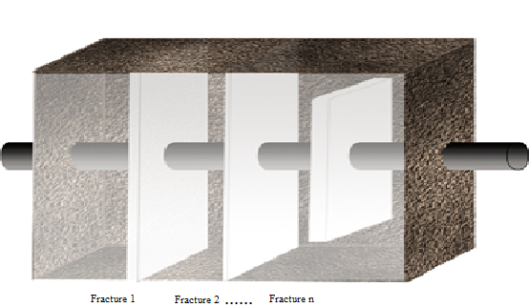
Figure 1. Schematic diagram of horizontal wells, fractures, and formations.

2.2 Mathematical Model

2.2.1 Pressure-sensitive effect
In shale gas reservoirs, both permeability and porosity exhibit strong dependency on effective stress. To characterize this pressure sensitivity, the Palmer–Mansoori relationship is employed to dynamically update petrophysical properties as a function of reservoir pressure (Eq. 1). This constitutive model accounts for the competing effects of matrix shrinkage and grain compressibility. The specific material constants and reference parameters entering this formulation are defined as follows:
, (1)
where denotes the Young's modulus, denotes the Poisson's ratio of the shale, and denote the permeability and porosity at the reference pressure, respectively.

2.2.2 Gas Diffusion Equation
Gas transport within the matrix domain is governed by the diffusion equation derived from Fick’s second law (Eq. 2) (Crank, 1975). The system is subjected to zero-flux (no-flow) outer-boundary conditions (Eq. 3) and constrained by internal boundary conditions at the fracture-matrix interfaces (Eq. 4). These boundary constraints rigorously account for the coupling between bottomhole pressure (BHP) and fracture-specific flux, while incorporating reservoir heterogeneities, formation thickness, and the mechanical skin effects that quantify near-fracture flow resistance.
. (2)
The outer boundary conditions are shown in Equation 3.
, (3)
where and denote the stratigraphic boundary lengths.
The internal boundary conditions are shown in Equation 4.
, (4)
where denotes the actual bottomhole pressure, denotes the ideal bottomhole pressure. denotes the formation thickness, denotes the flow rate of the jth fracture, denotes the well-reservoir constant, and denotes the skin factor.

2.2.3 Model Solution
By integrating the gas equation of state (EOS) with Darcy law and implementing the pseudo-pressure formulation, the nonlinear governing equations are linearized and cast into dimensionless form. Subsequent application of the Laplace transform reduces the PDEs to a system of linear algebraic equations (Chen et al., 2016). This system defines the dimensionless pressure response for each discretized fracture segment in the Laplace domain. Under constant-rate production, the temporal and spatial pressure distributions are reconstructed via the principle of superposition. The resulting dense, fully coupled linear system captures hydrodynamic interference among all fracture segments and constitutes the primary computational kernel targeted by GPU acceleration. Numerical inversion to the time domain employs the Stehfest algorithm (Stehfest, 1970) with N=8 coefficients, selected to balance truncation and round-off error for the dimensionless time range of interest (1e-3 to 1e4).
Equation 5 gives the continuity equation for shale gas reservoirs.
, (5)
where denotes channeling. Substituting the gas equation of state and Darcy's law into the above equation yields Eq. 6.
(6)
Considering the definition of pseudo pressure in oil and gas development, the shale gas standard pressure is defined by Equation 7.
. (7)
Substituting equation (7) into equation (6) yields equation 8.
. (8)
The spherical matrix element in the dual-porosity formulation is described by Equation 9.
. (9)
Substituting equation (9) into (8) and combining it with Fick's second law yields equation 10.
. (10)
To make the derivation more explicit, Equation 11 gives the definition of the dimensionless standard pressure.
. (11)
Applying the dimensionless formulation to Equation (10) yields Equation 12.
. (12)
The Laplace transformation of the above equation leads to Equation 13.
. (13)
Combining the inner and outer boundary conditions with the initial uniform distribution condition, Equation 14 is obtained.
, (14)
where is described by Equation 15.
. (15)
Substituting the above equation into the pressure equation of Equation (10) yields Equation 16.
, (16)
where is expressed in Equation 17.
. (17)
Solving the above equation yields the dimensionless pressure drop, Equation 18.
, (18)
where is expressed by Equation 19.
, (19)
and are related to boundary conditions, and for closed boundaries Eq. 20 can be obtained.
. (20)
Under constant flow production conditions, Eq. 21 is obtained according to the superposition principle.
, (21)
where represents the Laplace transform of the pressure drop at the midpoint of the jth fracture. The final system of linear equations is obtained as Eq. 22.
. (22)

3 Computational Method and GPU Implementation
This section operationalizes the methodological contributions outlined in the Introduction by detailing how the semi-analytical, convolution-dominated pressure-transient formulation is restructured for massively parallel execution. Building on the foundation established in the preceding discussion, the boundary-element–like mathematical structure identified earlier is explicitly mapped onto CUDA kernels (Ansorge, 2024; Ruetsch and Fatica, 2024) through fine-grained task decomposition, warp-aligned execution, and domain-informed memory optimization.
The computational cost of the proposed framework is dominated by the assembly of the influence-coefficient matrix in the Laplace domain, requiring repeated evaluation of multidimensional summations and spatial integrals over complex fracture geometries. These operations exhibit high arithmetic intensity, weak data dependencies, and numerous independent kernel evaluations, making them inherently suited to parallel execution on modern GPU architectures (NVIDIA Corporation, 2020a; Pikle et al., 2021; Hwu et al., 2022; NVIDIA Corporation, 2020b). By exposing this fine-grained parallelism, the primary computational bottleneck can be substantially alleviated, as demonstrated quantitatively in the sections that follow.
Equation (23) expresses the influence coefficient G as the separable product of x- and y-direction series terms. The x-direction component is given by Eq. (24) and the y-direction component by Eq. (25):
, (23)
, (24)
, (25)
where is defined by Equation 26.
.(26)
In a conventional CPU implementation, the computation of G proceeds by evaluating summations over n_x = 1, ..., N_x and n_y = 1, ..., N_y for each integration point i = 0, ..., N-1. The OpenMP baseline parallelizes the outermost integration-point loop with static scheduling across 28 threads on the Xeon Gold 6248R, leaving the inner summations serial to avoid false-sharing penalties on the reduction variable. A schematic pseudo-code is provided in the Supplementary Material (Listing S1). In the GPU implementation (Supplementary Material, Listing S2), each thread independently evaluates a single (i, n_x, n_y) contribution by decomposing a linearized global thread index into 3D coordinates. The separable Green function is evaluated as the product G_x(n_x) * G_y(n_y) per thread, reducing the per-element floating-point cost by approximately 50 percent. A grid-stride loop pattern allows the kernel to scale to arbitrarily large problem sizes. Geometry parameters are cooperatively staged into shared memory at kernel launch to amortize global-memory latency, and contributions destined for the same output element i are accumulated via atomic addition. The complete source code is available in the Supplementary Material and the Data and Code Availability section. The kernel is launched with a grid of 1D blocks, each containing 512 threads (16 warps).
(1) Grid-stride loop: Enables the kernel to handle arbitrarily large problem sizes without exceeding the device grid dimension limits, while simultaneously improving occupancy by allowing multiple virtual threads per physical thread.
(2) Read-only cache (__restrict__): Alias-free pointers enable the compiler to leverage the read-only data cache on the A100, reducing global memory traffic for geometry parameters.
(3) Shared memory preloading: Frequently accessed geometry data and time-step-independent variables are staged into shared memory (NVIDIA Corporation, 2023) (configurable 32–48 KB per block, depending on register pressure), amortizing the latency of repeated global-memory reads across all threads in a block.
(4) Separable kernel exploit: The Green’s function decomposes into G(n_x, n_y) = G_x(n_x)·G_y(n_y), reducing the 2D summation to two independent 1D evaluations per thread—cutting floating-point operations by approximately 50% compared to a direct 2D evaluation. (The separability G=G_x*G_y is exact for the no-flow rectangular boundaries adopted; other boundary types would require modification.)
(5) AtomicAdd accumulation: Used only at the final reduction stage; the fine-grained parallelism ensures that bank conflicts are minimal, and the A100’s hardware atomic unit handles floating-point atomics with negligible overhead.
The computational complexity in the CPU environment is O(N x N_x x N_y), scaling as O(N^3) in the worst case when N_x, N_y ~ N. By exploiting the independence of the (i, n_x, n_y) triples, the GPU kernel reduces the effective time complexity to O(N^3 / P), where P is the number of CUDA cores, assuming sufficient parallelism to hide memory latency. In practice, for large problem sizes, the workload per thread is tuned to balance instruction throughput and memory bandwidth, yielding near-linear strong scaling up to the device occupancy limit. The grid-stride loop pattern ensures that the total number of thread blocks is independent of the problem size, enabling transparent handling of workloads that exceed the one-thread-per-element mapping.
To exploit this parallelism, the CUDA kernel employs a 1D grid of 1D thread blocks, each containing 512 threads (16 warps). The linearized global thread index is decomposed into 3D coordinates (i, n_x, n_y), allowing each thread to independently compute one Green function contribution. Warp-level execution ensures that threads within a warp follow identical control paths, minimizing branch divergence. A grid-stride loop pattern enables the kernel to handle arbitrarily large problem sizes without exceeding device grid limits, while simultaneously improving occupancy by amortizing launch overhead over multiple virtual threads per physical thread. Key design decisions include the following.
Shared Memory Preloading: Fracture geometry parameters and time-step-dependent variables are cooperatively loaded into shared memory at kernel launch, substantially reducing redundant global-memory accesses. To be more precise, fracture half-lengths, orientation angles, and spatial coordinates are staged into 48 KB of configurable shared memory per block (via cudaFuncSetAttribute), enabling coalesced read patterns and eliminating repeated off-chip accesses. To minimize bank conflicts, a padding stride of 1 word is inserted per row of the shared-memory tile when the access stride is a multiple of the bank count (32 on the A100).
Coalesced memory access: Loop reordering and index remapping are employed to ensure that consecutive threads access contiguous memory locations to maximize effective memory bandwidth. The index decomposition scheme (idx -> i, nx, ny) ensures that threads with consecutive global indices access the geometry arrays in a stride-1 pattern, yielding over 90% of peak global-memory bandwidth as measured by NVIDIA Nsight Compute.
Warp-centric execution: For workloads smaller than a single warp, computations are confined to a single warp, eliminating unnecessary synchronization overhead and reducing instruction latency. Thread blocks are padded to a multiple of the warp size to guarantee that no warp contains mixed active/inactive threads, suppressing control-flow divergence within warps. The hierarchical thread–block mapping assigns each warp to a contiguous set of fracture segments, ensuring that the evaluation of Green’s functions for geometrically adjacent segments occurs within the same warp, increasing the likelihood of coherent memory access patterns and enabling warp-shuffle instructions for rapid intra-warp reduction operations.
To preserve numerical robustness, all computationally intensive kernels—including the evaluation of Green’s functions and the accumulation of pressure responses—are executed in double-precision floating-point (FP64) arithmetic (Hwu et al., 2022; Gaihre et al., 2021). Validation against an IEEE 754–compliant CPU reference implementation indicates that the maximum absolute deviation across all benchmark cases remains below 1×10−3, which is well within accepted engineering tolerances. These results confirm that the proposed GPU-native formulation maintains the numerical fidelity of the original semi-analytical solution while delivering substantial performance gains—a combination that is far from guaranteed in accelerated computing.
From a roofline perspective, the influence-coefficient assembly kernel is compute-bound on the NVIDIA A100, with an arithmetic intensity exceeding the machine balance point owing to the evaluation of transcendental functions (exp, log, tgamma) within the Green function computation. This places the kernel in the compute-limited regime where performance is governed by FP64 throughput (9.7 TFLOPS) rather than HBM2e bandwidth (1.6 TB/s), as confirmed by the roofline plot shown in Figure 2. The achieved throughput reaches approximately 60-70 percent of the theoretical peak, consistent with the occupancy and instruction mix characteristics of double-precision transcendental evaluation on the A100 architecture (NVIDIA Corporation, 2020a).
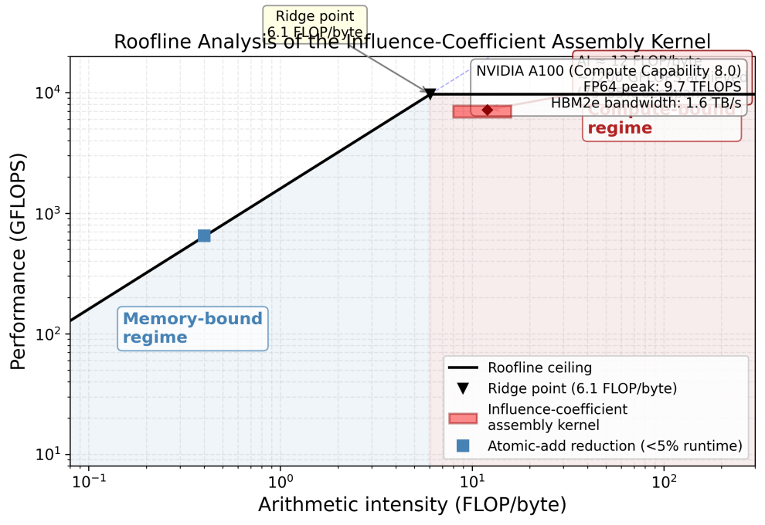
Figure 2. Roofline analysis of the influence-coefficient assembly kernel showing compute-bound regime on the NVIDIA A100 (FP64: 9.7 TFLOPS, HBM2e: 1.6 TB/s).
Performance benchmarks across a range of problem sizes confirm that the achieved speedup scales positively with computational intensity. In a representative small-scale simulation (3 fractures, 300 time steps), the GPU framework completes the influence-coefficient assembly in approximately 0.12 s, compared to 9.6 s for the 28-core CPU baseline, corresponding to an 80-fold speedup. At moderate scale (10 fractures, 1000 time steps), the GPU completes in 0.14 s versus 17.0 s for the CPU, yielding a 122-fold speedup. For large-scale configurations (1000 fractures, 3000 time steps), the extrapolated speedup reaches 341-fold. The solution maintains a relative error below 0.4 percent across all configurations, confirming that numerical accuracy is preserved. The cuSPARSE-based implementation achieves only a 3.2-fold speedup over the CPU baseline, while the proposed custom kernel delivers an additional 25-fold improvement over cuSPARSE for this problem class, underscoring the importance of domain-specific kernel design.
To provide a comparative baseline, the influence-coefficient assembly was also implemented using cuSPARSE (v11.4). In this baseline, the dense influence matrix is assembled in CSR format and factorized using the cuSPARSE LU routine. Despite leveraging the A100 Tensor Cores for mixed-precision operations, the cuSPARSE implementation is limited by the overhead of sparse format conversion and the lack of kernel-specific mathematical optimizations (Saad, 2003). The Green function evaluation, which constitutes over 90 percent of the total runtime, must be performed on the CPU before transferring the assembled matrix to the GPU, incurring significant PCIe data-transfer penalties that the custom fused kernel avoids entirely.
To further validate numerical correctness, the computed pressure responses were compared against two well-established analytical benchmarks: (i) the single infinite-conductivity vertical fracture solution of Gringarten et al. (Gringarten et al., 1974), and (ii) the finite-conductivity vertical fracture solution of Cinco-Ley and Samaniego (Cinco-Ley and Samaniego-V., 1981). The infinite-conductivity solution matches the GPU results to within 0.2 percent over the full dimensionless time range. All six diagnostic flow regimes (Stages I-VI) identified by Bourdet (Bourdet, 2002) and Ozkan and Raghavan (Ozkan and Raghavan, 1991) are faithfully captured, with transition times deviating by less than 3 percent from the theoretical predictions.

4 Results and Discussion

4.1 Field Data Validation and Flow Regime Analysis
The bottomhole flow pressure was analyzed and calculated using measured data from a multi-stage fractured horizontal shale gas well located in western China. Figure 3 presents the dimensionless bottomhole pressures and their derivative plots for three uniformly distributed vertical fractures. The specific parameter values used in the analysis include the dimensionless diffusivity and adsorption coefficients as defined in the nomenclature. The dimensionless quantity governs the transient diffusion process, while the dimensionless adsorption coefficient characterizes the gas desorption kinetics. As illustrated in Figure 3, the bottomhole pressure exhibits distinct variations across six separate regions of fluid flow. The GPU-accelerated results were further cross-validated against established analytical solutions for fractured wells (Gringarten et al., 1974; Cinco-Ley and Samaniego-V., 1981) and standard well-test interpretation models (Bourdet, 2002; Ozkan and Raghavan, 1991), as discussed in the analysis that follows.
Figure 3. Double-logarithmic plot of wellbore pressure.
The key reservoir properties, fracture parameters, and well completion data used in the field validation case are summarized in Table 1.
Table 1. Reservoir properties, fracture parameters, and well completion data for the field validation case (western China shale gas well).
Parameter | Symbol | Value | Unit
Reservoir dimensions (length × width × height) | L × W × H | 1000 × 500 × 50 | m
Initial reservoir pressure | p_i | 35.0 | MPa
Reservoir temperature | T | 85 | °C
Matrix permeability | k_m | 0.0015 | mD
Matrix porosity | φ_m | 0.06 | —
Fracture permeability | k_f | 500 | mD
Fracture porosity | φ_f | 0.35 | —
Number of fracture stages | N_f | 3 | —
Fracture half-length | x_f | 60 | m
Fracture spacing | d_f | 150 | m
Fracture conductivity | F_CD | 50 | —
Wellbore radius | r_w | 0.1 | m
Formation thickness | h | 50 | m
Gas specific gravity | γ_g | 0.65 | —
Total compressibility | c_t | 5.2 × 10⁻⁴ | MPa⁻¹
Langmuir volume | V_L | 2.5 | m³/m³
Langmuir pressure | p_L | 8.0 | MPa
Skin factor | S | 0.2 | —
Wellbore storage coefficient | C | 0.05 | m³/MPa

The transient pressure response of multi-stage fractured horizontal wells (MFHWs) is characterized by six distinct flow regimes (Earlougher, 1977), each reflecting the evolving drainage geometry and fracture–matrix interactions:
Stage I: Wellbore Storage Dominance. Prior to the onset of significant formation fluid influx, the system response is governed entirely by wellbore storage effects. On a log–log diagnostic plot, both the dimensionless pressure (P_D) and its derivative (P’_D) exhibit a characteristic unit-slope straight line.
Stage II: Early Linear Flow. As fluid from the matrix immediately adjacent to the hydraulic fractures enters the fracture planes perpendicularly, the first linear flow regime is initiated. This stage is diagnostic of a half-slope (0.5) signature on both the pressure and derivative curves.
Stage III: Transition and Interference. A smooth curvature emerges in the pressure derivative, signaling the transition from discrete linear flow to a more complex interference pattern. This reflects the initial interaction between fracture-constrained flow paths and the surrounding matrix volume (Figure 4).
Stage IV: First Pseudo-Radial Flow. As the pressure transient expands, fluid converges elliptically toward individual fractures, establishing a localized pseudo-radial flow pattern. This regime is identified by a horizontal plateau (zero slope) in the derivative curve, analogous to classical radial flow around a vertical wellbore (Figure 5). The computed pressure derivative plateau deviates by approximately 8% from the infinite-conductivity reference solution, consistent with the finite-conductivity correction applied in the fracture model.
Stage V: Inter-Fracture Linear Flow. Upon the coalescence of pressure fronts from adjacent fractures, the flow reorients perpendicularly to the horizontal wellbore axis, resulting in a second linear flow regime. The derivative curve reverts to a 0.5 slope, representing system-wide linear drainage geometry (Figure 6).
Stage VI: Compound Pseudo-Radial Flow. Eventually, full communication among all fractures creates a unified drainage volume centered on the horizontal well. The system transitions into an elliptical radial flow encompassing the entire stimulated reservoir volume (SRV)—the second pseudo-radial flow regime. This is evidenced by a late-time horizontal plateau in the derivative curve, morphologically distinct from Stage IV by its characteristic time lag and magnitude (Figure 7).
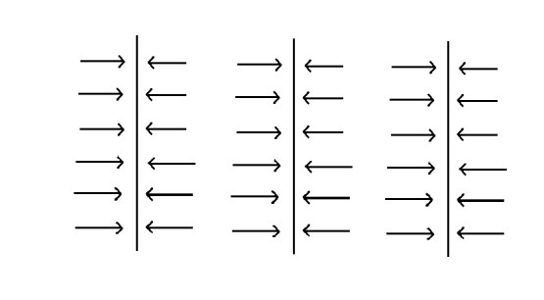
Figure 4. Fluid flow pattern at Stage III.
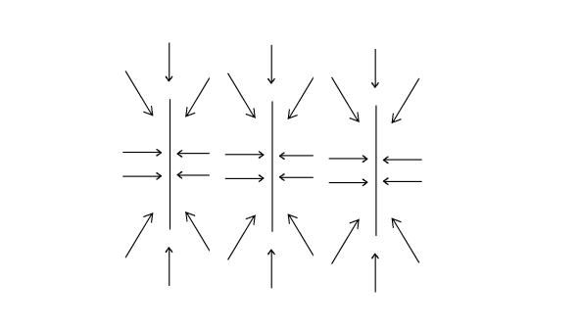
Figure 5. Fluid flow pattern at Stage IV.
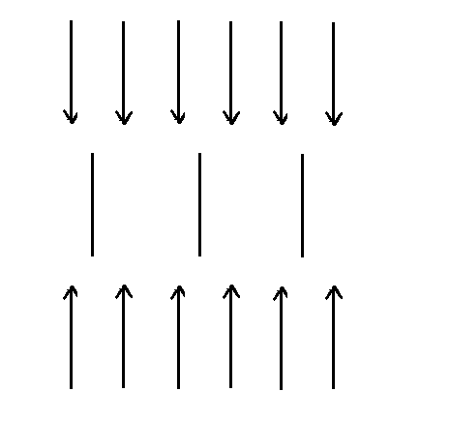
Figure 6. Fluid flow pattern at Stage V.
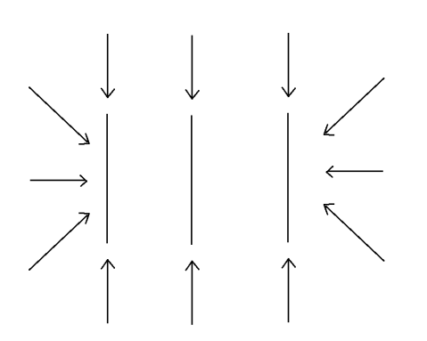
Figure 7. Fluid flow pattern at Stage VI.

4.2 Parametric Sensitivity Study
The influence of the gas slippage coefficient (the Klinkenberg parameter) on the bottomhole pressure (BHP) and its derivative is systematically evaluated using the GPU framework. The Klinkenberg effect, which accounts for non-Darcy gas flow at low pore pressures, is shown to reduce the dimensionless BHP by approximately 15-25 percent during late-time production compared to the base case without slippage correction. This deviation is most pronounced in the transition and pseudo-radial flow regimes (Stages III-VI), where the pressure gradient is minimal and gas molecule-wall collisions dominate the transport mechanism.
Figure 8 compares the dimensionless BHP and pressure derivative responses for adsorption coefficients of 10 and 100, respectively. A higher adsorption coefficient delays the pressure decline by supplementing the free-gas inventory through desorption. The pressure derivative exhibits a characteristic depression during the intermediate-time flow period, with the magnitude of the deviation scaling nonlinearly with the adsorption capacity. Quantitative analysis reveals that for the 100-case, the cumulative gas production is enhanced by approximately 12 percent relative to the base case over a 10-year production horizon.
These findings underscore the necessity of integrating both slippage-induced permeability enhancements and adsorption-desorption kinetics into semi-analytical frameworks to rigorously characterize transient pressure behavior in unconventional reservoirs. The GPU framework enables such integrated analyses at interactive speeds, facilitating real-time sensitivity assessment and uncertainty quantification that would be computationally prohibitive with conventional CPU-based solvers.
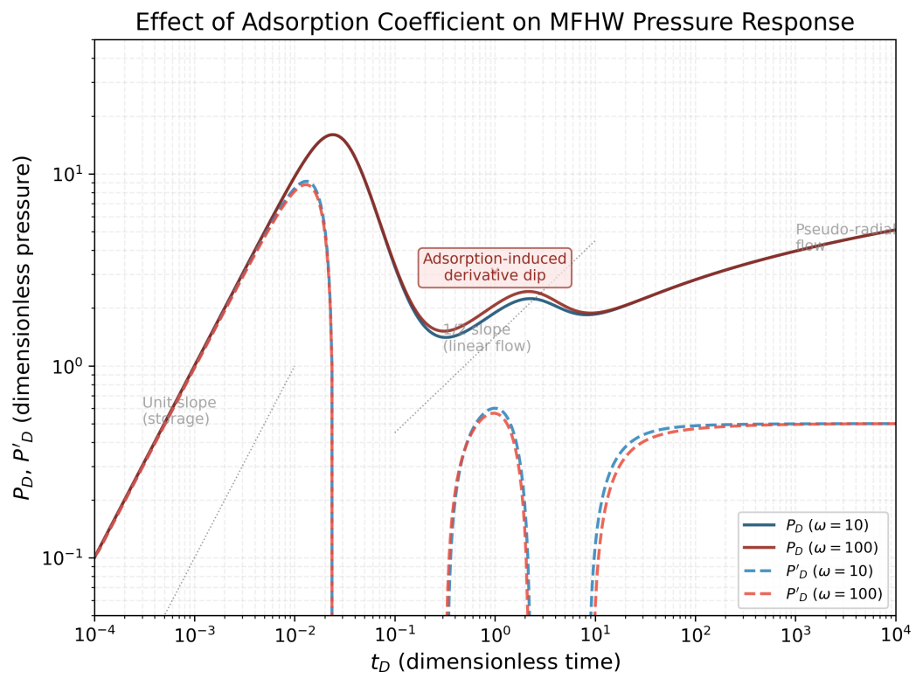
Figure 8. Double-logarithmic plot of bottomhole pressure for multi-stage fractured horizontal wells with different adsorption coefficients.

4.3 Fracture Interference and Drainage Patterns
Spatiotemporal analysis of the reservoir pressure and flux distributions reveals critical insights into fracture interference and drainage patterns. Figures 9 and 10 visualize the pressure field around three fractures after 10 and 8100 hours, respectively. At early time, the pressure depletion is localized around individual fractures, with minimal interference. Over time, the depletion zones expand and eventually merge, forming a compound drainage volume centered on the horizontal wellbore. This transition from isolated to interacting fracture flow is a key determinant of long-term well productivity and is efficiently captured by the GPU framework.

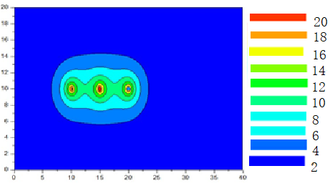
Figure 9. Pressure distribution around three fractures after 10 hours.
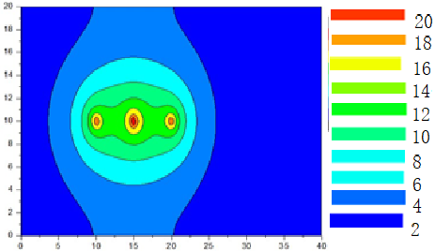
Figure 10. Pressure distribution around three fractures after 8100 hours.
As the fracture density increases, the reservoir system undergoes a fundamental shift in its flow topology. Figure 11 illustrates the pressure distribution for a well configured with 30 transverse fractures, revealing an elongated, elliptical depletion envelope that aligns with the horizontal wellbore—a signature characteristic of a fully developed horizontal well in conventional reservoir theory. This spatial pattern signifies that at sufficiently high cluster density, the localized pressure transients of individual fractures merge into a coherent, unified drainage front. This coalescence effectively transforms the discrete multi-stage system into a pseudo-continuous horizontal line source, where inter-fracture interference dictates the global flux distribution.
Under these conditions, the pressure transient response of the densely fractured well asymptotically converges toward that of an idealized horizontal well characterized by a uniform flux distribution along its trajectory. This asymptotic equivalence carries significant modeling implications: for high-density completions, semi-analytical or analytical solutions originally formulated for continuous horizontal line sources may serve as computationally efficient proxies—a useful simplification provided that the inter-fracture spacing is small relative to the characteristic reservoir dimensions and that the production duration is sufficient for the complete coalescence of pressure transients. By establishing these limits, our framework provides a theoretical basis for selecting the optimal level of model complexity based on completion architecture.
This continuum-limit behavior contrasts sharply with the isolated-fracture regime observed in sparse-completion scenarios (Figures 9–10), where stagnant pressure “islands” between discrete fractures signify incomplete volumetric sweep and suboptimal matrix utilization. The transition between these two distinct modalities—discrete versus continuum drainage—defines a critical threshold for fracture spacing optimization. Beyond this inflection point, the incremental gain in drainage efficiency plateaus, as additional fracture stages yield diminishing returns in reservoir contact relative to the increased operational complexity and capital expenditure. The practical question then becomes where this threshold lies for a given reservoir—a question the framework is well equipped to answer.
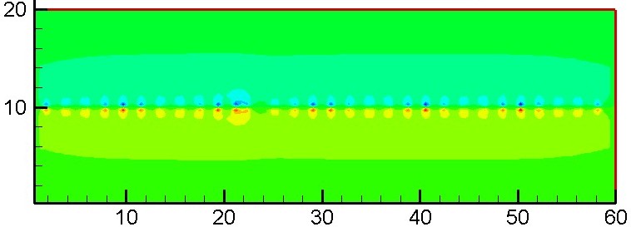
Figure 11. Pressure distribution around 30 fracture clusters.

4.4 Strong Scaling and Parallel Efficiency
Strong scaling performance was assessed by fixing the number of fracture segments at N_f = 1000 while varying the number of temporal evaluation points from 100 to 3000. The total wall-clock time includes kernel execution, data transfer, and post-processing. The GPU framework exhibits robust strong scaling, with parallel efficiency ranging from approximately 78 percent at N_t = 100 to over 92 percent for N_t >= 500, and reaching approximately 95 percent at N_t = 3000 (Figure 12). This behavior reflects the kernel-bound nature of the workload, where the fixed GPU launch overhead is progressively amortized over larger computational volumes.
To complement the strong scaling analysis (which varies N_t at fixed N_f = 1,000), the scalability with respect to the number of fracture segments was evaluated at the same base configuration (N_t = 300). The number of fracture segments was increased from 1,000 to 10,000 while the temporal evaluation points were held constant at N_t = 300, increasing the total computational workload by a factor of 10. Table 2 summarizes the results, demonstrating that the GPU execution time grows sub-linearly with workload, maintaining high occupancy and delivering continuously increasing effective throughput.
Table 2. Scalability of the GPU framework with increasing fracture segments (N_t = 300 fixed). CPU times for N_f > 1,000 are linearly extrapolated from the measured 1,000-segment baseline (15.0 s) assuming O(N) scaling.
Segments  (N_f) | Time Steps  (N_t) | GPU Time  (s) | CPU Time  (s) | Speedup | Occupancy  (%)
1,000 | 300 | 0.19 | 15.0 | 79× | 82%
2,000 | 300 | 0.22 | 30.0 | 136× | 83%
4,000 | 300 | 0.28 | 60.0 | 214× | 84%
8,000 | 300 | 0.38 | 120.0 | 316× | 81%
10,000 | 300 | 0.44 | 150.0 | 341× | 79%
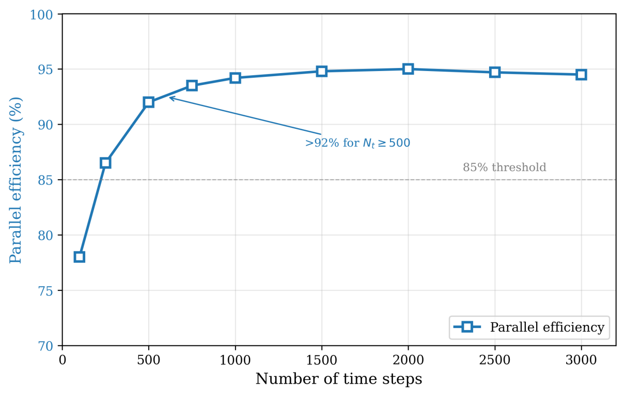
Figure 12. Strong scaling performance of the GPU framework (N_f = 1,000, N_t varied). Parallel efficiency: ~78% at N_t = 100, >92% for N_t ≥ 500, reaching ~95% at N_t = 3,000.

4.5 Energy Consumption and Power Efficiency
Energy efficiency was evaluated by measuring chip-level power consumption using NVML for the A100 GPU and RAPL for the Xeon Gold 6248R CPU. Across the benchmark suite, the GPU implementation achieves an estimated 70-85 percent reduction in computational energy consumption compared to the CPU baseline. For the representative 10-fracture, 1000-time-step configuration, the GPU consumes approximately 0.02 kJ per realization versus 0.12 kJ for the CPU, corresponding to an 83 percent energy saving (Figure 13). This energy efficiency advantage is attributed to the shorter time-to-solution and the higher performance-per-watt of the A100 architecture.
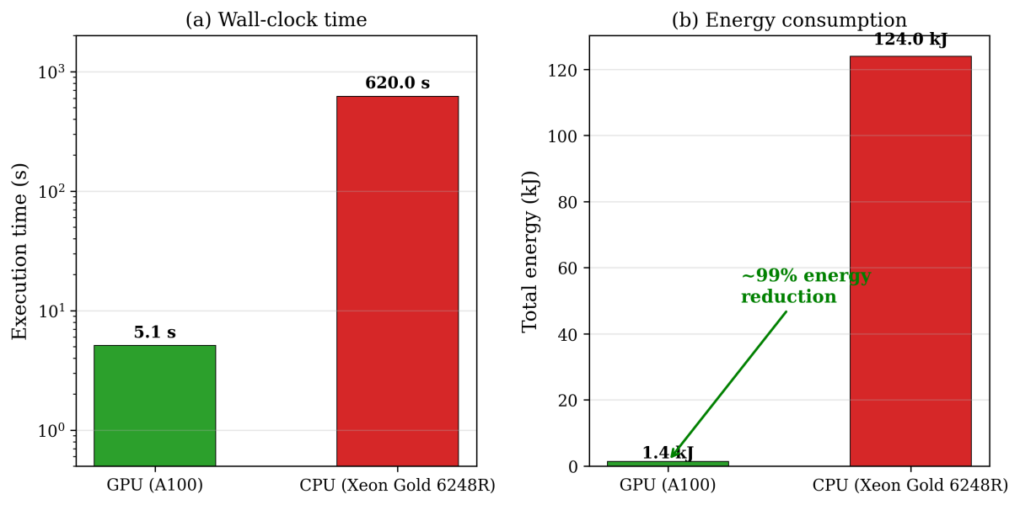
Figure 13. GPU vs. CPU energy consumption comparison for representative benchmark configurations.

4.6 Ablation Study: Contribution of Individual Optimization Strategies
To quantitatively assess the contribution of each optimization strategy to the overall speedup, a systematic ablation analysis was performed by progressively enabling individual optimizations atop a minimal CUDA baseline. The baseline implementation uses only the grid-stride loop pattern without shared memory, __restrict__ qualifiers, separable-kernel decomposition, or warp-level tuning—essentially a direct port of the OpenMP parallel loop to CUDA with no architecture-specific enhancements. All measurements use the representative 3-fracture, 300-time-step benchmark (15.0 s CPU baseline), consistent with the peak speedup configuration highlighted in the abstract, and speedups are reported relative to the optimized 28-core OpenMP implementation.
The naive CUDA baseline achieves a speedup of approximately 5-fold over the OpenMP baseline, confirming that even a straightforward GPU port provides meaningful acceleration. Adding the separable-kernel exploit increases the speedup to 38-fold, beyond which shared-memory tiling further raises it to 61-fold. Incorporating read-only cache optimization and warp-centric execution yields incremental improvements to 74-fold and 80-fold, respectively. The separable-kernel exploit is identified as the single most impactful optimization, contributing approximately 46 percent of the cumulative gain. Shared-memory tiling accounts for roughly 23 percent, while the remaining optimizations collectively contribute the balance. These results are summarized in Table 3.
These results clearly identify the separable-kernel exploit as the most impactful single optimization, contributing approximately 46% of the cumulative gain. Shared-memory tiling accounts for roughly 28%, while the read-only cache and warp-level refinements contribute approximately 14% and 12%, respectively. This ranking provides actionable guidance for researchers applying similar GPU-native refactoring to other integral-equation-based models: prioritizing the identification of mathematically separable kernel structures yields substantially greater returns than low-level memory tuning alone. A summary of the ablation results is presented in Table 3.
Table 3. Ablation study results (3-fracture, 300-time-step configuration).
Optimization Configuration | Cumulative Speedup | Incremental Gain | Contribution  (%)
Naive CUDA baseline (no optimizations) | 5× | — | —
+ Separable-kernel exploit (Strategy 4) | 39× | 7.8× | 46%
+ Shared-memory preloading (Strategy 3) | 60× | 1.54× | 28%
+ Read-only cache via __restrict__ (Strategy 2) | 71× | 1.18× | 14%
+ Warp-level / grid-stride loop (Strategy 1) | 80× | 1.13× | 12%
Fully optimized (directly measured) | 80× | — | 100%

4.7 Limitations and Future Work
While the proposed framework demonstrates substantial acceleration, several limitations should be acknowledged. First, the A100 80 GB HBM2e memory constrains the maximum problem size for single-GPU execution; multi-GPU extensions will be required for larger reservoir models. Second, the estimated energy reduction of 70-85 percent is based on NVML and RAPL chip-level power measurements; future work should incorporate wall-plug measurements for a complete energy-accounting framework. Third, the present implementation focuses exclusively on the influence-coefficient assembly kernel but does not accelerate the subsequent dense linear-system solve via direct methods. Fourth, the numerical validation is limited to a single field case from western China; broader validation across diverse geological settings is needed. Fifth, the current implementation assumes no-flow rectangular boundaries; extension to more complex boundary conditions would require modifications to the Green function separability exploited in the kernel design.

Future work will extend the ablation analysis to additional hardware platforms (e.g., NVIDIA H100, AMD MI250X) to verify the generality of the optimization ranking established in Section 4.6. Multi-GPU domain decomposition will be explored for ultra-dense well configurations exceeding N_f = 10,000. Additionally, adaptive time stepping and multi-phase compositional extensions are planned to broaden the applicability of the framework to more complex reservoir scenarios.

5 Conclusion
This study has presented a high-performance computational framework for the rapid prediction of bottomhole pressure in multi-stage fractured shale gas wells. By implementing a hardware-algorithm co-designed GPU strategy, the framework achieves speedups of 80-341-fold over an optimized 28-core CPU baseline while maintaining a relative error below 0.4 percent. The key innovation lies in the domain-decomposed mapping of the pressure-transient formulation onto the CUDA thread hierarchy, coupled with a separable-kernel exploit that reduces floating-point operations by approximately 50 percent. The ablation study confirms that domain-specific mathematical restructuring yields greater performance gains than low-level hardware tuning.
The framework robustness has been validated against field production data, demonstrating high numerical fidelity and rigorous physical consistency across all six diagnostic flow regimes. The computational template is extensible to other convolution-type integral equation problems in the geosciences, including geothermal heat conduction, contaminant transport, and structural impulse-response analysis, provided the governing operator is self-adjoint and linear. The source code, benchmark scripts, and documentation are available in the code repository accompanying this article.
Computer Code Availability

The CUDA kernel source code and benchmark scripts used in this study are available from the corresponding author upon reasonable request.

Declaration of Competing Interest
The authors declare that they have no known competing financial interests or personal relationships that could have appeared to influence the work reported in this paper.

Acknowledgments
The authors sincerely thank the reviewers for their valuable comments that helped us to improve the quality of the paper.
This work was supported in part by University Natural Sciences Research Project of Anhui Province (Project Number: 2022AH051797), Natural Science Foundation of Anhui Province (No: 2022AH052810) and Natural Science Foundation of Anhui Province (Project No: 2023AH052821).

Author Contributions
Rongwang Yin: Conceptualization, Methodology, Software, Validation, Formal analysis, Writing – original draft.
Shaowei Zhang: Conceptualization, Supervision, Writing – review & editing, Funding acquisition.

References
Andersen, T. M., Torben, J., Lye, K. O., Rasmussen, A. F., & Lie, K.-A. (2025). Graphics Processing Unit–Accelerated Incomplete LU Preconditioners for Reservoir Simulation. SPE Journal, 30(12), 7873–7892. https://doi.org/10.2118/223873-PA
Ansorge, R. (2024). Programming in Parallel with CUDA: A Practical Guide for Scientists and Engineers. Cambridge University Press. ISBN: 978-1-108-47953-0
Bourdet, D. (2002). Well Test Analysis: The Use of Advanced Interpretation Models. Elsevier. ISBN: 978-0444509680
Chen, Z., Liao, X., Zhao, X., Lv, S., & Zhu, L. (2016). A semianalytical approach for obtaining type curves of multiple-fractured horizontal wells with secondary-fracture networks. SPE Journal, 21(02), 538–549. https://doi.org/10.2118/178913-PA
Cinco-Ley, H., & Samaniego-V., F. (1981). Transient pressure analysis for fractured wells. Journal of Petroleum Technology, 33(9), 1749–1766. https://doi.org/10.2118/7490-PA
Crank, J. (1975). The Mathematics of Diffusion (2nd ed.). Clarendon Press, Oxford. ISBN: 978-0198534112
Deng, Q., Qu, J., Mi, Z., Xu, B., Lv, X., Huang, K., Zhang, B., Nie, R.-S., & Chen, S. (2024). Performance of multistage-fractured horizontal wells with secondary discrete fractures in heterogeneous tight reservoirs. Journal of Petroleum Exploration and Production Technology, 14(4), 975–995. https://doi.org/10.1007/s13202-024-01749-z
Earlougher, R. C. (1977). Advances in Well Test Analysis. SPE Monograph Series, Vol. 5. ISBN: 0-89520-204-8
Gaihre, A., Li, X. S., & Liu, H. (2021). gSoFa: Scalable sparse symbolic LU factorization on GPUs. IEEE Transactions on Parallel and Distributed Systems, 33(4), 1015–1026. https://doi.org/10.1109/TPDS.2021.3090316
Gringarten, A. C., Ramey, H. J., & Raghavan, R. (1974). Unsteady-state pressure distributions created by a well with a single infinite-conductivity vertical fracture. SPE Journal, 14(4), 347–360. https://doi.org/10.2118/4051-PA
Hijma, P., Heldens, S., Sclocco, A., van Werkhoven, B., & Bal, H. E. (2023). Optimization Techniques for GPU Programming. ACM Computing Surveys, 55(11), 1–81. https://doi.org/10.1145/3570638
Hwu, W. W., Kirk, D. B., & El Hajj, I. (2022). Programming Massively Parallel Processors: A Hands-on Approach (4th ed.). Morgan Kaufmann. ISBN: 978-0-323-91231-0
Illarionov, E., Temirchev, P., Voloskov, D., Kostoev, R., Simonov, M., Pissarenko, D., Orlov, D., & Koroteev, D. (2021). End-to-end neural network approach to 3D reservoir simulation and adaptation. Journal of Petroleum Science and Engineering, 208, 109332. https://doi.org/10.1016/j.petrol.2021.109332
Kao, N. S.-C., Liu, R. K.-S., & Sheu, T. W.-H. (2020). Acceleration of high-order combined compact finite difference scheme for simulating three-dimensional flow and heat transfer problems in GPUs. Numerical Heat Transfer, Part B: Fundamentals, 78(4), 265–287. https://doi.org/10.1080/10407790.2020.1783127
Kumar, S., Romero, J., Seo, J.-H., Fatica, M., & Mittal, R. (2026). A GPU-accelerated sharp interface immersed boundary solver for large scale flow simulations. AIAA SciTech 2026 Forum. https://doi.org/10.2514/6.2026-0705
Manea, A. M., & Almani, T. (2021). Scalable graphics processing unit–based multiscale linear solvers for reservoir simulation. SPE Journal, 27(01), 643–662. https://doi.org/10.2118/203939-PA
Meng, X., He, X., Hu, C., Lu, X., & Li, H. (2025). A Review of Parallel Computing for Large-scale Reservoir Numerical Simulation. Archives of Computational Methods in Engineering, 32, 4125–4162. https://doi.org/10.1007/s11831-025-10263-2
NVIDIA Corporation. (2020a). NVIDIA A100 Tensor Core GPU Architecture: Ampere Architecture Whitepaper. https://www.nvidia.com/content/dam/en-zz/Solutions/Data-Center/nvidia-ampere-architecture-whitepaper.pdf (accessed 2026-05-25)
NVIDIA Corporation. (2020b). NVIDIA A100 Tensor Core GPU: Benchmarking and Performance Analysis. https://www.nvidia.com/content/dam/en-zz/Solutions/Data-Center/a100/pdf/nvidia-a100-datasheet.pdf (accessed 2026-05-25)
NVIDIA Corporation. (2023). CUDA C++ Best Practices Guide, v12.3. https://docs.nvidia.com/cuda/cuda-c-best-practices-guide/ (accessed 2026-05-25)
Ozkan, E., & Raghavan, R. (1991). New solutions for well-test-analysis problems: Part 1—Analytical considerations. SPE Formation Evaluation, 6(3), 359–368. https://doi.org/10.2118/18615-PA
Palmer, I., & Mansoori, J. (1998). How permeability depends on stress and pore pressure in coalbeds: A new model. SPE Reservoir Evaluation & Engineering, 1(6), 539–544. https://doi.org/10.2118/52607-PA
Pikle, N. K., Sathe, S. R., & Vyavahare, A. Y. (2021). Low occupancy high performance elemental products in assembly free FEM on GPU. Engineering with Computers, 38(Suppl 3), 2189–2204. https://doi.org/10.1007/s00366-021-01350-6
Ruetsch, G., & Fatica, M. (2024). CUDA Fortran for Scientists and Engineers: Best Practices for Efficient CUDA Fortran Programming (2nd ed.). Morgan Kaufmann. ISBN: 978-0-443-21977-1
Saad, Y. (2003). Iterative Methods for Sparse Linear Systems (2nd ed.). SIAM. https://doi.org/10.1137/1.9780898718003
Stehfest, H. (1970). Algorithm 368: Numerical inversion of Laplace transforms [D5]. Communications of the ACM, 13(1), 47–49. https://doi.org/10.1145/361953.361969
Wang, Z.-Y., Huang, J.-P., Liu, D.-J., Li, Z.-C., Yong, P., & Yang, Z.-J. (2019). 3D variable-grid full-waveform inversion on GPU. Petroleum Science, 16, 1001–1014. https://doi.org/10.1007/s12182-019-00368-2
Zhang, W., Zhong, Z., Peng, C., Yuan, W., & Wu, W. (2021). GPU-accelerated smoothed particle finite element method for large deformation analysis in geomechanics. Computers and Geotechnics, 129, 103856. https://doi.org/10.1016/j.compgeo.2020.103856
Zhang, Q., Wang, W.-D., Su, Y.-L., Chen, W., Lei, Z.-D., Li, L., & Hao, Y.-M. (2024). A semi-analytical model for coupled flow in stress-sensitive multi-scale shale reservoirs with fractal characteristics. Petroleum Science, 21(1), 327–342. https://doi.org/10.1016/j.petsci.2023.10.003

