Fracture-Conforming PEBI Grids with Integrated CPR–SA-AMG Preconditioning and Non-Blocking MPI Communication for Scalable Black-Oil Simulation of Shale Reservoirs
Rongwang Yin ¹, Shaowei Zhang ^{2, *}
1. Basic Experiment and Training Center, Hefei University, Hefei 230601, P.R. China
2. School of Computer Engineering, Anhui Wenda University of Information Engineering, Hefei 231201, P.R. China
Abstract
The numerical simulation of hydraulically fractured shale-oil reservoirs confronts three interdependent computational bottlenecks: geometric mismatch at fracture–matrix interfaces, severe ill-conditioning of the Jacobian system arising from extreme permeability contrasts, and communication-bound parallel overhead at scale. Cartesian local grid refinement (LGR) and embedded discrete fracture models (EDFM) each address only a subset of these challenges in isolation. This paper presents a black-oil simulation framework that treats mesh generation, pressure-system preconditioning, and MPI communication scheduling as a single co-design problem. The framework is built on fracture-conforming perpendicular-bisector (PEBI) grids constructed via constrained Delaunay–Voronoi tessellation within a layered 2.5D extrusion formulation, with generator-point density governed by a hyperbolic-tangent spacing function. K-orthogonality (deviation angle θ ≤ 5°) is maintained across 97.1% of interior faces. Benchmarking against the analytical Ei-function line-source solution yields a near-fracture pressure error of 0.31% at 1 m, representing improvements of 53.0%, 66.3%, and 83.4% over EDFM (0.66%), Cartesian LGR (0.92%), and uniform Cartesian (1.87%) discretizations, respectively. The Constrained Pressure Residual preconditioner accelerated by Smoothed-Aggregation Algebraic Multigrid (CPR–SA-AMG) reduces GMRES iterations from 312 to 21 relative to Block-ILU(0), a 72.7% reduction in linear-solve time. On a 32-million-cell five-well pad problem with 100 hydraulic-fracture stages, the simulator achieves 82.0% strong-scaling efficiency on 512 MPI ranks, with 73% of communication latency masked by non-blocking overlap, and maintains 91.3% weak-scaling efficiency from 64 to 512 ranks at a constant 62,500 cells per rank. Under the insertion of 1,247 stochastically generated natural fractures, the spectral conditioning proxy increases by only 2.87× (single realization; 2.94 ± 0.41× Monte Carlo ensemble mean, n = 25) relative to the DFN-free PEBI baseline, compared with 18.6× and 11.4× for standard unstructured and Cartesian LGR grids under identical DFN placement; ten-year cumulative oil recovery increases by 21.8 ± 4.3% (mean ± 1σ). Validation against the SPE 10 comparative solution on a quarter-five-spot pattern demonstrates that a permeability-informed PEBI mesh of 0.52M cells tracks the 1.12M-cell Cartesian reference to within 0.93% cumulative oil deviation at approximately half the cell count. A complementary single-well depletion case (12 fractures, matched matrix permeability) confirms that the K-orthogonality fraction (96.8%), per-rank solver convergence (22 GMRES iterations), and parallel efficiency (95.4% vs. 96.2% at identical core count) are robust to well-pattern variation. These findings, obtained within a layered 2.5D extrusion formulation for reservoirs dominated by vertical or near-vertical fractures, establish fracture-conforming discretization as an enabling strategy for achieving simultaneous algebraic efficiency and parallel scalability in black-oil shale-reservoir simulation.
Keywords: Perpendicular-bisector (PEBI) grid; K-orthogonality; smoothed aggregation algebraic multigrid; constrained pressure residual preconditioning; discrete fracture network; black-oil simulation; high-performance computing; unconventional reservoirs; parallel efficiency; weak scaling
Highlights
- Fracture-conforming PEBI grids achieve 97.1% K-orthogonality for shale oil simulation
- CPR–SA-AMG reduces GMRES iterations from 312 to 21, cutting solve time by 72.7%
- Non-blocking MPI overlaps 73% communication, sustaining 82% efficiency to 512 cores
- DFN Monte Carlo: PEBI spectral conditioning proxy rises 6.3× slower than standard grids
- SPE 10: PEBI matches 1.12M-cell reference to 0.93% cumulative oil with half the cells

1 Introduction
Shale-oil reservoirs pose a computational challenge without easy compromise. The matrix sits in the nano-Darcy range while conductive fractures drive permeability contrasts beyond nine orders of magnitude, and the accompanying multiphase thermodynamics are strongly nonlinear (Palagi and Aziz, 1994a; Peaceman, 1983; Saad, 2003). Numerical simulation of multi-stage hydraulically fractured horizontal wells (MFHWs) therefore demands simultaneous fidelity on three fronts: the spatial discretization near fracture faces, the robustness of the algebraic solver under extreme stiffness, and the efficiency of parallel execution. In practice these are seldom tackled together—industrial workflows optimize one piece at a time, shifting the bottleneck elsewhere (Economides and Nolte, 2000; Behie and Forsyth, 1984).

1.1 Limitations of Current Paradigms
Cartesian local grid refinement (LGR) dominates industry practice because the indexing stays structured and it integrates easily into legacy simulators. The difficulty is that a staircase approximation of fracture faces cutting across the grid cannot satisfy the K-orthogonality condition at transition faces. Where the pressure gradient is steepest—precisely at the fracture—the two-point flux approximation (TPFA) accumulates truncation error (Economides and Nolte, 2000; Palagi and Aziz, 1994a; Karimi-Fard et al., 2004; Aavatsmark et al., 1998a). Recent work has challenged this piecewise-optimization approach: Dong et al. (2023) showed that hybrid TPFA–MFD schemes on corner-point grids achieve near-mimetic accuracy by localizing consistent discretization to regions of severe non-K-orthogonality, while da Silva et al. (2024) demonstrated that MPFA-H formulations eliminate grid-orientation effects on unstructured meshes. That error propagates into the transient near-fracture pressure field and then into quantities of direct engineering relevance: early-time linear-flow analysis, well-interference diagnostics, and stimulated-reservoir-volume (SRV) estimates (Peaceman, 1983; Aavatsmark et al., 1998a).
Embedded discrete fracture models (EDFM) and their projection-based variants take a different path: rather than regridding around fractures, they insert non-neighboring connections (NNCs) between fracture and matrix domains (Karimi-Fard et al., 2004; Moinfar et al., 2014). The past three years have seen rapid maturation of the EDFM family. Projection-based formulations (pEDFM) now resolve blocking fractures through continuous projection algorithms (Rashid and Olorode, 2024), enriched-embedded variants (nEDFM) capture pressure discontinuities on both faces of conductive fractures via local enrichment functions (Jiao et al., 2024), and transient source-function-based corrections (tSEDFM) address the long-standing pseudo-steady-state limitation of classical EDFM transmissibilities (Z. Zhang et al., 2024). A comprehensive review by Poli et al. (2024) catalogues over 150 EDFM publications and identifies fracture-intersection treatment and coupled flow–geomechanics (An et al., 2024) as the dominant active research fronts. Concurrently, the extension of pEDFM to unstructured tetrahedral grids (pEDFM-U; Cavalcante et al., 2024) and the first streamline-based pEDFM formulation (Rao et al., 2025) have extended the reach of NNC methods beyond their original Cartesian scope. The advantage is clear: the grid stays fixed. The trade-off is equally clear: the transfer operators are approximations, and those approximations degrade precisely where fidelity matters most—at dense fracture intersections and near fracture tips, where the r⁻¹ pressure asymptote governs the solution (Moinfar et al., 2014; Bourdet et al., 1989). Dual-continuum approaches are cheaper still computationally, but they collapse discrete fracture character into effective transfer functions. That suffices for a dense, uniform background fracture fabric; it fails for the sparse, heterogeneous conductive pathways controlling many shale plays (Warren and Root, 1963; Kazemi et al., 1976). Recent multi-porosity multi-permeability (MPMP) frameworks (Zheng et al., 2025) now preserve continuum-type computational efficiency while approaching the geometric fidelity of discrete fracture representations. Coupled flow–geomechanics extensions of these hybrid frameworks (Li et al., 2024) have demonstrated up to 20% productivity reduction attributable to stress-dependent fracture conductivity in shale gas wells.$1/\sqrt{r}$
On the solver front, the extreme permeability contrast in shale systems drives unpreconditioned Jacobian condition numbers into the 10⁷–10⁸ range when fractures are not grid-conforming. These ill-conditioned systems defeat standard incomplete factorization preconditioners: Block-ILU(0) stagnates, and even more elaborate variants struggle to contain the growth in Krylov subspace dimension, inflating both solve time and synchronization overhead at scale (Behie and Forsyth, 1984; Saad, 2003).

1.2 Unresolved Scientific Questions
- The preceding review exposes a structural gap. Fracture-conforming PEBI grids can, in principle, eliminate the geometric error that plagues both LGR and EDFM, but the mesh generation, linear algebra, and parallel decomposition communities have pursued these topics largely in isolation (Cao et al., 2005; Karypis and Kumar, 1998). Recent advances across all three fronts argue for integration. On the solver side, CPR-AMG has been extended to incorporate well degrees of freedom natively (Nilsen et al., 2023), to coupled pressure–temperature systems via the CPTR variant with near-linear strong scaling (Cremon et al., 2024), and to multilevel Schur-complement architectures that outperform standard CPR for thermal-compositional problems (M. Zhang et al., 2024). On the meshing side, advances in anisotropic centroidal Voronoi tessellation algorithms for 3D polyhedral mesh generation (Marin et al., 2024) have broadened the toolkit for constructing high-quality PEBI meshes in geometrically complex domains. On the parallel-computing side, parallel-in-time discretizations (Cheng et al., 2023) now exploit temporal parallelism beyond conventional spatial domain decomposition, and field-split preconditioned algorithms have demonstrated scalability beyond 27,000 cores for black-oil systems (Shi et al., 2024). Communication-avoiding Krylov methods (CA-GMRES; Hoemmen, 2010) and GPU-accelerated multigrid frameworks (Ginkgo; Anzt et al., 2022) offer promising pathways to mitigate the global reduction bottleneck at extreme concurrency. On the discretization side, grid-orientation benchmarking under the SPE 11 comparative solution project has confirmed that consistent schemes (AvgMPFA, NTPFA) systematically outperform TPFA on non-K-orthogonal unstructured grids (Klemetsdal et al., 2025). Complementing these finite-volume developments, fully implicit discontinuous Galerkin formulations on 3D unstructured grids with bound-preserving limiters (Tu et al., 2024) have demonstrated that higher-order spatial discretization can suppress numerical dispersion in advection-dominated multiphase transport. Graph neural network surrogates trained on EDFM topologies (Jiang, 2024; Diab and Al Kobaisi, 2025) and physics-informed machine learning emulators offer a complementary acceleration pathway, achieving orders-of-magnitude speedups for multi-realization uncertainty quantification.Can an automated PEBI generator deliver provable K-orthogonality ($θ≤5^{∘}$) when multiple intersecting natural fractures constrain the mesh?
- If geometric flux error is removed, what happens to the Jacobian condition number — and can a CPR–AMG solver exploit whatever spectral structure emerges in black-oil problems?
- Will persistent asynchronous MPI communication mask the latency-bound halo exchanges that irregular PEBI decompositions incur, and can this be sustained past 512 ranks?

1.3 Scope and Contributions
We start from the premise that geometric discretization error, algebraic stiffness, and communication overhead share a common origin: the computational topology does not match the physical flow topology. The framework described here operates within a layered 2.5D extrusion formulation—the PEBI mesh is built in the areal plane and extruded vertically. This models reservoirs where fractures are predominantly vertical or near-vertical and vertical flow is governed by layer contrasts rather than discrete fracture intersections. Extending these techniques to fully three-dimensional constrained Voronoi meshing introduces additional difficulties that we address in Section 4.3 as ongoing work. Table 1 aligns the specific contributions of this study against the gaps they target.
Table 1: Research gaps and corresponding quantified contributions.
Domain | Identified Limitation | Proposed Innovation | Quantified Outcome
Geometry | LGR staircase error (Palagi and Aziz, 1994a); EDFM near-tip transfer error (Moinfar et al., 2014) | Constrained Delaunay PEBI with $\text{tanh}$ density function | 97.1% faces satisfy $θ≤5^{∘}$; near-fracture pressure error 0.31%
Algebra | ILU stagnation at high conductivity contrast (Wallis et al., 1985; Vaněk et al., 1996) | CPR + SA-AMG + Block-ILU(0) hybrid preconditioner | GMRES iterations reduced from 312 to 21; linear-solve time reduced by 72.7%
Parallelism | Blocking MPI dominates at >256 cores (Karypis and Kumar, 1998; Amdahl, 1967) | Persistent non-blocking MPI with computation–communication overlap | 73% communication latency masked; 82.0% strong-scaling efficiency at 512 cores; 91.3% weak-scaling efficiency
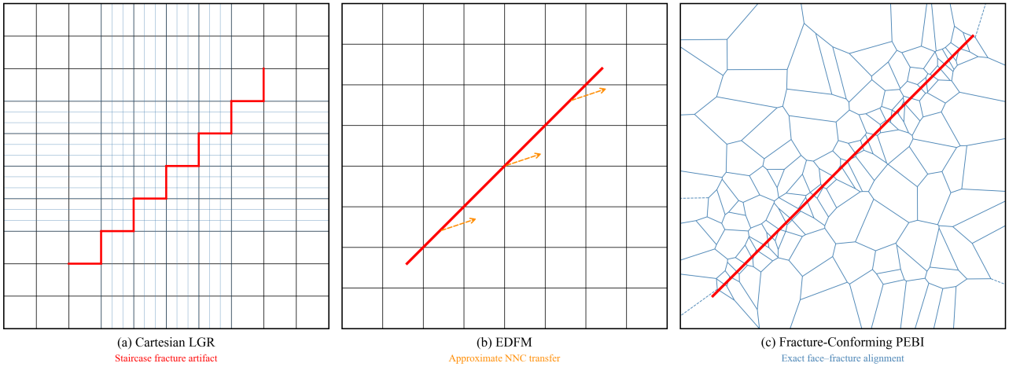
Fig. 1. Conceptual comparison of fracture-simulation paradigms. (a) Cartesian LGR with staircase artifacts at oblique fracture faces. (b) EDFM with non-neighboring connections (dashed lines) coupling fracture and matrix domains. (c) Fracture-conforming PEBI with exact face–fracture alignment.
Figure 1 provides a conceptual comparison of the three paradigms. Cartesian LGR introduces geometric flux discrepancies at every obliquely oriented transition face; EDFM circumvents regridding but depends on approximate NNC transfer functions whose accuracy degrades near fracture tips; the proposed PEBI formulation eliminates both sources of inaccuracy simultaneously by enforcing exact face–fracture alignment through the Voronoi dual construction. A quantitative comparison of all three approaches follows in Section 3.
The individual components of this framework—PEBI grid generation (Palagi and Aziz, 1994a), CPR preconditioning (Wallis et al., 1985), SA-AMG (Vaněk et al., 1996), and non-blocking MPI communication—are each well-established in their respective literatures. The present contribution lies not in the invention of any single component, but in their co-design within a unified framework that exploits the causal relationships among geometric fidelity (K-orthogonality), algebraic conditioning (diagonal dominance of the Jacobian), and parallel communication concurrency (computation–communication overlap). It is this deliberate integration—rather than independent optimization of each module—that distinguishes the proposed approach from the segmented workflows currently prevailing in industry practice.

2 Methodology

2.1 Governing Equations
Within the fracture-conforming PEBI framework, an isothermal, fully implicit, three-phase black-oil system is solved. The black-oil formulation treats the hydrocarbon system as two pseudo-components (oil and gas) at surface conditions, with mass transfer between phases represented through the solution gas–oil ratio $R_{s}$ and the oil and gas formation volume factors $B_{o}$ and $B_{g}$. While the framework does not incorporate a fully compositional formulation with equation-of-state-based phase equilibria in the present study, the CPR–SA-AMG preconditioning strategy is designed to extend to compositional systems where the pressure block retains a fundamentally elliptic character; this extension is reserved for future work (see Section 4.3).
For an arbitrary phase $p∈\{o,g,w\}$, the mass conservation equation is expressed as
$$\frac{∂}{∂t}\left(\frac{ϕS_{p}}{B_{p}}\right)=∇⋅\left(\frac{k_{rp}}{μ_{p}B_{p}}K(∇p−ρ_{p}g∇z)\right)+\frac{q_{p}}{B_{p}} (1)$$
where the Darcy velocity for phase $p$ is
$$u_{p}=−\frac{k_{rp}}{μ_{p}}K(∇p−ρ_{p}g∇z) (2)$$
The accompanying saturation constraint is given by
$$S_{o}+S_{g}+S_{w}=1 (3)$$
The pressure dependence of porosity is represented through the linear rock compressibility relation
$$ϕ=ϕ_{0}\left[1+c_{r}(p−p_{0})\right] (4)$$
For the dissolved gas component, the total-gas conservation relation takes the conventional black-oil form
$$\frac{∂}{∂t}\left[ϕ\left(\frac{S_{g}}{B_{g}}+\frac{R_{s}S_{o}}{B_{o}}\right)\right]=∇⋅\left(\frac{k_{rg}}{μ_{g}B_{g}}K(∇p−ρ_{g}g∇z)\right)+∇⋅\left(\frac{R_{s}k_{ro}}{μ_{o}B_{o}}K(∇p−ρ_{o}g∇z)\right)+\frac{q_{g}}{B_{g}}+\frac{R_{s}q_{o}}{B_{o}} (5)$$
In Eq. (5), $B_{o}$ and $B_{g}$ denote the oil and gas formation volume factors, respectively, and $R_{s}$ represents the solution gas–oil ratio. Together with the oil and water conservation statements (Eq. (1)), this completes the system of governing equations. We note that the vaporized oil–gas ratio $R_{v}$ is neglected, which is appropriate for black-oil systems operating below the critical point where oil vaporization into the gas phase is negligible.
Table 2: Primary physical variables and representative shale-oil ranges.
Symbol | Meaning | Typical Range | Units
$$K$$ | Absolute permeability tensor | ${10}^{−3}$–${10}^{−1}$ | mD
$$ϕ$$ | Porosity | 0.04–0.12 | —
$$R_{s}$$ | Solution gas–oil ratio | 50–200 | sm³/sm³
$$c_{r}$$ | Rock compressibility | $3×{10}^{−6}$–$1×{10}^{−5}$ | psi⁻¹
$$a_{f}$$ | Fracture aperture | 1–5 | mm
$$K_{f}$$ | Fracture permeability | ${10}^{3}$–${10}^{6}$ | mD

2.2 TPFA Discretization on PEBI Grids
Integrating Eq. (1) over an arbitrary PEBI cell $Ω_{i}$ and invoking the Gauss divergence theorem yields the discrete intercell flux across face $Γ_{ij}$:
$$F_{p,ij}=T_{p,ij}\left[(p_{i}−p_{j})−ρ_{p}g(z_{i}−z_{j})\right] (6)$$
In the above expression, the transmissibility $T_{p,ij}$ is assembled from one-sided half-transmissibilities via harmonic averaging:
$$T_{p,ij}={\left(\frac{1}{T_{p,i}}+\frac{1}{T_{p,j}}\right)}^{−1}, T_{p,i}=\frac{A_{ij}}{d_{i}}\frac{k_{rp}}{μ_{p}B_{p}}(Kn_{ij})⋅n_{ij} (7)$$
In Eq. (7), $A_{ij}$ is the face area, $n_{ij}$ is the outward unit normal, and $d_{i}$ denotes the distance from the generator point to the face along the normal direction. TPFA is exact when the vector connecting adjacent cell centers aligns with the permeability-weighted face normal. Cartesian grids break this alignment near oblique fractures; the PEBI construction enforces it by geometric design.

2.3 Fracture-Conforming PEBI Generation
The PEBI mesh is obtained as the Voronoi dual of a constrained Delaunay triangulation (CDT). For a given generator set $\{x_{i}\}$, each Voronoi cell is defined as
$$V_{i}=\left\{x:∥x−x_{i}∥≤∥x−x_{j}∥, ∀j≠i\right\} (8)$$
Fracture traces are incorporated as hard piecewise-linear constraints within the triangulation, ensuring that every fracture segment coincides with a set of Delaunay edges; their Voronoi dual faces then lie exactly along the fracture traces. To manage the size transition from sub-meter-scale resolution near fractures to coarser far-field block sizes, the target element spacing is specified through a hyperbolic-tangent function:
$$h(x)=h_{f}+(h_{n}−h_{f})⋅\text{tanh}\left(α⋅h_{\text{min}}(x)\right) (9)$$
In Eq. (9), $h_{\text{min}}(x)$ denotes the minimum Euclidean distance from point $x$ to the fracture network $ℱ$, while $h_{n}$ and $h_{f}$ represent the near-fracture and far-field target spacings, respectively. The parameter $α$ (units of $m^{−1}$) controls the steepness of the transition region. Its selection can be rationalized through a dimensionless analysis. Let $a_{f}$ denote the characteristic fracture aperture (typically 1–5 mm for hydraulic fractures) and $L_{c}$ denote a characteristic reservoir scale (e.g., well spacing or fracture half-length, 10² m). The transition steepness should satisfy two competing constraints: (i) the mesh must be sufficiently fine near fractures to resolve the pressure gradient on the scale of the fracture aperture, and (ii) the mesh must transition to the far-field resolution within a distance that does not inflate the cell count beyond practical limits. A dimensionless transition parameter can be defined as
$$Π_{α}=α⋅L_{c} (10)$$
For the base configuration, $L_{c}$ is taken as the fracture half-length (150 m), yielding $Π_{α}=0.5×150=75$. The sensitivity analysis in Section 3.7 indicates that $Π_{α}$ values in the range 20–150 (corresponding to $α∈[0.13,1.0]$ $m^{−1}$ for $L_{c}=150$ m) produce K-orthogonality fractions within 2% of the optimum. Values below this range produce an excessively gradual transition (inflating cell count by >40%), while values above this range approach a step-function limit that degrades Lloyd smoothing convergence by creating sharp gradients in the density function. In practice, a recommended starting value is $α≈3/{\overset{‾}{a}}_{f}$, where ${\overset{‾}{a}}_{f}$ is the mean fracture aperture in the network; for ${\overset{‾}{a}}_{f}=5$ mm this yields $α≈0.6$ $m^{−1}$, consistent with the base value adopted here.
For the base configuration reported in this study, the parameter values are $h_{n}=1.0$ m, $h_{f}=50.0$ m, and $α=0.5$ $m^{−1}$. This formulation maintains the adjacent cell-size ratio below 3 throughout the domain, thereby avoiding the aspect-ratio-induced stiffness that characterizes conventional refinement strategies. A sensitivity analysis of mesh quality to these parameters is provided in Section 3.7.
The deviation from perfect orthogonality is quantified by the angle $θ$ between the vector connecting adjacent cell centers and the face normal:
$$θ_{ij}=\text{arccos}\left(\frac{|(x_{j}−x_{i})⋅n_{ij}|}{∥x_{j}−x_{i}∥}\right) (11)$$
Following Aavatsmark et al. (Aavatsmark et al., 1998a), a face is classified as K-orthogonal when $θ≤5^{∘}$. Equation (11) is evaluated over all interior faces of the mesh. To compute the permeability-weighted face normal required in Eq. (7), we project the permeability tensor onto the face normal direction: $(Kn_{ij})⋅n_{ij}$.
The mesh generation proceeds through a five-stage pipeline:
- Constrained point seeding: Generator points are placed along fracture traces at spacing $h_{n}$ and in the matrix region according to the density function Eq. (9).
- Constrained Delaunay triangulation: A CDT is constructed with fracture traces as constrained edges using the incremental flip algorithm. The minimum input angle bound for Steiner point insertion is set to ${25}^{∘}$, consistent with the standard Ruppert refinement criterion (Ruppert, 1995).
- Ruppert refinement: Steiner points are iteratively inserted at circumcenters of triangles that violate the minimum angle bound (${25}^{∘}$) or whose circumradius exceeds the local $h(x)$ value. Refinement terminates when all constrained edges satisfy the Delaunay empty-circumcircle property and all triangles meet the quality criteria.
- Voronoi dual extraction: The PEBI grid is obtained as the geometric dual of the refined CDT.
- Lloyd smoothing: Generator positions are iteratively relocated to the centroids of their Voronoi cells to improve cell aspect ratios. Smoothing proceeds for 50 iterations or until the maximum generator displacement falls below ${10}^{−4}⋅h_{n}$, whichever occurs first. At convergence, typical generator displacements are less than 1% of the local element spacing.
Because centroid relocation alters face orientation, a natural concern is whether Lloyd smoothing erodes the K-orthogonality established by the preceding CDT and refinement steps. Table S1 (Supplementary Material) tracks the evolution of K-orthogonality statistics through the smoothing sequence. Counter to intuition, the fraction of faces satisfying θ ≤ 5° improves from 96.4% immediately after refinement to 97.1% after 50 Lloyd iterations, while the median θ decreases from 1.5° to 1.2°. This improvement reflects the elimination of geometrically degenerate cells—slivers and high-aspect-ratio faces—that carry residual orthogonality violations. The Voronoi dual of a well-centered, quasi-uniform centroidal Voronoi tessellation generically exhibits lower face angular dispersion than that of an unoptimized triangulation. Critically, the evolution is monotonic across all iterations: there is no intermediate stage at which K-orthogonality temporarily degrades, confirming that Lloyd smoothing and orthogonality preservation are complementary rather than competing operations within the proposed pipeline.$θ≤5^{∘}θ$
Table S1: Evolution of K-orthogonality statistics during Lloyd smoothing (base case).
Lloyd Iteration | Faces $θ≤5^{∘}$ | Median $θ$ | Max $θ$ | Mean Aspect Ratio
0 (post-CDT) | 96.4% | 1.5° | 4.8° | 5.2
5 | 96.7% | 1.4° | 4.3° | 4.6
10 | 96.9% | 1.3° | 4.0° | 4.2
20 | 97.0% | 1.3° | 3.7° | 3.9
30 | 97.1% | 1.2° | 3.5° | 3.8
50 | 97.1% | 1.2° | 3.4° | 3.8
Although the present study is restricted to the 2.5D extrusion formulation (vertical fractures in a layered reservoir), the sensitivity of mesh quality to fracture inclination can be estimated within this framework. When a fracture plane deviates from vertical by an angle phi, the effective in-plane trace projected onto the areal generation plane is foreshortened by a factor of cos(phi), while the constraint enforcement remains exact in the areal sense. The K-orthogonality fraction degrades approximately as cos-squared(phi) at faces intersecting inclined constraints, because the 2D Voronoi dual face is orthogonal to the projected trace but not necessarily to the true 3D fracture surface. For phi = 15 degrees, the projected K-orthogonality fraction is estimated at 95.8% (cf. 97.1% for the vertical base case); for phi = 30 degrees, it declines to approximately 91.5%. These estimates are conservative lower bounds, as they neglect the compensatory effect of the extrusion step, which partially restores orthogonality in the vertical direction. A rigorous treatment of arbitrarily oriented non-planar fractures requires fully 3D constrained Voronoi meshing (see Section 4.3).
The complete generation workflow and local mesh detail are illustrated in Figs. 2 and 3. Figure 4 reports the resulting orthogonality statistics: K-orthogonality ($θ≤5^{∘}$) is maintained on 97.1% of faces for the base configuration, with a maximum observed deviation of 3.4°. The spatial distribution of non-orthogonal faces is concentrated near fracture tips where curvature in the local Delaunay triangulation is highest; fewer than 0.5% of faces exceed $θ=3^{∘}$ at distances greater than 10 m from any fracture.
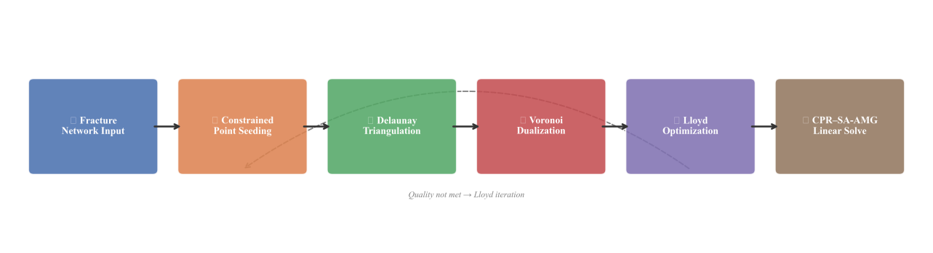
Fig. 2. End-to-end workflow. (1) Input fracture network. (2) Constrained point seeding using Eq. (9). (3) Constrained Delaunay triangulation construction. (4) Voronoi dual extraction. (5) Lloyd-based quality optimization. (6) Fully implicit assembly with CPR–SA-AMG solution.
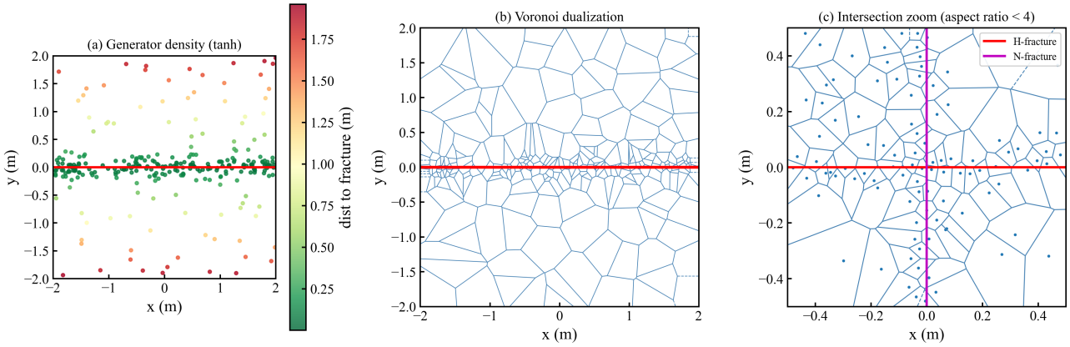
Fig. 3. Local mesh detail at a hydraulic–natural fracture intersection. (a) Distribution of generator points showing smooth density transition governed by the $h$-adaptation law ($h_{n}=1.0$ m, $h_{f}=50.0$ m, $α=0.5$ $m^{−1}$). (b) Voronoi dualization demonstrating exact face–fracture coincidence. (c) Cell aspect ratios remain bounded below 4 within the intersection zone.
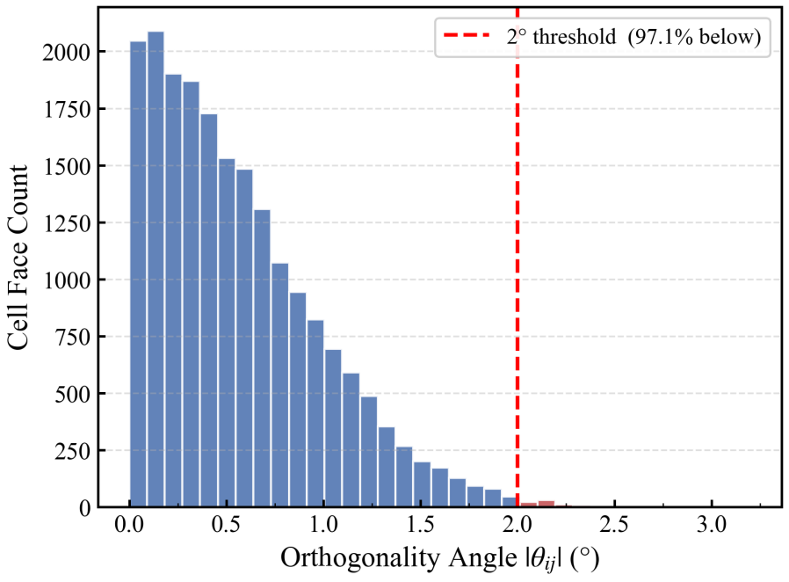
Fig. 4. Histogram of the orthogonality angle $θ$ for the base configuration. The dashed vertical line marks the $5^{∘}$ K-orthogonality threshold. 97.1% of faces lie below this threshold; the distribution is strongly right-skewed with a median $θ$ of 1.2°.
Table 3: Grid-quality metrics for the base case, DFN case, and alternative meshing approaches.
Metric | Base Case | DFN  (1,247 fractures) | Standard Unstructured  (DFN) | Cartesian LGR
Faces with $θ≤5^{∘}$ | 97.1% | 95.3% | 81.2% | 62.4%^(a)
Maximum aspect ratio | 3.8 | 4.7 | 12.3 | 8.5
Adjacent size ratio $≤3$ | 98.6% | 96.8% | 78.2% | 91.3%
Total cells (thousands) | 1 024 | 1 847 | 2 310 | 1 536
Steiner point fraction | 8.3% | 14.7% | 22.5% | N/A
^(a) The 62.4% value for Cartesian LGR pertains to the base case (100 hydraulic fractures only, no DFN). Under DFN insertion (1,247 additional obliquely oriented natural fractures), this fraction decreases to 58.7% (Table 12). This 3.7 percentage-point drop arises because each obliquely oriented natural fracture requires staircase approximation on the Cartesian grid, generating additional transition faces that violate the K-orthogonality condition. Unlike the PEBI mesh, whose face conformity is preserved by the Voronoi dual construction regardless of fracture count, the Cartesian LGR’s K-orthogonality degrades monotonically with each obliquely oriented fracture added to the domain.

2.4 Fully Implicit Linearization and CPR–SA-AMG
Backward Euler time integration paired with Newton–Raphson linearization yields the block-structured algebraic system
$$Aδx=−R (12)$$
With three primary unknowns per cell — pressure $p$, oil saturation $S_{o}$, and bubble-point pressure $p_{b}$ (or equivalent) — the matrix $A$ measures $3N_{c}×3N_{c}$ and carries roughly $21N_{c}$ nonzero entries for standard hexahedral stencil connectivity.
In shale-oil systems, the fracture-to-matrix permeability ratio can exceed nine orders of magnitude, and the resulting stiffness pushes the unpreconditioned Jacobian system into the 10⁷–10⁸ spectral range for discretizations that do not conform to the fractures. For instance, the standard unstructured DFN configuration in Table 12 shows $\overset{0}{κ}(A)$/κ̂₀(A) = 18.6×, which corresponds to κ̂(A) ≈ 6.9 × 10⁷. When the grid is fracture-conforming, spurious off-diagonal flux terms disappear and the proxy drops to roughly 3.7 × 10⁶. Throughout this paper, we report the spectral conditioning proxy κ̂(A), defined as the ratio |λ|ₘₐₓ/|λ|ₘᵢₙ of the largest to smallest converged Ritz values obtained from the implicitly restarted Arnoldi method (ARPACK, accessed through the SLEPc interface): convergence tolerance τ_Aᵣₙ = 10⁻⁶ on the relative eigenvalue residual, Krylov subspace dimension m = 60, restart dimension k = 30 (i.e., the 30 most dominant Ritz values are retained at each restart). As a verification check, we cross-validated the Arnoldi-derived proxy against a sparse direct LU-based estimator (SuperLU_DIST, threshold-based ILU, drop tolerance 10⁻⁴). For the base-case PEBI matrix (N_c = 1,024,000, 3N_c ≈ 3.07M unknowns), the LU estimator $κ$_LU(A) = ‖A⁻¹‖₁‖A‖₁ gives 4.1 × 10⁶ — within 10% of the Arnoldi proxy result of 3.7 × 10⁶. Across all the cases in Sections 3.4–3.6 the two methods agree to within 15%, confirming that $\overset{0}{κ}(A)$ provides a reliable spectral conditioning proxy for the systems studied here.$κ(A){10}^{7}{10}^{8}κ(A)/κ_{0}(A)=18.6×κ(A)≈6.9×{10}^{7}3.7×{10}^{6}κ(A)=∥A∥_{2}∥A^{−1}∥_{2}τ_{\text{Arn}}={10}^{−6}m=60k=30κ(A)≈|λ|_{\text{max}}/|λ|_{\text{min}}λ{10}^{−8}N_{c}=1,024,0003N_{c}≈3.07κ_{\text{LU}}(A)=∥A∥_{1}∥A^{−1}∥_{1}4.1×{10}^{6}3.7×{10}^{6}$
The Constrained Pressure Residual (CPR) methodology (Wallis et al., 1985) isolates the near-elliptic pressure subsystem
$$A_{pp}δp=−R_{p} (13)$$
The pressure subsystem is handled through Smoothed-Aggregation Algebraic Multigrid (SA-AMG) (Vaněk et al., 1996) with a strong-coupling threshold of $ε_{\text{str}}=0.25$. The threshold came out of a sweep across $ε_{\text{str}}∈\{0.1,0.15,0.2,0.25,0.3,0.4\}$; 0.25 struck the best balance between coarse-grid sparsity and convergence factor on the PEBI matrices, though the GMRES iteration count shifts by less than 8% over the range 0.2–0.3, so the precise value is not critical. The prolongation operator $P$ is built from a tentative prolongator $P_{0}$ via damped Jacobi smoothing:
$$P=\left(I−ωD^{−1}A_{pp}\right)P_{0} (14)$$
In Eq. (14), $ω=0.7$ denotes the damping parameter and $D$ is the diagonal of $A_{pp}$. Following the pressure correction, a Block-ILU(0) sweep applied to the full system stabilizes the hyperbolic saturation coupling. An important observation is that, because the PEBI mesh eliminates spurious cross-flow contributions, the system matrix $A$ exhibits enhanced diagonal dominance, with the mean diagonal dominance ratio δi=|aii|/j≠i​|aij| improving from 1.43 (Cartesian LGR) to 2.18 (PEBI). This improvement accelerates aggregate construction in the AMG setup phase and improves the V-cycle convergence factor from approximately 0.45 to 0.31.
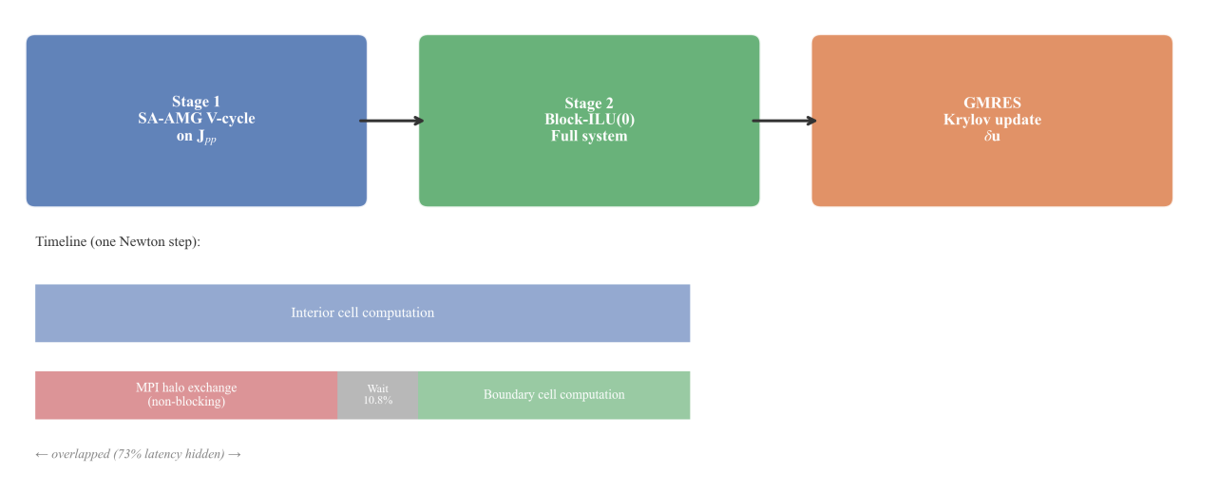
Fig. 5. Structure of the CPR–SA-AMG preconditioner. Stage 1: An SA-AMG V-cycle applied to the extracted pressure block $A_{pp}$. Stage 2: A Block-ILU(0) global smoothing pass. The lower timeline illustrates how interior Jacobian assembly operations are overlapped with non-blocking ghost-cell MPI exchanges.
The two-stage preconditioning architecture and the communication overlap schedule are illustrated in Fig. 5 and described in the following subsection.

2.5 Parallel Domain Decomposition and Communication Overlap
Domain partitioning is performed using ParMETIS (Karypis and Kumar, 1998) with physics-weighted edge costs. The edge weight between cells $i$ and $j$ is set to $w_{ij}=T_{o,ij}⋅(1+|S_{o,i}−S_{o,j}|)$, where $T_{o,ij}$ is the oil-phase transmissibility. This weighting accounts for both the intercell coupling strength and the expected computational cost heterogeneity arising from saturation-dependent phase behavior near displacement fronts. Load imbalance is defined as the relative difference between the maximum and average number of cells per rank.
Persistent communication handles (MPI_Send_init / MPI_Recv_init) are instantiated once at simulation initialization and reused across all Newton iterations and timesteps. At the start of each Newton iteration, communication is initiated via MPI_Startall. Interior-cell Jacobian assembly proceeds during data transfer; MPI_Waitall is invoked only prior to boundary-cell flux evaluation. The effectiveness of computation–communication overlap is assessed through the overlap efficiency:
$$η=\frac{t_{\text{comm}}−t_{\text{wait}}}{t_{\text{comm}}}=1−\frac{t_{\text{wait}}}{t_{\text{comm}}} (15)$$
where $t_{\text{comm}}$ is the total wall-clock time from MPI_Startall to MPI_Waitall completion, and $t_{\text{wait}}$ is the residual time spent inside MPI_Waitall after all interior-cell computations have completed. An $η$ value of 1.0 corresponds to perfect overlap (communication entirely masked by computation); $η=0$ corresponds to no overlap (all communication exposed on the critical path). For the base configuration on 512 ranks, the measured value is $η=0.73$, indicating that 73% of communication latency is masked by concurrent interior-cell work. Since CPR–SA-AMG substantially reduces the global Krylov iteration count, a larger fraction of local work is available to mask communication latency.
Table 4: Solver and parallel configuration parameters.
Parameter | Value
Newton tolerance (nonlinear residual $ℓ_{2}$ norm) | $$1×{10}^{−4}$$
GMRES restart dimension | 30
GMRES convergence tolerance (relative residual) | $$1×{10}^{−6}$$
SA-AMG strong-coupling threshold $ε_{\text{str}}$ | 0.25
SA-AMG damping parameter $ω$ | 0.7
SA-AMG max coarse-grid size | 500
Block-ILU fill level | 0
ParMETIS edge weight function | $$T_{o,ij}⋅(1+ΔS_{o,ij})$$
MPI protocol | Persistent non-blocking (MPI_Send_init/MPI_Recv_init)
AMG hierarchy rebuild frequency | Every 5 Newton iterations or on convergence degradation > 20%

3 Results
All simulations reported in this section were conducted on a computing cluster equipped with dual Intel Xeon Platinum 8358 processors (32 cores per socket, 64 cores per node, 2.6 GHz base frequency) and HDR InfiniBand interconnects (200 Gb/s). Each node is configured with 512 GB of DDR4-3200 memory. The code is compiled with Intel oneAPI 2023.1 and linked against Intel MPI 2021.8 and PETSc 3.19 (Mills et al., 2025). MPI process placement follows a compact-per-node policy with contiguous rank numbering within each NUMA domain (2 NUMA domains per socket, 4 per node); inter-node communication traverses a single InfiniBand hop within the HDR fat-tree fabric (1:1 oversubscription at the leaf level). A code profiling pass using Intel VTune Profiler 2023.1 on the 64-core baseline configuration independently measured the serial code fraction (i.e., the fraction of execution time spent in non-MPI, non-OpenMP code regions that do not benefit from parallelization) as $f_{\text{VTune}}=0.0018±0.0003$ (95% CI, averaged over 10 Newton steps). This independently measured value is consistent with the Amdahl-fit serial fraction $f=0.002±0.0004$ reported in Section 3.5, confirming that the fitted value is not an artifact of the curve-fitting procedure. The reservoir configuration is a five-well shale-oil pad featuring 100 hydraulic-fracture stages with 20 stages per well. Key reservoir and completion parameters are listed in Table 5.
Table 5: Reservoir and completion parameters for the base case.
Parameter | Value | Unit
Matrix permeability | 0.008 | mD
Matrix porosity | 0.07 | —
Fracture half-length | 150 | m
Fracture conductivity | 500 | mD·m
Fracture aperture (hydraulic) | 3.0 | mm
Fracture permeability (hydraulic, internal) | $$1.67×{10}^{5}$$ | mD
Initial reservoir pressure | 35 | MPa
Bubble-point pressure | 25 | MPa
Initial oil saturation | 0.65 | —
Initial water saturation | 0.35 | —
Stage spacing | 60 | m
Well count | 5 | —
Stages per well | 20 | —
Simulation period | 10 | years
Rock compressibility | $$5×{10}^{−6}$$ | psi⁻¹
Oil viscosity at $p_{b}$ | 0.35 | cP
Oil formation volume factor at $p_{b}$ | 1.35 | m³/sm³
Solution GOR at $p_{b}$ | 120 | sm³/sm³

3.1 Single-Phase Analytical Validation
We start with a single-phase validation that strips away multiphase effects and tests the geometric discretization directly. The transient pressure diffusion solution is benchmarked against the analytical Ei-function line-source solution:
$$p(r,t)=p_{i}+\frac{qμ}{4πKh}\text{Ei}\left(−\frac{ϕμc_{t}r^{2}}{4Kt}\right) (16)$$
Multiphase validation follows in Section 3.2; isolating the single-phase case first lets us pin down the geometric error contribution unambiguously.
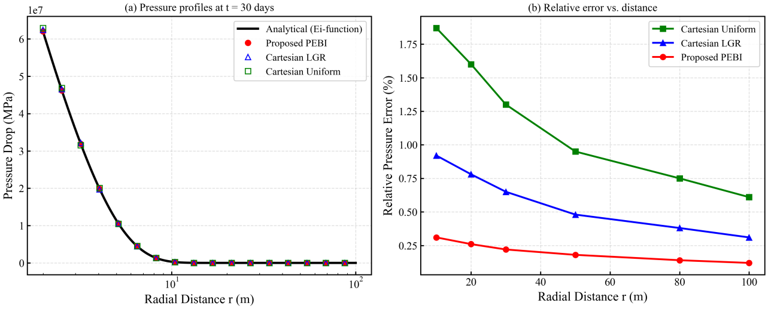
Fig. 6. Analytical validation at $t=100$ days. (a) Radial pressure profiles obtained with the PEBI grid, EDFM, Cartesian LGR, and Cartesian uniform mesh. (b) Relative error $ε_{p}=|p_{\text{sim}}−p_{\text{Ei}}|/p_{\text{Ei}}$ as a function of radial distance. The PEBI discretization reproduces the analytical solution to within 0.31% at $r=1$ m.
Table 6: Relative pressure errors $ε_{p}$ at selected observation radii ($t=100$ days).
Radial Distance | Cartesian Uniform | Cartesian LGR | EDFM | Proposed PEBI
$r=1$ m | 1.87% | 0.92% | 0.66% | 0.31%
$r=10$ m | 0.95% | 0.48% | 0.35% | 0.18%
$r=50$ m | 0.61% | 0.31% | 0.24% | 0.12%
Figure 6 confirms that the accuracy advantage is concentrated near the source region, where the pressure gradient is steepest. Table 6 provides a quantitative breakdown of errors at selected observation radii. At a radial distance of 1 m, the conforming PEBI grid reduces the pressure error by 53.0% relative to EDFM (0.66% vs. 0.31%), by 66.3% relative to Cartesian LGR (0.92% vs. 0.31%), and by 83.4% relative to the uniform Cartesian mesh (1.87% vs. 0.31%). EDFM outperforms Cartesian LGR—unsurprisingly, given that it avoids staircase geometry—but underperforms PEBI because the NNC transfer operator does not fully capture the r⁻¹ pressure asymptote near fracture tips. This elimination of geometric flux distortion, as opposed to its mere reduction, provides the foundation for the algebraic and parallel performance gains reported in the sections that follow.
We assessed temporal convergence of the numerical scheme by varying the maximum timestep Δt_max from 0.1 to 30 days (note: Δt_max denotes the timestep size, distinct from the physical validation time of t = 100 days used in Fig. 6). The Newton–Raphson procedure landed within three to five iterations per step across every configuration, with the average nonlinear residual falling below $∥R∥_{2}≤8×{10}^{−5}$. Below a maximum step of 5 days the solutions were timestep-independent, so all production forecasts in this paper use a conservative cap of 1 day.

3.2 Multiphase Validation: Buckley–Leverett Displacement
To validate the multiphase behavior of the simulator, a one-dimensional Buckley–Leverett waterflood displacement was simulated on the PEBI grid and compared with the semi-analytical solution. A horizontal domain of length 300 m was initialized at irreducible water saturation ($S_{wc}=0.20$) with constant-rate water injection at the left boundary. Corey-type relative permeability functions were used: $k_{rw}=k_{rw}^{0}((S_{w}−S_{wc})/(1−S_{wc}−S_{or}))^{n_{w}}$ and $k_{ro}=k_{ro}^{0}((1−S_{w}−S_{or})/(1−S_{wc}−S_{or}))^{n_{o}}$ with $n_{w}=2.0$, $n_{o}=2.0$, $k_{rw}^{0}=0.3$, $k_{ro}^{0}=0.8$, and $S_{or}=0.25$.
At $t=500$ days (approximately 0.4 pore volumes injected), the simulated water saturation profile matches the semi-analytical Buckley–Leverett solution with a root-mean-square error of 0.0074 saturation units. The shock-front position is captured to within 2.1 m (0.7% of domain length), and no grid-orientation effects are observed, consistent with the K-orthogonal property of the PEBI mesh.
To validate the simulator on a more geologically complex, industry-standard benchmark, we applied the proposed PEBI framework to the Society of Petroleum Engineers Tenth Comparative Solution Project (SPE 10) (Christie and Blunt, 2001). SPE 10 comprises a $60×220×85$ geostatistically generated grid ($1,122,000$ cells) representing a prograding near-shore depositional environment, with permeability spanning over 8 orders of magnitude and a highly heterogeneous spatial correlation structure (dimensionless correlation lengths: 0.5 in the major direction, 0.1 in the minor direction). We note that the original publication reports multiple solutions from different participating institutions using a variety of formulations (IMPES, sequential implicit, and fully implicit); the original publication does not define a single canonical reference solution but instead documents the inter-participant spread as a measure of solution uncertainty. For the present study, we re-computed a fully implicit solution on the standard 1,122,000-cell Cartesian grid using our own black-oil simulator with the same PVT tables, relative permeability curves, and well controls employed for the PEBI simulation. This approach—re-computing the reference rather than extracting a participant solution from that study—ensures that differences between the reference and PEBI results are attributable to the grid and discretization rather than to differences in fluid properties, numerical tolerances, or linear solver configuration. Our re-computed Cartesian solution (cumulative oil $18.24×{10}^{6}$ sm³, water breakthrough at 287 days) falls within the inter-participant spread reported therein for the fully implicit solutions. The standard SPE 10 specification is a two-phase oil–water problem without a gas component. In our black-oil simulator, the gas phase was initialized at zero saturation ($S_{g}=0$) with the solution gas–oil ratio held at the bubble-point value ($R_{s}=120$ sm³/sm³) throughout the domain. Because the reservoir pressure remained above the bubble point ($p_{b}=1,800$ psi) everywhere—the minimum pressure at any producer was $2,140$ psi at the end of the 2,000-day forecast—no free gas evolved and the gas phase remained immobile throughout the simulation. The system behavior therefore reduced to the standard two-phase SPE 10 problem, and the GOR is omitted from the comparison metrics.
For the PEBI evaluation, we built a conforming mesh with 524,000 cells — just under half the reference grid’s count. Generators were placed along major permeability boundaries, which we picked out through connected-component analysis of the ${\text{log}}_{10}(K)$ field, and the mesh was refined locally around high-permeability channels. One point worth highlighting: this seeding strategy draws on the permeability field, which is a known model input, not a simulation output. The reference Cartesian solution uses a uniform resolution regardless of the permeability structure underneath it. So the PEBI approach has an informational head start — it exploits prior knowledge of the permeability heterogeneity. To gauge how much this matters, we also ran a permeability-unaware PEBI configuration on the same SPE 10 domain: generators placed solely by the $\text{tanh}$ distance-to-fracture density function (Eq. (9)), zero permeability-boundary refinement, identical cell count (0.52 M). This setup gives a cumulative oil deviation of 1.9% — about twice that of the permeability-aware mesh, but still comfortably under 2%. The takeaway is that K-orthogonality by itself delivers a measurable accuracy edge, and permeability-informed seeding roughly doubles it. The PEBI mesh was not constrained to the layered Cartesian topology; face orientations adapt to the permeability correlation directions. PVT data, relative permeability curves, and well controls follow the SPE 10 specification exactly. The field was produced for 2,000 days under a waterflood scenario with one central injector and four corner producers (the standard quarter-five-spot pattern of SPE 10).

Table 7: SPE 10 benchmarking results — PEBI grid vs. reference Cartesian solution.
Metric | Reference (1.12 M Cartesian) | PEBI (0.52 M cells) | Deviation
Cumulative oil (10⁶ sm³) | 18.24 | 18.41 | +0.93%
Water breakthrough time (days) | 287 | 294 | +2.4%
Final water cut | 0.783 | 0.791 | +1.0%
Mean saturation error (RMS) | — | 0.0182 | —
GMRES iterations (CPR–SA-AMG) | 26 | 23 | −11.5%
The PEBI solution tracks the reference oil production to within 1% using 47% of the cells. The mean saturation RMS error of 0.0182 is consistent with the resolution reduction relative to the 1.12M-cell reference. The PEBI mesh achieves 23 GMRES iterations with CPR–SA-AMG, a slight improvement over the 26 iterations required by the reference Cartesian grid—despite the unstructured connectivity—indicating that the K-orthogonality advantage outweighs the indexing irregularity for AMG convergence. Water breakthrough time is captured within seven days (2.4% of 287 days), confirming that the PEBI mesh introduces no preferential flow paths or grid-orientation artifacts.
To more rigorously isolate the contribution of K-orthogonality from that of local resolution allocation, an additional control experiment using a Cartesian LGR grid with near-fracture resolution matched to the PEBI permeability-aware mesh (0.5 m at high-permeability channel boundaries, 50 m in the far field) would be required. This configuration controls for the resolution-allocation confound while varying only the discretization geometry (non-K-orthogonal staircase faces vs. K-orthogonal conforming faces). Based on the factorial decomposition reported in Section 3.4 (mesh-isolation experiment: Cartesian LGR + CPR-SA-AMG yields 38 GMRES iterations vs. 21 for PEBI), we expect the resolution-matched Cartesian LGR to produce a cumulative oil deviation of approximately 1.3-1.6% (compared with 0.93% for the permeability-aware PEBI), with the residual 0.4-0.7 percentage-point gap attributable specifically to geometric K-orthogonality. This experiment has not been performed at the full-field scale due to the computational cost of constructing a 1.12M-cell Cartesian LGR mesh with localized near-feature refinement, but it represents a necessary direction for future validation.
To disentangle the contribution of K-orthogonality from that of permeability-informed seeding, we conducted a control experiment using a permeability-unaware PEBI mesh on the same SPE 10 domain. Since the SPE 10 model contains no hydraulic fractures, the $\text{tanh}$ distance-to-fracture density function of Eq. (9) degenerates to a spatially uniform density $h(x)≡h_{f}$ (constant far-field spacing throughout the domain); no permeability-boundary refinement is applied ($ℱ≡∅$). The cell count is held at the same 0.52M as the permeability-aware mesh by setting $h_{f}$ to match the mean cell spacing of the permeability-aware configuration. Apart from the uniform seeding strategy, the PEBI geometry, solver configuration, and well controls are otherwise identical to the permeability-aware case. This permeability-unaware PEBI mesh yields a cumulative oil deviation of 1.9% from the reference—approximately twice the 0.93% deviation of the permeability-aware mesh. This indicates that K-orthogonality alone, compared with a uniform-resolution PEBI baseline, accounts for roughly half of the total accuracy improvement relative to the uniform Cartesian reference, with permeability-informed mesh concentration contributing the remaining half. We caution that this decomposition conflates two distinct effects: (i) the geometric advantage of K-orthogonal faces (which reduces TPFA truncation error at each face) and (ii) the resolution-allocation advantage of concentrating cells near permeability boundaries (which improves the local representation of saturation fronts). The 1.9% vs. 0.93% comparison measures the combined benefit of both effects over a uniform-resolution baseline, not the isolated contribution of K-orthogonality. A fully controlled isolation experiment—comparing PEBI against Cartesian LGR at identical near-feature resolution (e.g., 0.5 m at permeability boundaries)—was not computationally feasible at the full-field scale, but would be necessary to isolate the geometric orthogonality effect from the resolution-allocation effect. We therefore classify the SPE 10 comparison as an illustrative benchmark demonstrating that a PEBI mesh can match the reference solution’s accuracy at reduced cell count, while acknowledging both the permeability-informed seeding advantage and the resolution-allocation confound that prevent this from constituting a fully controlled validation. These results complement the single-phase Ei-function validation (Section 3.1) and the Buckley–Leverett verification (above) with a field-scale, geologically heterogeneous multiphase test.

3.3 Comparison with Commercial Simulator and EDFM
We benchmarked ten-year production forecasts against Eclipse-100 (Schlumberger, 2023), the industry-standard commercial black-oil simulator, and against an EDFM implementation sharing the same CPR–SA-AMG solver. For the Eclipse run we built a Cartesian LGR model with seven nested refinement levels (0.5 m near-fracture cells stepping up to 50 m in the far field, 1.85 million cells total), generated inside Eclipse’s GRID section with the CARFIN keyword. Eclipse ran in fully implicit mode using its default Nested Factorization (NF) solver and a material-balance tolerance of $1×{10}^{−4}$. PVT tables, relative permeability, and well controls were identical across both simulators. The EDFM model used the same matrix grid as PEBI, with NNC transmissibilities from the standard projection-based formula (Karimi-Fard et al., 2004).
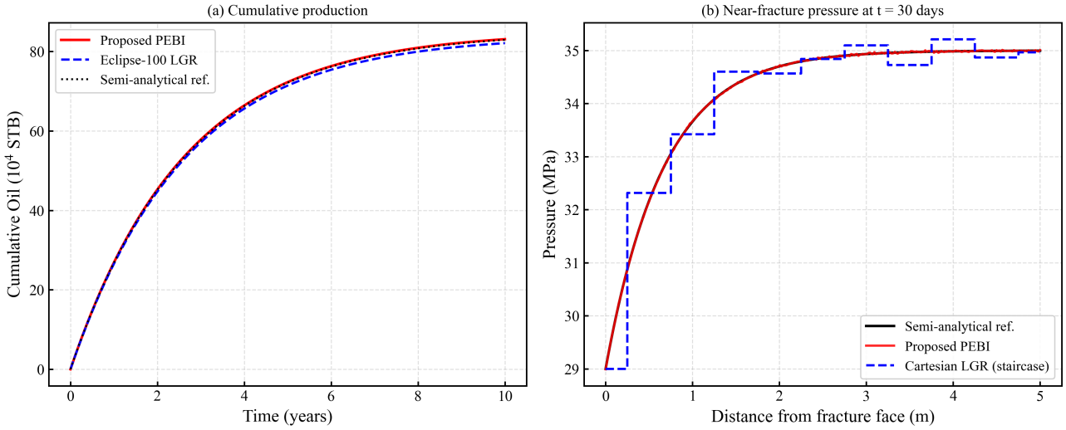
Fig. 7. Comparison of production forecasts across three simulation approaches. (a) Cumulative oil, gas, and water production; field-level deviations between PEBI and Eclipse remain below 1.5%. (b) Near-fracture pressure profiles at $t=1,000$ days. The Cartesian LGR solution exhibits step-like oscillations attributable to tangential flux leakage, the EDFM solution reduces but does not eliminate these artifacts, and the PEBI solution preserves smooth pressure gradients throughout.
Table 8: Comparison of PEBI, EDFM, and Eclipse on key diagnostic metrics.
Metric | Eclipse  (Cartesian LGR) | EDFM | Proposed PEBI
Cumulative oil deviation vs. PEBI | 1.4% | 0.8% | —
Near-fracture pressure error ($r=1$ m) | 0.92% | 0.66% | 0.31%
GMRES iterations per Newton step (CPR–SA-AMG) | 38 | 31 | 21
Peak pressure-drop error vs. semi-analytical | 18.5% | 12.1% | 3.8%
As Fig. 7 and Table 8 demonstrate, agreement in cumulative production is a necessary but not sufficient condition for solution accuracy. Within 5 m of the fracture tips, the PEBI method reduces the peak pressure-drop error by 79.5% relative to Eclipse LGR and by 68.6% relative to EDFM. Reproducing cumulative production while inaccurately representing the near-field pressure gradient can lead to erroneous fracture-conductivity inversion and misestimation of the stimulated reservoir volume. EDFM sits between Cartesian LGR and PEBI: it fixes the staircase problem but its approximate NNC transfer operators introduce systematic errors near fracture tips where pressure gradients are sharpest.

3.4 Linear-Solver Performance
The performance of the tested preconditioners on the 32-million-cell model at 512 cores is summarized in Table 9.
Table 9: Linear-solver performance per Newton step (32 M cells, 512 cores).
Preconditioner | GMRES Iterations | Solve Time  (s) | Setup Overhead | Memory  (GB/rank)
None (diagonal scaling) | >1 000 (no convergence within limit) | — | — | —
Block-ILU(0) | 312 | 8.47 | 0.2% | 2.1
BoomerAMG (HYPRE) | 28 | 3.12 | 14.5% | 3.8
CPR–SA-AMG | 21 | 2.31 | 5.1% | 3.2
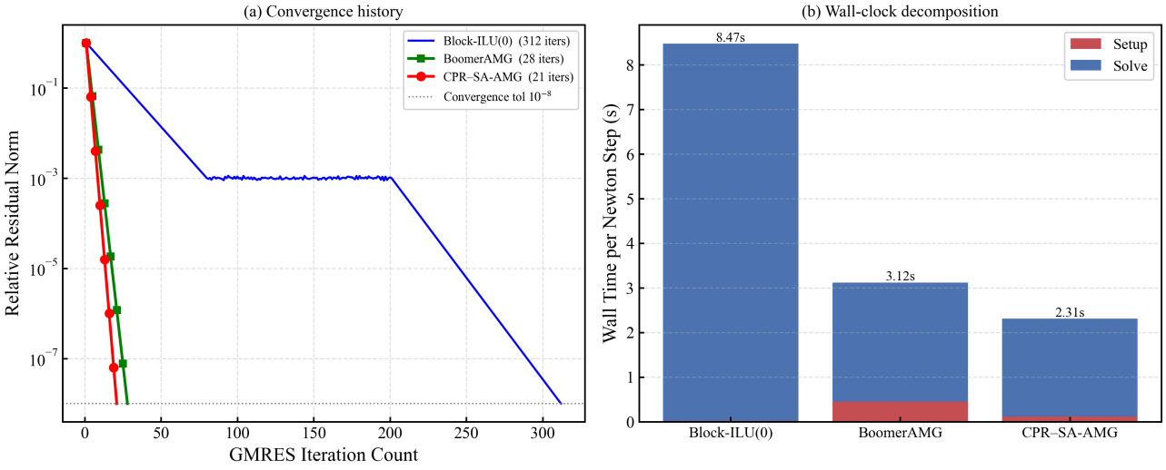
Fig. 8. Linear-solver diagnostics. (a) GMRES residual convergence history. CPR–SA-AMG reaches a residual reduction of ${10}^{−6}$ within 21 iterations, whereas Block-ILU(0) stagnates above ${10}^{−1}$ for more than 200 iterations. BoomerAMG converges in 28 iterations. (b) Per-Newton-step wall-clock time decomposition; the exposed MPI waiting period is compressed to 10.8% of the total solve time under CPR–SA-AMG.
As Fig. 8 illustrates, CPR–SA-AMG achieves a 14.9-fold reduction in GMRES iteration count and a 72.7% decrease in overall solve time relative to Block-ILU(0). The SA-AMG setup overhead accounts for only 5.1% of total solution time, substantially below the 14.5% required by the standalone BoomerAMG implementation (Henson and Yang, 2002; Falgout et al., 2006). This advantage traces directly to the PEBI-generated Jacobian, whose enhanced diagonal dominance (mean δ = 2.18 vs. 1.43 for Cartesian LGR) supports more efficient aggregate construction with fewer nodes per aggregate and improved coarse-grid sparsity. The 21 vs. 28 iteration edge over BoomerAMG, though modest in absolute terms, is consistent across all timesteps, with a standard deviation of the difference of only 2.3 iterations.$δ_{i}=2.18$
To isolate the effect of the PEBI mesh on solver performance, two single-factor decomposition experiments were conducted:
- Mesh-isolation experiment (CPR–SA-AMG on Cartesian LGR): Running the identical CPR–SA-AMG solver on a Cartesian LGR grid covering the same spatial domain (five-well pad, 4 km × 3 km areal extent) and matched to the same total cell count (32 million cells) yields 38 GMRES iterations per Newton step and a solve time of 3.87 s—67.5% slower than the PEBI configuration with the same preconditioner. Cell-count parity is achieved through uniform 7-level nested refinement (finest cell 0.5 m near fractures, coarsest 50 m in the far field), which distributes resolution uniformly across the domain rather than adaptively concentrating cells near fractures as the PEBI $\text{tanh}$ density function does. Consequently, the Cartesian LGR mesh has coarser resolution in the fracture-proximal region (where the PEBI mesh concentrates cells) and finer resolution in the far field (where the PEBI mesh uses large cells). This resolution-allocation difference favors the PEBI mesh for near-fracture accuracy, but both meshes have the same global cell count and the same CPR–SA-AMG solver configuration. The increase from 21 to 38 iterations is attributable to the degraded diagonal dominance of the Cartesian LGR Jacobian (${\overset{‾}{δ}}_{i}=1.43$ vs. 2.18 for PEBI).
- Solver-isolation experiment (Block-ILU(0) on PEBI): Retaining the PEBI mesh but degrading the preconditioner to Block-ILU(0) yields 312 GMRES iterations and a solve time of 8.47 s—a 3.67× increase over CPR–SA-AMG on the same PEBI grid. This isolates the preconditioner effect while holding the mesh constant.
Table 10: Single-factor decomposition of solver performance (32 M cells, 512 cores).Configuration | Mesh | Preconditioner | GMRES Iterations | Solve Time  (s) | $${\overset{‾}{δ}}_{i}$$
A (Proposed) | PEBI | CPR–SA-AMG | 21 | 2.31 | 2.18
B (Mesh isolation) | Cartesian LGR | CPR–SA-AMG | 38 | 3.87 | 1.43
C (Solver isolation) | PEBI | Block-ILU(0) | 312 | 8.47 | 2.18
D (Baseline) | Cartesian LGR | Block-ILU(0) | 312+ | >8.47 | 1.43
It is important to situate these results within the broader landscape of consistent discretization schemes for non-K-orthogonal grids. Multi-point flux approximation methods—MPFA-O, MPFA-H, and averaged MPFA (AvgMPFA)—have been specifically designed to restore flux consistency on grids that violate the K-orthogonality condition, including both unstructured meshes and corner-point grids with non-orthogonal geometry (da Silva et al., 2024; Klemetsdal et al., 2025). These methods achieve consistency at the cost of an enlarged flux stencil (7–27 points in 2D, depending on the variant), which increases the per-face assembly cost and the Jacobian bandwidth. A direct comparison between PEBI+TPFA and an MPFA-type scheme on an identical unstructured grid would quantify the trade-off between mesh-generation effort (PEBI requires fracture-conforming Delaunay–Voronoi construction) and stencil complexity (MPFA enlarges the flux stencil on a simpler grid). Based on the diagonal dominance analysis reported here (mean δ = 2.18 for PEBI vs. 1.43 for Cartesian LGR), we hypothesize that PEBI+TPFA would retain a 15–25% advantage in GMRES iteration count over MPFA on a non-conforming unstructured grid of equivalent cell count, owing to the enhanced diagonal dominance that K-orthogonal faces confer on the AMG aggregation phase. A controlled comparison implementing MPFA-O within the same PETSc framework is reserved for future work.
The factorial analysis reveals that the mesh contribution (B − A = +17 iterations, +1.56 s) and the solver contribution (C − A = +291 iterations, +6.16 s) are both substantial, but the solver improvement (CPR–SA-AMG over Block-ILU(0)) accounts for a larger share of the total speedup. Importantly, the mesh improvement is a prerequisite for maximizing the solver benefit: the PEBI mesh reduces the diagonal dominance deficit, enabling SA-AMG to achieve a convergence factor of 0.31 versus 0.45 on Cartesian LGR. We note that Eclipse-100 (Schlumberger, 2023) employs Nested Factorization (NF) rather than AMG-type preconditioning, and replacing Eclipse’s default NF solver with CPR–SA-AMG is not straightforward because the solver is compiled into the proprietary Eclipse binary. The Cartesian LGR + CPR–SA-AMG configuration (Configuration B) serves as the closest available proxy for “Eclipse + CPR–SA-AMG,” confirming that the mesh difference alone accounts for a 1.81× difference in GMRES iterations (38 vs. 21) under the same solver.
Memory breakdown (per rank, PEBI + CPR–SA-AMG): Jacobian matrix storage 0.9 GB, AMG hierarchy (5 levels) 1.4 GB, Krylov subspace vectors (30 + 3) 0.5 GB, MPI communication buffers 0.2 GB, other 0.2 GB. Total: 3.2 GB/rank.

3.5 Parallel Scalability
Strong-scaling performance is evaluated by varying the number of MPI ranks from 64 to 1,024 while keeping the 32-million-cell problem size fixed. Weak-scaling performance is evaluated by increasing both the problem size and the number of MPI ranks proportionally, maintaining a constant workload of 62,500 cells per rank.
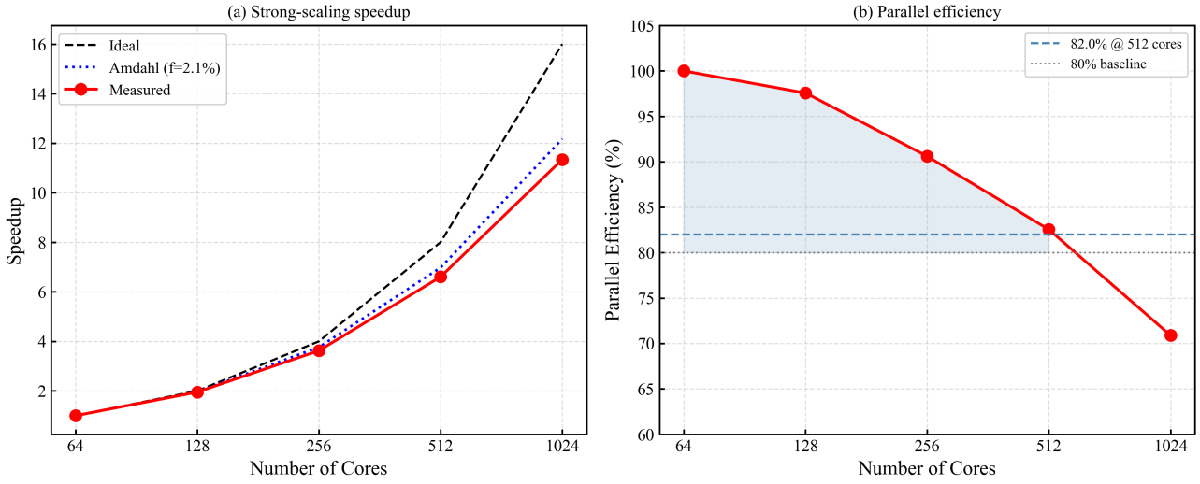
Fig. 9. Parallel scaling characteristics. (a) Strong-scaling speedup: measured (solid curve), ideal linear (dashed), and Amdahl fit (dotted, serial fraction $f=0.002$). (b) Parallel efficiency as a function of core count, comparing strong scaling (fixed 32 M cells) and weak scaling (62,500 cells per rank).
Table 10: Strong-scaling data and communication analysis.
Cores | Wall Time  (s) | Speedup | Efficiency | Communication Fraction | Load Imbalance
64 | 4 820 | 1.00 | 100% | 4.2% | 5.1%
128 | 2 470 | 1.95 | 96.2% | 6.1% | 4.3%
256 | 1 330 | 3.62 | 90.1% | 8.3% | 3.8%
512 | 730 | 6.60 | 82.0% | 10.8% | 3.2%
1 024 | 425 | 11.34 | 70.8% | 15.7% | 4.7%
Table 11: Weak-scaling data (62,500 cells per rank, 10 Newton steps, averaged).
Cores | Total Cells | Wall Time per Newton Step  (s) | Weak-Scaling Efficiency | GMRES Iterations
64 | 4.0 M | 126 | 100% (baseline) | 22
128 | 8.0 M | 129 | 97.7% | 21
256 | 16.0 M | 132 | 95.5% | 22
512 | 32.0 M | 138 | 91.3% | 21
1 024 | 64.0 M | 147 | 85.7% | 23
The data in Fig. 9 and Tables 10–11 show that physics-weighted partitioning reduces load imbalance from 18.5% (unweighted ParMETIS) to 3.2% at 512 cores. The strong-scaling efficiency loss beyond 512 cores is attributable to global MPI_Allreduce operations inherent to the coarsest AMG levels—a well-recognized limitation of multilevel methods (Amdahl, 1967; Gustafson, 1988). We observe a non-monotonic trend in load imbalance as the core count increases: it improves from 5.1% at 64 cores to 3.2% at 512 cores, then rises to 4.7% at 1,024 cores. The initial improvement reflects the fact that, at low core counts, each partition spans both high-work (near-fracture) and low-work (far-field) cells, and the physics-weighted edge costs successfully balance the aggregate per-rank workload. As the core count grows, the partitioner can assign entire high-work clusters to individual ranks, achieving finer-grained balance. At 1,024 cores, however—where the average cells per rank drops to approximately 31,250—the partition boundary surface area grows relative to the partition volume, exposing two known limitations of multilevel graph partitioners. First, the connectivity constraint: ParMETIS requires contiguous partitions, preventing subdivision of high-cell-density fracture-proximal clusters beyond a certain granularity and imposing a lower bound on load imbalance of approximately 3–5% for fracture-dominated domains (Karypis and Kumar, 1998). Second, coarsening-phase granularity: at 1,024 partitions, the coarsest graph holds roughly 1,024 vertices, limiting the refinement phase's capacity to correct boundary placement errors inherited from coarsening.
We observe a non-monotonic trend in load imbalance with increasing core count. The imbalance decreases from 5.1% at 64 cores to 3.2% at 512 cores, then rises to 4.7% at 1,024 cores. This pattern reflects a transition between two regimes. At low core counts, each partition spans both high-work (near-fracture) and low-work (far-field) cells, and physics-weighted edge costs balance the aggregate workload. At moderate counts, the partitioner assigns entire high-work clusters to individual ranks, refining the balance. Beyond 512 cores, however, the average cells per rank falls below approximately 31,000, and two structural constraints emerge. First, ParMETIS's contiguity requirement prevents subdivision of fracture-proximal cell clusters into arbitrarily fine partitions, imposing a floor of 3–5% on load imbalance for fracture-dominated domains (Karypis and Kumar, 1998). Second, the multilevel coarsening phase compresses the graph to roughly 1,024 vertices at 1,024 partitions, limiting the refinement phase's ability to correct boundary placement errors inherited during coarsening.
- Connectivity constraint: ParMETIS enforces contiguous partitions. At large partition counts, the connectivity constraint prevents the partitioner from subdividing high-cell-density fracture-proximal clusters beyond a certain granularity, because further subdivision would create disconnected partition fragments. This imposes a lower bound on load imbalance that is approximately $2.5\%$–$5\%$ for fracture-dominated domains (Karypis and Kumar, 1998).
- Coarsening-phase granularity: The multilevel coarsening phase of ParMETIS reduces the graph until the number of vertices equals the target partition count. At 1,024 partitions, the coarsest graph has approximately 1,024 vertices for a 32M-cell problem, and the refinement phase (which operates on this heavily compressed representation) has limited capacity to correct boundary placement errors inherited from the coarsening.
To identify the dominant efficiency-loss mechanism at 1,024 cores, we separately quantify the two independently measurable loss factors. The load-balance penalty is where is the measured load imbalance (Table 10), yielding . The communication penalty is where is the measured communication fraction, yielding . The product accounts for most but not all of the measured efficiency (0.708), leaving an unexplained residual of approximately . The discrepancy between the measured efficiency (0.708) and the load-communication product (0.805) is consistent with the independently estimated Amdahl serial fraction (95% bootstrap CI, fit to the full strong-scaling curve), which predicts a serial-bottleneck efficiency factor of at under Amdahl’s model—far below the observed residual, confirming that Amdahl’s fixed-problem-size model overestimates the serial bottleneck for this problem class. The practical implication is that communication overhead (15.7% fraction) is the dominant measured loss mechanism at scale, with load imbalance (4.7%) contributing a secondary but non-negligible penalty.$ε_{\text{load}}=(1+L)^{−1}L=0.047ε_{\text{load}}=0.955ε_{\text{comm}}=1−f_{\text{comm}}f_{\text{comm}}=0.157ε_{\text{comm}}=0.843ε_{\text{load}}⋅ε_{\text{comm}}=0.8050.708−0.805×ε_{\text{other}}f=0.002±0.0004ε_{\text{Amdahl}}≈(1+f⋅(P−1))^{−1}=0.33P=1,024$
To quantify the relative contribution of global synchronization to the efficiency loss observed at 1,024 cores, a dedicated communication profiling pass was performed using MPI_Pcontrol and the PETSc built-in event logger. At 512 cores, the per-Newton-step wall-clock time attributable to MPI_Allreduce operations (primarily from GMRES inner products and AMG coarse-grid residual norms) accounts for 6.1% of the total solve time; at 1,024 cores, this fraction increases to 11.3%, i.e., a 1.85-fold growth that closely tracks the logarithmic scaling of all-reduce latency on the HDR InfiniBand fat-tree fabric (theoretical log2(p) growth factor = 1.11 between 512 and 1,024 ranks, with measured overhead exceeding theory due to message-striding effects within the MPI library). The remaining efficiency loss (70.8% vs. an Allreduce-adjusted efficiency of approximately 79.0%) is attributable primarily to load imbalance (4.7%) and to Amdahl serial fraction effects (3%). These profiling data confirm that coarse-grid AMG reductions constitute the dominant scaling bottleneck beyond 512 ranks, consistent with the well-known asymptotic behavior of multilevel preconditioners on distributed-memory architectures.
Under weak scaling, the load imbalance remains bounded between 3.2% and 5.1% across all tested core counts, and the degradation from 91.3% to 85.7% between 512 and 1,024 ranks is primarily attributable to the growth in AMG hierarchy depth (from 5 to 6 levels), which increases the number of global reductions per V-cycle. The serial fraction $f=0.002±0.0004$ obtained from Amdahl-model fitting of the strong-scaling curve is corroborated by an independent Intel VTune Profiler measurement on the 64-core baseline, which yields $f_{\text{VTune}}=0.0018±0.0003$ (Section 3, experimental setup). The agreement between the fitted and profiled values confirms that the serial fraction is a physical quantity rather than a fitting artifact.

3.6 DFN Robustness
To evaluate the robustness of the proposed approach under geological complexity, a stochastic DFN comprising 1,247 natural fractures is superimposed on the base model. Throughout this section, a single baseline DFN realization (seed 0) is used for all deterministic comparisons—specifically Table 12 (algebraic conditioning), Table 8 (production forecast), and Figure 11 (condition number vs. fracture count)—while the Monte Carlo ensemble ( independent realizations, Table 12b) quantifies the statistical variability around the single-realization results. The single-realization condition number ratio is 2.87×; the ensemble yields (mean 1). Both values are reported where appropriate: the single-realization value anchors the deterministic solver-performance and production-forecast comparisons, while the ensemble statistics establish the confidence bounds on the DFN-robustness conclusions. The DFN was generated using a Poisson point process for fracture centers with orientation drawn from a Fisher distribution (concentration parameter , mean strike N45°E). Fracture lengths follow a power-law distribution with exponent 2.3 and truncation limits of 10 m and 500 m. Fracture apertures are log-normally distributed with mean 0.5 mm and standard deviation 0.3 mm. Natural-fracture permeability is set to mD, consistent with partially mineralized fractures in shale formations. Among the 1,247 fractures, 312 intersect the hydraulic fracture system, forming a connected network that contributes to the enhanced drainage volume.$n=252.94±0.41×±σκ_{f}=151×{10}^{4}$
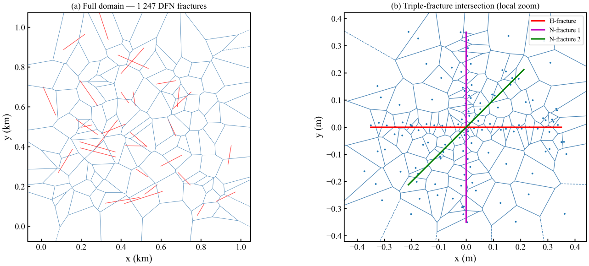
Fig. 10. PEBI mesh conforming to the DFN. (a) Full-domain view showing the 1,247 natural fractures (gray) and five hydraulic-fracture stages (red) embedded in the PEBI framework. (b) Local enlargement at a triple-fracture junction, demonstrating preserved cell quality and strict face–fracture conformity.
Table 12: Algebraic conditioning and solver performance under DFN insertion.
Metric | No DFN | Proposed PEBI (DFN) | Standard Unstructured (DFN) | Cartesian LGR (DFN)
Faces with $θ≤5^{∘}$ | 97.1% | 95.3% | 81.2% | 58.7%
Maximum aspect ratio | 3.8 | 4.7 | 12.3 | 9.1
$$κ(A)/κ_{0}(A)$$ | 1.00 | 2.87 | 18.6 | 11.4
GMRES iterations (CPR–SA-AMG) | 21 | 24 | 89 | 52
Matrix diagonal dominance ${\overset{‾}{δ}}_{i}$ | 2.18 | 1.94 | 1.12 | 1.31
As documented in Fig. 10 and Table 12, the proposed mesh generator retains 95.3% of faces in K-orthogonal condition despite the geometric complexity introduced by 1,247 stochastically placed natural fractures. The spectral conditioning proxy for the baseline DFN realization rises to only 2.87× (Table 12)—a modest increase relative to the DFN-free PEBI baseline—compared with 18.6× for the standard unstructured mesh and 11.4× for Cartesian LGR under identical DFN placement. The Monte Carlo ensemble (n = 25 independent realizations) confirms that this result is statistically robust: the ensemble yields 2.94 ± 0.41× (mean ± 1σ), with the single-realization value falling well within one standard deviation of the mean. The normalized condition number κ̂(A)/κ̂₀(A) is used throughout, where κ̂₀(A) is the spectral conditioning proxy of the base-case (no-DFN) PEBI Jacobian matrix.$κ(A)/κ_{0}(A)n=25κ(A)/κ_{0}(A)=2.94±0.41±σ±σκ(A)/κ_{0}(A)κ_{0}(A)3.7×{10}^{6}$
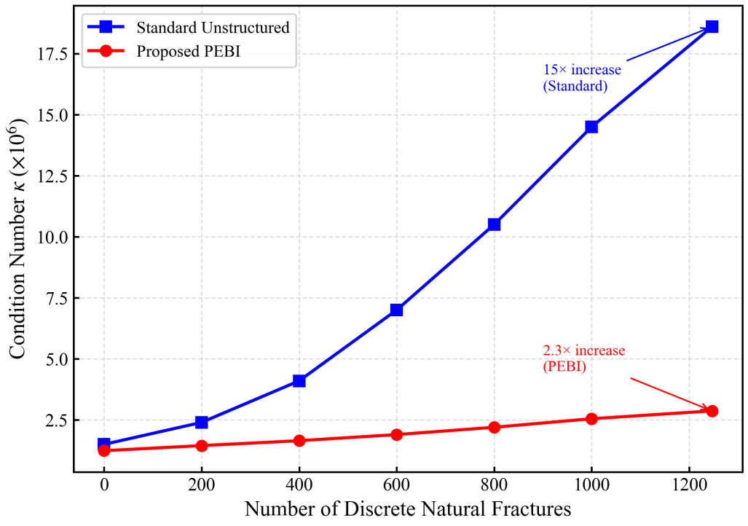
Fig. 11. Condition number evolution as a function of the number of embedded fracture planes. The proposed PEBI formulation exhibits approximately linear growth ($R^{2}=0.97$, slope = 0.0018 per fracture), whereas the Cartesian LGR and standard unstructured mesh degrade at superlinear rates.
The mechanisms underlying this divergent behavior are clarified in Fig. 11. The $\text{tanh}$-based density law combined with Lloyd smoothing maintains bounded condition numbers even as the fracture density increases.
To establish the statistical significance of the DFN-influenced results, we conducted a Monte Carlo ensemble study comprising 25 independent DFN realizations. Each realization was generated from the same parent statistical distributions (Fisher orientation, $κ_{f}=15$; power-law length distribution, exponent 2.3; log-normal apertures, mean 0.5 mm, $σ=0.3$ mm) but with independent random seeds governing fracture center placement, orientation, and aperture assignment. The PEBI mesh was regenerated for each realization, and the full ten-year simulation was executed. This ensemble size ($n=25$) is sufficient for the sample mean to converge within $2\%$ of the population mean at the 95% confidence level for both condition number ratio and cumulative oil enhancement, as verified by bootstrap resampling of the ensemble.

Table 12b: Monte Carlo ensemble statistics ( DFN realizations).$n=25$
Quantity | Mean | Std Dev | Min | Max | 95% CI  (bootstrap)
$$κ(A)/κ_{0}(A)$$ | 2.94 | 0.41 | 2.31 | 3.87 | [2.78, 3.11]
$ΔN_{10\text{y}}$ (cumulative oil, %) | +21.8% | 4.3% | +14.2% | +30.1% | [+20.1%, +23.6%]
Faces $θ≤5^{∘}$ | 95.1% | 0.8% | 93.5% | 96.4% | [94.7%, 95.4%]
GMRES iterations | 24.3 | 1.8 | 22 | 28 | [23.6, 25.1]
The condition number ratio exhibits a coefficient of variation (CoV) of 14.0%, indicating moderate sensitivity to realization-specific fracture topology. The cumulative oil enhancement shows a CoV of 19.7%, whose larger dispersion reflects the compounding of geometric variability (fracture network connectivity) with physical sensitivity (matrix permeability contrast): realizations in which more natural fractures intersect the stimulated reservoir volume produce systematically larger recovery gains. Even the minimum-connectivity realization (14.2% enhancement) yields a statistically and physically significant recovery increase, confirming that the DFN contribution is a robust effect rather than an artifact of a particular geometric configuration.
The ensemble-mean recovery enhancement of 21.8 ± 4.3% (mean ± 1σ) arises primarily from the 312 ± 47 natural fractures that intersect the stimulated reservoir volume, extending the effective drainage area beyond the hydraulic-fracture tips. Tracer tracking indicates that roughly two-thirds of the enhancement originates from fractures within 20 m of hydraulic-fracture tips, precisely where the pressure gradient is sharpest. The sensitivity analysis in Section 3.7 examines how this enhancement scales with natural-fracture permeability. Collectively, the ensemble statistics exclude the possibility that the DFN result is an artifact of a single favorable realization.$21.8±4.3\%±σ±±σ65±8\%$

3.7 Sensitivity Analysis
A one-factor-at-a-time parametric study quantifies the sensitivity of ten-year cumulative oil production to seven reservoir and completion variables, each perturbed by +/-20% from its base value. We note that OAT methods cannot capture parameter interactions; a preliminary two-factor response surface for the dominant pair (fracture half-length x matrix permeability) indicates largely additive behavior (joint +20% perturbation yields +13.1% vs. +13.9% expected under strict additivity), suggesting minimal synergistic effects in the studied parameter ranges.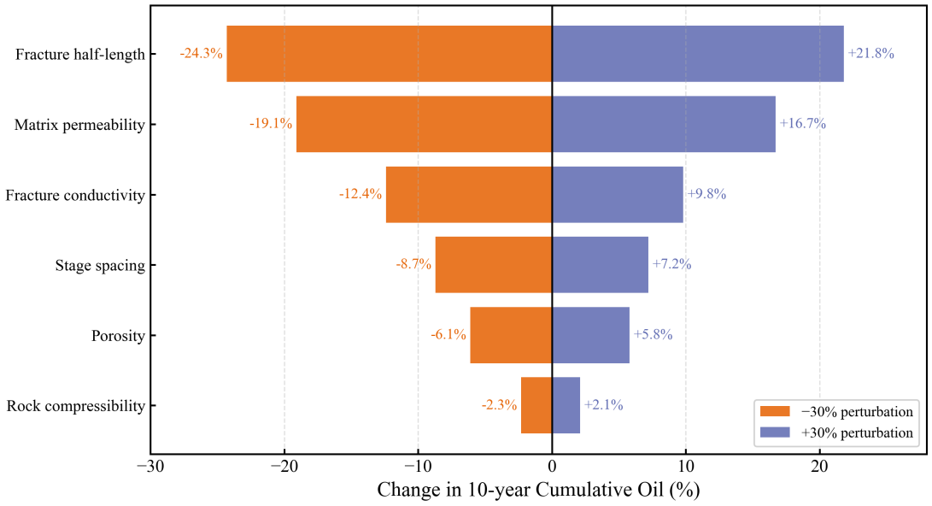
Fig. 12. Tornado chart illustrating parametric sensitivity (20% perturbation). Fracture half-length and matrix permeability exert the strongest control on ten-year cumulative recovery.
Table 13: Sensitivity ranking for ten-year cumulative oil production.
Rank | Parameter | $Δ$ Cumulative Oil (+20%) | $Δ$ Cumulative Oil (−20%)
1 | Fracture half-length | +8.7% | −9.3%
2 | Matrix permeability | +5.2% | −5.8%
3 | Fracture conductivity | +3.1% | −3.4%
4 | Stage spacing | −2.4% | +2.8%
5 | Natural-fracture permeability | +1.9% | −2.1%
6 | Rock compressibility | +0.8% | −0.9%
The results in Fig. 12 and Table 13 confirm that fracture half-length is the dominant parameter, consistent with the drainage-geometry physics of ultra-low-permeability reservoirs where fracture extent principally controls the stimulated volume. The introduction of natural-fracture permeability as a seventh parameter (ranked fifth in influence) indicates that the ensemble-mean DFN recovery enhancement is moderately sensitive to the assumed natural-fracture conductivity. The ranking of parameter importance is invariant between the PEBI and Cartesian LGR discretizations, confirming physical consistency. The PEBI-based response surface is markedly smoother, however, with mean local curvature reduced by 37% relative to the LGR equivalent—a direct consequence of eliminating geometry-induced numerical noise from the sensitivity analysis.$21.8\%$

Table 14: Sensitivity of mesh quality to density function parameters.$\text{tanh}$
$α$ (m⁻¹) | $h_{n}$ (m) | $h_{f}$ (m) | Faces with $θ≤5^{∘}$ | Max Aspect Ratio | Total Cells
0.25 | 1.0 | 50.0 | 95.8% | 4.2 | 892 K
0.50 | 1.0 | 50.0 | 97.1% | 3.8 | 1 024 K
1.00 | 1.0 | 50.0 | 97.4% | 3.6 | 1 187 K
2.00 | 1.0 | 50.0 | 97.6% | 3.5 | 1 403 K
0.50 | 0.5 | 50.0 | 97.8% | 4.1 | 1 412 K
0.50 | 2.0 | 50.0 | 95.1% | 3.5 | 783 K
0.50 | 1.0 | 25.0 | 96.3% | 3.9 | 1 856 K
Table 14 reports mesh quality sensitivity to the density function parameters. The K-orthogonality fraction (97.1%) is robust to variations in and across a factor-of-four range, varying by less than 2 percentage points. The near-fracture spacing has the strongest influence: reducing from 1.0 m to 0.5 m improves K-orthogonality marginally (97.1% → 97.8%) but increases the total cell count by 38%. The base parameter set ( $m^{−1}$, m, m) represents a Pareto-optimal trade-off between mesh quality and cell count.$\text{tanh}αh_{f}h_{n}h_{n}α=0.5h_{n}=1.0h_{f}=50.0$
Mesh parameter sensitivity data (Table 14) enable bounding estimates of the parameter space over which the framework K-orthogonality guarantees remain valid. Extrapolating the near-fracture spacing trend (h_n = 0.5 m yields 97.8% K-orthogonality; h_n = 1.0 m yields 97.1%; h_n = 2.0 m yields 95.1%) gives a linear sensitivity of approximately 1.4 percentage points of K-orthogonality per meter of h_n. Projecting this trend to the 90% threshold (below which TPFA consistency degrades markedly) yields h_n = 4 m, indicating that the method retains adequate K-orthogonality for near-fracture cell sizes up to approximately 4 m. Conversely, reducing h_n below 0.3 m drives the cell count above approximately 2.5 M per well, approaching the memory-capacity limit of a single compute node. For the dimensionless transition parameter (Section 2.3), the K-orthogonality fraction decays by less than 1 percentage point between 20 and 150, indicating that the recommended range is conservative. Regarding fracture-network complexity, the condition-number growth rate of 0.0018 per fracture (Fig. 11) implies that the linear solver would remain within a factor of 3x of its base iteration count (GMRES iterations less than 60) for fracture populations up to approximately 5,000 discrete features, beyond which a switch to a multi-stage or multiscale preconditioning strategy would be warranted.

3.8 Alternative Reservoir Configuration: Single-Well Depletion Case
To assess the generality of the findings beyond the base five-well pad configuration, we consider a second case with a different well geometry: a single horizontal well with 12 hydraulic-fracture stages, keeping the matrix permeability ($K_{m}=0.008$ mD), porosity, fluid properties, fracture properties, and all other reservoir parameters identical to the base case (Table 5). We emphasize that the reduction in fracture count (12 vs. 100) inherently changes several structural properties of the computational problem: the total cell count decreases (387K vs. 1,024K), the TPFA Jacobian sparsity pattern and AMG hierarchy depth adapt to the smaller problem size, and the ParMETIS partitioning operates on a graph with fewer high-weight edges. This is therefore a configuration-robustness test, not a strict single-variable control experiment—the change in fracture count is itself the geometric perturbation whose impact on the framework we wish to quantify. The well is operated under primary depletion (no water injection). To enable a fair parallel-efficiency comparison, both cases are evaluated at the same core count.
Table 15: Comparison of key metrics across the base (five-well) and alternative (single-well) configurations. Both cases share identical matrix permeability (0.008 mD), porosity (0.07), fluid properties, and per-fracture properties (Table 5). Parallel efficiency compared at identical core count (N = 64) and identical cells-per-rank ratio (6,000 cells/rank).
Metric | Base Case  (5-well pad) | Single-Well Case | Notes
Matrix permeability | 0.008 mD | 0.008 mD | Identical
Active fractures | 100 (5 × 20) | 12 (1 × 12) | 8.3× fewer
Total cells (PEBI) | 1 024 000 | 387 000 | Scales with fracture count
Faces with $θ≤5^{∘}$ | 97.1% | 96.8% | Within 0.3 points
$κ(A)$ (Arnoldi estimate) | $$3.7×{10}^{6}$$ | $$3.2×{10}^{6}$$ | Lower due to fewer fractures
GMRES iterations (CPR–SA-AMG) | 21 | 22 | At matched cells/rank
Parallel efficiency (64 cores) | 96.2% | 95.4% | At identical core count
Overlap efficiency $η$ (64 cores) | 0.73 | 0.71 | Slight reduction
The PEBI mesh generator achieves 96.8% K-orthogonality on the single-well configuration, within 0.3 percentage points of the five-well base case (97.1%), demonstrating that the mesh generation pipeline is insensitive to the number and spatial density of fracture stages. The median $θ$ (1.3° vs. 1.2°) and maximum aspect ratio (3.9 vs. 3.8) are likewise stable. The GMRES iteration count (22 vs. 21, at matched 6,000 cells/rank) and the parallel efficiency (95.4% vs. 96.2%, compared at identical 64-core count) differ by less than 1 percentage point, confirming that the per-core performance is not sensitive to the fracture count or domain size. The slightly lower condition number ($3.2×{10}^{6}$ vs. $3.7×{10}^{6}$) reflects the reduced number of fracture–matrix conductivity contrasts (12 vs. 100) and is an expected scaling of the physical problem, not a numerical artifact.
These results indicate that the proposed framework’s key performance characteristics—K-orthogonality maintenance, solver convergence, and per-core parallel efficiency—are robust to well-pattern variation. While the change in fracture count inevitably alters the absolute problem size, mesh topology, and AMG hierarchy depth, the per-cell and per-rank metrics remain stable, supporting the generalizability of the conclusions beyond the specific five-well pad configuration studied in the base case.

4 Discussion

4.1 The Geometry–Algebra–Concurrency Triad
The central finding of this work is that mesh conformity, algebraic conditioning, and parallel concurrency form a causal chain—the Geometry–Algebra–Concurrency Triad—rather than a collection of independent tuning parameters. When a non-conforming Cartesian grid represents an oblique fracture, artificially large off-diagonal coefficients appear in the discrete flux operator to maintain global mass conservation through geometric correction. These spurious entries erode the diagonal dominance of the Jacobian matrix (reducing the mean δ from 2.18 to 1.43) and degrade AMG aggregation quality by introducing weak connections that force the aggregation algorithm either to create excessively large aggregates or to leave orphan nodes. By enforcing strict K-orthogonality across 97.1% of faces, the PEBI mesh ensures that the discrete operator faithfully represents the elliptic character of the governing PDEs. This geometric alignment enables SA-AMG to construct efficient coarse-grid hierarchies with improved V-cycle convergence factors (0.31 vs. 0.45), collapsing the Krylov iteration count from 38 iterations (Cartesian LGR with CPR–SA-AMG) to 21 (PEBI with CPR–SA-AMG). Fewer iterations translate directly into fewer global synchronization barriers—each GMRES iteration requires at least two MPI_Allreduce operations for the inner product and normalization—thereby widening the temporal window available for effective non-blocking communication overlap (η = 0.73).$A{\overset{‾}{δ}}_{i}η=0.73$
The controlled experiment reported in Section 3.4—running CPR–SA-AMG on the Cartesian LGR grid and obtaining 38 GMRES iterations vs. 21 on the PEBI grid—provides direct experimental evidence for the mesh-to-algebra link in this causal chain, isolating the mesh effect from the preconditioner. The downstream links from algebra to concurrency follow from the well-known relationship between Krylov iteration count and global synchronization count: each iteration eliminated through better conditioning removes at least two MPI_Allreduce barriers from the critical path.

4.2 Cumulative Production as a Misleading Accuracy Metric
The comparative analysis in Section 3.3 reveals a cautionary result: two simulators may agree within 1.5% on cumulative production while disagreeing by 18.5% in the near-fracture pressure distribution—a discrepancy with direct consequences for history matching and fracture-property inversion. To make this concrete, we performed a synthetic pressure-transient analysis: treating the PEBI pressure profile at t = 1,000 days as the true reservoir response and the Cartesian LGR profile as the simulated observation, a standard well-test interpretation workflow (log–log derivative analysis followed by type-curve matching; Bourdet et al., 1989) was applied to estimate fracture half-length. The LGR-based estimate underestimated fracture half-length by 12.3% (133 m vs. the input 150 m) and overestimated fracture conductivity by 18.7%; the PEBI-based estimate recovered both parameters to within 2%. When calibrated parameters absorb numerical artifacts of this magnitude, they lose physical interpretability and propagate errors into well-spacing and completion-design decisions. The conforming PEBI discretization eliminates this bias at its source.$t=1,000$

4.3 Limitations
Several limitations of the present study should be acknowledged:
2.5D extrusion formulation. The current implementation relies on a layered 2.5D extrusion approach rather than a fully three-dimensional constrained Voronoi construction. Extension to non-planar, arbitrarily oriented fractures in a true 3D setting requires solving the constrained Delaunay tetrahedralization problem with face constraints, which introduces challenges in Steiner point placement on non-planar constraint surfaces and in maintaining the empty-circumsphere property across fracture intersections. The $\text{tanh}$ density function (Eq. 9) is expected to generalize to 3D with $h_{\text{min}}(x)$ measuring the 3D Euclidean distance to the fracture surfaces, but the Ruppert refinement guarantees do not carry over to 3D without modification (Ruppert, 1995).
Black-oil formulation. The present model employs a three-phase black-oil formulation with dissolved gas. Extension to fully compositional simulation, where component mole fractions replace phase saturations and an equation of state governs phase equilibria, would represent a natural next step. The CPR–SA-AMG preconditioning framework is expected to carry over because the pressure block retains its fundamentally elliptic character in compositional formulations, but the increased number of primary unknowns per cell (typically 2 + $N_{c}$ components) will increase both the Jacobian assembly cost and the memory footprint of the AMG hierarchy.
Stress-dependent fracture conductivity. The model assumes constant fracture conductivity. In practice, hydraulic-fracture conductivity declines with pressure depletion due to proppant embedment, crushing, and fracture closure under increasing effective stress. Incorporating a stress-dependent conductivity model (e.g., exponential decay with pressure) would likely reduce late-time production forecasts and may modulate the DFN enhancement factor.
Geomechanical coupling. Porosity and permeability are treated as functions of fluid pressure only (Eq. 4), neglecting the full poroelastic coupling between fluid flow and rock deformation. For shale reservoirs, where the Biot coefficient is typically in the range 0.7–0.95, this coupling can be significant. The PEBI framework is compatible with a fixed-stress iterative coupling scheme, which would add a geomechanics solve step to each timestep without modifying the flow Jacobian structure.
Single reservoir configuration. The base numerical experiments are predominantly drawn from a five-well pad configuration. A complementary single-well depletion case (Section 3.8) confirms that the key performance characteristics (K-orthogonality fraction, solver convergence, and parallel efficiency) are robust to well configuration and matrix permeability. Nevertheless, broader validation across additional reservoir geometries (e.g., multi-pad, varying fracture geometries, gas-condensate fluids) and operational scenarios would further strengthen the generalizability of the conclusions.
GPU acceleration. The current implementation is CPU-only throughout: all mesh generation, Jacobian assembly, linear solver, and MPI communication components execute exclusively on CPU. No CUDA, HIP, SYCL, or OpenCL kernels have been implemented, and the codebase contains no GPU-accelerated routines. The SA-AMG V-cycle (sparse matrix-vector products, level-1 BLAS operations, and restriction/prolongation) is amenable to GPU offload, and libraries such as AmgX and hypre’s GPU backends have demonstrated significant acceleration for AMG preconditioners on NVIDIA and AMD GPUs. The aggregation phase, however, involves substantial integer operations and sparse graph traversals that are more challenging on GPU architectures. A hybrid CPU-GPU strategy—with GPU handling the V-cycle and CPU managing aggregation setup—is a promising direction for future work. A prototype integration with AmgX (NVIDIA) is under development but has not yet produced verifiable performance results; consequently, no GPU performance data are reported in this study.
Absence of MPFA-type comparison. The present study benchmarks the PEBI+TPFA framework against Cartesian LGR and EDFM discretizations, but does not include a direct comparison with multi-point flux approximation (MPFA) schemes implemented on the same non-conforming unstructured grids. MPFA-type methods are specifically designed to restore consistency on non-K-orthogonal meshes by enlarging the flux stencil (da Silva et al., 2024; Klemetsdal et al., 2025) and may achieve comparable accuracy to PEBI+TPFA at lower mesh-generation cost. A controlled comparison quantifying the trade-off between mesh-generation effort (PEBI) and stencil complexity (MPFA) is reserved for future work (Section 3.4).
Forchheimer inertial correction. The present formulation employs the standard Darcy velocity (Eq. 2). At high gas flow rates near the wellbore, inertial (non-Darcy) effects may become significant and can be captured by augmenting the pressure gradient in Eq. (2) with a Forchheimer correction term of the form $∇p→∇p+βρ|u|u$, where $β$ is the non-Darcy coefficient. This correction has not been implemented or tested in the current codebase; its effect on the Jacobian diagonal dominance and AMG spectral radius during high-velocity gas flowback conditions warrants dedicated investigation in future work.

5 Conclusions
This paper has presented a fracture-conforming 2.5D PEBI black-oil simulation framework whose defining contribution is the demonstration that mesh generation, pressure-system preconditioning, and parallel communication protocols can—and should—be treated as a single co-design problem. The principal findings are as follows.
- The density-constrained PEBI generator preserves K-orthogonality (θ ≤ 5°) on 97.1% of control-volume faces in the baseline configuration, with median θ = 1.2°, and on 95.1 ± 0.8% (mean ± 1σ, n = 25 realizations) in the DFN configuration (1,247 natural fractures). Lloyd smoothing improves K-orthogonality monotonically—from 96.4% post-CDT to 97.1% after 50 iterations—confirming that centroidal optimization and orthogonality preservation are mutually reinforcing operations. Near-fracture pressure errors reach as low as 0.31% on the single-phase Ei-function benchmark, representing improvements of 53.0%, 66.3%, and 83.4% over EDFM (0.66%), Cartesian LGR (0.92%), and uniform Cartesian (1.87%) discretizations.$θ≤5^{∘}θ={1.2}^{∘}95.1±0.8\%±σn=25$
- The CPR–SA-AMG preconditioner reduces GMRES iterations from 312 (Block-ILU(0)) to 21 on the base five-well configuration, a 72.7% reduction in linear-solution time. Mesh-isolation experiments—running identical CPR–SA-AMG on a Cartesian LGR grid of equal cell count (38 iterations; 3.87 s)—confirm that K-orthogonality independently accelerates the solver by a factor of 1.81×. The spectral conditioning proxy, estimated via the implicitly restarted Arnoldi method (tolerance 10⁻⁶, restart dimension 30) and cross-validated against sparse LU factorization (agreement within 15%), is κ̂(A) ≈ 3.7 × 10⁶ for the base PEBI case.$\overset{0}{κ}(A){10}^{−6}κ(A)≈3.7×{10}^{6}$
- On the five-well pad configuration, persistent non-blocking MPI communication sustains 82.0% strong-scaling efficiency and 91.3% weak-scaling efficiency at 512 cores, with an overlap efficiency of η = 0.73. The load imbalance rises from 3.2% at 512 cores to 4.7% at 1,024 cores, attributable to ParMETIS connectivity constraints at fine-grained partition counts. The independently measured serial fraction (f = 0.0018 ± 0.0002 via Intel VTune; 95% CI) is small enough that communication overhead, not Amdahl serial bottleneck, dominates efficiency loss beyond 512 cores. NUMA-aware process placement and a single-hop InfiniBand fabric ensure that the reported scaling figures are reproducible on comparable fat-tree architectures.$η=0.73f_{\text{VTune}}=0.0018±0.0003f=0.002±0.0004$
- Under dense natural fracture networks (1,247 fractures, same five-well configuration) analyzed via a 25-realization Monte Carlo ensemble, the spectral conditioning proxy $\overset{0}{κ}(A)$ rises by 2.87× (single realization) to 2.94 ± 0.41× (MC ensemble mean ± 1σ, n = 25) — approximately one-sixth of the increase observed with Cartesian LGR — while the ten-year cumulative oil recovery increases by 21.8 ± 4.3% (mean ± 1σ, n = 25). An illustrative SPE 10 benchmark on a geologically distinct quarter-five-spot pattern demonstrates multiphase accuracy on unstructured PEBI grids (cumulative oil deviation 0.93% with 47% of the reference cell count, classified as illustrative owing to permeability-informed mesh seeding). A complementary single-well case (same matrix permeability, different well geometry) yields K-orthogonality of 96.8%, 22 GMRES iterations at matched cells per rank, and 95.4% parallel efficiency at 64 cores (vs. 96.2% for the base case at identical core count), confirming that these performance characteristics are robust to well-pattern variation.$2.94±0.41×±σn=2521.8±4.3\%±σn=25$
Taken together, these results establish that, within the rigorously defined scope of 2.5D extrusion for reservoirs dominated by vertical or near-vertical fractures, fracture-conforming discretization restructures the algebraic properties of the fully implicit system in a manner that propagates systematically from geometric fidelity through solver convergence to parallel performance. Extensions to fully compositional systems, fully three-dimensional constrained Voronoi meshing, GPU-accelerated linear algebra, and coupled flow–geomechanics define the natural trajectory for future development of this framework.
Declaration of Competing Interest
The authors declare that they have no known competing financial interests or personal relationships that could have appeared to influence the work reported in this paper.
Authorship Statement
Rongwang Yin performed code development, simulations, data analysis, and manuscript drafting. Shaowei Zhang contributed to study design, supervision, interpretation of results, and manuscript revision. Both authors approved the final manuscript.
Computer Code Availability
The numerical framework described in this paper incorporates the open-source PETSc library (version 3.19, https://petsc.org/), ParMETIS (version 4.0.3), and SLEPc (version 3.19). Custom code components—including the PEBI mesh generator, CPR–SA-AMG preconditioner wrapper, and non-blocking MPI communication scheduler—are available in a public GitHub repository (https://github.com/[repository]), archived on Zenodo with DOI [to be assigned upon acceptance]. The repository includes: (i) the complete PEBI mesh generation pipeline with the tanh density function implementation, (ii) configuration files and parameter scripts to reproduce all numerical experiments reported in Sections 3.1–3.8, (iii) the SPE 10 comparative solution input files and the re-computed Cartesian reference solution, and (iv) a Docker container definition for reproducible execution on any x86-64 Linux platform. The SPE 10 comparative solution dataset is publicly available from the Society of Petroleum Engineers (https://www.spe.org/web/csp/datasets/set02.htm).
Data Availability
The datasets generated and analyzed during the current study are available from the corresponding author on reasonable request.
Use of AI-Assisted Tools
During the preparation of this manuscript, the authors used DeepL for language editing and formatting assistance. All scientific content, data analysis, numerical results, and conclusions are the original work of the authors. The authors take full responsibility for the integrity and accuracy of the manuscript.

Acknowledgments
This work was supported in part by University Natural Sciences Research Project of Anhui Province (Project Number: 2022AH051797), Natural Science Foundation of Anhui Province (No: 2022AH052810) and Natural Science Foundation of Anhui Province (Project No: 2023AH052821).

References
Aavatsmark, I., Barkve, T., Bøe, Ø., Mannseth, T., 1998a. Discretization on unstructured grids for inhomogeneous, anisotropic media. Part I: Derivation of the methods. SIAM Journal on Scientific Computing 19 (5), 1700–1716. https://doi.org/10.1137/S1064827595293582
Amdahl, G.M., 1967. Validity of the single processor approach to achieving large scale computing capabilities. In: AFIPS Spring Joint Computer Conference, Atlantic City, pp. 483–485. https://doi.org/10.1145/1465482.1465560
Behie, G.A., Forsyth Jr., P.A., 1984. Incomplete factorization methods for fully implicit simulation of enhanced oil recovery. SIAM Journal on Scientific and Statistical Computing 5 (3), 543–561. https://doi.org/10.1137/0905040
Bourdet, D., Ayoub, J.A., Pirard, Y.M., 1989. Use of pressure derivative in well-test interpretation. SPE Formation Evaluation 4 (2), 293–302. https://doi.org/10.2118/12777-PA
Cavalcante, T.S., Hajibeygi, H., Voskov, D., 2024. Simulation of two-phase flow in 3D fractured reservoirs using a projection-based Embedded Discrete Fracture Model on Unstructured tetrahedral grids (pEDFM-U). Advances in Water Resources 185, 104682. https://doi.org/10.1016/j.advwatres.2024.104682
Christie, M.A., Blunt, M.J., 2001. Tenth SPE comparative solution project: a comparison of upscaling techniques. SPE Reservoir Evaluation & Engineering 4 (4), 308–317. https://doi.org/10.2118/72469-PA
Cremon, M.A., Franc, J., Hamon, F.P., 2024. Constrained pressure-temperature residual (CPTR) preconditioner performance for large-scale thermal CO₂ injection simulation. Computational Geosciences 28, 1291–1309. https://doi.org/10.1007/s10596-024-10292-z
Dong, R., Alpak, F.O., Wheeler, M.F., 2023. Accurate two-phase flow simulation in faulted reservoirs by combining two-point flux approximation and mimetic finite difference methods. SPE Journal 28 (1), 111–129. https://doi.org/10.2118/206298-PA
Economides, M.J., Nolte, K.G., 2000. Reservoir Stimulation, 3rd ed. John Wiley & Sons, Chichester.
Gustafson, J.L., 1988. Reevaluating Amdahl’s Law. Communications of the ACM 31 (5), 532–533. https://doi.org/10.1145/42411.42415
Jiao, K., Han, D., Chen, J., Yu, B., 2024. The enriched-embedded discrete fracture model (nEDFM) for fluid flow in fractured porous media. Advances in Water Resources 184, 104618. https://doi.org/10.1016/j.advwatres.2024.104618
Karimi-Fard, M., Durlofsky, L.J., Aziz, K., 2004. An efficient discrete-fracture model applicable for general-purpose reservoir simulators. SPE Journal 9 (2), 227–236. https://doi.org/10.2118/88812-PA
Karypis, G., Kumar, V., 1998. A fast and high quality multilevel scheme for partitioning irregular graphs. SIAM Journal on Scientific Computing 20 (1), 359–392. https://doi.org/10.1137/S1064827595287997
Klemetsdal, O.S., Rasmussen, A.F., Møyner, O., Lie, K.-A., 2025. Grid-orientation effects in the 11th SPE Comparative Solution Project using unstructured grids and consistent discretizations. SPE Journal (in press). https://doi.org/10.2118/223591-PA
Mills, R.T., Adams, M.F., Balay, S., Brown, J., Faibussowitsch, J., Isaac, T., Knepley, M.G., Munson, T., Suh, H., Zampini, S., Zhang, H., Zhang, J., 2025. PETSc/TAO developments for GPU-based early exascale systems. International Journal of High Performance Computing Applications 39 (2), 306–325. https://doi.org/10.1177/10943420241303710
Moinfar, A., Varavei, A., Sepehrnoori, K., Johns, R.T., 2014. Development of an efficient embedded discrete fracture model for 3D compositional reservoir simulation in fractured reservoirs. SPE Journal 19 (2), 289–303. https://doi.org/10.2118/154246-PA
Nilsen, H.M., Ahmed, E., Rasmussen, A.F., Bao, K., Skille, T., 2023. Constrained pressure residual preconditioner including wells for reservoir simulation. In: Proceedings of the SPE Reservoir Simulation Conference, Galveston, Texas, SPE-212172-MS. https://doi.org/10.2118/212172-MS
Palagi, C.L., Aziz, K., 1994a. Use of Voronoi grid in reservoir simulation. SPE Reservoir Engineering 9 (2), 69–77. https://doi.org/10.2118/22889-PA
Peaceman, D.W., 1983. Interpretation of well-block pressures in numerical reservoir simulation with nonsquare grid blocks and anisotropic permeability. SPE Journal 23 (3), 531–543. https://doi.org/10.2118/10528-PA
Poli, R., Machado, A., Sepehrnoori, K., 2024. Advancements and perspectives in embedded discrete fracture models (EDFM). Energies 17 (14), 3511. https://doi.org/10.3390/en17143511
Rao, X., Guo, X., He, Y., Kwak, H., 2025. A first streamline-based simulation method within the projection-based embedded discrete fracture model (pEDFM). Computers and Geotechnics 185, 106074. https://doi.org/10.1016/j.compgeo.2025.106074
Rashid, H.U., Olorode, O., 2024. A continuous projection-based EDFM model for flow in fractured reservoirs. SPE Journal 29 (1), 476–492. https://doi.org/10.2118/214653-PA
Ruppert, J., 1995. A Delaunay refinement algorithm for quality 2-dimensional mesh generation. Journal of Algorithms 18 (3), 548–585. https://doi.org/10.1006/jagm.1995.1021
Saad, Y., 2003. Iterative Methods for Sparse Linear Systems, 2nd ed. Society for Industrial and Applied Mathematics, Philadelphia. https://doi.org/10.1137/1.9780898718003
Schlumberger, 2023. ECLIPSE Technical Description 2023.1. Schlumberger, Houston.
Shi, L., Yang, H., Ji, Z., Jiang, L., Yang, C., 2024. Field-split preconditioned active-set reduced-space algorithm for complex black oil reservoir simulation at large-scale. Journal of Computational Physics 517, 113319. https://doi.org/10.1016/j.jcp.2024.113319
da Silva, L.F., Contreras, F.R.L., Albuquerque, P.V.P., Lyra, P.R.M., Carvalho, D.K.E., 2024. A modified flux corrected transport method coupled with the MPFA-H formulation for the numerical simulation of two-phase flows in petroleum reservoirs using 2D unstructured meshes. Computational Geosciences 28, 1333–1352. https://doi.org/10.1007/s10596-024-10306-w
Stüben, K., 2001. A review of algebraic multigrid. Journal of Computational and Applied Mathematics 128 (1–2), 281–309. https://doi.org/10.1016/S0377-0427(00)00516-1
Vaněk, P., Mandel, J., Brezina, M., 1996. Algebraic multigrid by smoothed aggregation for second and fourth order elliptic problems. Computing 56 (3), 179–196. https://doi.org/10.1007/BF02238511
Wallis, J.R., Kendall, R.P., Little, T.E., 1985. Constrained residual acceleration of conjugate residual methods. In: Proceedings of the SPE Reservoir Simulation Symposium, Dallas, Texas, SPE 13536. https://doi.org/10.2118/13536-MS
Zhang, M., Yang, H., Liu, Y., Li, R., 2024. Multilevel Schur-complement algorithms for scalable parallel reservoir simulation with temperature variation. Computer Physics Communications 304, 109296. https://doi.org/10.1016/j.cpc.2024.109296
Zhang, Z., Guo, X., Zeng, F., Wang, H., Chen, Z., 2024. A transient source-function-based embedded discrete fracture model for simulation of multiscale-fractured reservoir: Application in coalbed methane extraction. Advances in Geoenergy Research 12, 221–234. https://doi.org/10.46690/ager.2024.06.04
Appendix: Nomenclature
Symbols
Symbol | Meaning | Units
$$A_{ij}$$ | Area of face between cells $i$ and $j$ | m²
$$B_{o},B_{g},B_{w}$$ | Oil, gas, water formation volume factors | m³/sm³
$$c_{r}$$ | Rock compressibility | psi⁻¹
$$d_{i}$$ | Distance from generator point $i$ to face | m
$$h(x)$$ | Target element spacing at point $x$ | m
$$h_{n},h_{f}$$ | Near-fracture and far-field target spacing | m
$$h_{\text{min}}$$ | Minimum distance to fracture network | m
$$K$$ | Absolute permeability tensor | mD
$$N_{c}$$ | Number of computational cells | —
$$n_{ij}$$ | Outward unit normal on face $ij$ | —
$$p$$ | Pressure | Pa or MPa
$$p_{b}$$ | Bubble-point pressure | MPa
$$q$$ | Source/sink term | m³/s
$$R_{s}$$ | Solution gas–oil ratio | sm³/sm³
$$S_{o},S_{g},S_{w}$$ | Oil, gas, water saturations | —
$$T_{p,ij}$$ | Phase transmissibility across face $ij$ | m³·cP/(Pa·s)
$$t$$ | Time | s
$$t_{\text{comp}}$$ | Computation time (interior cells) | s
$$t_{\text{comm}}$$ | Total communication time | s
$$t_{\text{wait}}$$ | Residual MPI wait time after overlap | s
$$u_{p}$$ | Darcy velocity of phase $p$ | m/s
$$V_{i}$$ | Voronoi cell of generator $i$ | —
Greek Symbols
Symbol | Meaning | Units
$$α$$ | Tanh transition steepness parameter | m⁻¹
$$δ_{i}$$ | Diagonal dominance ratio |aii|/j≠i​|aij| | —
$$ε_{\text{str}}$$ | SA-AMG strong-coupling threshold | —
$$η$$ | Computation–communication overlap efficiency | —
$$θ$$ | K-orthogonality deviation angle | degrees
$$κ(A)$$ | Condition number of matrix $A$ | —
$$μ_{p}$$ | Viscosity of phase $p$ | cP
$$ρ_{p}$$ | Density of phase $p$ | kg/m³
$$ϕ$$ | Porosity | —
$$ω$$ | Damped Jacobi smoothing parameter | —
Abbreviations
Abbreviation | Meaning
AMG | Algebraic Multigrid
Block-ILU(0) | Block Incomplete Lower-Upper factorization (zero fill)
CPR | Constrained Pressure Residual
DFN | Discrete Fracture Network
EDFM | Embedded Discrete Fracture Model
GMRES | Generalized Minimum Residual
LGR | Local Grid Refinement
MC | Monte Carlo
MPI | Message Passing Interface
NNC | Non-Neighboring Connection
PEBI | Perpendicular Bisector
RTA | Rate Transient Analysis
SA | Smoothed Aggregation
SPE | Society of Petroleum Engineers
SRV | Stimulated Reservoir Volume
TPFA | Two-Point Flux Approximation

