ILLUMINATION

Step1: Input area of room // limited to square rooms, not sure if I want to split to length and width input fields

// as to eliminate external computations

Step2: input lamp lumens

Step3: choose coeff. Utilization // we need to research still the default value for this when nothing is inputted

// output is at initial illum.

Step4: choose a main. factor // inputting a value here will give a result in the maint.Illumination output

Step5: calculate

Luminance

Step1: input lamp lumens // or input total lumens and n=1

Step2: input number of lamps //

Step3: input transmission factor // we need to research still the default value for this when nothing is inputted

Step4: input room area // limited to square rooms, not sure if I want to split to length and width input fields

Step5: calculate

2D p-to-p

Step1: input lamp lumens //

Step2: compute for I //

Step3: input length and width of room // length = 2x , width = 2y

Step4: compute for d //

Step5: input theta // theta = arctan ( length / height)

// considering adding a height input field as to limit external computations

Step6: calculate

3D p-to-p

Step1: input lamp lumens //

Step2: compute for I //

Step3: input height, length and width of room

Step4: calculate

Tobe added in the immediate future:

Quantity of fixtures

Step1: subject to change

Metric: English:

TAB: ILLUMINATION



INPUT: lumens [ illumLumens ]

Area [ illumArea ]

CU [ illumCU ]

OUTPUT: INITIAL ILLUMINATION [ illumInitial ]**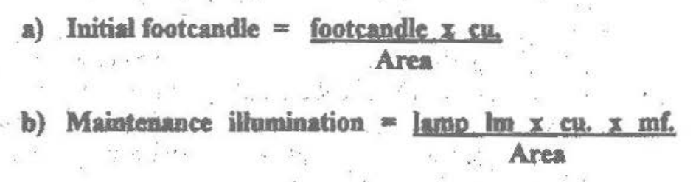

INPUT: lumens [ illumLumens ]

Area [ illumArea ]

CU [ illumCU ]

MF [ illumMF ]

OUTPUT: MAINTANANCE ILLUMINATION [ illumMaintained ]**

TAB: LUMINANCE



INPUT: lumens [ luminLumens ]

Transmission factor [ luminTF ]

Area [ luminArea ]

Number of lamps [ luminNumber ]

( multiply lumens by number of lamps for total)

*if luminNumber is not filled in, default=1

OUTPUT: footlambert [ luminOutput ]**

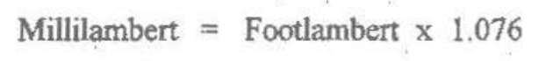

Millilambert = metric ; footlambert = English

/*

The output section on luminance has some contradictions…

Eto na lang muna ilagay mo kuya ^_^

*/

TAB: 2D POINT-BY-POINT

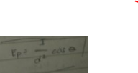 *d = sqrt( side2 + height2)

*I = lumens / 4π

INPUT: lumens [ twodLumens ]

Length of room (2X) [ twodLength ]

Width of room (2Y) [ twodWidth ]

Theta [twodAngle ]

*theta = arctan ( side / height )

OUTPUT: lux/fc [ twodOutput ]

TAB: 3D POINT-BY-POINT

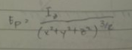 *that’s raised to 3/2

*I = lumens / 4π

*numerator is I * z

INPUT: lumens [ threedLumens ]

Length of room (2X) [ threedLength ]

Width of room (2Y) [ threedWidth ]

Height ( Z ) [ threedHeight ]

OUTPUT: lux/fc [ threedOutput ]

/* 2d and 3d are subject to change but that’s all I can do for now…

Will discuss with groupmates ^_^ */