irrb
User Manual
version 0.3



Features

The Irrlicht/Blender Exporter exports Blender scene and static node data to the native Irrlicht scene (.irr) and mesh (.irrmesh) file formats.
Implemented Features
- Blender Scene data is exported to Irrlicht native scene format (.irr).
- Blender Mesh data is exported to the Irrlicht native mesh format (.irrmesh).
- Export Blender Logic Properties as Irrlicht scene UserData.
- Export Lamp, Mesh, Camera, and Empty objects.
- Export Game Engine Materials and corresponding UV data.
- Export Blender Generated Lightmap/Baked Materials.
- Export Object Parent/Child relationships and transforms.
- Specify Textures as two-sided, transparent, and/or using lighting per face.
- UV Images may optionally be copied to a user specified location and format.
- Automatic translation between Blender and Irrlicht coordinate systems.
- Optionally "walk test" your scene immediately after it is exported using Irrlicht.
Working on for 0.4
- animation
- bug fixes
- tutorials
Todo
- Tangent & Binormal calculation for EVT_TANGENTS generation
- Sound nodes
- Collision
- Particles
- Triggers
- Animation

Installation
The latest stable download of irrb is accessible from both the "Project" and "Downloads" tabs of this Google Code project. On the "Projects" tab, irrb is listed in the "Featured Downloads" section.
The current version is 0.2. It may be downloaded from here:
irrb-0.2.zip
The contents of the zip package are:
irrb.py
irrbmodules/iExporter.py
irrbmodules/iFilename.py
irrbmodules/iGUI.py
irrbmodules/iMaterials.py
irrbmodules/iMesh.py
irrbmodules/iMeshBuffer.py
irrbmodules/irrblend.png
irrbmodules/iScene.py
irrbmodules/iTGAWriter.py
irrbmodules/iUtils.py
irrbmodules/__init__.py
irrbmodules/docs/changes.txt
irrbmodules/docs/UserManual.odt
irrbmodules/docs/UserManual.pdf

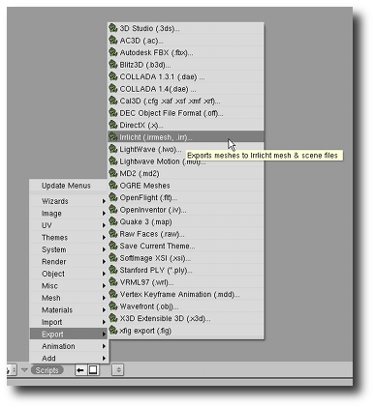
Unzip the contents of the zip file into either the Blender scripts directory (".blender/scripts") or the user defined scripts directory. It is important that the "irrbmodules" directory is created as a sub-directory underneath the Blender/User Defined scripts directory.
Linux users should install irrb to your user defined scripts directory. If you don't have one, create one and set the location in Blenders Preferences (Python:). This directory should also contain the sub-directories: "bpydata/config" in order for irrb to successfully save configuration options between Blender sessions. Failing to do so, will likely result in irrb's configuration data not being saved due to permission related problems.
After irrb has been installed, either restart Blender or refresh the Scripts menu by selecting "Update Menus" within the Blender scripts menu.
irrb should then appear as an option under the Blender Scripts|Export menu
Documentation on installing and configuring "iwalktest" for both Windows and Linux may be found here: irrb Utilities

Before You Start
Key Points
- Blender Objects map to Irrlicht scene nodes in scene files (.irr).
- Blender Mesh Data Blocks map to mesh files (.irrmesh).
- Multiple Blender Objects may link to the same Mesh Data Block. In this case only a single .irrmesh file will be generated and multiple nodes will be written to the scene file.
- irrb only exports materials that have been UV mapped to images set up in the UV/Image Editor. These are sometimes referred to as "Game Engine Materials".
Details
Before you start using irrb you should at the very least have a fundamental understanding of how to use Blender.
In order to better understand how irrb works with Blender, it will help you to look at the relationship between Blenders "Objects" and "DataBlocks".
You can find a technical explanation here: Blender Architecture
In simpler terms, Blender "Objects" (sometimes referred to as Nodes) specify the Position, Rotation, and Scale of the "DataBlock" that an "Object" links to. You may also have multiple "Objects" link to the same "DataBlock". Let's have a closer look.
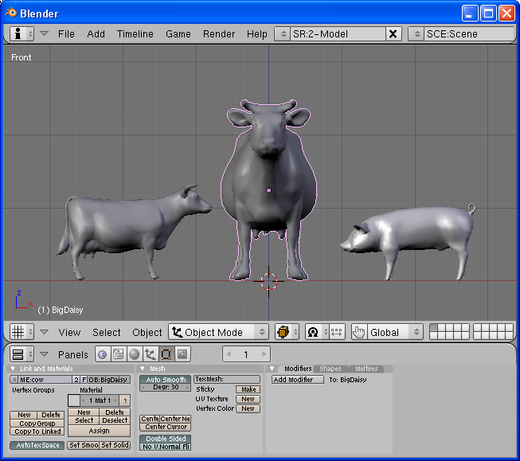
If the entire scene pictured above were to be exported, how many mesh files would be created and how many Irrlicht "nodes" would be written to the "Scene.irr" file?
- If you answered - 3 mesh files and 3 nodes. Keep reading.
- If you answered - 2 mesh files and 3 nodes. Keep reading.
- If you answered - it's not possible to tell from the image. You may skip to the next section.
The reason for not knowing what will be exported is that you must individually select both "cow" objects/nodes to find out if they are linked to the same or different mesh DataBlocks.

Selecting the cow on the far left (right click in object mode) and pressing F9 (edit mode window), we can see that this cow object is named "LilDaisy" (OB:LilDaisy) and it is linked to a mesh DataBlock named "cow" (ME:cow).
Selecting the cow in the middle would display an object named "BigDaisy" along with a link to a mesh DataBlock named "cow".
Selecting the pig on the far right would show the pigs object name is "Wilbur" and that it is linked to a mesh DataBlock named "pig".
Now that we know which Objects are linked to which DataBlocks, we can answer the question posed above - "How many mesh files will be created and how many nodes will be written to the Scene.irr file?". The answer is
- 3 nodes will be written to the Scene.irr file: "LilDaisy", "BigDaisy", and "Wilbur".
- 2 .irrmesh files will be created: "cow.irrmesh" and "pig.irrmesh".
The reason only a single "cow.irrmesh" is created is that both cow objects are linked to the same mesh DataBlock.
You may be asking yourself how can both cow objects use the same mesh file? The cow on the left (LilDaisy) is smaller and facing a different direction than BigDaisy. To answer that, let's have a look at the partial contents of the generated Scene.irr file (lamp and camera excluded):
<?xml version="1.0"?>
<!-- Created 03/10/2008 10:45 by irrb v0.2 - "Irrlicht/Blender Exporter" -->
<irr_scene>
<node type="mesh">
<attributes>
<string name="Name" value="LilDaisy" />
<int name="Id" value="-1" />
<vector3d name="Position" value="-0.880993, -0.278409, 0.000000" />
<vector3d name="Rotation" value="0.000000, -80.097466, 0.000000" />
<vector3d name="Scale" value="0.519058, 0.519058, 0.519058" />
<bool name="Visible" value="true" />
<bool name="AutomaticCulling" value="true" />
<bool name="DebugDataVisible" value="false" />
<bool name="IsDebugObject" value="false" />
<string name="Mesh" value="c:\test\meshes\cow.irrmesh" />
<bool name="ReadOnlyMaterials" value="false" />
</attributes>
</node>
<node type="mesh">
<attributes>
<string name="Name" value="BigDaisy" />
<int name="Id" value="-1" />
<vector3d name="Position" value="0.000000, 0.000000, 0.000000" />
<vector3d name="Rotation" value="0.000000, 0.000000, 0.000000" />
<vector3d name="Scale" value="1.000000, 1.000000, 1.000000" />
<bool name="Visible" value="true" />
<bool name="AutomaticCulling" value="true" />
<bool name="DebugDataVisible" value="false" />
<bool name="IsDebugObject" value="false" />
<string name="Mesh" value="c:\test\meshes\cow.irrmesh" />
<bool name="ReadOnlyMaterials" value="false" />
</attributes>
</node>
<node type="mesh">
<attributes>
<string name="Name" value="Wilbur" />
<int name="Id" value="-1" />
<vector3d name="Position" value="0.840124, -0.324030, -0.066227" />
<vector3d name="Rotation" value="-90.000000, 180.000000, -0.000000" />
<vector3d name="Scale" value="1.000000, 1.000000, 1.000000" />
<bool name="Visible" value="true" />
<bool name="AutomaticCulling" value="true" />
<bool name="DebugDataVisible" value="false" />
<bool name="IsDebugObject" value="false" />
<string name="Mesh" value="c:\test\meshes\pig.irrmesh" />
<bool name="ReadOnlyMaterials" value="false" />
</attributes>
</node>
</irr_scene>
We can see that both the LilDaisy and BigDaisy nodes reference the same mesh by looking at each nodes "Mesh" attribute:
<string name="Mesh" value="c:\test\meshes\cow.irrmesh" />
So how can LilDaisy be a different size, position, and orientation? Well, have a look at the "Position", "Rotation", and "Scale" attributes (transform data) for each node in the Scene.irr data. They are different. Looking back at Image 2, we can see that Blender's Object "Transform Properties" are exported to the Scene.irr file. Compare LilDaisy's properties in Image 2, to those that were created in the Scene.irr file. They are the same, except that Blender's Y and Z axis information have been rearranged for your convenience.
irrb honors Blender's Object
<->
DataBlock relationships. This may cause unexpected results especially when exporting Meshes only. More on this later.

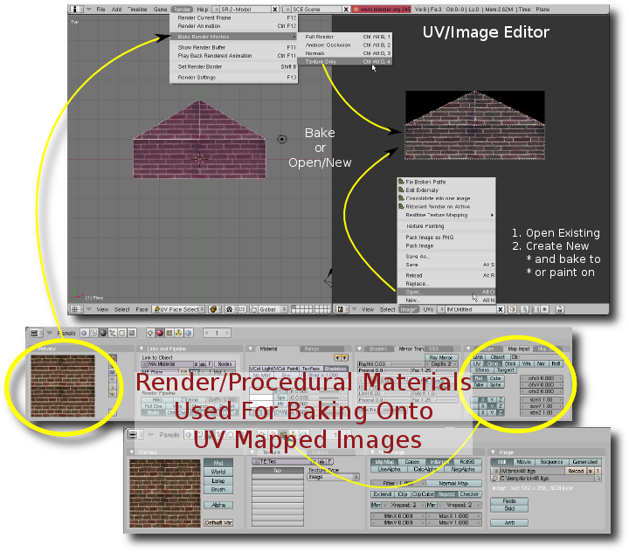
As stated in the key points, irrb only exports images that have been assigned in the UV/Image editor. From Image 3 you can see that images may be "assigned" from two different sources:
- Open an existing image.
- Create a new blank Image.
Once an image has been assigned to a particular UV layer, you may optionally use Blenders powerful render/procedural material system to create new textures via baking.
It is important to understand that render/procedural materials are NOT exported. They are simply used for creating textures, lightmaps, and/or normal maps.

Starting The Exporter
The easiest and quickest way to call up irrb is to select it from the menu: File | Exporters | Irrlicht. Using this method will typically cause the irrb interface to overlay the active window possibly hiding your 3D view.
If you repeatedly export and examine your scene using iwalktest, you may find it convenient to run the exporter in "split" screen mode:
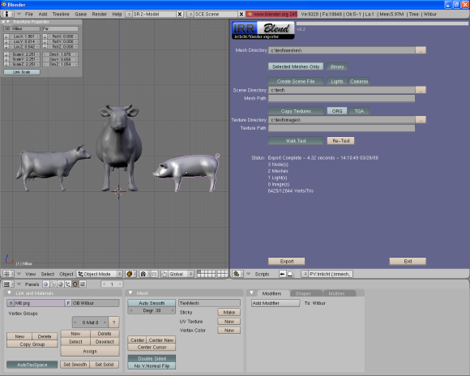
Steps to create a split screen with irrb in the right half of the Blender window:
- Right click the top border of the 3D view window.
- Select the "Split Area" menu option.
- Move the divider to the middle of the 3D view and left click to anchor it.
- Select "Scripts Window" for the window type (lower left corner of the right half of the screen).
- In the "Scripts" menu, select "Export" and then "Irrlicht".

