
irrb
User Guide
version 0.6

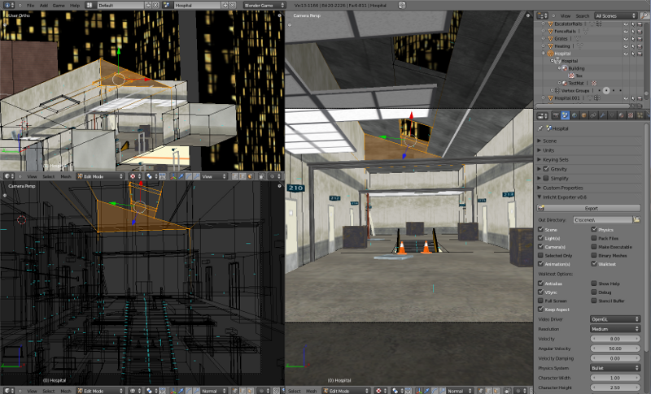
irrb-0.6.blend Link

Copyright 2008-2011 Tubras LTD
All Rights Reserved

This document and its contents were created using LibreOffice 3.2, GIMP 2.6, and Inkscape 0.48.

Table of Contents
Chapter 1 Features 1
Chapter 2 Installation & Requirements 2
Requirements 3
Chapter 3 Before You Start 4
Chapter 4 Starting The Exporter 10
Chapter 5 The irrb Interface 11
Chapter 6 Output File Generation 14
Chapter 7 Saving Packed Images 16
Chapter 8 Irrlicht Material Generation 18
Irrlicht Standard Material Types 19
Chapter 9 Running The Exporter 22
Chapter 10 iwalktest Integration And Usage 23
Chapter 11 Binary Mesh Format 24
Chapter 12 ID Properties 26
Default Property Attributes 28
Blender's ID Property Editor 28
Generating ID Properties 30
Material ID Properties 31
Accessing User Attributes 32
Chapter 13 Exporting Cameras And Lights 33
Chapter 14 Exporting Billboards 36
Chapter 15 Exporting A Skybox 37
Chapter 16 Exporting Fog 38
Chapter 17 Exporting Collision & Physics Data 40
Chapter 18 irrb Utilities 45
Installation 45
Configuration 45
iwalktest Usage 49
imeshcvt Usage 51
Chapter 19 Notes 52
Chapter 20 FAQ 53

Features

The Irrlicht/Blender Exporter exports Blender scene and static node data to the native Irrlicht scene (.irr) and mesh (.irrmesh) file formats.
Implemented Features
- Blender Scene data is exported to Irrlicht native scene format (.irr).
- Blender Mesh data is exported to the Irrlicht native mesh format (.irrmesh).
- Export Blender ID Properties and Logic Properties as Irrlicht scene UserData.
- Export Blender Lamp, Mesh, Camera, and Empty objects.
- Export Game Engine Materials and corresponding UV data.
- Export Blender Generated Lightmap/Baked Materials.
- Export Object Parent/Child relationships and transforms.
- Export Irrlicht Skybox, SkyDome, and Billboards.
- Export Fog – Blender Mist settings.
- Export Collision, Sensor, Constraint, and Rigid body physics data.
- Export materials that require Irrlicht's EVT_TANGENTS vertex type.
- Export Irrlicht's hardware mapping hints.
- Export Meshes with 64k+ vertices.
- Export Meshes as Octree nodes.
- Export Volumetric Light and Water Surface nodes.
- Specify Textures as two-sided, transparent, and/or using lighting per face.
- Blender Packed UV Images are automatically saved to disk.
- Automatic translation between Blender and Irrlicht coordinate systems.
- Export all assets (scene, mesh, & textures) to a single file (.zip).
- Optionally generate a 32 and/or 64 bit executable with embedded assets.
- Optionally "walk test" your scene immediately after it has been exported using the Irrlicht render engine.

Working on for 0.7
- Particles
- iwalktest Bullet Integration

Todo
- Sound nodes
- Animation

Installation & Requirements
The latest stable download of irrb is accessible from both the "Project Home" and "Downloads" tabs of the Tubras Google Code project. On the "Project Home" tab, irrb is listed in the "Featured Downloads" section.
The current version is 0.6. It may be downloaded from here:
http://tubras.googlecode.com/files/irrb-0.6.zip
The contents of the zip package are:
io_export_irrlicht.py
docs/changes.txt
docs/license.html
docs/UserGuide.pdf

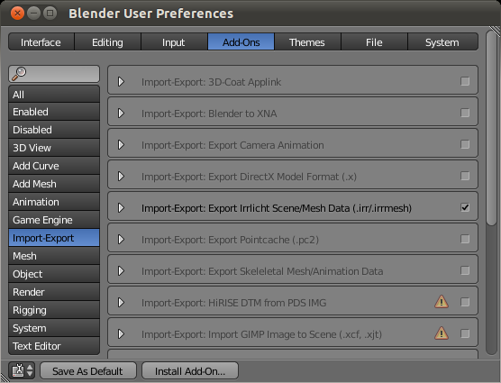
To install irrb, unzip the contents of the zip file into a temporary directory and install it as a Blender “addon”.
1. Start Blender and call up the “User Preferences” dialog (File | User Preferences..).
2. Click on the “Add-Ons” tab and the the “Install Add-On...” button located at the bottom of the dialog.
3. Navigate to the directory that you previously unzipped the irrb zip file to, select the file “io_export_irrlicht.py”, and then click the “Install Add-On...” button.
4. Locate the irrb exporter in the “Import-Export” section and enable it by selecting the check box.
If you would like irrb to be automatically activated every time you start Blender, then click the “Save As Default” button located at the bottom of the dialog. If you don't click “Save As Default”, you will need activate the irrb add-on each time you start up Blender.
Documentation on installing and configuring "iwalktest" for both Windows and Linux may be found here: irrb Utilities

Requirements
Blender - Supported Blender Versions are 2.56+
Python – irrb uses Blender's internal version of Python 3.x so you are not required to install Python.

Before You Start
Key Points
- Blender Objects map to Irrlicht scene nodes in scene files (.irr).
- Blender Mesh Data Blocks map to mesh files (.irrmesh).
- Multiple Blender Objects may link to the same Mesh Data Block. In this case only a single .irrmesh file will be generated and multiple nodes will be written to the scene file.
- irrb only exports materials that have been UV mapped to images set up in the UV/Image Editor. These are sometimes referred to as "Game Engine Materials".
Details
Before you start using irrb you should at the very least have a fundamental understanding of how to use Blender.
In order to better understand how irrb works with Blender, it will help you to look at the relationship between Blenders "Objects" and "DataBlocks".
You can find a technical explanation here: Blender Architecture
In simpler terms, Blender "Objects" (sometimes referred to as Nodes) specify the Position, Rotation, and Scale of the "DataBlock" that an "Object" links to. You may also have multiple "Objects" link to the same "DataBlock". Let's have a closer look.
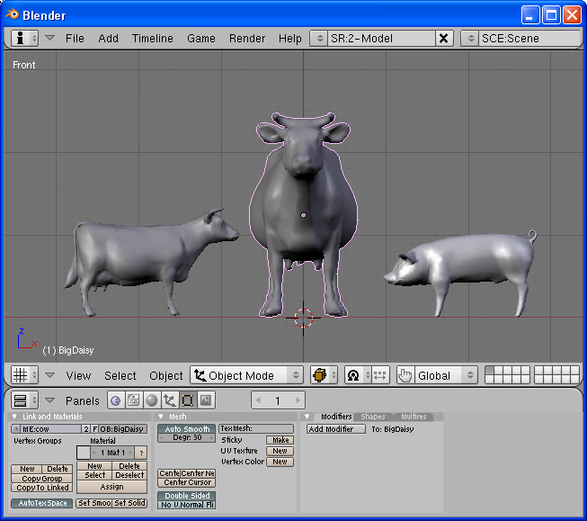Illustration 1: LilDaisy, BigDaisy, and Wilbur.
If the entire scene pictured above were to be exported, how many mesh files would be created and how many Irrlicht scene "nodes" would be written to the "Scene.irr" file?
- If you answered - 3 mesh files and 3 nodes. Keep reading.
- If you answered - 2 mesh files and 3 nodes. Keep reading.
- If you answered - it's not possible to tell from the image. You may skip to the next section.
The reason for not knowing what will be exported is that you must individually select both "cow" objects/nodes to find out if they are linked to the same or different mesh DataBlocks.
Illustration 2: object and mesh datablock links.
Selecting the cow on the far left (right click in object mode) and pressing F9 (edit mode window), we can see that this cow object is named "LilDaisy" (OB:LilDaisy) and it is linked to a mesh DataBlock named "cow" (ME:cow).
Selecting the cow in the middle would display an object named "BigDaisy" along with a link to a mesh DataBlock named "cow".
Selecting the pig on the far right would show the pigs object name is "Wilbur" and that it is linked to a mesh DataBlock named "pig".
Now that we know which Objects are linked to which DataBlocks, we can answer the question posed above - "How many mesh files will be created and how many nodes will be written to the Scene.irr file?". The answer is
- 3 nodes will be written to the Scene.irr file: "LilDaisy", "BigDaisy", and "Wilbur".
- 2 .irrmesh files will be created: "cow.irrmesh" and "pig.irrmesh".
The reason only a single "cow.irrmesh" is created is that both cow objects are linked to the same mesh DataBlock.
You may be asking how can both cow objects use the same mesh file? The cow on the left (LilDaisy) is smaller and facing a different direction than BigDaisy. To answer that, let's have a look at the partial contents of the generated Scene.irr file (lamp and camera nodes excluded):
<?xml version="1.0"?>
<!-- Created 11/26/2009 10:45 by irrb v0.4 - "Irrlicht/Blender Exporter" -->
<irr_scene>
<node type="mesh">
<attributes>
<string name="Name" value="LilDaisy" />
<int name="Id" value="-1" />
<vector3d name="Position" value="-0.880993, -0.278409, 0.000000" />
<vector3d name="Rotation" value="0.000000, -80.097466, 0.000000" />
<vector3d name="Scale" value="0.519058, 0.519058, 0.519058" />
<bool name="Visible" value="true" />
<bool name="AutomaticCulling" value="true" />
<bool name="DebugDataVisible" value="false" />
<bool name="IsDebugObject" value="false" />
<string name="Mesh" value="meshes\cow.irrmesh" />
<bool name="ReadOnlyMaterials" value="false" />
</attributes>
</node>
<node type="mesh">
<attributes>
<string name="Name" value="BigDaisy" />
<int name="Id" value="-1" />
<vector3d name="Position" value="0.000000, 0.000000, 0.000000" />
<vector3d name="Rotation" value="0.000000, 0.000000, 0.000000" />
<vector3d name="Scale" value="1.000000, 1.000000, 1.000000" />
<bool name="Visible" value="true" />
<bool name="AutomaticCulling" value="true" />
<bool name="DebugDataVisible" value="false" />
<bool name="IsDebugObject" value="false" />
<string name="Mesh" value="meshes\cow.irrmesh" />
<bool name="ReadOnlyMaterials" value="false" />
</attributes>
</node>
<node type="mesh">
<attributes>
<string name="Name" value="Wilbur" />
<int name="Id" value="-1" />
<vector3d name="Position" value="0.840124, -0.324030, -0.066227" />
<vector3d name="Rotation" value="-90.000000, 180.000000, -0.000000" />
<vector3d name="Scale" value="1.000000, 1.000000, 1.000000" />
<bool name="Visible" value="true" />
<bool name="AutomaticCulling" value="true" />
<bool name="DebugDataVisible" value="false" />
<bool name="IsDebugObject" value="false" />
<string name="Mesh" value="meshes\pig.irrmesh" />
<bool name="ReadOnlyMaterials" value="false" />
</attributes>
</node>
</irr_scene>
We can see that both the LilDaisy and BigDaisy nodes reference the same mesh by looking at each nodes "Mesh" attribute:
<string name="Mesh" value="meshes\cow.irrmesh" />
So how can LilDaisy be a different size, position, and orientation? Well, have a look at the "Position", "Rotation", and "Scale" attributes (transform data) for each node in the Scene.irr file. They are different. Looking back at Illustration 2, we can see that Blender's Object "Transform Properties" are exported to the Scene.irr file. Compare LilDaisy's properties in Image 2 to those that were created in the Scene.irr file. They are the same, except that Blender's Y and Z axis information have been rearranged for your convenience.

irrb honors Blender's Object DataBlock relationships. This may cause unexpected results especially when exporting Meshes only. More on this later.
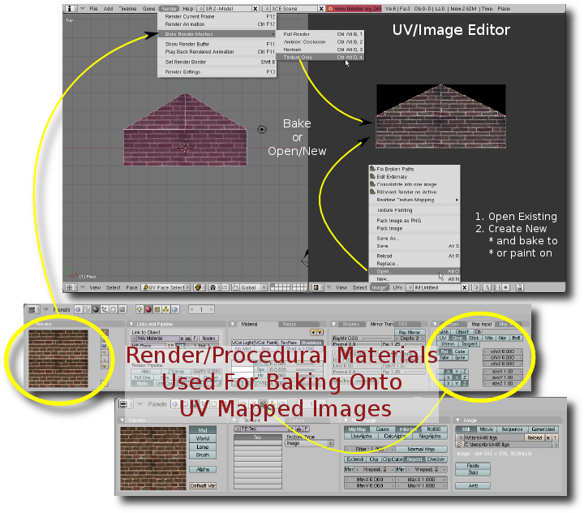Illustration 3: The lil' big picture.
As stated in the key points, irrb only exports images that have been assigned in the UV/Image editor. From Illustration 3, you can see that images may be "assigned" from two different sources:
- Open an existing image.
- Create a new blank Image.
Once an image has been assigned to a particular UV layer, you may optionally use Blenders powerful render/procedural material system to create new textures via baking.
It is important to understand that render/procedural materials are NOT exported. They are simply used for creating textures, lightmaps, and/or normal maps.

Starting The Exporter
The quickest way to start irrb is to select it from Blenders File menu: “File | Exporters | Irrlicht”. Using this method will typically cause the irrb interface to overlay the active window possibly hiding your 3D view. If you repeatedly export and examine your scene using iwalktest, you may find it convenient to run the exporter in "split" screen mode:
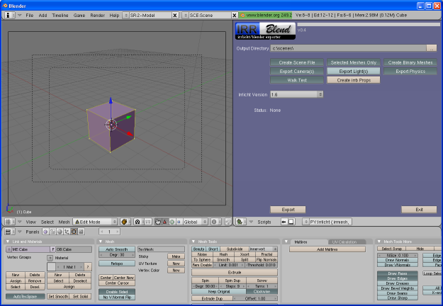Illustration 4: Split Screen View
Steps to create a split screen with irrb in the right half of the Blender window:
- Right click the top border of the 3D view window.
- Select the "Split Area" menu option.
- Move the divider to the middle of the 3D view and left click to anchor it.
- Select "Scripts Window" for the window type (lower left corner of the right half of the screen).
- In the "Scripts" menu, select "Export" and then "Irrlicht".

The irrb Interface
First time irrb users will see Illustration 5 with the default options:
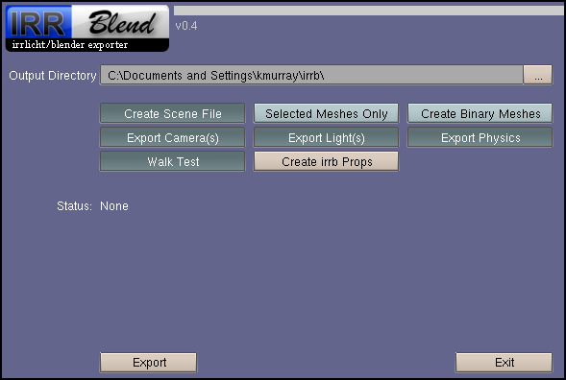Illustration 5: irrb Default Options.
For both Windows and Linux, the Output Directory will default to a sub-directory named “irrb” underneath the user “home” directory.
irrb stores your preferences and directory locations in a configuration file so your favorite options are remembered between Blender sessions.
Let's take a quick look at all of the irrb options:

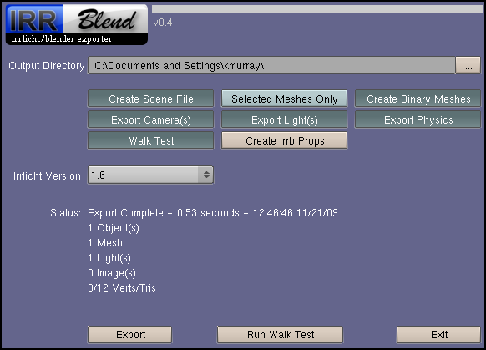Illustration 6: irrb Options.
(note that light/dark green buttons are "toggle" buttons)
Output Directory – This is the directory location where irrb will export data to. When "Create Scene File" is enabled, the scene file (.irr) is written to this directory and mesh and packed textures are exported to "mdl" and "tex" sub-directories respectively. For example, if the "Output Directory" field is set to "c:/scenes/" and the scene contains a cube mesh with one packed texture named "cubediff.png", the following files will be generated:
c:/scenes/Scene.irr // the scene file
c:/scenes/mdl/Cube.irrmesh // the cube mesh/model file
c:/scenes/tex/cubediff.png // the cube texture
All references are written relative to the Output Directory. For example, the Mesh node in the Scene.irr file would reference the Cube mesh as "mdl/Cube.irrmesh". Additional information on the generated output may be found in the section named "Output File Generation".
Create Scene File - Toggle button used to control whether or not a scene file (".irr") is generated. If selected, scene related options will appear.
Selected Meshes Only - This toggle button will only export meshes that are selected in the current scene. When un-selected, all nodes and linked meshes will be exported.
Create Binary Meshes - This toggle button will only appear if you have the imeshcvt utility installed and properly configured. When selected, the meshes will be exported using the experimental ".irrbmesh" (binary .irrmesh) format. imeshcvt is the program used to convert from .irrmesh to .irrbmesh. The original .irrmesh files are left intact. For more information on the .irrbmesh format, see the section named "Binary Mesh Format".
Export Camera(s) - Toggle button to indicate whether or not to write camera objects to the ".irr" scene file.
Export Light(s) - Toggle button to indicate whether or not to write light objects to the ".irr" scene file.
Export Physics – Toggle button to indicate whether or not to include collision/physics data in the ".irr" scene file.
Walk Test – This toggle button that will appear if you have the IWALKTEST OS environment variable defined. When selected, the program defined by the IWALKTEST environment variable is executed with your exported scene file as parameter immediately after a successful export. The "irrb Utilities" contains a program that you may use to examine an exported scene.
Create irrb Properties – This push button creates "irrb" default ID Properties for selected objects and Blender materials. When clicked, the "Status" area will display information on the number of objects that were updated. For more information on creating "irrb" ID Properties, see the section named: ID Properties.
Irrlicht Version – This experimental option allows you to select the target Irrlicht version for binary meshes. It will only appear if the "Create Binary Meshes" option is selected.
Export - Makes the magic happen.
Run Walk Test - Button that re-runs the iwalktest application with the last scene exported.
Exit - Exits the irrb export script.

Output File Generation
Key Points
- References to mesh and image locations are ALL relative.
- The relative location is based on the location of the "Output Directory" field.

Details
irrb allows you to choose a single Output Directory. Depending on whether or not you choose to export a scene file, irrb behaves as follows:
- “Create Scene File” - Not Selected. All mesh files (.irrmesh) and packed images are saved to the Output Directory location.
- “Create Scene File” - Selected. All mesh files (.irrmesh) are saved to a sub-directory named “mdl” (model) underneath the Output Directory location. All packed textures are saved to a sub-directory named “tex” underneath the Output Directory location.
Given:
- You are exporting a singe scene named “test”.
- The scene contains a single cube named “Cube”, and a packed texture named “checkers.png”.
- The “Ouput Directory” is set to “c:\scenes\”.
The following will be generated:
c:/scenes/test.irr // scene file
c:/scenes/mdl/Cube.irrmesh // Cube mesh
c:/scenes/tex/checkers.png // checkers texture
All mesh and texture references will be relative to the “Output Directory”. In the example above, the test.irr scene file will reference the Cube mesh as “mdl/Cube.irrmesh”:
<node type="mesh">
<attributes>
<string name="Mesh" value="mdl/Cube.irrmesh"/>
The Cube.irrmesh file will reference the checkers texture as “tex/checkers.png”:
<buffer>
<material bmat="uvmat:checkers.png:00100">
<texture name="Texture1" value="tex/checkers.png"/>
Note that non-packed texture references are also written relative to the “Output Directory”. For example, if you open and assign an existing image (“c:\myimages\patterns\brick.png”) to the Cube UV map, the Cube.irrmesh texture reference would then look like:
<buffer>
<material bmat="uvmat:checkers.png:00100">
<texture name="Texture1" value="../myimages/patterns/brick.png"/>

iwalktest can be very useful for determining why a mesh isn't appearing in a scene and/or why a texture isn't appearing properly. The first question to ask yourself: "Is the mesh/texture being loaded?". iwalktest will log mesh/texture loading errors to its log file "iwalktest.log" which is located in the same directory as the iwalktest executable. Windows users can also check for load errors in the iwalktest console window if it is configured to be displayed (default).

Saving Packed Images
Key Points
- Blender allows you to create UV mapped images within Blender itself. The newly created images can be saved to disk or optionally “packed” (saved within the .blend file).
- Packed images are a convenient method for exchanging .blend files with other artists without having to worry about keeping external images/textures in sync.
- irrb automatically saves packed images to disk when exporting.

Details
Blender allows you to "pack" texture images. This means the images are physically stored inside of the .blend file. Images that are stored in the .blend file will NOT be accessible to the application that is loading an exported scene or mesh file.
Why pack images then? As mentioned above - convenience. Especially if you exchange .blend files with someone else working on a scene/mesh.
Regardless of the image source (externally opened or created within Blender), you can pack and unpack an image by clicking on the packing icon:
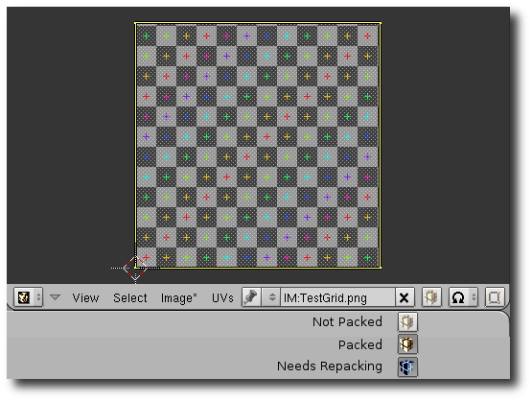Illustration 7: Blender Image Pack Icons
- Top icon indicates the current image is NOT packed.
- Middle icon indicates the current image is packed.
- Bottom icon indicates the current image needs to be re-packed.
Images will only need to be re-packed if the original image was previously packed and then the image is later modified via baking or texture painting.
Images that are created by Blender and neither packed or saved, are stored internally in the .blend file as 24 bit TGA images. It is important to note that if you modify (texture paint or bake) an image created within Blender, the modifications are not saved internally in the .blend file. In order to save modifications, you must either pack the image or save it to an external file.

Irrlicht Material Generation
Key Points
- irrb generates Irrlicht materials based on a Blender UV Layer name.
- UV Images map directly to the Irrlicht material "Texture#" attribute. Top UV image is written to "Texture1", Second UV image is written to "Texture2"...
Details
irrb generates Irrlicht materials based on Blenders UV layer stack. All of Irrlicht's standard Materials require either one or two images to be assigned to a materials "texture" attributes located in the .irrmesh file:
<material bmat="uvmat:untitled:100">
<enum name="Type" value="lightmap_m2"/>
...
<texture name="Texture1" value="cowuvmap.tga"/>
<texture name="Texture2" value="lightmap.tga"/>
<texture name="Texture3" value=""/>
<texture name="Texture4" value=""/>
...
</material>
irrb maps the images assigned in Blender's UV layer stack to the Irrlicht Texture# attribute one to one:
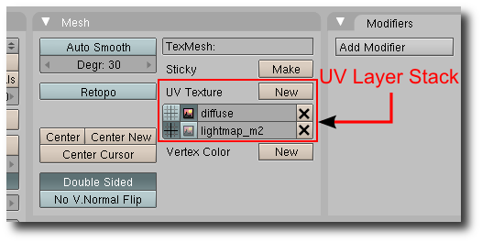
The image assigned to the top layer is written to the Texture1 attribute. The image assigned to the second layer is written to the Texture2 attribute.
From the example above you can see a material section in the .irrmesh file format allows up to four texture layers to be defined even though the standard Irrlicht materials only require up to two.
So how does irrb determine the type of material to generate? (enum name="Type" value="lightmap_m2")
Easy, you assign one of Blenders UV layer names an Irrlicht material name that matches one of Irrlicht's built-in standard material names. The built-in standard Irrlicht material names may be found in the "ematerialtypes.h". file. The material names are also defined below for your convenience.
Starting with Blender's top layer in the UV layer stack and working its way down, irrb looks for a match against Irrlicht's material names. If it finds a match, the matching material name will be used as the material type value.
If no match is found, irrb defaults the material type to "solid".
irrb is also capable of generating material types that match your custom material renderer which you register with either addMaterialRenderer() or addAndDropMaterialRenderer(). To do this, simply prefix your custom material name with a "$" in the Blender UV Layer Name. For example, if you have a custom material renderer named "MyMaterial", you would enter "$MyMaterial" in one of Blenders UV layer names. irrb will remove the $ and generate:
<material bmat="uvmat:untitled:100">
<enum name="Type" value="MyMaterial"/>
...
</material>

Irrlicht Standard Material Types
solid - Standard solid material. Only first texture is used as the diffuse texture.
solid_2layer - Solid material with 2 texture layers. The second is blended onto the first using the alpha value of the vertex colors. This material is currently not implemented in OpenGL, but it works with DirectX.
lightmap - Material type with standard lightmap technique: There should be 2 textures: The first texture layer is a diffuse map, the second is a light map. Vertex light is ignored.
lightmap_add - Material type with standard lightmap technique but lightmap and diffuse texture are not modulated, but added instead.
lightmap_m2 - Material type with standard lightmap technique: There should be 2 textures: The first texture layer is a diffuse map, the second is a light map. Vertex light is ignored. The texture colors are effectively multiplied by 2 for brightening.
lightmap_m4 - Material type with standard lightmap technique: There should be 2 textures: The first texture layer is a diffuse map, the second is a light map. Vertex light is ignored. The texture colors are effectively multiplied by 4 for brightening.
lightmap_light - Like lightmap, but also supports dynamic lighting.
lightmap_light_m2 - Like lightmap_m2, but also supports dynamic lighting.
lightmap_light_m4 - Like lightmap_m4, but also supports dynamic lighting.
detail_map - Detail mapped material. The first texture is diffuse color map, the second is added to this and usually displayed with a bigger scale value so that it adds more detail. The detail map is added to the diffuse map using ADD_SIGNED, so that it is possible to add and substract color from the diffuse map. For example a value of (127,127,127) will not change the appearance of the diffuse map at all. Often used for terrain rendering.
sphere_map - Environment reflection Material. The "sphere relfection map" must be Texture 1.
reflection_2layer - A reflecting material with an optional additional non reflecting texture layer. The reflection map should be set as Texture 1.
trans_add - A transparent material. Only the first texture is used. The new color is calculated by simply adding the source color and the dest color. This means if for example a billboard using a texture with black background and a red circle on it is drawn with this material, the result is that only the red circle will be drawn a little bit transparent, and everything which was black is 100% transparent and not visible. This material type is useful for particle effects.
trans_alphach - Makes the material transparent based on the texture alpha channel. The final color is blended together from the destination color and the texture color, using the alpha channel value as blend factor. Only first texture is used. If you are using this material with small textures, it is a good idea to load the texture in 32 bit mode (video::IVideoDriver::setTextureCreationFlag()). Also, an alpha ref is used, which can be manipulated using SMaterial::MaterialTypeParam. If set to 0, the alpha ref gets its default value which is 0.5f and which means that pixels with an alpha value >127 will be written, others not. In other, simple words: this value controls how sharp the edges become when going from a transparent to a solid spot on the texture. Note that irrb sets Param1 to 0.000001.
trans_alphach_ref - Makes the material transparent based on the texture alpha channel. If the alpha channel value is greater than 127, a pixel is written to the target, otherwise not. This material does not use alpha blending and is a lot faster than trans_alphach. It is ideal for drawing stuff like leaves of plants, because the borders are not blurry but sharp. Only first texture is used. If you are using this material with small textures and 3d object, it is a good idea to load the texture in 32 bit mode (video::IVideoDriver::setTextureCreationFlag()).
trans_vertex_alpha - Makes the material transparent based on the vertex alpha value.
trans_reflection_2layer - A transparent reflecting material with an optional additional non reflecting texture layer. The reflection map should be set as Texture 1. The transparency depends on the alpha value in the vertex colors. A texture which will not reflect can be set als Texture 2. Please note that this material type is currently not 100% implemented in OpenGL. It works in Direct3D.
normalmap_solid - A solid normal map renderer. First texture is the color map, the second should be the normal map. Note that you should use this material only when drawing geometry consisting of vertices of type S3DVertexTangents (EVT_TANGENTS). You can convert any mesh into this format using IMeshManipulator::createMeshWithTangents() (See SpecialFX2 Tutorial). This shader runs on vertex shader 1.1 and pixel shader 1.1 capable hardware and falls back on a fixed function lighted material if this hardware is not available. Only two lights are supported by this shader, if there are more, the nearest two are chosen. Currently, this shader is only implemented for the D3D8 and D3D9 renderers.
normalmap_trans_add - A transparent normal map renderer. First texture is the color map, the second should be the normal map. Note that you should use this material only when drawing geometry consisting of vertices of type S3DVertexTangents (EVT_TANGENTS). You can convert any mesh into this format using IMeshManipulator::createMeshWithTangents() (See SpecialFX2 Tutorial). This shader runs on vertex shader 1.1 and pixel shader 1.1 capable hardware and falls back on a fixed function lighted material if this hardware is not available. Only two lights are supported by this shader, if there are more, the nearest two are chosen. Currently, this shader is only implemented for the D3D8 and D3D9 renderers.
normalmap_trans_vertexalpha - A transparent (based on the vertex alpha value) normal map renderer. First texture is the color map, the second should be the normal map. Note that you should use this material only when drawing geometry consisting of vertices of type S3DVertexTangents (EVT_TANGENTS). You can convert any mesh into this format using IMeshManipulator::createMeshWithTangents() (See SpecialFX2 Tutorial). This shader runs on vertex shader 1.1 and pixel shader 1.1 capable hardware and falls back on a fixed function lighted material if this hardware is not available. Only two lights are supported by this shader, if there are more, the nearest two are chosen. Currently, this shader is only implemented for the D3D8 and D3D9 renderers.
parallaxmap_solid - Just like normalmap_solid, but uses parallax mapping too, which looks a lot more realistic. This only works when the hardware supports at least vertex shader 1.1 and pixel shader 1.4. First texture is the color map, the second should be the normal map. The normal map texture should contain the height value in the alpha component. The IVideoDriver::makeNormalMapTexture() method writes this value automaticly when creating normal maps from a heightmap when using a 32 bit texture. The height scale of the material (affecting the bumpiness) is being controlled by the SMaterial::MaterialTypeParam member. If set to zero, the default value (0.02f) will be applied. Otherwise the value set in SMaterial::MaterialTypeParam is taken. This value depends on with which scale the texture is mapped on the material. Too high or low values of MaterialTypeParam can result in strange artifacts.
parallaxmap_trans_add - A material just like parallaxmap_solid, but it is transparent, using EMT_TRANSPARENT_ADD_COLOR as base material.
parallaxmap_trans_vertexalpha - A material just like EMT_PARALLAX_MAP_SOLID, but it is transparent, using EMT_TRANSPARENT_VERTEX_ALPHA as base material.
onetexture_blend - BlendFunc = source sourceFactor + dest destFactor ( E_BLEND_FUNC ) Using only Textures(0). generic Blender

Running The Exporter
Press the "Export" button to initiate the exporting of your scene and mesh files.
While irrb is exporting, the main GUI screen is hidden and status information is displayed in it's place. The status line contains information about the current mesh being exported.
You may choose to cancel the export at any time by pressing the Escape key.
After the export has completed, the main GUI screen will again be displayed with a summary of the information that was exported:
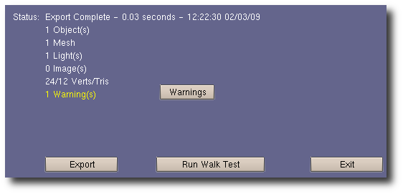
If irrb detects potential problems while exporting, it will display a list of warnings after the export completes. Click the "Back" button to return to the main GUI window.

iwalktest Integration And Usage
irrb integrates an optional utility named "iwalktest" which allows you to view and walk through your freshly exported scene using the Irrlicht engine. iwalktest is currently available to execute on both the Windows and Linux platforms.
Instructions on iwalktest installation and usage may be found here: irrb Utilities
The "Walk Test" GUI button will only appear in irrb's GUI if the following conditions are met:
- The "IWALKTEST" OS environment variable is defined.
- The irrb "Create Scene File" toggle button is selected.
With these conditions met, it's simply a matter of selecting the "Walk Test" toggle button to view your scene immediately after exporting.
After you export a scene for the first time, a "Run Walk Test" push button will appear at the bottom of the irrb interface. Clicking on this button will re-execute iwalktest with the last scene exported.
If you prefer to run a different application other than "iwalktest.exe", you may do so by setting the "IWALKTEST" environment variable to point to your own application.
A couple of notes on how irrb executes the external application:
- irrb sets the current directory to the directory in which the external application resides before running the application.
- irrb passes the full scene file path and file name to the external application. If the environment variable contains a "$1", the scene file is substituted in its place. A "$2" substitution variable is replaced with value of the "Output Directory" path.

Binary Mesh Format
Key Points
- The binary mesh format is currently experimental and subject to change.
- irrbmesh files (binary mesh) load into your application very quickly.
- The code to read/write the .irrbmesh format is freely available to you under the same license as Irrlicht.
Details
The experimental .irrbmesh binary mesh format is fast loading. Irrlicht's native .irrmesh format is based on XML and all though it's nice for exchanging mesh information, it can be painfully slow to load especially for larger scenes and meshes. The following screen shot displays the load times for a high-poly “yoda” mesh exported as .irrmesh, .b3d, and .irrbmesh:
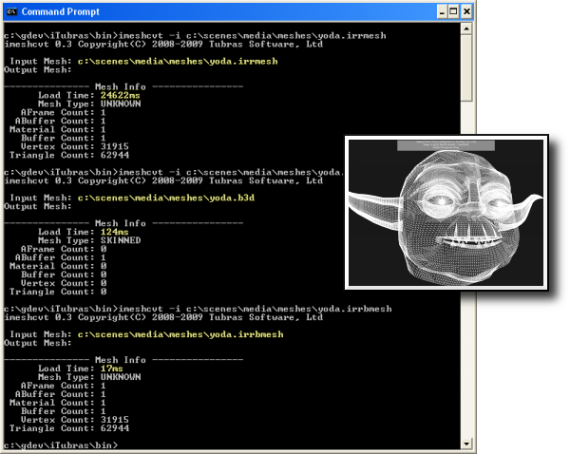
The respective files sizes and load times are:
- yoda.irrmesh - 4,713,164 bytes loaded in 24.6 seconds.
- yoda.b3d - 1,521,446 bytes loaded in 124 milli-seconds.
- yoda.irrbmesh - 2,548,107 bytes loaded in 17 milli-seconds.
The yoda mesh contains approximately 60k faces in a single mesh buffer. This particular test was run several times in sequence in order to allow Windows disk caching to "work itself out". The main reason the .irrbmesh format performs so well is that it mimics Irrlicht's internal mesh buffer and material formats. Very little parsing is required.
Using .irrbmesh In Your Application
It is relatively easy to enable your application(s) to read and write .irrbmesh files. Simply save the following files to your applications source directory.
For Loading:
- CIrrbMeshFileLoader.h
- CIrrBMeshFileLoader.cpp
For Writing:
- CIrrbMeshWriter.h
- CIrrBMeshWriter.cpp
Then add the following code snippet to your application somewhere in your initialization code:
// define _IRR_COMPILE_WITH_IRRB_MESH_LOADER_ to compile the loader
// loader depends on writers header
#include "CIrrBMeshWriter.h"
#include "CIrrBMeshLoader.h"
// code for loading .irrbmesh files
//
// ISceneManager* sceneManager - previously initialized.
// IfileSystem* fileSystem - previously initialized.
CIrrBMeshFileLoader* loader = new CIrrBMeshFileLoader(sceneManager,fileSystem);
sceneManager->addExternalMeshLoader(loader);
loader->drop();
Now you're ready to load .irrbmesh files:
IAnimatedMesh* pmesh = sceneManager->getMesh("mymesh.irrbmesh");
To write .irrbmesh files:
#include "CIrrBMeshWriter.h"
// code for writing .irrbmesh files
//
// IvideoDriver* videoDriver - previously initialized.
// IfileSystem* fileSystem - previously initialized.
// IMesh* mesh - previously initialized.
IMeshWriter* writer = new CIrrBMeshWriter(m_videoDriver,m_fileSystem);
((CIrrBMeshWriter*)writer)->setVersion(0x0106); - Irrlicht version target
((CirrbMeshWRiter*)writer)->setCreator("myapp"); - Creator

IWriteFile* file;
file = fileSystem->createAndWriteFile("test.irrbmesh");
writer->writeMesh(file,mesh);

ID Properties
Key Points
- Blender's “ID Property” system allows users to attach arbitrary data to Blender Objects, Data Blocks, and Materials.
- irrb uses Object and DataBlock ID Properties when generating .irr scene node Standard and User attributes.
- irrb optionally uses Material ID Properties when generating .irrmesh material attributes.
Details
Blender allows custom “string”, “int”, “float”, “array”, and “group” data values to be assigned to any data block and/or object. This type of data is known as “ID Properties” in Blender. irrb makes use of ID Properties (when available) to generate Standard and User attributes for scene nodes and Material attributes for Irrlicht mesh buffers located in .irrmesh files.
Id Properties are “key”, “value” pairs where a “key” may be any arbitrary identifier and the “value” may be any of the data types mentioned above. A “group” value type is simply a group of additional properties. The following is an example of ID Properties that may be assigned to an object:
Key Value Type
“irrb” group group
|
|--”StandardAttributes” group group (sub-group of 'irrb')
|----”Visible” 0 int
|----”IsDebugObject” 1 int
|
|--”UserAttributes” group group (sub-group of 'irrb')
|----”Static” 1 int
|----”Collider” “box” string
|----”testFloat” 1.234 float
|
This example starts with a top level group (think Python dictionary) named “irrb” which contains all of the other properties. This group is required by the irrb exporter in order to differentiate and avoid conflicts with other scripts that may also choose to use ID Properties for storing script specific data.
Underneath the “irrb” group, there are two “sub-groups” named “StandardAtrributes” and “UserAttributes”. Let's have a look at these two sub-groups and how irrb uses them when generating scene node data .
Every scene node that is written to an .irr scene file contains standard and optional user attributes. Standard attributes include:
<vector3d name="Position" value="0.000000, 0.000000, 0.000000" />
<vector3d name="Rotation" value="0.000000, 0.000000, 0.000000" />
<vector3d name="Scale" value="1.000000, 1.000000, 1.000000" />
<bool name="Visible" value="true" />
<bool name="IsDebugObject" value="false" />

The position, rotation, and scale are automatically created and assigned by irrb according to the object (mesh, light, camera) being exported. These attributes may not be overridden using ID Properties. However, attributes such as “Visible”, “IsDebugObject”, “Id”, etc. may be overridden using ID Properties. When irrb exports an object like the “Cube” in this example, it performs the following checks when generating the scene node Standard attributes:
- Set the Cube attributes from the “defaults”.
- Does the Cube DataBlock contain a top level ID Property group named “irrb”. If so, override the current attributes with those present in the DataBlock “StandardAttributes” properties.
- Does the Cube Object contain a top level ID Property group named “irrb”. If so, override the current attributes with those present in the Object “StandardAttributes” properties.

This same logic is also used for “UserAttributes”. Again, using our example above, the following scene node would be created in the scene .irr file:

<node type="mesh">
<attributes>
<string name="Name" value="Cube" />
<int name="Id" value="-1" />
<vector3d name="Position" value="0.000000, 0.000000, 0.000000" />
<vector3d name="Rotation" value="0.000000, 0.000000, 0.000000" />
<vector3d name="Scale" value="1.000000, 1.000000, 1.000000" />
<bool name="Visible" value="false" />
<enum name="AutomaticCulling" value="frustum_box" />
<bool name="DebugDataVisible" value="false" />
<bool name="IsDebugObject" value="true" />
<bool name="ReadOnlyMaterials" value="false" />
<string name="Mesh" value="meshes/Cube.irrmesh" />
</attributes>
<userData>
<attributes>
<int name="Static" value="1" />
<string name="Collider" value="box" />
<float name="testFloat" value="1.234000" />
</attributes>
</userData>
</node>
So where do the values for “AutomaticCulling”, “DebugDataVisible”, and “ReadOnlyMaterials” come from? The answer: the “global” default values, which are also configurable by you, the user. Before we discuss default values, let's have a look at the order in which irrb extracts attributes from ID Properties:
1. Default Properties
2. DataBlock Properties (mesh, camera, light, etc.)
3. Object Properties
For every object exported, it is assigned the “Default” properties. The Default properties are then overridden by DataBlock properties, if they exist. And finally, DataBlock properties are overridden by the Object properties, if they exist.

Default Property Attributes
When irrb is loaded by Blender, it reads the default scene node and material attributes from the “iConfig” module (iConfig.py) located in the “irrbmodules” sub-directory. This module contains a group of Python dictionaries which hold the default attribute values for Scene Nodes and Materials.
You could modify this file to change the defaults (don't do it), but your changes would be overwritten the next time you upgrade irrb to the latest version. Instead of modifying “iConfig.py”, simply copy it to a file named “UserConfig.py” in the same directory (irrbmodules) as “iConfig.py”. Any changes you make to “UserConfig.py” will then become the global “defaults”.

Blender's ID Property Editor
Blender contains a crude ID Property editor which allows you to add, update, and/or delete properties at the Object and DataBlock level. Let's walk through the process of manually adding a UserData attribute to the default Cube Object that typically appears when Blender is first started.
Start the ID Property editor by selecting the Blender Menu Item: “Help|ID Property Browser”. The “empty” attribute window will like this:
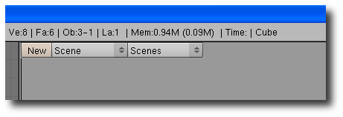
Because we want to add a user attribute to the “Cube” Object, select “Objects”, and then select “Cube” from the list of available objects on the left:
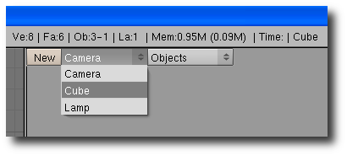
The first property we need to add is the top level “irrb” group property:
- Click the “New” button.
- Set the “Name” field to “irrb”.
- Select the “Subgroup” button.
- Click the “OK” button.
The top level “irrb” group will now look like this:
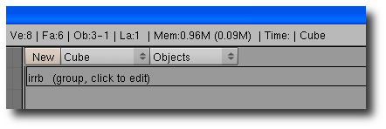
Within the “irrb” group we are now ready to create the “UserAttributes” group:
- Click “irrb” group - “irrb (group, click to edit)”.
- Add another group with the name “UserAttributes” following the same steps used to create the “irrb” group.
Move into the “UserAttributes” group by clicking on “UserAttributes (group, click to edit)”. Now we are ready to add one or more user attributes. Let's add a String attribute named “MyAttribute”:
- Click the “New” button.
- Set the “Name” field to “MyAttribute”.
- Select the “String” button.
- Click the “OK” button.
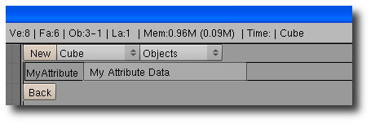
This creates a String property named “MyAttribute” with an empty value. Update the value by typing in the value data and then press the Enter key:
Now whenever we export this scene, the Cube scene node will always contain the following UserData attribute:
<userData>
<attributes>
<string name="MyAttribute" value="My Attribute Value" />
</attributes>
</userData>

Generating ID Properties
From the previous section, it is easy to see that manually creating ID properties using Blender's property editor can be tedious at best. A quicker more efficient method is to use the “Create irrb Props” push button located in the irrb exporter interface:
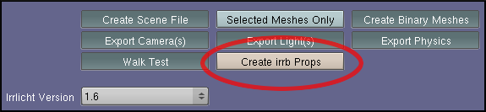
Clicking on “Create irrb Props” will perform two operations:
- Create the top-level “irrb” group and sub-groups: “StandardAttributes” and “UserAttributes” for all selected objects.
- Create the top-level “irrb” group and default Irrlicht material attributes for all Blender Materials.
Note that if an Object, DataBlock, or Material already contains a top-level “irrb” group, the property generator skips over it. It does NOT replace existing properties. When the property generator finishes its work, it displays update information in the status area of the irrb exporter:
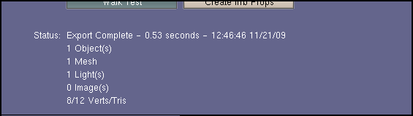

Material ID Properties
ID Properties assigned to Blender materials may be used to control the generated .irrmesh material attributes. Using the “Create irrb Props” button, will automatically generate ID Properties:
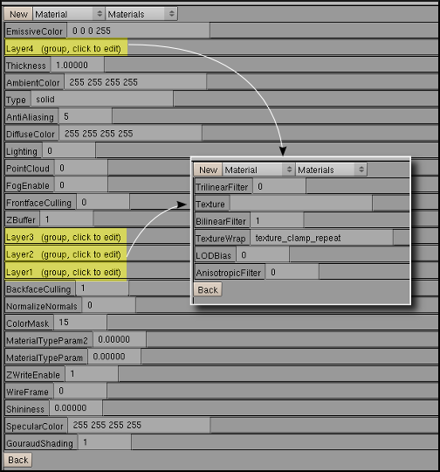Illustration 8: Generated ID Properties for a Blender Material
Notice that Material Layer attributes are contained within individual sub-groups named “Layer#”. To modify a specific layer attribute value (TextureWrap, BilinearFilter, LODBias, etc.), simply click on the group name to display the corresponding properties.
When the property generator creates “irrb” properties for new materials, it sets the values to those located in the global defaults (iConfig.py or iUserConfig.py).
All “Color” related property values are specified as “string” values entered as “r g b a” integers 0-255.

Accessing User Attributes
In order to access scene node UserData properties in your application, you will need a class that implements the ISceneUserDataSerializer interface overriding the OnReadUserData method:
void SerializerClass::loadScene(const c8* fileName)
{
//
// ISceneManager* sceneManager (previously initialized)
//
// The 2nd parameter to "loadScene" is a pointer a ISceneUserDataSerializer
// interface.
//
sceneManager->loadScene(fileName,this);
}
//
// this will be invoked for every scene node that contains UserData attributes.
//
void SerializerClass::OnReadUserData(ISceneNode* forSceneNode,
io::IAttributes* userData)
{
bool value=false;
if(userData->existsAttribute("Dynamic"))
value = userData->getAttributeAsBool("Dynamic");
if(value)
{
ESCENE_NODE_TYPE type = forSceneNode->getType();
if(type == ESNT_MESH)
{
//
// do something to make the mesh "dynamic"
//
}
}
}
Custom scene node properties aren't limited to just meshes. They may also be defined for lights and cameras.

Exporting Cameras And Lights
Key Points
- irrb allows you to export camera and light node data to scene files.
- Camera/Light node attributes are based on some of Blenders settings but may be overridden by assigning specific Blender ID Properties.
Camera Details
A camera node in a .irr scene file will appear as follows:
<node type="camera">
<attributes>
<string name="Name" value="Camera" />
<int name="Id" value="-1" />
<vector3d name="Position" value="7.481132, 5.343665, -6.507640" />
<vector3d name="Rotation" value="26.440704, -46.691944, 0.000000" />
<vector3d name="Scale" value="1.000000, 1.000000, 1.000000" />
<bool name="Visible" value="true" />
<enum name="AutomaticCulling" value="frustum_box" />
<bool name="DebugDataVisible" value="false" />
<bool name="IsDebugObject" value="false" />
<bool name="ReadOnlyMaterials" value="false" />
<vector3d name="Target" value="0.000000, 0.000000, 0.000000" />
<vector3d name="UpVector" value="0.000000, 1.000000, 0.000000" />
<float name="Fovy" value="0.857556" />
<float name="Aspect" value="1.250000" />
<float name="ZNear" value="0.10" />
<float name="ZFar" value="100.00" />
</attributes>
</node>
The camera specific attributes are: Target, UpVector, Fovy, Aspect, ZNear, and ZFar. All but the Target and UpVector may be set using the Camera properties (F9):
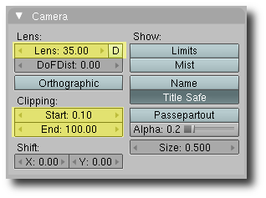
Fovy. Set to (2 * atan(16.0 / (Blenders Lens -> Lens value)). May be overridden with a "float" logic property named "Fovy".
Aspect. Set to the constant 1.25. May be overridden with a "float" logic property named "Aspect".
ZNear. Set to Clipping -> Start value.
ZFar. Set to Clipping -> End value.
For now, the Target and UpVector attributes are set to (0,0,0) and (0,1,0) respectively.
Light Details
A light node in a .irr scene file will appear as follows:
<node type="light">
<attributes>
<string name="Name" value="Lamp" />
<int name="Id" value="-1" />
<vector3d name="Position" value="4.076245, 5.903862, 1.005454" />
<vector3d name="Rotation" value="52.738953, -16.936317, 0.000000" />
<vector3d name="Scale" value="1.000000, 1.000000, 1.000000" />
<bool name="Visible" value="true" />
<enum name="AutomaticCulling" value="frustum_box" />
<bool name="DebugDataVisible" value="false" />
<bool name="IsDebugObject" value="false" />
<bool name="ReadOnlyMaterials" value="false" />
<enum name="LightType" value="Point" />
<colorf name="AmbientColor" value="0.000000,0.000000, 0.000000, 1.000000" />
<colorf name="DiffuseColor" value="1.000000, 1.000000, 1.000000 1.000000" />
<colorf name="SpecularColor" value="1.000000,1.000000, 1.000000, 1.000000" />
<vector3d name="Attenuation" value="0.000000 0.500000 0.000000" />
<float name="Radius" value="60.00" />
<bool name="CastShadows" value="true" />
</attributes>
</node>
The light specific attributes are: LightType, DiffuseColor, SpecularColor, Attenuation, Radius, and CastShadows.
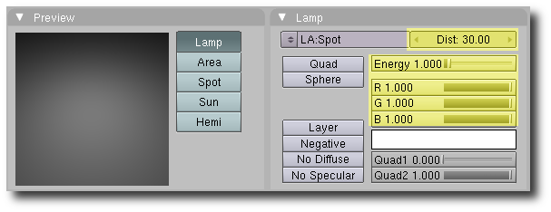
LightType. Based on Blenders lamp type:
- lamp -> Point
- area -> Directional
- spot -> Spot
- sun -> Directional
- hemi -> Directional
AmbientColor. Constant (0,0,0).
DiffuseColor. Set to the R,G,B components of the light color.
SpecularColor. Constant (1,1,1).
Attenuation. Set to (0.5 / (Blenders Energy Value)).
Radius. Set to (2.0 * (Blenders Distance Value)).
CastShadows. Constant "True".

Exporting Billboards
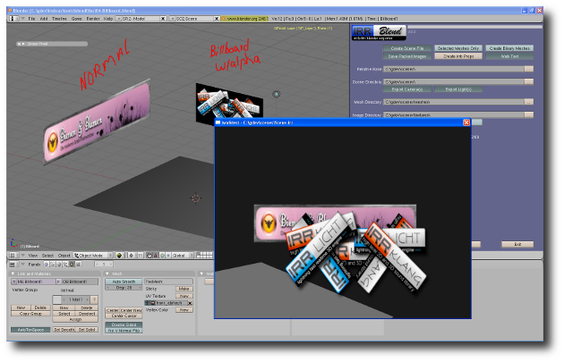Illustration 9: Sample Billboard .blend file – 04-Billboard.blend
Creating a Billboard in Blender that will be exported as an Irrlicht Billboard scene node may be performed in 3 steps:

- Add a plane (quad) to your scene. The position and scale of the plane are relevant. The rotation is ignored.
- Assign an image to the Billboard using Blender's UV/Image Editor.
- Add and “irrb” object ID property (“inodetype” = “billboard”) to the plane indicating that the object should be exported as a Billboard scene node.
The Billboard size is automatically calculated by irrb using the Plane's vertex coordinates as well as the scale factor.
Irrlicht Billboard scene nodes contain two optional color parameters named "Shade_Top" and "Shade_Down". The default values are White (0xFFFFFFFF). You may optionally override the colors by assigning color values to Billboard object's ID Properties:
"irrb" | "Shade_Top" | "r g b a"
"irrb" | "Shade_Down" | "r g b a"

Exporting A Skybox
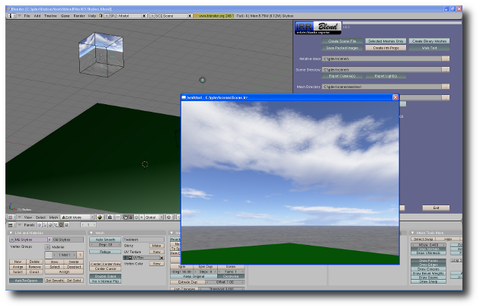Illustration 10: Sample Skybox .blend file – 03-Skybox.blend
Creating a Skybox in Blender that will be exported as an Irrlicht Skybox scene node requires 4 steps:
- Add a Cube mesh to your scene. The position and scale are not relevant. However, the rotation is important. The Cube should NOT be arbitrarily rotated. In order for irrb to determine the which images are the front/back, left/right, and top/bottom, each side of the cube must be perpendicular to the Blender axes.
- Each one of the six Skybox images must be individually mapped to the appropriate face on the cube. The easiest method for doing this is to use “face select mode” CTRL-TAB, “faces”. Select the appropriate face to map, unwrap (U), and then assign the corresponding image.
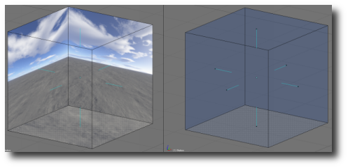
- Flip the face normals so that all of normals are facing inward – Select all of the faces (CTRL-A), W, “flip normals”.
- Add an “irrb” object ID property (“inodetype” = “skybox”) to the Cube indicating that the object should be exported as an Irrlicht Skybox scene node.

Exporting Fog
irrb allows you to add fog to your Irrlicht scene using Blender's Mist settings:
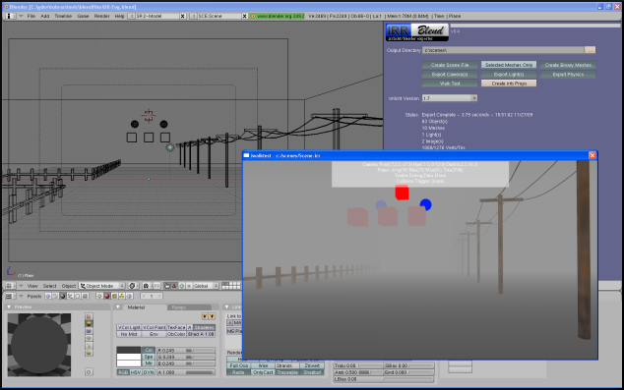Illustration 11: Sample Fog .blend file - 08-Fog.blend
Note that irrb saves the Fog settings to Irrlicht's Scene attributes (irr_scene). Fog attribute de/serialization was added to Irrlicht post 1.6. Therefore, you'll need an Irrlicht build using svn revision 2773 or later (pre 1.7).
Blender's global Mist settings are located in the World panel:
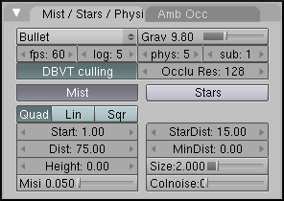

Exported settings and Irrlicht translations are:
Blender | Irrlicht
Horizon Color | Fog Color
Quad, Lin, Sqr | Fog Type – EFT_FOG_EXP, EFT_FOG_LIN, and EFT_FOG_EXP2.
Start | Start
Dist | End
Height | Exported but not used by Irrlicht.
Misi – Mist Intensity | Density

Disabling mist in Blender prevents the Fog attributes from being written to the scene file.
In addition to the global fog settings, you may also disable fog for individual objects in your scene. This may done by assigning a material to the object and setting the "No Mist" option in the Blender material or by setting the FogEnabled attribute to 0 in an assigned Material ID Property.

Exporting Collision & Physics Data
irrb allows exporting Blender's collision and physics data to an Irrlicht scene file (.irr). Collision and Physics data are written to the Scene file (.irr) and saved to each object/nodes UserData section. For example:
<node type="mesh">
<attributes>
<string name="Name" value="Cube"/>
<int name="Id" value="-1"/>
<vector3d name="Position" value="0.000000, 0.000000, 0.000000"/>
<vector3d name="Rotation" value="0.000000, -0.000000, 0.000000"/>
<vector3d name="Scale" value="1.000000, 1.000000, 1.000000"/>
<bool name="Visible" value="true"/>
<enum name="AutomaticCulling" value="frustum_box"/>
<bool name="DebugDataVisible" value="false"/>
<bool name="IsDebugObject" value="false"/>
<bool name="ReadOnlyMaterials" value="false"/>
<string name="Mesh" value="mdl/Cube.irrbmesh"/>
</attributes>
<userData>
<attributes>
<string name="Physics.BodyType" value="static"/>
<string name="Physics.BodyShape" value="box"/>
<bool name="Physics.Visible" value="true"/>
<float name="Physics.Friction" value="0.50"/>
<float name="Physics.Restitution" value="0.00"/>
</attributes>
</userData>
</node>
Collision and Physics data are only written to the exported scene file when the "Export Physics" button is toggled on:
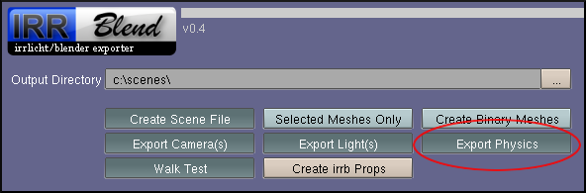
It's important to note that in order to take advantage of the exported Collision/Physics data, your application will require code to extract, initialize, and process the data in order for it to be meaningful. In other words, your application will need to integrate an existing 3rd party Collision/Physics library such as:
- Bullet – http://bulletphysics.org
- Physx - http://www.nvidia.com/object/physx_new.html
- Newton - http://newtondynamics.com
- Open Dynamics Engine (ODE) - http://www.ode.org/
- Havok - http://havok.com/
You may also choose to use Irrlicht's own built-in collision system which is capable of collision detection/response only (no dynamics simulation).
As previously mentioned, irrb writes Collision/Physics data to an exported object's scene node as UserData. The following tags may be generated by irrb:

irrb UserData Tag | Description
Physics.BodyType | Object body type – static, none, trigger, soft, dynamic, rigid, soft, or occluder.
Physics.BodyShape | Object body shape to be used for collision – box, sphere, cylinder, cone, concavemesh, or convexmesh.
Physics.Visible | Boolean used to indicate whether or not the geometry is visible.
Physics.Mass | The object mass.
Physics.Friction
Physics.Restitution | The object restitution.
Physics.Ghost
Physics.Actor
Physics.CollisionResponse

Object Collision/Physics properties exported by irrb are controlled by setting the various options available on Blender's Logic Panel (F4):
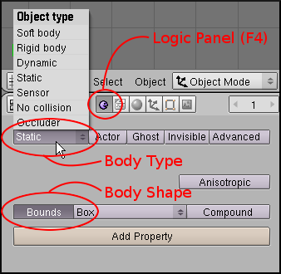
When an object is added to a Blender scene, by default it is added with Collision Body Type of "static". irrb generates a value named "Physics.BodyType" in the object's UserData section of the scene file.

The following table is a map of Blender body types to what is exported by irrb:
Body Type Map
Blender Body Type | irrb "Physics.BodyType" value
Static | "static"
No Collision | "none"
Sensor | "trigger"
Dynamic | "dynamic"
Rigid body | "rigid"
Soft body | "soft"
Occluder | "occluder"

irrb generates the Physics.BodyShape value based on Blender's "Bounds" parameter setting. The following table is a map Blender's Bounds types to what is exported by irrb:
Body Shape Map
Blender Bounds Type | irrb "Physics.BodyShape" value
Bounds Unchecked | "concavemesh"
Box | "box"
Sphere | "sphere"
Cylinder | "cylinder"
Cone | "cone"
Convex Hull | "convexmesh"
Triangle Mesh | "concavemesh"

Depending on the Blender Body Type that has been chosen, the following additional parameters may be exported:
Additional Tags Map
Blender Field | irrb Generated Tag
Mass | Physics.Mass – Float value.
Radius | Physics.Radius – Float value.
Ghost | Physics.Ghost – Boolean value.
Invisible | Physics.Visible – Boolean value
Compound | Physics.Compound – Boolean value
Gravity (Blender's World Settings) | Gravy – Float value exported to Root Node UserData section.
Exporting Custom Logic Properties
irrb also supports exporting custom Blender Logic Properties to an object's scene node UserData section. For example, the follow Blender Logic Properties:
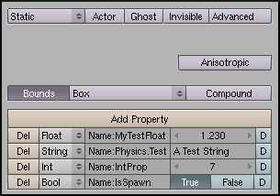
Would be exported to the scene file as:
<node type="mesh">
<attributes>
<string name="Name" value="Cube"/>
<int name="Id" value="-1"/>
...
</attributes>
<userData>
<attributes>
<float name="MyTestFloat" value="1.230000"/>
<string name="Physics.Test" value="A Test String"/>
<int name="IntProp" value="7"/>
<bool name="IsSpawn" value="true"/>
<string name="Physics.BodyType" value="static"/>
<string name="Physics.BodyShape" value="box"/>
<bool name="Physics.Visible" value="true"/>
</attributes>
</userData>
</node>

Note that the logic property type "timer" is ignored (not exported) by irrb.

Collision/Physics Testing with IWalkTest
IWalkTest currently contains limited support for Collision/Physics data with the following restrictions:
- By default, iwalktest supports character collision response (character controller) only using Irrlicht's Collision Response Animator.
- iwalktest may be configured to support dynamic simulation using Bullet physics, but doing so disables the character controller (no collision response for the camera).
The Bullet character controller is expected to be implemented in a future version of iwalktest.

Sample Code For Parsing Scene Collision Physics Data

Sample code for extracting and incorporating collision and physics data exported by irrb may be found at:
http://code.google.com/p/tubras/source/browse/#svn/trunk/tools/irrlicht/examples/irrbPhysics

main.cpp – Contains the code for:
- Irrlicht initialization.
- Scene Loading.
- Collision/Physics attribute deserialization.
- Render loop.
IrrlichtFuncs.cpp, irrphysxFuncs.cpp, and bulletFuncs.cpp – Contain the “library” specific code for adding collision/physics data into the appropriate library as well the code necessary for stepping the simulation.
The library to use may be specified in main.h by one of the following defines:
USE_IRR - Use the Irrlicht collision response system.
USE_IRRPHYSX - Use IrrPhysx.
USE_BULLET - Use Bullet.

At the time of this writing, only the Irrlicht collision response is implemented.

irrb Utilities
The utilities iwalktest and imeshcvt may be optionally installed to enhance the functionality of irrb.
iwalktest is used to view exported Blender scenes. imeshcvt is used to convert meshes to an experimental binary mesh format (.irrbmesh).

Installation
The latest stable download of irrbUtilities is accessible from both the "Project" and "Downloads" tabs of this Tubras Google Code project. On the "Projects" tab, irrbUtilities is listed in the "Featured Downloads" section.
The current version is 0.4. It may be downloaded from here:
Windows:
irrbUtils-0.4-win32.zip
Linux:
irrbUtils-0.4-linux32.zip

The contents of the zip package are:
iwalktest.exe // windows executable
iwalktest // linux executable
imeshcvt.exe // windows executable
imeshcvt // linux executable
data/cfg/irrlicht.cfg // irrlicht configuration definitions
data/cfg/iwalktest.cfg // iwalktest configuration
data/fnt/defaults.zip // fonts used by iwalktest
data/tex/lamp.tga // texture used for debug lights
Unzip the contents to a user writable directory because iwalktest creates a log file in the directory it is executed from.

Configuration
In order to integrate iwalktest and imeshcvt with irrb, you need to set up environment variables which point to the locations of their respective executables.
Windows If installed/unzipped to "c:\irrbutils", then you would set the following environment variables:
IWALKTEST=c:\irrbutils\iwalktest.exe -i "$1" -a "$2"
IMESHCVT=c:\irrbutils\imeshcvt.exe
Linux if installed to "/home/kmurray/irrbutils", then you would set the following environment variables:
IWALKTEST=/home/kmurray/irrbutils/iwalktest -i "$1" -a "$2"
IMESHCVT=/home/kmurray/irrbutils/imeshcvt
The "$1" and "$2" substitution variables inform irrb where to insert the “Scene File” and “Base Directory” command line parameters.
Regardless of the OS you use, you may wish to run a different application instead of iwalktest (maybe your own or irrEdit). To do this simply set the appropriate value in the IWALKTEST environment variable. For example to run irrEdit under Windows you would set the value to (assuming irrEdit is installed to "c:\irredit"):
IWALKTEST=c:\irredit\irredit.exe "$1"
This will cause the scene you export with irrb to be opened in irrEdit immediately after the export finishes (the scene file name is passed to irrEdit as a parameter).
If you want to run an application that requires information other than the scene file name you may set up the environment variable using the "$1" substitution variable. For example, your application (myapp.exe) requires a "-i" in front of the scene file name:
IWALKTEST=c:\myappdir\myapp.exe -i "$1" -u
irrb will make the appropriate substitution before invoking your application.
After the environment variables have been properly set up, you may choose to configure iwalktest by tweaking its configuration file "iwalktest.cfg":

require 'irrlicht'
options =
{
debug = 1,
console = true,
velocity = 4.0,
angularvelocity = 100.0,
maxvertangle = 80,
showcursor = true,
defcampos = {0, 5, -50},
defcamtarget = {0, 0, 0},
-- loadscene = '/temp/scene.irr',
}

video =
{
driver = EDT_OPENGL,
-- driver = EDT_DIRECT3D9,
resolution = {1024, 728},
-- resolution = {800, 600},
-- resolution = {640, 480},
colordepth = 32,
fullscreen = false,
vsync = true,
stencilbuffer = false,
-- antialias - 0, 2, 4, 8, 16
antialias = 8,
bgcolor = {25,25,25,255},
guiskin = 'gui/tubras2.cfg',
}

filesystems =
{
-- folders = {'c:/scenes/'},
zipfiles = {},
pakfiles = {},
}

keybindings =
{
['key.down.w'] = 'frwd 1',
['key.up.w'] = 'frwd 0',
['key.down.a'] = 'left 1',
['key.up.a'] = 'left 0',
['key.down.s'] = 'back 1',
['key.up.s'] = 'back 0',
['key.down.d'] = 'rght 1',
['key.up.d'] = 'rght 0',
['key.down.e'] = 'mvup 1',
['key.up.e'] = 'mvup 0',
['key.down.c'] = 'mvdn 1',
['key.up.c'] = 'mvdn 0',
['key.down.right'] = 'rotr 1',
['key.up.right'] = 'rotr 0',
['key.down.left'] = 'rotl 1',
['key.up.left'] = 'rotl 0',
['key.down.up'] = 'rotf 1',
['key.up.up'] = 'rotf 0',
['key.down.down'] = 'rotb 1',
['key.up.down'] = 'rotb 0',
['key.down.lshift'] = 'avel 3.5',
['key.up.lshift'] = 'avel 1.0',
['key.down.i'] = 'invert-mouse',
['key.down.f1'] = 'help',
['key.down.f2'] = 'idbg',
['key.down.f3'] = 'wire',
['key.down.f4'] = 'pdbg',
['key.down.f5'] = 'cdbg',
['key.down.f6'] = 'xfrm',
['key.down.prtscr'] = 'sprt',
['key.down.esc'] = 'quit',
}

iwalktest field descriptions:
-options-
debug (int).
- The amount of debug information written to "iwalktest.log".
console (bool).
- Whether or not iwalktest should create a console window that displays debug information. Windows only.
velocity (float).
- The camera movement speed in units/second.
angularvelocity (float).
- The camera rotational speed in ?/second.
maxvertangle (float).
- The maximum angle (up/down) a camera may rotate to.
showcursor (bool).
- Whether or not the OS cursor should be visible. Linux users should leave this set to "false".
loadscene (string).
- The scene that should be loaded if a scene isn't passed on the command line.
defcampos (vector3f).
- The initial position of the default camera created by iwalktest.
defcamtarget (vector3f).
- The initial target of the default camera created by iwalktest.

-video-
driver (int).
- The Irrlicht video driver to use. EDT_OPENGL – OpenGL, EDT_DIRECT3D9 – DirectX.
bgcolor (vector3d).
- The RGB colour values (0-255) to use for the background colour.
antialias (int).
- Anti-aliasing level.
colordepth (int).
- The colour depth to use.
fullscreen (bool).
- Whether or not to run in full screen mode.
resolution (int int).
- The X,Y screen resolution to use.
vsync (bool).
- Whether or not to run in vsync mode.
-media-
fontfolder (string).
- Used to control the location of the default fonts used by iwalktest.

-filesystems-
This sections contains the filesystems that iwalktest should load/mount during initialization. Possible values include:
<folder>, <zipfile>, and/or <pakfile>

-keybindings-
This section is used for setting up key bindings to "commands" used by iwalktest. These bindings primarily control camera movement. The defaults are "wasd" for movement and arrow keys for rotation. The mouse may also be used for rotation.

iwalktest Usage
The default application used to view scenes exported by irrb is iwalktest.
iwalktest is a simple Irrlicht application that allows you to freely (God camera) move around and view your scene. It also allows you to easily switch (F9 key) between the various cameras you choose to export.
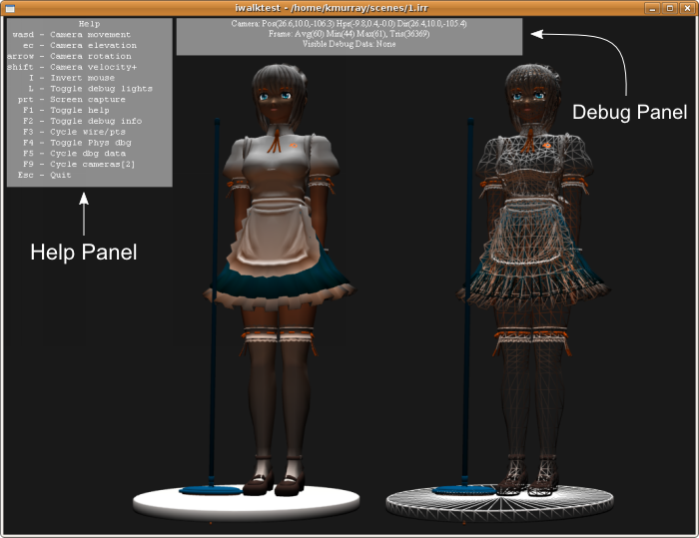
From the screen shot above you can see that iwalktest is capable of displaying two overlay panels - the help panel and the debug panel.
When iwalktest initially starts, the help panel is visible and the debug panel isn't. The help panel identifies the keys and functionality that is available while iwalktest is running:
wasd - Camera movement keys. Holding the Shift key while moving will accelerate the movement by the amount defined in iwalktest.cfg ("avel" command). Note the "e" and "c" keys will move the camera up and down respectively.
Help Panel
arrow – The up/down/left/right arrow keys control camera rotation.
I - Inverts the up-down mouse movement.
L – Toggles visual light debug data.
prt - (Print Screen) will save a screen shot of the view to a file named "cap##.png" (## - screen shot number). The file will be save into the same directory iwalktest is located in.
F1 - Toggles the visibility of the Help panel.
F2 - Toggles the visibility of the Debug panel.
F3 - Cycles the display mode (textured, wireframe, point cloud).
F4 - Not implemented.
F5 - When the Debug Panel is visible, cycles through the various visual debug modes: vertex normals, bounding box, half transparency etc.
F9 - If more than one camera exists in the scene, F9 cycles the active camera.
Debug Panel
The first line of the debug panel displays camera information:
[camera name]: Pos(x,y,z), Hpr(x,y,z), Dir(x,y,z)
"Hpr" - Heading, Pitch, Roll
iwalktest always creates a default scene camera named "tcam".
The second line of the debug panel displays frame rate info and the number of triangles that are being rendered.
The third line of the debug panel displays what visual debug data is currently visible (if any).

imeshcvt Usage
imeshcvt is a command line utility that allows you to:
- Display information about a mesh.
- Convert a mesh to another format.
- Manipulate a mesh using Irrlicht's IMeshManipulator.
imeshcvt options:
usage: imeshcvt <options> -i[input file] -o<output file>
<options> - Generic options:
-a : folder archive
-v : target mesh version (.irrbmesh only)
<options> - Mesh Manipulator options:
-f : flip surfaces
-n : recalculate normals
-s : recalculate normals smooth
-t : create tangents

[input file] Input mesh file to convert or report on. if no output mesh is specified, info is displayed for the input mesh. Required.

<output file> Output mesh file to convert to.
If no output file is given, imeshcvt will simply display information about the input mesh:
Input Mesh: \test\meshes\sphere.irrmesh
Output Mesh:
--------------- Mesh Info ----------------
Load Time: 76ms
Mesh Type: UNKNOWN
AFrame Count: 1
ABuffer Count: 1
Material Count: 1
Buffer Count: 1
Vertex Count: 994
Triangle Count: 1984

Notes
- add iwalktest export to /etc/environment on Ubuntu.
- if permissions problem saving irrbexport.cfg on Linux, create a writeable user defined scripts directory and point Blender's user defined scripts to it ("Python" in preferences). This newly created directory must contain a sub-directory named "bpydata/config".
- to view irrb stdout debug info on Linux, start Blender from a console window: "gnome-terminal/xterm -e blender -w". "-w" runs Blender in windowed mode.
- Blender lamp type conversions lamp->point, area->direction, spot->spot, sun->directional, and hemi->directional.
- Concave quads should be converted to Triangles before exporting. Show example...

FAQ
Q: I have a question, where do I go?
A: You may post irrb related questions in this Irrlicht thread. Please read the appropriate section of this document before posting a question.

Q: Can I export animated meshes?
A: Not Yet. The .irrmesh file format currently doesn't support animation.

Q: Can irrb invoke my own application instead of iwalktest after exporting?
A: Yes. See the section "iwalktest Integration And Usage"

Q: Where can I report bugs?
A: In the irrb Bug thread.

Q: Where can I submit a patch?
A: In the irrb Patch thread.

