Your Company
123 Your Street
Your City, ST 12345
(123) 456-7890

Welcome to Company Name
We’re so glad to have you join the team! This guide is meant to provide team specific information to help you get off to a great and productive start.
WHO WE ARE 1
Our mission 1
The team 1
PRODUCT & PROCESS 2
Project Process 2
Weekly Meetings 2
ONBOARDING TASKLIST 2
Week 1 2
Week 2 2
RESOURCES 2
Mailing lists 2
Glossary of terms 2

WHO WE ARE

Our mission
Lorem ipsum dolor sit amet, consectetuer adipiscing elit, sed diam nonummy nibh euismod tincidunt ut laoreet dolore magna aliquam erat.

The team
Lorem ipsum dolor sit amet, consectetuer adipiscing elit, sed diam nonummy nibh euismod tincidunt ut laoreet dolore magna aliquam erat.
Get to know your team and explore the office! Here are some fun activities you can schedule with your teammates to get to know them better.

PRODUCT & PROCESS

Project Process
Lorem ipsum dolor sit amet, consectetuer adipiscing elit, sed diam nonummy nibh euismod tincidunt ut laoreet dolore magna aliquam erat.

Weekly Meetings
Lorem ipsum dolor sit amet, consectetuer adipiscing elit, sed diam nonummy nibh euismod tincidunt ut laoreet dolore magna aliquam erat.

ONBOARDING TASKLIST

Week 1
- Lorem ipsum dolor sit amet
- Consectetuer adipiscing elit

Week 2
- Lorem ipsum dolor sit amet
- Consectetuer adipiscing elit

RESOURCES

Mailing lists
Lorem ipsum dolor sit amet, consectetuer adipiscing elit.
- Lorem ipsum
- Dolor sit amet

Glossary of terms
Lorem ipsum dolor sit amet, consectetuer adipiscing elit, sed diam nonummy nibh euismod tincidunt ut laoreet dolore magna aliquam erat.
Introduction
Lorem ipsum dolor sit amet, consectetuer adipiscing elit, sed diam nonummy nibh euismod tincidunt ut laoreet dolore magna aliquam erat volutpat. Ut wisi enim ad minim veniam, quis nostrud exerci tation ullamcorper suscipit lobortis nisl ut aliquip ex ea commodo consequat. Duis autem vel eum iriure dolor in hendrerit in vulputate velit esse molestie consequat, vel illum dolore eu feugiat nulla facilisis at vero eros et accumsan.


Lorem ipsum
Lorem ipsum dolor sit amet, consectetuer adipiscing elit, sed diam nonummy nibh euismod tincidunt ut laoreet dolore magna aliquam erat volutpat. Ut wisi enim ad minim veniam, quis nostrud exerci tation ullamcorper suscipit lobortis nisl ut aliquip ex ea commodo consequat. Duis autem vel eum iriure dolor in hendrerit in vulputate velit esse molestie consequat, vel illum dolore eu feugiat nulla facilisis at vero eros et accumsan. Nam liber tempor cum soluta nobis eleifend option congue nihil imperdiet doming id quod mazim placerat facer possim assum. Typi non habent claritatem insitam; est usus legentis in iis qui facit eorum claritatem. Investigationes demonstraverunt lectores legere me lius quod ii legunt saepius.
Lorem ipsum dolor sit amet, consectetuer adipiscing elit, sed diam nonummy nibh euismod tincidunt ut laoreet dolore magna aliquam erat volutpat. Ut wisi enim ad minim veniam, quis nostrud exerci tation ullamcorper suscipit lobortis nisl ut aliquip ex ea commodo consequat.
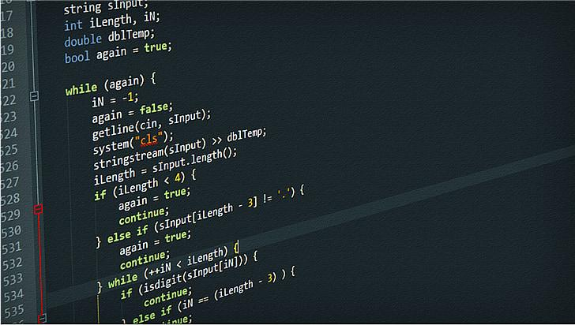
Dolor sit amet
Nam liber tempor cum soluta nobis eleifend option congue nihil imperdiet doming id quod mazim placerat facer possim assum. Typi non habent claritatem insitam; est usus legentis in iis qui facit eorum claritatem. Investigationes demonstraverunt lectores legere me lius quod ii legunt saepius. Duis autem vel eum iriure dolor in hendrerit in vulputate velit esse molestie consequat, vel illum dolore eu feugiat nulla facilisis at vero eros et accumsan.

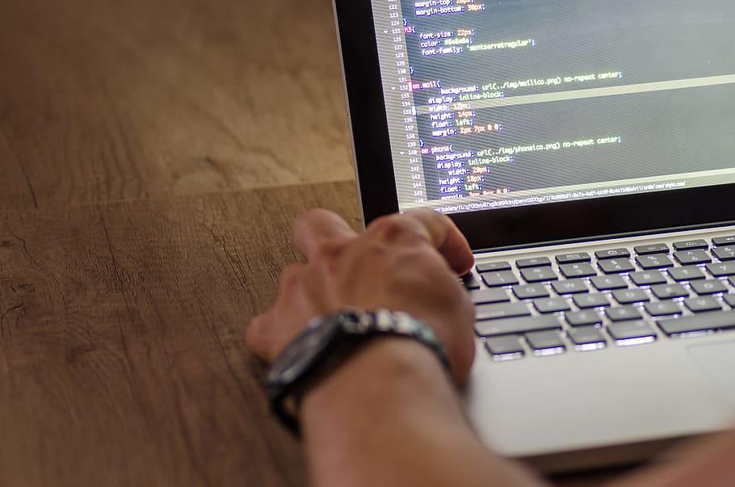
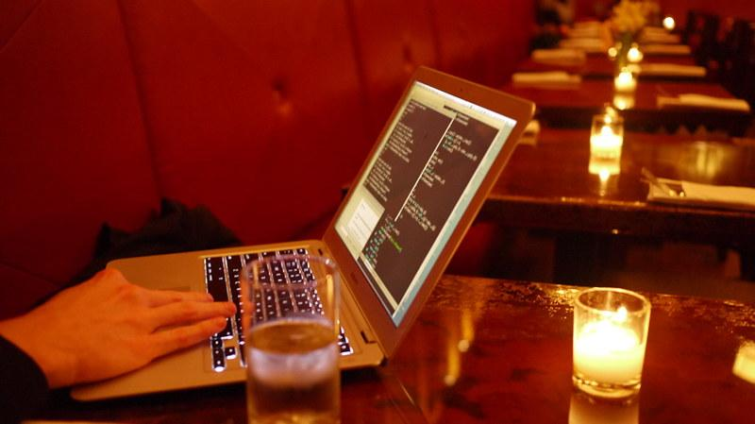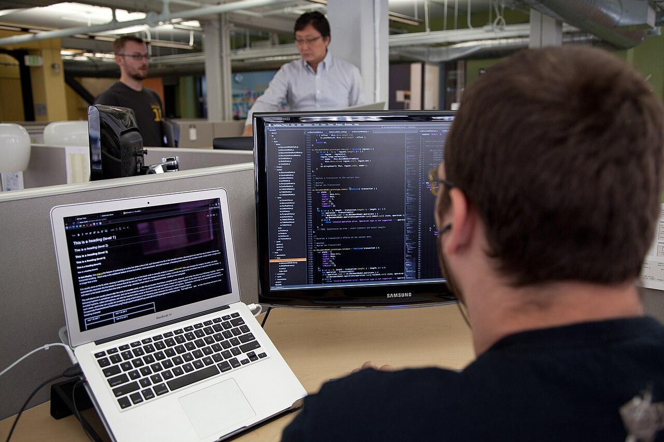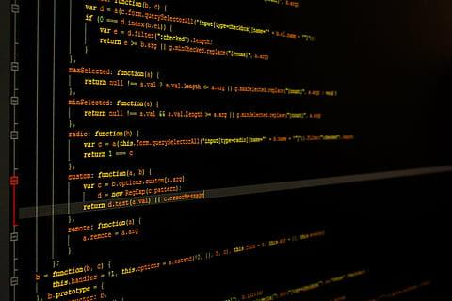
Kafka
One morning, when Gregor Samsa woke from troubled dreams, he found himself transformed in his bed into a horrible vermin. He lay on his armour-like back, and if he lifted his head a little he could see his brown belly, slightly domed and divided by arches into stiff sections. The bedding was hardly able to cover it and seemed ready to slide off any moment. His many legs, pitifully thin compared with the size of the rest of him, waved about helplessly as he looked. "What's happened to me?" he thought. It wasn't a dream. His room, a proper human room although a little too small, lay peacefully between its four familiar walls. A collection of textile samples lay spread out on the table - Samsa was a travelling salesman - and above it there hung a picture that he had recently cut out of an illustrated magazine and housed in a nice, gilded frame. It showed a lady fitted out with a fur hat and fur boa who sat upright, raising a heavy fur muff that covered the whole of her lower arm towards the viewer. Gregor then turned to look out the window at the dull weather.
Pangram
The quick, brown fox jumps over a lazy dog. DJs flock by when MTV ax quiz prog. Junk MTV quiz graced by fox whelps. Bawds jog, flick quartz, vex nymphs. Waltz, bad nymph, for quick jigs vex! Fox nymphs grab quick-jived waltz. Brick quiz whangs jumpy veldt fox. Bright vixens jump; dozy fowl quack. Quick wafting zephyrs vex bold Jim. Quick zephyrs blow, vexing daft Jim. How quickly daft jumping zebras vex. Two driven jocks help fax my big quiz. Quick, Baz, get my woven flax jodhpurs! "Now fax quiz Jack!" my brave ghost pled. Five quacking zephyrs jolt my wax bed. Flummoxed by job, kvetching W. zaps Iraq. Cozy sphinx waves quart jug of bad milk. A very bad quack might jinx zippy fowls. Few quips galvanized the mock jury box. Quick brown dogs jump over the lazy fox. The jay, pig, fox, zebra, and my wolves quack! Blowzy red vixens fight for a quick jump. Joaquin Phoenix was gazed by MTV for luck. A wizard’s job is to vex chumps quickly in fog. Watch "Jeopardy!", Alex Trebek's fun TV quiz game. Woven silk pyjamas exchanged for blue quartz.

Product | Category | Price
Laptop | Computer | 999.99
Coffee maker | Electronics | 25
Desk | Furniture | 20.5
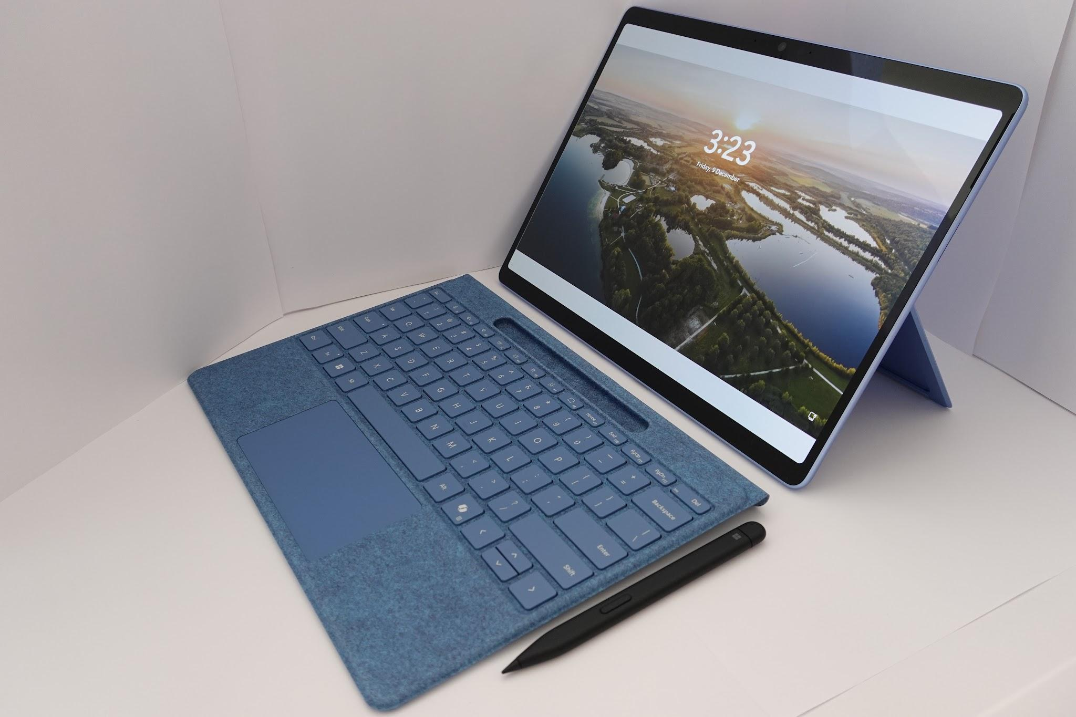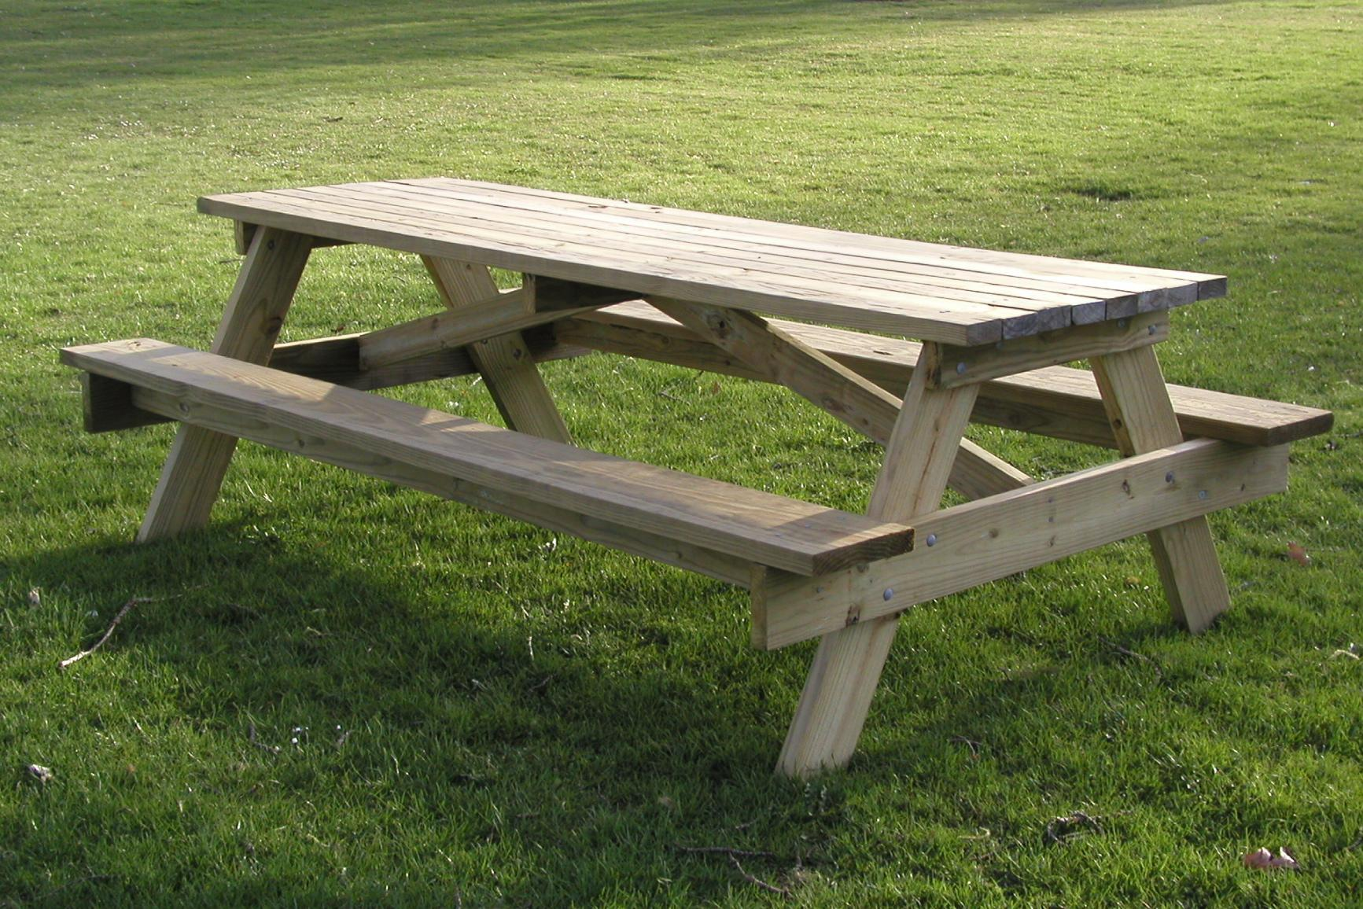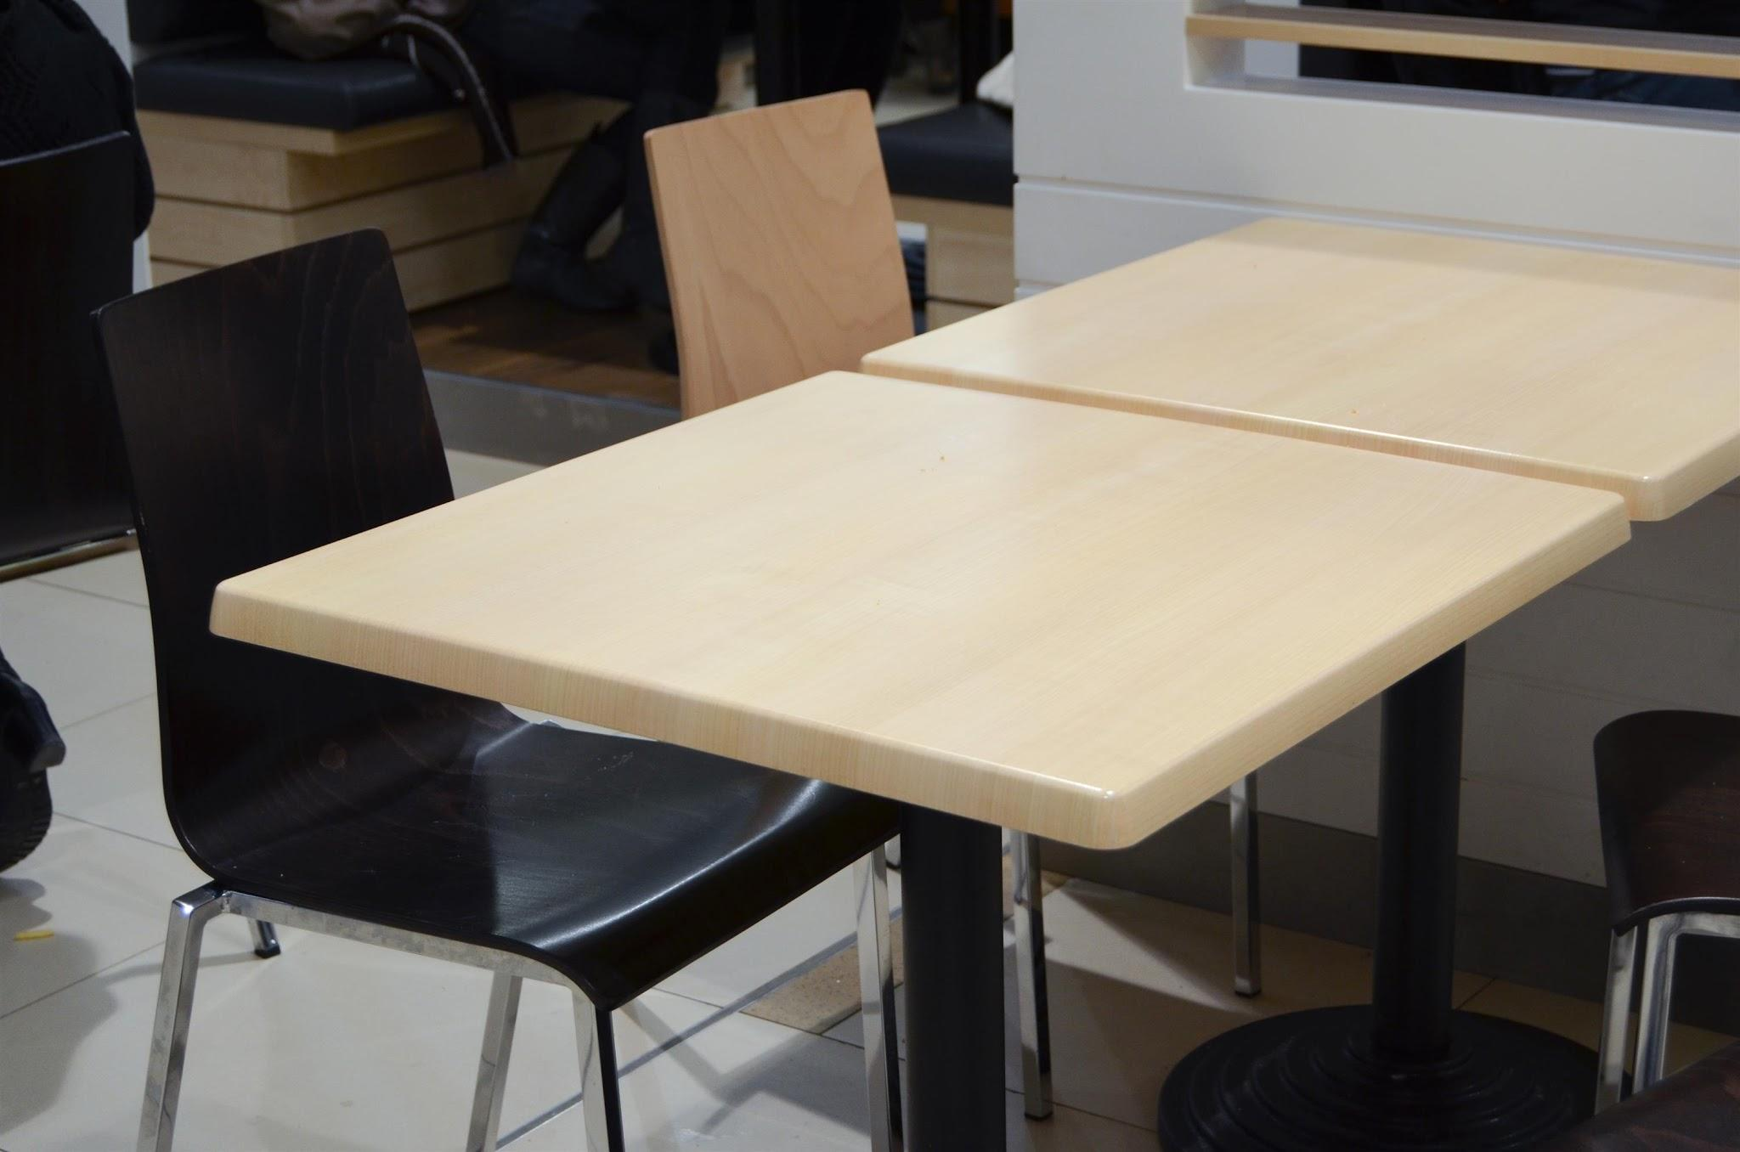
Faraway
Far far away, behind the word mountains, far from the countries Vokalia and Consonantia, there live the blind texts. Separated they live in Bookmarksgrove right at the coast of the Semantics, a large language ocean. A small river named Duden flows by their place and supplies it with the necessary regelialia. It is a paradisematic country, in which roasted parts of sentences fly into your mouth. Even the all-powerful Pointing has no control about the blind texts it is an almost unorthographic life One day however a small line of blind text by the name of Lorem Ipsum decided to leave for the far World of Grammar. The Big Oxmox advised her not to do so, because there were thousands of bad Commas, wild Question Marks and devious Semikoli, but the Little Blind Text didn’t listen. She packed her seven versalia, put her initial into the belt and made herself on the way. When she reached the first hills of the Italic Mountains, she had a last view back on the skyline of her hometown Bookmarksgrove, the headline of Alphabet Village and the subline of her own road, the Line Lane. Pityful a rethoric question ran over her cheek.

Werther
A wonderful serenity has taken possession of my entire soul, like these sweet mornings of spring which I enjoy with my whole heart. I am alone, and feel the charm of existence in this spot, which was created for the bliss of souls like mine. I am so happy, my dear friend, so absorbed in the exquisite sense of mere tranquil existence, that I neglect my talents. I should be incapable of drawing a single stroke at the present moment; and yet I feel that I never was a greater artist than now. When, while the lovely valley teems with vapour around me, and the meridian sun strikes the upper surface of the impenetrable foliage of my trees, and but a few stray gleams steal into the inner sanctuary, I throw myself down among the tall grass by the trickling stream; and, as I lie close to the earth, a thousand unknown plants are noticed by me: when I hear the buzz of the little world among the stalks, and grow familiar with the countless indescribable forms of the insects and flies, then I feel the presence of the Almighty, who formed us in his own image, and the breath.
Like these sweet mornings of spring which I enjoy with my whole heart. I am alone, and feel the charm of existence in this spot, which was created for the bliss of souls like mine. I am so happy, my dear friend, so absorbed in the exquisite sense of mere tranquil existence, that I neglect my talents. I should be incapable of drawing a single stroke at the present moment; and yet I feel that I never was a greater artist than now. When, while the lovely valley teems with vapour around me, and the meridian sun strikes the upper surface of the impenetrable foliage of my trees, and but a few stray gleams steal into the inner sanctuary, I throw myself down among the tall grass by the trickling stream; and, as I lie close to the earth, a thousand unknown plants are noticed by me: when I hear the buzz of the little world among the stalks, and grow familiar with the countless indescribable forms of the insects and flies, then I feel the presence of the Almighty, who formed us in his own image, and the breath.

Lorem ipsum
Lorem ipsum dolor sit amet, consectetuer adipiscing elit. Aenean commodo ligula eget dolor. Aenean massa. Cum sociis natoque penatibus et magnis dis parturient montes, nascetur ridiculus mus. Donec quam felis, ultricies nec, pellentesque eu, pretium quis, sem. Nulla consequat massa quis enim. Donec pede justo, fringilla vel, aliquet nec, vulputate eget, arcu. In enim justo, rhoncus ut, imperdiet a, venenatis vitae, justo. Nullam dictum felis eu pede mollis pretium. Integer tincidunt. Cras dapibus. Vivamus elementum semper nisi. Aenean vulputate eleifend tellus. Aenean leo ligula, porttitor eu, consequat vitae, eleifend ac, enim. Aliquam lorem ante, dapibus in, viverra quis, feugiat a, tellus. Phasellus viverra nulla ut metus varius laoreet. Quisque rutrum. Aenean imperdiet. Etiam ultricies nisi vel augue. Curabitur ullamcorper ultricies nisi. Nam eget dui. Etiam rhoncus. Maecenas tempus, tellus eget condimentum rhoncus, sem quam semper libero, sit amet adipiscing sem neque sed ipsum. Nam quam nunc, blandit vel, luctus pulvinar, hendrerit id, lorem. Maecenas nec odio et ante tincidunt tempus. Donec vitae sapien ut libero venenatis faucibus. Nullam quis ante. Etiam sit amet orci eget eros faucibus tincidunt. Duis leo. Sed fringilla mauris sit amet nibh. Donec sodales sagittis magna. Sed consequat, leo eget bibendum sodales, augue velit cursus nunc.

Bullets
- Item 1
- Item 2
- Item 3
- Item 4
- Item 5
- Item 6

Nested Bullets
- Videos
  - MP4
  - MOV
- Audios
  - MP3
  - M4A
- Documents
  - DOCX
  - PDF
- Archives
  - ZIP
  - TAR GZ

PRODUCT & PROCESS

Project Process
Lorem ipsum dolor sit amet, consectetuer adipiscing elit, sed diam nonummy nibh euismod tincidunt ut laoreet dolore magna aliquam erat.

Weekly Meetings
Lorem ipsum dolor sit amet, consectetuer adipiscing elit, sed diam nonummy nibh euismod tincidunt ut laoreet dolore magna aliquam erat.

ONBOARDING TASKLIST

Week 1
- Lorem ipsum dolor sit amet
- Consectetuer adipiscing elit

Week 2
- Lorem ipsum dolor sit amet
- Consectetuer adipiscing elit

RESOURCES

Mailing lists
Lorem ipsum dolor sit amet, consectetuer adipiscing elit.
- Lorem ipsum
- Dolor sit amet

Glossary of terms
Lorem ipsum dolor sit amet, consectetuer adipiscing elit, sed diam nonummy nibh euismod tincidunt ut laoreet dolore magna aliquam erat.
Introduction
Lorem ipsum dolor sit amet, consectetuer adipiscing elit, sed diam nonummy nibh euismod tincidunt ut laoreet dolore magna aliquam erat volutpat. Ut wisi enim ad minim veniam, quis nostrud exerci tation ullamcorper suscipit lobortis nisl ut aliquip ex ea commodo consequat. Duis autem vel eum iriure dolor in hendrerit in vulputate velit esse molestie consequat, vel illum dolore eu feugiat nulla facilisis at vero eros et accumsan.
Lorem ipsum
Lorem ipsum dolor sit amet, consectetuer adipiscing elit, sed diam nonummy nibh euismod tincidunt ut laoreet dolore magna aliquam erat volutpat. Ut wisi enim ad minim veniam, quis nostrud exerci tation ullamcorper suscipit lobortis nisl ut aliquip ex ea commodo consequat. Duis autem vel eum iriure dolor in hendrerit in vulputate velit esse molestie consequat, vel illum dolore eu feugiat nulla facilisis at vero eros et accumsan. Nam liber tempor cum soluta nobis eleifend option congue nihil imperdiet doming id quod mazim placerat facer possim assum. Typi non habent claritatem insitam; est usus legentis in iis qui facit eorum claritatem. Investigationes demonstraverunt lectores legere me lius quod ii legunt saepius.
Lorem ipsum dolor sit amet, consectetuer adipiscing elit, sed diam nonummy nibh euismod tincidunt ut laoreet dolore magna aliquam erat volutpat. Ut wisi enim ad minim veniam, quis nostrud exerci tation ullamcorper suscipit lobortis nisl ut aliquip ex ea commodo consequat.
Dolor sit amet
Nam liber tempor cum soluta nobis eleifend option congue nihil imperdiet doming id quod mazim placerat facer possim assum. Typi non habent claritatem insitam; est usus legentis in iis qui facit eorum claritatem. Investigationes demonstraverunt lectores legere me lius quod ii legunt saepius. Duis autem vel eum iriure dolor in hendrerit in vulputate velit esse molestie consequat, vel illum dolore eu feugiat nulla facilisis at vero eros et accumsan.
Kafka
One morning, when Gregor Samsa woke from troubled dreams, he found himself transformed in his bed into a horrible vermin. He lay on his armour-like back, and if he lifted his head a little he could see his brown belly, slightly domed and divided by arches into stiff sections. The bedding was hardly able to cover it and seemed ready to slide off any moment. His many legs, pitifully thin compared with the size of the rest of him, waved about helplessly as he looked. "What's happened to me?" he thought. It wasn't a dream. His room, a proper human room although a little too small, lay peacefully between its four familiar walls. A collection of textile samples lay spread out on the table - Samsa was a travelling salesman - and above it there hung a picture that he had recently cut out of an illustrated magazine and housed in a nice, gilded frame. It showed a lady fitted out with a fur hat and fur boa who sat upright, raising a heavy fur muff that covered the whole of her lower arm towards the viewer. Gregor then turned to look out the window at the dull weather.
Pangram
The quick, brown fox jumps over a lazy dog. DJs flock by when MTV ax quiz prog. Junk MTV quiz graced by fox whelps. Bawds jog, flick quartz, vex nymphs. Waltz, bad nymph, for quick jigs vex! Fox nymphs grab quick-jived waltz. Brick quiz whangs jumpy veldt fox. Bright vixens jump; dozy fowl quack. Quick wafting zephyrs vex bold Jim. Quick zephyrs blow, vexing daft Jim. How quickly daft jumping zebras vex. Two driven jocks help fax my big quiz. Quick, Baz, get my woven flax jodhpurs! "Now fax quiz Jack!" my brave ghost pled. Five quacking zephyrs jolt my wax bed. Flummoxed by job, kvetching W. zaps Iraq. Cozy sphinx waves quart jug of bad milk. A very bad quack might jinx zippy fowls. Few quips galvanized the mock jury box. Quick brown dogs jump over the lazy fox. The jay, pig, fox, zebra, and my wolves quack! Blowzy red vixens fight for a quick jump. Joaquin Phoenix was gazed by MTV for luck. A wizard’s job is to vex chumps quickly in fog. Watch "Jeopardy!", Alex Trebek's fun TV quiz game. Woven silk pyjamas exchanged for blue quartz.

Product | Category | Price
Laptop | Computer | 999.99
Coffee maker | Electronics | 25
Desk | Furniture | 20.5
Faraway
Far far away, behind the word mountains, far from the countries Vokalia and Consonantia, there live the blind texts. Separated they live in Bookmarksgrove right at the coast of the Semantics, a large language ocean. A small river named Duden flows by their place and supplies it with the necessary regelialia. It is a paradisematic country, in which roasted parts of sentences fly into your mouth. Even the all-powerful Pointing has no control about the blind texts it is an almost unorthographic life One day however a small line of blind text by the name of Lorem Ipsum decided to leave for the far World of Grammar. The Big Oxmox advised her not to do so, because there were thousands of bad Commas, wild Question Marks and devious Semikoli, but the Little Blind Text didn’t listen. She packed her seven versalia, put her initial into the belt and made herself on the way. When she reached the first hills of the Italic Mountains, she had a last view back on the skyline of her hometown Bookmarksgrove, the headline of Alphabet Village and the subline of her own road, the Line Lane. Pityful a rethoric question ran over her cheek.

Werther
A wonderful serenity has taken possession of my entire soul, like these sweet mornings of spring which I enjoy with my whole heart. I am alone, and feel the charm of existence in this spot, which was created for the bliss of souls like mine. I am so happy, my dear friend, so absorbed in the exquisite sense of mere tranquil existence, that I neglect my talents. I should be incapable of drawing a single stroke at the present moment; and yet I feel that I never was a greater artist than now. When, while the lovely valley teems with vapour around me, and the meridian sun strikes the upper surface of the impenetrable foliage of my trees, and but a few stray gleams steal into the inner sanctuary, I throw myself down among the tall grass by the trickling stream; and, as I lie close to the earth, a thousand unknown plants are noticed by me: when I hear the buzz of the little world among the stalks, and grow familiar with the countless indescribable forms of the insects and flies, then I feel the presence of the Almighty, who formed us in his own image, and the breath.
Like these sweet mornings of spring which I enjoy with my whole heart. I am alone, and feel the charm of existence in this spot, which was created for the bliss of souls like mine. I am so happy, my dear friend, so absorbed in the exquisite sense of mere tranquil existence, that I neglect my talents. I should be incapable of drawing a single stroke at the present moment; and yet I feel that I never was a greater artist than now. When, while the lovely valley teems with vapour around me, and the meridian sun strikes the upper surface of the impenetrable foliage of my trees, and but a few stray gleams steal into the inner sanctuary, I throw myself down among the tall grass by the trickling stream; and, as I lie close to the earth, a thousand unknown plants are noticed by me: when I hear the buzz of the little world among the stalks, and grow familiar with the countless indescribable forms of the insects and flies, then I feel the presence of the Almighty, who formed us in his own image, and the breath.

Lorem ipsum
Lorem ipsum dolor sit amet, consectetuer adipiscing elit. Aenean commodo ligula eget dolor. Aenean massa. Cum sociis natoque penatibus et magnis dis parturient montes, nascetur ridiculus mus. Donec quam felis, ultricies nec, pellentesque eu, pretium quis, sem. Nulla consequat massa quis enim. Donec pede justo, fringilla vel, aliquet nec, vulputate eget, arcu. In enim justo, rhoncus ut, imperdiet a, venenatis vitae, justo. Nullam dictum felis eu pede mollis pretium. Integer tincidunt. Cras dapibus. Vivamus elementum semper nisi. Aenean vulputate eleifend tellus. Aenean leo ligula, porttitor eu, consequat vitae, eleifend ac, enim. Aliquam lorem ante, dapibus in, viverra quis, feugiat a, tellus. Phasellus viverra nulla ut metus varius laoreet. Quisque rutrum. Aenean imperdiet. Etiam ultricies nisi vel augue. Curabitur ullamcorper ultricies nisi. Nam eget dui. Etiam rhoncus. Maecenas tempus, tellus eget condimentum rhoncus, sem quam semper libero, sit amet adipiscing sem neque sed ipsum. Nam quam nunc, blandit vel, luctus pulvinar, hendrerit id, lorem. Maecenas nec odio et ante tincidunt tempus. Donec vitae sapien ut libero venenatis faucibus. Nullam quis ante. Etiam sit amet orci eget eros faucibus tincidunt. Duis leo. Sed fringilla mauris sit amet nibh. Donec sodales sagittis magna. Sed consequat, leo eget bibendum sodales, augue velit cursus nunc.

Bullets
- Item 1
- Item 2
- Item 3
- Item 4
- Item 5
- Item 6

Nested Bullets
- Videos
  - MP4
  - MOV
- Audios
  - MP3
  - M4A
- Documents
  - DOCX
  - PDF
- Archives
  - ZIP
  - TAR GZ

PRODUCT & PROCESS

Project Process
Lorem ipsum dolor sit amet, consectetuer adipiscing elit, sed diam nonummy nibh euismod tincidunt ut laoreet dolore magna aliquam erat.

Weekly Meetings
Lorem ipsum dolor sit amet, consectetuer adipiscing elit, sed diam nonummy nibh euismod tincidunt ut laoreet dolore magna aliquam erat.

ONBOARDING TASKLIST

Week 1
- Lorem ipsum dolor sit amet
- Consectetuer adipiscing elit

Week 2
- Lorem ipsum dolor sit amet
- Consectetuer adipiscing elit

RESOURCES

Mailing lists
Lorem ipsum dolor sit amet, consectetuer adipiscing elit.
- Lorem ipsum
- Dolor sit amet

Glossary of terms
Lorem ipsum dolor sit amet, consectetuer adipiscing elit, sed diam nonummy nibh euismod tincidunt ut laoreet dolore magna aliquam erat.
Introduction
Lorem ipsum dolor sit amet, consectetuer adipiscing elit, sed diam nonummy nibh euismod tincidunt ut laoreet dolore magna aliquam erat volutpat. Ut wisi enim ad minim veniam, quis nostrud exerci tation ullamcorper suscipit lobortis nisl ut aliquip ex ea commodo consequat. Duis autem vel eum iriure dolor in hendrerit in vulputate velit esse molestie consequat, vel illum dolore eu feugiat nulla facilisis at vero eros et accumsan.
Lorem ipsum
Lorem ipsum dolor sit amet, consectetuer adipiscing elit, sed diam nonummy nibh euismod tincidunt ut laoreet dolore magna aliquam erat volutpat. Ut wisi enim ad minim veniam, quis nostrud exerci tation ullamcorper suscipit lobortis nisl ut aliquip ex ea commodo consequat. Duis autem vel eum iriure dolor in hendrerit in vulputate velit esse molestie consequat, vel illum dolore eu feugiat nulla facilisis at vero eros et accumsan. Nam liber tempor cum soluta nobis eleifend option congue nihil imperdiet doming id quod mazim placerat facer possim assum. Typi non habent claritatem insitam; est usus legentis in iis qui facit eorum claritatem. Investigationes demonstraverunt lectores legere me lius quod ii legunt saepius.
Lorem ipsum dolor sit amet, consectetuer adipiscing elit, sed diam nonummy nibh euismod tincidunt ut laoreet dolore magna aliquam erat volutpat. Ut wisi enim ad minim veniam, quis nostrud exerci tation ullamcorper suscipit lobortis nisl ut aliquip ex ea commodo consequat.
Dolor sit amet
Nam liber tempor cum soluta nobis eleifend option congue nihil imperdiet doming id quod mazim placerat facer possim assum. Typi non habent claritatem insitam; est usus legentis in iis qui facit eorum claritatem. Investigationes demonstraverunt lectores legere me lius quod ii legunt saepius. Duis autem vel eum iriure dolor in hendrerit in vulputate velit esse molestie consequat, vel illum dolore eu feugiat nulla facilisis at vero eros et accumsan.
Kafka
One morning, when Gregor Samsa woke from troubled dreams, he found himself transformed in his bed into a horrible vermin. He lay on his armour-like back, and if he lifted his head a little he could see his brown belly, slightly domed and divided by arches into stiff sections. The bedding was hardly able to cover it and seemed ready to slide off any moment. His many legs, pitifully thin compared with the size of the rest of him, waved about helplessly as he looked. "What's happened to me?" he thought. It wasn't a dream. His room, a proper human room although a little too small, lay peacefully between its four familiar walls. A collection of textile samples lay spread out on the table - Samsa was a travelling salesman - and above it there hung a picture that he had recently cut out of an illustrated magazine and housed in a nice, gilded frame. It showed a lady fitted out with a fur hat and fur boa who sat upright, raising a heavy fur muff that covered the whole of her lower arm towards the viewer. Gregor then turned to look out the window at the dull weather.
Pangram
The quick, brown fox jumps over a lazy dog. DJs flock by when MTV ax quiz prog. Junk MTV quiz graced by fox whelps. Bawds jog, flick quartz, vex nymphs. Waltz, bad nymph, for quick jigs vex! Fox nymphs grab quick-jived waltz. Brick quiz whangs jumpy veldt fox. Bright vixens jump; dozy fowl quack. Quick wafting zephyrs vex bold Jim. Quick zephyrs blow, vexing daft Jim. How quickly daft jumping zebras vex. Two driven jocks help fax my big quiz. Quick, Baz, get my woven flax jodhpurs! "Now fax quiz Jack!" my brave ghost pled. Five quacking zephyrs jolt my wax bed. Flummoxed by job, kvetching W. zaps Iraq. Cozy sphinx waves quart jug of bad milk. A very bad quack might jinx zippy fowls. Few quips galvanized the mock jury box. Quick brown dogs jump over the lazy fox. The jay, pig, fox, zebra, and my wolves quack! Blowzy red vixens fight for a quick jump. Joaquin Phoenix was gazed by MTV for luck. A wizard’s job is to vex chumps quickly in fog. Watch "Jeopardy!", Alex Trebek's fun TV quiz game. Woven silk pyjamas exchanged for blue quartz.

Product | Category | Price
Laptop | Computer | 999.99
Coffee maker | Electronics | 25
Desk | Furniture | 20.5
Faraway
Far far away, behind the word mountains, far from the countries Vokalia and Consonantia, there live the blind texts. Separated they live in Bookmarksgrove right at the coast of the Semantics, a large language ocean. A small river named Duden flows by their place and supplies it with the necessary regelialia. It is a paradisematic country, in which roasted parts of sentences fly into your mouth. Even the all-powerful Pointing has no control about the blind texts it is an almost unorthographic life One day however a small line of blind text by the name of Lorem Ipsum decided to leave for the far World of Grammar. The Big Oxmox advised her not to do so, because there were thousands of bad Commas, wild Question Marks and devious Semikoli, but the Little Blind Text didn’t listen. She packed her seven versalia, put her initial into the belt and made herself on the way. When she reached the first hills of the Italic Mountains, she had a last view back on the skyline of her hometown Bookmarksgrove, the headline of Alphabet Village and the subline of her own road, the Line Lane. Pityful a rethoric question ran over her cheek.

Werther
A wonderful serenity has taken possession of my entire soul, like these sweet mornings of spring which I enjoy with my whole heart. I am alone, and feel the charm of existence in this spot, which was created for the bliss of souls like mine. I am so happy, my dear friend, so absorbed in the exquisite sense of mere tranquil existence, that I neglect my talents. I should be incapable of drawing a single stroke at the present moment; and yet I feel that I never was a greater artist than now. When, while the lovely valley teems with vapour around me, and the meridian sun strikes the upper surface of the impenetrable foliage of my trees, and but a few stray gleams steal into the inner sanctuary, I throw myself down among the tall grass by the trickling stream; and, as I lie close to the earth, a thousand unknown plants are noticed by me: when I hear the buzz of the little world among the stalks, and grow familiar with the countless indescribable forms of the insects and flies, then I feel the presence of the Almighty, who formed us in his own image, and the breath.
Like these sweet mornings of spring which I enjoy with my whole heart. I am alone, and feel the charm of existence in this spot, which was created for the bliss of souls like mine. I am so happy, my dear friend, so absorbed in the exquisite sense of mere tranquil existence, that I neglect my talents. I should be incapable of drawing a single stroke at the present moment; and yet I feel that I never was a greater artist than now. When, while the lovely valley teems with vapour around me, and the meridian sun strikes the upper surface of the impenetrable foliage of my trees, and but a few stray gleams steal into the inner sanctuary, I throw myself down among the tall grass by the trickling stream; and, as I lie close to the earth, a thousand unknown plants are noticed by me: when I hear the buzz of the little world among the stalks, and grow familiar with the countless indescribable forms of the insects and flies, then I feel the presence of the Almighty, who formed us in his own image, and the breath.

Lorem ipsum
Lorem ipsum dolor sit amet, consectetuer adipiscing elit. Aenean commodo ligula eget dolor. Aenean massa. Cum sociis natoque penatibus et magnis dis parturient montes, nascetur ridiculus mus. Donec quam felis, ultricies nec, pellentesque eu, pretium quis, sem. Nulla consequat massa quis enim. Donec pede justo, fringilla vel, aliquet nec, vulputate eget, arcu. In enim justo, rhoncus ut, imperdiet a, venenatis vitae, justo. Nullam dictum felis eu pede mollis pretium. Integer tincidunt. Cras dapibus. Vivamus elementum semper nisi. Aenean vulputate eleifend tellus. Aenean leo ligula, porttitor eu, consequat vitae, eleifend ac, enim. Aliquam lorem ante, dapibus in, viverra quis, feugiat a, tellus. Phasellus viverra nulla ut metus varius laoreet. Quisque rutrum. Aenean imperdiet. Etiam ultricies nisi vel augue. Curabitur ullamcorper ultricies nisi. Nam eget dui. Etiam rhoncus. Maecenas tempus, tellus eget condimentum rhoncus, sem quam semper libero, sit amet adipiscing sem neque sed ipsum. Nam quam nunc, blandit vel, luctus pulvinar, hendrerit id, lorem. Maecenas nec odio et ante tincidunt tempus. Donec vitae sapien ut libero venenatis faucibus. Nullam quis ante. Etiam sit amet orci eget eros faucibus tincidunt. Duis leo. Sed fringilla mauris sit amet nibh. Donec sodales sagittis magna. Sed consequat, leo eget bibendum sodales, augue velit cursus nunc.

Bullets
- Item 1
- Item 2
- Item 3
- Item 4
- Item 5
- Item 6

Nested Bullets
- Videos
  - MP4
  - MOV
- Audios
  - MP3
  - M4A
- Documents
  - DOCX
  - PDF
- Archives
  - ZIP
  - TAR GZ

PRODUCT & PROCESS

Project Process
Lorem ipsum dolor sit amet, consectetuer adipiscing elit, sed diam nonummy nibh euismod tincidunt ut laoreet dolore magna aliquam erat.

Weekly Meetings
Lorem ipsum dolor sit amet, consectetuer adipiscing elit, sed diam nonummy nibh euismod tincidunt ut laoreet dolore magna aliquam erat.

ONBOARDING TASKLIST

Week 1
- Lorem ipsum dolor sit amet
- Consectetuer adipiscing elit

Week 2
- Lorem ipsum dolor sit amet
- Consectetuer adipiscing elit

RESOURCES

Mailing lists
Lorem ipsum dolor sit amet, consectetuer adipiscing elit.
- Lorem ipsum
- Dolor sit amet

Glossary of terms
Lorem ipsum dolor sit amet, consectetuer adipiscing elit, sed diam nonummy nibh euismod tincidunt ut laoreet dolore magna aliquam erat.
Introduction
Lorem ipsum dolor sit amet, consectetuer adipiscing elit, sed diam nonummy nibh euismod tincidunt ut laoreet dolore magna aliquam erat volutpat. Ut wisi enim ad minim veniam, quis nostrud exerci tation ullamcorper suscipit lobortis nisl ut aliquip ex ea commodo consequat. Duis autem vel eum iriure dolor in hendrerit in vulputate velit esse molestie consequat, vel illum dolore eu feugiat nulla facilisis at vero eros et accumsan.
Lorem ipsum
Lorem ipsum dolor sit amet, consectetuer adipiscing elit, sed diam nonummy nibh euismod tincidunt ut laoreet dolore magna aliquam erat volutpat. Ut wisi enim ad minim veniam, quis nostrud exerci tation ullamcorper suscipit lobortis nisl ut aliquip ex ea commodo consequat. Duis autem vel eum iriure dolor in hendrerit in vulputate velit esse molestie consequat, vel illum dolore eu feugiat nulla facilisis at vero eros et accumsan. Nam liber tempor cum soluta nobis eleifend option congue nihil imperdiet doming id quod mazim placerat facer possim assum. Typi non habent claritatem insitam; est usus legentis in iis qui facit eorum claritatem. Investigationes demonstraverunt lectores legere me lius quod ii legunt saepius.
Lorem ipsum dolor sit amet, consectetuer adipiscing elit, sed diam nonummy nibh euismod tincidunt ut laoreet dolore magna aliquam erat volutpat. Ut wisi enim ad minim veniam, quis nostrud exerci tation ullamcorper suscipit lobortis nisl ut aliquip ex ea commodo consequat.
Dolor sit amet
Nam liber tempor cum soluta nobis eleifend option congue nihil imperdiet doming id quod mazim placerat facer possim assum. Typi non habent claritatem insitam; est usus legentis in iis qui facit eorum claritatem. Investigationes demonstraverunt lectores legere me lius quod ii legunt saepius. Duis autem vel eum iriure dolor in hendrerit in vulputate velit esse molestie consequat, vel illum dolore eu feugiat nulla facilisis at vero eros et accumsan.
Kafka
One morning, when Gregor Samsa woke from troubled dreams, he found himself transformed in his bed into a horrible vermin. He lay on his armour-like back, and if he lifted his head a little he could see his brown belly, slightly domed and divided by arches into stiff sections. The bedding was hardly able to cover it and seemed ready to slide off any moment. His many legs, pitifully thin compared with the size of the rest of him, waved about helplessly as he looked. "What's happened to me?" he thought. It wasn't a dream. His room, a proper human room although a little too small, lay peacefully between its four familiar walls. A collection of textile samples lay spread out on the table - Samsa was a travelling salesman - and above it there hung a picture that he had recently cut out of an illustrated magazine and housed in a nice, gilded frame. It showed a lady fitted out with a fur hat and fur boa who sat upright, raising a heavy fur muff that covered the whole of her lower arm towards the viewer. Gregor then turned to look out the window at the dull weather.
Pangram
The quick, brown fox jumps over a lazy dog. DJs flock by when MTV ax quiz prog. Junk MTV quiz graced by fox whelps. Bawds jog, flick quartz, vex nymphs. Waltz, bad nymph, for quick jigs vex! Fox nymphs grab quick-jived waltz. Brick quiz whangs jumpy veldt fox. Bright vixens jump; dozy fowl quack. Quick wafting zephyrs vex bold Jim. Quick zephyrs blow, vexing daft Jim. How quickly daft jumping zebras vex. Two driven jocks help fax my big quiz. Quick, Baz, get my woven flax jodhpurs! "Now fax quiz Jack!" my brave ghost pled. Five quacking zephyrs jolt my wax bed. Flummoxed by job, kvetching W. zaps Iraq. Cozy sphinx waves quart jug of bad milk. A very bad quack might jinx zippy fowls. Few quips galvanized the mock jury box. Quick brown dogs jump over the lazy fox. The jay, pig, fox, zebra, and my wolves quack! Blowzy red vixens fight for a quick jump. Joaquin Phoenix was gazed by MTV for luck. A wizard’s job is to vex chumps quickly in fog. Watch "Jeopardy!", Alex Trebek's fun TV quiz game. Woven silk pyjamas exchanged for blue quartz.

Product | Category | Price
Laptop | Computer | 999.99
Coffee maker | Electronics | 25
Desk | Furniture | 20.5
Faraway
Far far away, behind the word mountains, far from the countries Vokalia and Consonantia, there live the blind texts. Separated they live in Bookmarksgrove right at the coast of the Semantics, a large language ocean. A small river named Duden flows by their place and supplies it with the necessary regelialia. It is a paradisematic country, in which roasted parts of sentences fly into your mouth. Even the all-powerful Pointing has no control about the blind texts it is an almost unorthographic life One day however a small line of blind text by the name of Lorem Ipsum decided to leave for the far World of Grammar. The Big Oxmox advised her not to do so, because there were thousands of bad Commas, wild Question Marks and devious Semikoli, but the Little Blind Text didn’t listen. She packed her seven versalia, put her initial into the belt and made herself on the way. When she reached the first hills of the Italic Mountains, she had a last view back on the skyline of her hometown Bookmarksgrove, the headline of Alphabet Village and the subline of her own road, the Line Lane. Pityful a rethoric question ran over her cheek.

Werther
A wonderful serenity has taken possession of my entire soul, like these sweet mornings of spring which I enjoy with my whole heart. I am alone, and feel the charm of existence in this spot, which was created for the bliss of souls like mine. I am so happy, my dear friend, so absorbed in the exquisite sense of mere tranquil existence, that I neglect my talents. I should be incapable of drawing a single stroke at the present moment; and yet I feel that I never was a greater artist than now. When, while the lovely valley teems with vapour around me, and the meridian sun strikes the upper surface of the impenetrable foliage of my trees, and but a few stray gleams steal into the inner sanctuary, I throw myself down among the tall grass by the trickling stream; and, as I lie close to the earth, a thousand unknown plants are noticed by me: when I hear the buzz of the little world among the stalks, and grow familiar with the countless indescribable forms of the insects and flies, then I feel the presence of the Almighty, who formed us in his own image, and the breath.
Like these sweet mornings of spring which I enjoy with my whole heart. I am alone, and feel the charm of existence in this spot, which was created for the bliss of souls like mine. I am so happy, my dear friend, so absorbed in the exquisite sense of mere tranquil existence, that I neglect my talents. I should be incapable of drawing a single stroke at the present moment; and yet I feel that I never was a greater artist than now. When, while the lovely valley teems with vapour around me, and the meridian sun strikes the upper surface of the impenetrable foliage of my trees, and but a few stray gleams steal into the inner sanctuary, I throw myself down among the tall grass by the trickling stream; and, as I lie close to the earth, a thousand unknown plants are noticed by me: when I hear the buzz of the little world among the stalks, and grow familiar with the countless indescribable forms of the insects and flies, then I feel the presence of the Almighty, who formed us in his own image, and the breath.

Lorem ipsum
Lorem ipsum dolor sit amet, consectetuer adipiscing elit. Aenean commodo ligula eget dolor. Aenean massa. Cum sociis natoque penatibus et magnis dis parturient montes, nascetur ridiculus mus. Donec quam felis, ultricies nec, pellentesque eu, pretium quis, sem. Nulla consequat massa quis enim. Donec pede justo, fringilla vel, aliquet nec, vulputate eget, arcu. In enim justo, rhoncus ut, imperdiet a, venenatis vitae, justo. Nullam dictum felis eu pede mollis pretium. Integer tincidunt. Cras dapibus. Vivamus elementum semper nisi. Aenean vulputate eleifend tellus. Aenean leo ligula, porttitor eu, consequat vitae, eleifend ac, enim. Aliquam lorem ante, dapibus in, viverra quis, feugiat a, tellus. Phasellus viverra nulla ut metus varius laoreet. Quisque rutrum. Aenean imperdiet. Etiam ultricies nisi vel augue. Curabitur ullamcorper ultricies nisi. Nam eget dui. Etiam rhoncus. Maecenas tempus, tellus eget condimentum rhoncus, sem quam semper libero, sit amet adipiscing sem neque sed ipsum. Nam quam nunc, blandit vel, luctus pulvinar, hendrerit id, lorem. Maecenas nec odio et ante tincidunt tempus. Donec vitae sapien ut libero venenatis faucibus. Nullam quis ante. Etiam sit amet orci eget eros faucibus tincidunt. Duis leo. Sed fringilla mauris sit amet nibh. Donec sodales sagittis magna. Sed consequat, leo eget bibendum sodales, augue velit cursus nunc.

Bullets
- Item 1
- Item 2
- Item 3
- Item 4
- Item 5
- Item 6

Nested Bullets
- Videos
  - MP4
  - MOV
- Audios
  - MP3
  - M4A
- Documents
  - DOCX
  - PDF
- Archives
  - ZIP
  - TAR GZ

PRODUCT & PROCESS

Project Process
Lorem ipsum dolor sit amet, consectetuer adipiscing elit, sed diam nonummy nibh euismod tincidunt ut laoreet dolore magna aliquam erat.

Weekly Meetings
Lorem ipsum dolor sit amet, consectetuer adipiscing elit, sed diam nonummy nibh euismod tincidunt ut laoreet dolore magna aliquam erat.

ONBOARDING TASKLIST

Week 1
- Lorem ipsum dolor sit amet
- Consectetuer adipiscing elit

Week 2
- Lorem ipsum dolor sit amet
- Consectetuer adipiscing elit

RESOURCES

Mailing lists
Lorem ipsum dolor sit amet, consectetuer adipiscing elit.
- Lorem ipsum
- Dolor sit amet

Glossary of terms
Lorem ipsum dolor sit amet, consectetuer adipiscing elit, sed diam nonummy nibh euismod tincidunt ut laoreet dolore magna aliquam erat.
Introduction
Lorem ipsum dolor sit amet, consectetuer adipiscing elit, sed diam nonummy nibh euismod tincidunt ut laoreet dolore magna aliquam erat volutpat. Ut wisi enim ad minim veniam, quis nostrud exerci tation ullamcorper suscipit lobortis nisl ut aliquip ex ea commodo consequat. Duis autem vel eum iriure dolor in hendrerit in vulputate velit esse molestie consequat, vel illum dolore eu feugiat nulla facilisis at vero eros et accumsan.
Lorem ipsum
Lorem ipsum dolor sit amet, consectetuer adipiscing elit, sed diam nonummy nibh euismod tincidunt ut laoreet dolore magna aliquam erat volutpat. Ut wisi enim ad minim veniam, quis nostrud exerci tation ullamcorper suscipit lobortis nisl ut aliquip ex ea commodo consequat. Duis autem vel eum iriure dolor in hendrerit in vulputate velit esse molestie consequat, vel illum dolore eu feugiat nulla facilisis at vero eros et accumsan. Nam liber tempor cum soluta nobis eleifend option congue nihil imperdiet doming id quod mazim placerat facer possim assum. Typi non habent claritatem insitam; est usus legentis in iis qui facit eorum claritatem. Investigationes demonstraverunt lectores legere me lius quod ii legunt saepius.
Lorem ipsum dolor sit amet, consectetuer adipiscing elit, sed diam nonummy nibh euismod tincidunt ut laoreet dolore magna aliquam erat volutpat. Ut wisi enim ad minim veniam, quis nostrud exerci tation ullamcorper suscipit lobortis nisl ut aliquip ex ea commodo consequat.
Dolor sit amet
Nam liber tempor cum soluta nobis eleifend option congue nihil imperdiet doming id quod mazim placerat facer possim assum. Typi non habent claritatem insitam; est usus legentis in iis qui facit eorum claritatem. Investigationes demonstraverunt lectores legere me lius quod ii legunt saepius. Duis autem vel eum iriure dolor in hendrerit in vulputate velit esse molestie consequat, vel illum dolore eu feugiat nulla facilisis at vero eros et accumsan.
Kafka
One morning, when Gregor Samsa woke from troubled dreams, he found himself transformed in his bed into a horrible vermin. He lay on his armour-like back, and if he lifted his head a little he could see his brown belly, slightly domed and divided by arches into stiff sections. The bedding was hardly able to cover it and seemed ready to slide off any moment. His many legs, pitifully thin compared with the size of the rest of him, waved about helplessly as he looked. "What's happened to me?" he thought. It wasn't a dream. His room, a proper human room although a little too small, lay peacefully between its four familiar walls. A collection of textile samples lay spread out on the table - Samsa was a travelling salesman - and above it there hung a picture that he had recently cut out of an illustrated magazine and housed in a nice, gilded frame. It showed a lady fitted out with a fur hat and fur boa who sat upright, raising a heavy fur muff that covered the whole of her lower arm towards the viewer. Gregor then turned to look out the window at the dull weather.
Pangram
The quick, brown fox jumps over a lazy dog. DJs flock by when MTV ax quiz prog. Junk MTV quiz graced by fox whelps. Bawds jog, flick quartz, vex nymphs. Waltz, bad nymph, for quick jigs vex! Fox nymphs grab quick-jived waltz. Brick quiz whangs jumpy veldt fox. Bright vixens jump; dozy fowl quack. Quick wafting zephyrs vex bold Jim. Quick zephyrs blow, vexing daft Jim. How quickly daft jumping zebras vex. Two driven jocks help fax my big quiz. Quick, Baz, get my woven flax jodhpurs! "Now fax quiz Jack!" my brave ghost pled. Five quacking zephyrs jolt my wax bed. Flummoxed by job, kvetching W. zaps Iraq. Cozy sphinx waves quart jug of bad milk. A very bad quack might jinx zippy fowls. Few quips galvanized the mock jury box. Quick brown dogs jump over the lazy fox. The jay, pig, fox, zebra, and my wolves quack! Blowzy red vixens fight for a quick jump. Joaquin Phoenix was gazed by MTV for luck. A wizard’s job is to vex chumps quickly in fog. Watch "Jeopardy!", Alex Trebek's fun TV quiz game. Woven silk pyjamas exchanged for blue quartz.

Product | Category | Price
Laptop | Computer | 999.99
Coffee maker | Electronics | 25
Desk | Furniture | 20.5
Faraway
Far far away, behind the word mountains, far from the countries Vokalia and Consonantia, there live the blind texts. Separated they live in Bookmarksgrove right at the coast of the Semantics, a large language ocean. A small river named Duden flows by their place and supplies it with the necessary regelialia. It is a paradisematic country, in which roasted parts of sentences fly into your mouth. Even the all-powerful Pointing has no control about the blind texts it is an almost unorthographic life One day however a small line of blind text by the name of Lorem Ipsum decided to leave for the far World of Grammar. The Big Oxmox advised her not to do so, because there were thousands of bad Commas, wild Question Marks and devious Semikoli, but the Little Blind Text didn’t listen. She packed her seven versalia, put her initial into the belt and made herself on the way. When she reached the first hills of the Italic Mountains, she had a last view back on the skyline of her hometown Bookmarksgrove, the headline of Alphabet Village and the subline of her own road, the Line Lane. Pityful a rethoric question ran over her cheek.

Werther
A wonderful serenity has taken possession of my entire soul, like these sweet mornings of spring which I enjoy with my whole heart. I am alone, and feel the charm of existence in this spot, which was created for the bliss of souls like mine. I am so happy, my dear friend, so absorbed in the exquisite sense of mere tranquil existence, that I neglect my talents. I should be incapable of drawing a single stroke at the present moment; and yet I feel that I never was a greater artist than now. When, while the lovely valley teems with vapour around me, and the meridian sun strikes the upper surface of the impenetrable foliage of my trees, and but a few stray gleams steal into the inner sanctuary, I throw myself down among the tall grass by the trickling stream; and, as I lie close to the earth, a thousand unknown plants are noticed by me: when I hear the buzz of the little world among the stalks, and grow familiar with the countless indescribable forms of the insects and flies, then I feel the presence of the Almighty, who formed us in his own image, and the breath.
Like these sweet mornings of spring which I enjoy with my whole heart. I am alone, and feel the charm of existence in this spot, which was created for the bliss of souls like mine. I am so happy, my dear friend, so absorbed in the exquisite sense of mere tranquil existence, that I neglect my talents. I should be incapable of drawing a single stroke at the present moment; and yet I feel that I never was a greater artist than now. When, while the lovely valley teems with vapour around me, and the meridian sun strikes the upper surface of the impenetrable foliage of my trees, and but a few stray gleams steal into the inner sanctuary, I throw myself down among the tall grass by the trickling stream; and, as I lie close to the earth, a thousand unknown plants are noticed by me: when I hear the buzz of the little world among the stalks, and grow familiar with the countless indescribable forms of the insects and flies, then I feel the presence of the Almighty, who formed us in his own image, and the breath.

Lorem ipsum
Lorem ipsum dolor sit amet, consectetuer adipiscing elit. Aenean commodo ligula eget dolor. Aenean massa. Cum sociis natoque penatibus et magnis dis parturient montes, nascetur ridiculus mus. Donec quam felis, ultricies nec, pellentesque eu, pretium quis, sem. Nulla consequat massa quis enim. Donec pede justo, fringilla vel, aliquet nec, vulputate eget, arcu. In enim justo, rhoncus ut, imperdiet a, venenatis vitae, justo. Nullam dictum felis eu pede mollis pretium. Integer tincidunt. Cras dapibus. Vivamus elementum semper nisi. Aenean vulputate eleifend tellus. Aenean leo ligula, porttitor eu, consequat vitae, eleifend ac, enim. Aliquam lorem ante, dapibus in, viverra quis, feugiat a, tellus. Phasellus viverra nulla ut metus varius laoreet. Quisque rutrum. Aenean imperdiet. Etiam ultricies nisi vel augue. Curabitur ullamcorper ultricies nisi. Nam eget dui. Etiam rhoncus. Maecenas tempus, tellus eget condimentum rhoncus, sem quam semper libero, sit amet adipiscing sem neque sed ipsum. Nam quam nunc, blandit vel, luctus pulvinar, hendrerit id, lorem. Maecenas nec odio et ante tincidunt tempus. Donec vitae sapien ut libero venenatis faucibus. Nullam quis ante. Etiam sit amet orci eget eros faucibus tincidunt. Duis leo. Sed fringilla mauris sit amet nibh. Donec sodales sagittis magna. Sed consequat, leo eget bibendum sodales, augue velit cursus nunc.

Bullets
- Item 1
- Item 2
- Item 3
- Item 4
- Item 5
- Item 6

Nested Bullets
- Videos
  - MP4
  - MOV
- Audios
  - MP3
  - M4A
- Documents
  - DOCX
  - PDF
- Archives
  - ZIP
  - TAR GZ

PRODUCT & PROCESS

Project Process
Lorem ipsum dolor sit amet, consectetuer adipiscing elit, sed diam nonummy nibh euismod tincidunt ut laoreet dolore magna aliquam erat.

Weekly Meetings
Lorem ipsum dolor sit amet, consectetuer adipiscing elit, sed diam nonummy nibh euismod tincidunt ut laoreet dolore magna aliquam erat.

ONBOARDING TASKLIST

Week 1
- Lorem ipsum dolor sit amet
- Consectetuer adipiscing elit

Week 2
- Lorem ipsum dolor sit amet
- Consectetuer adipiscing elit

RESOURCES

Mailing lists
Lorem ipsum dolor sit amet, consectetuer adipiscing elit.
- Lorem ipsum
- Dolor sit amet

Glossary of terms
Lorem ipsum dolor sit amet, consectetuer adipiscing elit, sed diam nonummy nibh euismod tincidunt ut laoreet dolore magna aliquam erat.
Introduction
Lorem ipsum dolor sit amet, consectetuer adipiscing elit, sed diam nonummy nibh euismod tincidunt ut laoreet dolore magna aliquam erat volutpat. Ut wisi enim ad minim veniam, quis nostrud exerci tation ullamcorper suscipit lobortis nisl ut aliquip ex ea commodo consequat. Duis autem vel eum iriure dolor in hendrerit in vulputate velit esse molestie consequat, vel illum dolore eu feugiat nulla facilisis at vero eros et accumsan.
Lorem ipsum
Lorem ipsum dolor sit amet, consectetuer adipiscing elit, sed diam nonummy nibh euismod tincidunt ut laoreet dolore magna aliquam erat volutpat. Ut wisi enim ad minim veniam, quis nostrud exerci tation ullamcorper suscipit lobortis nisl ut aliquip ex ea commodo consequat. Duis autem vel eum iriure dolor in hendrerit in vulputate velit esse molestie consequat, vel illum dolore eu feugiat nulla facilisis at vero eros et accumsan. Nam liber tempor cum soluta nobis eleifend option congue nihil imperdiet doming id quod mazim placerat facer possim assum. Typi non habent claritatem insitam; est usus legentis in iis qui facit eorum claritatem. Investigationes demonstraverunt lectores legere me lius quod ii legunt saepius.
Lorem ipsum dolor sit amet, consectetuer adipiscing elit, sed diam nonummy nibh euismod tincidunt ut laoreet dolore magna aliquam erat volutpat. Ut wisi enim ad minim veniam, quis nostrud exerci tation ullamcorper suscipit lobortis nisl ut aliquip ex ea commodo consequat.
Dolor sit amet
Nam liber tempor cum soluta nobis eleifend option congue nihil imperdiet doming id quod mazim placerat facer possim assum. Typi non habent claritatem insitam; est usus legentis in iis qui facit eorum claritatem. Investigationes demonstraverunt lectores legere me lius quod ii legunt saepius. Duis autem vel eum iriure dolor in hendrerit in vulputate velit esse molestie consequat, vel illum dolore eu feugiat nulla facilisis at vero eros et accumsan.
Kafka
One morning, when Gregor Samsa woke from troubled dreams, he found himself transformed in his bed into a horrible vermin. He lay on his armour-like back, and if he lifted his head a little he could see his brown belly, slightly domed and divided by arches into stiff sections. The bedding was hardly able to cover it and seemed ready to slide off any moment. His many legs, pitifully thin compared with the size of the rest of him, waved about helplessly as he looked. "What's happened to me?" he thought. It wasn't a dream. His room, a proper human room although a little too small, lay peacefully between its four familiar walls. A collection of textile samples lay spread out on the table - Samsa was a travelling salesman - and above it there hung a picture that he had recently cut out of an illustrated magazine and housed in a nice, gilded frame. It showed a lady fitted out with a fur hat and fur boa who sat upright, raising a heavy fur muff that covered the whole of her lower arm towards the viewer. Gregor then turned to look out the window at the dull weather.
Pangram
The quick, brown fox jumps over a lazy dog. DJs flock by when MTV ax quiz prog. Junk MTV quiz graced by fox whelps. Bawds jog, flick quartz, vex nymphs. Waltz, bad nymph, for quick jigs vex! Fox nymphs grab quick-jived waltz. Brick quiz whangs jumpy veldt fox. Bright vixens jump; dozy fowl quack. Quick wafting zephyrs vex bold Jim. Quick zephyrs blow, vexing daft Jim. How quickly daft jumping zebras vex. Two driven jocks help fax my big quiz. Quick, Baz, get my woven flax jodhpurs! "Now fax quiz Jack!" my brave ghost pled. Five quacking zephyrs jolt my wax bed. Flummoxed by job, kvetching W. zaps Iraq. Cozy sphinx waves quart jug of bad milk. A very bad quack might jinx zippy fowls. Few quips galvanized the mock jury box. Quick brown dogs jump over the lazy fox. The jay, pig, fox, zebra, and my wolves quack! Blowzy red vixens fight for a quick jump. Joaquin Phoenix was gazed by MTV for luck. A wizard’s job is to vex chumps quickly in fog. Watch "Jeopardy!", Alex Trebek's fun TV quiz game. Woven silk pyjamas exchanged for blue quartz.

Product | Category | Price
Laptop | Computer | 999.99
Coffee maker | Electronics | 25
Desk | Furniture | 20.5
Faraway
Far far away, behind the word mountains, far from the countries Vokalia and Consonantia, there live the blind texts. Separated they live in Bookmarksgrove right at the coast of the Semantics, a large language ocean. A small river named Duden flows by their place and supplies it with the necessary regelialia. It is a paradisematic country, in which roasted parts of sentences fly into your mouth. Even the all-powerful Pointing has no control about the blind texts it is an almost unorthographic life One day however a small line of blind text by the name of Lorem Ipsum decided to leave for the far World of Grammar. The Big Oxmox advised her not to do so, because there were thousands of bad Commas, wild Question Marks and devious Semikoli, but the Little Blind Text didn’t listen. She packed her seven versalia, put her initial into the belt and made herself on the way. When she reached the first hills of the Italic Mountains, she had a last view back on the skyline of her hometown Bookmarksgrove, the headline of Alphabet Village and the subline of her own road, the Line Lane. Pityful a rethoric question ran over her cheek.

Werther
A wonderful serenity has taken possession of my entire soul, like these sweet mornings of spring which I enjoy with my whole heart. I am alone, and feel the charm of existence in this spot, which was created for the bliss of souls like mine. I am so happy, my dear friend, so absorbed in the exquisite sense of mere tranquil existence, that I neglect my talents. I should be incapable of drawing a single stroke at the present moment; and yet I feel that I never was a greater artist than now. When, while the lovely valley teems with vapour around me, and the meridian sun strikes the upper surface of the impenetrable foliage of my trees, and but a few stray gleams steal into the inner sanctuary, I throw myself down among the tall grass by the trickling stream; and, as I lie close to the earth, a thousand unknown plants are noticed by me: when I hear the buzz of the little world among the stalks, and grow familiar with the countless indescribable forms of the insects and flies, then I feel the presence of the Almighty, who formed us in his own image, and the breath.
Like these sweet mornings of spring which I enjoy with my whole heart. I am alone, and feel the charm of existence in this spot, which was created for the bliss of souls like mine. I am so happy, my dear friend, so absorbed in the exquisite sense of mere tranquil existence, that I neglect my talents. I should be incapable of drawing a single stroke at the present moment; and yet I feel that I never was a greater artist than now. When, while the lovely valley teems with vapour around me, and the meridian sun strikes the upper surface of the impenetrable foliage of my trees, and but a few stray gleams steal into the inner sanctuary, I throw myself down among the tall grass by the trickling stream; and, as I lie close to the earth, a thousand unknown plants are noticed by me: when I hear the buzz of the little world among the stalks, and grow familiar with the countless indescribable forms of the insects and flies, then I feel the presence of the Almighty, who formed us in his own image, and the breath.

Lorem ipsum
Lorem ipsum dolor sit amet, consectetuer adipiscing elit. Aenean commodo ligula eget dolor. Aenean massa. Cum sociis natoque penatibus et magnis dis parturient montes, nascetur ridiculus mus. Donec quam felis, ultricies nec, pellentesque eu, pretium quis, sem. Nulla consequat massa quis enim. Donec pede justo, fringilla vel, aliquet nec, vulputate eget, arcu. In enim justo, rhoncus ut, imperdiet a, venenatis vitae, justo. Nullam dictum felis eu pede mollis pretium. Integer tincidunt. Cras dapibus. Vivamus elementum semper nisi. Aenean vulputate eleifend tellus. Aenean leo ligula, porttitor eu, consequat vitae, eleifend ac, enim. Aliquam lorem ante, dapibus in, viverra quis, feugiat a, tellus. Phasellus viverra nulla ut metus varius laoreet. Quisque rutrum. Aenean imperdiet. Etiam ultricies nisi vel augue. Curabitur ullamcorper ultricies nisi. Nam eget dui. Etiam rhoncus. Maecenas tempus, tellus eget condimentum rhoncus, sem quam semper libero, sit amet adipiscing sem neque sed ipsum. Nam quam nunc, blandit vel, luctus pulvinar, hendrerit id, lorem. Maecenas nec odio et ante tincidunt tempus. Donec vitae sapien ut libero venenatis faucibus. Nullam quis ante. Etiam sit amet orci eget eros faucibus tincidunt. Duis leo. Sed fringilla mauris sit amet nibh. Donec sodales sagittis magna. Sed consequat, leo eget bibendum sodales, augue velit cursus nunc.

Bullets
- Item 1
- Item 2
- Item 3
- Item 4
- Item 5
- Item 6

Nested Bullets
- Videos
  - MP4
  - MOV
- Audios
  - MP3
  - M4A
- Documents
  - DOCX
  - PDF
- Archives
  - ZIP
  - TAR GZ

