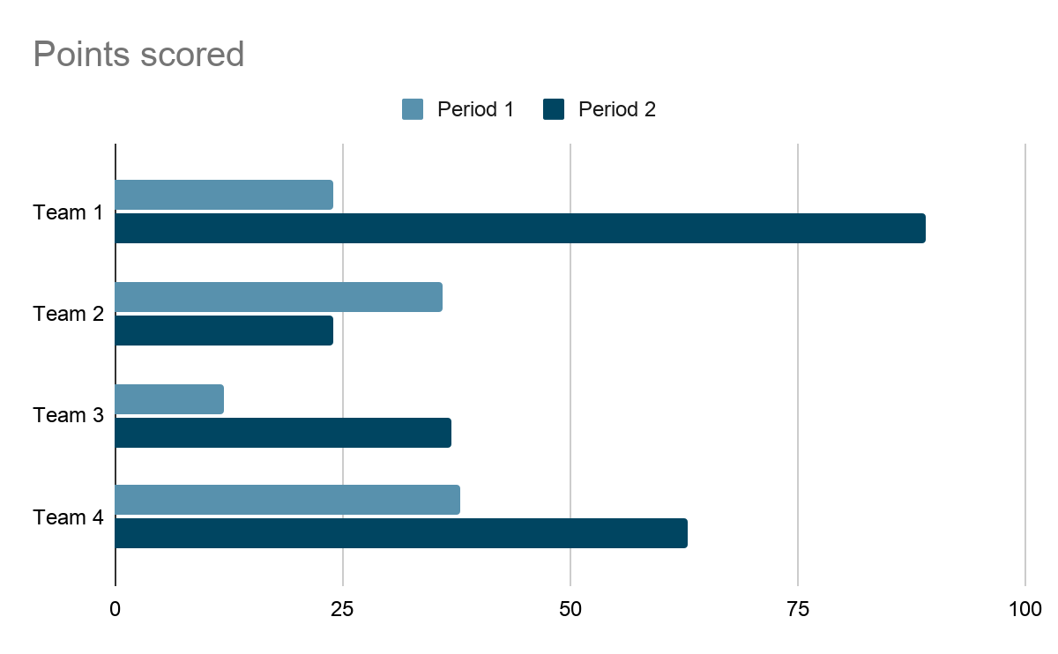

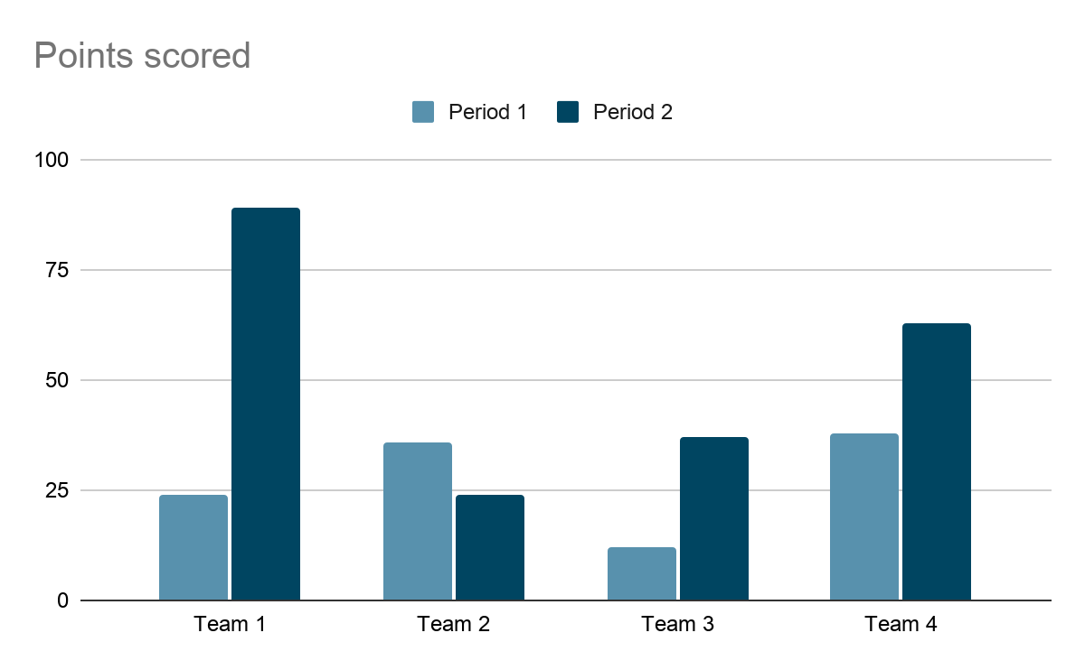
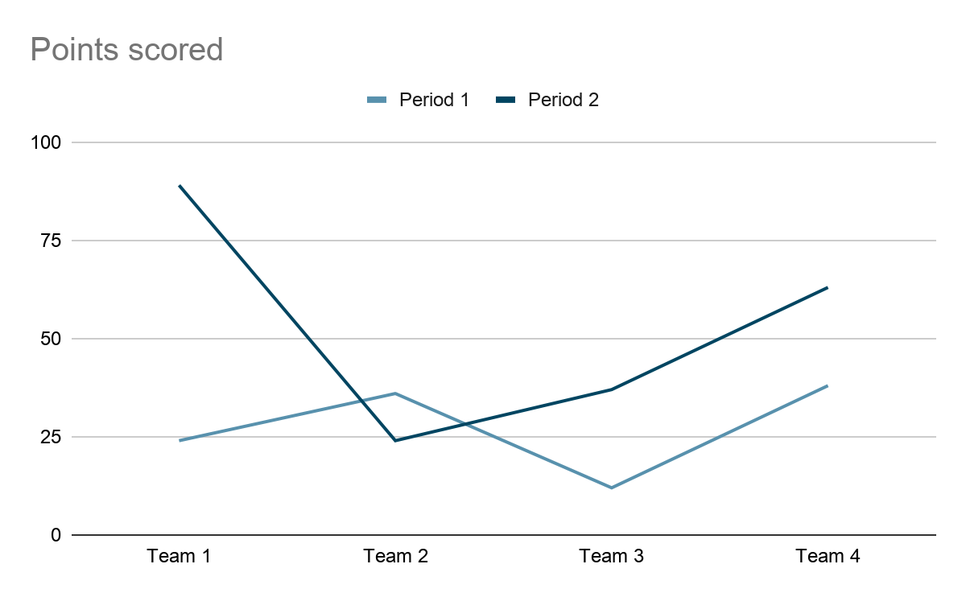
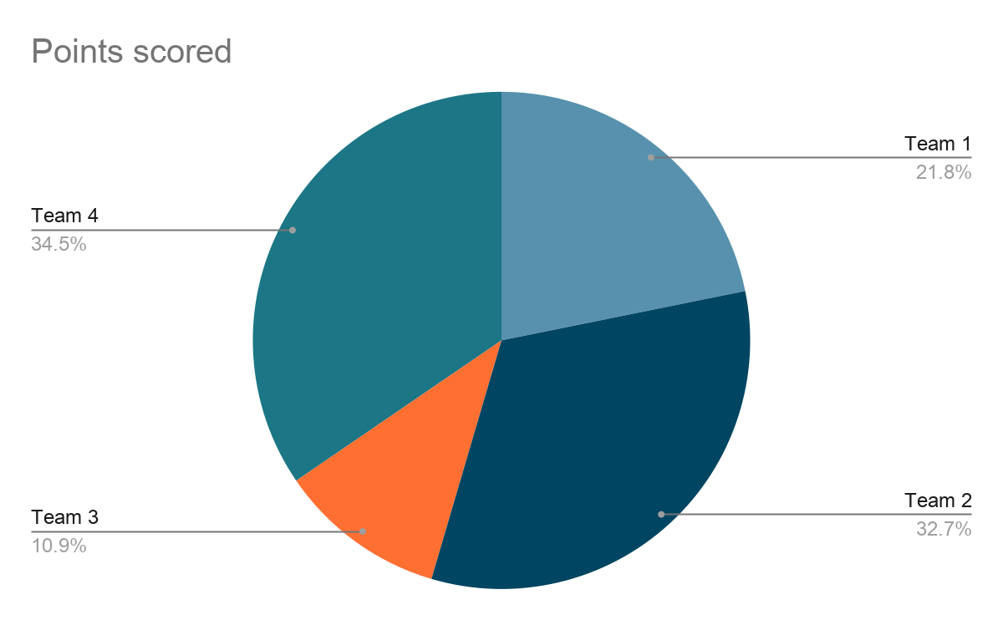
Special characters:
←↑→↓↔↕↖↗↘↙↣↢↡↠↟↞↝↜↛↚↤↥↦↧↨↩↪↫↬↭↷↶↴↵↴↳↲↱↰

