Dr. Svetlin Nakov
Software University – https://softuni.org
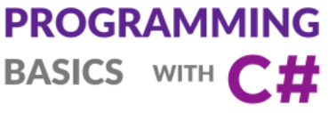
Issue 3 / 8
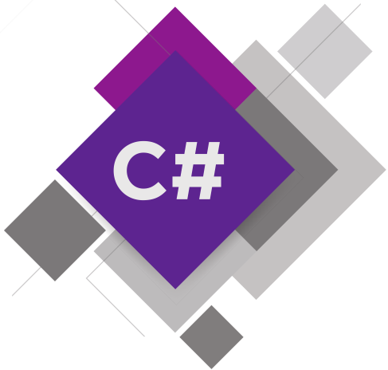
Simple Condiitions
Learn about the if-else conditional statements, how to check conditions and how to implement conditional logic in your programs. Solve practical exercises.

Get an idea how to build simple Desktop GUI app
“Multi-Currency Converter” in C# using Visual Studio.

Simple Conditions
In this mini book, we will discuss the conditional statements in the C# language, through which our program may have different effects, depending on a condition. We'll explain the syntax of conditional operators for checks (if and if-else) with appropriate examples and we will see in what range a variable (its scope) lives. Finally, we will go through debugging techniques to track the path that runs through our program during implementation.

Video: Overview
Watch the video about what we will learn in this mini book: https://youtu.be/sstA00rIWk0.

Introduction to Simple Conditions by Examples
In programming we can check conditions and execute different blocks of code depending on the check. This is typically performed using the if-else constructs:
var size = decimal.Parse(Console.ReadLine());
if (size < 0)
Console.WriteLine($"Negative size: {size}");
else if (size > 1000)
Console.WriteLine($"Size too big: {size}");
else
{
Console.WriteLine($"Size accepted: {size}");
Console.WriteLine($"Area: {size * size}");
}
Run the above code example: https://repl.it/@nakov/size-checker-if-else-csharp.
When executed, the above code will enter a decimal number and will check its value several times. Depending on the above conditions, it will display different messages. Examples are shown below.
If we enter -20 as input, the output will be as follows:
Negative size: -20
If we enter 150 as input, the output will be as follows:
Size accepted: 150
Area: 22500
If we enter 3200 as input, the output will be as follows:
Size too big: 3200
Let's explain in greater detail how to use simple if-else conditions in C#.

Comparing Numbers
In programming, we can compare values using the following operators:
- Operator < (less than)
- Operator > (greater than)
- Operator <= (less than or equals)
- Operator >= (greater than or equals)
- Operator == (equals)
- Operator != (different from)
When compared, the result is a Boolean value true or false, depending on whether the result of the comparison is true or false.

Video: Comparing Numbers
Watch the video lesson about comparing numbers: https://youtu.be/KTdqDWg7Wf8.

Examples for Comparing Numbers
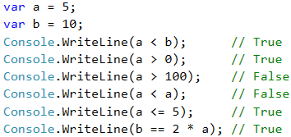
Note that when printing the true and false values in C # language, they are printed with a capital letter, respectively True and False.

Comparison Operators
In C #, we can use the following comparison operators:
Operator | Notation | Applicable for
Equals | == | numbers, strings, dates
Not equal | !=
Greater than | > | numbers, dates, other comparable objects
Greater than or equals | >=
Less than | <
Less than or equals | <=
Example:
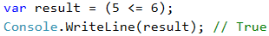

Simple If Conditions
In programming we often check particular conditions and perform various actions depending on the result of the check. This is done by if condition, which has the following structure:
if (condition)
{
// condition body;
}

Video: Simple If / If-Else Conditions
Watch the video lesson about the simple if-conditions: https://youtu.be/M-G4nOaVDVA.

Example: Excellent Grade
We read the grade from the console and check if it's excellent (≥ 5.50).
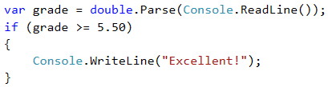
Test the code from the example locally. Try entering different grades, for example 4.75, 5.49, 5.50 and 6.00. For grades less than 5.50, the program will not give any output, however if the grade is 5.50 or greater, the output would be "Excellent!".

Testing in the Judge System
Test your solution from the example here:
https://judge.softuni.org/Contests/Practice/Index/506#0.

If-Else Conditions
The if construction may also contain an else clause to give a specific action in case the Boolean expression (which is set at the beginning if (bool expression) ) returns a negative result (false). Built this way, the conditional statement is called if-else and its behavior is as follows: if the result of the condition is positive (true) – we perform some actions, when it is negative (false) – others. The format of the construction is:
if (condition)
{
// condition body;
}
else
{
// else construction body;
}

Example: Excellent Grade or Not
Like the example above, we read the grade from the console and check if it's excellent, but this time we should output the result in both cases.
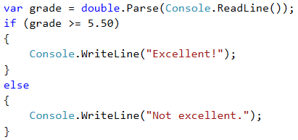

Testing in Judge System
Test your solution from the example here: https://judge.softuni.org/Contests/Practice/Index/506#1.

About the Curly Braces {} After If / Else
When we have only one command in the body of the if construction, we can skip the curly brackets, indicating the conditional operator body. When we want to execute block of code (group of commands), curly brackets are required. In case we drop them, only the first line after the if clause will be executed.
 | It's a good practice to always put curly braces, because it makes our code more readable and cleaner.
Here is an example where dropping curly braces leads to confusion:
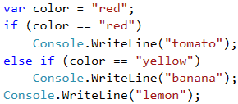
Executing the above code will output the following console result:
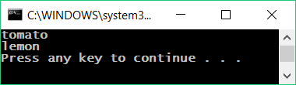
With curly braces:
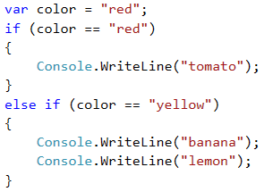
The following output will be printed on the console:
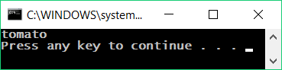

If-Else Conditions – Examples
Now let's take a few examples (exercises) to learn how to use if-else conditional statements in practice.

Video: Examples of If-Else
Watch the video lesson about the "Even or Odd Number" and "The Larger Number" problems and their solutions: https://youtu.be/qIUoKiObr-A.

Example: Even or Odd Number
Write a program that checks whether an integer is even or odd.

Hint and Guidelines
We can solve the problem with one if-else statement and the operator %, which returns a remainder by dividing two numbers.
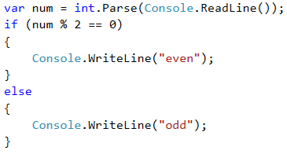

Testing in the Judge System
Test your solution here:
https://judge.softuni.org/Contests/Practice/Index/506#2.

Example: The Larger Number
Write a program that reads from the console two integers and prints the larger of them. Print "Greater number: " + the bigger number.
The input comes as two numbers, each on a separate line. Sample input:
3
5
The output is a message like the shown below. Sample output:
Greater number: 5

Hint and Guidelines
Our first task is to read the two numbers from the console. Then, with a simple if-else statement, combined with the operator for greater than (>), we do check. Part of the code is deliberately blurred, so you can test what you learned so far.
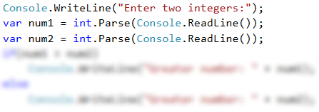

Testing in the Judge System
Test your solution here: https://judge.softuni.org/Contests/Practice/Index/506#3.

Variable Scope
Each variable has a range in which it exists, called variable scope. This range specifies where a variable can be used and how long is its lifetime. In the C# language, the scope in which a variable exists, starts from the line in which we defined it and ends with the first closing curly bracket } (of the method, the if statement, etc.).
Thus, it is important to know that any variable defined inside the body of certain if statement will not be available outside of it, unless we have defined it higher in the code.

Video: Variable Scope
Watch the video lesson about the variable scope: https://youtu.be/J54TJBnY5vQ.

Variable Scope – Example
In the example below, on the last line we are trying to print the variable salary that is defined in the if statement, we will get an error because we don't have access to it.
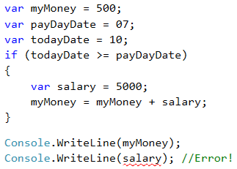
The above code will not compile, because we are trying to access a variable out of its scope.

Sequence of If-Else Conditions
Sometimes we need to do a sequence of conditions before we decide what actions our program will execute. In such cases, we can apply the construction if-else if ... -else in series. For this purpose, we use the following format:
if (condition)
{
// condition body;
}
else if (second condition)
{
// condition body;
}
else if (third condition)
{
// condition body;
}
…
else
{
// else construction body;
}

Video: Series of If-Else Checks
Watch the video lesson about the if-else checks: https://youtu.be/PUvf7gtKSz4.

Example: Digits in English
Print the digits in the range of 1 to 9 (digits are read from the console) in English. We can read the digit and then, through a sequence of conditions we print the relevant English word:
int num = int.Parse(Console.ReadLine());

if (num == 1)
{
Console.WriteLine("one");
}
else if (num == 2)
{
Console.WriteLine("two");
}
else if (…)
{
…
}
else if (num == 9)
{
Console.WriteLine("nine");
}
else
{
Console.WriteLine("number too big");
}
The program logic from the above example sequentially compares the input number from the console with the digits from 1 to 9, when each following comparison is being performed only in case the previous comparison is not true. Eventually, if none of the if statements are true, the last else clause is performed.

Testing in the Judge System
Test your solution here: https://judge.softuni.org/Contests/Practice/Index/506#4.

Debugging – Simple Operations with Debugger
So far, we wrote a lot of code, and there were some mistakes in it, right? Now we will show a tool that can help us find mistakes more easily: the debugger.

Video: Debugging Code in Visual Studio
Watch the video lesson about debugging code in Visual Studio: https://youtu.be/2asLYeJ6TeI.

What is "Debugging"?
Debugging is the process of "attaching" to the program execution, which allows us to track step by step the process. We can track line by line what happens in our program, what path it follows, what are the values of defined variables at each step of debugging, and many other things that allow us to detect errors (bugs).
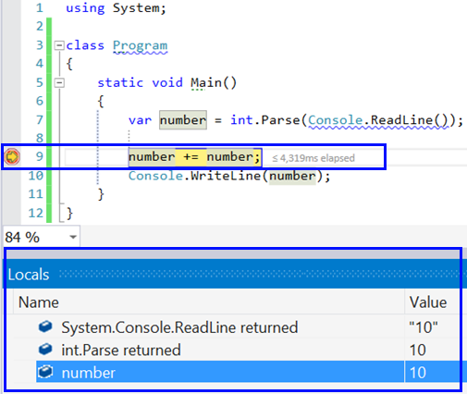

Debugging in Visual Studio
By pressing the [F10] button, we run the program in debug mode. We move to the next line again with [F10].
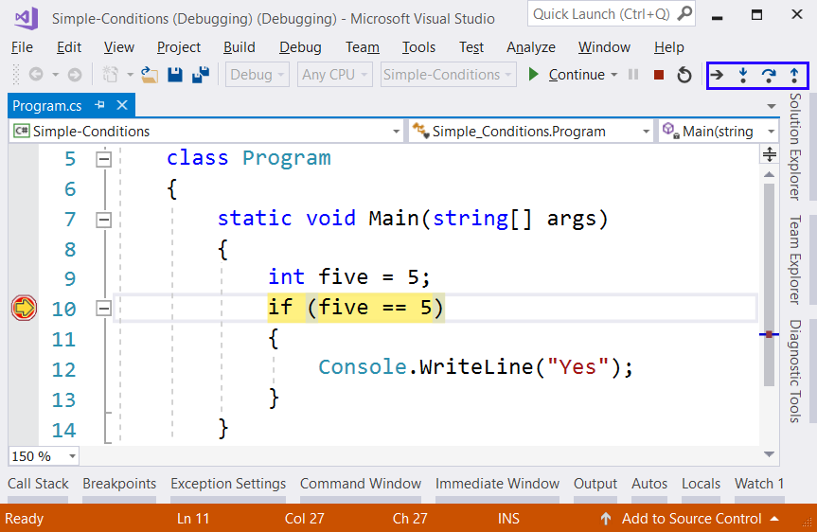
With [F9] we create the so-called breakpoints, that we can reach directly using [F5] when we start the program.

Exercises: Simple Conditions
Now let's practice the lessons learned about of conditional statements if and if-else. We will solve a few practical exercises.

Video: Summary
Watch the following video to summarize what we learned: https://youtu.be/mdv28HD5qes.

What We Learned?
Let's summarize what we learned:
- Numbers can be compared by the ==, <, >, <=, >= and != operators:
Console.WriteLine(5 <= 10); // True
- Simple if-conditions check a condition and execute a code block if it is true:
if (a > 5)
{
Console.WriteLine("The number `a` is bigger than 5");
}
- The if-else construction executes one of two blocks depending on whether a condition is true or false:
if (a > 5)
{
Console.WriteLine("The number `a` is bigger than 5");
}
else
{
Console.WriteLine("The number `a` is smaller or equal than 5");
}
- If-else constructions can be chained as if-else-if-else sequences:
if (a > 100)
{
Console.WriteLine("The number `a` is bigger than 100");
}
else if (a > 20)
{
Console.WriteLine("The number `a` is bigger than 20");
}
else
{
Console.WriteLine("The number `a` is smaller or equal than 20");
}

Empty Visual Studio Solution (Blank Solution)
At the start we create a Blank Solution in Visual Studio to organize better the task solutions from the exercise – each task will be in a separate project and all projects will be in a common solution.
We run Visual Studio and create a new Blank Solution: [File] -> [New] -> [Project].
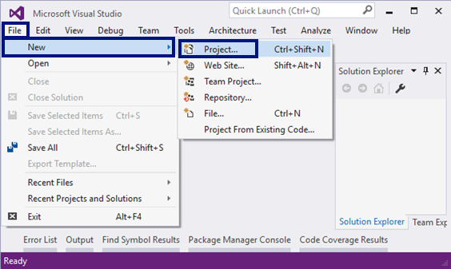
Choose from the dialog box [Templates] -> [Other Project Types] -> [Visual Studio Solutions] -> [Blank Solution] and give an appropriate project name, for example: “Simple-Conditions”:
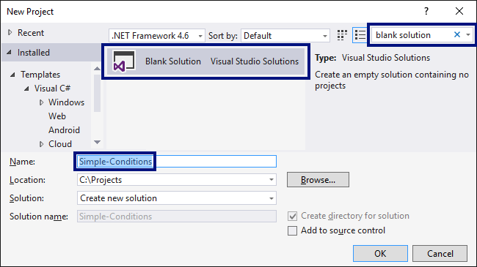
Now we have an empty Visual Studio Solution (no projects in it):
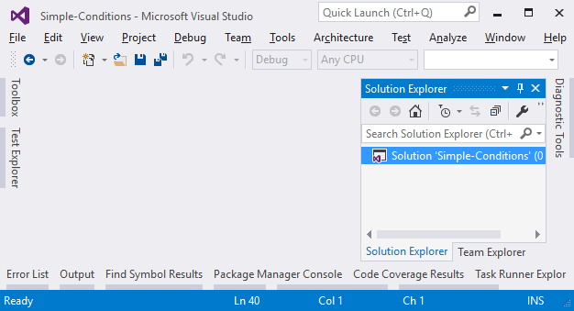
We will use this solution to create a separate project for each of the problems, which we will solve as exercises.

Problem: Excellent Grade
The first exercise for this topic is to write a console program that inputs the grade (decimal number) and prints Excellent! if the grade is 5.50or higher.

Sample Input and Output
Input | Output
6 | Excellent!
5 | (no output)
5.5 | Excellent!
5.49 | (no output)

Creating a New C# Project
We create a new project in the existing Visual Studio solution. In Solution Explorer, right-click on Solution 'Simple-Conditions'. Then choose [Add] -> [New Project]:
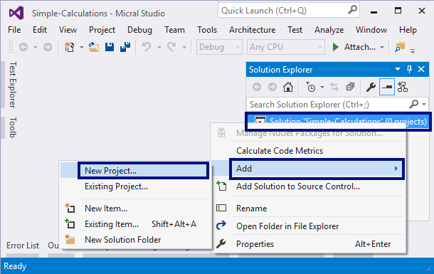
A dialog box will open for selecting a project. Choose C # console application and specify a name, for example "Excellent-Result":
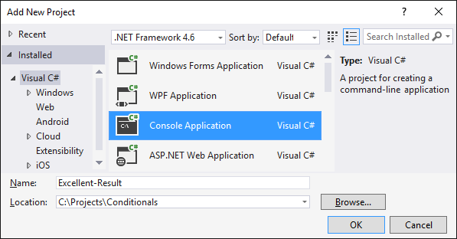
Now we have a solution with one console application in it. What remains is to write the code to solve the problem.

Writing the Program Code
For this purpose, we go into the body of the Main (string [] args) method and write the following code:
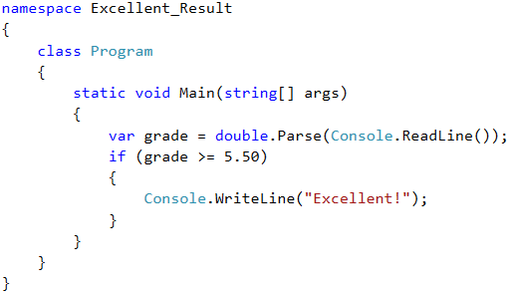
Run the program with [Ctrl+F5], to test it with different input values:
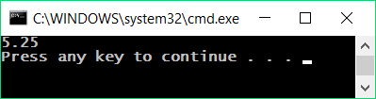
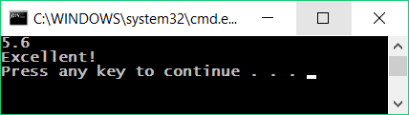

Testing in the Judge System
Test your solution from the example here: https://judge.softuni.org/Contests/Practice/Index/506#0.
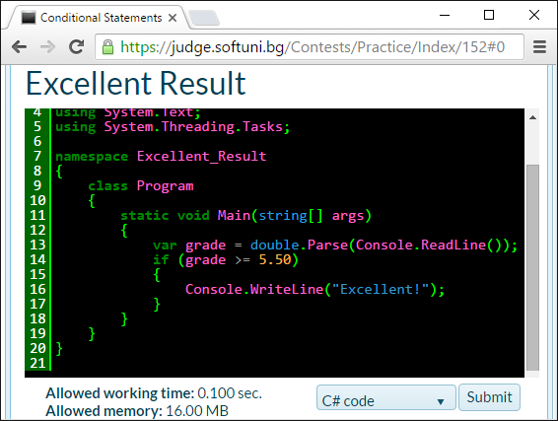
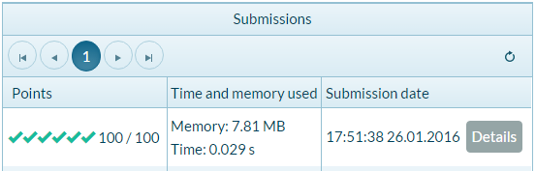

Problem: Excellent Grade or Not
The next exercise from this topic is to write a console program that inputs the grade (decimal number) and prints Excellent! if the grade is 5.50 or higher, otherwise "Not excellent.".

Sample Input and Output
Input | Output
6 | Excellent!
5 | Not excellent.
5.5 | Excellent!
5.49 | Not excellent.

Creating a New C# Project and Writing the Program Code
First, we create a new C# console project in the Simple-Conditions solution.
- We click on the solution in Solution Explorer and choose [Add] -> [New Project].
- We choose [Visual C#] -> [Windows] -> [Console Application] and specify a name, for example: “Excellent-or-Not”.
Now we have to write the code of the program. You can get help by using the sample code from the picture:

Automatic Switching to the Current Project
We turn on the mode for automatic switching to the current project by right-clicking on the main Solution and choosing [Set StartUp Projects...]:
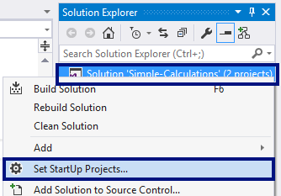
A dialog box will appear, and you have to choose [Startup Project] -> [Current selection]:
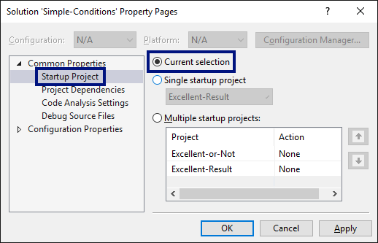

Local Testing
Now we run the program as usual with [Ctrl + F5] and test if it works correctly:
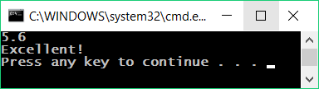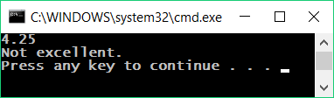

Testing in the Judge System
Test your solution here: https://judge.softuni.org/Contests/Practice/Index/506#1.
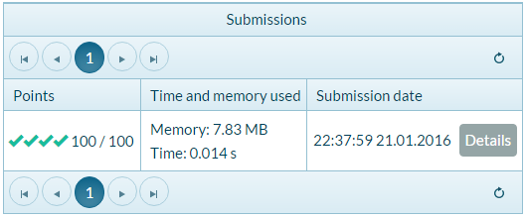

Problem: Even or Odd
Write a program that checks whether an integer is even or odd.

Sample Input and Output
Input | Output
2 | even
3 | odd
25 | odd
1024 | even

Hints and Guidelines
Again, first we add a new C # console project in the existing solution. In the static void Main () method, we have to write the program code. Checking if a given number is even can be done with the operator %, which will return the remainder from an integer divided by 2 as follows: var isEven = (num % 2 == 0).
Now we run the program with [Ctrl + F5] and test it:
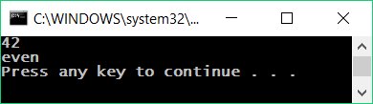

Testing in the Judge System
Test your solution here: https://judge.softuni.org/Contests/Practice/Index/506#2.

Problem: Finding the Greater Number
Write a program that inputs two integers and prints the larger one.

Sample Input and Output
Input | Output
5  3 | 5
3  5 | 5
10  10 | 10
-5  5 | 5

Hints and Guidelines
As usual, first we need to add a new C # console project to the existing solution. For the code of the program we need a single if-else statement. You can partially get assistance for the code from the picture that is deliberately blurred to make you think about how to write it yourself:
When we are done with the implementation of the solution, we run the program with [Ctrl + F5] and test it:
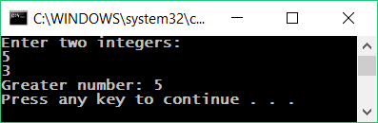

Testing in the Judge System
Test your solution here: https://judge.softuni.org/Contests/Practice/Index/506#3.

Problem: Typing a Digit in Words
Write a program that inputs an integer in the range [0 ... 9] and outputs it in words in English. If the number is out of range, print "number too big".

Sample Input and Output
Input | Output
5 | five
1 | one
9 | nine
10 | number too big

Hints and Guidelines
We can use a series of if-else statements to examine the possible 11 cases.

Testing in the Judge System
Test your solution here: https://judge.softuni.org/Contests/Practice/Index/506#4.

Problem: Bonus Score
We have an integer – the number of points. Bonus score are charged on it, according to the rules described below. Write a program that calculates bonus score for this figure and total points with bonuses.
- If the number is up to 100 including, bonus score is 5.
- If the number is larger than 100, bonus score is 20% of the number.
- If the number is larger than 1000, bonus score is 10% of the number.
- Additional bonus score (accrued separately from the previous ones):
- for even number -> + 1 p.
- for number, that ends with 5 -> + 2 p.

Sample Input and Output
Input | Output
20 | 6  26
175 | 37  212
2703 | 270.3  2973.3
15875 | 1589.5  17464.5

Video: Bonus Score
Watch the video lesson about the solution of the "Bonus Score" problem: https://youtu.be/hstZ5rNJ7vs.

Hints and Guidelines
We can calculate the main and additional bonus score with a series of if-else-if-else statements. For the main bonus score we have 3 cases (when the entered number is up to 100, between 100 and 1000 and larger than 1000), and for extra bonus score – 2 more cases (when the number is even and odd).
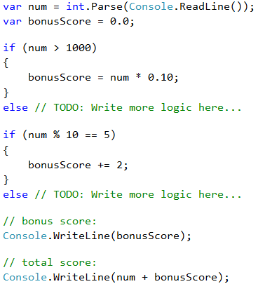
Here's an example solution:
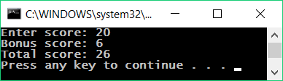
Note that for this exercise, the judge is set to ignore anything that is not a number, so we can print not only the numbers, but also specifying text.

Testing in the Judge System
Test your solution here: https://judge.softuni.org/Contests/Practice/Index/506#5.

Problem: Guess the Password
Write a program that inputs a password (one line with random text) and checks if the input matches the phrase "s3cr3t!P@ssw0rd". If it matches, print "Welcome", otherwise "Wrong password!".

Sample Input and Output
Input | Output
qwerty | Wrong password!
s3cr3t!P@ssw0rd | Welcome
s3cr3t!p@ss | Wrong password!

Hints and Guidelines
Use an if-else statement.

Testing in the Judge System
Test your solution here: https://judge.softuni.org/Contests/Practice/Index/506#8.

Problem: Summing Up Seconds
Three athletes finish in a particular number of seconds (between 1 and 50). Write a program that introduces the times of the contestants and calculates their total time in "minutes:seconds" format. Seconds need to be zeroed at the front (2 -> "02", 7 -> "07", 35 -> "35").

Sample Input and Output
Input | Output
35  45  44 | 2:04
22  7  34 | 1:03
50  50  49 | 2:29
14  12  10 | 0:36

Video: Summing Up Seconds
Watch the video about the "Summing Up Seconds" problem and its step-by-step solution: https://youtu.be/bnNxe79X-wo.

Hints and Guidelines
First, we sum up the three numbers to get the total result in seconds. Since 1 minute = 60 seconds, we will have to calculate the number of minutes and seconds in the range 0 to 59:
- If the result is between 0 and 59, we print 0 minutes + calculated seconds.
- If the result is between 60 and 119, we print 1 minute + calculated seconds minus 60.
- If the result is between 120 and 179, we print 2 minutes + calculated seconds minus 120.
- If the seconds are less than 10, we print the number with zero in front.
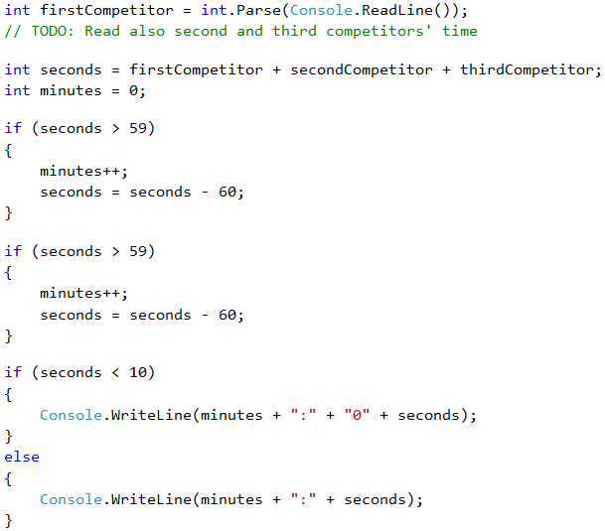

Testing in the Judge System
Test your solution here: https://judge.softuni.org/Contests/Practice/Index/506#6.

Problem: Metric Converter
Write a program that convert a distance between the following 8 units of measure: m, mm, cm, mi, in, km, ft, yd. Use the below table:
Input measure | Output measure
1 meter (m) | 1000 millimeters (mm)
1 meter (m) | 100 centimeters (cm)
1 meter (m) | 0.000621371192 miles (mi)
1 meter (m) | 39.3700787 inches (in)
1 meter (m) | 0.001 kilometers (km)
1 meter (m) | 3.2808399 feet (ft)
1 meter (m) | 1.0936133 yards (yd)
You have three input lines:
- First line: number for converting.
- Second line: input unit.
- Third line: output unit (for result).

Sample Input and Output
Input | Output
12  km  ft | 39370.0788
150  mi  in | 9503999.99393599
450  yd  km | 0.41147999937455

Video: Metric Converter
Watch the following video lesson to learn how to solve the "Metric Converter" problem: https://youtu.be/Bd6NgaHhrko.

Hints and Guidelines
We read the input data, and we can add ToLower() function when we read the measuring units. The function will make all letters small. As we can see from the table in the condition, we can only do converting between meters and some other measuring unit. Then, first we have to calculate the number for converting in meters. That's why, we need to make a set of checks to define the input unit and then the output unit.
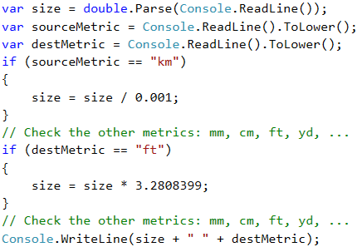

Testing in the Judge System
Test your solution here: https://judge.softuni.org/Contests/Practice/Index/506#7.

Problem: Numbers from 100 to 200
Write a program that inputs an integer and checks if it is below 100, between 100 and 200 or over 200. Print the appropriate message as in the examples below.

Sample Input and Output
Input | Output
95 | Less than 100
120 | Between 100 and 200
210 | Greater than 200

Testing in the Judge System
Test your solution here: https://judge.softuni.org/Contests/Practice/Index/506#9.

Problem: Identical Words
Write a program that inputs two words and checks if they are the same. Do not make difference between uppercase and lowercase letters. You have to print "yes" or "no".

Sample Input and Output
Input | Output
Hello  Hello | yes
SoftUni  softuni | yes
Soft  Uni | no
banana  lemon | no
HeLlO  hELLo | yes

Hints and Guidelines
Before comparing the words, turn them into a lowercase to avoid the letter size influence (uppercase / lowercase): word = word.ToLower().

Testing in the Judge System
Test your solution here: https://judge.softuni.org/Contests/Practice/Index/506#10.

Problem: Speed Assessment
Write a program that inputs the speed (decimal number) and prints speed information. For speed up to 10 (inclusive), print "slow". For speed over 10 and up to 50, print "average". For speed over 50 and up to 150, print "fast". For speed over 150 and up to 1000, print "ultra fast". For higher speed, print "extremely fast".

Sample Input and Output
Input | Output
8 | slow
49.5 | average
126 | fast
160 | ultra fast
3500 | extremely fast

Testing in the Judge System
Test your solution here: https://judge.softuni.org/Contests/Practice/Index/506#11.

Problem: Areas of Figures
Write a program that inputs the sizes of a geometric figure and calculates its area. The figures are four types: square, rectangle, circle and triangle.
The first line of the input provides the type of the figure (square, rectangle, circle, triangle).
- If the figure is a square, the next line provides one number – the length of its side.
- If the figure is a rectangle, the next two lines we provide two numbers – the lengths of its sides.
- If the figure is a circle, the next line provides one number – the radius of the circle.
- If the figure is a triangle, the next two lines provide two numbers – the length of the side and the length of its height.
Round the result up to the third digit after the decimal point.

Sample Input and Output
Input | Output
square  5 | 25
rectangle  7  2.5 | 17.5
circle  6 | 113.097
triangle  4.5  20 | 45

Testing in the Judge System
Test your solution here: https://judge.softuni.org/Contests/Practice/Index/506#12.

Problem: Time + 15 Minutes
Write a program that inputs hours and minutes of a 24-hour day and calculates what will be the time after 15 minutes. Print the result in hh:mm format. Hours are always between 0 and 23, and minutes are always between 0 and 59. Hours are written with one or two digits. Minutes are always written with two digits and zero at the front when needed.

Sample Input and Output
Input | Output
1  46 | 2:01
0  01 | 0:16
23  59 | 0:14
11  08 | 11:23
12  49 | 13:04

Hints and Guidelines
Add 15 minutes and check using a few conditions. If minutes are over 59, increase hours with 1 and reduce minutes with 60. Identically, check the case when hours are over 23. When you print the minutes, you should check for zero at the front.

Testing in the Judge System
Test your solution here: https://judge.softuni.org/Contests/Practice/Index/506#13.

Problem: Equal 3 Numbers
Write a program that inputs 3 numbers and prints whether they are the same (yes / no).

Sample Input and Output
Input | Output
5  5  5 | yes
5  4  5 | no
1  2  3 | no

Testing in the Judge System
Test your solution here: https://judge.softuni.org/Contests/Practice/Index/506#14.

Problem: * Writing the Numbers from 0 to 100 in Words
Write a program that converts a number in the range of [0 ... 100] into text.

Sample Input and Output
Input | Output
25 | twenty five
42 | forty two
6 | six

Hints and Guidelines
First check for one-digit numbers and if the number is one-digit, print the appropriate word for it. Then check for two-digit numbers. Print them in two parts: left part (tens = number / 10) and right part (units = number % 10). If the number has 3 digits, it must be 100 and can be considered a special case.

Testing in the Judge System
Test your solution here: https://judge.softuni.org/Contests/Practice/Index/506#15.

Lab: GUI (Desktop) Application – Currency Converter
After we've done some exercises on conditional statements (checks), now let's do something more interesting: an application with a graphical user interface (GUI) for converting currencies. We will use the knowledge from this mini book to choose from several available currencies and make calculations at different rate to the selected currency.
Now let's see how to create a graphical (GUI) app for currency conversion. The app will look like the picture below:
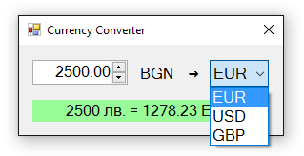

Video: Building a GUI App "Currency Converter"
Watch the video lesson about building a Windows Forms based GUI app "Currency Converter": https://youtu.be/IIkPmoXmjdg.

Creating a New C# Project and Adding Controls
This time we create a new Windows Forms Application with name “Currency-Converter”:
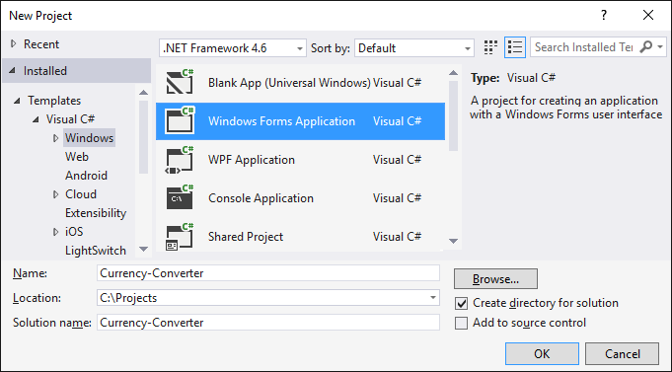
We order the following controls in the form:
- One box for entering a number (NumericUpDown)
- One drop-down list with currencies (ComboBox)
- Text block for the result (Label)
- Several inscriptions (Label)
We set the sizes and their properties to look like the picture below:
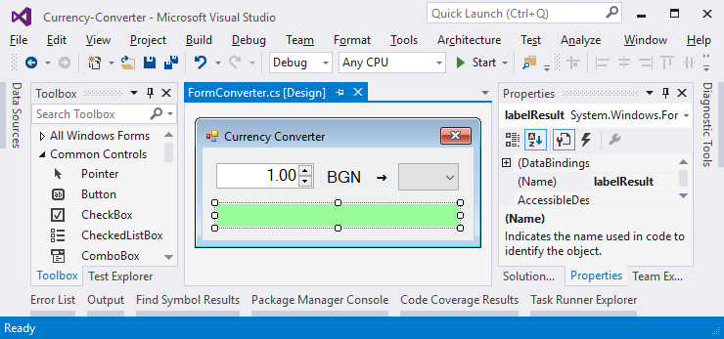

Configuring the UI Controls
We apply the following settings for the UI controls:
- For the main form (Form) that contains all the controls:
  - (name) = FormConverter
  - Text = "Currency Converter"
  - Font.Size = 12
  - MaximizeBox = False
  - MinimizeBox = False
  - FormBorderStyle = FixedSingle
- For the field for entering a number (NumericUpDown):
  - (name) = numericUpDownAmount
  - Value = 1
  - Minimum = 0
  - Maximum = 1000000
  - TextAlign = Right
  - DecimalPlaces = 2
- For the drop-down list of currencies (ComboBox):
  - (name) = comboBoxCurrency
  - DropDownStyle = DropDownList
  - Items =
    - EUR
    - USD
    - GBP
- For the result text block (Label):
  - (name) = labelResult
  - AutoSize = False
  - BackColor = PaleGreen
  - TextAlign = MiddleCenter
  - Font.Size = 14
  - Font.Bold = True

Events and Event Handlers
We need to take the following events to write the C# code that will be executed upon their occurrence:
- The event ValueChanged of numeric entry control numericUpDownAmount:
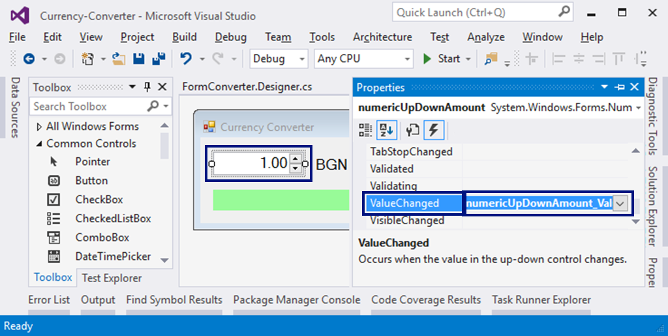
- The event Load of the form FormConverter
- The event SelectedIndexChanged of the drop-down list for choosing the currency comboBoxCurrency
We will use the following C# code for event handling:
private void FormConverter_Load(object sender, EventArgs e)
{
this.comboBoxCurrency.SelectedItem = "EUR";
}

private void numericUpDownAmount_ValueChanged(object sender, EventArgs e)
{
ConvertCurrency();
}

private void comboBoxCurrency_SelectedIndexChanged(object sender, EventArgs e)
{
ConvertCurrency();
}
Our task is to select the currency "EUR" when we start the program and change the values in the sum or currency field then calculating the result by calling the ConvertCurrency() method.

Writing the Program Code
We have to write the event ConvertCurrency() to convert the leva amount into the selected currency:
private void ConvertCurrency()
{
var originalAmount = this.numericUpDownAmount.Value;
var convertedAmount = originalAmount;
if (this.comboBoxCurrency.SelectedItem.ToString() == "EUR")
{
convertedAmount = originalAmount / 1.95583m;
}
else if (this.comboBoxCurrency.SelectedItem.ToString() == "USD")
{
convertedAmount = originalAmount / 1.80810m;
}
else if (this.comboBoxCurrency.SelectedItem.ToString() == "GBP")
{
convertedAmount = originalAmount / 2.54990m;
}
this.labelResult.Text = originalAmount + " lv. = " +
Math.Round(convertedAmount, 2) + " " +
this.comboBoxCurrency.SelectedItem;
}
The above code takes the amount for converting the field numericUpDownAmount and the selected currency for the result from the field comboBoxCurrency. Then with a conditional statement, according to the selected currency, the amount is divided by the exchange rate (which is fixed in the source code). Finally, a text message with the result (rounded to the second digit after the decimal point) is generated and recorded in the green box labelResult. Try it!

What’s Next?
The “Programming Basics” series consists of publications for beginners in programming that covers the following topics:
- First Steps in Programming – commands, programs, C#, Visual Studio,
- Simple Calculations – variables, calculations, console input / output
- Simple Conditions – conditional statements, the “if-else” construction
- More Complex Conditions – nested if-else, logical “and”, “or”, “not”
- Repetitions (Loops) – simple for-loops (repeat from 1 to n)
- Nested Loops – nested loops and problem solving, drawing 2D figures
- More Complex Loops – loops with a step, infinite loops with breaks
- How to Become a Software Engineer?
The next topics are coming. Be patient!

Sign-Up to Study in SoftUni
The easiest way to become a software engineer is to go through the “Software University” training program at SoftUni. Signup now for the free Programming Basics training course:
https://softuni.org/apply
Join the SoftUni community and study programming for free in our interactive training platform. Get live support and mentoring from our trainers. Become a software developer now!

