**Abstract and High Level Use Cases**

**Assignment Number :03**

**High Level Use Case**  
**R1 NTSS allowing user to Create an Online Account  
Use case:** Create an Online Account (**Verb:** Create + **Noun**: Online Account)

**Actor:** User(Business Customer/Participant/Speaker/Exhibitor)

**System:** NTSS Application

**TUCBW:** User clicks on the create an online account button.

**TUCEW:** User sees account creation status message.

**R 1.1 NTSS allowing user to Login Using a Valid Email Address**

**Use case:** Login using valid email and password (**Ver**b :Login +**Noun**: Valid email address and password)

**Actor:** User(Business Customer/Participant/Speaker/Exhibitor)

**System:** NTSS Application

**TUCBW:** User clicks on the login button.

**TUCEW:** User is directed to NTSS Homepage.

**R 1.1.1 NTSS allowing user to change temporary password at first login**

**Use case:** change temporary password at first login(**Verb** : Change +**Noun:** temporary password)

**Actor:** User(Business Customer/Participant/Speaker/Exhibitor)

**System:** NTSS Application

**TUCBW:** User clicks on the login button.

**TUCEW:** User is prompted to change the password on first time login.

**R 1.1.2 NTSS allowing a user to request for a Password Reset**

Use case: request for password reset (**Verb:** Request **+Noun :**Password Reset**)**

Actor: User(Business Customer/Participant/Speaker/Exhibitor)

**System:** NTSS Application

**TUCBW:** User clicks on password reset button.

**TUCEW:** User is informed that the password is reset successfully.

**R2 NTSS submitting an Event Proposal form with the required fields to describe the event**

**Use case**: Submit an Event Proposal (**Verb :** Submit **+ Noun :** Event Proposal**)**

**Actor:** Event Organizer

**System:** NTSS Application

**TUCBW:** Event Organizer submits an event proposal.

**TUCEW:** Event Organizer is redirected to payment gateway.

**R2.1 Submission of the Payment Slip to the Event Organizer**

**Use case:** Provide payment(**Verb :** Submission + **Noun :** Payment Slip)

**Actor:** Event Organizer

**System:** NTSS Application

**TUCBW:** Event Organizer provides payment via payment gateway.

**TUCEW:** Event Organizer is informed about the payment and event proposal status details.

**R2.2 NTSS to change status of event proposal from “Pending Review” to “Submitted”**

**Use case:** Change an Event Proposal (**Verb :** Change + **Noun :**Event Proposal status)

**Actor:** Event Organizer

**System:** NTSS Application

**TUCBW:** Event Organizer chooses to edit the submitted event proposal.

**TUCEW:** Event Organizer is displayed about that the event proposal is modified successfully.

**R3: NTSS allows an Event Organizer to cancel an event with 15% cancellation charge)**

**Use case:** Cancel a Submitted Event Proposal (**Verb:** Cancel + **Noun**: Event)

**Actor:** Event Organizer

**System:** NTSS Application

**TUCBW:** Event Organizer selects to cancel submitted event proposal.

**TUCEW:** Event Organizer is charged 15% of the deposit fee and event proposal is canceled.

**R4 NTSS allows an Event Organizer to edit an submitted or pending review proposal**

**without any charge**

**Use case: Edit an Event Proposal (Verb :** Edit**+ Noun :**Event Proposal**)**

**Actor:** Event Organizer

**System**: NTSS Application

**TUCBW:** Event Organizer chooses to edit the submitted event proposal.

TUCEW: Event Organizer is displayed about that the event proposal is modified successfully.

**R5 NTSS Allows staff to Evaluate the Project Proposal**

**Use case:** NTSS staff to take a Decision (Acceptance /Rejection) of the Project Proposal submitted by the Event Organizer and give the feedback to the Event Organizer, If the project proposal is rejected ,a proper justification need to be given by the NTSS Staff for the Evaluation

(**Verb:** Evaluate + **Noun:** Project Proposal)

**Actor:** NTSS Staff

**System:** NTSS Application

**TUCBW:** NTSS Staff evaluates the Project Proposal and gives Decision

**TUCEW:** Event Organizers can check the decision (Acceptance/Rejection) and view the feedback and can check the justification of the rejection of the project proposal submitted.

**R6.1 :NTSS allows Exhibitor for the Submission of Booth Lease Request and Exhibitor can choose the desired size of the booth**

**Use case:** NTSS displays to choose the floor plan of the booth according to the width and the length of the booth , which has small , medium and large booths , so that according to the exhibitor’s choice they can select the size of the booth to exhibit their products.

(**Verb:** Lease request + **Noun:** Booth)

**Actor:** Exhibitor

**System:** NTSS Application

**TUCBW:** NTSS Opens display for the Exhibitors to choose the floor plan of the Booth to lease.

**TUCEW:** Exhibitors can choose the desired size of the booth according to their requirement.

**R6.2 NTSS will generate a summary and the estimation of the payment reciept and details of the allocated number of the Booth to the Exhibitor and Exhibitor can take print out of the receipt.**

**Use case:** (**Verb:** Generate, Print + **Noun:** Summary , Payment Receipt)

**Actor:** Exhibitor

**System:** NTSS Application

**TUCBW:** NTSS would be generating the summary and estimation of the payment receipt.

**TUCEW:** Exhibitors can view the allocated number and take the print out of the receipt.

**R6.3 After receiving the payment NTSS will change the status to pending review , and notification is sent to the exhibitor for his reference.**

**Use case:** (**Verb:** Change + **Noun:** Status of booth lease)

**System:** NTSS Application

**TUCBW:** NTSS will change the status to pending review and notifies the exhibitor

**TUCEW:** Exhibitors can view the status which is sent for the review and contact the NTSS for any issues or incorrect data.

**R7: NTSS allows an Exhibitor to cancel an booth lease with 10% cancellation charge)**

**Use case:** Cancel a Submitted Booth Lease Request (**Verb:** Cancel+ **Noun**: Booth lease)

**Actor:** Exhibitor

**System:** NTSS Application.

**TUCBW:** Exhibitor can cancel submitted Booth Lease Request.

**TUCEW:** Exhibitor is charged 10% of the deposit fee and Booth Lease is canceled.

**R8 NTSS Allows staff to Evaluate the Booth Lease Request**

**Use case:** NTSS staff to take a Decision (Acceptance /Rejection) of the Booth Lease Request submitted by the Exhibitor and give the feedback to the Exhbitor for the rejection. NTSS staff will give you an update of the Booth Lease Request through notification. As soon as the Booth Lease is occupied and confirmed , it is marked as Unavailable in the NTSS Portal

(**Verb:** Evaluate + **Noun:**Booth Lease Request)

**Actor:** NTSS Staff

**System:** NTSS Application

**TUCBW:** NTSS Staff evaluates the Booth Lease Request and gives Decision with the justification for the rejection. NTSS staff is also responsible to notify the status of the Booth Lease request to the Exhibitor and mark the Booth Lease slot availability to be occupied.

**TUCEW:** Exhibitors can check the decision (Acceptance/Rejection) and can check the justification of the rejection of the Booth Lease Request submitted. Exhibitors can view the notified updates by the NTSS Staff regarding the status of the Booth Lease Allocation.

**R9. NTSS allows a potential participant to register through a variety search criteria**

**Use case:** NTSS would be allowing a potential participant to do a special search .

(**Verb:** Register through variety search criteria + **Noun:**potential participant)

**Actor:** Potential Participant

**System:** NTSS Application

**TUCBW:** NTSS has a special option for the potential participant using variety search criteria.

**TUCEW:** Potential Participant can search the Event through special search criteria given by NTSS

**R10 NTSS shall allow a Potential Participant to register for one or more events.**

**Use case:**

NTSS shall allow a potential participant to register for one or more events.

(**Verb**: Register for one or more + **Noun**: Events)

**Actor**: Potential Participant

**System**: NTSS Application

**TUCBW**: Participant clicks on the Events view page to check the list of Events available.

**TUCEW**: Participant is displayed a list of events that can be selected according to interest.

**R10.1 NTSS generates the payment receipt and total payment where the Potential participant can take a print out and after receiving the payment NTSS will notify the user that the payment is received.**

**Use case:** NTSS generates the payment receipt and total payment where the Potential participant can take a print out and even after receiving the payment NTSS will notify the user that the payment is received.  
**(Verb:**Notify and Generate+**Noun:** Payment details and receipt)

**Actor**: Participant

**System**: NTSS Application

**TUCBW**: NTSS generates the payment receipt and gives the status on the participation for the event

**TUCEW**: Participant get notified about the status of the payment and confirmation of the participation and can take the print out of the payment receipt

**R11. A registered participant may cancel their registration without charge up to one week before the event, and with a 10% cancellation fee after that.**

**Use case:** A registered participant has a cool off period of one week to cancel their participation and after one week there is a cancellation fee of 10% of the total payment.

(**Verb**: Cancel + **Noun**:Registration)

**Actor**: Registered Participant

**System**: NTSS Application

**TUCBW:** Registered Participant can cancel Registration Request for free till one week before the event

**TUCEW:** Registered Participant will be charged 10 % of the cancellation fee after one week before the event.

**R12 . Allow Payment Method by NTSS through Payment Interface**

**Use case:** NTSS accepts the following payment methods: credit cards, cashier's checks, personal checks, money orders, and PayPal.

(**Verb :** Accepts + **Noun:** Payment Method)

**Actor:** Participant

**System**: NTSS Application

**TUCBW:** Participant provides payment via payment gateway like credit cards, cashier's checks, personal checks, money orders, and PayPal.

**TUCEW:** Participant is notified about the payment status and event registration details.

**Identify Use Cases Table:**

| **Req** | **Verb/Noun** | **Business Process** | **Begin w/Actor** | **End w/Actor** | **Accomplish Business Task** | **Use Case** | **Actors** |
| --- | --- | --- | --- | --- | --- | --- | --- |
| R1 | Create an online account | Y | Y | Y | Y | Y | User |
| R1.1 | Login using Email Address | Y | Y | Y | Y | Y | User |
| R1.2 | Send Temporary Password | N | N | N | Y | N | System |
| R1.3 | Change/Reset Temporary Password | N | Y | Y | Y | N | User |
| R2 | Submit Event Proposal | Y | Y | Y | Y | Y | User |
| R2.1 | Generate Payment Slip | N | N | Y | Y | N | Organizer,Exhibitor, Speaker, Observer |
| R2.2 | Change of Status | Y | Y | Y | Y | Y | System |
| R3 | Cancel an Event | Y | Y | Y | Y | Y | Event Organizer |
| R4 | Edit an Event Proposal | Y | Y | Y | Y | Y | Event Organizer |
| R5 | Evaluate Event Proposal | Y | Y | Y | Y | Y | NTSS Staff |
| R6.1 | Submit Booth lease | Y | Y | Y | Y | Y | Exhibitor |
| R6.2 | Generate Summary and Payment Slip | N | N | Y | Y | N | System |
| R6.3 | Change status of Booth Lease | Y | N | N | Y | N | System |
| R7 | Cancel Booth Lease | Y | Y | Y | Y | Y | Exhibitors |
| R8 | View Booth Lease Request | N | Y | Y | N | N | Exhibitor/NTSS |
| R9 | Evaluate Booth Lease Request | Y | Y | Y | Y | Y | NTSS Staff |
| R10 | Register for one or more events | Y | Y | Y | Y | Y | Participant |
| R10.1 | Generate Payment Receipt and print payment Slip | N | N | Y | N | N | System |
| R11 | Cancel Registration | Y | Y | Y | Y | Y | Participant |
| R12 | Allow Payment | Y | Y | Y | Y | Y | Participant |

**Use Case Diagrams:**

1. **NTSS/Create an Account**  
     
   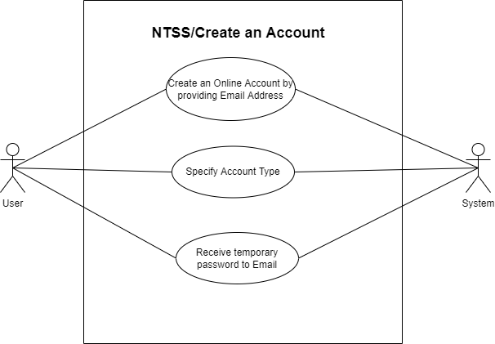
2. **NTSS/Log-In**

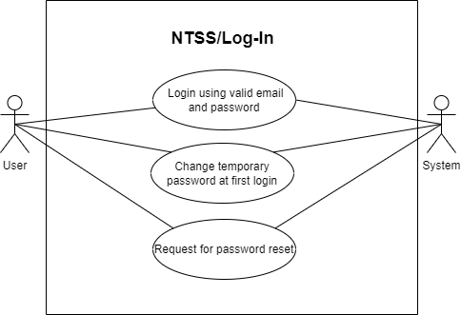

1. **NTSS/Event Proposal**  
   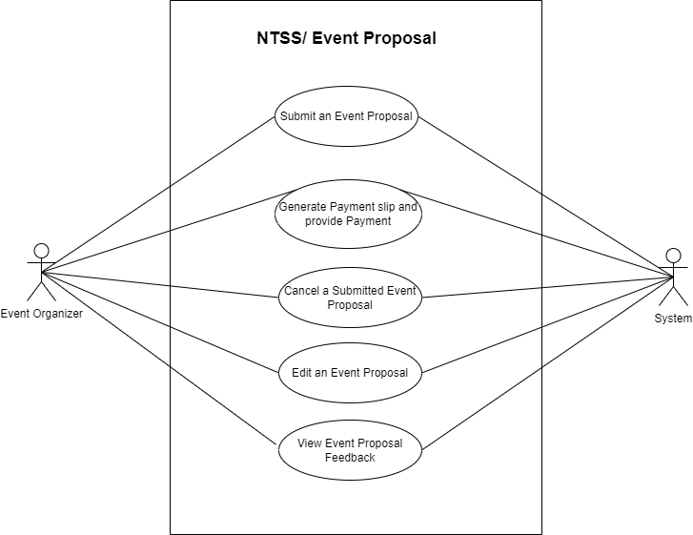
2. **NTSS/Register for an Event**

