EXAMINE VARIABLES=Conf_ind_pre Conf_ind_post2
/COMPARE VARIABLE
/PLOT=BOXPLOT
/STATISTICS=NONE
/NOTOTAL
/MISSING=LISTWISE.

Explore

[DataSet1] /Users/katherinechiluiza2 1/Dropbox/Temarios/muestra/Datosestudiantes.sav

Case Processing Summary
 | Cases
 | Valid |  | Missing |  | Total
 | N | Percent | N | Percent | N | Percent
Nivel de conf calif individual - PRE | 22 | 100.0% | 0 | 0.0% | 22 | 100.0%
Nivel de conf calif individual - POST2 | 22 | 100.0% | 0 | 0.0% | 22 | 100.0%

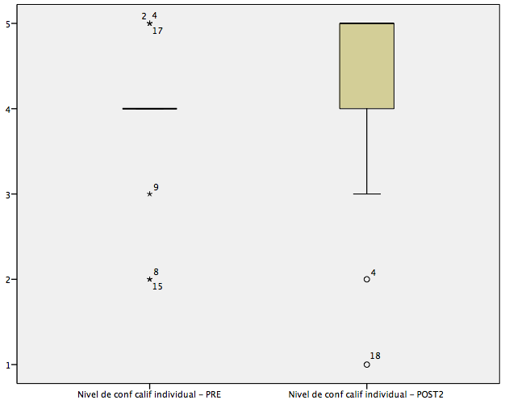

EXAMINE VARIABLES=Conf_grup_pre Conf_grup_post2
/COMPARE VARIABLE
/PLOT=BOXPLOT
/STATISTICS=NONE
/NOTOTAL
/MISSING=LISTWISE.

Explore

[DataSet1] /Users/katherinechiluiza2 1/Dropbox/Temarios/muestra/Datosestudiantes.sav

Case Processing Summary
 | Cases
 | Valid |  | Missing |  | Total
 | N | Percent | N | Percent | N | Percent
Nivel de conf calif grupal - PRE | 22 | 100.0% | 0 | 0.0% | 22 | 100.0%
Nivel de conf calif grupal - POST2 | 22 | 100.0% | 0 | 0.0% | 22 | 100.0%

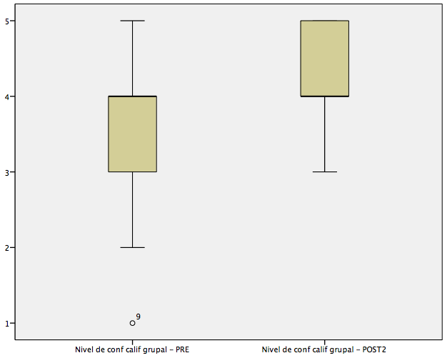

EXAMINE VARIABLES=Eq_carga_pre Eq_carga_post2
/COMPARE VARIABLE
/PLOT=BOXPLOT
/STATISTICS=NONE
/NOTOTAL
/MISSING=LISTWISE.

Explore

[DataSet1] /Users/katherinechiluiza2 1/Dropbox/Temarios/muestra/Datosestudiantes.sav

Case Processing Summary
 | Cases
 | Valid |  | Missing |  | Total
 | N | Percent | N | Percent | N | Percent
Equidad distribución carga -PRE | 22 | 100.0% | 0 | 0.0% | 22 | 100.0%
Equidad distribución carga -POST2 | 22 | 100.0% | 0 | 0.0% | 22 | 100.0%

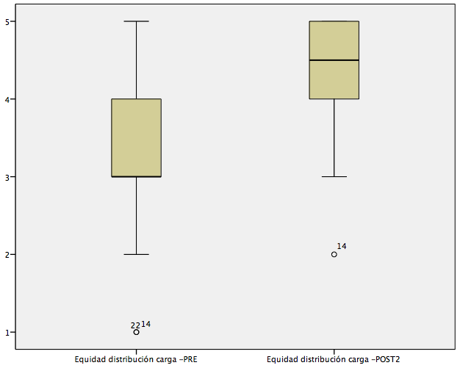

EXAMINE VARIABLES=Aportereal_pre Aportereal_post2
/COMPARE VARIABLE
/PLOT=BOXPLOT
/STATISTICS=NONE
/NOTOTAL
/MISSING=LISTWISE.

Explore

[DataSet1] /Users/katherinechiluiza2 1/Dropbox/Temarios/muestra/Datosestudiantes.sav

Case Processing Summary
 | Cases
 | Valid |  | Missing |  | Total
 | N | Percent | N | Percent | N | Percent
Reflejo de aporte real - PRE | 22 | 100.0% | 0 | 0.0% | 22 | 100.0%
Reflejo de aporte real - POST2 | 22 | 100.0% | 0 | 0.0% | 22 | 100.0%

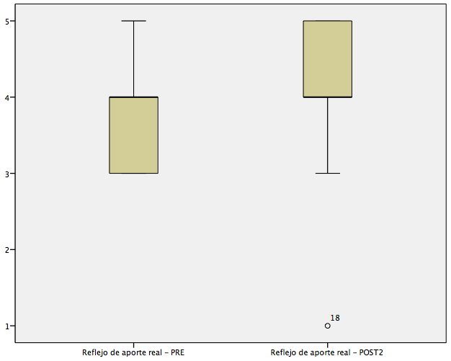

NPAR TESTS
/WILCOXON=Conf_ind_pre Conf_grup_pre Eq_carga_pre Aportereal_pre WITH Conf_ind_post2 Conf_grup_post2 Eq_carga_post2 Aportereal_post2 (PAIRED)
/MH=Conf_ind_pre Conf_grup_pre Eq_carga_pre Aportereal_pre WITH Conf_ind_post2 Conf_grup_post2 Eq_carga_post2 Aportereal_post2 (PAIRED)
/STATISTICS DESCRIPTIVES QUARTILES
/MISSING ANALYSIS
/METHOD= MC CIN(99) SAMPLES(10000).

NPar Tests

[DataSet1] /Users/katherinechiluiza2 1/Dropbox/Temarios/muestra/Datosestudiantes.sav

Descriptive Statistics
 | N | Mean | Std. Deviation | Minimum | Maximum | Percentiles
 |  |  |  |  |  | 25th | 50th (Median)
Nivel de conf calif individual - PRE | 22 | 3.91 | .750 | 2 | 5 | 4.00 | 4.00
Nivel de conf calif grupal - PRE | 22 | 3.68 | 1.086 | 1 | 5 | 3.00 | 4.00
Equidad distribución carga -PRE | 22 | 3.41 | 1.221 | 1 | 5 | 3.00 | 3.00
Reflejo de aporte real - PRE | 22 | 3.86 | .640 | 3 | 5 | 3.00 | 4.00
Nivel de conf calif individual - POST2 | 22 | 4.27 | 1.120 | 1 | 5 | 4.00 | 5.00
Nivel de conf calif grupal - POST2 | 22 | 4.32 | .646 | 3 | 5 | 4.00 | 4.00
Equidad distribución carga -POST2 | 22 | 4.32 | .839 | 2 | 5 | 4.00 | 4.50
Reflejo de aporte real - POST2 | 22 | 4.14 | .990 | 1 | 5 | 4.00 | 4.00

Descriptive Statistics
 | Percentiles
 | 75th
Nivel de conf calif individual - PRE | 4.00
Nivel de conf calif grupal - PRE | 4.00
Equidad distribución carga -PRE | 4.25
Reflejo de aporte real - PRE | 4.00
Nivel de conf calif individual - POST2 | 5.00
Nivel de conf calif grupal - POST2 | 5.00
Equidad distribución carga -POST2 | 5.00
Reflejo de aporte real - POST2 | 5.00

Wilcoxon Signed Ranks Test

Ranks
 |  | N | Mean Rank | Sum of Ranks
Nivel de conf calif individual - POST2 - Nivel de conf calif individual - PRE | Negative Ranks | 3ª | 12.50 | 37.50
 | Positive Ranks | 13^{b} | 7.58 | 98.50
 | Ties | 6^{c}
 | Total | 22
Nivel de conf calif grupal - POST2 - Nivel de conf calif grupal - PRE | Negative Ranks | 3^{d} | 6.00 | 18.00
 | Positive Ranks | 12e | 8.50 | 102.00
 | Ties | 7^{f}
 | Total | 22
Equidad distribución carga -POST2 - Equidad distribución carga -PRE | Negative Ranks | 1^{g} | 8.50 | 8.50
 | Positive Ranks | 12^{h} | 6.88 | 82.50
 | Ties | 9^{i}
 | Total | 22
Reflejo de aporte real - POST2 - Reflejo de aporte real - PRE | Negative Ranks | 3^{j} | 8.33 | 25.00
 | Positive Ranks | 10^{k} | 6.60 | 66.00
 | Ties | 9^{l}
 | Total | 22

a. Nivel de conf calif individual - POST2 < Nivel de conf calif individual - PRE
b. Nivel de conf calif individual - POST2 > Nivel de conf calif individual - PRE
c. Nivel de conf calif individual - POST2 = Nivel de conf calif individual - PRE
d. Nivel de conf calif grupal - POST2 < Nivel de conf calif grupal - PRE
e. Nivel de conf calif grupal - POST2 > Nivel de conf calif grupal - PRE
f. Nivel de conf calif grupal - POST2 = Nivel de conf calif grupal - PRE
g. Equidad distribución carga -POST2 < Equidad distribución carga -PRE
h. Equidad distribución carga -POST2 > Equidad distribución carga -PRE
i. Equidad distribución carga -POST2 = Equidad distribución carga -PRE
j. Reflejo de aporte real - POST2 < Reflejo de aporte real - PRE
k. Reflejo de aporte real - POST2 > Reflejo de aporte real - PRE
l. Reflejo de aporte real - POST2 = Reflejo de aporte real - PRE

Test Statistics^{a,c}
 |  |  | Nivel de conf calif individual - POST2 - Nivel de conf calif individual - PRE | Nivel de conf calif grupal - POST2 - Nivel de conf calif grupal - PRE | Equidad distribución carga -POST2 - Equidad distribución carga -PRE
Z |  |  | -1.659^{b} | -2.501^{b} | -2.623^{b}
Asymp. Sig. (2-tailed) |  |  | .097 | .012 | .009
Monte Carlo Sig. (2-tailed) | Sig. |  | .089 | .015 | .006
Monte Carlo Sig. (2-tailed) | 99% Confidence Interval | Lower Bound | .081 | .012 | .004
Monte Carlo Sig. (2-tailed) | 99% Confidence Interval | Upper Bound | .096 | .018 | .007
Monte Carlo Sig. (1-tailed) | Sig. |  | .045 | .008 | .003
Monte Carlo Sig. (1-tailed) | 99% Confidence Interval | Lower Bound | .040 | .006 | .001
Monte Carlo Sig. (1-tailed) | 99% Confidence Interval | Upper Bound | .051 | .011 | .004

Test Statistics^{a,c}
 |  |  | Reflejo de aporte real - POST2 - Reflejo de aporte real - PRE
Z |  |  | -1.540^{b}
Asymp. Sig. (2-tailed) |  |  | .124
Monte Carlo Sig. (2-tailed) | Sig. |  | .171
Monte Carlo Sig. (2-tailed) | 99% Confidence Interval | Lower Bound | .161
Monte Carlo Sig. (2-tailed) | 99% Confidence Interval | Upper Bound | .181
Monte Carlo Sig. (1-tailed) | Sig. |  | .085
Monte Carlo Sig. (1-tailed) | 99% Confidence Interval | Lower Bound | .077
Monte Carlo Sig. (1-tailed) | 99% Confidence Interval | Upper Bound | .092

a. Wilcoxon Signed Ranks Test
b. Based on negative ranks.
c. Based on 10000 sampled tables with starting seed 1993510611.

