Garcia, Seane Karl S.
CS-401
2203-6APSI

Design System
The tokens and components below come from the real PixelRack client. Colours and fonts come from the @theme block in client/src/index.css. Components come from client/src/components/. None of this was decided in the abstract. Contrast ratios are computed, not guessed.
Step A: Choose your styling approach
My approach: Tailwind CSS, version 4, with a CSS-first theme. Tokens live in the @theme block of client/src/index.css. Tailwind compiles this straight into real CSS custom properties. Utility classes like bg-bg-primary or text-accent-blue read from those properties. Tailwind v4 does not need a tailwind.config.js file for this. The theme is declared in CSS instead.
Approach | Where tokens live
CSS Modules / plain CSS | :root custom properties (--color-primary)
Tailwind (this project) | the @theme block in client/src/index.css (Tailwind v4 does not need a tailwind.config.js file)
styled-components | a theme object passed through ThemeProvider
A UI library (MUI, Chakra) | the library's theme object. You override its defaults.

Step B: Colour tokens
Five roles, five tokens. Mapped onto the palette already shipping in index.css, plus two supporting tokens the app uses constantly: secondary text and the success state.
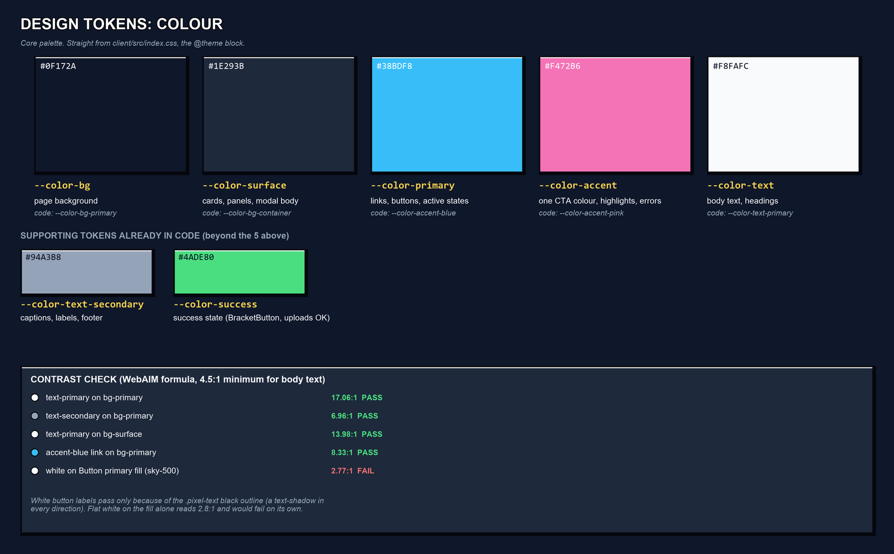
Colour tokens with hex codes, plus the WebAIM contrast check for every text and background pair actually used.
One honest gap: white button labels sit directly on saturated fills (sky-500, green-500, orange-500). Those read below 3:1 on their own. The .pixel-text utility adds a black text-shadow in all four directions, and that is what keeps the labels readable. It is a deliberate fix, not a clean WCAG pass. Rule going forward: never put flat white text on a saturated button fill without the pixel-text outline.
Step C: Type scale
Three sizes, rendered below at their real pixel size. font-pixel is shown in a bold system face, and font-mono is shown in Consolas, since the project's webfonts are not installed in this renderer. The sizes and weights themselves are exact.
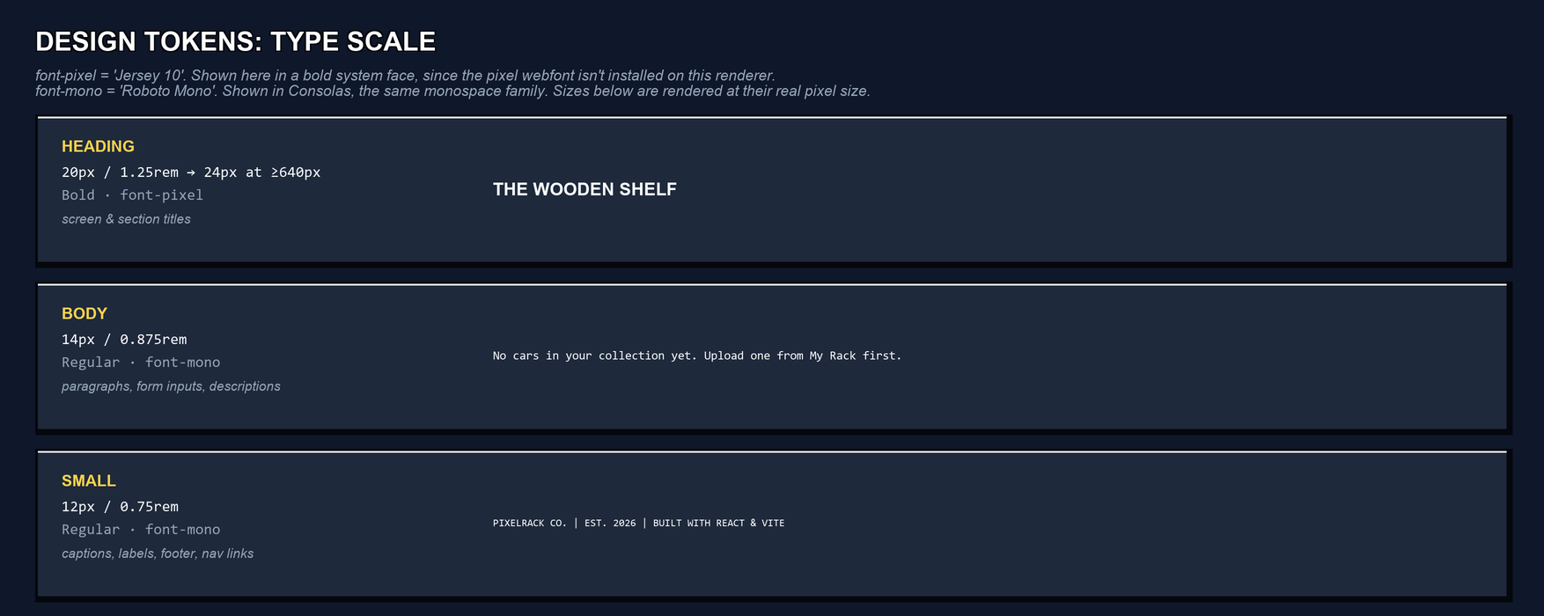
Type scale: Heading (font-pixel 'Jersey 10'), Body and Small (font-mono 'Roboto Mono').
Step D: Spacing rule
Base unit: 4px. This matches --spacing: 4px in the @theme block. It was chosen to line up with the pixel-art grid, not the more common 8px.
- Tight spacing, between related items: 8px (--space-1, Tailwind gap-2). Used for icon and label pairs, the RackHeader stat chip, and form field gaps.
- Standard spacing, between sections: 24px (--space-4, Tailwind gap-6). Used between the Dashboard sidebar and the rack, and between the rack panel and the environment gallery.
- Screen edge padding: 24px (px-6). Used on the Navbar and the Dashboard main column.
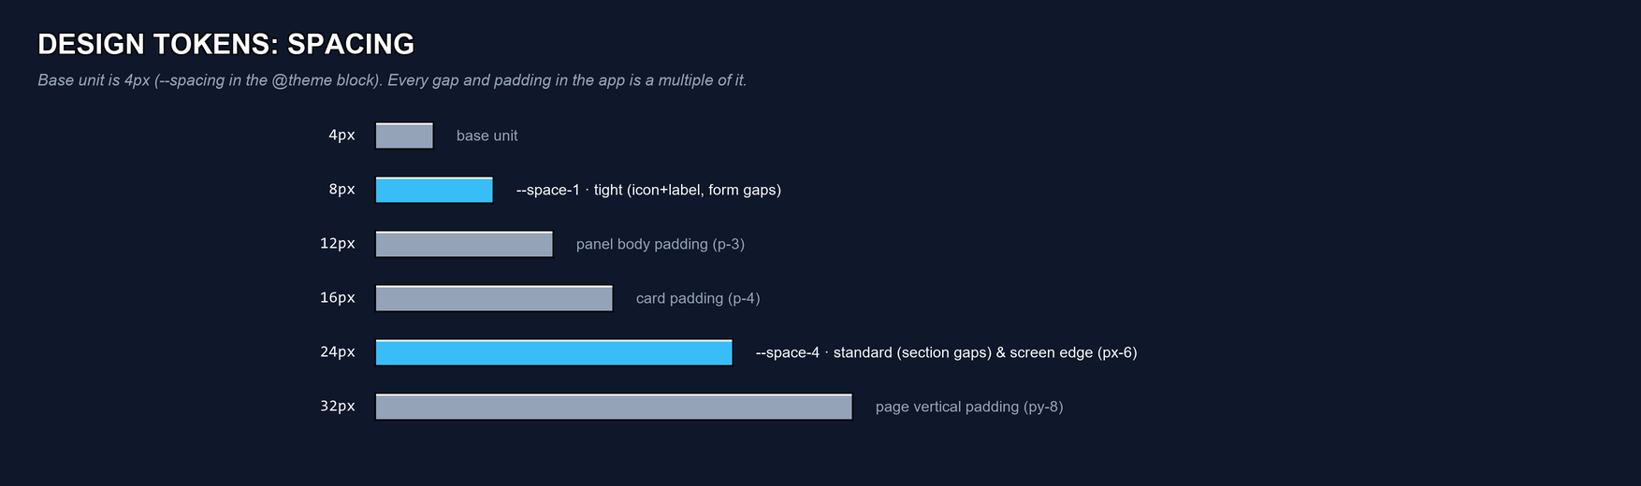
Spacing scale drawn to true relative width, from 4px to 32px, with the tight and standard steps highlighted.
Step E: Reusable components
Pulled from the actual component tree. Every entry below renders on more than one screen, or more than once on the same screen. No UI library is in use, so nothing here is "free". Each atom is hand-built in Tailwind.
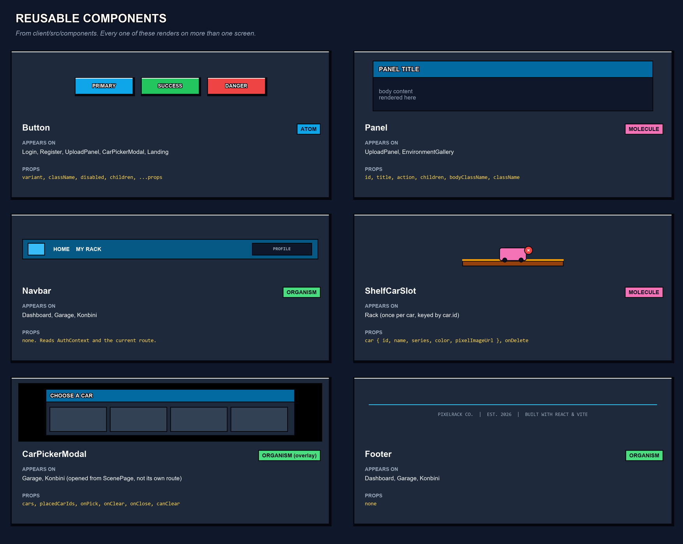
Six components that repeat across PixelRack, with their real prop signatures.
Component | Level | Appears on | Props it takes
Button | atom | Login, Register, UploadPanel, CarPickerModal, Landing | variant, className, disabled, children
Panel | molecule | UploadPanel, EnvironmentGallery | id, title, action, children, bodyClassName
Navbar | organism | Dashboard, Garage, Konbini | none. Reads AuthContext and the route.
ShelfCarSlot | molecule | Rack (once per car) | car, onDelete
CarPickerModal | organism (overlay) | Garage, Konbini, via ScenePage | cars, placedCarIds, onPick, onClear, onClose, canClear
Footer | organism | Dashboard, Garage, Konbini | none

Not tabled: BracketButton is a second button atom, styled green with brackets around the label. It only appears once, in UploadPanel's submit button. That does not meet the worksheet's “more than one screen” rule yet, so it is noted here instead of forced into the table.
Step F: Responsive plan
Below 640px, on phone: the picker grid drops from 3 columns to 2, car sprites shrink from h-12 to h-10, and Panel and RackHeader titles drop from text-xl to text-lg. Everything already stacks to one column below this width, since the app is single-column by default.
Above 1024px, on desktop: the Dashboard switches from a stacked layout to grid-cols-[320px_1fr]. The Upload sidebar sits beside the rack instead of above it. This is the only place a second breakpoint is needed. Garage and Konbini stay a single responsive scene box at every width.
These are the only two breakpoints used in the codebase: sm: at 640px and lg: at 1024px. Confirmed by grep, not assumed. No horizontal scroll at 375px: verified, since every layout is flex-col or a single grid column below sm:.
Accessibility check (before you build)
⚠ PARTIAL Every text-on-background pair passes 4.5:1. True for all plain text: 17.1:1, 7.0:1, 14.0:1, and 8.3:1 measured. The three saturated button fills only pass because of the .pixel-text outline, not on flat colour alone. See Step B.
☑ PASS Real semantic elements, not a div with an onClick. Navbar uses <header> and <nav>. DashboardPage uses <main>. Footer uses <footer>. Every clickable scene slot in ScenePage is a real <button type="button">.
☑ PASS Every meaningful image has alt text. CarSprite defaults to alt ?? ''. The Navbar logo has alt="PixelRack". Decorative nav and scene icons use alt="".
☐ GAP Every form input has a matching label. Not yet true. LoginPage, RegisterPage, and two of the three UploadPanel inputs rely on placeholder text alone, with no <label htmlFor> and id pair. Only the UploadPanel file-drop input is labelled, through its wrapping <label>. This is a real to-do before the final project leans on these forms further.
☑ PASS Tab-reachable with a visible focus state. All interactive elements are real <button>, <a>, and <input> elements, so Tab order is native. Inputs and selects show focus:border-accent-blue explicitly. Button and BracketButton do not override focus, so they fall back to the browser’s default ring. That still works, it just does not match the pixel theme yet.
What to keep
This page, filled in, is the design reference for the rest of the project.
- The colour, type, and spacing tokens above already exist as the @theme block in client/src/index.css. Nothing needs to migrate. This document just makes them visible in one place.
- Each reusable component in Step E already lives once under client/src/components/, and is rendered everywhere it appears. This was confirmed against the real imports, not assumed.
- The responsive plan in Step F maps to the sm: and lg: breakpoints already in the classNames.
- The one open item is the accessibility gap in Step F: add <label htmlFor> and id pairs to the Login, Register, and UploadPanel text inputs before the final submission.

