Garcia, Seane Karl S.
CS-401
2203-6APSI

Wireframes & Component Breakdown
Boxes and labels only; no colour or typography decisions here, those come later. Diagrams below are generated from the actual PixelRack client (its routes, Navbar, DashboardPage and ScenePage components) rather than sketched from the template, so the boxes match what the app really renders today.

Step A: Screen map
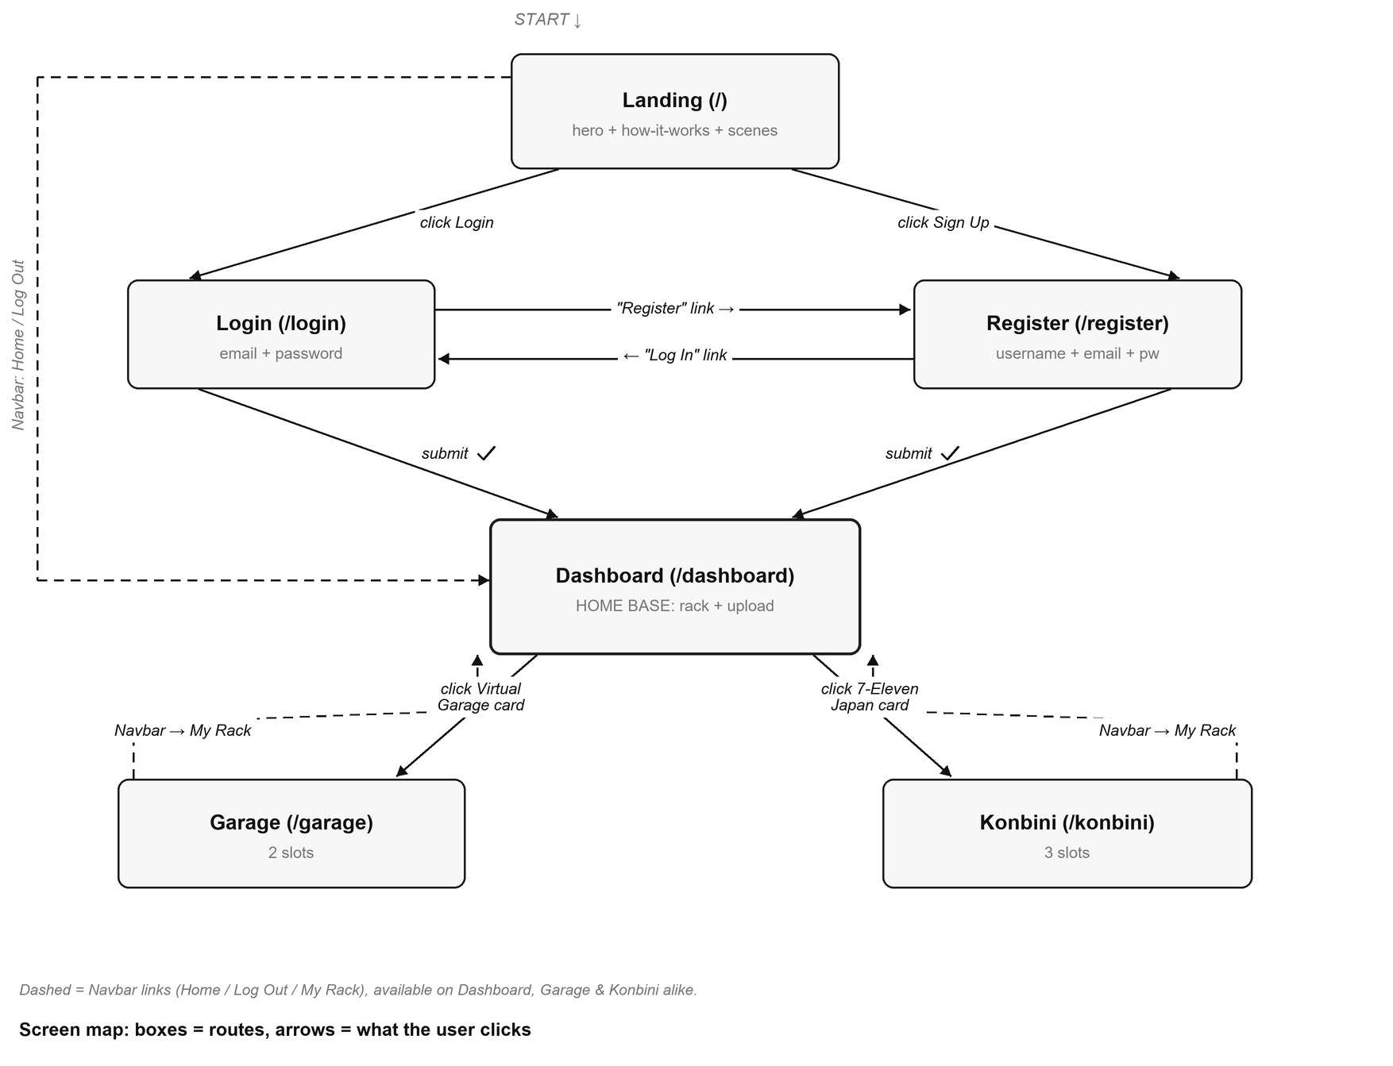
What is the first screen the user lands on? Landing (/): the hero with the PixelRack emblem, the “How It Works” steps and the scene previews.
Is there a “home base” most others return to? Yes: Dashboard (/dashboard). It's where a successful login/register lands, and the shared Navbar (present on Dashboard, Garage and Konbini) always has a “My Rack” link back to it. That's the app's nav.
Any screen with no way back? Nothing is fully dead-ended, but one rough edge is real: Login and Register have no Navbar and no labelled “Back” link; the only way to Landing is clicking the PixelRack logo image at the top of the form. It works, but it isn't discoverable as a nav action the way a text link would be. Worth a small “← Back to Home” link if there's time; not worth blocking on.

Step B: One box-sketch per screen
Four sketches, not six: Login/Register share one mirrored layout, and Garage/Konbini share one ScenePage template with different artwork and slot counts, the same grouping the app proposal already used, because they really are the same component.
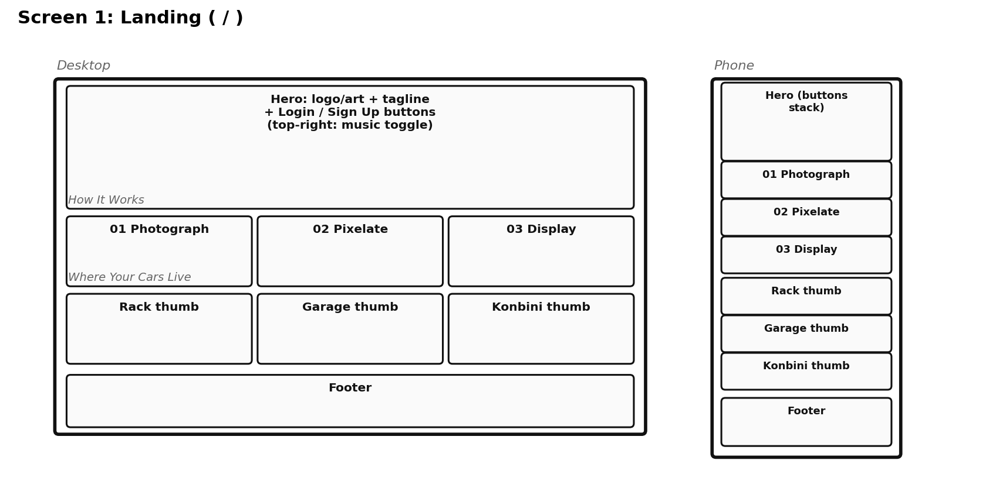
Screen 1: Landing (/)
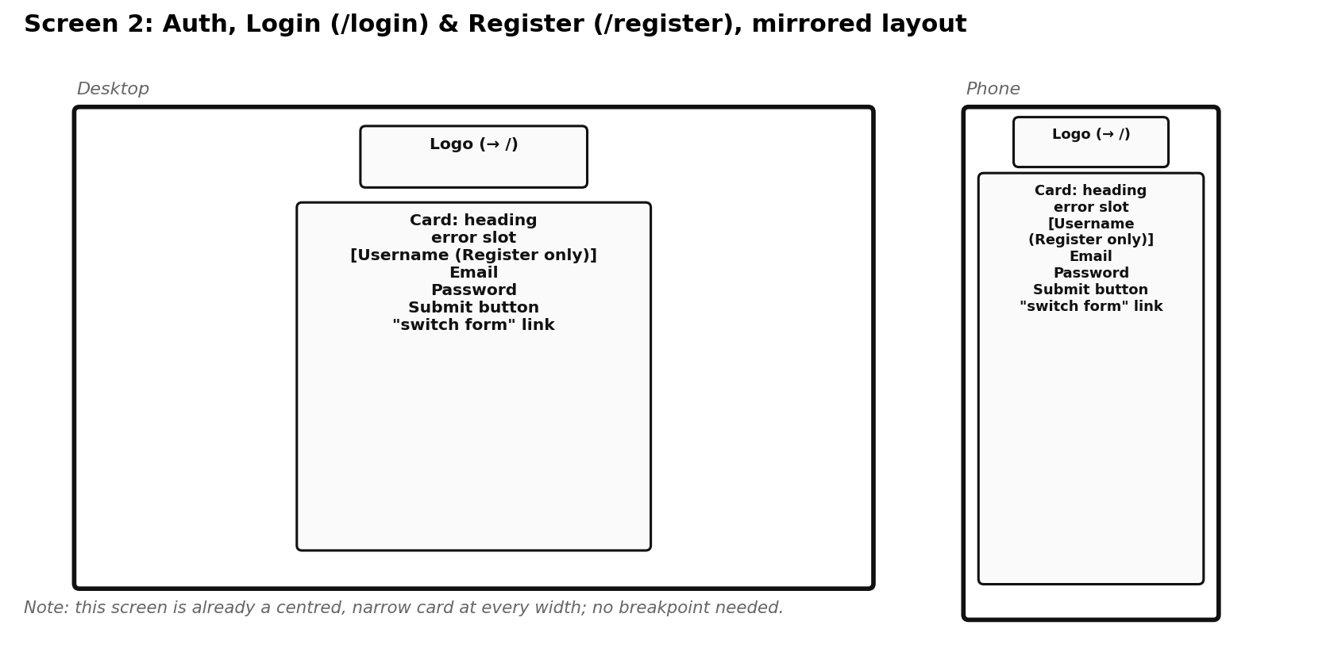
Screen 2: Auth, Login (/login) & Register (/register)
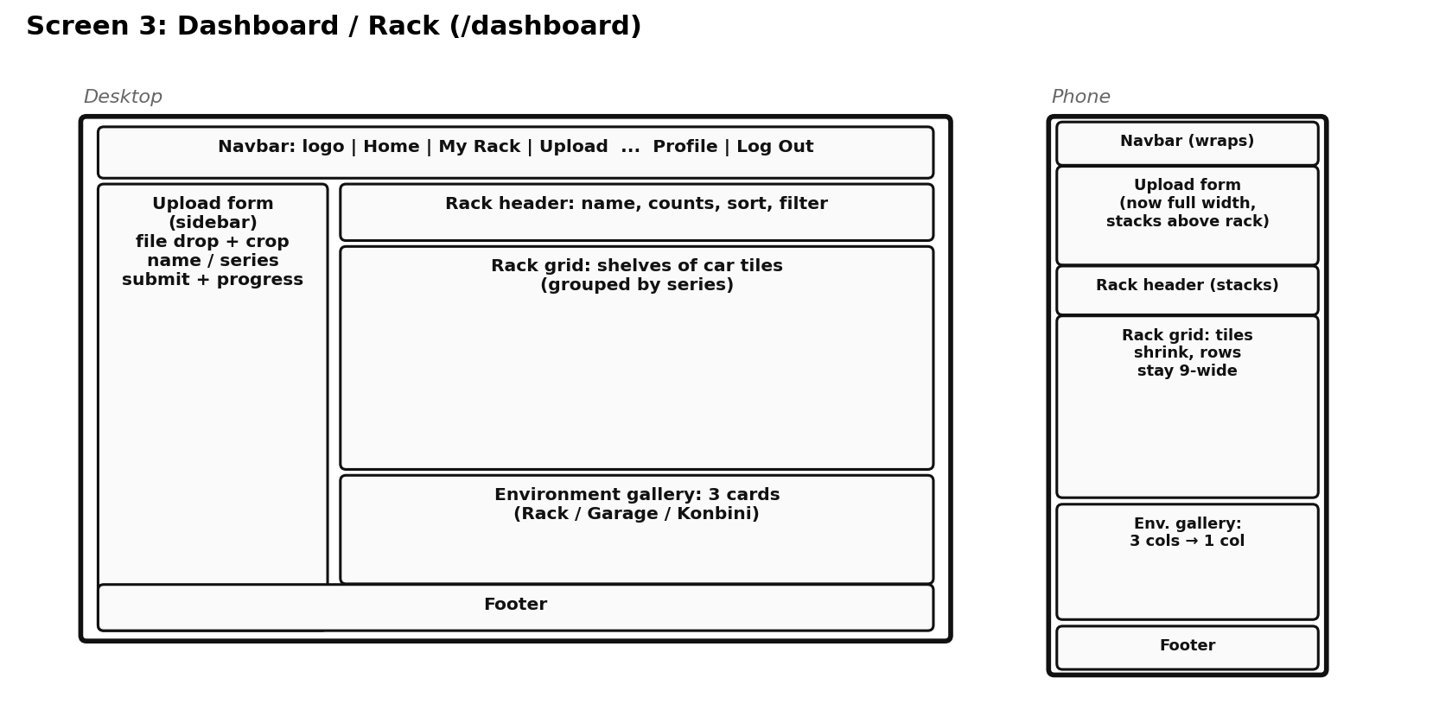
Screen 3: Dashboard / Rack (/dashboard)
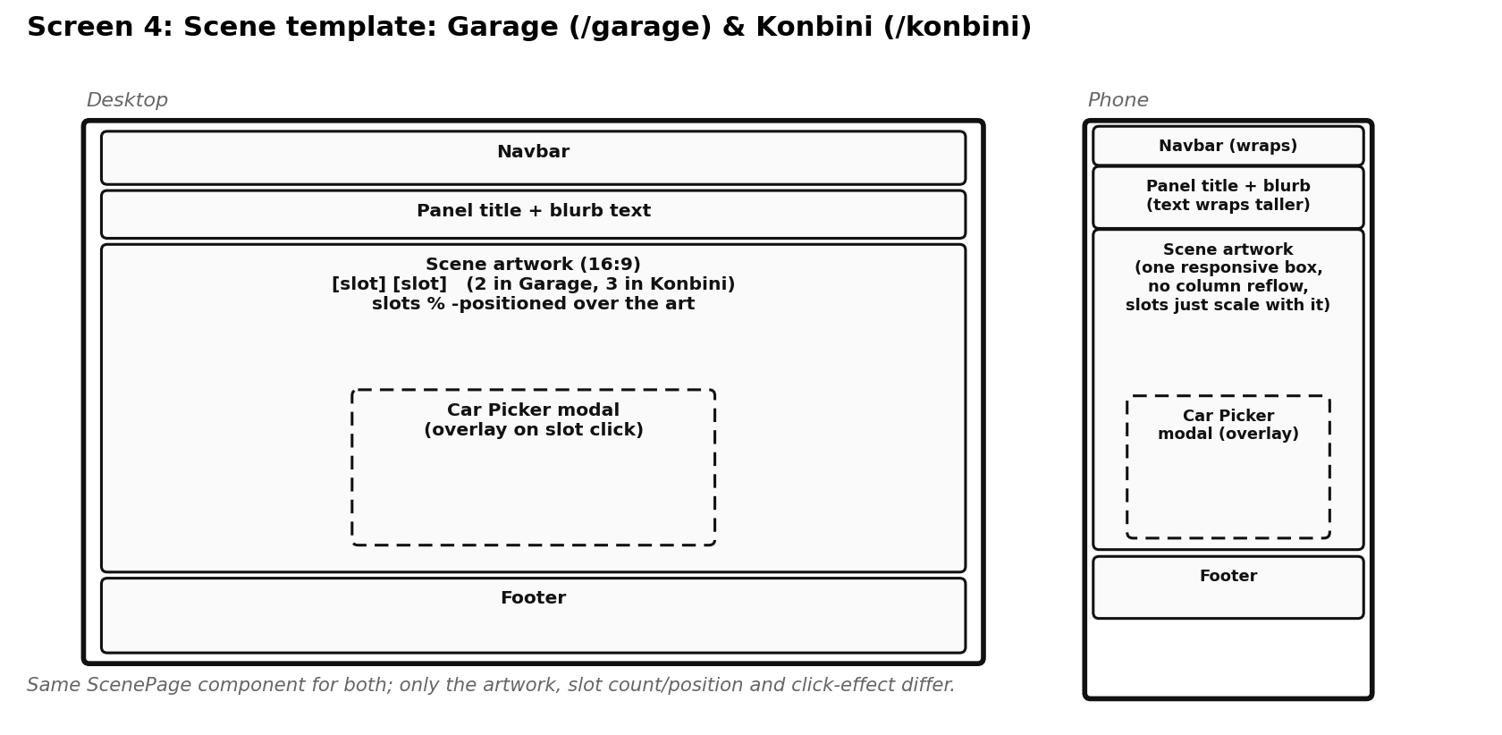
Screen 4: Scene template, Garage (/garage) & Konbini (/konbini)
Same layout facts as a table, for quick reference:
Screen | Desktop layout | Phone layout (what stacks) | Navigates to
Landing (/) | Hero + 2 rows of 3 cards + footer | Everything stacks to a single column | Login, Register (or straight to Dashboard if signed in)
Auth (/login, /register) | Centred narrow card | Same card, no reflow needed | Dashboard (on submit); the other auth screen (via link)
Dashboard (/dashboard) | Navbar + 320px upload sidebar + main column | Navbar wraps; sidebar becomes full width and stacks above the rack; gallery 3 cols → 1 | Garage, Konbini (via gallery cards); Landing (via Navbar)
Garage (/garage) | Navbar + title/blurb + 16:9 scene (2 slots) | Same single responsive scene box, no column reflow | Dashboard (via Navbar)
Konbini (/konbini) | Navbar + title/blurb + 16:9 scene (3 slots) | Same single responsive scene box, no column reflow | Dashboard (via Navbar)

Step C: Component tree
Busiest screen: Dashboard, since it's the only one that both reads and writes data (upload, sort, filter, delete) rather than just placing cars in slots.
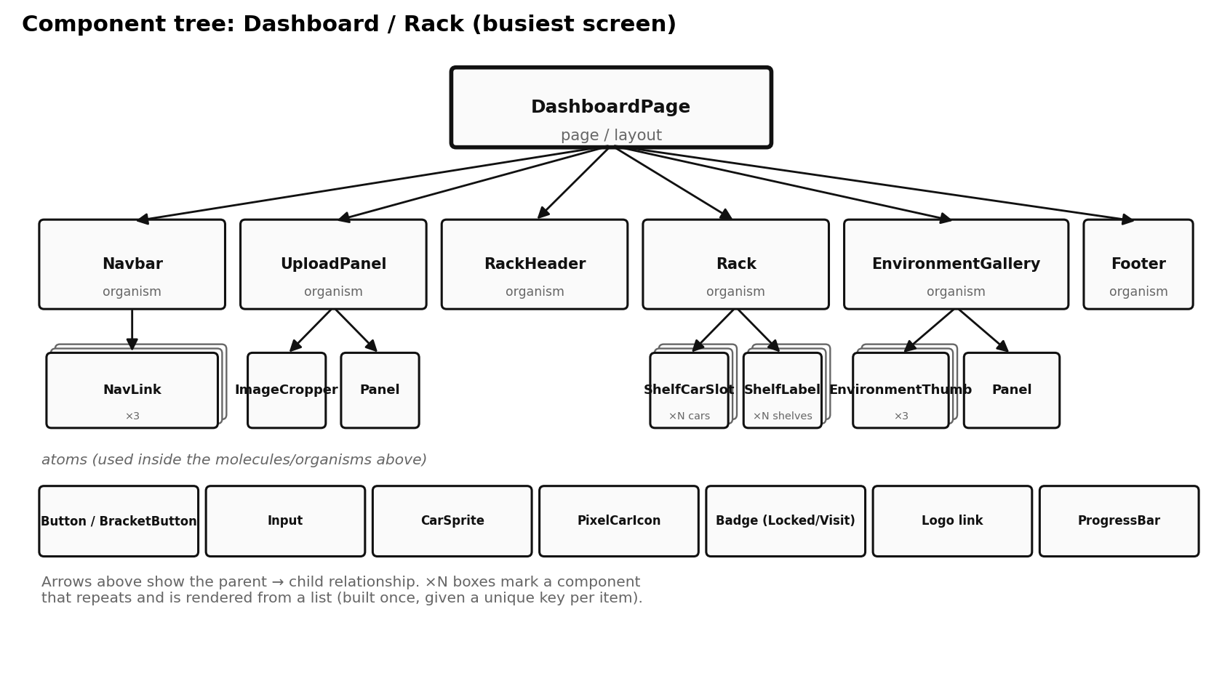
Level | What it is | Your components
Atoms | smallest pieces | Button, BracketButton, Input (bare <input>), CarSprite, PixelCarIcon, status badge (Locked/Visit/slots), logo Link, ProgressBar fill
Molecules | small groups of atoms | Panel (header bar + body slot, reused everywhere), NavLink (icon + label), ShelfCarSlot (sprite + delete button + name tooltip), EnvironmentThumb (art + name + badge), ImageCropper
Organisms | whole sections | Navbar, UploadPanel, RackHeader, Rack, EnvironmentGallery, Footer, and ScenePage (the Garage/Konbini organism, with CarPickerModal as an overlay it opens)
Page / layout | the screen that arranges organisms | DashboardPage (Dashboard); GaragePage / KonbiniPage (each just configures ScenePage with its own artwork + slots)

Sanity-check the two rules:
- A component that repeats is a real component. ShelfCarSlot renders once per car (keyed by car.id), EnvironmentThumb once per environment, NavLink once per nav entry; all marked ×N in the tree above, all built once and rendered from a list.
- A level uses the levels below it, never above. Rack (organism) renders ShelfCarSlot (molecule) which renders CarSprite (atom); never the reverse. The one component that appears in two organisms is Panel (used by both UploadPanel and EnvironmentGallery), which is fine: a molecule can be reused by more than one organism, it just can't reach back up.

Step D: Sanity check
Most important task: upload a car, then place it in the Garage. Walking it screen by screen:
- Landing (/) → click Login → Login screen.
- Submit email + password → redirected to Dashboard; cars and environments load.
- Fill the Upload form in the sidebar (photo, crop, name, series) → submit → new car appears in the Rack grid (optimistic add via onUpload).
- Click the Virtual Garage card in the Environment gallery → Garage screen.
- Click an empty slot → Car Picker modal opens (an overlay, not its own route).
- Pick the new car → modal closes → it appears in the Garage slot.
- Click the car → plays the wash effect (shine + bubbles).
- Click My Rack in the Navbar → back to Dashboard.
Did I hit a screen I forgot to sketch? Yes, once: the Car Picker modal. It isn't a route, so it doesn't get its own Step B sketch, but it's a real, self-contained piece of UI; it's called out as an overlay on the Scene wireframe (Screen 4) and sits in the component tree conceptually alongside ScenePage, even though the tree above focuses on Dashboard.
Did any navigation have nowhere to go? No hard dead end. The one soft spot is the Login/Register → Landing path noted in Step A (logo click only, no labelled link).
Does every piece of state from the proposal have an owning component? Yes, checked against the proposal's state table: cars, environments, sort, seriesFilter, isLoading, error all live in DashboardPage; the upload form's own fields (file, previewUrl, crop, name, series, progress, isProcessing, pixelationEnabled) live in UploadPanel and only call back up once, via onUpload; placements, pickingSlot, activeEffect live in ScenePage. Nothing is missing an owner.

What to keep
- The screen map above → becomes the <Routes> in App.jsx and the links in Navbar (both already built, so this documents what exists).
- Each labelled box in Step B → a component under client/src/components/ or client/src/pages/, already sorted into the atomic levels in Step C.
- The “what stacks on a phone” notes → the Tailwind breakpoints already in use (sm:, lg:, flex-wrap), confirmed against the real classNames, not guessed.

