Ans 1)

import java.util.*;
public class Main
{
public static void main(String[] args) {
Scanner scn = new Scanner(System.in);
int i = 0;
int pos_num = 0;
int neg_num = 0;
int odd_num = 0;
int even_num = 0;
int no_of_zero = 0;

while(i<20){
int t = scn.nextInt();
if(t>0){
pos_num++;
}
if(t<0){
neg_num++;
}
if(t%2==1){
odd_num++;
}
if(t%2==0){
even_num++;
}
if(t==0){
no_of_zero++;
}
i++;
}
System.out.println("Postive No "+pos_num);
System.out.println("Negative No "+neg_num);
System.out.println("Odd No "+odd_num);
System.out.println("Even No "+even_num);
System.out.println("No of zero "+no_of_zero);

}
}

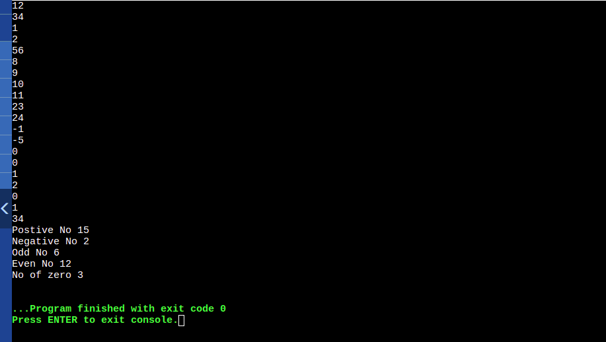

Ans 2)
import java.util.*;
public class Main
{
public static void main(String[] args) {
Scanner scn = new Scanner(System.in);
int n = scn.nextInt();

int arr[] = new int[n];

for(int i = 0;i<n;i++){
arr[i] = scn.nextInt();
}

int arr1[] = new int[5];
int arr2[] = new int[5];

int t = 0;
for(int i = 0;i<n;i++){
if(i<5){
arr1[i] = arr[i];
}
else{
arr2[t] = arr[i];
t++;
}
}
int m = arr1.length;
int k = arr2.length;
for(int i = 0;i<m;i++){
System.out.print(arr1[i]+" ");
}
System.out.println();

for(int i = 0;i<m;i++){
System.out.print(arr2[i]+" ");
}

}
}

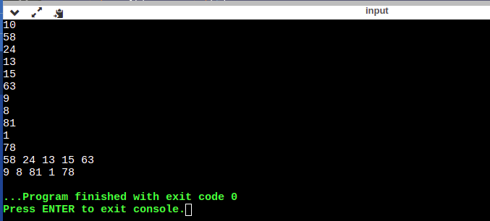

Ans 3)
class parent{
void print1(){
System.out.println("this is parent");
}
}
class child extends parent{
void print2(){
System.out.println("this is chid");
}
}
public class Main
{
public static void main(String[] args) {
parent p1 = new parent();
child p2 = new child();

p1.print1();
p2.print2();
p2.print1();
}
}

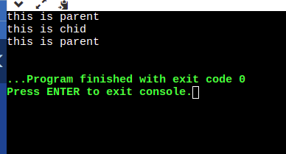

Ans 6) equals checks only value.
== checks value and reference

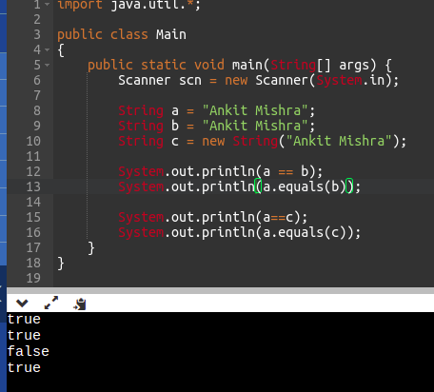

Ans 7 )
Stringbuffer :-
1) StringBuffer is syncronized i.e it is threadsafe .It means two threads can’t call methods of Stringbuffer simultaneously.
2)It is leass efficient than StringBuilder

StringBuilder :-
1)StringBuilder is non syncronized i.e it is not threadsafe.It means two threads can call methods of StringBuiler simultaneously.
2)It is more effficient than StringBuffer.

Ans 8)
final variable: If a variable is defined final it can not be changed and redefined.
Final method : If a method is defined final it can be redefined and can not be overriden.
Final class: final class can’t be inherited.

Ans 9)

If we use exit then the finally block will not run

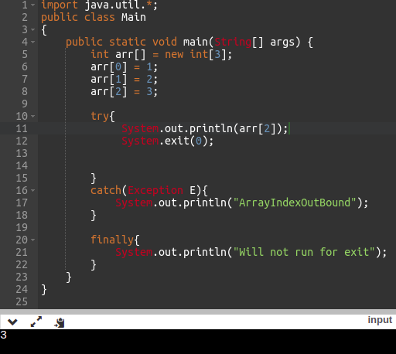

Ans 10) In shallow copy only field of primitive data type are copied while object reference are not copied In hard copy both primitive data type aswell as object reference are copied.

Ans 11)It will give arithmetic execption divided /by zero.

Ans 12) As finally we always run so it recommened to use finally block.

Ans 13)
when we will execute the code it will ArrayIndexOutOfBoundException Error.As Array is 0 index based.

Ans 14)

A ) 2 object will be created.

B) 1 object will be created.

C) 3object will be created.

Ans 15)
string_name.isEmpty();

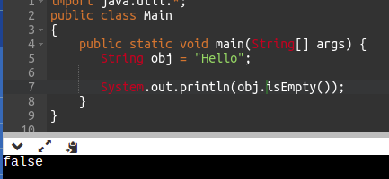

Ans 16)

addAll() method is used for adding one arrayList into other.

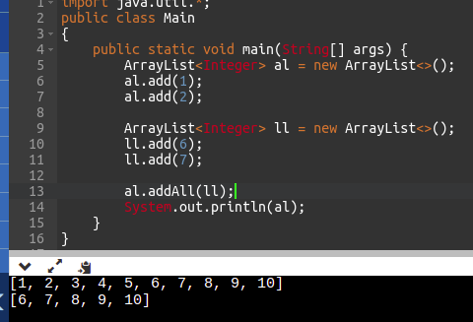

Ans 17)

Arrays.fill() will be used

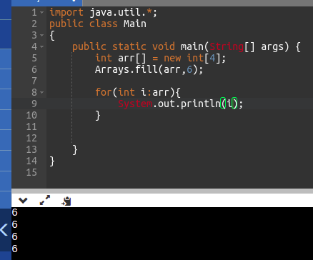

Ans 18)
The main purpose of Generics is to provide type safety and to resolve the typecasting problem.
1) Arrays are type-safe, the type of the elements inside the array is ensured.
2) If we are declaring a String type array, then only String type can be stored inside that particular array.
3) It is not possible to add any other type of element in that particular String array. Let us have look at a simple program.

Ans 19)
comparable:-
1) It provide a single sorting sequence .For ex:- we can sort on the basis of single element such
as id,name or price.
2)Comparable provide campareTo() method to sort element.
3)we can sort the list elelmnt of comparable type by Collecions.sort(List)

comparator:-
1)It provide multiple sorting sequence .For ex:-we can sort on the basis of multiple element such as name,id and price.
2)comparator provide compare() method to sort element.
3)we sort the list element of Comparatot type by Collections.sort(List,Comparator) method.

Ans 20)

The throw keyword in java is used to explicitly throw an exception from a method or block of code.

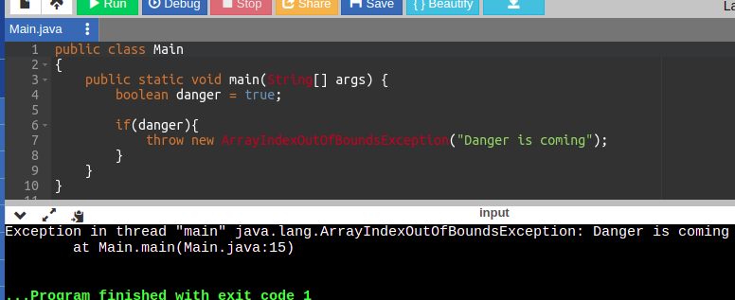

Ans 21)
== just check the value of the string

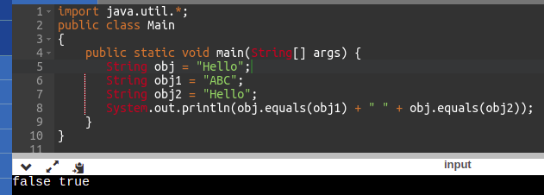

Ans 5)

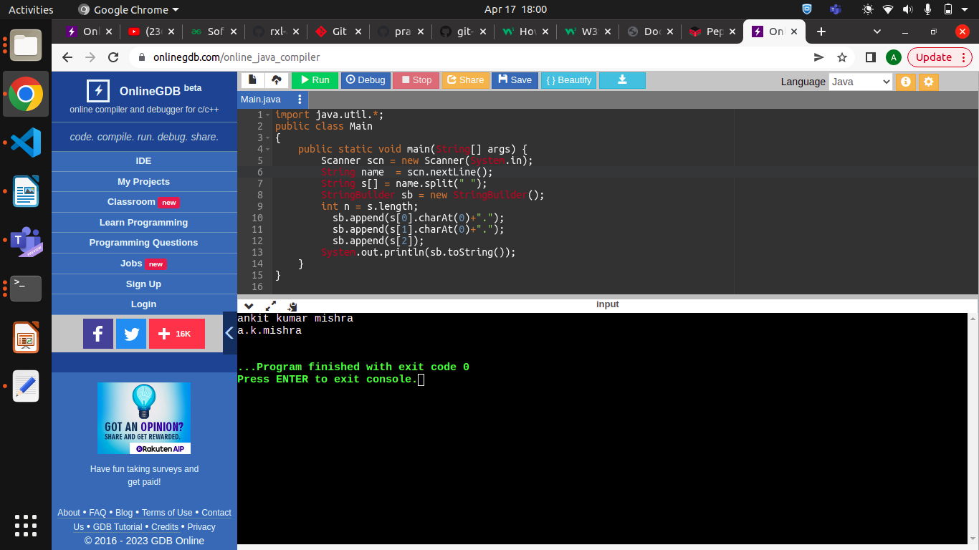

Ans 22)

class Member{
String name;
int age;
long phone;
String address;
int salary;

Member(String name,int age,long phone,String address,int salary){
this.name = name;
this.age = age;
this.phone = phone;
this.address = address;
this.salary = salary;
}

void printSalary(){
System.out.println("Salary : "+this.salary);
}
}
class Employee extends Member{
String specialization;

Employee(String name,int age,long phone,String address,int salary,String specialization){
super(name,age,phone,address,salary);
this.specialization = specialization;
}

void printInfo(){
System.out.println(this.name);
System.out.println(this.age);
System.out.println(this.phone);
System.out.println(this.address);
System.out.println(this.salary);
System.out.println(this.specialization);
}

}
class Manager extends Member{
String department;
Manager(String name,int age,long phone,String address,int salary,String department){
super(name,age,phone,address,salary);
this.department = department;
}
void printInfo(){
System.out.println(this.name);
System.out.println(this.age);
System.out.println(this.phone);
System.out.println(this.address);
System.out.println(this.salary);
System.out.println(this.department);
}

}
public class Main
{
public static void main(String[] args) {
Manager m = new Manager("Ankit",22,991168875,"India",50000,"Software Engineer");
Employee e = new Employee("Ankit",22,991168875,"India",50000,"Frontend");
m.printInfo();
e.printInfo();
}
}

