Responde lo que se te pide

1. Barry __________ not ___________ to have breakfast early.

A) did / use

B) did / used

C) must / use

D) must / used

2. Lucy was ___________ with the results.

A) discourage

B) discouraged

C) discourages

D) discouraging

3. Dr. Smith said the results of the operation ________________ not ___________ .

A) did / convinced

B) were / convinced

C) did / convincing

D) were / convincing

4. My sister ____________working at the Memorial Hospital last summer.

A) was

B) did

C) can

D) may

5. _____________ Harry use to ___________ to his office everyday before the accident?

A) Did / walk

B) Would / walk

C) Did / walked

D) Would / walked

6. Jenny’s the champion. She ___________ all the games.

A) win

B) won

C) to win

D) winning

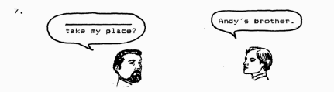

A) Who is

B) Who can

C) Whose is

D) Whose can

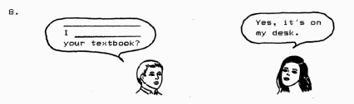

A) Will / take

B) May / take

C) Will / took

D) May / took

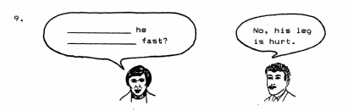

A) Is / run

B) May / to run

C) Can / run

D) Might / to run

10. Peter and Henry ________________ twice this month

A) travels

B) to travel

C) traveled

D) traveling

11. David _____________ a poem to Beth.

A) translated

B) bought

C) read

D) made

12. Vicky doesn’t feel well. She ____________ not be able to take the exam.

A) should

B) must

C) can

D) may

13. She has a new _____________ machine.

A) wash

B) washer

C) washing

D) to wash

14. __________ you ____________ this problem next class?

A) Are / explain

B) Will / explain

C) Are / explained

D) Will / explained

15. Paula doesn’t have ___________ friends.

A) lot

B) a lot

C) many

D) many of

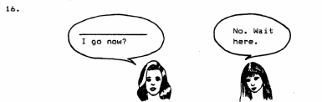

A) May

B) Did

C) Was

D) Would

17. She _________ not able ____________ a hundred yards.

A) is / run

B) is / to run

C) can / run

D) can / to run

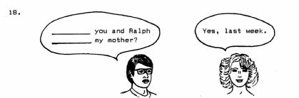

A) Did / met

B) Were / met

C) Did / meet

D) Were / meet

19. The doctor said you __________ not _________ milk if you are sick.

A) might / drink

B) should / drink

C) might / to drink

D) should / to drink

20. Did Charlie ____________ the candles with his ball?

A) to break

B) breaks

C) broke

D) break

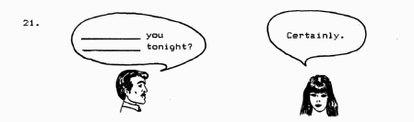

A) Do / come

B) Do / coming

C) Could / come

D) Could / coming

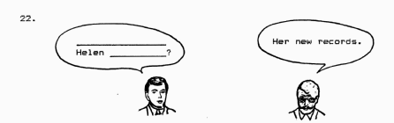

A) What is / lost

B) Whose is / lost

C) What did / lose

D) Whose did / lose

23. Mother _________ going _______ very tired soon.

A) is /be

B) will / be

C) is / to be

D) will / to be

24. Mary will ____________ at the library.

A) work

B) works

C) working

D) to work

25. John ________ not _______ the postcard. Tim hid it.

A) does / read

B) did / read

C) does / reading

D) did / reading

26. The class ___________ going ___________ in ten minutes.

A) is / start

B) will / start

C) is / to start

D) will / to start

27. Peter and Jane ___________ not _________ their lessons last Monday.

A) did / began

B) did / begin

C) do / began

D) do / begin

28. Clint ___________the article for grandfather.

A) lent

B) said

C) described

D) translated

29. The students ____________ going _____________ the homework tomorrow.

A) are not / to do

B) are / not to do

C) will not / to do

D) will / not to do

30. The little boy ________ on the piano is Walt’s brother.

A) practiced

B) practicing

C) to practice

D) is practicing