Problem 1

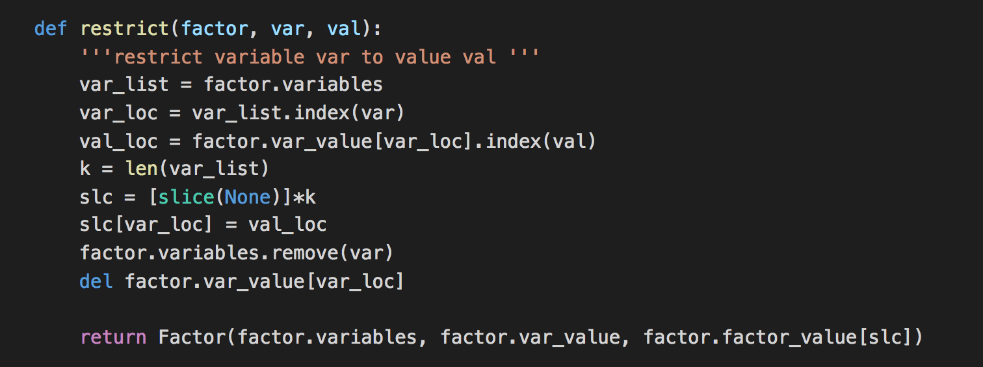

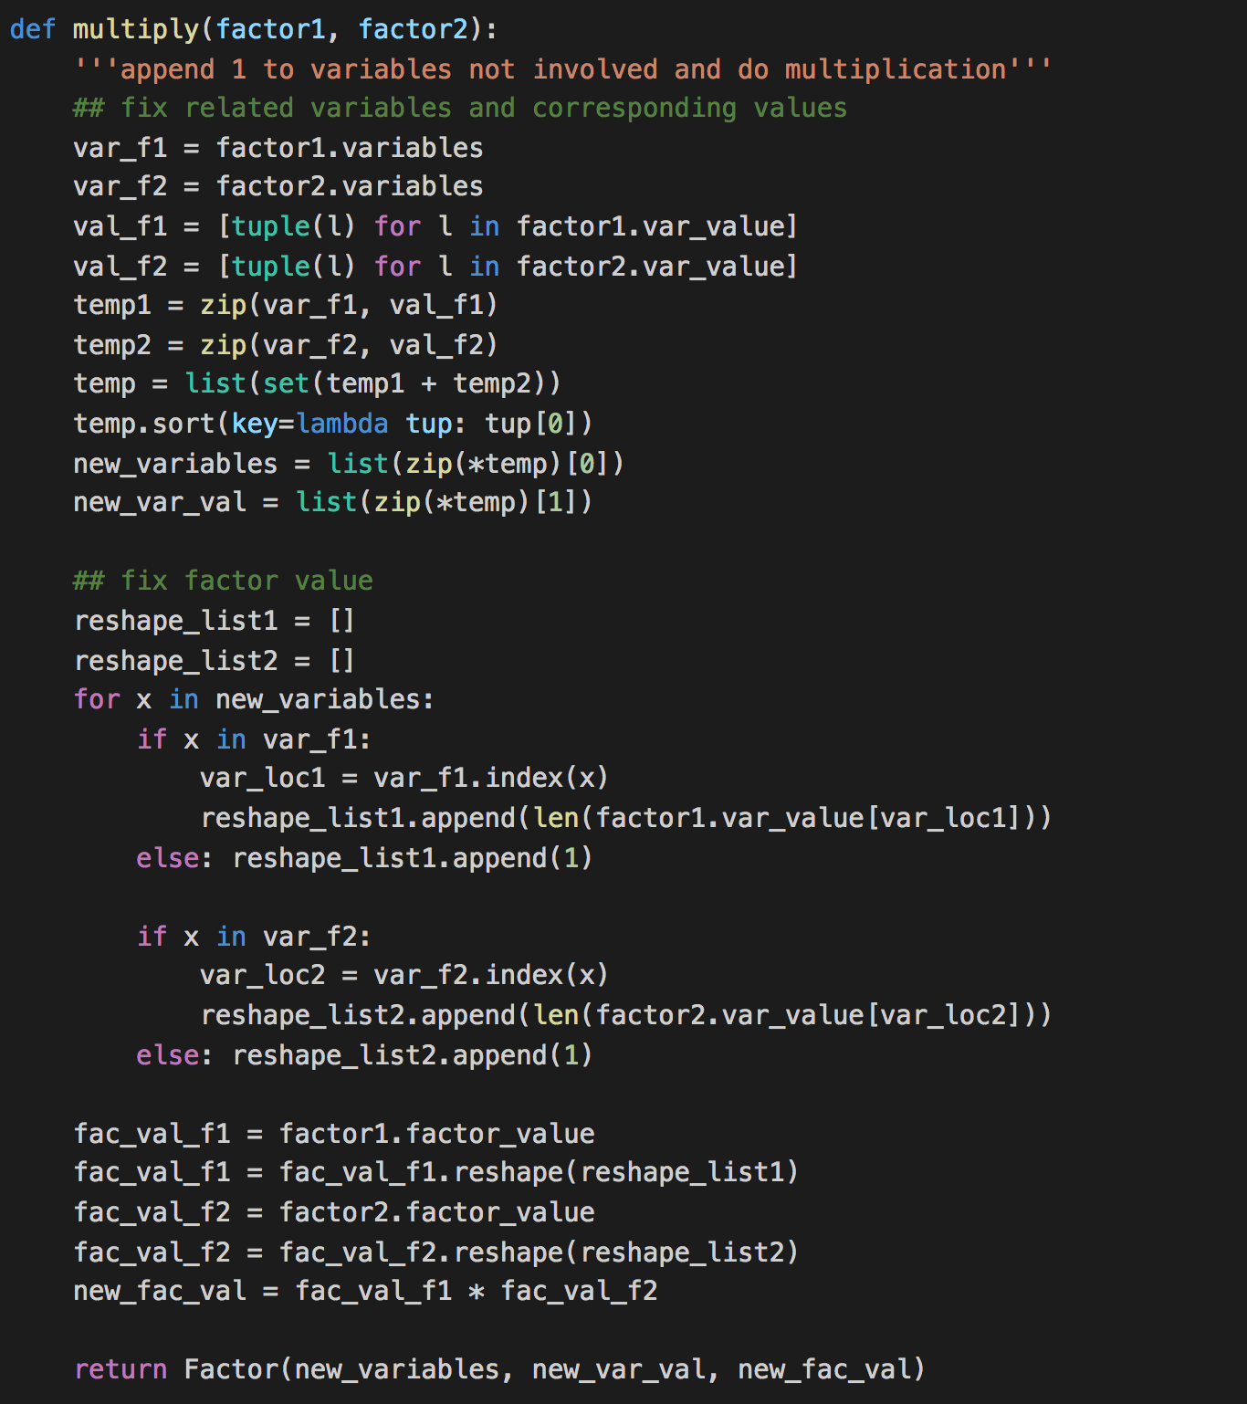

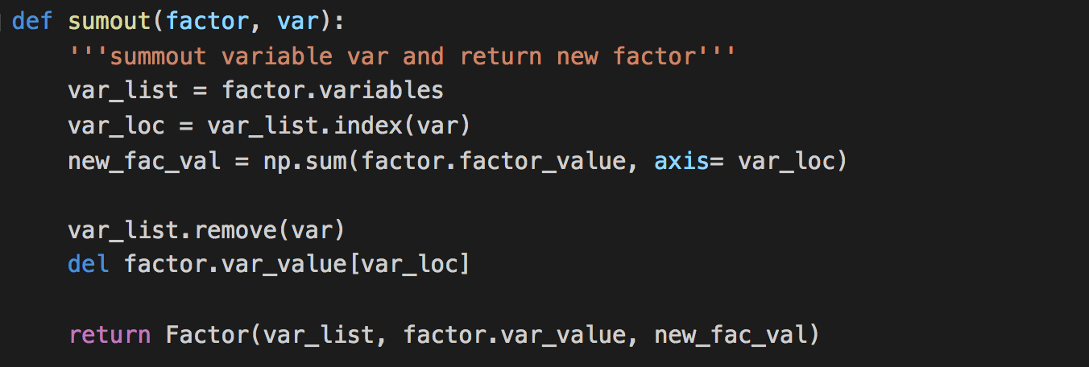

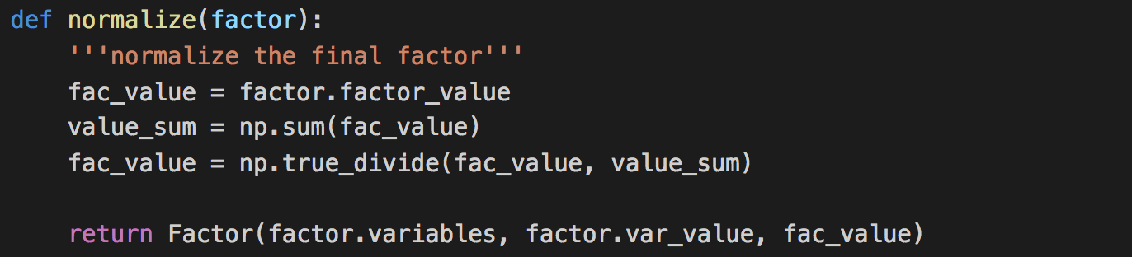

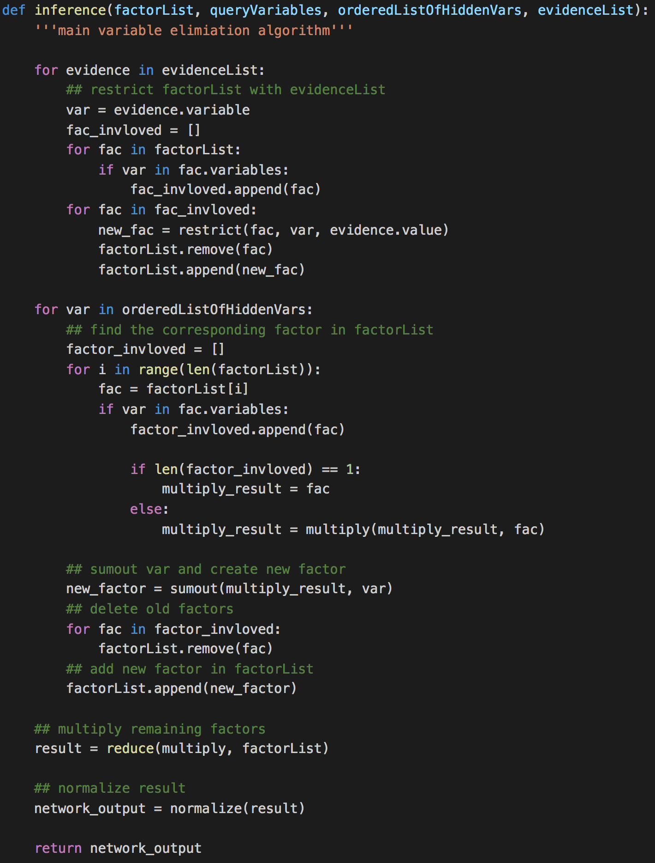

Problem 2

1. Bayes Network

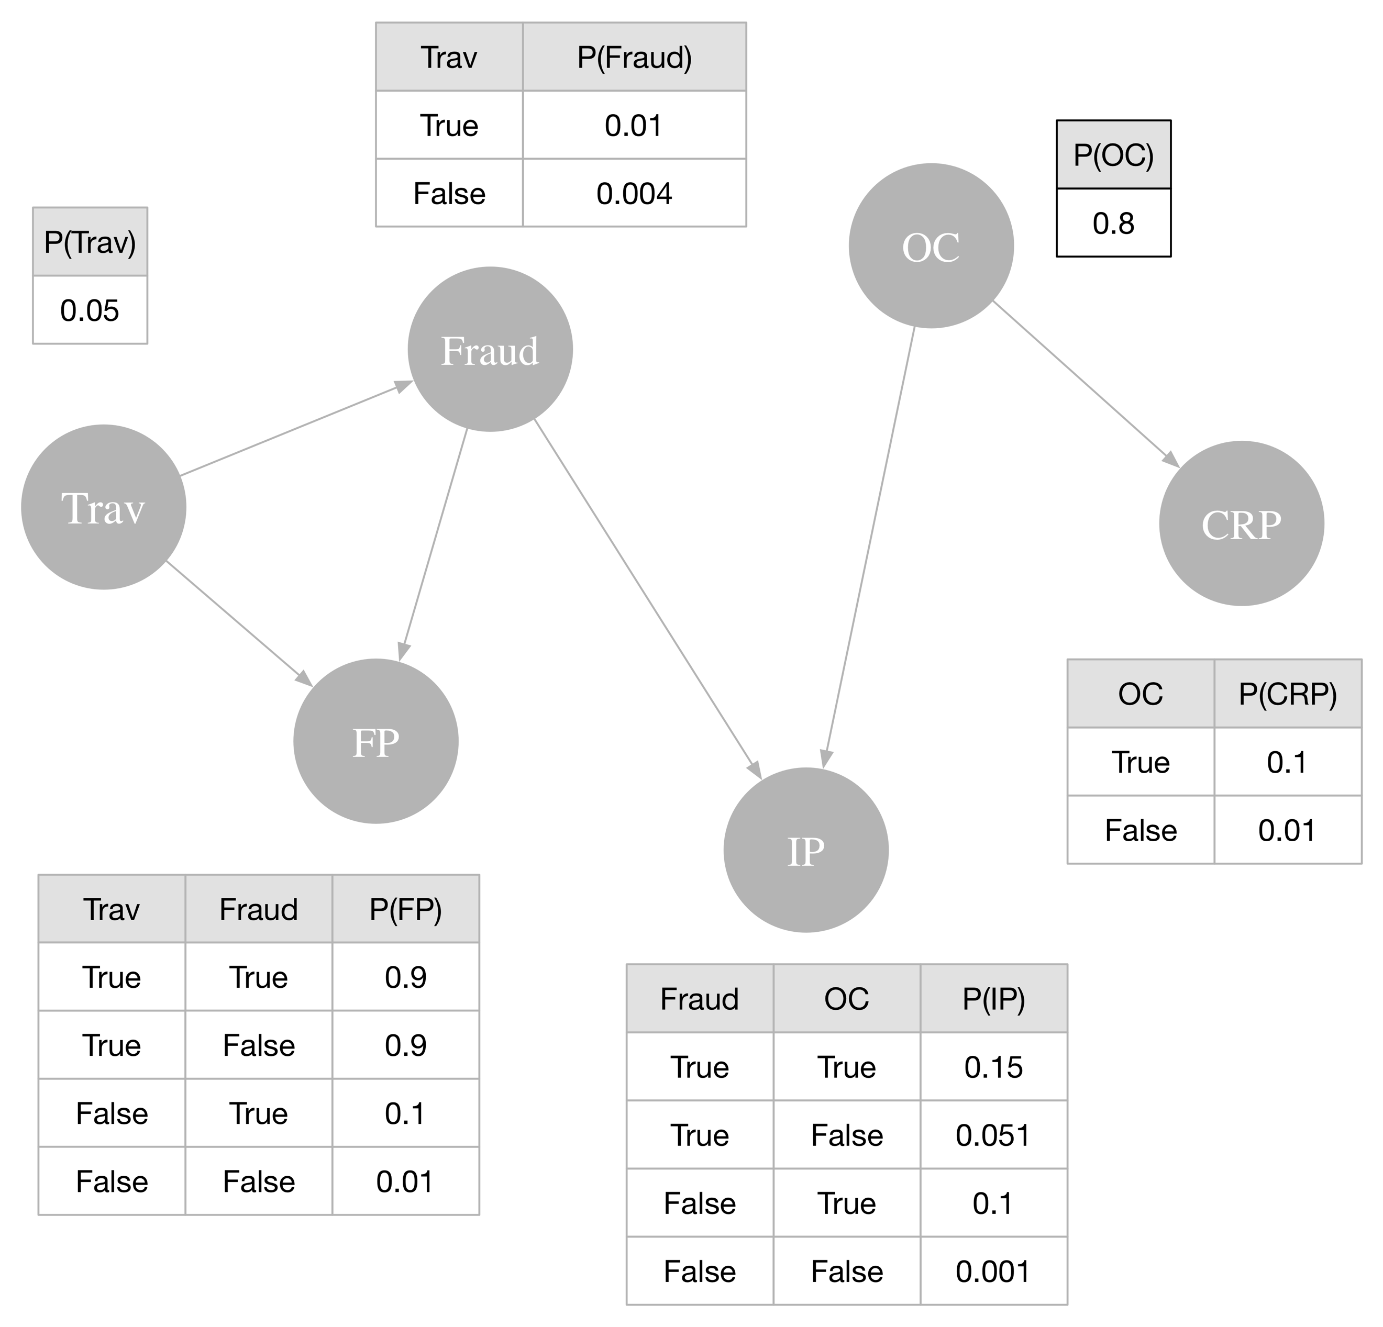

1. P(Fraud) = 0.430%

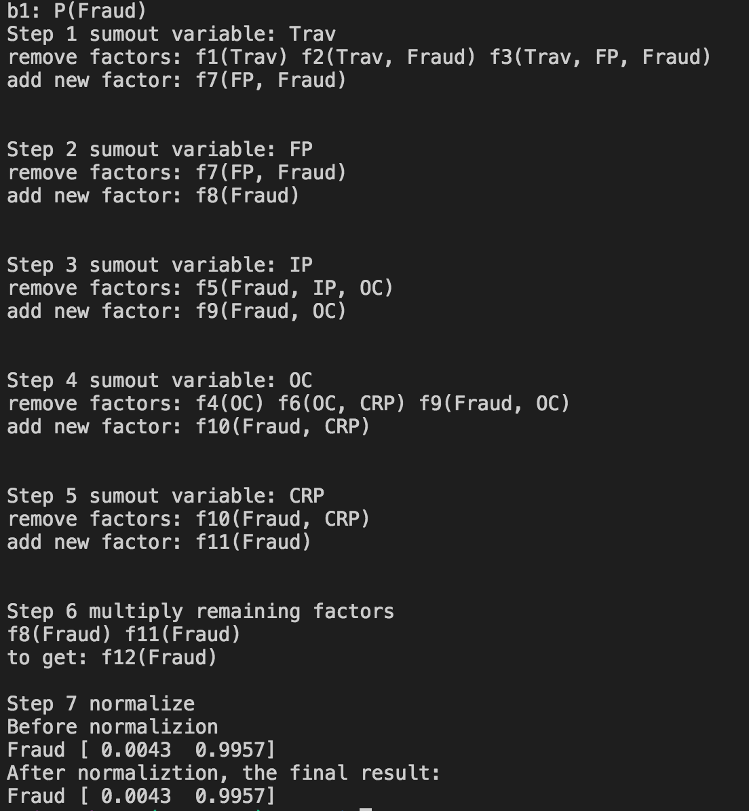

P(Fraud|fp, ~ip, crp) = 1.431%

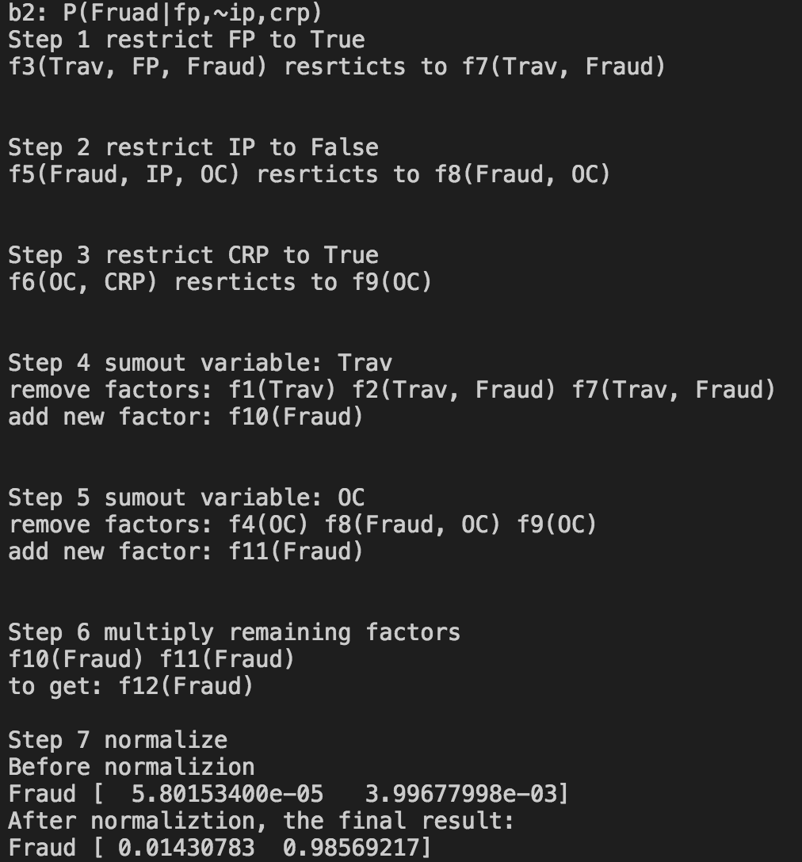

1. P(Fraud|fp, ~ip, crp, trav) = 0.945%

The probability decreases 0.486%

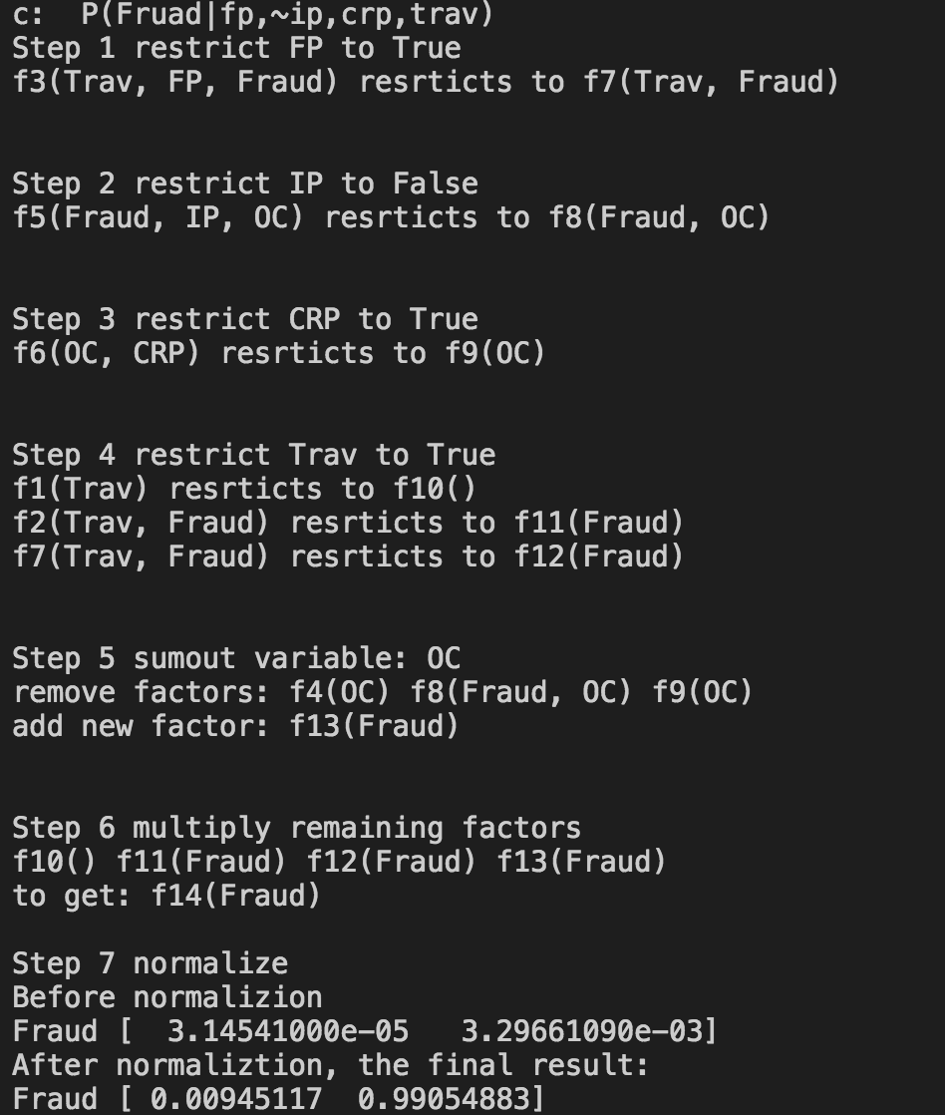

1. You can purchase computer related items prior to your internet purchase to pretend the car holder has a computer. This will reduce the risk when doing internet purchase. According to the screenshot, P(Fraud|ip) = 0.696% and P(Fraud|ip, crp) = 0.649%. Then the probability of a fraud gets reduced by 0.047%.

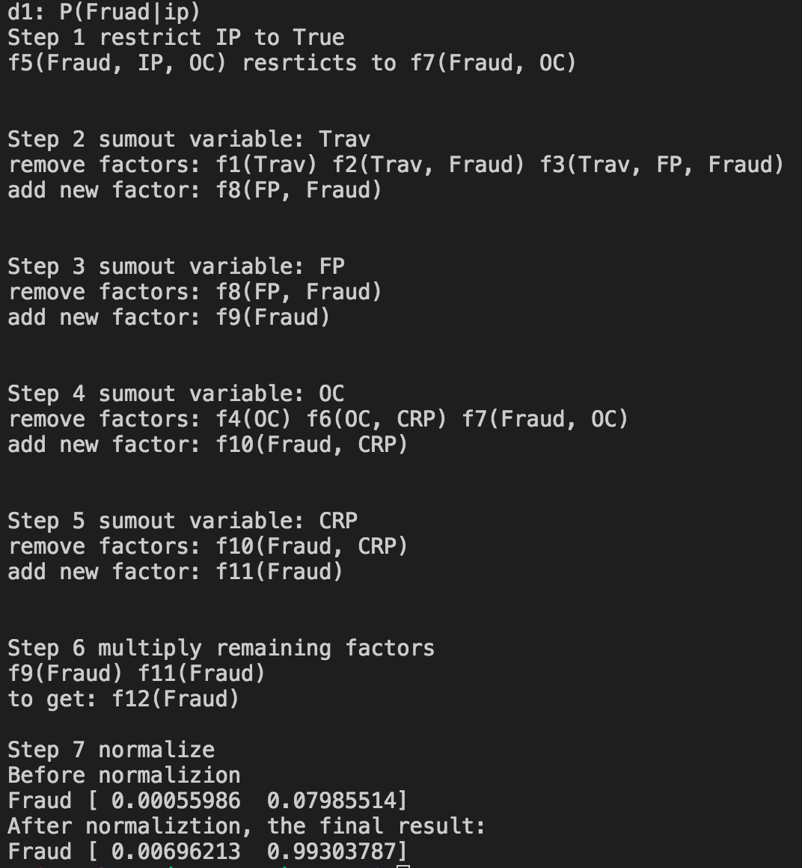

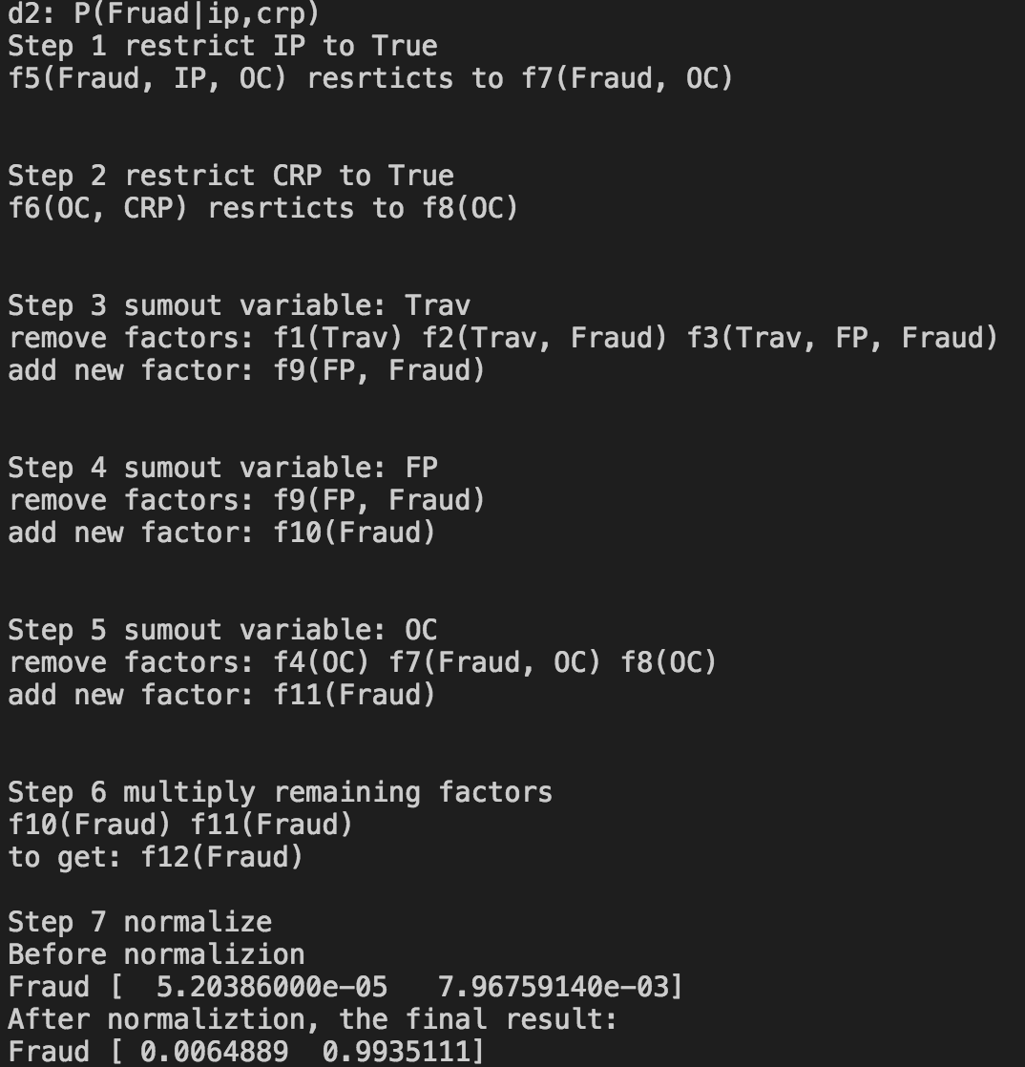

Problem 3

1. 1. No. D and G have a direct connection. Also, information can be delivered through F since F is not given. Hence, D and G is dependent.

2. No. Information can be delivered via the direct connection between D and G, even though F given, therefore D and G is dependent.

3. Yes. B is not given and the information is blocked based on case 3. A and G is independent.

4. No. When B is given, the information tunnel opens based on case 3, then information can be delivered through A, B, C, D, (F) to G. Hence, A and G is dependent.

5. Yes. Based the last question, the information tunnel is blocked by C given, according to case 1. Another tunnel through A, B, C, E, F to G is also blocked when E is not given. Therefore, A and G is independent.

6. Yes. Almost same as last question. The tunnel is blocked by D given for this time, according to case 2. Another tunnel is still blocked. Then A and G is independent.

7. No. Based on last question. Tunnel though A, B, C, E, F to G opens when B and E is given. Then A and G is dependent.

1. According to the algorithm, the relevant variables should be C, D, E and F.

Explanation: C is the query so C is relevant. D is C’s parent, then, relevant. E belongs to the descendant set of C, so E is relevant. F is parent of E, then relevant.