Rukshar Parwin

SOCIAL COMPUTING PROJECT REPORT

Sentiment Analysis On Trump related Tweets

Table of Contents

OBJECTIVE 3
SIGNIFICANCE 3
CHALLENGES 4
METHODOLOGY 5
FUTURE DIRECTION 9
CONCLUSION 9
IMPLICATION OF WORK 9
REFERENCES 9

OBJECTIVE

With the current political environment and the use of social media by political figures in highest office in the country (specially Twitter), I believe that tweets around political figures are good indicators of people’s general perspective/ sentiments. In this project, I want to concentrate on tweets around the President of the United States. My key word search would include tags like @RealDonaldTrump, @POTUS, Trump or anything similar. I plan to exclude tweets from @RealDonalTrump (and from @POTUS account) but include any tweets that mention Trump.

The goal of the project is to develop a topic-based social media crawler for ‘Trump’ related activities on twitter. The crawler would search social media site and return what people talk about. Not every person who talks about the President is in favor of Trump. I plan to distinguish tweets related to Trump in three different categories that includes 1) neutral, 2) negative and 3) positive. The purpose of this project is to crawl related data from Twitter and use Semantria and do a sentiment analysis on each tweet.

My hope is to learn more about the tool and how Semantria works. Just based on Twitter data, I am hoping to do analysis on each category and draw visualization.

SIGNIFICANCE

A Trump supporter would naturally incline to think that tweets about Trump are usually positive (may be because of the users he or she follows). Similarly, a person who does not necessarily like Trump would think in general people do not like him (may be because he has similar users in his network). And there are other users who doesn’t necessarily like or unlike Trump, but are just curious. With this project, I am visualizing data from these categories to see how Trump’s popularity is (has he been consistently disliked, has he been consistently liked, are there similar number of users between his base and people who opposes etc...).

In past generations, it was difficult to figure out what the most powerful person in the world was thinking. We had to rely on press secretaries or political speeches. Now, these thoughts trickle out in a constant stream for all to see. A leader with a constant communication channel to the world is unprecedented.

This method of data extracting from twitter provides real-time data and when combined with Sentiment Analysis, can be useful in many different ways such as:

- What policy matter the President is thinking about.
- What is Presidents inclination on a particular topic?
- Unfiltered and unedited access to Presidents thoughts to better understand policy decisions.

CHALLENGES

While researching for this topic, I came across a lot of work that analyses tweets from Trump. There are a lot of works that captures Trump top Tweet subjects to Trump’s top insults etc. To add another dimension to the work done on tweets by Trump, I focused on Tweets that do not come from either Trump’s twitter handle @RealDonaldTrump or official @POTUS. I decided to look at tweets that mentions Trump but not from Trump.

One can argue all those followers or tweets are not from real person and can very well be bots. I agree that it will be pretty difficult to separate these out. I still think a trend on these tweets sentiments would be directionally reliable.

For the technical end of the project:

Data Crawling

NodeXL free version has a limit of 18000 tweets max or data extract for one week activity (whichever comes first). With about 60 Million Trump’s followers on twitter, I was probably able to collect a day or less than day worth of data. The final data set included data from multiple crawls for terms like ‘Trump’, ‘Donald Trump’ and ‘POTUS’ to collect all the tweets.
Semantria

Semantria free version has a limit of 15000 tweets for sentiment analysis.

Excel
Excel was used to create visualization and look at data in different buckets (negative, positive, and neutral)

METHODOLOGY

Twitter data was crawled for search term like like ‘Trump’, ‘Donald Trump’ and ‘POTUS’ using NodeXL. As NodeXL has the limit of extracting 18,000 tweets, there were multiple steps of crawling involved.

Once the data was collected in the spreadsheet, the tweets were cleaned to make sure none of the tweets are either from handle @RealDonaldTrump or official @POTUS. The cleaned dataset was then processed through Semantria for Sentiment Analysis and were distributed in three different sentiment categories (Positive, Negative, and Neutral).

Here is the screenshot for the crawled data set from twitter. The data from multiple search results are merged into one excel sheet. The attribute ‘Tweet’ is an important part of this project.
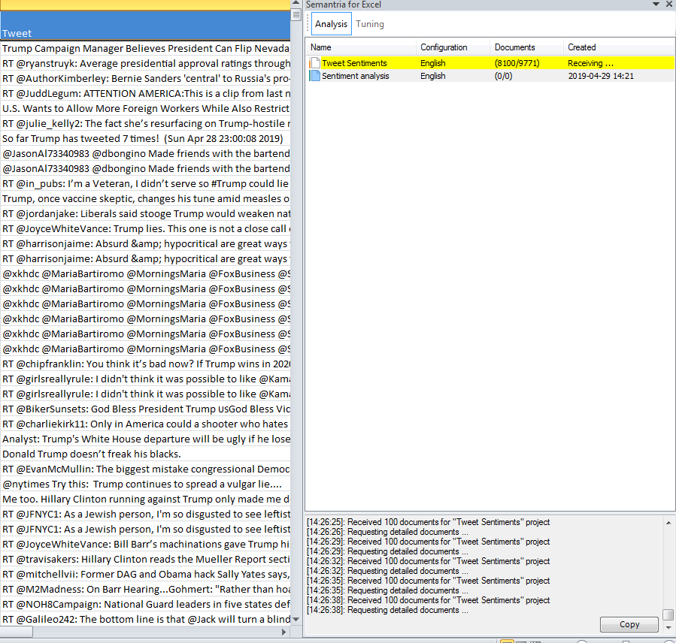

The cleaned data were then selected to run the analysis using Semantria excel plug-in. The numbers of rows in the data set collected were about 9,371 records. Semantria free version has the limitation of processing 15,000 records. Sentiment scoring allows a computer to consistently rate the positive or negative assertions that are associated with a document or entity. The scoring of sentiment (sometimes referred to as tone) from a document is a problem that was originally raised in the context of marketing and business intelligence, where being able to measure the public’s reaction to a new marketing campaign (or a corporate scandal) can have a measurable financial impact on your business.

Semantria does this breakdown of negative, neutral and positive based on different iterations by phrase detail, theme detail, entity theme detail and query category detail. Below view how negative phrases are highlighted and the tweet is captured as negative sentiment.

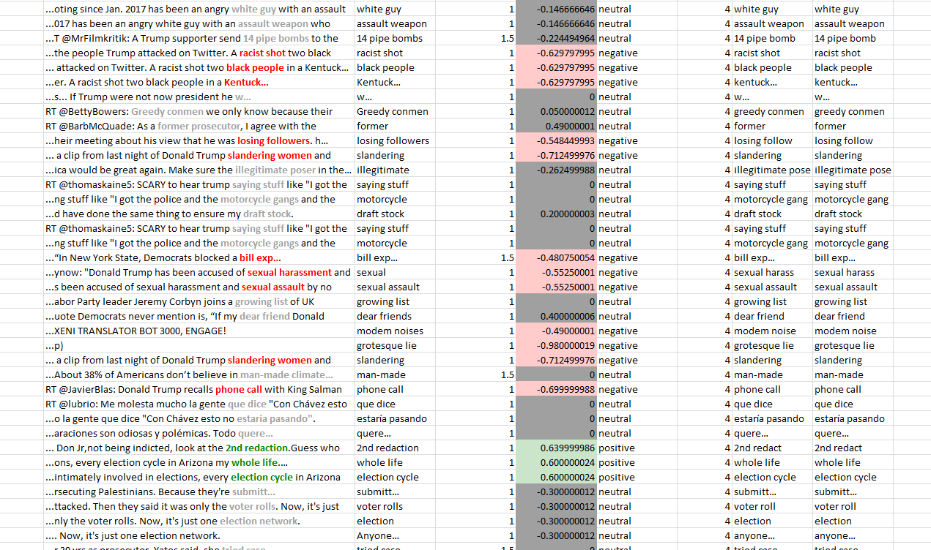

Semantria software identifies the emotive phrases within a document and then scores these phrases (roughly - 1 to +1) and then combines them to discern the overall sentiment of the sentence. Importantly, Semantria sentiment scoring will score those sentences the same every time they’re exposed to them – the software is not affected by whether or not it has had its morning coffee, or whether it is a fan of the team that lost (or that won!). That’s consistency, and that’s important.

The first step in determining the tone of a document is to break the document into its basic parts of speech (POS tagging). POS tagging is a mature technology that identifies all the structural elements of a document or sentence, including verbs, nouns, adjectives, adverbs, etc. This process in reality is how human process sentiment in a sentence.

Human identifies the parts of speech within a document that indicate an emotion. The difference, of course, is that our software needs to actually assign a number to the sentiment – as opposed to human, when you’re reading it, just think “darn, they lost again...badly”. What Semantria did is created a very, very large dictionary of sentiment bearing phrases and their relative scores. These scores are pre-determined by how frequently a given phrase occurs near a set of known good words (e.g. good, wonderful, spectacular) and a set of bad words (e.g. bad, horrible, awful). They then used an extremely large corpus of text (the web, via an internet search engine) to evaluate the nearness of known good and bad words to the phrase being considered.

Here is another screenshot which captures another iteration of Sentiment analysis classification by query category detail.

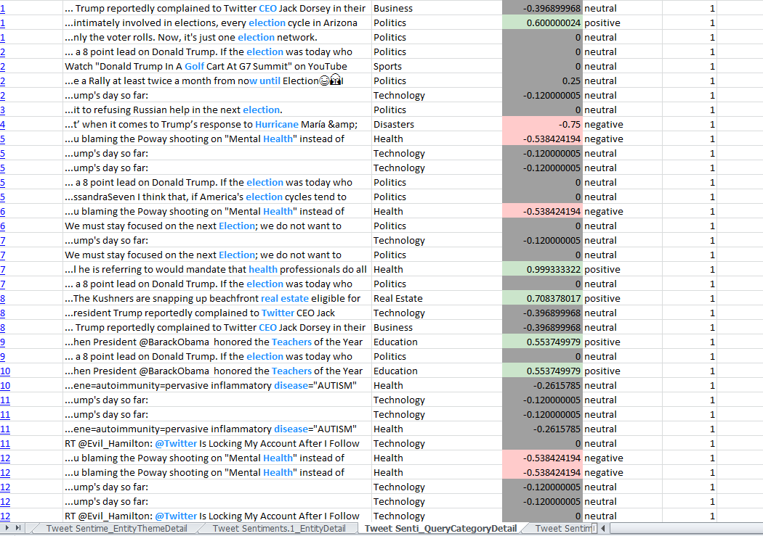

While processing the data, Semantria creates different analysis results. One of the intermediate step breakdown phrases mentioned in each tweet and the sentiment based on the sentiment score for the tweet. Below screenshot captures the details:

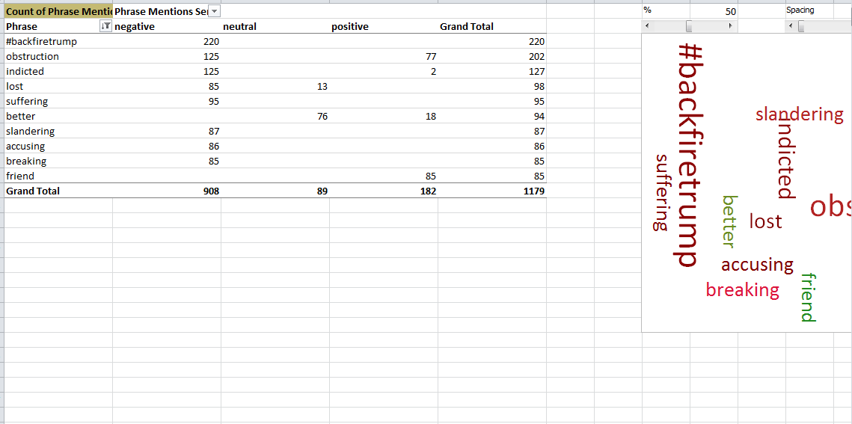

The overall sentiment score with positive, negative and neutral indicator for all the tweets were captured in a separate excel, which was then grouped in its respective bucket as shown below.
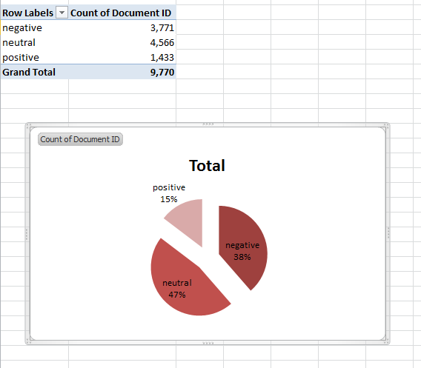

For the 9,770 tweets I extracted, here is the classification of the sentiment. About 47% of the tweets are classified as neutral, 15% as positive and rest, 38% as negative.

FUTURE DIRECTION

This was an interesting project and I learned a lot about data crawling, data collection, and running sentiment analysis. However, with the amount of data I was able to collect with free version, I don’t think I could show any trend of actual sentiments.

The project is more of a proof of concept and can be extended to paid version subscription to continue detailed analysis. One can also classify Tweets, Re-tweets and mentions in separate bucket for individual analysis of these categories.

This work can be expanded to other world leaders as well to either understand peoples perspective about the leader or the thoughts of the leader himself.

CONCLUSION

Uses of social networking sites by public official are rather common starting that includes leaders in highest offices in this country and other countries at large. In generations past, it was difficult to figure out what the most powerful person in the world or the leaders of other countries are thinking. We had to rely on press secretaries or political speeches to gain insights to their thought process. Now, these thoughts trickle out in a constant stream for all to see. A leader with a constant communication channel to the world is unprecedented.

IMPLICATION OF WORK

As discussed in other section of the paper, the project will have implication in many different fields. This can be used to understand what policy matter the President is thinking about, what is Presidents inclination on a particular topic. It also gives unfiltered and unedited access to Presidents thoughts to better understand policy decisions.

REFERENCES

[1] https://www.lexalytics.com/content/whitepapers/Lexalytics-WP-Sentiment-Extraction.pdf?data-popup=%27yes%27
[2] https://medium.com/swlh/analyzing-trumps-tweets-5368528d2c90

