FSD for Disbursement

1. High Level User Procedure

1.1 【Same as Batch2】Normal Process
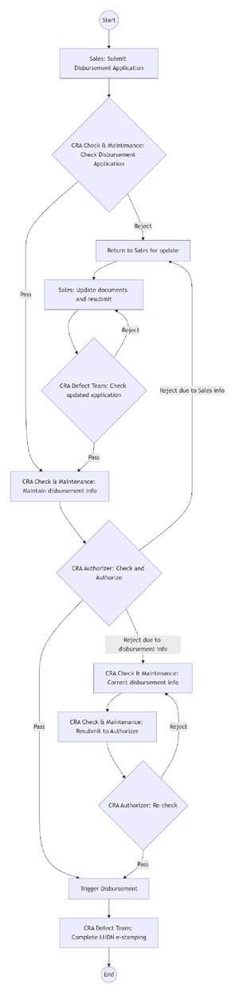

1.2 【Same as Batch2】FBR/FBT
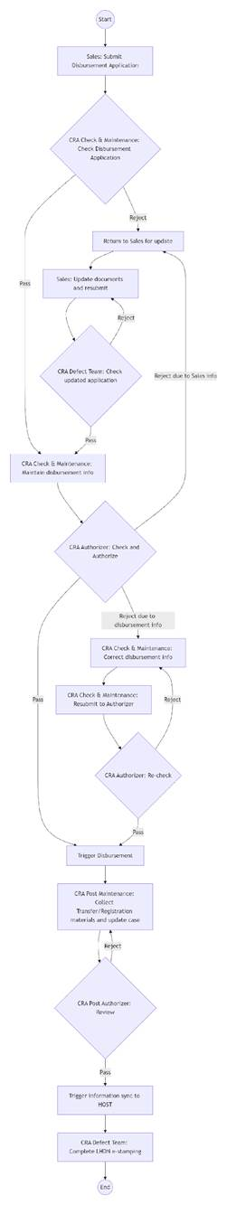

1.3. 【Same as Batch2】Funded with Defect
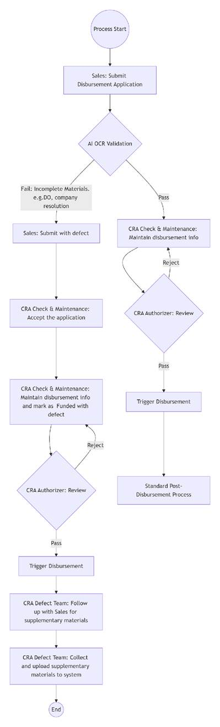

1.4. STP

1.4.1 Definition
STP (Straight-Through Processing) : refers to a processing mode in which, after Sales submits a case to CRA and the case passes the Expert Rules validation, no intervention by a CRA Authorizer is required before disbursement is completed.
Note: The Expert Rules validation result checking and modification step is performed by OCR and the CRA Checker and Maintenance roles. This step is not considered a manual authorization activity and therefore does not affect the determination of whether a case qualifies for STP.

1.4.2 High Level Flow
- Sales uploads the required files and submits the case. Upon submission, the system triggers real-time CRA Expert Rules validation, which consists of both OCR-based automated validation and manual verification.
- If any file is identified as incorrect, Sales is required to re-upload the file and complete the file classification and case re-submission procedure.
- CRA Checker and Maintenance reviews the OCR results, performs an overall assessment of the Expert Rules validation results, and records any identified defects. If defects are identified, the case may be returned to Sales for file re-upload.
- After completing the Expert Rules validation result checking and modification and maintaining the required disbursement information, CRA clicks “Next” at the bottom-right corner of the Detail page to submit the case.
- Once the information is successfully saved, the system performs the STP eligibility assessment. If the case qualifies for STP, the CRA Authorizer step is skipped and the system proceeds directly to invoke the subsequent disbursement interface. If the case does not qualify for STP, it is routed to the CRA Authorizer for manual authorization.
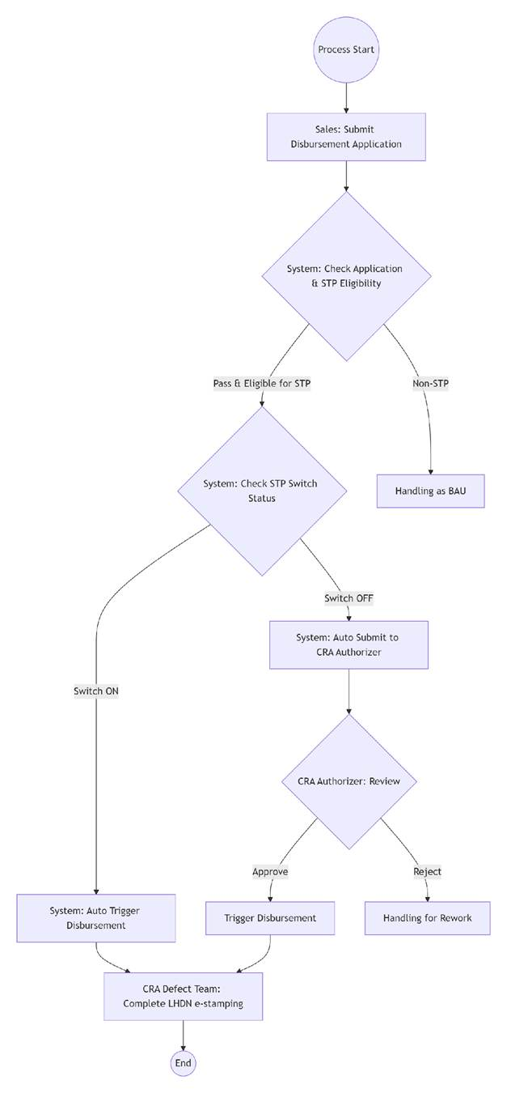
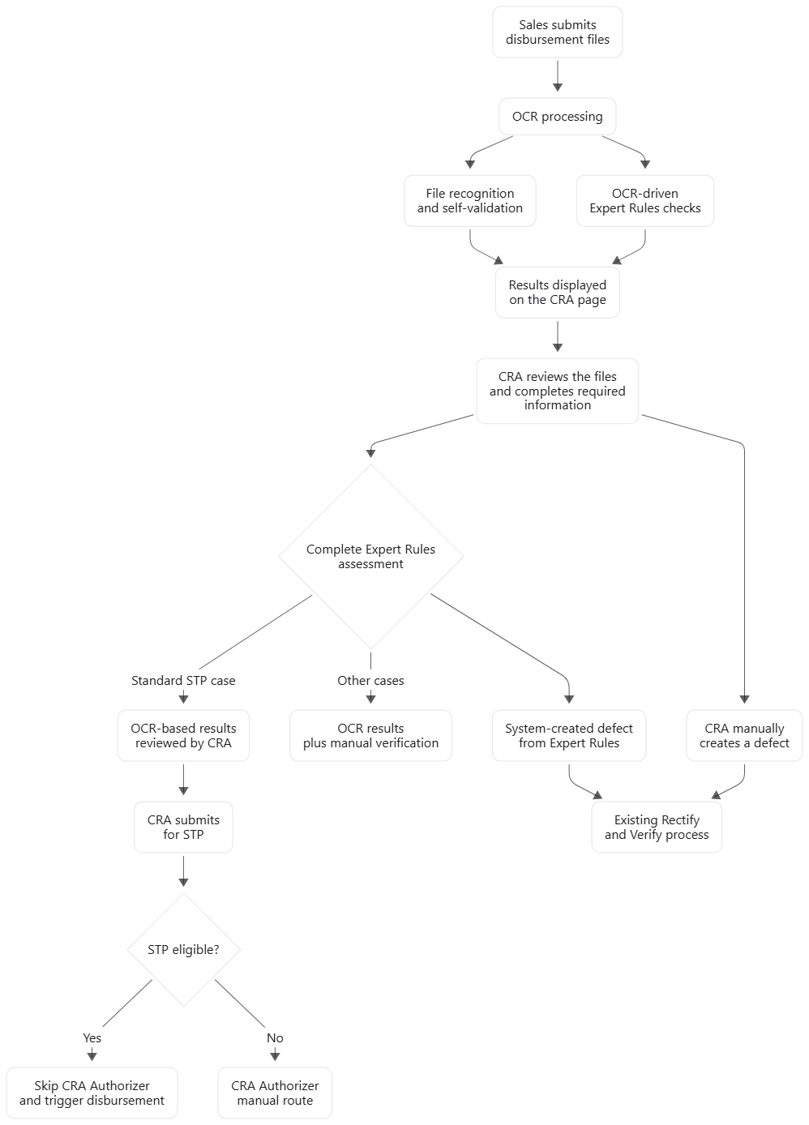

2. Disbursement Document Collection and submission by Sales
After collecting the loan disbursement documents, the sales staff upload them to CrediOS. After completing the integrity check of the documents, they submit the loan disbursement application to CRA.

2.1. 【Same as Batch2】CRA To Do List
- Entry Point: CRA - To Do List
- Filter Criteria and display will follow Sales Page Uniform Style
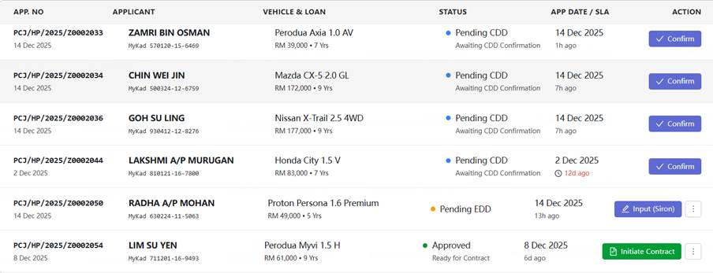

2.2. 【Same as Batch2】Application Query

- Query Entry Point
- Filter Criteria and display will follow Sales Page Uniform Style

2.3. 【30days Instinct】Trigger lodgment—【Waiting for Risk team to provide details on the 30-day instinct】

- Entry Point: Fundamental function follows Sales Page. Details refer to “Common Capabilities - Trigger Lodgment”
- Lodgment interface status: success, failure.(Same as Batch 2)
- If interface result is success, retrigger is not allowed；otherwise, retrigger is allowed.
- Support generate and download E-Hakmilik slip.

2.4. [Batch-3] Enhancement to E-Hakmilik Lodgment
- Entry Point: Common Functions -> E-Hakmilik -> View
- The screen displays a table with all interface log records for an application. Each record contains the following fields

Field | Description
Type | Enumeration Values for the Field TBD by CRA Team
FIS Result* | Mapped from the FIS result in E-Hakmilik and Inquiry screen:  COMPLETED -> Berjaya (Verified)  FAILED -> Gagal (Fail)  ERROR -> Error  SOCKET_TIMEOUT -> Connection Timeout
Remark | The field ‘desc’ from lodgment interface response
Request Time | Request time of this interface. Format: dd/MM/yyyy HH:mm, EEE (example: 16/08/2026 18:20, Sun)
Response Time | Response time of this interface. Format is the same as Request Time.

*Note: There is a mapping relationship between the two sets of enumerated values:
- One set is the order-level FIS Result, which is displayed in the order list on the E-Hakmilik and Inquiry page described earlier.
- The other set is the interface-level FIS Result, which is displayed in the interface log table on the E-Hakmilik detail page after opening a specific order. This is the set of FIS Result values covered in this section of the requirements.

2.5. FIS Query

2.5.1【Same as Batch2】Business rules
- The system automatically initiates a query upon entering the case details page.​
- Page display refer to “Common Capabilities - FIS Query”
- Provide a button next to the FIS result display area to support re-querying.​
- The system shall save the latest query result.​
- Automatic query upon case entry is suppressed if the latest saved vehicle status is "verified"; the query button, however, remains clickable.​
- Automatic query upon case entry is suppressed if the latest saved vehicle status is "processed"; additionally, the query button is disabled (grayed out).​
- Re-query Button should be controlled by User Access. Set disabled as default to sales, it depends on the sales team to determine whether to grant this access to sales personnel. The button is display in the position referred to the snipping below.
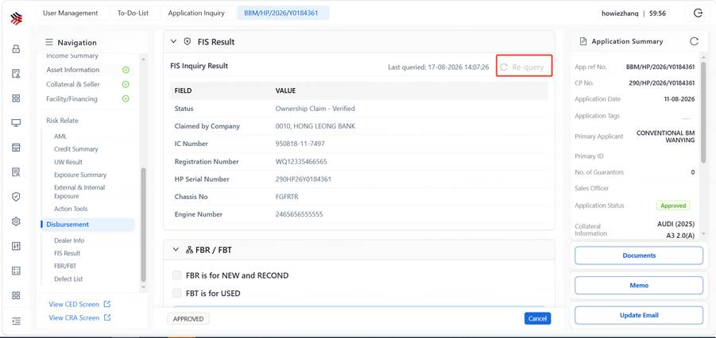

- To reduce cost, before automatically querying FIS upon page entry or refresh, the system first checks if a query has been made within the last X hours, X is configurable(Constant name: FIS_AUTO_INQUIRY_SPAN ). If yes, the cached result is used directly.
- In addition to saving cost, If FBR/FBT or IHP application, system to bypass the automatic FIS query.
- If FIS_INQUIRY_SWITCH is OFF, the system should not call the FIS interface and prompt “FIS inquiry is out of service, please try later.” and should gray out the re-query button.
- When displaying FIS result in the application detail page, show “Last query datetime” on the right of “Status”, as demonstrated below.

2.5.2 Re-query Permission
- [Batch-3] Grant the permission for FIS Re-query button only to users with the following roles:
  - HP_CRA_CHECKER_MAINTENANCE
  - HP_CRA_AUTHORIZER
  - HP_CRA_DEFECT_TEAM
  - HP_CRA_POST_MAINTENANCE
  - HP_CRA_POST_AUTHORIZER
  - HP_CRA_MANAGER
  - Certain Sales roles: to grant access to Sales Manager & Sales Head

2.6. 【Same as Batch2】Dealer Information Query
Sales verify the dealer’s qualification for conducting FBR/FBT business, and determine whether to adopt the FBR/FBT model based on the vehicle lodgment registration status.
- This query is only for indirect business mode
- Automatically initiate a query upon entering the case details page
- Query the dealer’s FBR/FBT qualification
a. To confirm whether the dealer have FBR/FBT quality based on the Undertaking Limit for FBR or Undertaking Limit for FBT. IF not empty and undertaking limit >=loan amount[h1] then have corresponding quality. FBR/FBT quality are configured separately.
b. If the vehicle status is verified​ and the dealer is qualified​ for FBR/FBT, display the prompt: "FBR/FBT applicable for this case". The salesperson must manually check an indicator​ to confirm.
c.If the vehicle status is not verified, display the prompt: "Vehicle lodgment status does not meet requirements"​ and disable​ the FBR/FBT option；
d.If the vehicle status is verified but the dealer is not qualified, display the prompt: "Dealer not qualified" and disable​ the FBR/FBT option.
- If the automatic query upon entering the case details page fails, provide a "Re-query dealer information button". After the query completes, follow the prompts and controls described above.​
- Determine the applicable scenario (FBR or FBT) based on the vehicle type (NEW/USED). Use FBR for new vehicles and FBT for used vehicles.

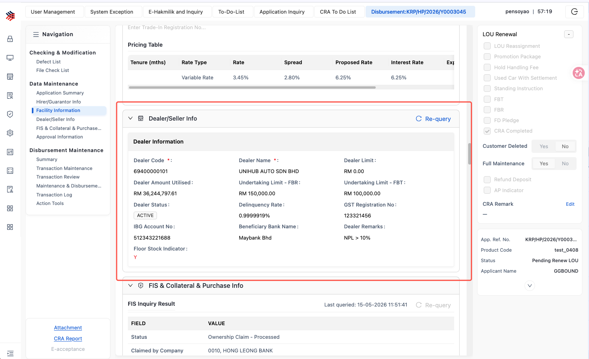

2.7. File Upload

2.7.1 Source Type
The File Center is the centralized entry point for file upload, classification, recognition, and rule validation during the Disbursement stage, covering all file-related operations under the Disbursement tab.
Users shall upload files requiring OCR processing through the OCR entry and upload other files through the Non-OCR entry, in accordance with the page guidance, to ensure the accuracy of AI OCR processing.
a. OCR Files:
Files uploaded through the OCR entry will be processed by the AI/OCR engine. The document types currently supported by the system are defined in the OCR File List.
Exception Handling:
- Files outside the OCR File List can still be uploaded through the OCR entry; however, the OCR system may not be able to classify, recognize, or extract information from such files.
- Where one source file contains multiple sub-documents that require different processing paths, e.g. some sub-documents require OCR while others do not, the system will not block the upload. However, OCR may not be able to accurately classify, recognize, or extract the contents of the file.
b. Non-OCR Files:
Files uploaded through the Non-OCR entry will not be processed by the AI/OCR engine by default. No AI-based classification or extraction will be performed for files uploaded through this entry.
Regardless of whether the document type itself is supported by OCR, any file uploaded through the Non-OCR entry shall be treated as a Non-OCR file.
c. System-Generated Documents:
Documents automatically generated by the system and archived in the File Center are categorized as system-generated documents. Such documents may also be manually uploaded through the Non-OCR entry for storage purposes.

2.7.2 Upload Role and Entry
Separate upload entries shall be provided based on the entity/role to which the document belongs. Each role entry shall provide both OCR and Non-OCR upload options.
The purpose of separating the upload entries by role is to associate the uploaded documents with the corresponding entity ID for subsequent matching and validation, thereby ensuring the accuracy of file recognition and data extraction.
a. Main Applicant:
Includes identity, income, vehicle, acceptance/signing, application, biometric, and other related documents of the main applicant. The scope follows the Batch 2 implementation.
b. Guarantor:
Includes guarantor identity, income, agreement/signing, and other related documents.
Each guarantor shall have an independent upload entry. The corresponding guarantor file upload entry will only become available after the guarantor information has been entered and the guarantor ID has been queried and confirmed.
c. Seller:
Includes seller identity-related documents.

2.7.3 Guarantor File Maintenance
- Sales shall complete the guarantor information before the corresponding guarantor upload entry is enabled in the File Center.
- If a guarantor is deleted：
  - the system shall prompt Sales that all files associated with the guarantor will also be automatically deleted from the active file list.
  - the related files will be moved to the Deleted Files list;
  - the deletion records shall remain available for record-tracking purposes.

2.7.4 Mandatory File List
Different case scenarios may require different mandatory document sets during the Disbursement stage. The Mandatory File List is used to guide Sales document preparation and subsequent CRA document checking.
Currently, there are three different document-list scopes in the system that are related to mandatory file checking, and these scopes are not fully aligned:
- Files actually uploaded by Sales during the application process:
The current scope is relatively limited and may not cover all documents that are actually required from a business perspective.
- Validation rules based on classified Document Types:
The system currently applies relevant validation rules only when a file has been assigned a specific Document Type.
If no corresponding Document Type exists, the document will not be treated as mandatory and no validation will be triggered.
- CRA Mandatory File Checklist:
The File Checklist used by CRA should, in principle, cover all documents and corresponding checking requirements applicable to the specific Case scenario.
Ideally, scope (a) and scope (c) should be aligned to minimize document supplementation and rework during CRA processing.
The current Mandatory Disbursement File Checklist parameters shall refer to 18.20 Mandatory Disbursement File Checking List.

2.7.5 File Display
- All Files:
The File Center shall display all files under the Case by Application and Disbursement stage.
Within each stage, files shall also be displayed by entity:
- Main Applicant;
- Guarantor, with a separate entry for each guarantor; and
- Seller.

- System-Generated Documents:
- System-generated documents are maintained for archival purposes and may also be manually uploaded where required.
- Such documents belong to the different entity, and shall be included under any Main Applicant, Guarantor, or Seller entry, with the creator by system.

- Deleted Files:
- The Deleted Files entry shall display records of deleted documents.
- Deleted files are retained for record purposes only and shall not support preview.

2.7.6 File Classification
Users shall upload files through the appropriate entry according to the processing requirement, i.e. OCR or Non-OCR.
- OCR Files:
The system will perform automatic file classification. Users may manually edit and confirm the classification result where required.
- Non-OCR Files:
Users shall manually select the Document Type for downstream business processing.
For example, during the Disbursement stage, only files with a defined Document Type can be associated with the relevant expert rules for preview and marking. Files without Document Type information cannot be associated with expert-rule preview or marking.

2.7.7 File Deletion
- File deletion can only be performed through the File List.
- Deleted file records shall be displayed in the Deleted Files list.
- Deleted files: cannot be previewed; and cannot be restored.

2.8. Disbursement Application Submission

2.8.1 【Same as Batch2】Submission Control Logic
- The disbursement application can only be submitted to CRA after all initially uploaded or updated files have been confirmed as complete. Such confirmation shall be completed through system file classification for OCR files or manual Document Type classification by Sales for Non-OCR files.
- Submission Control Matrix
Vehicle FIS Status | FBR/FBT Indicator Checked | FBR/FBT Indicator Not Checked
Verified | Submission is allowed. | The system shall display a warning to Sales. Submission is still allowed.
Processed | The system shall display the warning "FBR/FBT is not applicable when the vehicle status is Processed". Submission is still allowed. | Submission is allowed.
Other (neither Verified nor Processed) | The system shall display a warning to Sales. Submission is still allowed. | The system shall display a warning to Sales. Submission is still allowed.

- Additional Notes
Under the "Other" status, the system shall display a warning and shall not block submission regardless of whether the supplementary FIS result document has been subsequently uploaded. It is the CRA team to decide whether the Case is eligible for disbursement.
Missing document notification: if Sales has not checked the FBR/FBT indicator and has not uploaded the VOC, Road Tax and Insurance documents, the system shall only display a warning to Sales. Submission is still allowed.
- After Sales completes the file upload and clicks “Proceed To CRA”, the system shall trigger CIF Creation, Facility Creation, and Collateral Creation (Host Acceptance).
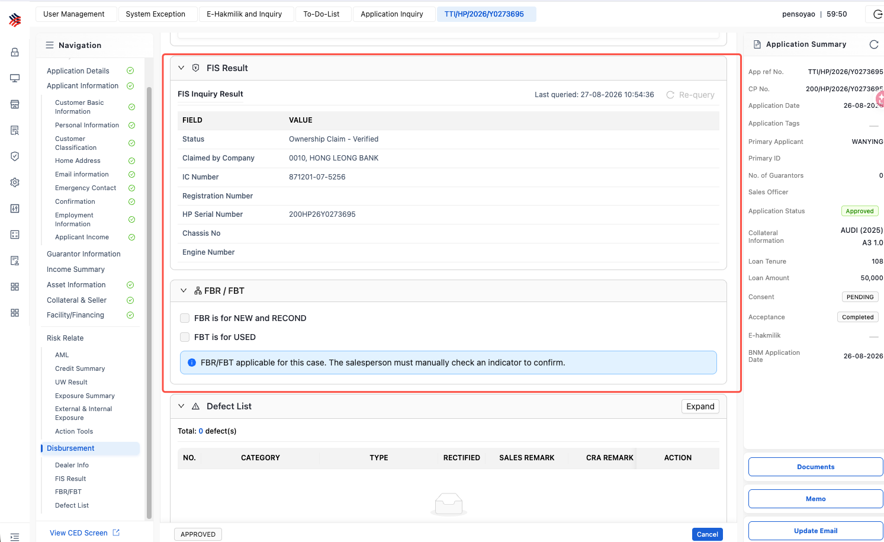

2.8.2 Submit for Verification
After files are uploaded, the user shall click the “Submit for Verification” button at the bottom-right corner of the File List page to trigger rule validation.
- Validation results for OCR files shall be displayed on the Cross Validation page.
- Where expert-rule validation is applicable to Non-OCR files, the corresponding results shall be displayed on the Manual Check Results sub-page.
Files without a defined Document Type shall not be processed for rule validation. Such files shall remain in the File List for storage and preview purposes only.

2.8.3 Rule Validation Method
- File content extraction (OCR Extraction) and rule validation are two independent processing steps. Files that have already completed extraction will not be extracted again. However, once any file under the Case is changed, including file addition or replacement, the system shall rerun rule validation against all files under the Case.

- Rule validation does not distinguish between validation of an individual file and validation of all files. After the user clicks “Revalidation & Submit” on the Cross Validation page, the system shall always rerun rule validation in batch for all files under the Case.
This is required because certain rules involve cross-document validation and therefore cannot be rerun against a single file independently. For example, income information contained in a supporting document may need to be validated for consistency against the primary identity document or other related documents.
- After revalidation is completed, the system shall retain only the latest validation result. Historical validation snapshots will not be retained and previous results cannot be viewed retrospectively.

2.8.4 Rule Source
- OCR-Processed Files (Cross Validation):
Validation shall be performed based on the predefined rules configured in the OCR system for each Document Type. The rules may include Eyeball Check, formula validation, consistency validation, and other applicable validation types.

- Manually Reviewed Files (Manual Check Results):
Expert rules shall also be configured for such files. However, where the files cannot be reliably processed by OCR due to file quality or other limitations, the relevant rules shall be verified manually by the user through visual inspection.

- All expert rules shall be mapped to the corresponding Defect List and OCR validation rules. Any failed rule may be used as the basis for recording the corresponding defect in the Defect List.

2.8.5 System Document Rule Validation
- Electronically Signed Archived Documents:
Documents automatically archived after electronic acceptance/signing shall be stored in the File Center with the creator recorded as System. Such documents shall not undergo OCR processing and shall be exempted from rule validation.
- Manually Signed Documents:
Documents under the Manual Acceptance scenario shall be uploaded by Sales through the Non-OCR entry, with the actual operating User recorded as the creator. After submission and confirmation, the documents shall be included in the manual review scope and the applicable rules shall be verified manually.
Under the Manual Acceptance scenario, the Agreement Date shall be sourced from the handwritten signing date stated on the physical agreement. The field shall not be extracted or auto-populated through OCR and shall instead be manually entered by CRA during the Data Maintenance process.
The Agreement Date shall still be manually verified under Manual Check Results by comparing the system value against the original document and determining whether the date complies with the applicable business requirements. However, when the value is synchronized or populated into the relevant system field, it shall not be automatically derived through OCR.

2.9. Modification and Resubmission of Disbursement Application
The updated disbursement files can only be submitted to CRA after they have been confirmed as complete. Such confirmation shall be completed through the system’s file classification and cross-validation process, or through manual Document Type classification by Sales for Non-OCR files.
When Sales handles a defect Case returned for rectification, the following two actions shall be completed independently. Neither action will automatically trigger the other, and both must be completed separately:
- Re-upload or replace the relevant defective file(s) in the File Center;
- Return to the workbench and manually mark the corresponding item as Rectified in the Defect List.
Supplement the permission boundaries for Sales after a Case is returned by CRA.
- The system shall support file updates.
- After files are uploaded, Sales shall review and confirm the system classification results and make any necessary corrections before submitting the files to CRA.
- After a Case is returned by CRA to Sales, Sales may upload additional files or replace existing files.
- Sales is not allowed to modify files that were previously uploaded.
Sales shall have access to the File List. For the Cross Validation and Manual Check Results pages, Sales shall not be permitted to perform any operations. Therefore, Sales cannot process or modify rule results that have already been marked by CRA.

3. CRA Checker/Maintenance
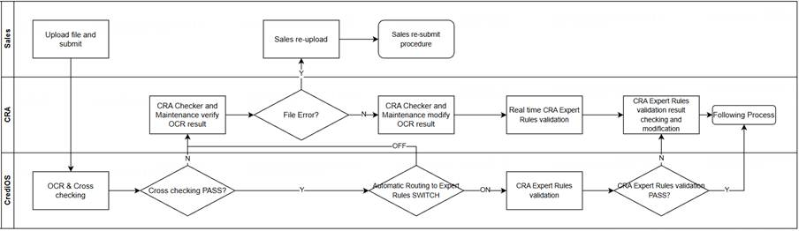

3.1. Disbursement Applications
With OCR support in the File Center, CRA can complete expert-rule review based on uploaded documents more efficiently, thereby reducing the effort required for other data entry and case-processing activities.
- Files may also be uploaded through the Non-OCR entry. In such cases, CRA can preview the documents in the File Center and manually complete the required review and processing for the Case.
- Expert rules shall be configured and associated with the relevant document processing areas in the File Center. After files are uploaded, the system shall execute the applicable rules and display the corresponding validation results or alerts.
- The system shall distinguish the rule-processing areas based on whether the files are uploaded through the OCR or Non-OCR entry. However, the upload entry shall not affect case assignment or queue routing.
- The existing case assignment and processing queue logic shall remain unchanged. No additional processing queue shall be introduced solely due to the implementation of expert rules.

3.2. Expert Rules Validation

3.2.1 【Same as Batch2】Validation Rule Type
- Summarize the existing production check rules, categorize them into several major types, and based on this, implement automated CRA expert rule checking.
- Expert Rule Validation Details: refer to Appendix - CRA Business Rules & Defect Code
Validation Rule Type | Example & Introduction
Fixed Value Comparison | Admin fee amount --EQUALS RM 270, parameter:ADM_FEE_AMOUNT
Date Consistency | Verify that dates across related documents/fields are consistent.
Amount Consistency | Verify that monetary amounts across related documents/fields are consistent.
Amount Range Validation | Check whether the amount fluctuation exceeds a specified allowable range.
Account Consistency | Verify that account information matches across relevant fields/documents.
Term Consistency | Validate those terms (e.g., pledge period) are correct as per business rules.
Date ≥ Specified Date | Validate that a given date is on or after a specified date.
Date ≤ Specified Date | Validate that a given date is on or before a specified date.
Addition/Subtraction Validation | Perform arithmetic checks, e.g., verify that the sum of disbursement amounts matches the total loan amount.
Application Date vs. Application Form Version Mapping | The Application Form version must correspond to (match) the application date.
Region/Area Check | If the dealer’s address is in Peninsular Malaysia (West Malaysia), the road tax document must not indicate a region in East Malaysia.
Special Document Verification | Check whether special documents required for specific scenarios are missing.
Value is not existing | Check whether special fields required for specific scenarios are missing[h2] .

3.2.2 Post-Validation Routing Rules
- If expert-rule validation fails, the Case shall subsequently be handled manually by CRA Checker/Maintenance.
- If expert-rule validation passes, the Case shall proceed to the STP Decision Module.
- Issues identified by expert rules shall not be automatically written into the Defect List. Based on the configured Rule-to-Defect Mapping, a Defect record will only be created after the user actively clicks the relevant “Create Defect” button on the page.

3.3. Application Assignment
The system automatically assigns pending cases according to defined rules and allows CRA Checker/Maintenance to manually select and pick up a case, to enable timely processing of tasks.
● The detailed case distribution rules are specified in the “Application Assignment Management”
● Special Rules:
a. Status of Assigned Cases: Pending Maintenance
b. Assignment or pick up is not allowed when the owner open the application in cra todo list
- When the owner of the application clicks the view button in cra todo list, the backend needs to record the current operatorId and current timestamp.When the CRA manager assigns the application, the backend needs to check whether someone is opening the application tab. If not, immediately assign. Otherwise, check elapsed time between current timestamp and opening application tab timestamp. If the elapsed time is more than X (configuration/parameter), immediately assign, otherwise alert that the application is processing, can not be assigned.
- X configuration/parameter is APP_LOCK_TIME_SPAN, default value is 30, unit: minutes.
c. Pop up the next assignee message when the application route to next action
- Related action transitioning application status: cra manager reassign, route to the cabinet, route to the exception queue(exception team)
- The popup shouldn't disappear too quickly. It currently displays for 5 seconds, but if the user clicks it, the timer should reset.

3.4. 【Same as Batch2】CRA To Do List
The System display application assigned to CRA Checker/Maintenance in “CRA To Do List”,
● Status of Application displayed:
Pending checking and Maintenance, from sales submission.
Pending Maintenance after defect Verification, from defect team.
● After the sales or defect team submit a disbursement application, the case is assigned to the user(or picked up by the user), the system will implement OCR extraction and cross checking simultaneously.
● In application list, display “OCR Status” (Finish-green / Processing-yellow / Failed-red)
● Before the system finishes OCR extraction and cross checking, the OCR status equals Processing or Failed, the user can process the application but will get prompt “OCR processing. Manual intervention now will disable OCR assistance for this case. Confirm to proceed?” .
a) IF users firstly accept manual process without OCR assistance, but exit application without Click Save Button, after the system finishes OCR processing, the user can handle this application with OCR assistance again.
b) IF users process the application without AIOCR assistance, the system needs to record the “Manual Process Indicator”(Y/N) as “Y” for report generation purposes.
● Case ordering, list fields displayed, display rules, and action items in the list are defined in the " Common Capabilities - My Task Query & Display"​ section.

3.5. 【Same as Batch2】Application Query
The System support to retrieve disbursement application assigned to CRA Checker/Maintenance

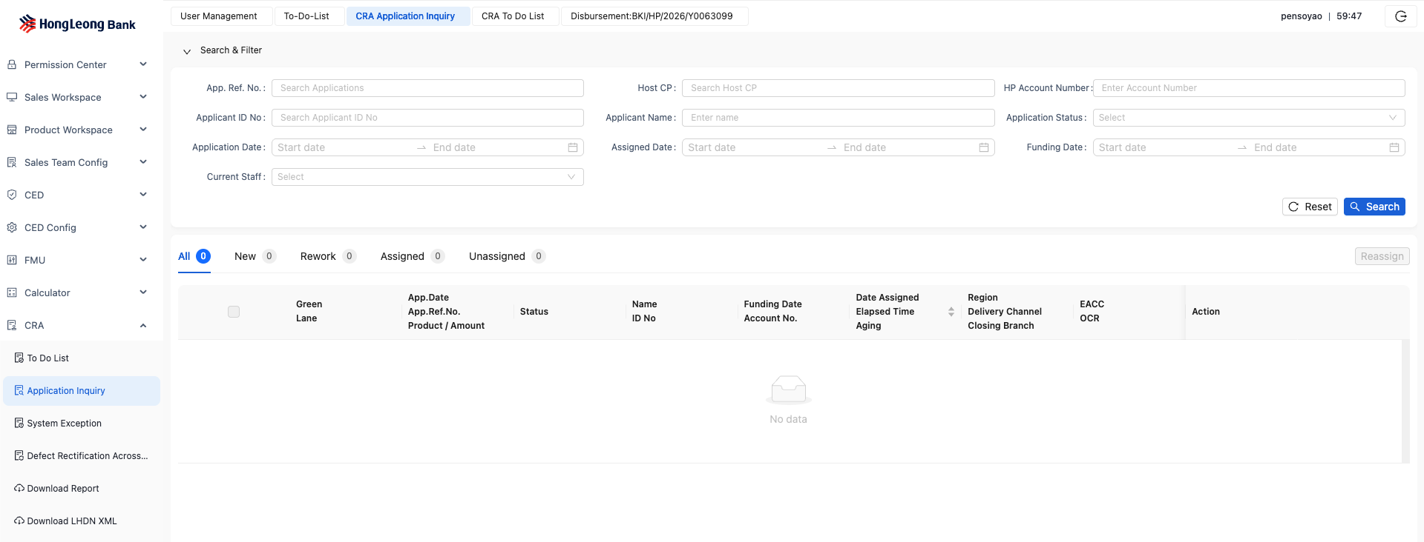
● Case status inquiry is supported: Pending Maintenance
● Filter criteria, list fields displayed, display rules, and action items in the list are defined in the "Common Capabilities - Application Query & Display"​ section.

3.6. 【Same as Batch2】FIS Query
The system support to retrieve lodgment result via FIS interface to identify whether a sales vehicle has completed lodgment and registration.
● Upon entering the case details page, display the cached results from historical queries.
● Page display refer to “Common Capabilities - FIS Query”
● Provide a button next to the FIS result display area to support re-querying.
● The system shall save the latest query result.
● When the latest vehicle status saved in the system is "processed", the query button is disabled (grayed out).
● If FIS_INQUIRY_SWITCH is OFF, the system should gray out the re-query button.”

3.7. 【Same as Batch2】Dealer Information Query
CRA Checker/Maintenance team view dealer information to confirm whether the dealer is qualified to conduct FBR/FBT business.

● This query is only for indirect business mode
● Automatically initiate a query upon entering the case details page
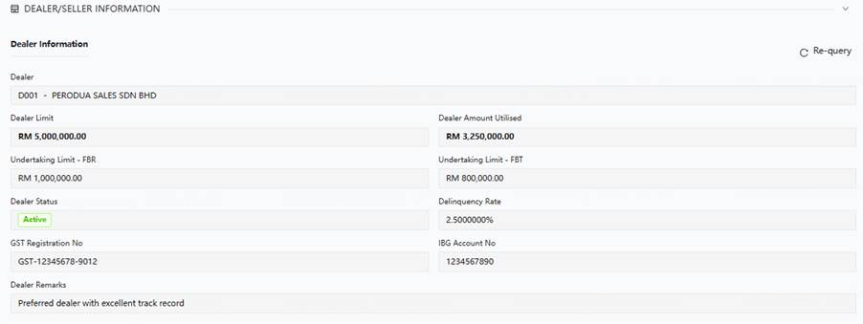
● Query the dealer’s FBR/FBT qualification,
a. To confirm whether the dealer has an FBR/FBT facility based on the Undertaking Limit for FBR or Undertaking Limit for FBT. IF not empty and undertaking limit > 0 then have corresponding quality. FBR/FBT qualifications are configured separately.
b. If the Sales has previously checked the FBR/FBT option, the CRA personnel shall log in to the HOST system to query the dealer's real-time available credit limit.
c. If the real-time available credit limit is insufficient, the CRA personnel must manually communicate with Sales​ to determine whether to:
a) Return the case to Sales for modification, or
b) Choose to wait for the credit limit to be released before proceeding with the disbursement.
● The user can click the "Re-query Dealer Information" button to retrieve dealer information.

3.8. 【Same as Batch2】 Post-Approval Overdue Reminder
AS CRA Checker/ Maintenance need to view the number of days that have passed from the approval date of the current loan application to the current date.
Highlight the display if it exceeds X days (where X is a system-defined parameter), and assess whether disbursement can proceed.

● Refer to “Common Capabilities – Post-Approval Overdue Reminder”
● The system initializes the overdue threshold (X) to 90 days.
● Displayed at the top as key information.
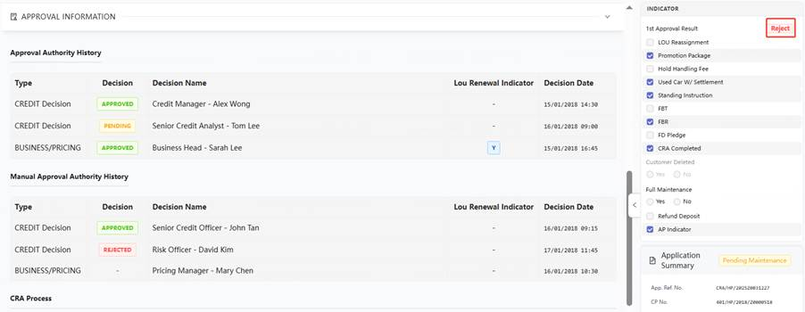
● If the elapsed time is within the threshold, it is displayed in green font.
● If the elapsed time exceeds the threshold, it is displayed in red font.
● The 90-day control follows a three-tiered comparison rule logic.
a. If the current work date is ≤ 90 days after the first approval date, the disbursement is allowed. Otherwise, proceed to ‘b’ and ‘c’.
b. If the vehicle registration date is missing, highlight the case as ineligible. (For FBR/FBT)
c. If the vehicle registration date is ≤ 90 days after the first approval date, disbursement is allowed. Otherwise, proceed to ‘d’ and ‘e’.
d. If the LOU renewal date is missing, highlight the case as ineligible.
e. If the current system work date is ≤ 90 days after the LOU renewal date, disbursement is allowed. Otherwise, highlight the case as ineligible.
Note:
The approval date is counted as Day 1.
The LOU renewal date is counted as Day 1.

● Prompt messages for various scenarios

Step | Condition | Result / Action | Warning/Alert to User (if applicable)
1 | Is the Current Work Date ≤ 90 days after the First Approval Date? | Yes → Disbursement ALLOWED. Process ends. | -
 | (Count Approval Date as Day 1)
 |  | No → Proceed to Step 2. | -
2 | Is the Vehicle Registration Date missing/blank? | Yes → Flag case as INELIGIBLE. Process ends. | "Alert: Case Ineligible. Exceed 1st Approval Date 90 days and Vehicle Registration Date is missing."
 | (For FBR/FBT cases)
 |  | No → Proceed to Step 3. | -
3 | Is the Vehicle Registration Date ≤ 90 days after the First Approval Date? | Yes → Disbursement ALLOWED. Process ends. | -
 | (Count Approval Date as Day 1)
 |  | No → Proceed to Step 4. | -
4 | Is the LOU Renewal Date missing/blank? | Yes → Flag case as INELIGIBLE. Process ends. | "Alert: Case Ineligible. Exceed 1st Approval Date 90 days and LOU Renewal Date is missing."
 |  | No → Proceed to Step 5. | -
5 | Is the Current System Work Date ≤ 90 days after the LOU Renewal Date? | Yes → Disbursement ALLOWED. | -
 | (Count LOU Renewal Date as Day 1)
 |  | No → Flag case as INELIGIBLE. | "Alert: Case Ineligible. Disbursement not allowed as the current date exceeds 90 days from the LOU Renewal Date."

3.9 Application Processing
This section introduces the CRA expert-rule processing flow, including the Header Summary area, Manual Check Results page, refresh and synchronization mechanisms, Defect creation and synchronization methods, the Next button, and the submission sequence.

3.9.1 Page Workflow
Where expert rules are involved in the File Center, CRA shall follow the required processing sequence before proceeding with subsequent Case handling.
- CRA shall first enter the File Center to review the files submitted by Sales, complete the review of OCR results and any required manual marking, and form the corresponding rule-processing conclusions.
- After completing the file and rule review, CRA shall return to the workbench to continue subsequent Case processing, including reviewing the summary information, synchronizing relevant results, and proceeding with disbursement submission.
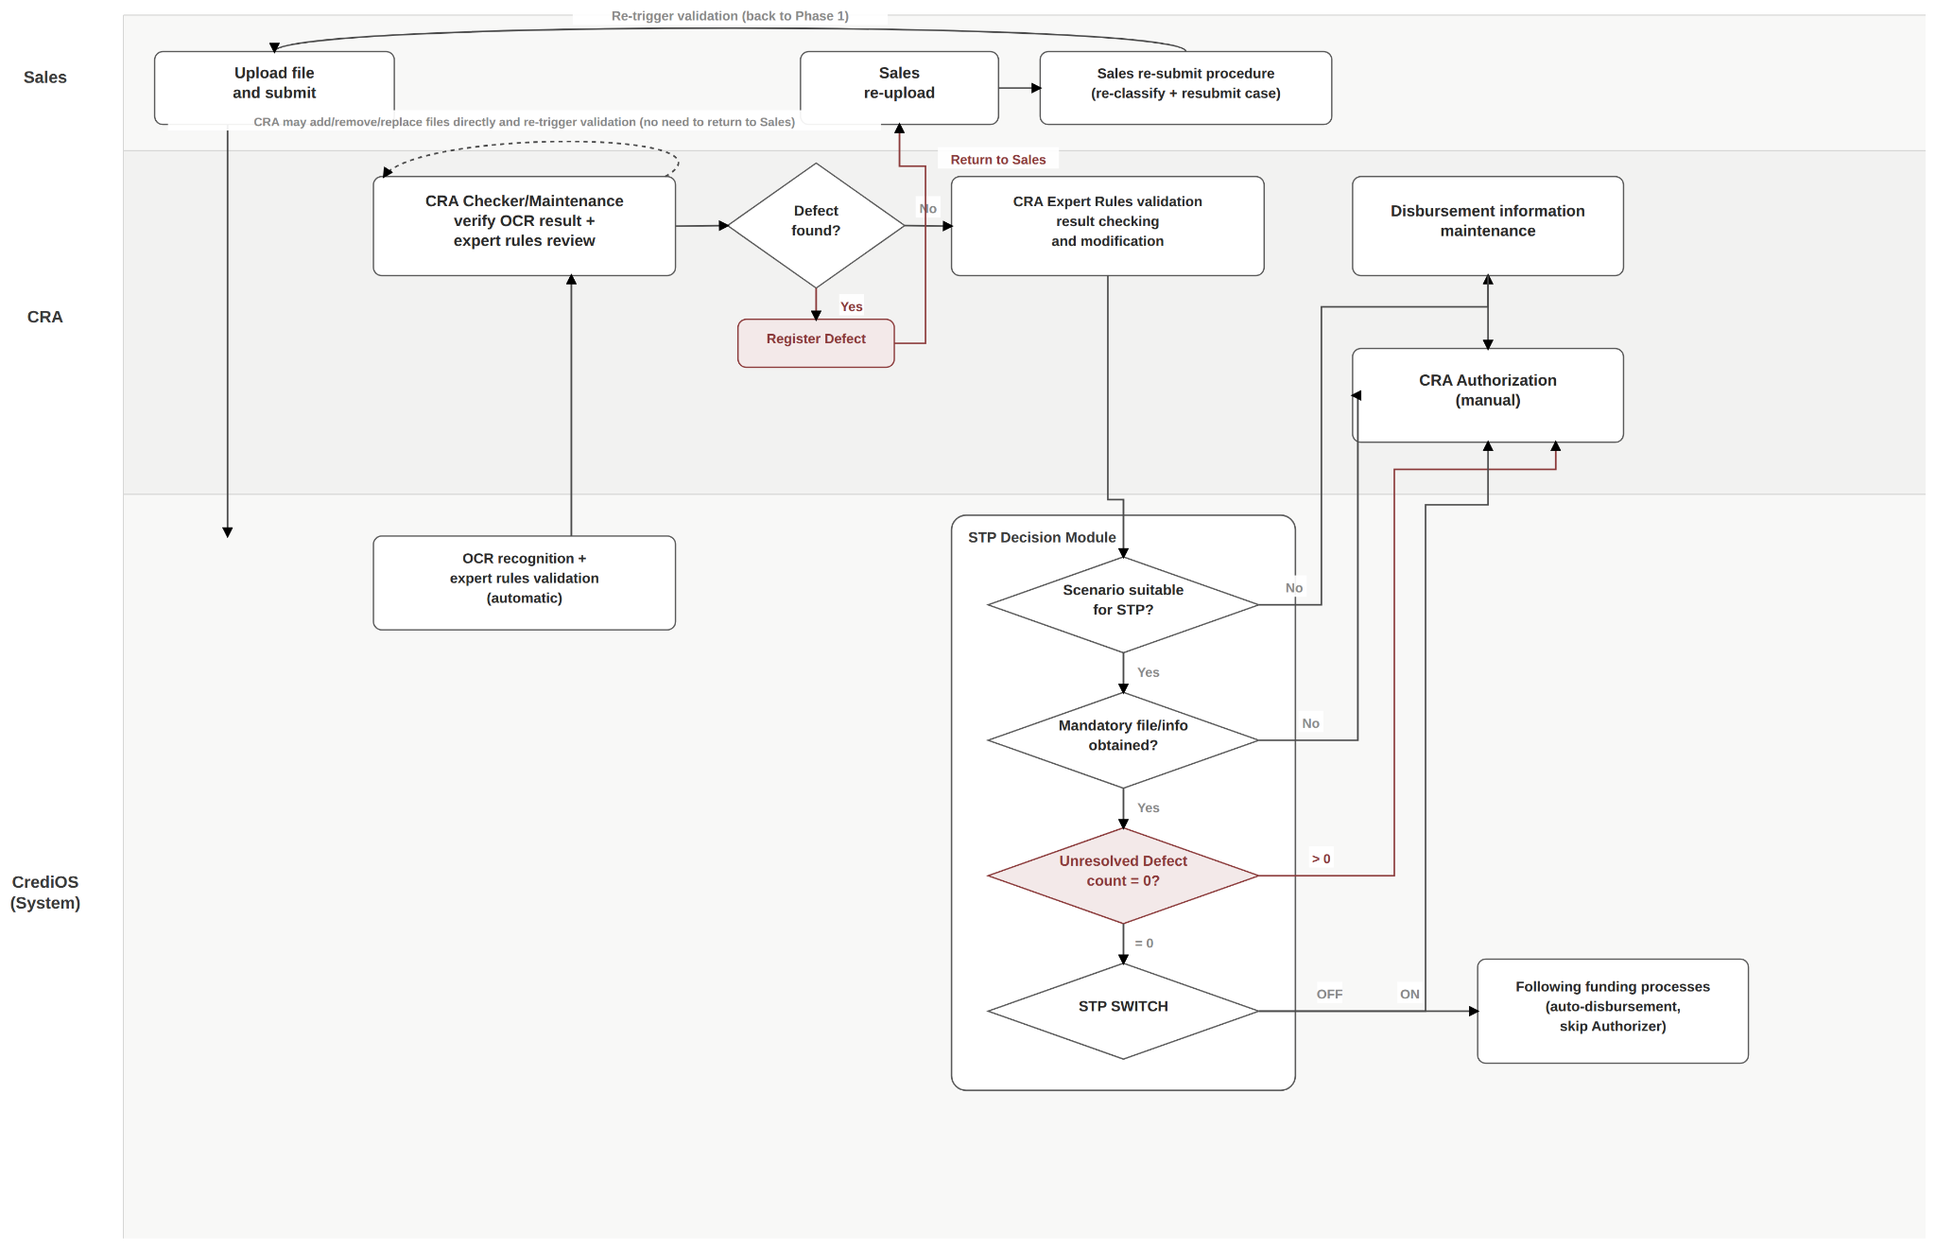

3.9.2 Header Summary
- The Header Summary shall display:
the number of mandatory files required for the Case and the number of files already uploaded;
the total number of applicable rules for the Case;
the number of rules for which a conclusion has already been recorded; and
among the concluded rules, the number of Passed and Failed results.
- Users may expand the summary area to view detailed information. A quick link shall also be provided to navigate directly to the Attachement（Document Center).
- For failed rules, a “Create Defect” button shall be provided. A Defect record will only be generated after the user actively clicks this button. Defect records shall not be created automatically.
- The Refresh function in the Header Summary shall not create, overwrite, or update existing Defect records. Defect records shall be maintained separately.
- Summary Refresh Mechanism:
  - After validation rules are rerun in the Attachement, the Header Summary and rule results shall be automatically refreshed when the Case undergoes a workflow status transition, i.e. when the responsible handler changes.
  - The refresh mechanism shall not be limited to specific workflow scenarios. It shall apply whenever the Case is routed to a new handler, including but not limited to:
    - Sales submits the Case to CRA Checker/Maintenance;
    - CRA Checker/Maintenance submits the Case to the Defect Team;
    - the Defect Team completes rectification processing and submits the Case back to CRA;
    - CRA submits the Case to the Authorizer; and
    - the Authorizer returns the Case.
  - Whenever such a workflow transition occurs, the system shall automatically refresh the latest rule results and Header Summary once when the new handler opens the Case.
  - If the Case remains with the same handler and no workflow status transition occurs, the system shall not refresh automatically. The user may manually click “Refresh Rule Results” to retrieve the latest results.
- The Header Summary shall display the latest refresh/save time. Only the timestamp shall be displayed; the specific operator shall not be shown.
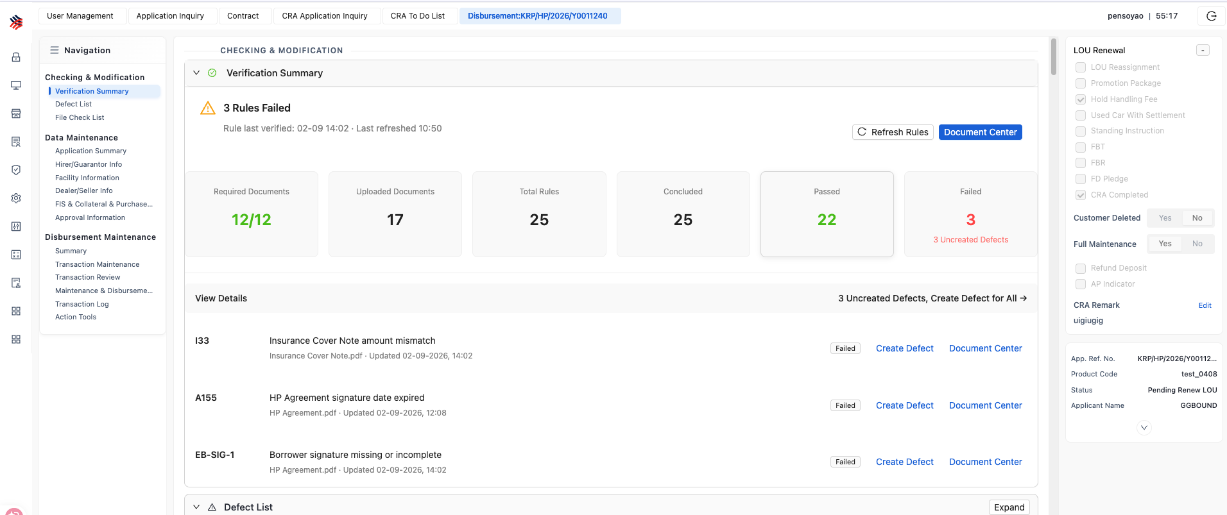

3.9.3 Cross-Validation Results Page (Attachment)
- Users shall primarily review and amend the expert-rule check results identified through OCR on this page.
- If the user confirms that the issue is caused by incorrect information in the source document, the Case may be returned to Sales. A Memo is mandatory when returning the Case.
- If the user confirms that the information is correct, or has manually corrected the identified issue based on the source document, the user may also retrigger rule validation and view the latest validation results in real time in the Header Summary.

3.9.4 Manual Check Results Page
- This page is used to display the manual expert-rule verification results for files that are not processed through OCR.
The file list and rule content displayed on this page shall be provided by CDM rather than the OCR system, because the files included in this page have not undergone OCR processing.
- List Page:
The page shall display all files under the Case that:are processed as Non-OCR files; and have been assigned a specific Document Type.
Files without a defined Document Type shall not be displayed on this page and shall remain available only in the File List.
- Details Page:
A pop-up window shall be provided for manual verification.
The left-hand side shall display the list of expert rules applicable to the corresponding file or Case, while the right-hand side shall display a preview of the original document, allowing the user to verify each rule against the source document.

- Two File Display Scenarios:
Combined / Mixed File Upload:
If the customer uploads one source file containing multiple sub-documents, the left-hand side shall display all expert rules associated with the Document Types identified or manually assigned to that mixed file. The user shall verify and mark the rules against the original document shown on the right-hand side.
Individual File Upload:
If documents are uploaded separately on a file-by-file basis, the system shall display and process the corresponding rule markings by individual file.

3.9.5 Expert Rule Check Results
- Expert Rule Handling
  - For rules that trigger alerts after OCR processing, CRA may handle them through any of the following methods:
① Amend the OCR result directly:
For example, if the system incorrectly recognizes a deposit amount as 80,000 while the original document shows 88,000, CRA may directly amend the field value and save it. The rule result shall then be determined based on the corrected value.
② Apply Justification:
For example, if CRA considers the difference between 88,000 and 80,000 acceptable, CRA may apply a Justification and mark the rule as passed without changing the extracted value.
③ Replace Document:
CRA may replace the relevant document and reprocess the rule accordingly.
All three methods are considered rectification or waiver of the corresponding validation result. Once handled, the rule shall be counted as Passed.
If the alert is retained without any action, the rule shall be treated as Failed and may subsequently be recorded as a Defect.
  - For Manual rules, only manual marking as Passed / Failed is supported.
If a rule is marked as Failed, CRA may create a corresponding Defect, or replace the relevant document and then manually mark the rule as Passed after re-verification.

- Rule results are classified into two categories: Passed and Failed.
  - Passed: Includes rules that are determined as passed after OCR or manual processing, including:
genuinely passed validation.
Justification / waiver;and
manually marked as passed;

  - Failed: Includes:
rules determined as failed; and
alerts that remain unresolved.

3.9.6 Refresh and Synchronization
- Refresh Rule Results:
  - A “Refresh Rule Results from OCR” button shall be provided in the Header Summary to synchronize the latest rule results from the File Center and update the summary information, including both rules that are still being processed and rules that have already been completed.
  - After the button is clicked, the system shall retrieve and display the latest rule-related fields from the File Center. This action shall not overwrite any values that have already been populated into downstream pages and shall not automatically create any new Defect records.

- Sync from OCR Button (Bottom of Page):
  - Upon clicking the button, a pop-up window shall display the OCR-extracted field values for comparison against the data currently entered on the page.
  - Users may select one or multiple OCR fields and populate the selected values into the frontend form. After population, the values shall remain editable and may be manually amended by the user.
  - The scope of fields available for synchronization shall include, among others, the checkbox status of the Mandatory File List.
  - This button shall only retrieve the latest OCR content. It shall be fully decoupled from the Refresh Rule Results function in the Header Summary and from any Defect-related refresh or synchronization function, in order to avoid unintended differences caused by linked updates.

- AIOCR Scope Limitation for Data Population:
  - The data population function shall only be available during the pre-disbursement stage. It shall no longer be available once the Case enters Post Maintenance / Post Authorization.
  - Fields derived from handwritten or manually signed content shall be explicitly excluded from automatic population. This includes, for example, handwritten dates and signatures on manually signed agreements.
  - Due to variations in handwriting and document templates, such fields are considered insufficiently reliable for OCR extraction and shall therefore be entered manually by the user.

3.9.7 Defect Creation and Synchronization
- General Principle
  - The Defect List shall be fully decoupled from the rule-result displays, including the Header Summary, Cross Validation, and Manual Check Results.
  - Both the “Refresh Rule Results” function in the Header Summary and the “Sync from OCR” function at the bottom of the page shall only update the content within their respective areas.
  - Neither function shall automatically create, overwrite, or delete any records in the Defect List.

- Defect Creation Source
Each Defect record in the Defect List shall contain a Creation Source field to identify how the record was created:
- System: The Defect is generated through the relevant “Create Defect” function.
- User: The Defect is manually created by a user directly in the Defect List.
The Creation Source field shall be retained for audit traceability and shall also be used to determine the applicable scope of Defect synchronization operations.

- Defect Creation and Synchronization Methods
The Defect List shall provide the following three creation and synchronization methods. The scope and impact of each method increase progressively.
① Create Single Defect
For one specific rule that is currently Failed, the user may manually create the corresponding Defect record.
② Batch Create Defects
The system shall generate Defect records in batch for all rules that:
· are currently Failed; and
· have not yet been associated with any existing Defect record.
This operation shall only create new Defect records.
It shall not delete or overwrite any existing Defect records, regardless of whether their Creation Source is System or User.
③ Synchronize System Defects
This function shall be provided within the Defect List area and shall only be triggered when the user actively clicks the corresponding synchronization button.
This operation shall apply only to Defect records with Creation Source = System:
· For rules that are currently Failed and do not yet have a corresponding Defect record, the system shall automatically create the relevant Defect;
· For System-generated Defect records that were previously created but whose corresponding rules have subsequently changed to Passed, the system shall automatically delete those Defect records.
Defect records with Creation Source = User shall not be affected by this synchronization operation.

- Common Rules
  - Methods ① and ② shall remain fully independent from rule-result refresh operations and shall not delete or overwrite any existing Defect records.
  - Method ③ is an optional synchronization function intended for users who need to align System-generated Defect records with the latest rule results. It shall not affect any manually created User-source Defect records.
  - De-duplication Rule:
For all three methods, the system shall determine whether a rule has already been associated with a Defect record based on the configured Rule-to-Defect Mapping. Duplicate Defect records shall not be created for the same mapped rule.

3.9.8 【Same as Batch2】Page Sections
- Indicator Section
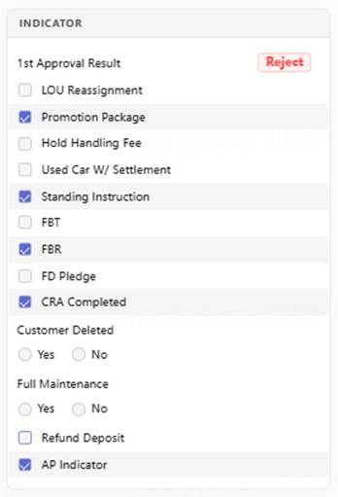
Field Name | Component Type | Remark | Use for
LOU Renewal | Display  Renewed/Pending Renewal | Highlight the system judgment result with an icon. Display detailed check results upon mouse hover.  ● Renewed: Display in green.  ● Pending Renewal: Display in red. | Judgment logic and prompts are detailed in the "Post-Approval Overdue Reminder" section.
LOU Reassignment | Checkbox | Tick Manually | Used to generate reports.
Promotion Package | Checkbox | Tick Manually | Used to generate reports.
Hold Handling Fee | Checkbox | Tick Manually | When ticked, the Handling Fee Section in the Disbursement Screen is greyed out.
Used Car with Settlement | Checkbox | For Direct scenarios, if a settlement letter is identified and passes manual verification, the system can automatically select/check the corresponding option.  Editable | Used to generate reports.
Standing Instruction | Checkbox | If an Standing Instruction is ticked by CED in conditional approval, the system can automatically select/check the corresponding option.  Editable | Used to generate reports. Manually selected. Once checked, the system generates a detailed report. Based on the report information, CRA manually enters the monthly auto-debit details into HOST, which is then responsible for executing the monthly auto-debit.
FBT | Checkbox | user manually decides whether to select/check the option based on the system's prompt.  When Sales selects FBT, the CRA page automatically display it  Editable | Used to generate reports.
FBR | Checkbox | user manually decides whether to select/check the option based on the system's prompt.  When Sales selects FBR, the CRA page automatically display it  Editable | Used to generate reports.
FD Pledge | Checkbox | If an FD Pledge indicator is ticked by CED in conditional approval , the system can automatically select/check the corresponding option.  Editable | Used to generate reports.
CRA Completed | Checkbox | Tick Manually | The Checker must select/check the box to proceed to maintenance.  Once checked, even if some defects remain unprocessed or some mandatory documents remain un-ticked, disbursement is still allowed.  In the "funded with defect" scenario, the system must record this special circumstance.
Customer Deleted | Radio Button(Yes/No) | If delete guarantor after Acceptance, the system can automatically display Yes, otherwise display No.  Non-editable. | Only logged and displayed, no report generated.
Full Maintenance | Radio Button(Yes/No) | Default: Yes, Editable. | Yes: No post-processing required.  No: Requires entering post maintenance and post authorization.  Desired default: Yes.
Refund deposit | Checkbox | If the first deposit receipt is identified and verified, the system can automatically select/check the corresponding option.  If the "used car settlement indicator" is selected/checked, the system can automatically select/check the corresponding option.  Editable | New Requirement: Provide a report to remind CRA to disburse funds to the seller.  Two Scenarios:  Scenario 1 (Common):​ The dealer is not eligible to receive the down payment or exceeds the limit.  Identification Method:​ Use the first deposit receipt​ to identify.  Scenario 2 :​ In a seller-and-buyer transaction without a dealer, the remaining balance after payoff is held in a suspense account, and payment is made only after the transfer is completed.  Identification Method:​ Use the used car with a settlement indicator​ to identify.
AP indicator | Checkbox | 1. For recon cars, the system can automatically select/check the corresponding option.  2. For used cars, if identified as "used recon" from the VOC, the system can automatically select/check the corresponding option.  Editable | New Requirement: Based on information in the VOC, identify "recon" and "used recon" vehicles, generate an AP requirement, and automatically flag the AP indicator.  Context:Its purpose is for future vehicle re-registration with JPJ in the scenario of repossession and resale after debt collection. Currently, CRA checkers and authorizers manually identify this from the VOC, log a defect, and the defect team follows up.
- Navigation of workflow
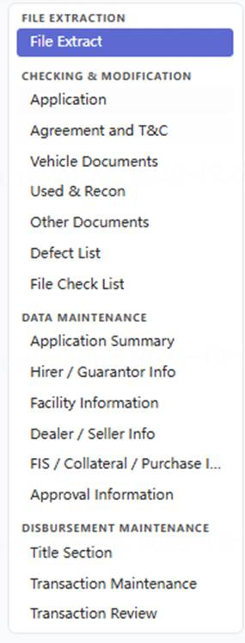

- File Checking Section
a) Including four parts:
Application, Agreement and T&C, Vehicle Documents, Use and Recon, Other Documents
File lists refer to “File Extract List Sequence” sheet in “Appendix - User Page Display”
b) Display two categories of File Checking errors:
Incomplete File: When OCR result is Incomplete File.
Field Value Suspicious: When field in file does not pass business rule checking.
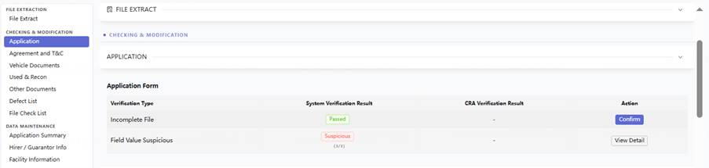
c) The User can directly confirm an "Incomplete File" error or change a system-judged "Passed" result to "Defect". The user can Undo the previous confirmation result, e.g. to cancel Confirm.
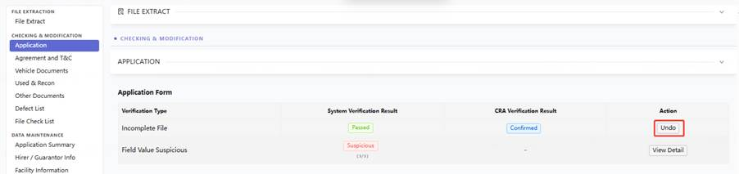
d) The User can click "View Detail" to see the Fields Verification List in a pop-up window.
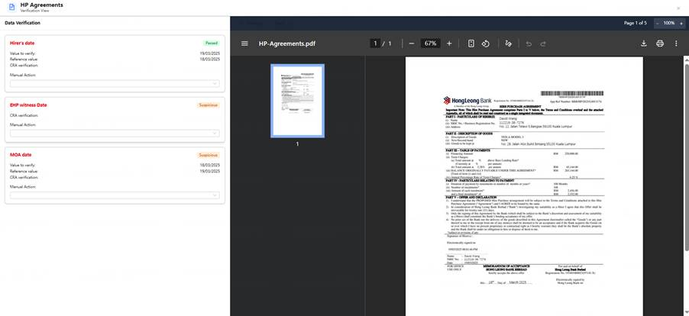
e) On this page, the User can review the system's check result for each field and adjust: If the system judges a field as "Passed", the User can change it to "Defect" or take no action. If the system judges a field as "Suspicious", the User can change it to "Confirm" or "Modify” or take no action. If "Modify" is selected, the modified value must be entered and is automatically saved.
f) Confirmation of the current file's check results is allowed whenever all items in the file have a status of "Passed", or "Suspicious" items have been set to either "Confirm" or "Modify", or there are still any "Suspicious" items that have not been confirmed. But if still any “Suspicious” item the file’s status will be kept suspicious and corresponding defect in defect list will not be set to verified.
g) After confirming the entire file, the system automatically ticks the corresponding item in the subsequent "File Check List".

- Defect List
a) Used to display various defects identified by the system or added by Users; supports editing Remarks; supports checking the Rectified and Verified status; supports the User adding and deleting defects.
b) When the User confirms in the File Checking stage that a suspicious item is not a defect or has made corrections, the system will mark the corresponding Defect item as "Verified". Support user to check the file corresponding to a certain defect item by clicking the document link at the end of each defect line.
c) Users can add ,edit or delete defect items, support fuzzy search when selecting DEFECT CATEGORY and DEFECT TYPE. Defect code configuration refers to “Parameter Management – Defect code”. The Remark field in the CRA defect list supports input 1k characters.
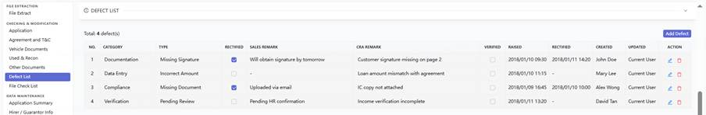
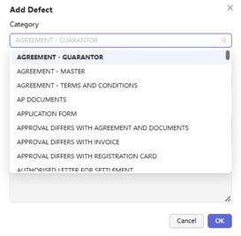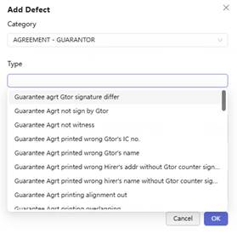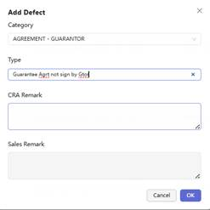

- File Check List Section
a) The File Check list supports configuration. Configuration rules are detailed in the "Parameter Management" section.
b) If, during the File Checking stage, the User confirms that neither type of error (Incomplete File, Field Value Suspicious) exists for a particular file or that they have been rectified, the system automatically ticks the corresponding file in the File Check List.
c) If, during the File Checking stage, the User changes a system-judged "Passed" result to "Defect", the system must correspondingly untick the file selection.
d) File list refer to “File Check List” in “Navigation” sheet in “Appendix – User Role Display”
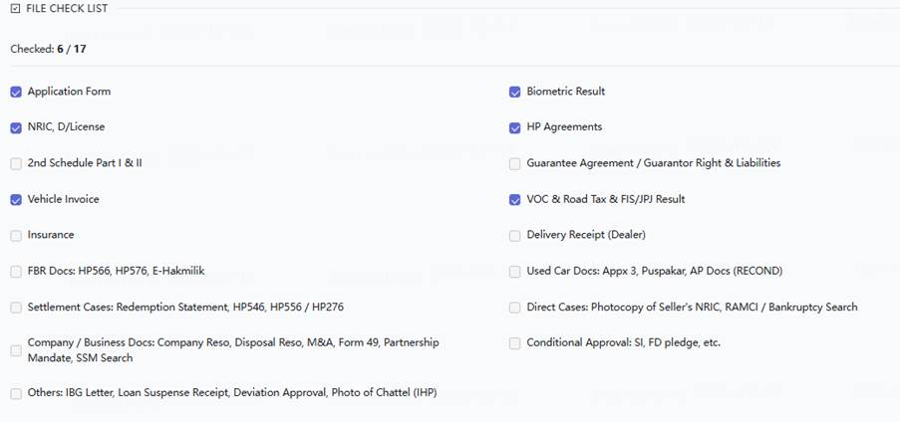
- Data Maintenance, including:
- Application Summary
- Hirer/Guarantor Information
- Facility Information
- FIS Information
- Dealer/Seller Information
- Collateral Information
- Purchase Information
– Approval Information
- Each section shall provide a “View Files” button. Upon clicking the button, the system shall open a new browser window or tab displaying the relevant file-viewing page.
- The mapping between each section and its corresponding file types is defined in the table below. The same mapping is also described in Appendix – User Page Display.
Hirer/Guarantor | IC, SSM search, Application form
Facility | HP Agreement (Part 1), Guarantee Agreement, Second Schedule
Dealer/Seller | Invoice
FIS & Collateral & Purchase | FIS:  FIS result  E-Hakmilik lodgement slip(Only for file upload by sales as an attachment)
 | File list: VOC, Application Form
 | Invoice, Insurance, VOC, Road Tax
 | FD Receipt
Approval Information | CRA Report, Credit Memorandum
Transanction Maintenance | IBG Letter, Invoice
Transanction Review | CRA Report

- Approval Information section:
a) Display Conditional Approval list first
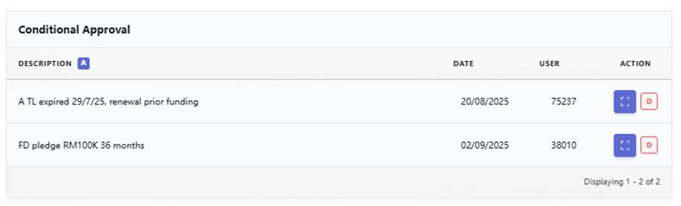
b) System support display Conditional Approval detail
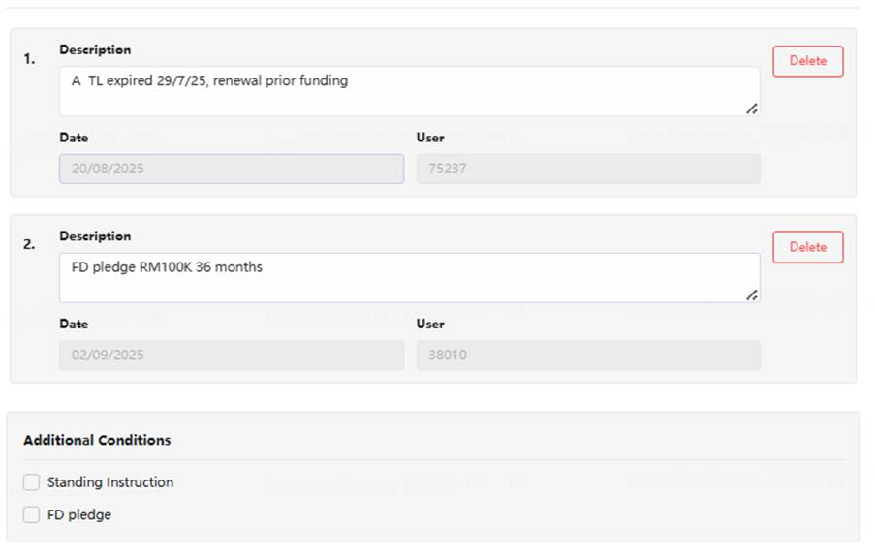
c) Display approval history first
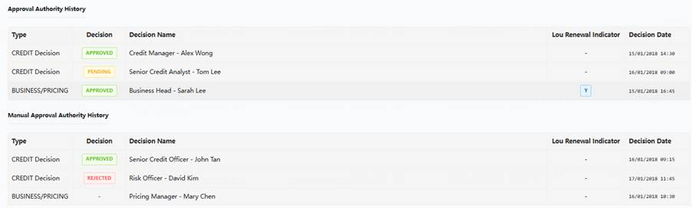

Detail refers to “CHECKER&AUTHORIZER” sheet in “Appendix – User Page Display”
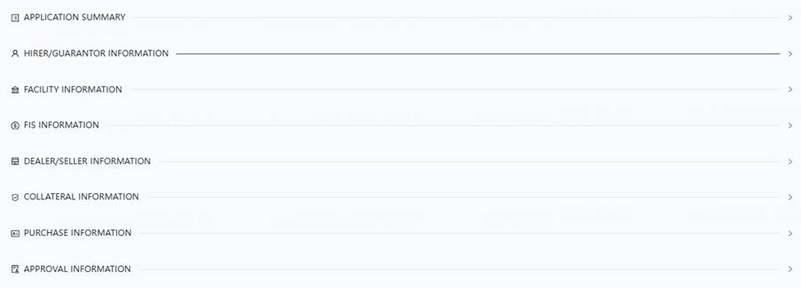
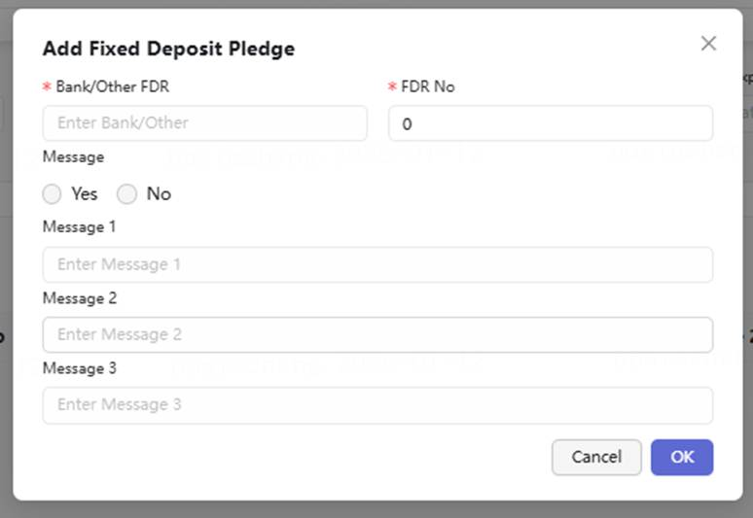

- Agreement Date maintenance
a) For manual acceptance, ensure the agreement date is consistent with the paper agreement, and key in the date manually.
b) For e-acceptance without a guarantor: for the first time to edit, populate the system’s current date as the agreement date and allow it to be modified; always display the save version.
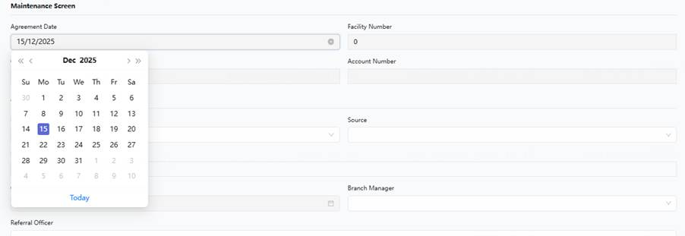

- FIS displayed here will not block submission, it is the FIS document tick box in File Checklist who will block submission.
- Purchase information validation rule:
a) Purchase Price = Total Price + Freight + Reg Fee + Insurance Premium
b) If not match, the user could not proceed to submit this disbursement application
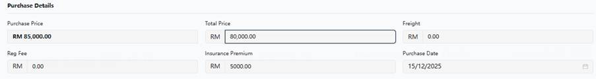
- Memo/Attachment/Report
a) Memo is a common component that supports logging Memos in a log format, including submitter, submission time, and Memo content.
b) Files uploaded here do not enter the OCR recognition, checking, and verification workflow. Therefore, it is only recommended for uploading files in urgent situations and manually modifying disbursement information.
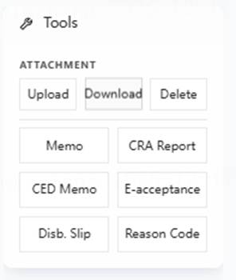

3.10 【Same as Batch2】Disbursement Information Maintenance Page
- Page Function: On this page, the user primarily completes the maintenance of disbursement fund transfer information and submits it for authorization upon completion.
- Page Sections
a. Handling fee: Accounting treatment for handling fee payment.
b. IBG: Transfer to an account at another bank via IBG.
c. Transfer: Transfer to an HLB CASA account.
d. Advice: Transfer to a designated General Ledger account.
e. Suspense: Transfer to a branch suspense account.
f. Payoff: Direct and settlement.
- Combinations of Various Accounting Treatment Methods
Processing paths for payments that can occur simultaneously.
 | IBG | Transfer | Advise | Suspense | Payoff
IBG | Y | Y | Y | Y | Y
Transfer | Y | Y | Y | Y | Y
Advise | Y | Y | Y | Y | Y
Suspense | Y | Y | Y | / | Y
Payoff | Y | Y | Y | Y | /
 | IBG | Transfer | Advise | Suspense | Payoff
Loan Amount | Y | Y | Y | Y | Y
Handling Fee | Y | Y | Y | Y | /
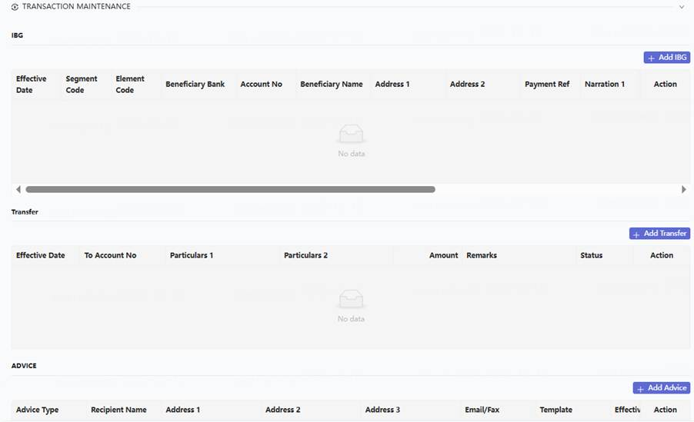

3.10.1 IBG Section
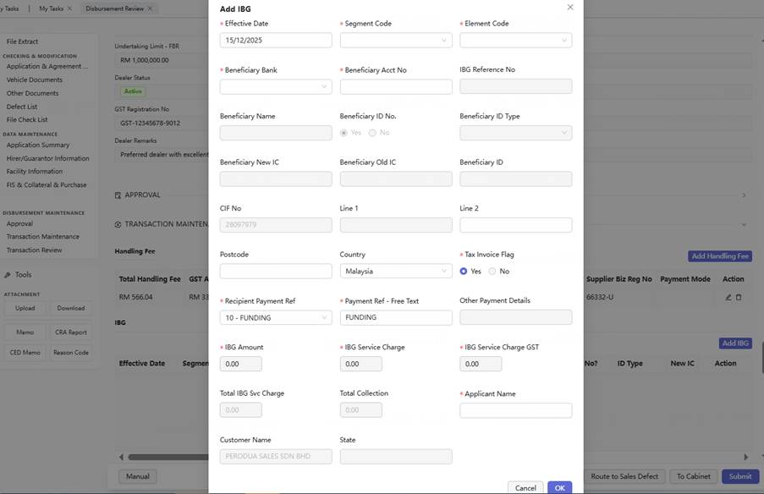
a. Fields and Auto population rule refer to “DISBURSEMENT” sheet in “Appendix – User Page Display”
b. Rules:
a) Supports "Remove" and "Add" IBG sections.
b) The IBG section information is populated by default, with value sourcing rules as per “DISBURSEMENT” sheet in “Appendix – User Page Display”.
c) Supports saving after entry, allowing multiple IBG records to be saved.
d) Saved IBG records are displayed in a tabular format. The fields are listed below.
e) Saved IBG records support "Delete" and "Modify".
f) If Beneficiary Bank or Beneficiary Account number not same as Dealer parameter, need to prompt “ALERT! Beneficiary Bank mismatch” or “ALERT! Beneficiary Acct. No. mismatch”
c. If the Handling Fee is to be paid via IBG, ensure that the Handling Fee is the first transaction detail submitted to the IBG Interface.
d. IBG record refer to “DISBURSEMENT” sheet in “Appendix – User Page Display”

3.10.2 Transfer Section
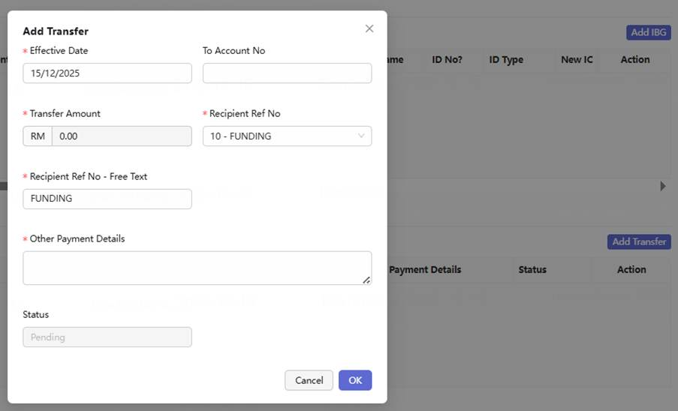
a. Fields and Auto population rule refer to “DISBURSEMENT” sheet in “Appendix – User Page Display”
b. Rules
a) Supports "Remove" and "Add" Transfer sections. A Transfer section exists by default.
b) The Transfer section information is populated by default, with value sourcing rules as per “DISBURSEMENT” sheet in “Appendix – User Page Display”.
c) Supports saving after entry, allowing multiple Transfer records to be saved.
d) Saved Transfer records are displayed in a tabular format. The fields are listed below.
e) Saved Transfer records support "Delete" and "Modify".
f) Supports querying the Account Status and Account Holder’s name using the entered "To Account No" via a button labeled "Account Inquiry". If CASA status = Closed / Dormant, system should not allow to save the transaction.
c. If the Handling Fee is to be paid via Transfer, ensure that the Handling Fee is the first transaction detail submitted to the Transfer Interface.
d. Transfer record refer to “DISBURSEMENT” sheet in “Appendix – User Page Display”

3.10.3 Advice section page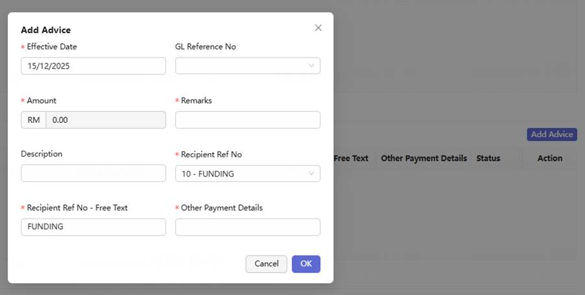
a. If the "Hold handling fee indicator" is checked, the handling fee must be automatically populated into the Advice record and submitted as the first transaction detail to the Advice Interface.
b. Fields and Auto population rule refer to “DISBURSEMENT” sheet in “Appendix – User Page Display”
c. Rules
a) Supports "Remove" and "Add" Advice sections. An Advice section exists by default.
b) The Advice section information is populated by default, with value sourcing rules as per “DISBURSEMENT” sheet in “Appendix – User Page Display”.
c) Supports saving after entry, allowing multiple Advice records to be saved.
d) Saved Advice records are displayed in a tabular format. The fields are listed below.
e) Saved Advice records support "Delete" and "Modify".
d. Advice record refer to “DISBURSEMENT” sheet in “Appendix – User Page Display”

3.10.4 Suspense Section
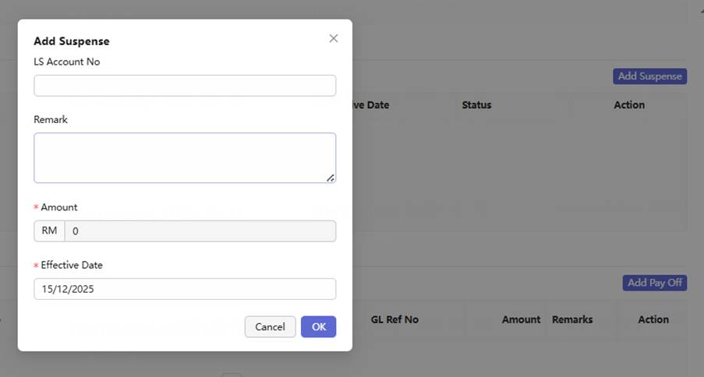
a. Fields and Auto population rule refer to “DISBURSEMENT” sheet in “Appendix – User Page Display”
b. Rules
a) Supports "Remove" and "Add" Suspense sections. A Suspense section exists by default.
b) The Suspense section information is populated by default, with value sourcing rules as per “DISBURSEMENT” sheet in “Appendix – User Page Display”.
c) Supports saving after entry, retaining a maximum of one Suspense record.
d) The saved Suspense record is displayed in a tabular format. The fields are listed below.
e) The saved Suspense record supports "Delete" and "Modify".
c. Suspense record refer to “DISBURSEMENT” sheet in “Appendix – User Page Display”

3.10.5 Payoff Section
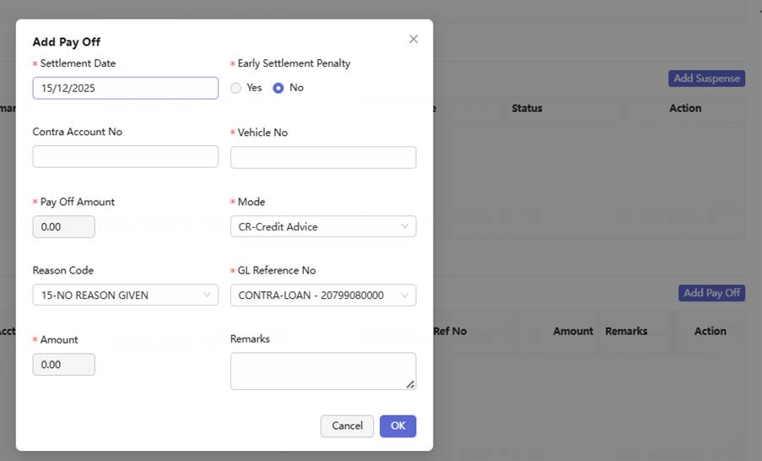
a. Fields and Auto population rule refer to “DISBURSEMENT” sheet in “Appendix – User Page Display”
b. Rules
a) Supports "Remove" and "Add" Payoff sections. A Payoff section exists by default.
b) The Payoff section information is populated by default, with value sourcing rules as per “DISBURSEMENT” sheet in “Appendix – User Page Display”.
c) Supports saving after entry, retaining a maximum of one Payoff record.
d) The saved Payoff record is displayed in a tabular format. The fields are listed below.
e) The saved Payoff record supports "Delete" and "Modify".

3.10.6 Handling fee Page Sections
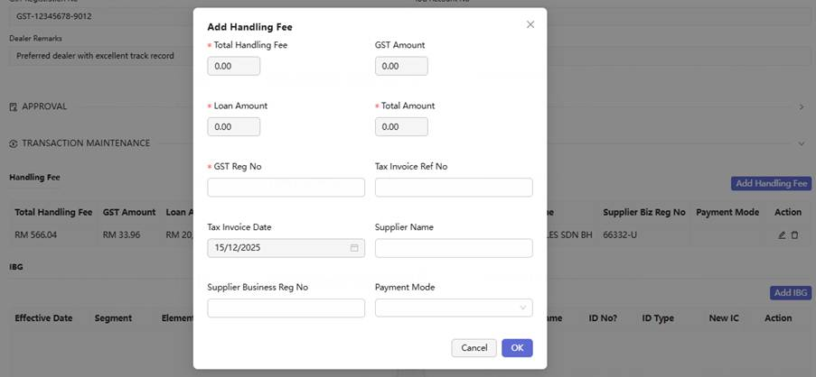
a. If the "Hold handling fee indicator" is checked, this section must be disabled (grayed out).
b. Fields and Auto population rule refer to “DISBURSEMENT” sheet in “Appendix – User Page Display”
c. The accounting mode into which the Handling Fee is recorded is determined by the selected payment mode, but it must be ensured that the Handling Fee transaction is sent as the first detail to the HOST Interface in every mode.

3.10.7 Reason Code
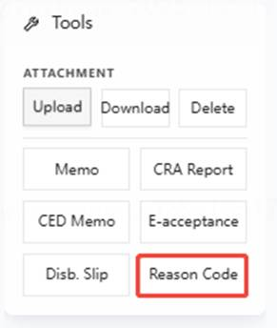
a. When the User modifies certain fields (e.g. , Engine number, Chassis number), the system automatically generates and saves a pending update record in the reason code section.Fields refer to Appendix - Reason Update and Synchronization Rules.
b. The User opens the reason code section, selects a reason for each record, checks "Verify reason code", and then clicks save.
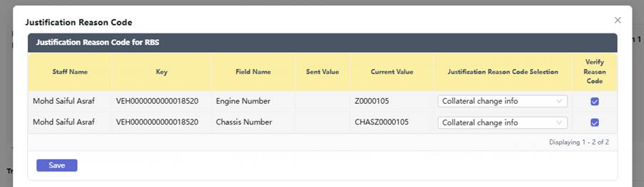
c. During subsequent data interfacing(CRA Authorizer Approval), the pre-recorded Reason code must be submitted as required.
Note:[h6] In CILT scenario, when the application is returned to sales and re-submission, sales and CED may modify fields that are related to B2B/ RBS SREF report. In corresponding step, sales and CED need to record down reason code, when sales submit for disbursement(so called Host Acceptance), system should report these modification reason code to B2B/ RBS.
d. System to prompt User if they omitted to update the reason code section. Reason code is mandatory for application submission.
e. Depending on the field modified, synchronization may be required to either the HOST system. Specific classification rules can be found in the Appendix – Reason Update and Synchronization Rules.
f. Display field

Field Name | Control Type | Input Field Format | Remarks and Logic
Staff Name | Display | VARCHAR2 (20) | Staff who perform changes on the field value in application
Key | Display | VARCHAR2 (20) | Primary key for the field name. In CRA scenario, use corresponding Vehicle Collateral No.
Field Name | Display | VARCHAR2 (40) | Name of field which contains updated value
Sent Value | Display | VARCHAR2 (20) | Field value which already interfaced to Host
Current Value | Display | VARCHAR2 (20) | Latest updated value in current application
Justification Reason Code Selection | Lookup | VARCHAR2 (60) | 1. When field value sent to Host/Ascend ≠ current value in application, an audit trail will be created. 2. Mandatory for user to insert justification reason code. If no reason selected, validator shall be prompted on screen. 3. The record will be disabled when changed value and justification reason has been interfaced to Host/Ascend.
Data sent | Display | VARCHAR2 (10) | Data sent to Host.
Verify Reason Code | Checkbox | - | 1. This column will only be applicable to CRA users. 2. The checkbox is required to be ticked to verify if the reason code is correctly inserted for each field. 3. If checkbox is not ticked, validation shall be prompted on screen. 4. If the Justification Reason Code Selection field was disabled (dimmed), Verify Reason Code checkbox will not be appeared.

3.10.8 Information Submission Validation
When a CRA checker/maintenance personnel submits disbursement information, the following rules must be validated. The submit button is only enabled if all validation passes.
a. (Approved Loan Amount + Handling Fee + GST + Total IBG Service Charge) – (Subsidy + Retention Sum) = (IBG Amount + Transfer Amount + Suspense Amount + Advise Amount)
b. Purchase Price = Total Price + Freight + Registration Fee + Insurance premium
c. Loan Amount = Purchase Price – Deposit
d. Margin of Financing cannot exceed 90%(90% is parameterized). MOF formula = Loan amount / OTR * 100%
e. Insurance, Registration Fee, Freight validation checking and prompt
a) Data Version 1 from VSO:​ After customer acceptance, data is written into the agreement and takes effect, this version of date is Data Version 1.
b) Data Version 2 from Invoice and VOC: Extract from Invoice and VOC after disbursement application submission
c) E-acceptance scenario: Compare Insurance, Registration Fee, Freight from Data Version 1 with from Data Version 2 separately
i. IF any of them is different, prompt “Insurance, Registration Fee, Freight information has defect! ”; provide “CANCEL”, “CONTINUE” button.
ii. If user click “CANCEL”, should not update Data Version 2 into system. Following process will follow CILT rules.
iii. If user click “CONTINUE”, as per BAU
d) Manual acceptance scenario: Compare OTR from Data Version 1 with from Data Version 2
i. IF OTR is different, prompt “OTR information have defect! ”; provide “CANCEL”, “CONTINUE” button.
ii. If user click “CANCEL”, should not update Data Version 2 into system. Following process will follow CILT rules.
iii. If user click “CONTINUE”, as per BAU

3.10.9 Manual process description
CRA manually download PDF documents uploaded by Sales Team and send hardcopy to customer. CRA manually uploads individual documents to LHDN for stamping and manually uploads attachments to the defect system for rectification.

3.11 "Next" Button and Submission Sequence

3.11.1 Button Function
- A unified “Next” button shall be provided at the bottom-right corner of the CRA Checker/Maintenance page.
- The “Next” button shall replace the existing “To Authorizer” button and is the only new button position introduced under this enhancement.
- For the Authorizer stage and all subsequent processing stages, the existing BAU button behavior and workflow routing logic shall remain unchanged.

3.11.2. Submission Control
Clicking “Next” shall not be hard-blocked solely because unresolved Defects or unconfirmed rule items still exist.
Consistent with the existing BAU logic, once the “CRA Completed” indicator is selected, the user may continue submission even if there are still unresolved Defects or unconfirmed rule items.
Before submission, the system shall perform a reminder-level quantity check based on the configured Rule-to-Defect Mapping.
The system shall check whether the number of rules that are:
- currently Failed; and
- not yet associated with any Defect record
is equal to zero.
If the number is greater than zero, the system shall display a confirmation prompt informing the user that there are still unhandled rule items.
The user may choose either:
- Return to Process – return to the page and continue handling the outstanding items; or
- Continue – confirm the warning and proceed with submission.
This validation is a warning control only and shall not itself block submission.

3.11.3. Backend Processing Sequence
After the user clicks “Next” and completes any applicable confirmation prompt, the system shall process the Case in the following sequence:
Step 1 – Pre-submission Validation
· Perform the reminder-level validation described above.
· If “CRA Completed” is selected, the user may proceed even where unresolved Defects or unconfirmed rule items remain.
Step 2 – Save
· The system shall execute Save and persist all current maintenance and input data before proceeding with the STP assessment.
Step 3 – STP Eligibility Assessment
· After the Save operation is completed successfully, the system shall invoke the STP eligibility assessment logic.
· STP eligibility shall include, but is not limited to:
- the STP Switch being enabled; and
- the number of unresolved Defects being zero.
· Zero unresolved Defects is a mandatory STP condition.
Therefore, even if “CRA Completed” has been selected and submission itself is allowed, the Case shall still be considered not eligible for STP if any unresolved Defect remains.
Step 4 – Workflow Routing
· If the Case meets all STP eligibility conditions, the system shall bypass the Authorizer stage and directly invoke the subsequent disbursement-related Host Interface(s) to proceed with the disbursement process.
· If the Case does not meet the STP eligibility conditions, including where one or more unresolved Defects remain, the Case shall be routed to the Authorizer for manual authorization.
· The existence of unresolved Defects therefore affects STP routing eligibility, rather than blocking submission itself.

3.11.4. User Feedback
· After the routing decision is completed, the system shall display a brief notification indicating the processing result.
· The notification shall clearly inform the user whether:
- the Case has entered the STP straight-through process; or
- the Case has been routed to the Authorizer for manual processing.

3.11.5 Scope
· The “Next” button shall only apply to the CRA Checker/Maintenance completion point, where the STP routing decision is performed.
· This is the only workflow point at which the system determines whether the Case proceeds through STP or is routed to the Authorizer.
· The logic introduced in this section shall not affect the existing buttons or workflow routing for subsequent stages, including Authorizer, Post Maintenance, and Post Authorizer.

4. STP Processing Module

Note: The Expert Rules validation result checking and modification step is performed by OCR and the CRA Checker and Maintenance roles. This step is not considered a manual authorization activity and therefore does not affect the determination of whether a case qualifies for STP.

4.1 STP Decision and Processing
STP (Straight-Through Processing) : refers to a processing mode in which, after Sales submits a case to CRA and the case passes the Expert Rules validation, no intervention by a CRA Authorizer is required before disbursement is completed.

4.1.1 Eligible STP Business Scenarios
- Restriction Rules for Eligible STP Business Scenarios
a. Individual.
b. New car.
c. Only one beneficiary and same with dealer’s beneficiary in deal management system.
d. No payoff.
e. Not FBR
f. No FD pledge
g. NO Floor stock dealer. (Based on new Floor Stock Dealer indicator in dealer management module)
h. E-Acceptance
i. Non-Panel Dealer
j. Pass 1st approval X days(The system initializes the overdue threshold (X) to 90 days.) verification rules. If the case can not pass these rules then cannot be routed to STP process. Checking rule is listed in table below
The 90-day control follows a three-tiered comparison rule logic.
a. If the current work date is ≤ 90 days after the first approval date, the disbursement is allowed. Otherwise, proceed to ‘b’ and ‘c’.
b. If the vehicle registration date is missing, the disbursement is not allowed. (For FBR/FBT)
c. If the vehicle registration date is ≤ 90 days after the first approval date, disbursement is allowed. Otherwise, proceed to ‘d’ and ‘e’.
d. If the LOU renewal date is missing, the disbursement is not allowed.
e. If the current system work date is ≤ 90 days after the LOU renewal date, disbursement is allowed. Otherwise, the disbursement is not allowed.
Note:
The approval date is counted as Day 1.
The LOU renewal date is counted as Day 1.

- If the current disbursement application belongs to an STP-eligible type, automatically populate or update the disbursement information based on the OCR recognition results.
- If the current disbursement application belongs to an STP-eligible type, it proceeds to the STP Switch Determination step and is marked as "STP".
- If the current disbursement application does not belong to an STP-eligible type, it proceeds to CRA Authorizer for handling.

4.1.2 Decision Timing and Gates
- The STP decision shall be made when CRA Checker/Maintenance has completed the review of all required information and clicks “Next” to submit the Case. This is the only point at which the formal STP routing decision is made.
- As the current STP eligibility criteria are based on a fixed set of predefined conditions, the system may perform a preliminary assessment in advance.
- The formal STP decision shall be performed in the following sequence. If any condition is not satisfied, the Case shall be routed according to the corresponding handling path.
Decision Step | Decision Criteria | Routing if Condition Is Not Met
① | Is the application scenario suitable for STP? | Route to manual processing at the Disbursement Information Maintenance stage
② | Have all mandatory files and required information been obtained? | Route to CRA Authorization
③ | Is the number of unresolved Defects equal to zero? | Route to CRA Authorization
④ | Is the STP SWITCH ON? | If OFF, route to CRA Authorization for manual authorization. If ON, proceed to the subsequent disbursement process
- If uncertain or dynamic variables are introduced into the STP eligibility rules in the future, the system may no longer be able to determine STP eligibility in advance and may require a rule-engine-like mechanism to complete the final assessment.
- Therefore, for system extensibility, the current design is that the final STP routing decision shall only be made after CRA has completed all required review and clicks “Next” to submit the Case. At that point, the system shall determine whether the Case proceeds through STP or is routed to the manual Authorizer process.

4.2. STP Switch Determination
- If the STP Switch is ON, disbursement applications that are eligible for STP shall proceed directly to the Automated Disbursement Processing flow:
  - If the “Full Maintenance Indicator” is selected, the system shall complete the full automated process, including disbursement, agreement document generation, email sending, and other applicable subsequent steps.
  - If the “Full Maintenance Indicator” is not selected, the system shall only proceed up to the disbursement step, after which the Case shall be routed to Post Maintenance for further processing.
- If the STP Switch is OFF, disbursement applications that are otherwise eligible for STP shall be routed to the CRA Authorizer for manual processing.
To Be Confirmed:
For STP straight-through processing, need to confirm whether Cases without the Full Maintenance Indicator selected should stop after the disbursement step and then be routed to Post Maintenance.

4.3. STP Process
- If the application pass STP decision, system should record a STP Application indicator, used for report filtering.

- If the application fails the STP assessment due to an unsuitable scenario, incomplete mandatory documents, unresolved Defects, or the STP Switch being OFF, the system shall not block submission. Instead, the Case shall be routed to the Authorizer for manual processing, and a corresponding notification shall be displayed after the user clicks “Next”.

5. CRA Authorizer

5.1. 【Same as Batch2】Application Assignment
AS Authorizer I WANT system automatically assigns pending cases according to defined rules and allows me to manually select and Pick Up a case, IN ORDER THAT I can finish task promptly.
● The detailed case distribution rules are specified in the “Application Assignment Management”
● Special Rules:
a. Status of Assigned Cases: Pending Authorization
b. It must be ensured that the case amount does not exceed the User’s Authorization Limit.
Authorization Limit = Approved Loan Amount + Handling Fee + GST/SST
CRA Authorizer limit is configured by a separate parameter.
c. Note: Control must be in place to ensure the authorizer is not the same person as the latest checker/maintenance or defect handler.

5.2. 【Same as Batch2】My task
AS CRA Authorizer I WANT System display application assigned to me in “My task”, IN ORDER THAT I can quickly view and select tasks.
● Status of Application displayed: Pending Authorization
● Case ordering, list fields displayed, display rules, and action items in the list are defined in the "Common Capabilities - My Task Query & Display" section.

5.3. 【Same as Batch2】Application Query
AS CRA Authorizer I WANT System support to retrieve disbursement application assigned to me, IN ORDER TO Proceed to subsequent disbursement processing.
● Case status inquiry is supported: Pending Authorization
● Filter criteria, list fields displayed, display rules, and action items in the list are defined in the “Common Capabilities - Application Query & Display” section.

5.4. Dealer Information Query
AS CRA Authorizer I WANT View maintained dealer information, IN ORDER TO confirm whether the dealer is qualified to conduct FBR/FBT business.
● This query is only for indirect business mode
● Automatically initiate a query upon entering the case details page
● Query the dealer’s FBR/FBT qualification,
a. To confirm whether the dealer has FBR/FBT quality based on the Undertaking Limit for FBR or Undertaking Limit for FBT. IF not empty and undertaking limit > 0 then have corresponding quality. FBR/FBT quality are configured separately.
b. If the Sales user has previously checked the FBR/FBT option, the CRA personnel shall log in to the HOST system to query the dealer's real-time available credit limit.
c. If the real-time available credit limit is insufficient, the CRA personnel must manually communicate with Sales​ to determine whether to:
a) Return the case to Sales for modification, or
b) Choose to wait for the credit limit to be released before proceeding with the disbursement.
● When the automatic query fails upon entering the case details page, provide a " Re-query Dealer Information " button.

5.5. Post-Approval Overdue Reminder
AS CRA Authorizer I WANT Prominently to display the number of days that have passed from the approval date of the current loan application to the current date. Highlight the display if it exceeds X days (where X is a system-defined parameter), IN ORDER TO assess whether disbursement can proceed.
● Same as CRA maintenance

5.6. 【Same as Batch2】Application Processing
AS CRA Authorizer I WANT system structurally presents disbursement information, IN ORDER TO efficiently complete authorization.
1. Business Rule
● In this stage, the Authorizer primarily reviews all disbursement information and selects one of the following processing paths: approve disbursement, return to maintenance for modification, or return to sales for modification.
● Page Sections
a. Indicator section same as CRA Checker and Maintenance
b. Navigation of workflow
Same as Check and Maintenance
c. File Checking Section
a) Including four parts:
Application & Agreement & Appendix, Vehicle Documents, Other Documents
b) The User can compare field information with the original file on a per-document basis. The results (passed, confirmed, modify) are displayed using the same page as the checker, but modifications are not allowed.
d. Defect List
a) Used to display various defects identified by the system; supports editing Remarks; supports checking the Rectified status; supports the User adding and deleting defects
e. File Check List section
a) The File Check list supports configuration. Configuration rules are detailed in the "Parameter Management" section.
b) File list same as Check and Maintenance.
f. Data Maintenance, including:
- Application Summary
- Hirer/Guarantor Information
- Facility Information
- FIS Information
- Dealer/Seller Information
- Collateral Information
- Purchase Information
- Purchase Information
– Approval Information
Detail refers to Appendix: “CHECKER&AUTHORIZER” sheet in “Appendix – User Page Display”
g. Agreement Date maintenance
a) For manual acceptance, ensure the agreement date is consistent with the paper agreement.
b) For E-acceptance, the agreement date displayed is the one entered during the maintenance stage and is not editable.
h. FIS information displayed here
i. Memo/Attachment/Report
a) Memo is a common component that supports logging Memos in a log format, including submitter, submission time, and Memo content.
b) Files uploaded here do not enter the OCR recognition, checking, and verification workflow. Therefore, it is only recommended for uploading files in urgent situations and manually modifying disbursement information.

6. Disbursement Procedure

6.1. Host maintenance
AS CRA Team I WANT system first completes the synchronization of disbursement information from CrediOS to HOST/RBS, IN ORDER THAT Subsequent processing can proceed smoothly.
1. Business Rule
● Synchronize hirer and guarantor information (including CIF, collateral, and facility) to HOST.
● Ensure the "Ori Date" (Facility Maintenance) and the "Effective Date" (Payment details) are set to the current work date.
● If the HOST interface fails, the application will be routed to the error queue and can be manually retriggered.

6.2. 【Same as Batch2】Account Creation
AS CRA Team I WANT system to finish Account Creation, IN ORDER THAT Subsequent disbursement can proceed normally.
● If the HOST interface fails, the application will be routed to the error queue and can be manually retriggered.

6.3. 【Same as Batch2】Disbursement
AS CRA Team I WANT the system completes the disbursement and accounting processes based on the information entered in disbursement maintenance.
● After successful disbursement, if the case is not a Full Maintenance case, its status is set to "Funded Pending Post Maintenance" to ensure it can subsequently flow into the Post Maintenance queue.
● If the HOST interface fails, the application will be routed to the error queue and can be manually retriggered.

6.4. Hirer/Guarantor Documents Generation
AS CRA Team I WANT system to generate Hirer/Guarantor documents automatically, IN ORDER THAT Sent to the customer promptly.
1. Business Rule
● A switch check must be performed before generating documents. If the switch is OFF, document generation is suspended and will proceed only after the switch is turned ON.
● Document Content:
a. HP Agreement and T&C, including hirer and guarantor agreement.
HP Agreement & T&C generation time:[h9]
If non-e-acceptance, use manual signed agreement.
If e-acceptance, use system generated agreement in which use disbursement date as agreement date.
b. Appendix to HP Agreement, generated after full disbursement (if FBR/FBT, after post maintenance)
c. HP Covering Letter for Hirer, follow Appendix generation time point.
d. HP Covering Letter for Guarantor , follow Appendix generation time point.
● The above documents are merged into a single PDF file in the following order: 1) HP Covering Letter, 2) HP Agreement and T&C, 3) Appendix to HP Agreement
● Based on the language (English or Malay) selected for this application, the corresponding language template is used to generate the document. Note: some templates are bilingual and do not differentiate between English and Malay.
● The same document content is sent to both the Hirer and the Guarantor, but they are sent separately, each with a different file password.
● Two versions of the file are generated: one encrypted for sending to the customer, and one unencrypted for future collection use. Both encrypted and unencrypted versions are automatically added to the case's attachments section, accessible for download by CRA personnel.
● Encryption Rules
a. Native individual: Birth date plus last 4 digits of NRIC e.g. 680312-00-1234 Security Pin : 12MAR19681234
b. Foreign individual: Birth date plus passport no e.g. A12345678 Security Pin : 12MAR1968A12345678
c. Non-individual: Company incorporation date plus registration no without "-" e.g. 12345-X Security Pin : 12MAR196812345X
● For Non-Full Maintenance business, this stage can only be processed after completing both Post Maintenance and Post Authorization.

6.5. Hirer/Guarantor Emailing
AS CRA Team I WANT the system automatically generates and sends an email to the customer, IN ORDER THAT informs customer as required by HP Act. disbursement result.
1. Business Rule
● Based on the agreement option selected by Sales during application entry regarding receiving documents via email: if "No" is chosen, the system only generates the attachments but does not generate or send the emails. The attachments are automatically added to the Attachment section for CRA personnel to download and mail.
● The email is generated and sent on Day X after full disbursement (where full disbursement day is Day 1), and X is configurable.
● Before generating the email, the system checks the email generation switch. If the switch is off, email generation is suspended until the switch is turned on.
● The email must include the encrypted Hirer/Guarantor documents (as mentioned in section 6.4) as attachments.
● Since there are three types of document encryption methods, there are three corresponding categories of email templates.
a. Native individual
b. Foreign individual
c. Non-individual
Email template refers to Appendix - Agreement E-mail template.
● Before sending an email, the system checks the email sending switch. If the switch is off, the email sending is suspended until the switch is turned on.
● For Non-Full Maintenance business, this stage can only be processed after completing both Post Maintenance and Post Authorization.

6.6. 【Same as Batch2】E-Hakmilik Slip Emailing
AS CRA Team I WANT the system automatically generates and sends the E-Hakmilik Slip email to the dealer, IN ORDER THAT The dealer can arrange for Vehicle Registration or Transfer.
1. Business Rule
● The E-Hakmilik Slip is generated and sent only if the dealer has provided an email address and has opted to receive it via email.
● It is manually triggered for sending after the Sales personnel completes the lodgment in CrediOS and returns a "success" status. `
● Refer to Appendix – E-Hakmilik Slip template for the template. (New requirement, email template to be provided).
● Before generating the email, the system checks the email generation switch. If the switch is off, email generation is suspended until the switch is turned on.
Notes: Before sending email to dealer, system also need to check whether has already obtained dealer’s valid email address and already ticked corresponding accepting email indicator in dealer management section. Details refer to Sales and Dealer Management FRS.
● Before sending the email, the system checks the email sending switch. If the switch is off, the email sending is suspended until the switch is turned on.
● If the interface network times out, the system supports retrying up to X times. If the maximum retry count is exceeded, the case falls into the Error queue. If the HOST interface reports an error due to incorrect submitted data, the case falls directly into the Error queue without retries.
● The retry count X and the retry interval are configurable.

6.7. Disbursement Slip Emailing
The system automatically generates and sends the Disbursement Slip email to the dealer.
● The Disbursement Slip is generated and sent only if the dealer has provided an email address and has opted to receive it via email.
● Separate Disbursement Slips must be generated for each beneficiary.
● Refer to Appendix – Disbursement Slip template for the template. (New requirement, email template currently unavailable).
● Separate notification emails must be generated for each beneficiary.
● Before generating the email, the system checks the email generation switch. If the switch is off, email generation is suspended until the switch is turned on.
● Before sending the email, the system checks the email sending switch. If the switch is off, the email sending is suspended until the switch is turned on.
● If the interface network times out, the system supports retrying up to X times. If the maximum retry count is exceeded, the case falls into the Error queue. If the HOST interface reports an error due to incorrect submitted data, the case falls directly into the Error queue without retries.
● The retry count X and the retry interval are configurable.

6.8. LHDN File Generation
AS CRA Team I WANT the system automatically generates the LHDN XML file upon completion of the disbursement, IN ORDER THAT the CRA Team can upload to the LHDN website for e-stamping.
Business Entry: Level 1 – CRA → Level 2 – Download LHDN XML page

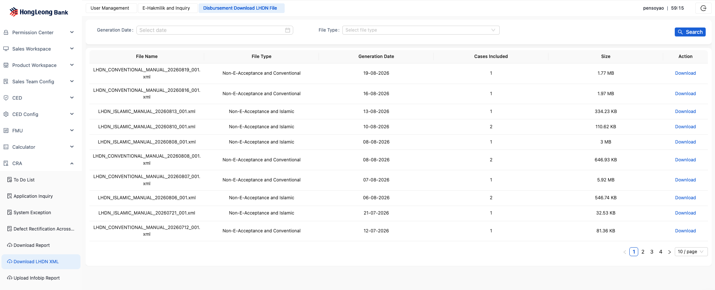
● Business Rule
● The generated LHDN XML file contains one or more <instrument> elements, each of which is for a primary applicant or a guarantor.
● Each <instrument> element contains a <refNo> element whose content value is in this format: {loanAccountNo}_{suffix}. For example, 02883004025_H for the hirer (primary applicant), 02883004025_G1 for the first guarantor.
● Each <instrument> element contains one or more <attachment> elements for embedding the required documents (file name and base64-encoded file content) into this XML file. The following documents must be included:
a. For primary applicant
a) HP Agreement and T&C, with file name “HP Agreement & T&C.pdf”
b) Appendix to HP Agreement, with file name “Appendix.pdf”
c) For e-acceptance scenario, include the e-acceptance report, with file name “Print Log.pdf”
b. For guarantor
a) HP Agreement for Guarantor, with file name “Guarantee Agreement.pdf”
c. If manual acceptance, use the manually signed HP Agreement. If e-acceptance, use system generated agreement in which use disbursement date as agreement date
d. Encode the PDF files in base64 and write them into the XML file. Refer to the interface documentation for details.
● The LHDN XML file is generated on Day X​ after full disbursement. The disbursement day is considered Day 1. X​ is a system parameter.
● The LHDN XML is a batch file containing all cases for a specific day. System should separate all cases into 4 groups:
a) E-acceptance and conventional
File name:
LHDN_CONVENTIONAL_E-ACCEPTANCE_YYYYMMDD_NNN.XML
Note: NNN is file sequence number, start from 001
b) E-acceptance and Islamic
File name:
LHDN_ISLAMIC_E-ACCEPTANCE_YYYYMMDD_NNN.XML
Note: NNN is file sequence number, start from 001
c) Manual acceptance and conventional
File name:
LHDN_CONVENTIONAL_MANUAL_YYYYMMDD_NNN.XML
Note: NNN is file sequence number, start from 001
d) Manual acceptance and Islamic
File name:
LHDN_ISLAMIC_MANUAL_YYYYMMDD_NNN.XML
Note: NNN is file sequence number, start from 001
● A single file must not exceed 30MB. If it exceeds this limit, it must be split into multiple files.
● After file generation, users with the CRA manager role can log in to a page to download the files. Page entry point: CRA - Download LHDN XML .
a． Support querying and downloading by generation date and lending type (Conventional / Islamic).
b． Files are retained for two months. After two months, the system physically deletes the LHDN XML file.
● For Non-Full Maintenance business, this stage can only be processed after completing both Post Maintenance and Post Authorization.
● If LHDN file generation fails (whether to retry is pending confirmation) and remains unsuccessful, the case must be placed in the Error queue.

6.9. 【RPA User Role】E-stamping Status Update
1. Business Rule:
● CRA user uploads LHDN XML files generated by system into 3rd party website manually as BAU
● CRA user follow 3rd party website verification result and pay for e-stamping manually as BAU
● CRA user follow 3rd party process result, manually obtain the LHDN Submission Report and LHDN Initiated Report (both are Excel files) , and trigger RPA to download files that finish e-stamping
● CRA user uploads the LHDN Submission Report and LHDN Initiated Report in the CrediOS system. The system reads the files and saves the customer-level data (e.g. Adjudikasi number) to the database.
● [Batch-3] The system displays an error message if it fails to process any data in a LHDN Submission Report or LHDN Initiated Report file, in a new column “Error Message” in the LHDN Report table. This error message is a summary of the errors during the processing of the report file and may not cover the details for each failed data row.
● CRA user uploads e-stamping file (eStamp certificate) into CrediOS, and the system automatically attaches the file to the corresponding application and customer.

● [Batch-3] The system needs to record the user who uploads the eStamp certificate file, and display the user’s staff ID and name in the file record row.
● [Batch-3] The system creates a new role for the RPA users, with the following config:
- Role Name: HP_CRA_RPA
- Permissions:
- All permissions as HP_CRA_INQUIRY
- Upload eStamp certificate file
- Delete eStamp certificate file

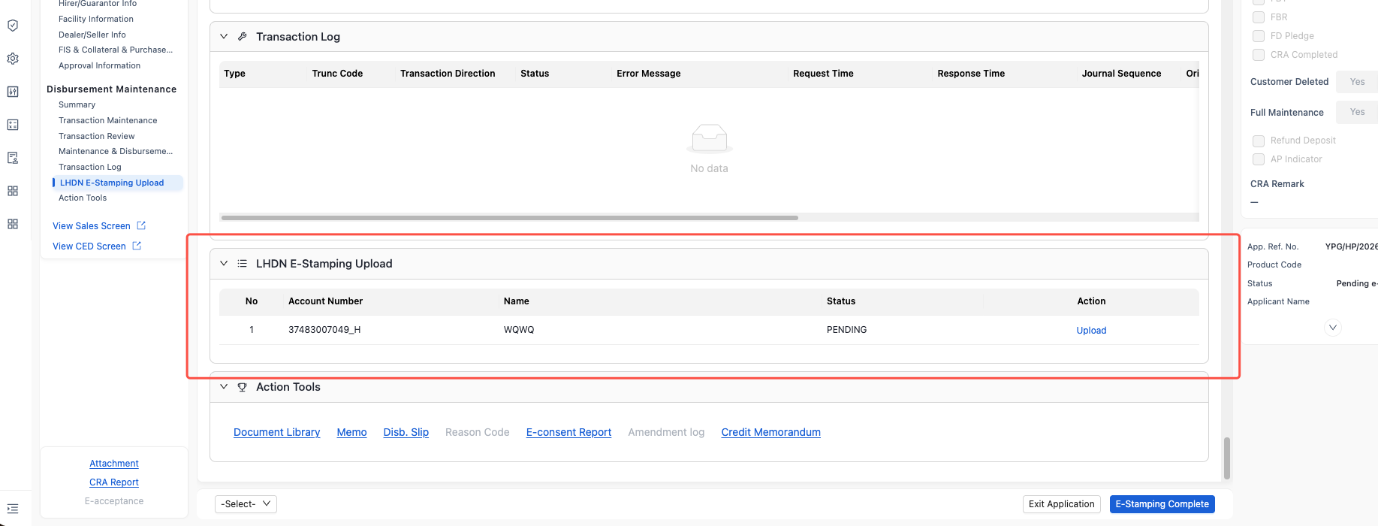

7. Post Maintenance

7.1. 【Same as Batch2】Application Assignment
AS CRA Post Maintenance I WANT system automatically assigns pending cases according to defined rules and also allows me to manually select and Pick Up a case, IN ORDER THAT I can process tasks in a timely manner.

● The detailed case distribution rules are specified in the “Application Assignment Management”
● Special Rules:
a. Status of Assigned Cases: Funded Pending Post Maintenance

7.2. 【Same as Batch2】CRA To Do List
AS CRA Post Maintenance I WANT System display application assigned to me in “CRA To Do List ”, IN ORDER THAT I can quickly view and select tasks.
● Status of Application displayed: Funded Pending Post Maintenances
● 1. Case ordering, list fields displayed, display rules, and action items in the list are defined in the “Common Capabilities - CRA To Do List Query & Display” section.

7.3. 【Same as Batch2】Application Query
AS CRA Post Maintenance I WANT System support to retrieve disbursement application assigned to me, IN ORDER THAT Proceed to subsequent disbursement processing.
1. Business Rule
● Case status inquiry is supported: Funded Pending Post Maintenance
● Filter criteria, list fields displayed, display rules, and action items in the list are defined in the “Common Capabilities - Application Query & Display” section.

7.4. Application Processing
The system supports CRA Post Maintenance uploading supplementary documents, performing document classification.
● In this stage, Post Maintenance primarily completes the file upload and supplemental entry of disbursement information and chooses between two processing paths: submitting for Post Authorization or update file collected from sales.
● Page Sections
a. Summary section same as Check and Maintenance
b. Indicator section same as Check and Maintenance
c. Navigation of workflow
Same as Check and Maintenance
d. File Checking Section
a) Including four parts:
Application & Agreement & Appendix, Vehicle Documents, Other Documents
b) Operational method is same as Checker and Maintenance
e. Defect List, same as Checker and Maintenance
f. File Check List, same as Checker and Maintenance
g. Data Maintenance, including:
- Application Summary
- Hirer/Guarantor Information
- Facility Information
- FIS Information
- Dealer/Seller Information
- Collateral Information
- Purchase Information
- Approval Information
Detail refers to Appendix: “CHECKER&AUTHORIZER” sheet in “Appendix – User Page Display”
h. FIS information displayed here
i. Memo/Attachment/Report, same as Checker and Maintenance
a) Memo is a common component that supports logging Memos in a log format, including submitter, submission time, and Memo content.
b) Files uploaded here do not enter the OCR recognition, checking, and verification workflow. Therefore, it is only recommended for uploading files in urgent situations and manually modifying disbursement information.
j. Reason code update: Same as CRA maintenance, after Post Authorization system synchronize reason code to RBS if related fields are modified. Fields refer to Appendix - Reason Update and Synchronization Rules.
● Submit for Authorization
a. If there are any defects remaining in the File Checking Section or the defect list, submission is not allowed.
b. Allow User to tick File Checking section and defect list
c. In Disbursed Pending Post Maintenance status, before submitting for post authorization, if a fixed deposit pledge has been completed, it isn’t allowed editing and deleting. Besides this, newly created fixed deposit pledge must not duplicate existing completed FDs. After submitting for post authorization , the system should trigger collateral creation for the newly created fixed deposit pledge.

7.5. Trigger Lodgment
AS CRA post maintenance Team I WANT System support to do lodgment, IN ORDER TO Used in payoff scenarios.
.
● Scenario Description:
a. Payoff refers to a scenario where the seller of a used car has an outstanding HP loan with HLB, and the hire purchase loan from the current transaction is used to settle that existing loan.
b. In this scenario, disbursement to the seller's loan account can proceed without first completing a new lodgment registration (as the asset is already mortgaged to HLB from the previous loan).
c. After disbursement, the seller first settles the outstanding loan, completes the discharge of lodgment, and then notifies HLB.
d. Upon receiving notification, the CRA Defect Team is responsible for triggering the lodgment process. Upon successful registration, the seller is notified to proceed with the ownership transfer.
● Function Entry Point: Fundamental function list. Details refer to Common Capabilities - Trigger Lodgment

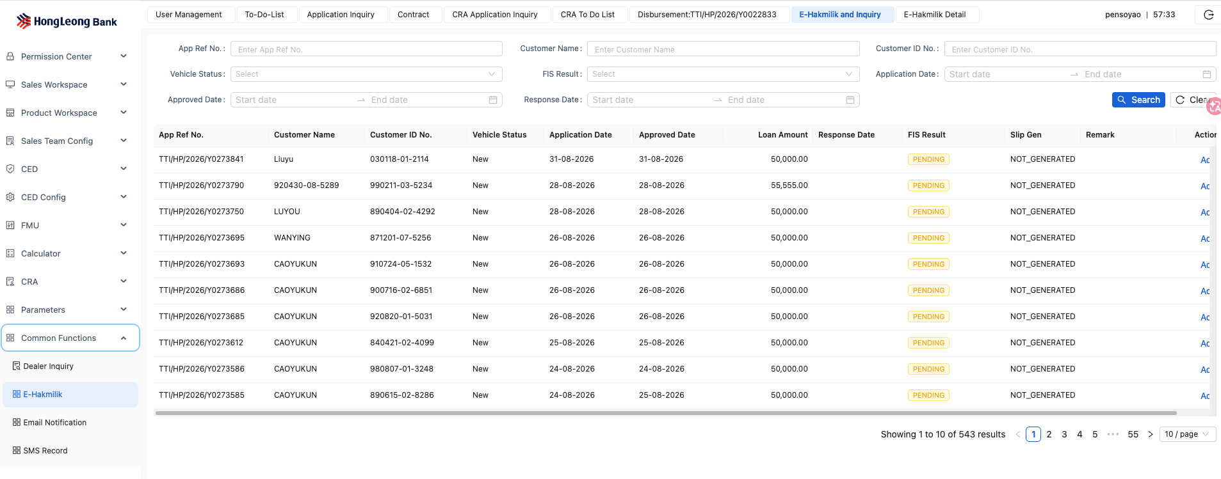

● After clicking "Submit": The interface status (Success / Failure) is displayed.
● If the interface call is successful, re-submission is not allowed.
● If the interface call fails, re-submission is allowed.

7.6. Email Notification for Additional Document Submission
After the successful disbursement of FBR/FBT business cases, the system must automatically send email notifications to the responsible Sales at pre-configured intervals, reminding them to follow up and submit additional required documents.
1. Business Process
- Trigger Point:
○ When the case status changes to "Disbursed Pending Post Maintenance", the system records the disbursement date.
○ Using this disbursement date as Day 1, the system automatically triggers email notifications on Day 3, Day 5, and Day 7.
○ This email is sent via postfix instead of Infobip since it is an internal email.
- Email Recipient Retrieval:
○ The system uses the Staff Code associated with the case to query the employee master data and retrieve the corresponding Sales email address.
○ If no valid email is found, an error is logged and the notification is skipped.
- Email Content Generation:
○ A pre-defined email template is used.
○ The case's App Ref No. and Disbursement Date are inserted as a dynamic parameter into the designated location within the template.
2. Email Template Design
● Template Example:
Subject: Reminder: Additional Documents Required for Case [App Ref No.]

Dear Sales Colleague,

Please follow up on your assigned application (Reference No.: [App Ref No.]), which was disbursed on [Disbursement Date].
As required, please ensure all supporting documents are submitted into the system within 10 days after disbursement.

Please take prompt action. Thank you.
If already finished, please ignore this email.
[System-generated email. Please do not reply.]
● Parameter Support: The template must support embedding dynamic variables such as [App Ref No.] and [Disbursement Date].
3. Recipient Retrieval Rules
● Input: Staff_Code from the case record.
● Process: Query the employee information table (or HR system interface) using Staff_Code to retrieve Sales_Name and Email_Address.
● Output: A valid email address to be used as the mail recipient.
4. Configuration Management Requirements
● The system must provide a configuration table allowing administrators to modify the sequence of days triggering email notifications.
● Configuration Example:
Configuration Item | Default Value | Description
NOTIFICATION_DAY_SEQUENCE | 3|5|7 | Configurated in Constant  Days post-disbursement to trigger notifications  (separated by “|”)
EMAIL_TEMPLATE_ID | TEMPLATE_FBR_FOLLOWUP | ID of the email template to be used

8. 【Same as Batch2】Post Authorizer

8.1. Application Assignment
AS Post Authorizer I WANT system automatically assigns pending cases according to defined rules and allows me to manually select and Pick Up a case, IN ORDER THAT I can finish task promptly.
● The detailed case distribution rules are specified in the “Application Assignment Management”
● Special Rules:
a. Status of Assigned Cases: Funded Pending Post Authorization
b. Control must be in place to ensure the post authorizer is not the same person as the last post maintenance handler.

8.2. CRA To Do List
AS Post CRA Authorizer I WANT System display application assigned to me in “CRA To Do List”, IN ORDER THAT I can quickly view and select tasks.
● Status of Application displayed: Funded Pending Post Authorization
● 1. Case ordering, list fields displayed, display rules, and action items in the list are defined in the “Common Capabilities - CRA To Do List Query & Display” section.

8.3. Application Query
AS Post CRA Authorizer I WANT System support to retrieve disbursement application assigned to me, IN ORDER THAT Proceed to subsequent disbursement processing.
● Case status inquiry is supported: Funded Pending Post Authorization
● Filter criteria, list fields displayed, display rules, and action items in the list are defined in the “Common Capabilities - Application Query & Display” section.

8.4. Application Processing
AS CRA Post Authorizer I WANT system structurally presents disbursement information, IN ORDER THAT efficiently complete authorization.
1. Business Rule
● In this stage, the Post Authorizer primarily reviews all disbursement information and chooses between two processing paths: granting authorization or returning to Post Maintenance for modification.
● Page Section
a. Indicator section same as CRA Authorizer.
b. Navigation of workflow
Same as Check and Maintenance
c. File Checking Section
c) Including four parts:
Application & Agreement & Appendix, Vehicle Documents, Other Documents
d) Operational method is same as Checker and Maintenance
d. Defect List, same as Checker and Maintenance
e. File Check List, same as Checker and Maintenance
f. Data Maintenance, including:
- Application Summary
- Hirer/Guarantor Information
- Facility Information
- FIS Information
- Dealer/Seller Information
- Collateral Information
- Purchase Information

– Approval Information
Detail refers to Appendix: “CHECKER&AUTHORIZER” sheet in “Appendix – User Page Display”
g. FIS information displayed here will not block submission, it is the FIS document tick box in File Checklist who will block submission.
h. Memo/Attachment/Report, same as Checker and Maintenance
a) Memo is a common component that supports logging Memos in a log format, including submitter, submission time, and Memo content.
b) Files uploaded here do not enter the OCR recognition, checking, and verification workflow. Therefore, it is only recommended for uploading files in urgent situations and manually modifying disbursement information.
● Submit for Subsequent Processing
a. Submission is not allowed if any defects remain in the File Checking Section or the defect list.

9. 【Same as Batch2】CRA Exception Team

9.1. Application Query
AS CRA Exception Team I WANT system to inquiry interface Error, IN ORDER To continue processing in a timely manner.
1. Business Rule
● Case Scope for Viewing: All cases that have experienced exceptions, including those that have exceeded the maximum processing attempts and those that have not.
● Filter Criteria: All fields are optional. Details are provided in the table below.
Query fields | Control Type | Input Field Format | Description | Display Name | Value Example
Application Reference Number | Input | VARCHAR2(20) |  | App. Ref. No. | KEP/HP/2015/Z0001325
Host CP/HP Account Number | Input | VARCHAR2(20) |  | Host CP | 028/HP/2015/Z0001325
Applicant ID No | Input | VARCHAR2(20) | NRIC,PASSPORT,SSMID | Applicant ID No
Applicant Name | Input | VARCHAR2(50) |  | Applicant Name
Application Status | Drop Down | VARCHAR2(50) |  | Application Status
Application Date | calendar | DD/MM/YYYY | Date span | Application Date
Assigned Date | calendar | DD/MM/YYYY | Date span | Assigned Date
Error Type | Drop Down |  |  | Error Type | HOST Maintenance, Account Creation, Disbursement, CRA E-Agreement Compiled, Sending copy of HPA via email, LHDN XML file generation

● Fields Displayed in List:
a. application number
b. error type
c. error code: display error code from HOST
d. error log: display error log from HOST
e. current processed times
f. current teller ID: Authorizer ID for non-STP cases; system teller ID for STP cases
g. current teller name: Authorizer name for non-STP cases; system teller name for STP cases

9.2. Error Handling
AS CRA Exception Team I WANT system support manual retriggering failed application caused by interface Error, IN ORDER TO handle errors in time.
● Action type:
a. Retrigger: CRA Exception Team retrigger interfacing directly, with initialization of retrigger times calculation
b. Reassign: CRA Exception Team reassigns the error case to current teller by default, if current teller is system teller, then could select an active maintenance or authorization(with consideration of authorization limit) teller; when reassigning, remark is mandatory to indicate how to handle the specific issue.
c. When reasign to Authorizer, system check whether current Authorizer has sufficient Authorization limit, if Authorizer Limit Level is empty or do not have sufficient limit then block reasignment
● After retrigger or reassigning, the specific application will be removed from Error QUEUE.

9.3. Retrigger Batch
- Batch Types:
  - executeAutoCRADSQTrigger
  - executeAutoCRAEmailTrigger
  - batchSendInfobipEmailTriggerCRA
  - executeGenerateLHDNXMLFileJobTrigger

Batch Name | Batch Purpose
executeAutoCRADSQTrigger | DSQ=document system queue  Agreement file generation for the purpose of emailing to customer, with both encrypted version and non-encrypted version.
executeAutoCRAEmailTrigger | Generate email together with attachment
batchSendInfobipEmailTriggerCRA | Push email with attachment to infobip
executeGenerateLHDNXMLFileJobTrigger | Generate LHDN XML file

- View Batch Processing Status:
  - Select batch type and date range, then click "Query".
  - Results are displayed daily.
- If batch processing fails, users are allowed to retrigger it.
- When the user clicks the "Retrigger" button, the system launches the batch job and displays a "Batch processing in progress" message.
- Upon querying the same batch again, the system shows the latest status.
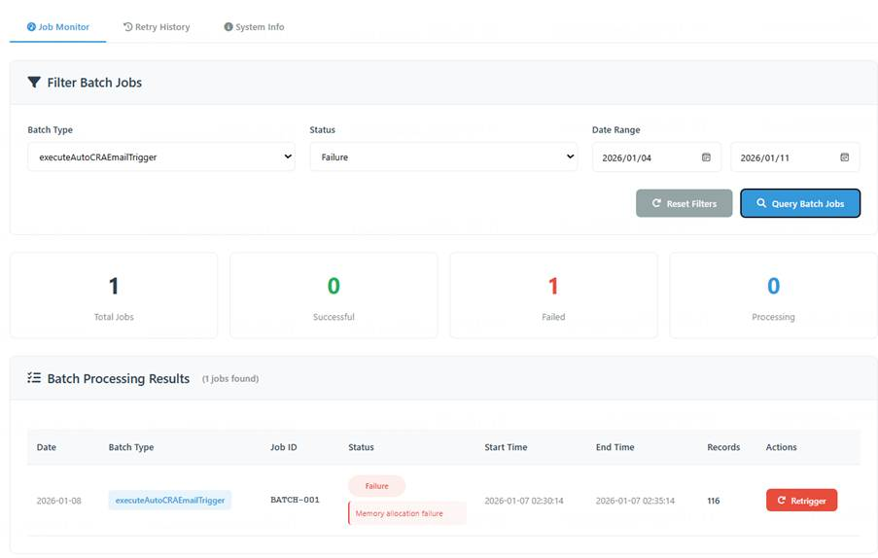
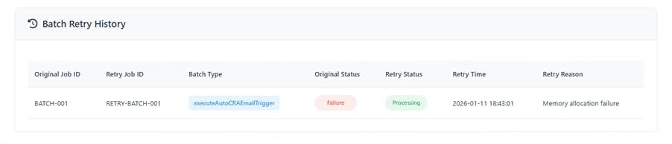

10. CRA Defect Team
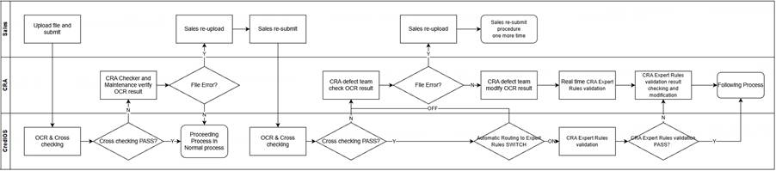
Note: “CRA Expert Rules validation result checking and modification” process in CRA lane is implemented by CRA Defect Team.

10.1. Disbursement Application Assignment
Regardless of whether the expert rules are processed through OCR, the existing Case handling rules for the Defect Team shall remain unchanged, with no special handling required.

10.2. 【Same as Batch2】Undisbursed Defect Application Assignment
AS CRA Defect Team I WANT system automatically assigns pending cases according to defined rules and also allows me to manually select and Pick Up a case, IN ORDER THAT I can handle my task efficiently.
● The detailed case distribution rules are specified in the “Application Assignment Management”
● Special Rules:
a. Status of Assigned Cases: Defect Pending Verification

10.3.【Same as Batch2】Manual Picking Up of Disbursed Defect Cases
AS CRA Defect Team I WANT system to support picking up application from application pool, IN ORDER THAT Accurately locate the specific case and prioritize its processing.
● Picking Up application status: Funded with Defect

10.4. 【Same as Batch2】CRA To Do List
AS CRA Defect Team I WANT System display application assigned to me in “CRA To Do List ”, IN ORDER THAT I can quickly view and select tasks.
● Status of Application displayed: Defect Pending Verification and Funded with Defect
● Case ordering, list fields displayed, display rules, and action items in the list are defined in the “Common Capabilities - CRA To Do List Query & Display” section.

10.5. 【Same as Batch2】Application Query
AS CRA Defect Team I WANT System support to retrieve disbursement application assigned to me, IN ORDER THAT Proceed to subsequent disbursement processing.
● Case status inquiry is supported: Defect Pending Verification, Funded with defect
● Filter criteria, list fields displayed, display rules, and action items in the list are defined in the “Common Capabilities - Application Query & Display” section.

10.6. 【Role Binding】FIS Query
AS CRA Defect Team I WANT System support to retrieve lodgment result via FIS interface, IN ORDER TO identify whether a sales vehicle has completed lodgment and registration.

● Upon entering the case details page, display the cached results from historical queries.
● Page display refer to “Common Capabilities - FIS Query”
● Provide a button next to the FIS result display area to support re-querying.
● The system shall save the latest query result.
● When the latest vehicle status saved in the system is "processed", the query button is disabled (grayed out).
● If FIS_INQUIRY_SWITCH is OFF, the system should gray out the re-query button.

10.7. Dealer Information Query
AS CRA Defect Team I WANT View maintained dealer information, IN ORDER TO confirm whether the dealer is qualified to conduct FBR/FBT business.
● This query is only for indirect business mode
● Automatically initiate a query upon entering the case details page
● Query the dealer’s FBR/FBT qualification,
a. To confirm whether the dealer have FBR/FBT quality based on the Undertaking Limit for FBR or Undertaking Limit for FBT. IF not empty and undertaking limit >=loan amount[h11] then have corresponding quality. FBR/FBT quality are configured separately.
b. If the Sales user has previously checked the FBR/FBT option, the CRA personnel shall log in to the HOST system to query the dealer's real-time available credit limit.
c. If the real-time available credit limit is insufficient, the CRA personnel must manually communicate with Sales​ to determine whether to:
a) Return the case to Sales for modification, or
b) Choose to wait for the credit limit to be released before proceeding with the disbursement.
● When the automatic query fails upon entering the case details page, provide a " Re-query Dealer Information " button.

10.8. Post-Approval Overdue Reminder
AS CRA Defect Team I WANT Prominently display the number of days that have passed from the approval date of the current loan application to the current date. Highlight the display if it exceeds X days (where X is a system-defined parameter), IN ORDER TO assess whether disbursement can proceed.
● Same as CRA maintenance
Trigger Scenario: In Application Inquiry, click on the number of elapsed days from the Loan Application Self-Approval Date to the current date. If the elapsed days exceed X days, a reminder pop-up will be displayed. Click Confirm in the pop-up to enter the Detail Page.

10.9. Undisbursed Application Defect Rectification
AS CRA Defect Team I WANT system structurally presents disbursement information, High light fields that the system judges potentially incorrect, IN ORDER TO finish defect rectification efficiently.
1. Business Rule
● The Defect Team primarily completes defect rectification for undisbursed cases and chooses between two processing paths: confirming rectification is complete and transferring the case to Maintenance or returning the case to Sales for modification.
● Processing Steps
a. The Defect Team verifies and modifies the field information results identified by the system from the files re-submitted by Sales.
b. The system performs expert rule validation (e.g., "Delivery date must be on or after registration date"), after which the Defect Team verifies and modifies the validation results.
c. The system automatically populates the corresponding fields with the verified results, highlights them, and presents them for the Defect Team's review.
d. The Defect Team can navigate to the defect list section via the navigation bar. After confirming that all issues in the defect list are rectified, they can submit the application to Maintenance for further updates to other disbursement information. If material issues are found, they can choose to return the application to Sales for re-submission of materials.
● Page Sections
a. Indicator section
Same as Check and Maintenance
b. Navigation of workflow
Same as Check and Maintenance
c. File Checking Section
a) Including four parts:
Application & Agreement & Appendix, Vehicle Documents, Other Documents
b) Operation method same as Checker and Maintenance
d. Defect List, same as Checker and Maintenance
e. File Check List, same as Checker and Maintenance
f. Data Maintenance, including:
- Application Summary
- Hirer/Guarantor Information
- Facility Information
- FIS Information
- Dealer/Seller Information
- Collateral Information
- Purchase Information

– Approval Information
Detail refers to Appendix: “CHECKER&AUTHORIZER” sheet in “Appendix – User Page Display”
g. FIS information displayed here will not block submission, it is the FIS document tick box in File Checklist who will block submission.
h. Memo/Attachment/Report, same as Checker and Maintenance
a) Memo is a common component that supports logging Memos in a log format, including submitter, submission time, and Memo content.
b) Files uploaded here do not enter the OCR recognition, checking, and verification workflow. Therefore, it is only recommended for uploading files in urgent situations and manually modifying disbursement information.
● Submit for Subsequent Processing
Submission is not allowed if any defects remain in the File Checking Section or the defect list. Users can temporarily skip this by ticking the CRA COMPLETE indicator.

10.11. 【Same as Batch2】Disbursed Application Defect Rectification
AS CRA Defect Team I WANT system structurally presents disbursement information, High light fields that the system judges potentially incorrect, IN ORDER TO finish defect rectification efficiently.
● In this stage, the Defect Team primarily completes defect rectification for already-disbursed cases. It is responsible for following up with Sales for material submission, verifying and uploading materials
● Page Sections
a. All sections are same as Undisbursed Application Defect Rectification
● Funded and Confirmed Ends
a. When all issues in the Defect List have been rectified, the case status is allowed to be set to "Funded and Confirmed End". This setting can only happen after all defects have been Rectified + Verified and the Pending eStamping step is completed.

10.12. 【Same as Batch2】Defect Rectification Across Queues
AS CRA Defect Team I WANT to directly modify cases that are in another user's To-do list or are not in the status of "Defect Pending Verification" or "Funded with Defect", IN ORDER THAT finish defect rectification efficiently.
1. Business Rule
● Application Query: Access the query interface from the Queue query function menu in the Fundamental functions area.
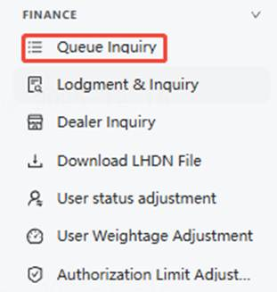
● Filter Criteria & Results Display: Same as "Common Capabilities - Application Query & Display".
● Case Details Display:
The case details page is the same as the standard Defect Team usage page.
● Upon entering the case details page, automatically jump to the Defect List Section.
● User Operations:
a. Only supports modifying items(CRA remark, Verified tick box, upload document) in the Defect List, uploading/downloading attachments, and adding memos.
b. If user upload file in this scenario, the newly uploaded file will be categorized into “Other document” and will not overwrite any other file uploaded previously or be overwritten by other file uploaded in the future.

11. 【Same as Batch2】Cabinet Queue
AS CRA Defect Team I WANT to place applications with complete materials that are ready for disbursement into a temporary queue, postponing the disbursement, IN ORDER THAT I can resume disbursement at an appropriate time.
● Usage Scenario examples
a. Other departments notify CRA via email to temporarily hold a specific case.
b. At the end of the fiscal year, Sales emails notification to temporarily hold disbursement for a specific product type (e.g., managed by product type like Islamic, conventional).
● Operation Permissions
a. Move to Cabinet:​ Grant to CRA Check and Maintenance team, and CRA Authorizer and CRA defect team.
b. Move out of Cabinet:​ Grant to Cabinet Controller role.
● Move to Cabinet Entry Point: Provide a button on the User's case details page.
● Move out of Cabinet Steps:
a． Application Query: Access the query interface from the Queue query function menu in Fundamental functions area.
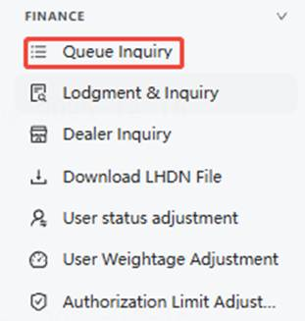
b． Filter Criteria & Results Display: Same as "Common Capabilities - Application Query & Display"
c． Case Details Display:
a) The case details page is identical to that used by CRA Check and Maintenance but is completely non-editable.
d． User Operations
a) Support Route to Sales.
b) Supports clicking the "Case Assignment"​ button.
a) Upon clicking, a pop-up supports selecting a specific User with the same role as the one who moved the case into the Cabinet and defaults to reassigning the case to the User who originally moved it into the Cabinet.
b) When assign to Authorizer, system check whether current Authorizer has sufficient Authorization limit, if Authorizer Limit Level is empty or do not have sufficient limit then block reassignment

12. Common Capabilities

12.1. 【Same as Batch2】CRA To Do List Query & Display
CRA Teams Shared "CRA To Do List " Query and Display Rules
1. Business Rule
● Entry Point: Level1 - CRA -> Level2 - To Do List

● Application display sequence:
1. Priority Display：​ Green Lane=Yes
2. Sorted by Date assigned in ascending order.
3. Sorted by Application reference number in ascending order.
● Fields Displayed in List:
Display IHP application in red text; others in black text.

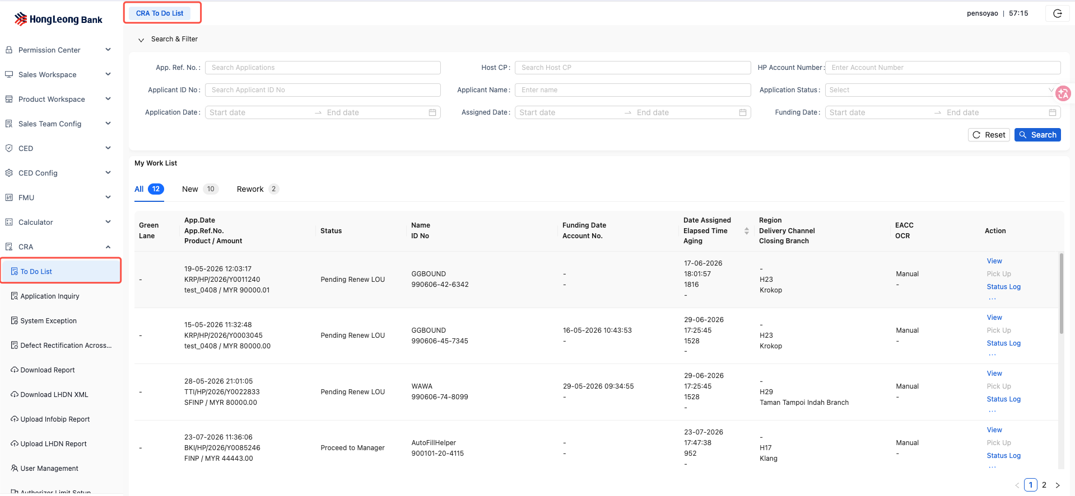
Display Fields in result List | Control Type | Display Format | Description | Display Name | Value Example
Green Lane | Display | VARCHAR2(3) | Yes or 'empty' | Green Lane | Yes
Date Assigned | Display | DD/MM/YYYY HH:MM |  | Date Assigned | 05/11/2025 11:32
Closing Branch | Display | VARCHAR2(50) | Display branch name, queried from the branch table using branch code. | Closing Branch | Kepong Branch
App.Date | Display | DD/MM/YYYY |  | App.Date
App.Ref.No. | Display | VARCHAR2(20) |  | App.Ref.No. | KEP/HP/2015/Z0001325
Applicant Name | Display | VARCHAR2(250) | From Sales key in | Applicant Name
Aging | Display | VARCHAR2(3) | Only for FBR/FBT and status equals "Disbursed Pending Post Maintenance" or "Disbursed Pending Post Authorization" display Aging value.  Aging value = Current date - Funding date + 1 | Aging | 10
Product / Amount | Display | VARCHAR2(30) |  | Product / Amount | VIUP (MYR 50,000.00)
Delivery Channel | Display | VARCHAR2(5) | From Sales key in |  | H05
E-Acceptance | Display | VARCHAR2(10) | Completed /Manual /'empty'. If non-manual and incomplete, leave empty |  | Completed
Region | Display | VARCHAR2(2) | WM/EM |  | WM-west Malaysia  EM-East Malaysia
Elapsed Time | Display | VARCHAR2(5) | In user todolist, equals to current datetime - assignate datetime；In application pool, equals to current datetime - datetime on which this application turn into current status.  Trasfer to X hours.  Round up to the nearest hour. |  | 24
● Display by Queue​: new, rework
● The associated tab shall be hidden when no cases exist in its queue.
● Action in Display list:

Action in Display List | Role
View | ALL
Reassign | Manager Only
Status Log | ALL
Route To | Depends on application status
Pick Up | Depends on application status
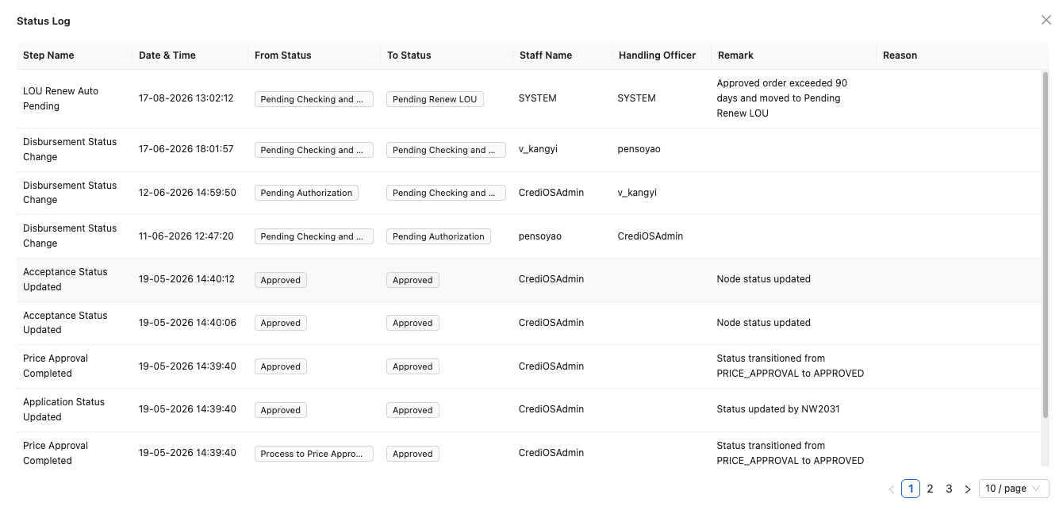
Currently status log only display the different application status and corresponding handler. In CRA, it also need to provide a log of reassignment, rbs creation, disbursement interface call, email.
- Need to consider the display granularity of each interface/api, status name mapping.
- Need to consider the visibility of status log for different use role, such as sales, ced, cra.

12.2. 【Same as Batch2】Application Query & Display
CRA Team Shared Application Query and Display Rules.
1. Business Rule
● Query Entry Point

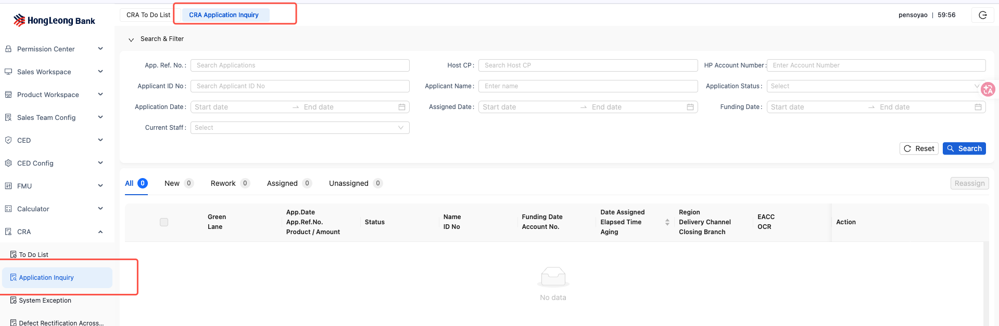
● Filter Criteria:
Query fields | Control Type | Input Field Format | Description | Display Name | Value Example
Application Reference Number | Input | VARCHAR2(20) |  | App. Ref. No. | KEP/HP/2015/Z0001325
Host CP | Input | VARCHAR2(20) |  | Host CP | 028/HP/2015/Z0001325
HP Account Number | Input | VARCHAR2(20) |  | HP Account Number
Applicant ID No | Input | VARCHAR2(20) | NRIC,PASSPORT,SSMID | Applicant ID No
Applicant Name | Input | VARCHAR2(50) |  | Applicant Name
Application Status | Drop Down | VARCHAR2(50) |  | Application Status
Application Date & Time | Callender | DD/MM/YYYY HH:MM:SS | Date and Time Range Selection​ | Application Date & Time
Assigned Date & Time | calendar | DD/MM/YYYY HH:MM:SS | Date and Time Range Selection​ | Assigned Date & Time | To match the latest datetime on which current user pick up the application or the application is assigned to current user.
Funding Date & Time | calendar | DD/MM/YYYY HH:MM:SS | Date and Time Range Selection​ | Funding Date & Time
a
Greenlane | Tick Box |  |  | Greenlane
Pending CTOS | Tick Box |  |  | Pending CTOS
e-Consent Status | Drop Down |  | Failed/Pending/Successful | e-Consent Status
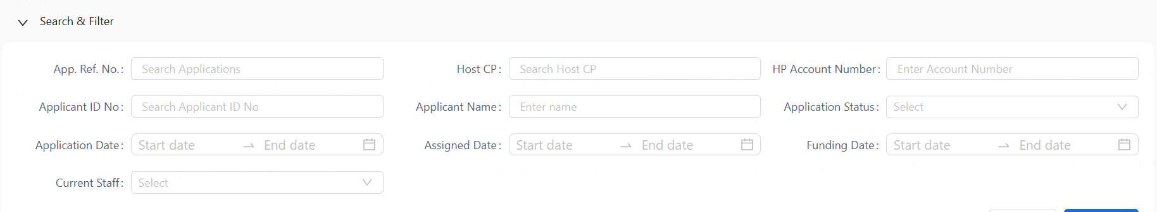
● Application display sequence:
1. Priority Display：​ Green Lane=Yes
2. Sorted by Date assigned in ascending order.
3. Sorted by Application reference number in ascending order.
● Fields Displayed in List:

Display Fields in result List | Control Type | Display Format | Description | Display Name | Value Example
Green Lane | Display | VARCHAR2(3) | Yes or 'empty' | Green Lane | Yes
Datetime Assigned | Display | DD/MM/YYYY HH:MM |  | Date Assigned | 05/11/2025 11:32
Closing Branch | Display | VARCHAR2(50) |  | Closing Branch | Kepong Branch
App.Date | Display | DD/MM/YYYY |  | App.Date
App.Ref.No. | Display | VARCHAR2(20) |  | App.Ref.No. | KEP/HP/2015/Z0001325
Applicant Name | Display | VARCHAR2(250) | From sales key in | Applicant Name
Aging | Display | VARCHAR2(3) | Only for FBR/FBT and status equals "Disbursed Pending Post Maintenance" or "Disbursed Pending Post Authorization" display Aging value.  Aging value = Current date - Funding date + 1 | Aging | 10
Product / Amount | Display | VARCHAR2(30) |  | Product / Amount | VIUP (MYR 50,000.00)
Delivery Channel | Display | VARCHAR2(5) | From sales key in |  | H05
OCR Status | Display | VARCHAR2(5) | Finish-green  Processing-yellow  Failed-red
E-Acceptance | Display | VARCHAR2(10) | Completed /Manual /’empty’. If non-manual and incomplete, leave empty |  | Completed
Region | Display | VARCHAR2(2) | WM/EM |  | WM-west Malaysia  EM-East Malaysia
Elapsed Time | Display | VARCHAR2(5) | In user todolist, equals to current datetime - assignate datetime；In application pool, equals to current datetime - datetime on which this application turn into current status.  Transfer to X hours.  Round up to the nearest hour. |  | 24

● Display by Queue​: new, rework
● The associated tab shall be hidden when no cases exist in its queue.
● Action in Display list:

Action in Display List | Role
View Details | ALL
Reassign | Manager Only

12.3. Post-Agreement Overdue Reminder
AS CRA Team I WANT Prominently prompt warning information if the number of days that have passed from the agreement date of the current loan application to the current date is exceeds X days (where X is a system-defined parameter), IN ORDER TO assess whether disbursement can proceed
1. Business Rule
● When user select a case in CRA To Do List or Queue Query, system prompt warning to user if current date is X days(The system initializes the overdue threshold (X) to 5 days.) after the agreement date of the corresponding application.
● X is configurable, refer to “Parameter Management - Post-agreement Overdue Reminder Parameter”
● This prompt is only suitable for manual acceptance applications.

12.4. Post-Approval Overdue Reminder
AS CRA Team I WANT Prominently prompt warning information if the number of days that have passed from the approval date of the current loan application to the current date is exceeds X days (where X is a system-defined parameter), IN ORDER TO assess whether disbursement can proceed.
1. Business Rule
● When user select a case in CRA To Do List or Queue Query, system prompt warning to user if current date is X days(The system initializes the overdue threshold (X) to 90 days.) after 1st approval date of the corresponding application.
● Warning Message: Loan approval has exceeded the maximum validity period. Do you want to continue reviewing this application?

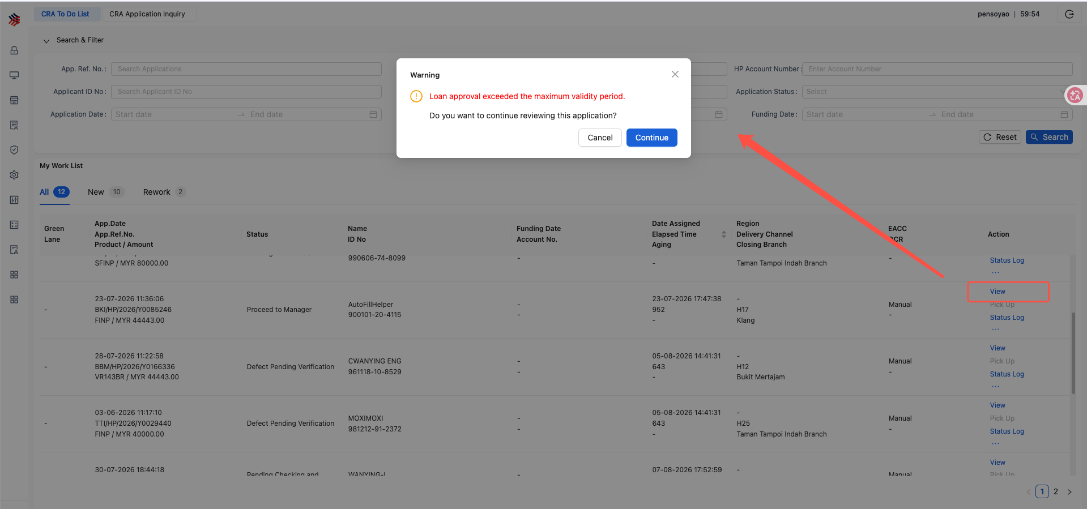

● X is configurable, refer to “Parameter Management - Post-Approval Overdue Reminder Parameter”

12.5. Trigger Lodgment
AS CRA Team and sales I WANT System support to do lodgment, IN ORDER THAT System auto populate details for fields in the FIS lodgement screen.
1. User page
● User enter trigger lodgment page
a) Page Entry Point: Common Function -> E-Hakmilik -> Add/View
b) System checks if EHAK_LODGEMENT_SWITCH is OFF, prompt ”E-Haklimik lodgment is out of service, please try later.”
● User start to trigger lodgment from the key in App Ref No.
a) Support User input App Ref No., system retrieve application information from data base and auto populate. Auto populate rules refer to “File list” below
b) If the dealer of the corresponding application is a non-panel dealer, the system prompts “Non-panel dealer detected, please confirm First Deposit Receipt Provided”.
● Trigger Lodgment page
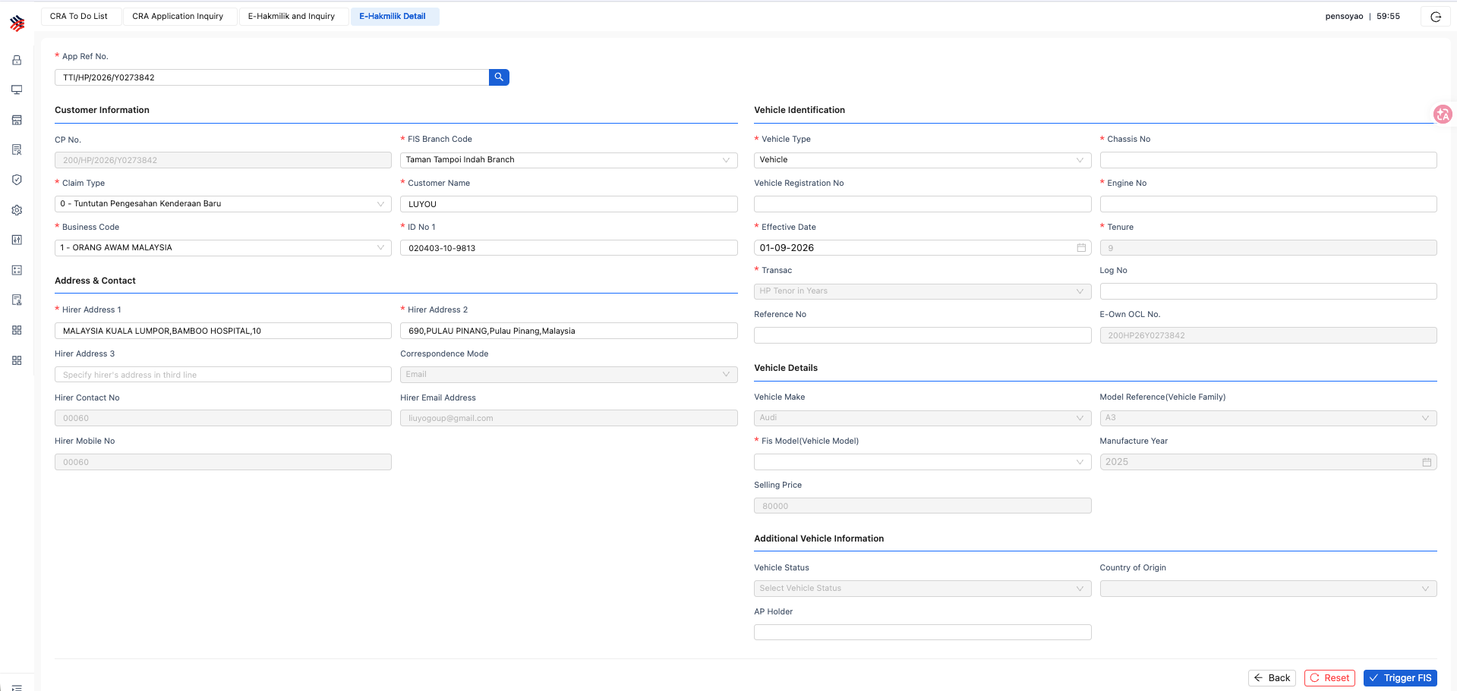

● E-Hakmilik and Inquiry
Note:
a. Besides the filter conditions displayed in the following demo picture, additional “App Ref No.” needed.
b. After query, system support use to “Download” e-hakmilik slip in pdf version
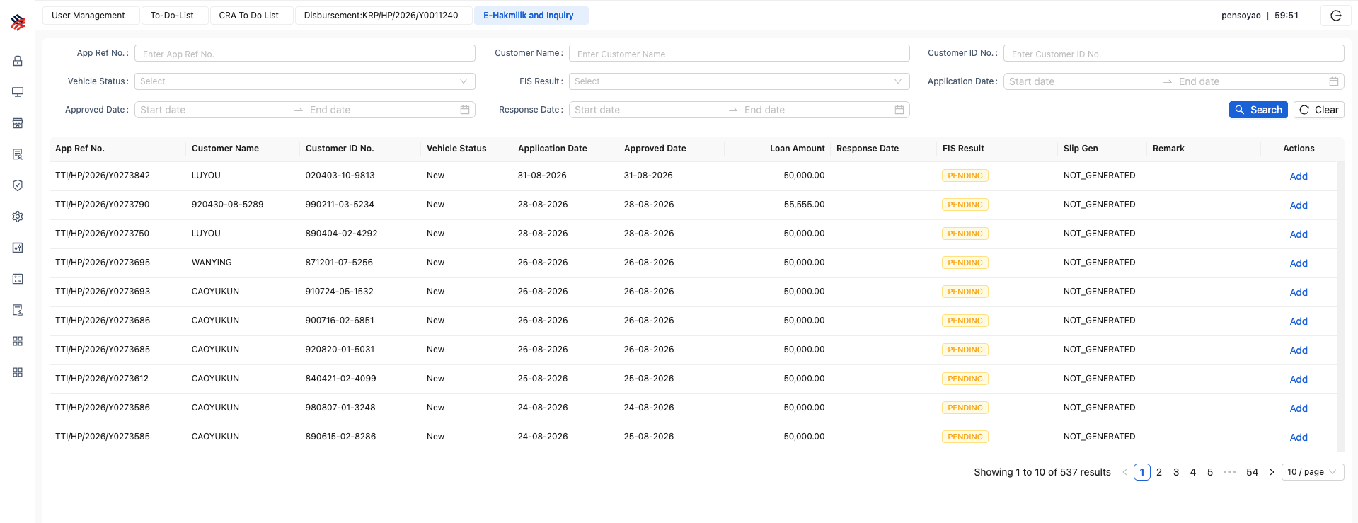
2. Field list
Field Name | Mandatory | Description
 | (Not null)
Branch Code | Y | Branch Code for the Ownership  Auto populate FIS Branch Code in Branch configuration.
Claim Type | Y | 0: Ownership New  1: Ownership Used2: Discharge  Claim Type 2 is allowed only if for the same vehicle the ownership claim is available in the system.
Auto populate based on sales input.
Mapping rules refer to “Vehicle Status System Code Setup (FIS Claim Type) ” in this chapter below.
Original Company Code | N | Applies only for Claim Type = 2 and if the company is a newly merged with another.  Provide the original FIS Assigned Company Code, that had issued the Ownership claim of this vehicle.  Interface field, not display.
Vehicle Type | Y | V: Vehicle, M: Motor, T: Trailer  Auto populate V
Chassis Number | Y | Chassis Number need to be specified as available on the vehicle/Trailer. No spaces allowed.  Auto populate based on sales input if existing for Used/Recond
Engine Number | Y/N | Engine Number need to be specified as available on the vehicle excluding spaces.  Engine Number is mandatory for Vehicle Types: M and V  Auto populate based on sales input if existing for Used/Recond
Registration Number | Y/N | Registration Number of the Vehicle/Trailer.  Mandatory for Claim Type = 1 or 2.  Specify as printed on the Registration Certificate, excluding spaces.  Auto populate based on sales input if existing for Used
Business Code | Y | The business code/category code  0 – Permanent Resident of Malaysia  1 – Malaysian Resident  2 – Police  3 – Army  4 – Company/Organization  5 – Government  6 – Statutory bodies  7 – Malaysian Birth Certificate  8 – Temporary ID receipt  9 – Non-Citizens/Non-Residents of Malaysia  A – Pendatang Tanpa Izin  S – Penduduk Sementara  For Business Code 1, Either New IC No or the Old IC Number has to be specified.  Auto populate based on sales input.  If IC type equals IC-blue, then “1”  If IC type equals SSM or Business registration number, then “4”  If IC type equals IC-red, then “0”  Otherwise not auto populate.
Vehicle Owner ID | Y/N | For Business Code 1 – Specify the New IC without Special Characters or spaces.  For All other Business codes – Specify the Identification Number as exists in the actual document, excluding spaces.  Auto populate based on sales input
Old IC no. | Y/N | For Business Code 1 – Specify the Old IC Number, no special characters or spaces allowed.  Auto populate based on sales input
Effective date | Y | Effective Date of this claim the date must follow the format YYYYMMDD  Interface field, not display.  Default current date.
Ownership Claim Serial Number  (E-Own OCL No. in display) | Y | Hire Purchase Serial Number. No spaces are allowed within the data. For claim type (2), HP Serial No should match with the one provided for the Ownership claim.  Auto populate: Branch+HP+Last 2 digits of Year+Last section of App Ref Number.  example : 288HP25Z0001363
Hirer | Y | Specify the name of the Hirer. No special characters are allowed.  Auto populate based on sales input
TRANSAC | Y | Specify the type of the Transaction.  H – HP Tenor in Months  R – HP Tenor in Years  L – Lessee  P – Personal Loan  If tenor is more than or equal to 100, then Auto populate “R”  If tenor is less than 100, then Auto populate “H”
Log no | N | Log Book Number – No Special Characters are allowed.  Auto populate based on sales input if any.
Reference No. | N | Individual Company’s Reference Number  Manual input
Tenor | Y | Tenor  If tenor is more than or equal to 100, then Auto populate (Tenor in month)/12, round up to nearest year.  If tenor is less than 100, then Auto populates Tenor in month.
Vehicle Make | Y/N | Specify the vehicle make code as in the Vehicle Make Table.  Vehicle make code is mandatory field for Vehicle Type – V and  Claim Type 0 - New Vehicle Ownership Claim or  Claim Type 1 - Used Vehicle Ownership Claim.  Auto populate based on sales input.  Source: FIS_VEHICLE_MAKE
Vehicle Family | Y/N | Specify the vehicle family code using Vehicle Make Code as the key field to allow user to select the Vehicle Family Code from the Vehicle Family Table.  Vehicle Family Code is mandatory field for Vehicle Type - V and  Claim Type 0 - Ownership New or  Claim Type 1 - Ownership Used.  Auto populate based on sales input.  Source: FIS_VEHICLE_MODEL
Vehicle Status | N | Specify the status of vehicle. Leave the field blank if none of below status stated.  REC - recon new  REB - Rebuild  Interface field, not display, if Recond then fill REC, otherwise empty.
Manufacture Year | Y/N | Specify vehicle year of manufactured in the format of yyyy.  Vehicle year of manufactured is mandatory field for  Vehicle Type - V  and  Claim Type 0 - Ownership New or  Claim Type 1 - Ownership Used.  Auto populate based on sales input
Country of Origin | Y/N | Specify country of origin for the vehicle.  Auto populate based on sales input if Recond
AP Holder | Y/N | Specify name of AP Holder.  Auto populate based on sales input if Recond
Hirer Address1 | Y | Specify hirer’s address in first line.  Auto populate based on sales input
Hirer Address2 | Y | Specify hirer’s address in second line.  Auto populate based on sales input
Hirer Address3 | Y/N | Specify hirer’s address in third line.  Auto populate based on sales input if any
Hirer Email Address | Y/N | Specify hirer’s email address if correspondence mode is E-Email.  Auto populate based on sales input
Hirer Mobile No. | Y/N | Specify hirer’s mobile number if correspondence mode is S-SMS.  Auto populate based on sales input
Hirer Contact No. | Y | Specify hirer’s contact number.  Auto populate based on sales input, also use Hire Mobile No.
Correspondence Mode | Y | Specify hirer’s correspondence mode.  S – SMS  E – Email  P - Postal  Auto populate “E”
Vehicle Model | Y | Specify the vehicle model code using Vehicle Make Code, Vehicle Family Code and Manufacture Year as the key fields to allow user to select the Vehicle Model Code from the Vehicle Model Table  Mandatory field for Vehicle Type – V and  Claim Type 0 - Ownership New or  Claim Type 1 - Ownership Used  SOURCE: COMMON_CODE.FIS_VEHICLE_MODEL_DTL
Selling Price | Y | Specify vehicle selling price. Mandatory field for  Vehicle Type – V and  Claim Type 0 - Ownership New or  Claim Type 1 - Ownership Used  Auto populate OTR(purchase price) based on sales input

3. Vehicle Status System Code Setup (FIS Claim Type)
This mapping is a system parameter without configuration screen.
Auto populate corresponding value based on Vehicle Status and mapping rules in the below table.
Vehicle Status | FIS Mapping | Bahasa Drop Down Display
New | 0 - Ownership New | 0-Tuntutan Pengesahan Kenderaan Baru
Used | 1 - Ownership Used | 1-Tuntutan Pengesahan Kenderaan Terpakai
Recond | 0 - Ownership New | 0-Tuntutan Pengesahan Kenderaan Baru

12.6. FIS Query

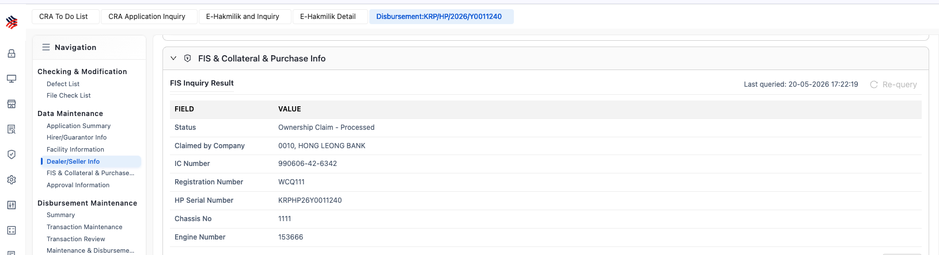
1. Display fields:
Field | Mapping | Value
Status | ClaimStatus | Ownership Claim – Processed
Claimed by Company | ClaimedByCompany | 2846, H.LEONG ISLAMIC
IC Number | ICOrBusRegNumber | 811012-XX-XXXX | IC number or Business Registration number depending on the application is Individual or Non Individual.
Registration Number | RegistrationNumber | VQC8812
HP Serial Number | ChassisOrSerialNumber | 226HP25L0001682 | Equal to E-Own OCL No.  Branch + HP + Last 2 digits of Year + Last section of App Ref Number.
Chassis No | ChassisNumber | L1NNSGHA7SB142191
Engine Number | EngineNumber | E8FE016311030000FA6

2. FIS Query Result Display Rule
a) Scenario 1:
i. If ErrorsFound="Y"and matchesfound="N", then display the error message from the <ErrorMessage>tag in the "FIS Result - Status" field.
b) Scenario 2:
i. If ErrorsFound="Y"and matchesfound="Y":
1. Display the error message from the <ErrorMessage>tag in the "FIS Result - Status" field.
2. Additionally, if records are returned in <OwnershipClaimRecords>with totalresults >=1, also display the record(s) with the latest Submission Date.
c) Scenario 3:
i. If ErrorsFound="N"and matchesfound="N", then display the fixed message: "matchedfound = N"​ in the "FIS Result - Status" field.
d) Scenario 4:
i. If ErrorsFound="N"and matchesfound="Y", but the <OwnershipClaimRecords>tag is not found or totalresults="0", then display the error message: "OwnershipClaimRecords not found".
e) Scenario 5:
i. If ErrorsFound="N", matchesfound="Y", and <OwnershipClaimRecords>has totalresults >=1:
1. If there is only 1 record, display it.
2. If there is more than 1 record, display the one with the latest <SubmissionDate>.
f) Scenario 7:
i. If the ErrorsFoundor matchesfoundvalues are blank or other than "Y"/"N"​ (invalid/irregular response):
1. If an <ErrorMessage>is present, display that FIS error.
2. Otherwise, if <OwnershipClaimRecords>has totalresults >=1, display the record(s) with the latest Submission Date.
Otherwise, display a generic error: "Invalid Response from FIS".

12.7. Defect List

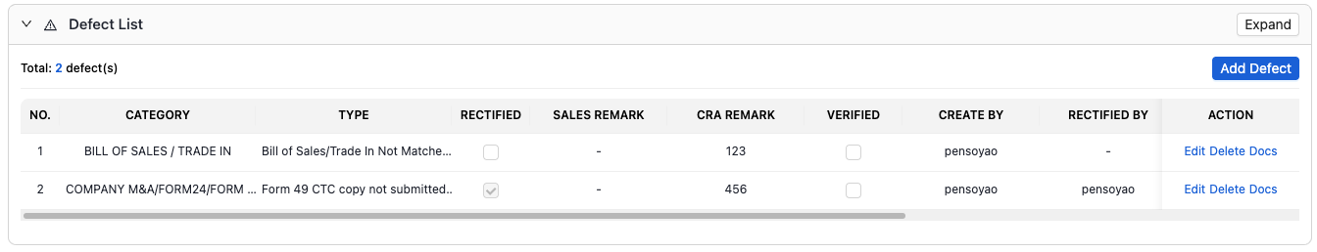
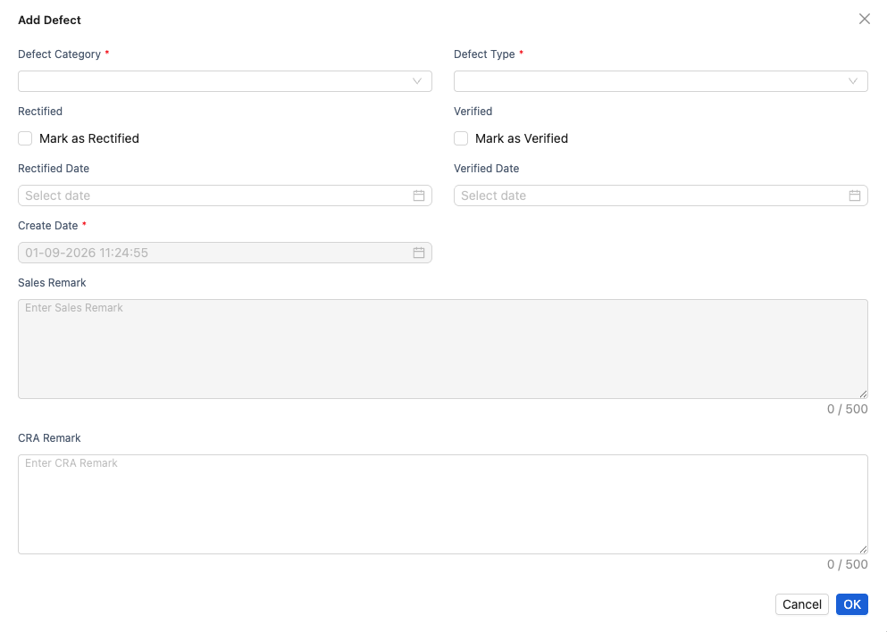

12.7.1. Roles and Tracking:
The CRA team and sales personnel track and manage defect resolution through a defect list.

12.7.2 Defect Sources:
- System: On the Verification Summary page Defect records generated through the relevant “Create Defect” button shall be marked with the source as System.
- User: Defect records manually created by CRA team members in the Defect List shall be marked with the source as User.
- The Defect List shall, by default, be fully decoupled from rule-result displays, including the Header Summary, Cross Validation, and Manual Check Results. Any Refresh or Sync operation shall not automatically create, overwrite, or delete records in the Defect List.

12.7.3. Defect Definition:
Each defect is associated with a predefined Defect Category and Defect Type, selected during creation. Categories are defined based on the type of document from which the defect originates.

12.7.4. 【Same as Batch2】Defect Defect List Fields
Field Display Name | Field Content | Control Type | Example Value
No. | Display sequence No. | VARCHAR2(3) | 1
Category | Defect Category | Drop list | Refer to Defect Category parameter
Type | Defect Type | Drop list | Refer to Defect Type parameter
Rectified | Rectified tick box | Checkbox | "✓" (or empty)
Sales Remark | Sales Remark Text | Multiline Text.  VARCHAR2(500) | "Will obtain signature by tomorrow"
Verified | Verified tick box | Checkbox | "✓" (or empty)
CRA Remark | CRA Remark Text | Multiline Text.  VARCHAR2(500) | "Will obtain signature by tomorrow"
Raised | Raised Date/Time | DISPLAY  VARCHAR2(20) | "2018/01/10 09:30"
Created By | Created By | DISPLAY  VARCHAR2(20) | "John Doe"
Updated | Updated Date/Time | DISPLAY  VARCHAR2(20) | If modified input Current datetime, otherwise keep empty.
Update User | Update User | DISPLAY  VARCHAR2(20) | If modified input Current User, otherwise keep empty.
Action | Action | Button / Icon | Edit  Delete  Upload: Upload document and bind to this defect  Docs: View documents bind to this defect  View:Only the defect details can be viewed; all fields are disabled.

12.7.5. 【Same as Batch2】Supported Operations in Defect List:
* Mark as Rectified: Sales and CRA.
* Edit Sales Remark: Sales only (visible to CRA).
* Mark as Verified: CRA team only (visible to Sales).
* Edit CRA Remark: CRA team only (visible to Sales).
* Upload Document: Available to both Sales and CRA. Supports multiple file uploads. The system records the file-defect relationship for future reference.
* View Document: Available to both Sales and CRA. Allows viewing all files linked to the defect.

12.7.6. Defect Creation and Synchronization
- ① Defect List Area:
For a specific rule that is currently Failed, the user may manually create the corresponding Defect record. The user may also manually create a Defect record that is not associated with any rule.
- ② Verification Summary Area:
The user may click “Sync Defect” to generate Defect records in batch for all rules that are currently Failed and have not yet been associated with any Defect record.
This operation shall only create new Defect records and shall not delete existing records. Where a duplicate corresponding record already exists:
- a record with Creation Source = System may be overwritten; and
- a record with Creation Source = User shall not be overwritten.
- Operations ① and ② shall be fully decoupled from the Summary refresh of rule results. Defect creation and synchronization must be triggered manually by the user.
- For the above methods, the system shall determine whether a rule has already been associated with a Defect record based on the configured Rule-to-Defect Mapping, so as to avoid duplicate Defect creation.

12.7.7 Rule–Defect Mapping
- OCR Rule Identification
  - Each expert rule in the OCR system shall have a unique Rule ID, using the OCR system’s own coding format.
- Rule-to-Defect Mapping Configuration
  - On the CDM side, a new column named “OCR Rule ID” shall be added to the existing expert-rule list / Rule-to-Defect Mapping Table.
  - The OCR Rule ID shall be mapped to the corresponding Defect Code and Defect Category maintained in CDM.
- Usage of the Mapping
The Rule-to-Defect Mapping shall serve as the basis for Defect creation and related validation logic.
  - Defect Creation:
For Create Defect, including single creation, batch creation, and synchronization, the system shall use the mapping to convert a Failed result generated from OCR or Manual Check into the corresponding Defect Code and Defect Category.
  - De-duplication:
The same mapping shall be used to determine whether a particular rule has already been associated with an existing Defect record, in order to prevent duplicate Defect creation.
  - Pre-submission Reminder Check:
The mapping shall also be used as the basis for determining whether any Failed rules remain without an associated Defect record before submission.
- De-duplication by Rule ID and File Owner
· De-duplication shall not be based on Rule ID alone. The file owner / entity must also be taken into account.
· The same document type, such as an Identity Document or Agreement, may exist separately under different entities, including:
  - Main Applicant;
  - Guarantor 1;
  - Guarantor 2; etc.
· The expert rules applicable to these files may use the same Rule ID. Therefore, Rule ID alone cannot uniquely identify which entity’s document the rule result belongs to.
· Each uploaded file already records its corresponding file owner / entity, and different entities use separate upload entries.
· Accordingly, Rule-to-Defect mapping and de-duplication shall be determined using the combination of:
Rule ID + File Owner / Entity
· This combined key shall be used to uniquely identify the applicable rule result and its corresponding Defect relationship.
· Duplicate documents of the same document type will not occur under the same entity.

12.7.8. Post-Verification Controls: Once a defect is marked 'Verified' and submitted:
* The defect record becomes read-only (no further edits).
* No additional files can be uploaded for that defect.
* Any new issues require the creation of a new defect record.

12.7.9.【Same as Batch2】 Disbursement Rules:
* Normal Process: All defects must be in both Rectified and Verified states before disbursement is allowed.
* Exception Process: Disbursement can proceed with outstanding defects if 'CRA Complete' is selected, initiating a 'funded with defect' workflow.

12.8.【Same as Batch2】CRA Report Generation
System support CRA team generating and downloading CRA report.
a. Entry Point: Trigger generation and download through the CRA Report function on the case details page.
b. CRA report template refers to Appendix - CRA report template.
c. Example Use Case: When switching to manual disbursement, the CRA REPORT needs to be printed and filed together with the BTS slip for record-keeping purposes.

12.9. Credit Memorandum View
System support CRA team downloading Credit Memorandum during the historical approval process.
● All CRA roles can download it.
● The downloading entry is located on the case details page.
● This report is generated by the CED (Credit Evaluation Department). The field content is defined in the CED section requirements.

12.10. 【Same as Batch2】Attachment from Tools
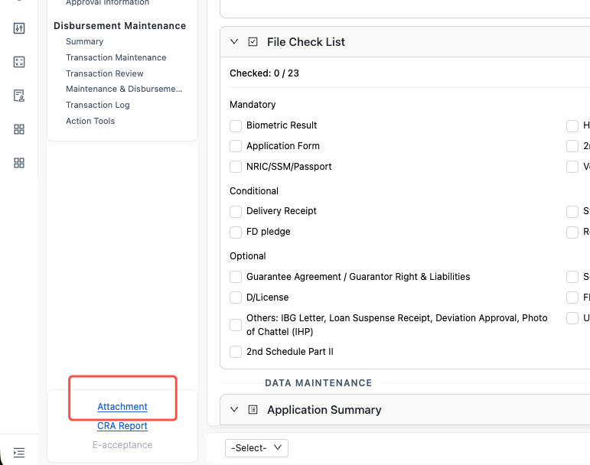

1. Business Rule
· When the user uploads files from Tools in application detail page, user will enter into OCR file upload page, then follow AIOCR design.
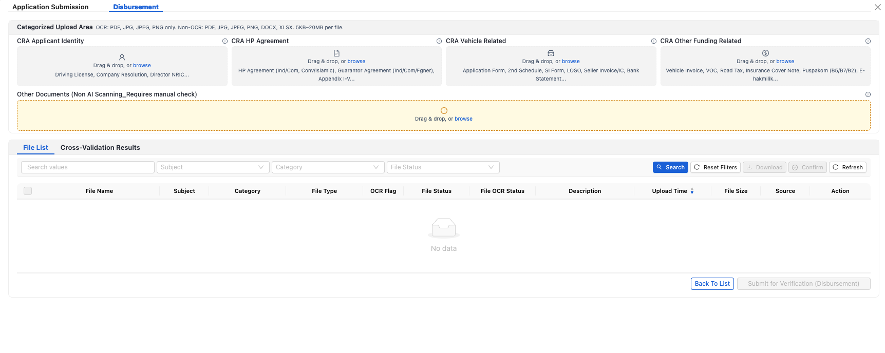

12.11. 【Same as Batch2】Delete Attachment
CRA Team Manager can delete attachment uploaded by a team member in specific scenarios.
● Only roles granted team manager privileges (not necessarily the actual manager) are allowed to delete attachments. This includes check/maintenance, authorizer, post maintenance, and post authorizer manager roles.
● Function Entry Point: Functional area in the case details page
● Function Description:
a. Click "Delete Attachment" to pop up a window displaying the attachment list.
b. The attachment list includes categorized files and "other documents".
c. Categorized files support expanding to view all historical versions. "Other documents" do not have the concept of historical versions.
d. For each file, display the file name, File Upload time, and File Uploader.
e. Supports viewing each file. Clicking the "View" button opens a new browser tab to display the file.
f. Supports deletion. Clicking "Delete" prompts: "This file cannot be recovered after deletion. Confirm deleting this file?"
g. Upon confirmation, the file is permanent deleted

12.12. Other Common Separate Features

12.12.1. 【Same as Batch2】Queue Inquiry
● Follow Common Capability - Application Query & Display
● Special query condition
CRA Exception Team: Follow “CRA Exception Team” chapter.
● Common Action: View, Status Log
● Special Action may vary based on user role
CRA Exception Team: Reassign
CRA Manager: Reassign
Cabinet Controller: Reassign, Back to sales
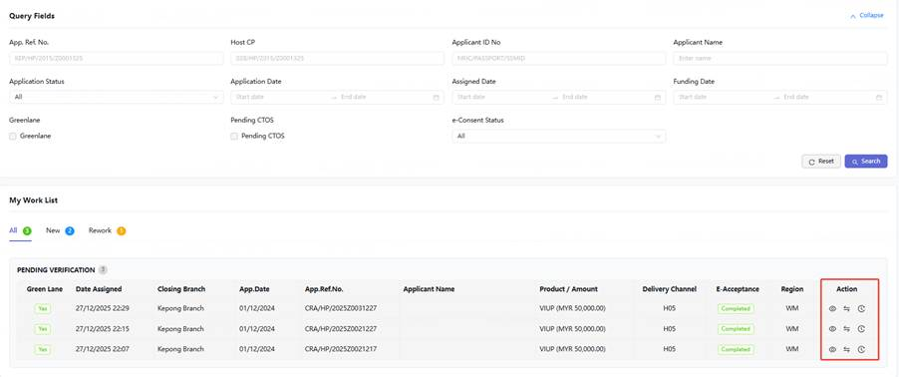

12.12.2 Dealer Inquiry:
● Follow Dealer Management Module Design
check with Sales modules.

12.12.3 【Same as Batch2】Download LHDN File
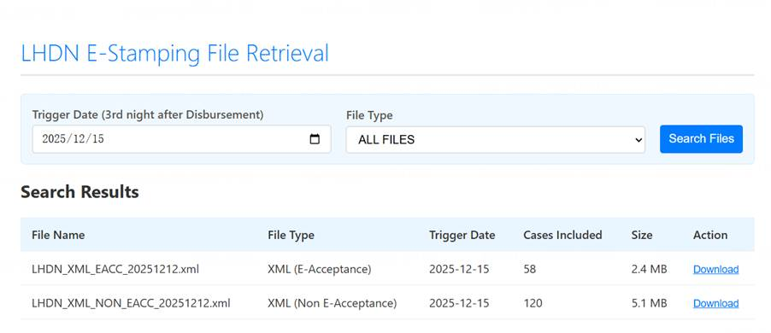
NOTE:
● File Type dictionary:
E-Acceptance & Conventional
E-Acceptance & Islamic
Non-E-Acceptance & Conventional
Non-E-Acceptance & Islamic
● Function Entry Point refer to following snapshot.
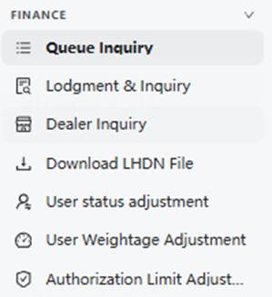

12.13. 【Download History Report】Infobip Email Reconciliation
- The system allows users to upload Infobip Reports.
- Page Entry Point：CRA - Upload Infobip Report
- The Infobip Reports is in excel format.
- System synchronize Infobip processing status, Infobip processing reason and processing datetime from Infobip Reports to CrediOS, this information will be displayed in Application screen and for use in reconciliation reports.
- System should keep all Infobip Email Reports.
- [Batch-3] System should allow users to download the uploaded Infobip Email Reports.
Add action, provide download function.

12.14. 【Same as Batch2】Disbursement Reversal
● Users could implement disbursement reversal when they find a mistake in a certain application.
● Suitable user role: CRA manager
● Feature entry point: Queue Query => Application detail => Action bar
● Action name: Tigger EC Interface (EC: error correction)
● Action result: Reverse all transaction treatment in this application disbursement
● Application status after reversal: Payment Reversed Manually Funded, this is a terminated status, the application can only be disbursed by “Manual” mode.
● This scenario could happen after the Authorizer approves the disbursement application, in both normal and defect situations.
● Composed transaction scenario that could support reversal
Principle rule: payoff can not support; If there are more than 1 type of transaction treatment(exclude Advise and suspense) then can not support.
Details refer to the table below.
 | IBG | Transfer | Advice | Suspense | Payoff
IBG | Y | N | Y | Y | N
Transfer | N | Y | Y | Y | N
Advise | Y | Y | Y | Y | N
Suspense | Y | Y | Y | Y | N
Payoff | N | N | N | N | N

● Reversal transaction rule:
○ Need to reverse loan disbursement accounting, IBG transaction, Transfer accounting, Advice accounting, Suspense accounting
○ If the IBG transaction reversal failed because the IBG transaction was already finished by EPP, then prompt “Reversal failed.”
○ If the Advice accounting failed because there is no sufficient fund in the CASA account, then prompt “Reversal failed.”

13. File Template

13.1. File Template Management
AS CRA Team I WANT The system supports configuration of various document templates, IN ORDER TO use when generating various internal and external documents.

● Document Category: Internal Use (e.g. CRA report), External Use
● Add Template Configuration:
a. Template ID: System-generated, used to associate scenarios where the system uses this template.
b. Template Name: Manually defined. User for internal system definition and let the user know what is the purpose of the current template.
c. Under a Template ID, support adding several Version
d. Under a specific Version, configurable items:
a) Version No.
b) Version Name: Manually defined.
c) Note:
a) Version Name is used for display in each page bottom of the corresponding document.
b) Because a certain template is used in several scenarios, in different scenarios the Version Name is different.
c) System support input multi Version Name in a single field, and extract the name based on scenario-name mapping rule.
d) Following pictures are examples and a current configured template version is

HP17NEWREV052025E|HP17USEDREV052025E|HP17RECONDREV052025E|ATB500NEWREV052025E|ATB500USEDREV052025E|ATB500RECONDREV052025E|IHP002NEW REV052025E|IHP002USED REV052025E|HP17 REV052025|ATB500 REV052025|IHP002 REV052025


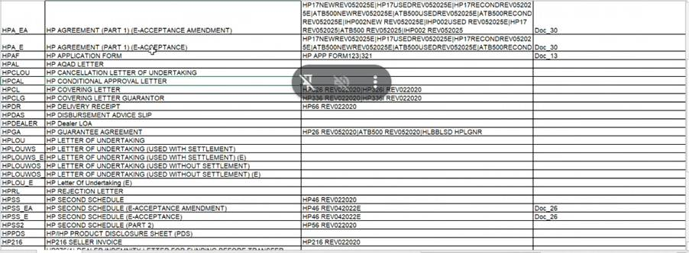
d) Immediate Activation: Yes / No
e) Effective Time: Not required if immediate; required if not immediate.
f) Template Format: Template structure file; manually uploaded.
g) Template Fields: Field mapping/source configuration file; manually uploaded.

● Update Template Configuration:
a. Template ID, Template Name, and Template Version cannot be modified after creation.
b. Modifiable Fields:
a) Immediate Activation: Yes / No
b) Effective Time: Not required if immediate; required if not immediate.
c) Template Format: Re-upload the template structure file.
d) Template Fields: Re-upload the field configuration file.

● Delete Template Configuration:
a. All configuration items under a Template ID can be deleted.
b. A strong confirmation prompt is required upon deletion.
c. only specific role(predefined) could delete/update file template

13.2. 【Same as Batch2】Agreement Generation Special Rule
When a customer accepts the loan each time, the system should generate a version of agreement, below are special rules for document generation.
1. The number of persons approved must be reflected in following files:
a. HP Agreement Part 1
b. 2nd schedule,
c. Appendix.
2. Calculation method: The count is based on the total number of individuals marked as "Approved" within the Credit approval section of the Credit Approval Authority History.
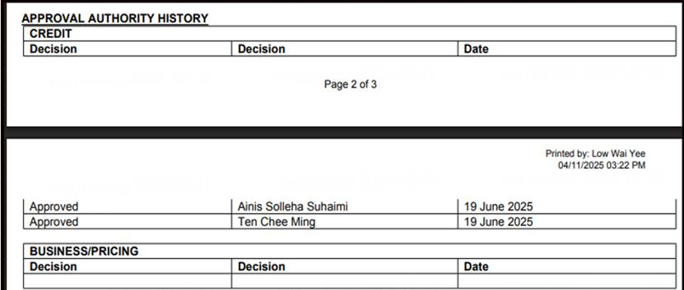
3. Display method: Add the number in parentheses at the bottom of the agreement documents.
4. This number is required at the bottom of every page in the document list.
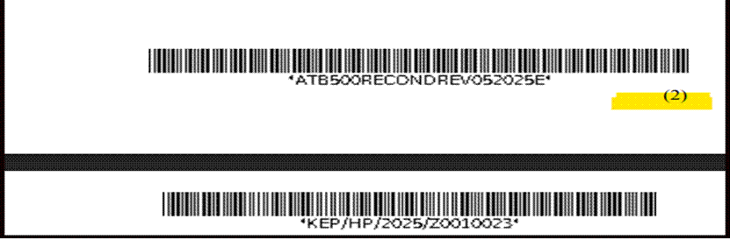

13.3. 【Same as Batch2】CRA Report
1. Follow current CRA report as baseline, refer to Appendix: CRA report template
2. Special Requirement-1
a. The CRA report must reflect the number of persons who approved the application.
b. Calculation Method: The count is based on the total number of individuals marked as "Approved" within the Credit approval section of the Credit Approval Authority History.
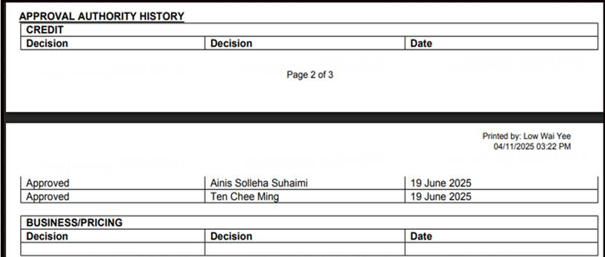
c. Display Method: Add the number in parentheses after the CA No.
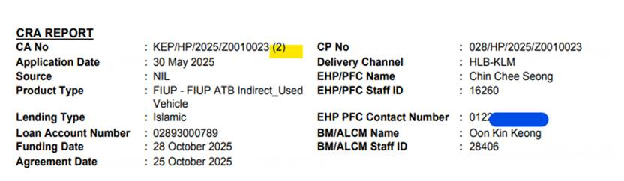
3. Special Requirement-2
a. Add E-acceptance report into CRA report
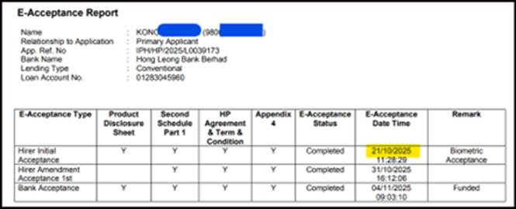
b. Add AP indicator, refund deposit indicator, LOU renewal indicator, 1st Signing date for E-Acceptance application, Company Old ID

14. 【Same as Batch2】User Role and Access Control

14.1. User Role and Access Control Management
AS CRA Team I WANT the system supports assigning one or multiple roles to a user and granting corresponding permissions for each role, IN ORDER TO manage operation permissions reasonably and accurately.
1. Fundamental Functions
These functions can be carried out separately without any influence to any applications.
Role & Action | Queue Inquiry | Trigger Lodgment | Download LHDN File | FIS request | User status adjustment | User Weightage Adjustment | Authorization Limit Adjustment
checker/Maintenance |  |  |  | Y
Authorizer
Defect Team |  |  |  | Y
Post Maintenance |  |  |  | Y
Post Authorizer
Cabinet Controller
Exception Team
e-hakmilik Team |  | Y
CRA inquiry | Y
Manager Group |  |  | Y |  | Y | Y
System Admin |  |  |  |  | Y | Y | Y

2. Application Process Functions
These functions are carried out while user processes application and mainly related to application content.
Role & Action | Modify Field | Tick Indicator | Dealer Inquiry | Memo | Upload Attachment | Download Attachment | Delete Attachment | CRA report | Credit Memorandum | E-acceptance report | Disbursement Slip | Reason code
checker/Maintenance | Y | Y | Y | Y |  | Y |  | Y | Y | Y | Y | Y
Authorizer |  | Y | Y | Y | Y | Y |  | Y | Y | Y | Y | Y
Defect Team | Y | Y | Y | Y | Y | Y |  | Y | Y | Y | Y | Y
Post Maintenance | Y | Y |  | Y | Y | Y |  | Y | Y | Y | Y | Y
Post Authorizer |  | Y |  | Y |  | Y |  | Y | Y | Y | Y | Y
Cabinet Controller
Exception Team
e-hakmilik Team
CRA inquiry-internal
CRA inquiry-external
Manager Group |  |  |  |  |  |  | Y
CRA Admin

3. Application Routine Functions
These functions are carried out while user processes application and mainly related to application status.
Role & Action | Exit Application | Proceed | Route to Sales Defect | Confirm end | To cabinet | Manual | Add Defect Item
checker/Maintenance | Y | Submit | Y |  | Y | Y | Y
Authorizer | Y | Approve/Reject | Y |  | Y | Y | Y
Defect Team | Y | Submit | Y | Y |  | Y | Y
Post Maintenance | Y | Submit | Y |  |  | Y | Y
Post Authorizer | Y | Approve/Reject | Y |  |  | Y | Y
Cabinet Controller |  | Case Assignment | Y |  |  |  | Y
Exception Team |  | Retrigger Interfaces
e-hakmilik Team
CRA inquiry-internal
CRA inquiry-external
Manager Group |  | Case Assignment
CRA Admin
4. Parameter Admin
Action & Role | CRA Admin
Letter Template Management | Y
Business Parameter Management | Y
Business Switch Maintenance | Y

14.2. Role Creation
● System support creating roles
a) When creation, input field include role id, role name, actions
b) Action is selected from Action List, which is pre-configurated in system.
c) A role could select more than 1 action from Action List
● System support editing roles
a) When edit, editable field include role name, actions
b) After edit, all user with corresponding role will be influenced immediately.
● Role creation, modification need maker and checker mechanism

14.3. User Role binding
● Binding Object: Staff Code
● Binding Process:
● Select User: The system allows searching by either Staff Code or Staff Name. Searching by one field will display the other to confirm the user's identity.
● Select Role: Supports multiple role selection from a list. The interface allows selecting or removing specific roles, followed by a confirmation click.
● Confirm Binding: Requires a maker-checker mechanism for approval. There are no dedicated maker/checker roles; the system only enforces that the two persons involved are not the same individual.
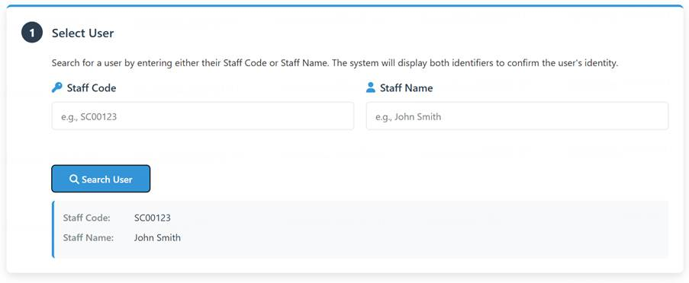
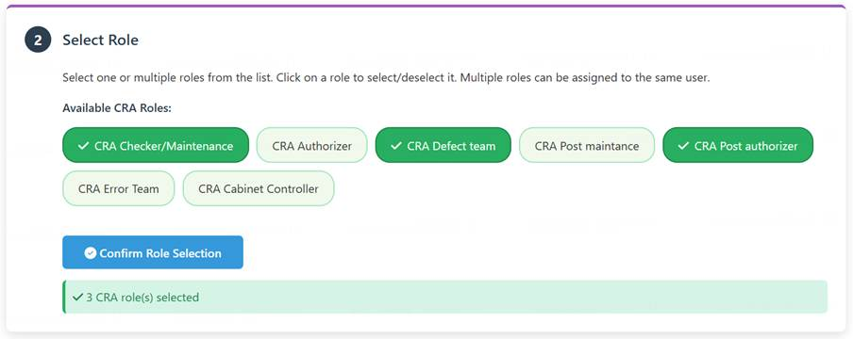
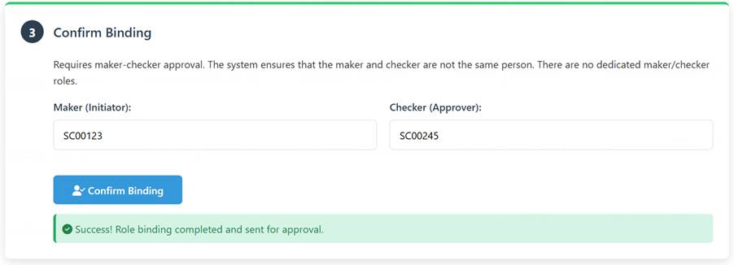

15. Application Assignment Management

15.1. 【Same as Batch2】Principle Introduction
1. Relation between Role, Application Status and Expected Queue Mode
Role | Application Status | Expected Queue Mode
CRA Checker and Maintenance | Pending checking and Maintenance | Round Robin
CRA Defect Team | Defect Pending Verification | Round Robin
 | Disbursed with Defect | Pick Up
CRA Checker and Maintenance | Pending Maintenance after defect Verification | Pick Up
CRA Authorizer | Pending Authorization | Round Robin
CRA Post Maintenance | Disbursed Pending Post Maintenance | Round Robin
CRA Post Authorizer | Disbursed Pending Post Authorization | Round Robin
CRA Cabinet Controller | Waiting in Cabinet | Pick Up
CRA Manager | Pending e-stamping
None(Final Status) | Funded and Confirmed End
 | Manually Funded
CRA Exception Team | Status following original queue with Interface Error Flag | Pick Up

15.2. 【Same as Batch2】User Role Status management
AS CRA Team manager I WANT the system supports manual configuration of a team member's user role status, IN ORDER TO allocate flexibly based on the actual situation.
1. Business Rule
● User Selection
The system supports searching for a user by entering either the Staff Code or Staff Name. When one field is entered, the system will retrieve and display the corresponding value for the other field for identity confirmation
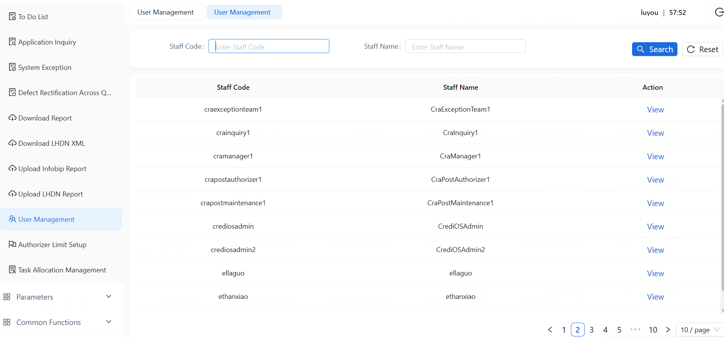.
● User Role Display & Configuration
After a user is selected, the system displays a list of roles assigned to that user. Each role entry supports the following configuration actions:
a) 【Available for CRA Manager and CRA ADMIN】Set User_Status: Configure as Active or Inactive, and set the corresponding effective datetime.
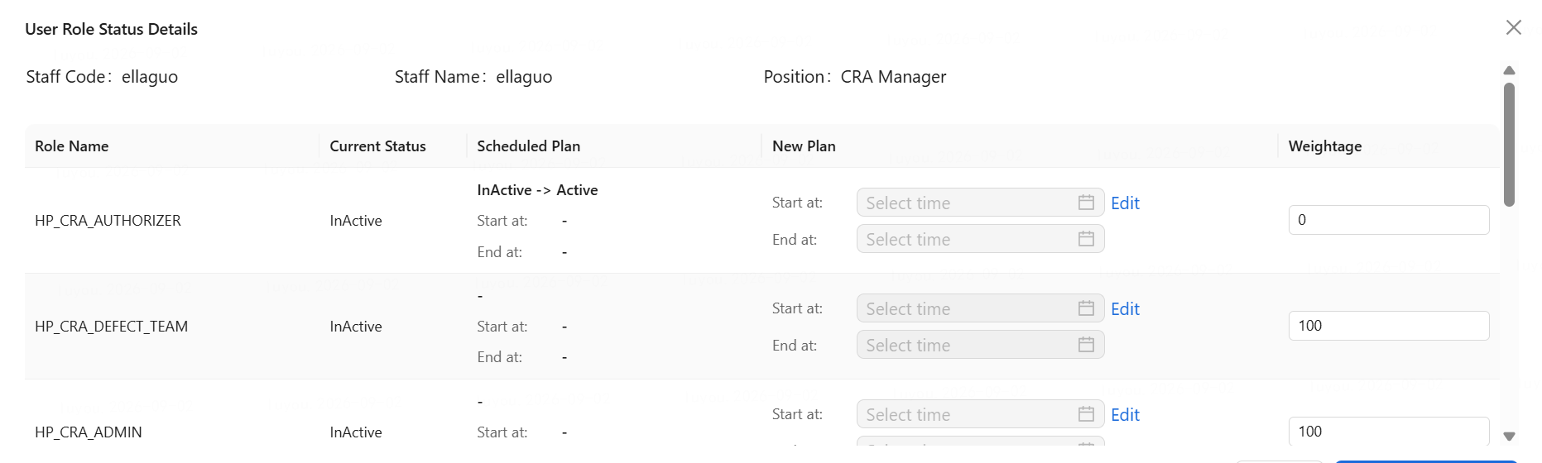

b) 【Available for CRA Manager and CRA ADMIN】Set Whether_Round_Robin: A mandatory field with options Y (supports round robin) or N (does not support round robin). The default value during user-role binding is Y.
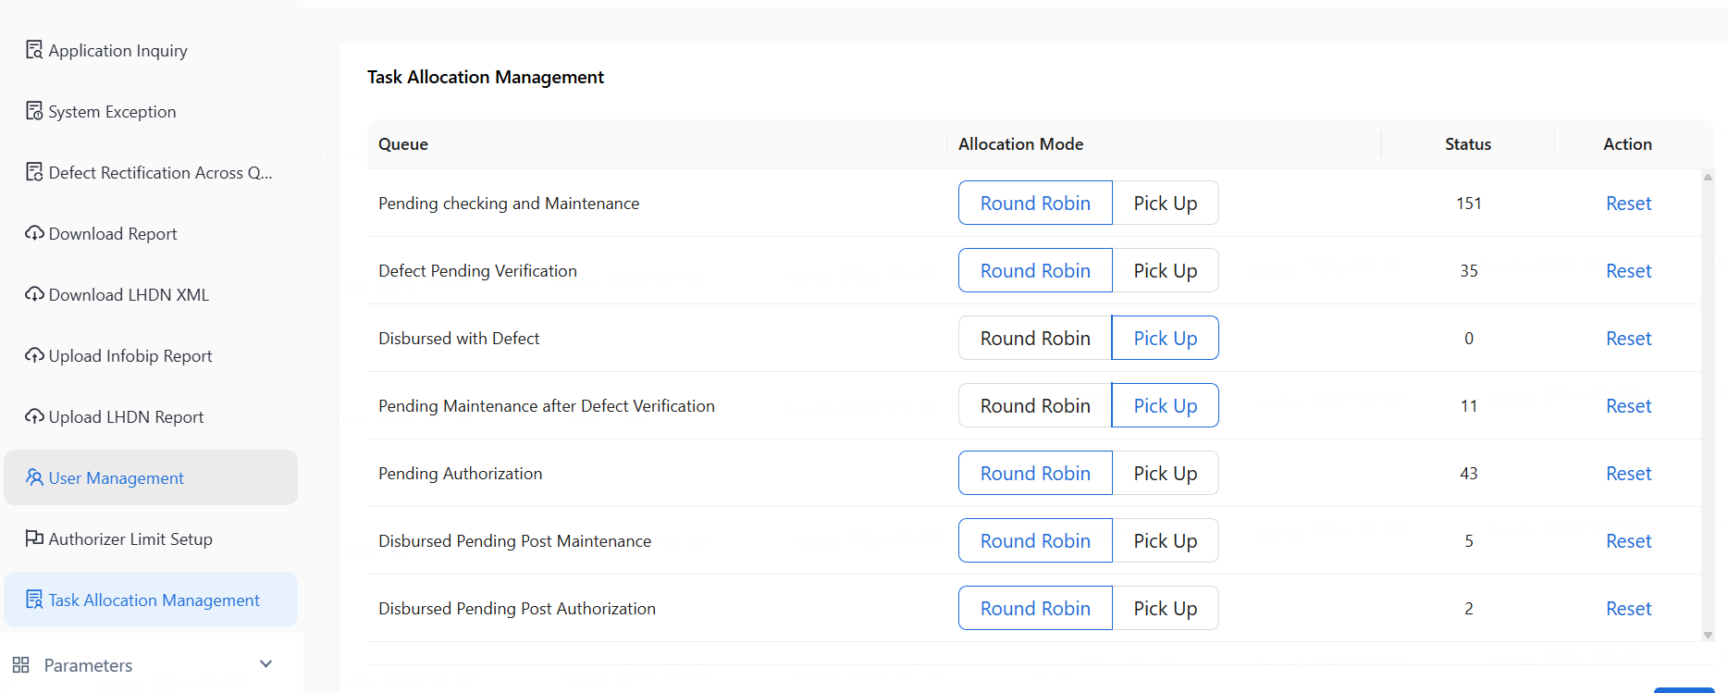

c) 【Available for CRA Manager and CRA ADMIN】Set User role weightage: Configurate via input a value from 0 to 100 for each role.
d) 【Available for CRA ADMIN】Set Authorizer_Level: Configured via a dropdown list. The options are populated from the CRA Authorization Limit parameter settings. This attribute is exclusive to the Authorizer role and is not visible for other roles.For CRA Authorizer Role this field is mandatory. The default value during user-role binding is empty.
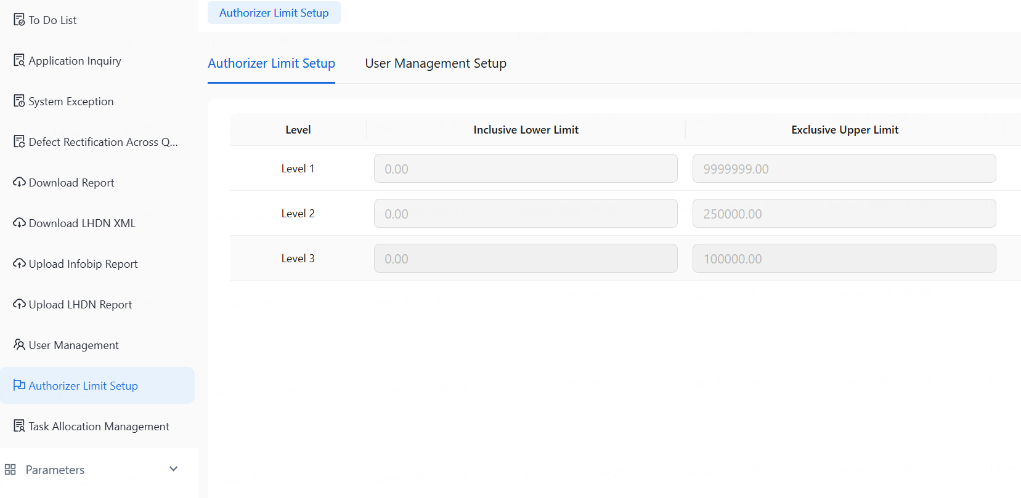

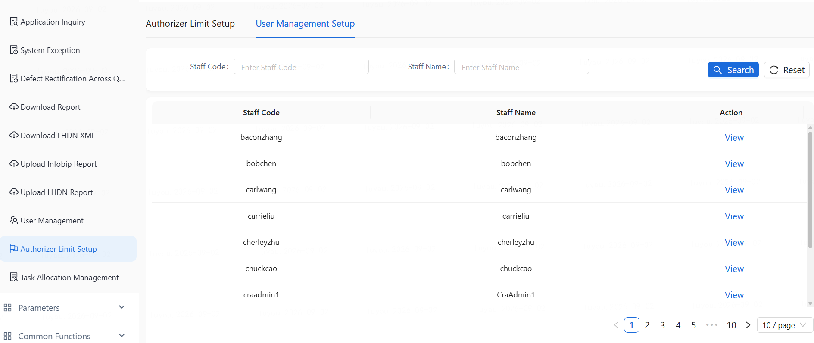

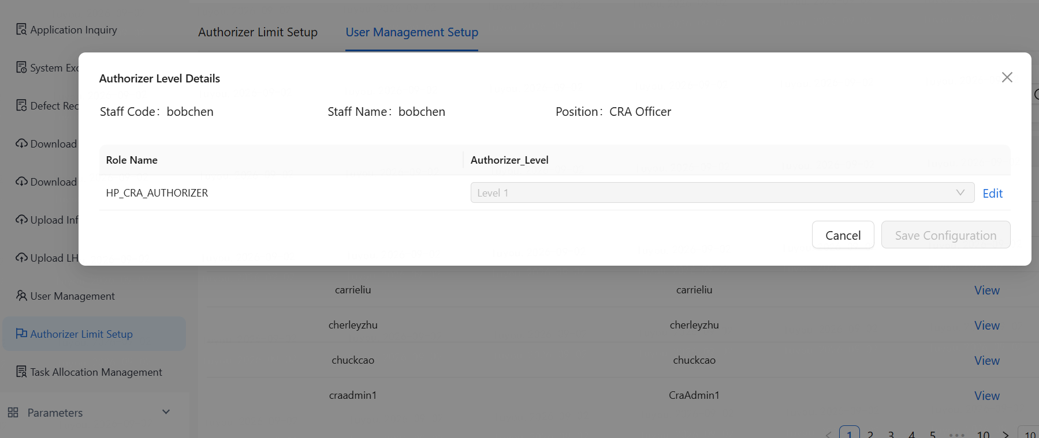

15.3. 【Same as Batch2】Application Allocation Configuration Rule
AS CRA Team I WANT the system supports both round-robin and manual Pick up modes, IN ORDER THAT Switch the case assignment method for specific scenarios or within specific time periods.
● Two allocation modes:
a. Round robin: The system automatically assigns cases based on the user's role, permissions, and weight, distributing them to the user role currently in the Active status.
b. Pick up: Manually select and claim cases from the pool.
● Configuration Dimensions:
a. Application Status. Status list refers to previous chapter of Principle Introduction
b. It must support configuring different case assignment methods for different queues handled by the same role. For example, the "funded with defect"​ status queue handled by the Defect Team can be configured for Pickup mode, while the "Defect Pending Verification"​ status queue can be configured for round robin mode​ simultaneously.
● Special Rules:
a. Pickup support pick up multi-cases in one time.

b. Data Maintenance or Checker cannot be an Authorizer for the same application. If a certain authorizer tries to pick up an application maintained or did defect rectification by himself, the system promotes "Maintenance or defect rectifier cannot be an Authorizer."
c. When Authorizer pick up, system check whether current Authorizer has sufficient Authorization limit, if Authorizer Limit Level is empty or do not have sufficient then block picking up.
d. When system round robin to Authorizer, system check whether current Authorizer has sufficient Authorization limit, if Authorizer Limit Level is empty or do not have sufficient limit then block round robin.

15.4. 【Same as Batch2】Round Robin Rules
AS CRA Team I WANT system to allocate applications based on user weightage, IN ORDER THAT Allocate based on the workload of the user's different roles.
● Cases are only assigned to users with an Active status, distributed according to each user's weightage.
● The last Data Maintenance, last Checker for an application cannot also be its Authorizer.
● Refer to the sample table below for specific allocation effects. The example assumes a total of 100 cases.
 | User Status | User Weightage (%) | Number of cases receive by User
User 1 | Active | 100 | 67
User 2 | Active | 50 | 33
User 3 | Inactive | 100 | 0
● The weightage could be set to 0, in this case the system should not assign application to this user, but this user still can obtain application via Pick Up mode or reassignment.
● Round robin weightage configuration
a. Select the user.
b. Select the role.
c. Input the weightage value.
d. Click save.

15.5. 【Same as Batch2】Application Assignment
AS CRA Team Manager I WANT system support to assign a specific application to a certain team member or back to the queue, IN ORDER THAT Flexibly adjust work arrangements.
● Entry Point: Main menu in left side of Use Page.
● Users with the Manager role can make cross-team adjustments. For example, a Check Manager can assign a case to a specific Authorizer.
● Cases cannot be assigned to users without the corresponding processing roles. For example, assigning a case from the maintenance queue to a user with the Authorizer role for processing is prohibited.
● When assigning a case to an Authorizer, the system ensures the Authorizer is not the same person as the Maintenance personnel of this application.
● When assigning a case to a Post Authorizer, the system ensures the Post Authorizer is not the same person as the Post maintenance personnel of this application.
● Query filter based on Application Query, add staff code as additional filter. When using the staff code filter, the system only displays the application which is in the task list of corresponding staff.
● User select application, click reassign button, then select target staff via staff code or staff name. After that confirm reassignment, system process and display result: “Total M, Reassigned N.” M is the total number of applications selected, N is the total number of applications assigned successfully.
● When reassigning to Authorizer, the system checks whether the current Authorizer has sufficient Authorization limit, if Authorizer Limit Level is empty or does not have sufficient limit then block reassignement.
● Support Reassignment multi-cases in one time.
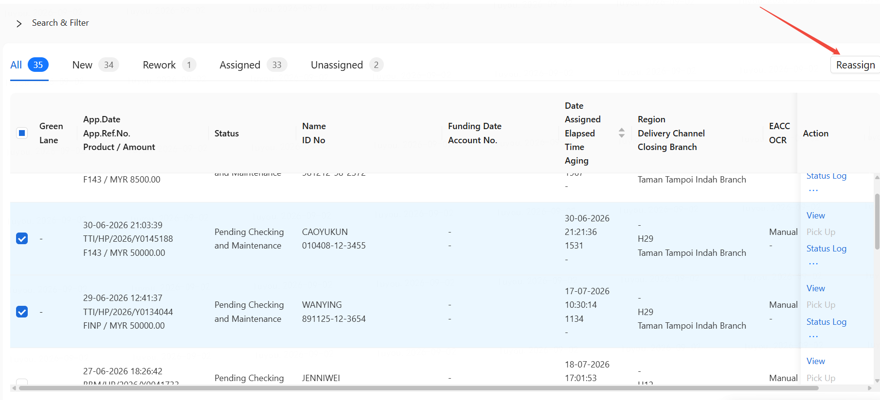
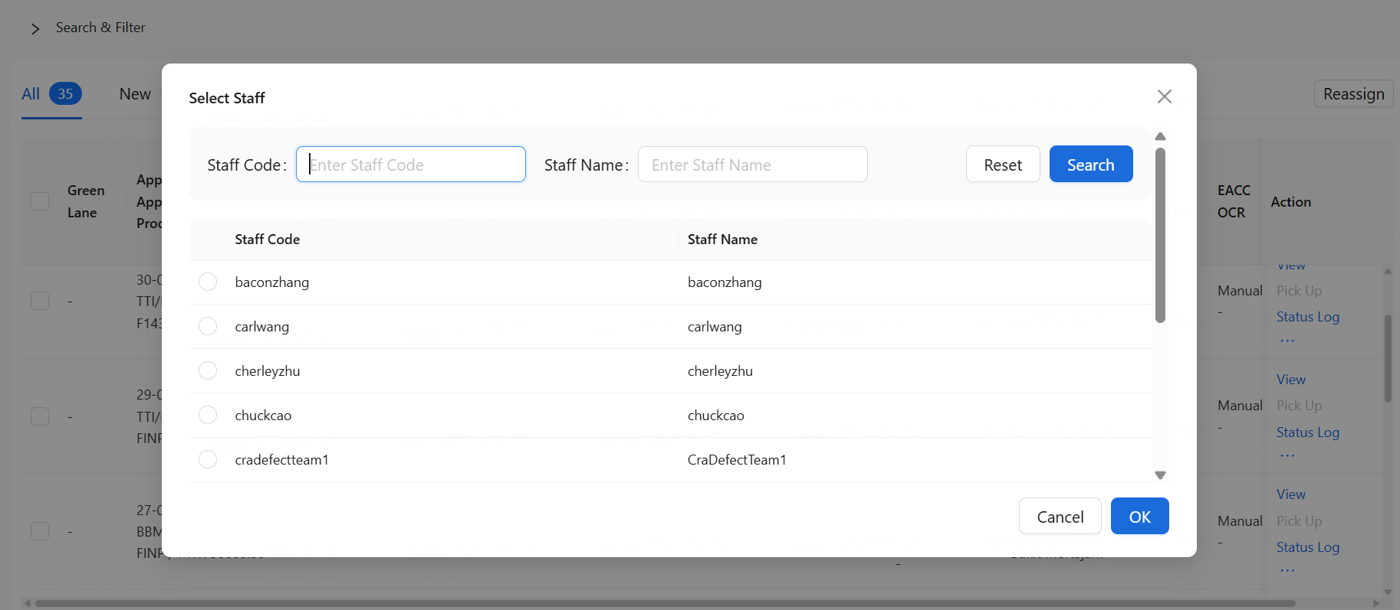

15.6. 【Same as Batch2】CRA Authorizer Limit
AS CRA Admin Team I WANT The system supports setting the maximum disbursement amount limit that each Authorizer is allowed to approve, IN ORDER TO ensure that the risk level of cases handled by a User matches their capability.
1. Business Rule
● CRA Authorizer level settings:
● Setting Dimension: Product (e.g., HP).
● Supports designing Level-1 to Level-3.
● Level-1 is the highest level, Level-3 is the lowest level.
● Set the approval amount range for Authorizers by level. Ranges for different levels should not overlap, for example:
 | Exclusive Upper Limit
Level 1 | 9,999,999.99
Level 2 | 250,000.00
Level 3 | 100,000.00
2. Control rules for assigning the CRA Authorizer role
a． When assigning the Authorizer role to a specific User, the corresponding Level​ must be selected simultaneously; otherwise, saving is not allowed
2. Example Scenario
Application route to CRA Authorizer:
5 applications loan amt + handling fee Less than RM100k
3 application Loan amt + handling fee Between RM100000.01 to RM250k
0 application > RM250000.00
 | User Status | User Weightage (%) | Number of cases receive by User
User 1 with Authorized Disbursement empowerment matrix Up to RM100K (Level 3) | Active | 100 | 5
User 2 with Authorized Disbursement empowerment matrix Up to RM250K (Level 2) | Active | 100 | 3
User 3 Authorized Disbursement empowerment matrix Up to Any Approved Amount (Level 1) | Active | 100 | 0

15.7. [Batch-3] Switch Allocation Mode And Assignment Optimization
- In order to automatically complete application assignments when switching the allocation mode from Pick-Up to Round-Robin for a queue/status, the system will add a scheduled job to scan unassigned applications whose status is in Round-Robin mode, and perform assignments based on the rules stated above in section 15.4.
- Assignment or pick up is not allowed when the owner opens the application in cra todo list. More detail in item b of 3.3 Application Assignment HP FSD Batch3-08-Disbursement
- Pop up the next assignee message when the application routes to the next action. More detail in item c of 3.3 Application Assignment HP FSD Batch3-08-Disbursement

16. Email/SMS template management

16.1. Email Template Management Entry
Display the exsting template list

16.2. Email Template Query Conditional Filter
Product type: dropdown list; HP only currently
Language: dropdown list; English, Malay
Reason Type: dropdown list; Predefined
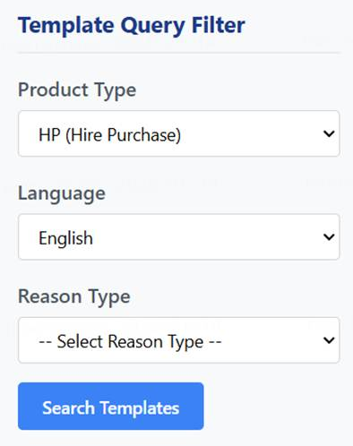

16.3. Email Template Action in Query Result list
Edit: Show template detail to modify.
Delete: Delete template.
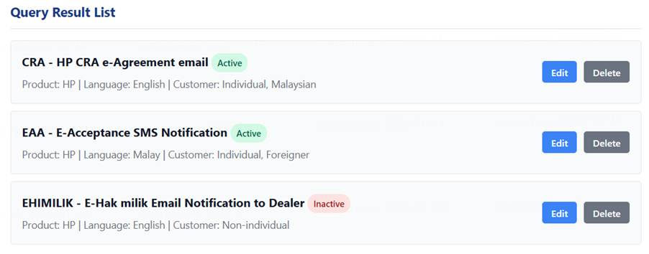

16.4. Email Template Detail Configuration
For each template code, administrators can configure the following information:

1) Basic Information
Template Code and Description: dropdown list

HTML Format: can tick HTML or plain text.
Email Sender Address: text box
Email Subject: text box (supports variables such as $DisplaySubjectByOrgCode, available variables predefined
Email Content: text area
Message ID: text box (for SMS, this must be the InApp message ID; for Email, it is optional)
User ID: dropdown list; Sales user, CED user, CRA user
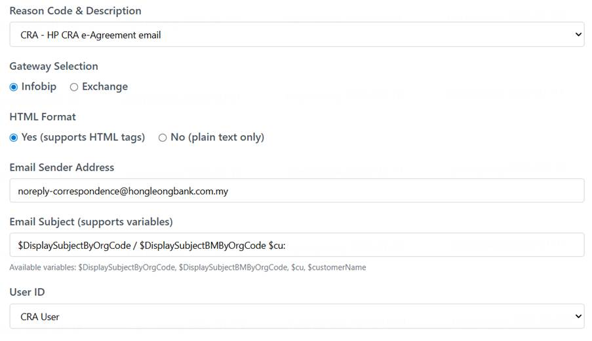

2) Sending Settings
Start Send Time (supports scheduled sending): input, e.g., 0900 means 9:00AM
Validity Period (in hours): input, e.g. 12

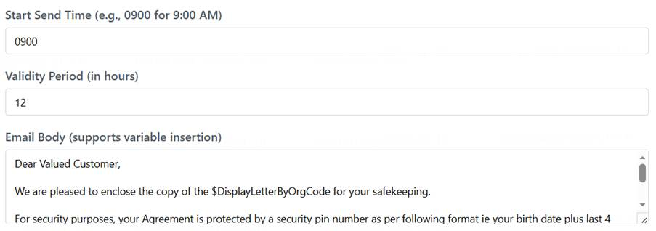

【need to be confirmed by CRA】 Modify email schedule time, whether immediately affect in-queue email tasks, or only new email tasks.

3) Letter Generation Options
Letter Generation: Mandatory, Optional, No Letter Generation
Letter Type Selection (dropdown)
Recipient and cc Configuration: multiple selector, e.g., Primary Hirer, Guarantor, etc.
Do Not Use Batch Scheduler Option: check box, if ticked email instantly, if unticked wait for nearest batch.
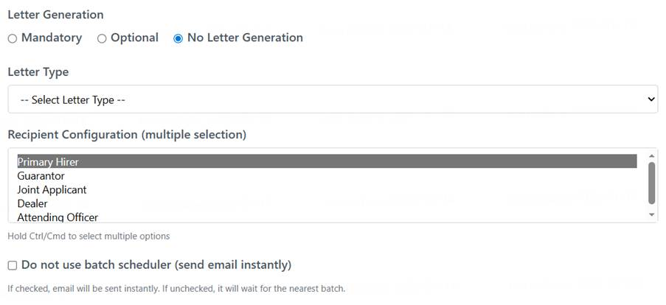

4) Condition Logic Configuration
Customer Type: radio box; Individual, Non-individual, Any
Nationality: radio box; Malaysian, Others (Foreigner), Any
Prefered Language: radio box; Malay, English


16.5. Email Template Status Management
Template status management: droplist; Active/Inactive
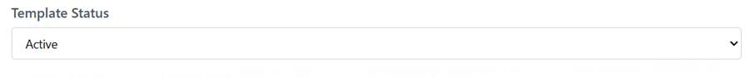


16.6. SMS Template
SMS template contents are managed in InApp.
CrediOS only provides the SMS message IDs which maps to templates in InApp, and not provide template management.

17. 【Same as Batch2】Email Sending retrigger
If a certain email sending failure, users can search and retrigger email sending.

17.1. Search Email Messages
Core Function: Provides multi-criteria combined search to quickly locate target email records.
Search Criteria:
Application Reference Number Range: App Ref No From / To
Creation Date Range: Create Date From / To
Sent Date Range: Sent Date From / To (As shown preset to recent dates: 01/01/2026 to 14/01/2026)
Email Status: Status (Dropdown, should include statuses like "Failed", "Sent", etc., for filtering failed emails)

Action Buttons:
Search: Executes the query.
Reset: Clears all search criteria.
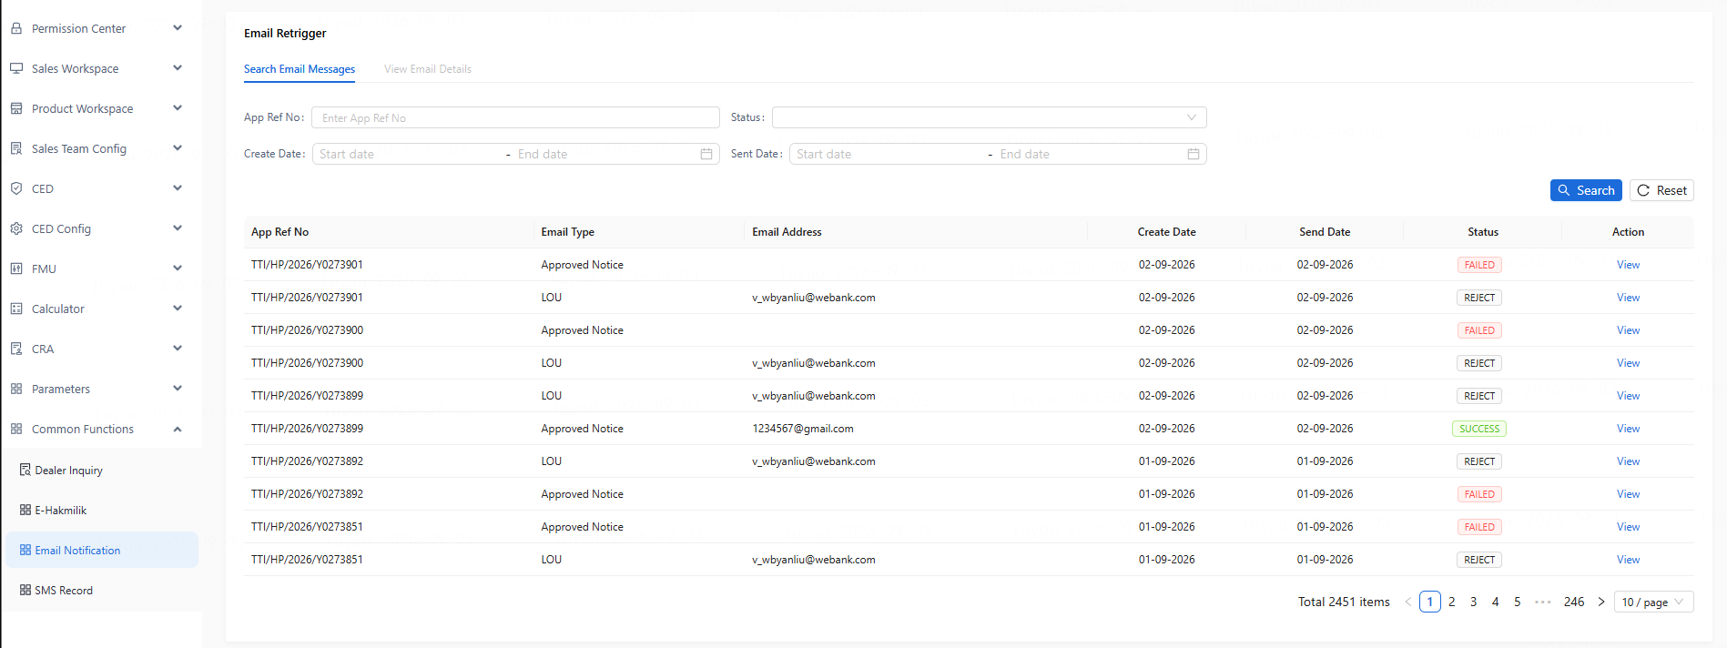

Search Results List:
Displayed Fields: App Ref No (Application Reference Number), Email Address (Recipient's Email), Create Date (Creation Date), Sent Date (Sent Date), Status, Action.
Action Items: In the Action column, a View Details button should be provided for each record to navigate to the next page.


17.2. View Email Message Details
Core Function: Displays the complete email content and provides an entry point for final confirmation and the resend operation.
Information Display Area (Formatted as a two-column table or similar layout):
Key Identifiers:
App Ref No (Corresponding business application), Email Type (Email type, e.g., LOSC.OTHER_NOTIFICATION as shown).
Email Metadata: Email Address (Recipient), Msg Locale (Language), Type, Subj (Email Subject).
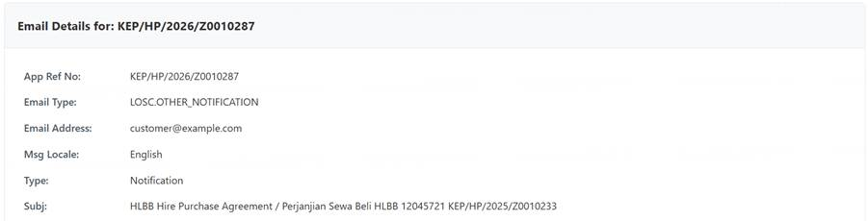
Content & Attachments: Displays the full email body (e.g., "Dear Valued Customer,...") and lists all attachment names (e.g., HP Agreement.pdf).
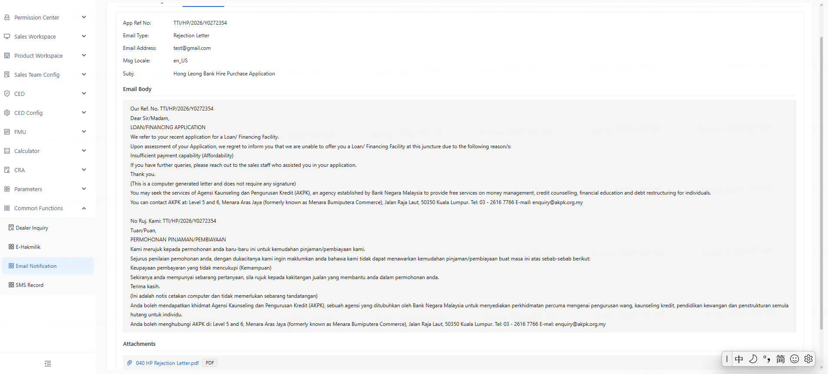
Resend Operation Area:
A prominent Resend Email button should be placed below the information display area.
Upon clicking, the system should display a confirmation dialog, e.g., "Confirm resending this email to [Recipient Email Address]?"
After confirmation, the system executes the resend logic and provides feedback on the success or failure of the operation.

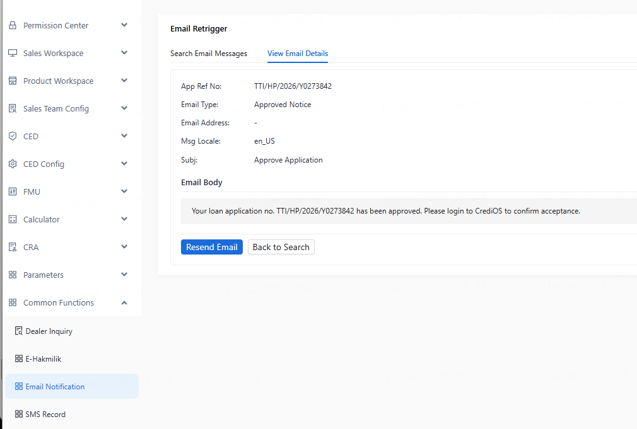

18. 【Same as Batch2】Parameter Management

18.1. CRA center
1. Code type: CRA_CENTER
2. CRA center creation
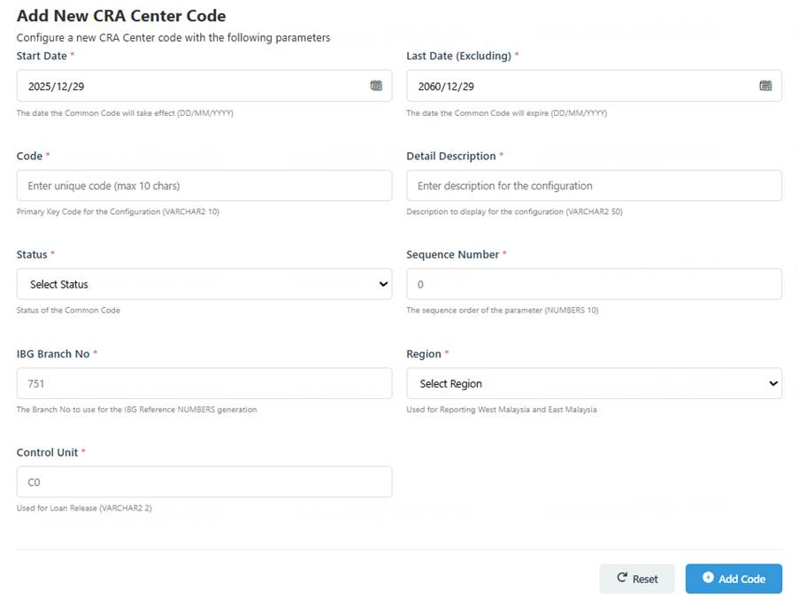
3. Because only 5 centers, only display the list without query features.
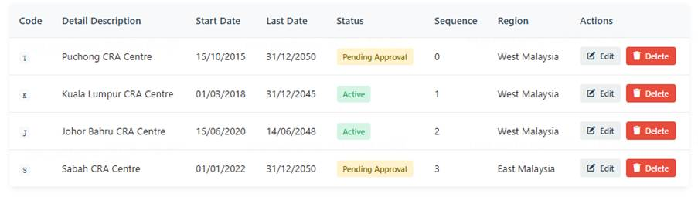
4. Support Edit and Delete.
5. Fields description
Field Name | Control Type | Input Field Format | M/N/C | Remarks
Start Date | Calendar | DD/MM/YYYY | M | The date the Common Code will take effect.
Last Date | Calendar | DD/MM/YYYY | M | The date the Common Code will expire.
Code | Input | VARCHAR2 (10) | M | Primary Key Code for the Configuration.
Detail Description | Input | VARCHAR2 (50) | M | Description to display for the configuration.
Status | Display | VARCAHR2 (1) | M | Status of the Common Code
Sequence Number | Input | NUMBERS (10) | M | The sequence order of the parameter. If multiple common codes are configured it will base on the sequence to determine the order.
IBG Branch No | Input | NUMBERS (10) | M | The Branch No to use for the IBG Reference NUMBERS generation.
Region | Input | VARCHAR2 (2) | M | Used for Reporting West Malaysia and East Malaysia.
 |  |  |  | WM - West Malaysia
 |  |  |  | EM - East Malaysia*
Control Unit | Input | VARCHAR2 (2) | M | Used for Loan Release.
6. Support Maker and Checker

18.2. Teller ID Configuration
2. Purpose: Used when interfacing disbursement to HOST. Obtain valid teller ID in sequence from teller ID list and post to interface.
3. When creation and edit, need to interface to HOST. On disbursement interface calling, Hos will verify whether the tell ID is valid.
4. Code type: TELLER_ID
5. Teller ID creation
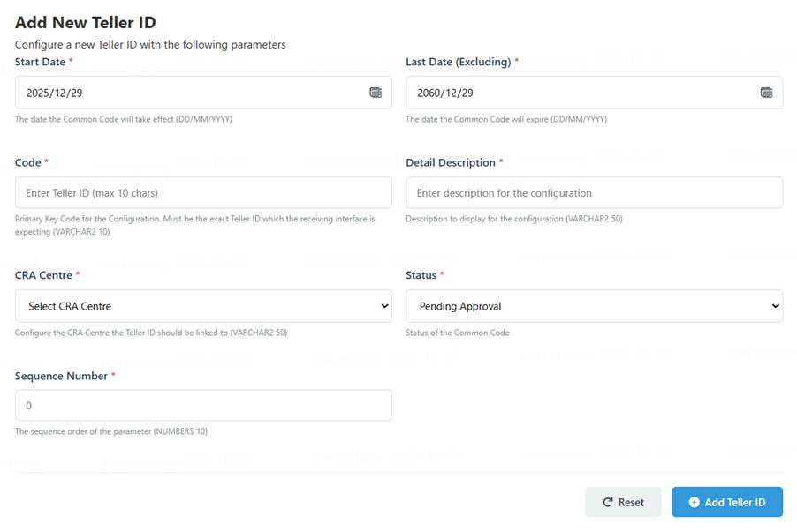

6. Search Parameters: Code, Detail Description, Status, Start Date From, Last Date to.
7. Button in search section: Clear, Search, New,Add Teller ID
8. Teller ID list display.
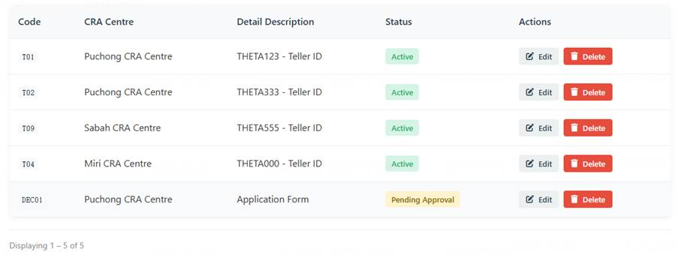
9. The Action column of the table supports: Edit and Delete
10. Field description
Field Name | Control Type | Input Field Format | M/N/C | Remarks
Start Date | Calendar | DD/MM/YYYY | M | The date the Common Code will take effect.
Last Date | Calendar | DD/MM/YYYY | M | The date the Common Code will expire.
Code | Input | VARCHAR2(10) | M | Primary Key Code for the Configuration. This field is required to be the exact Teller ID which the receiving interface is expecting.
Detail Description | Input | VARCHAR2(50) | M | Description to display for the configuration.
CRA Centre | Drop Down | VARCHAR2(50) | M | Configure the CRA Centre the Teller ID should be linked to.
Status | Display | VARCAHR2(1) | M | Status of the Common Code
Sequence Number | Input | NUMBERS(10) | M | The sequence order of the parameter. If multiple common codes are configured it will base on the sequence to determine the order.
7. Support Maker and Checker

18.3. ID Type Common Code Setup (FIS Business Code)
1. Code type: ID_TYPE
2. ID Type and FIS Business Code mapping Creation
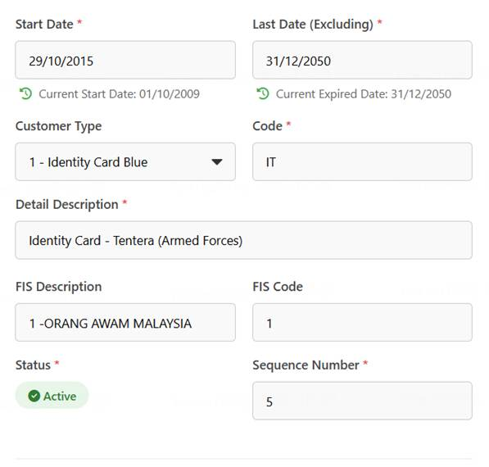
3. Search Parameters: Code, Detail Description, Customer Type, Status, Start Date From, Last Date to.
4. Button in search section: Clear, Search, New, Add Code Type

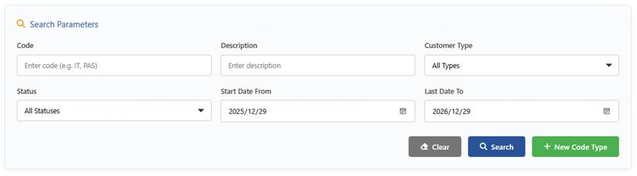
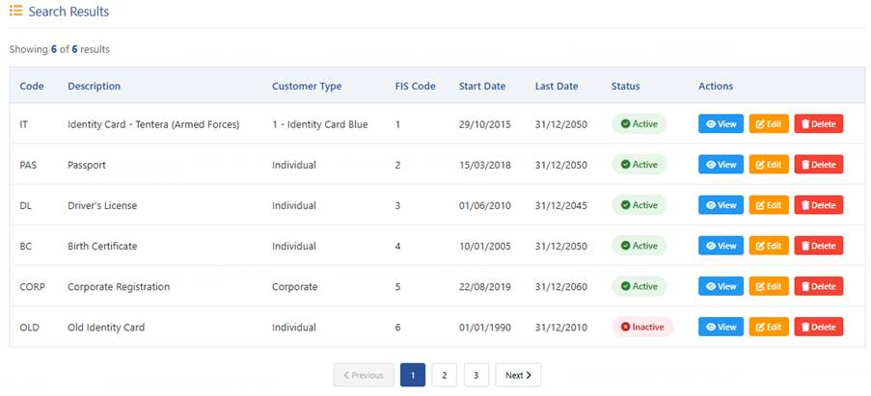
5. Support Edit and Delete
6. Field description
Field Name | Control Type | Input Field Format | M/N/C | Remarks
Start Date | Calendar | DD/MM/YYYY | M | The date the Common Code will take effect.
Last Date | Calendar | DD/MM/YYYY | M | The date the Common Code will expire.
Customer Type | Drop Down | VARCHAR2(20) | M | SOURCE: COMMON_CODE.ID_TYPE
Code | Input | VARCHAR2(10) | M | Primary Key Code for the Configuration. This field is required to be the exact Teller ID which the receiving interface is expecting.
Detail Description | Input | VARCHAR2(50) | M | Description to display for the configuration.
FIS  Description | Input | VARCHAR2(50) | N | Input the desired FIS Business Code Drop Down Description
FIS  Code | Input | VARCAHR2(1) | N | FIS Business Code to be sent to FIS
Status | Display | VARCAHR2(1) | M | Status of the Common Code
Sequence Number | Input | NUMBERS(10) | M | The sequence order of the parameter. If multiple common codes are configured it will base on the sequence to determine the order.

ID Type – CrediOS | FIS Mapping | Bahasa Drop Down Display
Business Registration | 4 - Business Registration | 4 -SYARIKAT / PERTUBUHAN
Certificate of Incorporation | 4 - Certificate of Incorporation | 4 -SYARIKAT / PERTUBUHAN
Registration Certificate | 4 - Registration Certificate | 4 -SYARIKAT / PERTUBUHAN
Foreign Business Registration | 4 - Foreign Business Registration | 4 -SYARIKAT / PERTUBUHAN
Government And Its Agencies | 5 - Government And It's Agencies | 5 -KERAJAAN / BADAN BERKANUN
Identity Card - Blue | 1 - Identity Card Blue | 1 -ORANG AWAM MALAYSIA
Identity Card - Red | 0 - Identity Card Red | 0 -PENDUDUK TETAP
Identity Card - Green | 0 - Identity Card Green | 0 -PENDUDUK TETAP
Identity Card - Police | 1 - Identity Card Police | 1 -ORANG AWAM MALAYSIA
Identity card - Tentera (Armed Forces) | 1 - Identity Card - Tentera (Armed Forces) | 1 -ORANG AWAM MALAYSIA
Passport | 9 - Passport | 9 -BUKAN WARGANEGARA
Identity Card - Foreign | 9 - Identity Card Foreign | 9 -BUKAN WARGANEGARA
Identity Card - Brown | 1 - Identity Card Brown | 1 -ORANG AWAM MALAYSIA
5. Support Maker and Checker

18.4. Pay Off Mode Common Code
1. Common Code Search
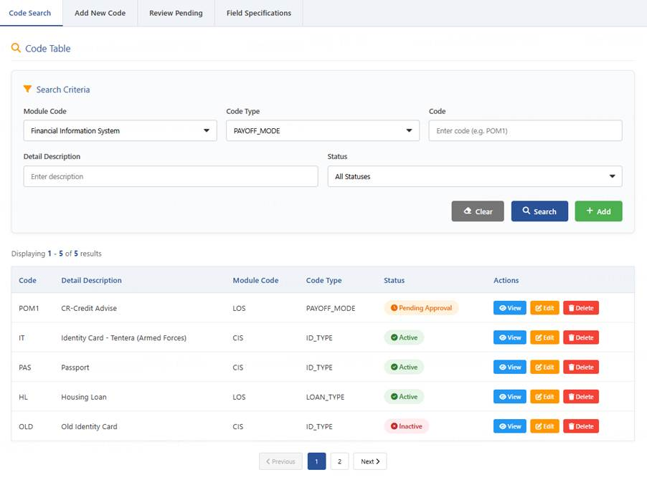
2. Add new Common Code
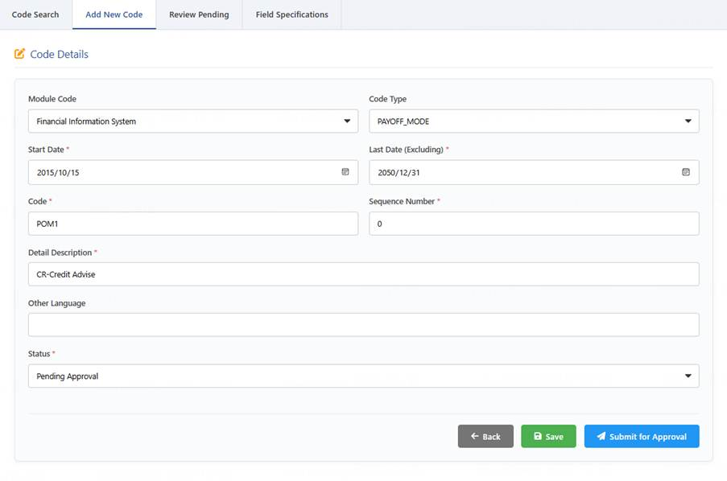
3. Support Edit and delete
4. Common Code Approval
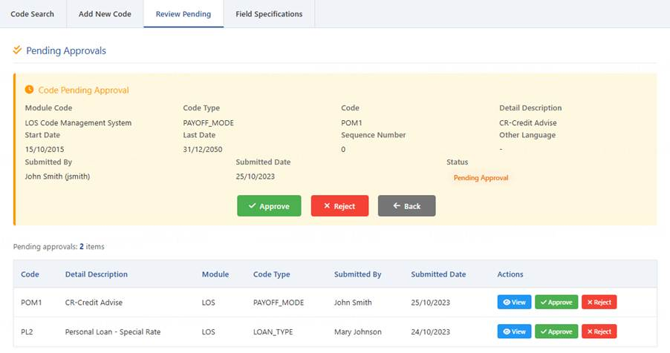
5. Code type: PAYOFF_MODE
6. Field list
Field Name | Control Type | Input Field Format | M/N/C | Remarks
Start Date | Calendar | DD/MM/YYYY | M | The date the Common Code will take effect.
Last Date | Calendar | DD/MM/YYYY | M | The date the Common Code will expire.
Code | Input | VARCHAR2 (10) | M | Primary Key Code for the Configuration.
Detail Description | Input | VARCHAR2 (50) | M | Description to display for the configuration.
Status | Display | VARCAHR2 (1) | M | Status of the Common Code
Sequence Number | Input | NUMBERS (10) | M | The sequence order of the parameter. If multiple common codes are configured it will base on the sequence to determine the order.
8. Support Maker and Checker

18.5. Pay Off Reason Code Common Code
1. User pages follow Common Page in Pay off Mode
2. Special fields compare to Common Page: Host Mapping
3. Code type: PAYOFF_REASON
4. Field list
Field Name | Control Type | Input Field Format | M/N/C | Remarks
Start Date | Calendar | DD/MM/YYYY | M | The date the Common Code will take effect.
Last Date | Calendar | DD/MM/YYYY | M | The date the Common Code will expire.
Code | Input | VARCHAR2 (10) | M | Primary Key Code for the Configuration.
Detail Description | Input | VARCHAR2 (50) | M | Description to display for the configuration.
Status | Display | VARCAHR2 (1) | M | Status of the Common Code
Host Mapping | Input | VARCHAR2(50) | M | Input Value to Map to Host
Sequence Number | Input | NUMBERS (10) | M | The sequence order of the parameter. If multiple common codes are configured it will base on the sequence to determine the order.

5. Host mapping
CrediOS Code | Host Mapping | Description
POR1 | 2 | 02 - CUSTOMER SERVICE EXPECTATIONS
POR2 | 7 | 07 - PRODUCT FEATURES
POR3 | 13 | 13 - SHIFT/MIGRATION
POR4 | 14 | 14 - DECEASED
POR5 | 15 | 15 - NO REASON GIVEN
POR6 | 21 | 21 - IMPROVED FINANCIAL POSITION
POR7 | 24 | 24 - MARKET CONDITION
POR8 | 25 | 25 - NON - MARGINABLE COUNTER
POR9 | 35 | 35 - INTEREST RATE (REFINANCING WITH OTHER BANK)
POR10 | 36 | 36 - DISPOSAL TO DEALER
POR11 | 37 | 37 - DISPOSAL TO OTHERS

18.6. GL Reference No Common Code
1. User pages follow Common Page in Pay off Mode
2. Special fields compare to Common Page: GL No
3. Code type: GL_REF_NO
4. Field list
Field Name | Control Type | Input Field Format | M/N/C | Remarks
Start Date | Calendar | DD/MM/YYYY | M | The date the Common Code will take effect.
Last Date | Calendar | DD/MM/YYYY | M | The date the Common Code will expire.
Code | Input | VARCHAR2(10) | M | Primary Key Code for the Configuration.
Detail Description | Input | VARCHAR2(50) | M | Description to display for the configuration.
GL No | Input | NUMBERS(19) | M | GL Reference No sent to Host for Payment by Advise
Status | Display | VARCAHR2(1) | M | Status of the Common Code
Sequence Number | Input | NUMBERS(10) | M | The sequence order of the parameter. If multiple common codes are configured it will base on the sequence to determine the order.
5. GL No mapping
CrediOS Code | Host Mapping | Description
GL1 | 10604115010 | GIRO SUSPENSE-AUTO LOAN - 10604115010
GL2 | 10604172200 | S/CRED - UMW TOYOTA - 10604172200
GL3 | 10604172210 | SUNDRY CREDITOR - HP CTRLIZED PAYMENT- CAR DLRS - 10604172210
GL4 | 10604176402 | POSTAGE - 10604176402
GL5 | 10605040000 | HP STAMP & POSTAGE FEES - 10605040000
GL6 | 10620000000 | DAY SETTLEMENT ACCOUNT - 10620000000
GL7 | 10620200000 | TELLER TRANSACTIONS - 10620200000
GL8 | 20704011000 | SUNDRY DEBTOR (HP) - HONDA - 20704011000
GL9 | 20704012000 | SUNDRY DEBTOR (HP)-HICOMOBIL - 20704012000
GL10 | 20799080000 | CONTRA-LOAN - 20799080000
GL11 | 20799090000 | CONTRA-HEAD OFFICE - 20799090000
GL12 | 60008303000 | ADMINSTRATION CHARGES/FEE - 60008303000
GL13 | 60008312000 | HP SERVICE FEES - 60008312000
GL14 | 60008313000 | HP ADMIN FEES - 60008313000
GL15 | 60008330000 | HP ROAD TAX FEES - 60008330000
GL16 | 60008340300 | HP ADMIN CHARGES ON FUNDING - 60008340300
GL17 | 60008990000 | OTHER FEE INCOME - 60008990000
GL18 | 60009190500 | SERVICE CHARGE REMITTANCE - 60009190500
GL19 | 70005032000 | ROAD TAX/INSURANCE - 70005032000
GL20 | 70006330000 | HANDLING FEE - 70006330000
GL21 | 70007052000 | FREIGHT CHARGES - 70007052000
GL22 | 70007060100 | STAMPS & POSTAGE - 70007060100
GL23 | 70007060200 | COURIER - 70007060200
GL24 | 70007144000 | OTHERS - 70007144000
GL25 | 70007164010 | ROB/ROC SEARCH FEES - 70007164010
GL26 | 70007180000 | MISC CHARGES - 70007180000
GL27 | 70007220000 | BANKERS & CORRESPONDENT CHARGES - 70007220000
GL28 | 70007500700 | RUNNER FEES - 70007500700

18.7. Recipient Payment Reference Common Code
1. User pages follow Common Page in Pay off Mode
2. Code type: REC_PAY_REF
3. Field list
Field Name | Control Type | Input Field Format | M/N/C | Remarks
Start Date | Calendar | DD/MM/YYYY | M | The date the Common Code will take effect.
Last Date | Calendar | DD/MM/YYYY | M | The date the Common Code will expire.
Code | Input | VARCHAR2 (10) | M | Primary Key Code for the Configuration.
Detail Description | Input | VARCHAR2 (50) | M | Description to display for the configuration.
Status | Display | VARCAHR2 (1) | M | Status of the Common Code
Sequence Number | Input | NUMBERS (10) | M | The sequence order of the parameter. If multiple common codes are configured it will base on the sequence to determine the order.
4. Code mapping
CrediOS Code | Host Mapping | Description | Drop Down Display
3 | 3 | BALANCE TRANSFER | 3-BALANCE TRANSFER
9 | 9 | FEES | 9-FEES
10 | 10 | FUNDING | 10-FUNDING
14 | 14 | LOAN PAYMENT | 14-LOAN PAYMENT
18 | 18 | REFUND | 18-REFUND
26 | 26 | OTHERS | 26-OTHERS
36 | 36 | HANDLING FEE | 36-HANDLING FEE
42 | 42 | STAMP DUTY FEE | 42-STAMP DUTY FEE
43 | 43 | UPFRONT FEE | 43-UPFRONT FEE

18.8. Branch Centre/Region (Reporting) Common Code
1. User pages follow Common Page in Pay off Mode
2. Code type: BRANCH_REGION
3. Field list
Field Name | Control Type | Input Field Format | M/N/C | Remarks
Start Date | Calendar | DD/MM/YYYY | M | The date the Common Code will take effect.
Last Date | Calendar | DD/MM/YYYY | M | The date the Common Code will expire.
Code | Input | VARCHAR2 (10) | M | Primary Key Code for the Configuration.
Detail Description | Input | VARCHAR2 (50) | M | Description to display for the configuration.
Status | Display | VARCAHR2 (1) | M | Status of the Common Code
Sequence Number | Input | NUMBERS (10) | M | The sequence order of the parameter. If multiple common codes are configured it will base on the sequence to determine the order.

18.9. Segment Code (IBG) Common Code
1. User pages follow Common Page in Pay off Mode
2. Code type: IBG_SEGMENT
3. Field list
Field Name | Control Type | Input Field Format | M/N/C | Remarks
Start Date | Calendar | DD/MM/YYYY | M | The date the Common Code will take effect.
Last Date | Calendar | DD/MM/YYYY | M | The date the Common Code will expire.
Code | Input | VARCHAR2 (10) | M | Primary Key Code for the Configuration.
Detail Description | Input | VARCHAR2 (50) | M | Description to display for the configuration.
Status | Display | VARCAHR2 (1) | M | Status of the Common Code
Sequence Number | Input | NUMBERS (10) | M | The sequence order of the parameter. If multiple common codes are configured it will base on the sequence to determine the order.
4. Host mapping
LOS Code | Host Mapping | Description
0 | 0 | 0-GOVERNMENT
1 | 1 | 1-PRIVATE
2 | 2 | 2-OTC
4 | 4 | 4-ACCOUNT GENERAL
6 | 6 | 6-E-SHARE TRANSACTION
7 | 7 | 7-E-DIVIDEND TRANSACTION

18.10. Element Code (IBG) Common Code
1. User pages follow Common Page in Pay off Mode
2. Code type: BRANCH_REGION
3. Field list
Field Name | Control Type | Input Field Format | M/N/C | Remarks
Start Date | Calendar | DD/MM/YYYY | M | The date the Common Code will take effect.
Last Date | Calendar | DD/MM/YYYY | M | The date the Common Code will expire.
Code | Input | VARCHAR2 (10) | M | Primary Key Code for the Configuration.
Detail Description | Input | VARCHAR2 (50) | M | Description to display for the configuration.
Status | Display | VARCAHR2 (1) | M | Status of the Common Code
Sequence Number | Input | NUMBERS (10) | M | The sequence order of the parameter. If multiple common codes are configured it will base on the sequence to determine the order.
4. Host mapping
LOS Code | Host Mapping | Description
0 | 0 | 0-RESIDENT
1 | 1 | 1-NON-RESIDENT

18.11. Bank Setup
Users could set up bank information via this feature, then use bank description parameters in dealer management and IBG transaction treatment maintenance process.
1. Search Bank
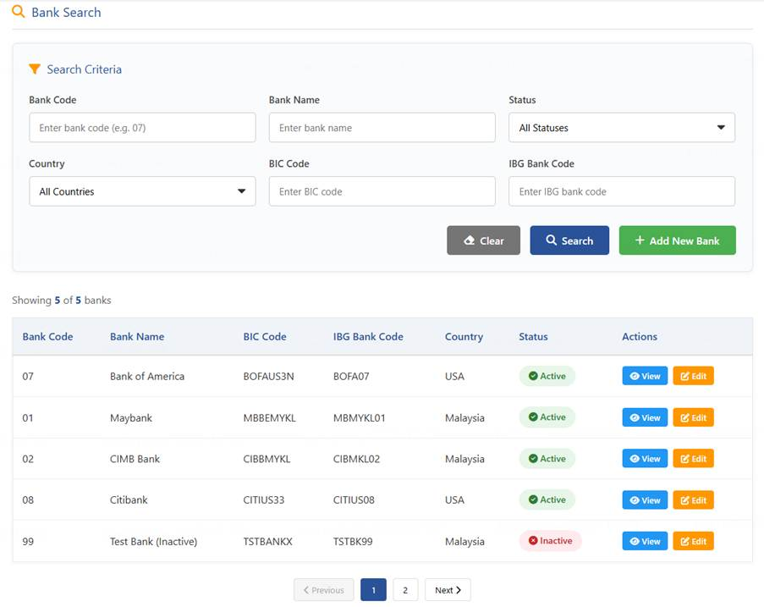
2. Edit Bank information
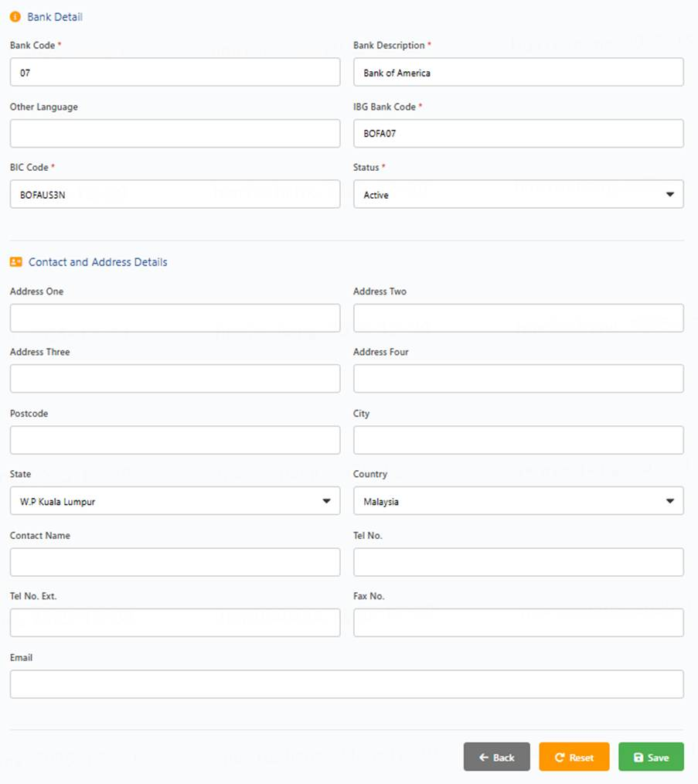
3. Field
Field Name | Control Type | Input Field Format | M/N/C | Remarks
Bank Code | Input | VARCHAR2 (10) | M | Unique identifier for the bank
Bank Description | Input | VARCHAR2 (50) | M | Script Update to have IBG Bank Code + Name
Other Language | Input | VARCHAR2 (50) | N | Bank description in another language
IBG Bank Code | Input | VARCHAR2 (20) | M | The IBG Bank Code used for the IBG Reference Number Generation.
BIC Code | Input | VARCHAR2 (20) | M | The BIC Code used for IBG Transactions.
Status | Dropdown | VARCHAR2 (10) | M | Active or Inactive status
Address One | Input | VARCHAR2 (100) | N | Primary address line
Address Two | Input | VARCHAR2 (100) | N | Secondary address line
Address Three | Input | VARCHAR2 (100) | N | Tertiary address line
Address Four | Input | VARCHAR2 (100) | N | Quaternary address line
Postcode | Input | VARCHAR2 (20) | N | Postal/ZIP code
City | Input | VARCHAR2 (50) | N | City name
State | Dropdown | VARCHAR2 (50) | N | State/Province
Country | Dropdown | VARCHAR2 (50) | N | Country name
Contact Name | Input | VARCHAR2 (100) | N | Primary contact person
Tel No. | Input | VARCHAR2 (20) | N | Telephone number
Tel No. Ext. | Input | VARCHAR2 (10) | N | Telephone extension
Fax No. | Input | VARCHAR2 (20) | N | Fax number
Email | Input | VARCHAR2 (100) | N | Email address

18.12. Branch Configuration
1. Follow Branch configuration, here to emphasize the special parameters for disbursement
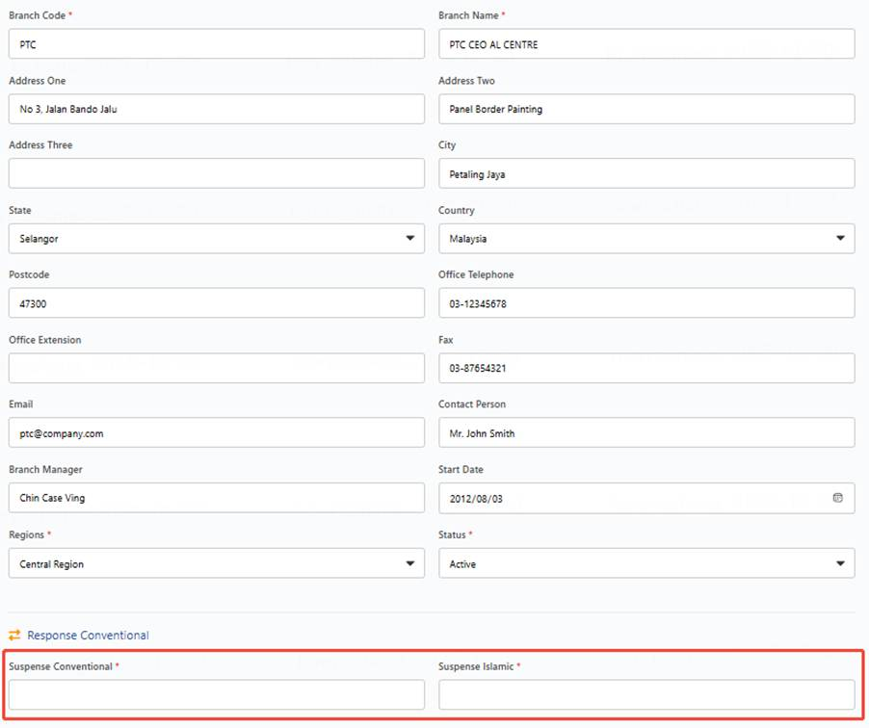
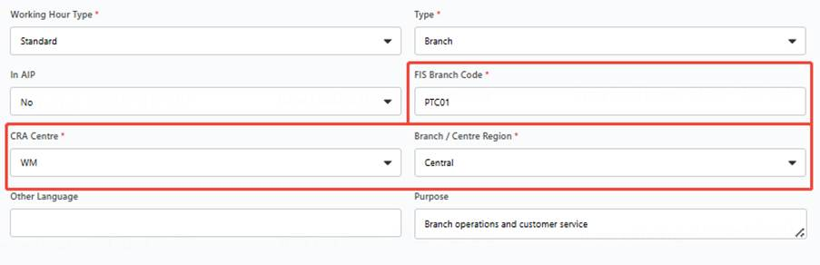
2. Fields
Field Name | Control Type | Input Field Format | M/N/C | Remarks
Suspense Conventional | Input | VARCHAR2 (20) | C | LOS will take this value for the LS Account No for Suspense Disbursement if the Lending Type is Conventional. Mandate if Type = Branch
Suspense Islamic | Input | VARCHAR2 (20) | C | LOS will take this value for the LS Account No for Suspense Disbursement if the Lending Type is Islamic. Mandate if Type = Branch
FIS Branch Code | Input | VARCHAR2 (20) | C | LOS will take this Code to send to FIS for the E-Hakmilik Registration. This will be the FIS Branch Code Interface Mapping. Mandate if Type = Branch
CRA Centre | Drop Down | VARCHAR2 (10) | C | This value will affect the routing of the application to the correct region of CRA Centre, i.e WM, EM1, EM2 and etc. The value will also affect the IBG Branch ID for the IBG Reference Number. Parameterised – Values taken from Common Code Mandate if Type = Branch
Branch / Centre Region | Drop Down | VARCHAR2 (10) | C | This value will affect Reporting based on Host Branch Region. Common Code Setup Mandate if Type = Branch

18.13. GST Tax Code General Constant
1. General Constant Search and result display
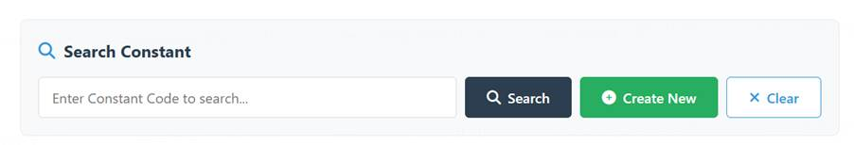
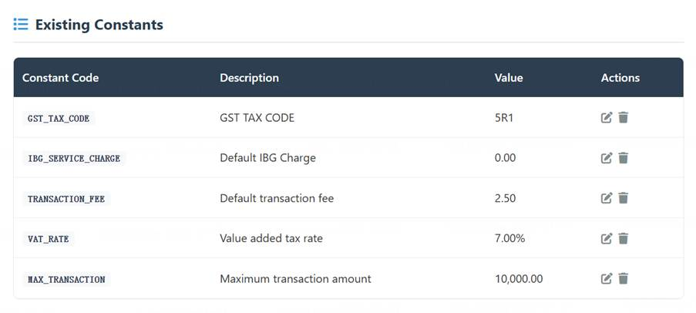
2. General Constant Creation
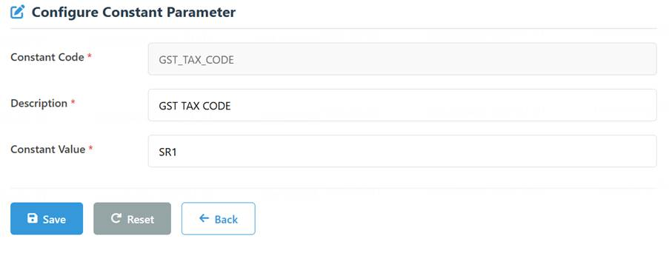
3. Constant Code: GST_TAX_CODE
4. Field
Field Name | Control Type | Input Field Format | M/N/C | Remarks
Description | Input | VARCHAR2(500) | M | Description of the Constant
Constant Value | Input | VARCHAR2(700) | M | Input Tax Code sent to IBG. (Example value: TX1)  Mandatory value for HOST (TBC).

18.14. IBG GST Indicator General Constant
1. Constant setting same as GST Tax Code
2. Constant Code: IBG_GST_INDICATOR
3. Field
Field Name | Control Type | Input Field Format | M/N/C | Remarks
Description | Input | VARCHAR2(500) | M | Description of the Constant
Constant Value | Input | VARCHAR2(700) | M | Input:  Y – Apply GST  N – Do Not Apply GST

18.15. GST Rate General Constant - 1
1. Constant setting same as GST Tax Code
2. Constant Code: GST_RATE
3. Field
Field Name | Control Type | Input Field Format | M/N/C | Remarks
Description | Input | VARCHAR2(500) | M | Description of the Constant
Constant Value | Input | VARCHAR2(700) | M | To determine the GST Rate ( Example: 0 * Currently set as Zero due to GST no longer applicable)

18.16. GST Rate General Constant - 2
1. Constant setting same as GST Tax Code
2. Constant Code: GST_TAX_CCODE_EPP
3. Field
Field Name | Control Type | Input Field Format | M/N/C | Remarks
Description | Input | VARCHAR2(500) | M | Description of the Constant
Constant Value | Input | VARCHAR2(700) | M | Purpose: Input Tax Code sent to IBG. (Example value: SR1 )  Mandatory value for EPP interface(TBC).

18.17. FIS Inquiry Interval General Constant
1. Constant setting same as GST Tax Code
2. Constant Code: FIS_INQUIRY_INTERVAL
3. Field
Field Name | Control Type | Input Field Format | M/N/C | Remarks
Description | Input | VARCHAR2(500) | M | Description of the Constant
Constant Value | Input | VARCHAR2(700) | M | Input interval hours. E.g. 1, 2, 3

4. Business Rule
● Supports configuration by hour, e.g. 1 hour, 2 hours
● The system is initialized with a configuration of x hours (TBD).
● Become valid instantly after configuration.

18.18. Post-Agreement Overdue Reminder Parameter General Constant
AS CRA Team I WANT the system support configurating Post-Agreement Overdue Reminder Parameter, IN ORDER THAT Adjust as needed.
1. Constant setting same as GST Tax Code
2. Constant Code: AGREEMENT_OVERDUE_DAYS
3. Field
Field Name | Control Type | Input Field Format | M/N/C | Remarks
Description | Input | VARCHAR2(500) | M | Description of the Constant
Constant Value | Input | VARCHAR2(700) | M | Input post-agreement overdue days. E.g. 5, 3, etc.

18.19. Post-Approval Overdue Reminder Parameter General Constant
AS CRA Team I WANT the system support configurating Post-Approval Overdue Reminder Parameter, IN ORDER THAT Adjust as needed.
4. Constant setting same as GST Tax Code
5. Constant Code: APPROVAL_OVERDUE_DAYS
6. Field
Field Name | Control Type | Input Field Format | M/N/C | Remarks
Description | Input | VARCHAR2(500) | M | Description of the Constant
Constant Value | Input | VARCHAR2(700) | M | Input post-approval overdue days. E.g. 30, 60, 90
7. Business Rule
● Supports configuration by day, e.g., 90 days.
● The system is initialized with a configuration of 90 days.

18.20. Mandatory Disbursement File checking list
AS CRA Team I WANT the system support configurating mandator file list displayed in application detail page, IN ORDER TO accurately track file upload and verification status.
1. Business Rule
● Support add, modify, inactive files.
● File List:
Files | Remark
Biometric Result | Mandatory
Application Form | Mandatory
NRIC/SSM/Passport | Mandatory
D/License | Mandatory
HP Agreements | Mandatory
2nd Schedule Part I | Mandatory
Vehicle Invoice | Mandatory
FIS/JPJ Result | Mandatory
Delivery Receipt | Conditional
VOC | Conditional
Road tax/JPJ Receipt | Conditional
Insurance | Mandatory
Standing Instruction | Conditional
FD pledge | Conditional
Guarantee Agreement / Guarantor Right & Liabilities | Optional
FBR Docs: HP566, E-Hakmilik | Optional
Used Car Docs: Appx 3, Appx 4, Puspakom, AP Docs (RECOND) | Optional
Settlement Cases: Redemption Statement, HP546, HP556 / HP276 | Optional
Direct Cases: Photocopy of Seller's NRIC, RAMCI / Bankruptcy Search | Optional
Company / Business Docs: Company Reso, Disposal Reso, M&A, Partnership Mandate, SSM Search | Optional
Conditional Approval: , etc. | Optional
Others: IBG Letter, Loan Suspense Receipt, Deviation Approval, Photo of Chattel (IHP) | Optional
2nd Schedule Part II | Optional

18.21. Interface Error Retrigger Maximum Times General Constant
AS CRA Team I WANT the system support configurating interface error retrigger maximum times, IN ORDER TO adjust when needed.
1. Constant setting same as GST Tax Code
2. Constant Code: INTERFACE_ERROR_RETRIGGER_MAXIMUM_TIMES
3. Field
Field Name | Control Type | Input Field Format | M/N/C | Remarks
Description | Input | VARCHAR2(500) | M | Description of the Constant
Constant Value | Input | VARCHAR2(700) | M | Input maximum retrigger times. E.g. 5.

4. Business Rule
● Initialized to 5

18.22. Interface Error Retrigger Interval General Constant
AS CRA Team I WANT the system support configurating HOST interface error retrigger interval, IN ORDER TO adjust when needed.
1. Constant setting same as GST Tax Code
2. Constant Code: INTERFACE_ERROR_RETRIGGER_INTERVAL
3. Field
Field Name | Control Type | Input Field Format | M/N/C | Remarks
Description | Input | VARCHAR2(500) | M | Description of the Constant
Constant Value | Input | VARCHAR2(700) | M | Input maximum retrigger interval in minute. E.g. 30.
4. Business Rule
● Applies to: Error scenarios during various external interface calls (e.g., network timeouts) that do not require modifying the submitted data. Defines the system's retry interval in such cases.
● Supports modification.
● System initialization: 30 minutes.

18.23. Hirer/Guarantor Email Generation Time General Constant
AS CRA Team I WANT the system to support configurating Hirer/Guarantor Email Generation Time, IN ORDER TO adjust when needed.
1. Constant setting same as GST Tax Code
2. Constant Code: EMAIL_GENERATION_TIME
3. Field
Field Name | Control Type | Input Field Format | M/N/C | Remarks
Description | Input | VARCHAR2(500) | M | Description of the Constant
Constant Value | Input | VARCHAR2(700) | M | Input Email generation time in days. E.g. 7.
4. Business Rule
● Support modification
● Initialized to 7 Day after disbursement, Disbursement Date is Day 1

18.24. LHDN XML File Generation Time General Constant
AS CRA Team I WANT system to support configurate File Generation Time, IN ORDER TO adjust when needed.
1. Constant setting same as GST Tax Code
2. Constant Code: LHDN_FILE_GENERATION_TIME
3. Field
Field Name | Control Type | Input Field Format | M/N/C | Remarks
Description | Input | VARCHAR2(500) | M | Description of the Constant
Constant Value | Input | VARCHAR2(700) | M | Input LHDN file generation time in day. E.g. 3.
4. Business Rule
● Support modification
● Initialized to 3 Day after disbursement, Disbursement Date is Day 1

18.25. Collateral Parameters Setup/Maintenance
Setup/maintenance to be covered at HP_Product_Sales FSD in view the usage during application creation stage.
1. Business Rule
● Migration current collateral parameter
● Support Create, Edit, Delete following Common Page in Pay off Mode
● Related Code Type
* Details of the parameter setup/maintenance to be covered at HP_Product_Sales FSD in view the usage during application creation stage.
CLASSIFICATION | Collateral Vehicle Detail=>Vehicle Type
V_MAKE_CODE | Collateral Vehicle Detail=>Make
V_MODEL_CODE | Collateral Vehicle Detail=>Model
HP_LOAN_PURPOSE | Collateral Vehicle Detail=>Purpose

18.26. Disbursement Parameter Used in CRA Maintenance Process
AS CRA Team I WANT system to support configurate and update Disbursement Parameter used in CRA Maintenance Process.
1. Business Rule
● Migration current disbursement parameter
● Support Create, Edit, Delete following Common Page in Pay off Mode
2. Related Code Type
Name | Usage Scenario | Special field
PAYOFF_MODE | PAYOFF->MODE | N/A
PAYOFF_REASON | PAYOFF->REASON CODE | Host mapping
REC_PAY_REF | IBG->Recipient Payment Reference | Host mapping
MSG_SEVERITY | Maintenance->Message Severity | N/A
MSG_TYPE | Maintenance->Message Code | N/A

18.27. FIS Parameters
AS CRA Team I WANT system to support configurate and update Vehicle Parameter provided by FIS, IN ORDER TO use them while e-Hakmilik lodgment.
1. Business Rule
● Migration current FIS parameter
● Support Create, Edit, Delete following Common Page in Pay off Mode
● Related Code Type
Name | Usage Scenario | Special field
FIS_BIZ_CODE | Trigger lodgment -> Business Code | N/A
FIS_CLAIM_TYPE | Trigger lodgment -> Claim Type | N/A
FIS_VEHICLE_MAKE | Trigger lodgment -> Vehicle Make | N/A
FIS_VEHICLE_MODEL | Trigger lodgment -> Vehicle Family | FIS family code
FIS_VEHICLE_MODEL_DTL | Trigger lodgment -> Vehicle Model | FIS family  FIS Mode Code  Year Group
FIS_CRPD_MODE | Trigger lodgment -> Correspondence Mode | N/A
FIS_STATUS | FIS interface process status | N/A
FIS_VEH_STATUS | Trigger lodgment -> Vehicle Status | N/A

18.28. Defect Code
AS CRA Team I WANT system to support configurate Defect Code and corresponding reason, IN ORDER TO display specific reason and to use when create new defect.
1. Business Rule
● Follow CRA current defect code definition and management structure
a． DEFECT_ID, DEFECT_CODE, DEFECT_CATEGORY, DEFECT_TYPE
b． Existing Defect codes continue to be used.
c． For new error scenarios generated by automatic validation rules, define new Defect codes following the existing management structure.
● Examples
a. Existing Scenario:
a) The Hirer's date in the HP Agreement must be greater than the approval date.
b) Corresponding parameters:
DEFECT_CODE: A130
DEFECT_CATEGORY: DFC0002 AGREEMENT - MASTER
DEFECT_TYPE: Agreement and all printed documents - Wrongly Dated
b. New Scenario:
a) Mapping relationship between the application date and the Application Form Version.
b) Corresponding parameters:
DEFECT_CODE: TBD
DEFECT_CATEGORY: DFC0002 AGREEMENT - MASTER
DEFECT_TPYE: TBD
2. Defect Code List refers to Appendix - CRA Business Rules & Defect Code
3. Defect Category Common Code
● User pages follow Common Page in Pay off Mode
● Code type: DEFECT_CATEGORY
● Support Maker and Checker
● Field listactive
Field Name | Control Type | Input Field Format | M/N/C | Remarks
Start Date | Calendar | DD/MM/YYYY | M | The date the Common Code will take effect.
Last Date | Calendar | DD/MM/YYYY | M | The date the Common Code will expire.
Code | Input | VARCHAR2 (10) | M | Primary Key Code for the Configuration.
Detail Description | Input | VARCHAR2 (50) | M | Description to display for the configuration.
Status | Display | VARCAHR2 (1) | M | Status of the Common Code  A-Active  D-Deleted  E-Expired  I-Inactive  SOURCE_CODE:COMMON_CODE. DEFECT_STATUS
Sequence Number | Input | NUMBERS (10) | M | The sequence order of the parameter. If multiple common codes are configured it will base on the sequence to determine the order.

4. Defect Code
● Search Defect Code
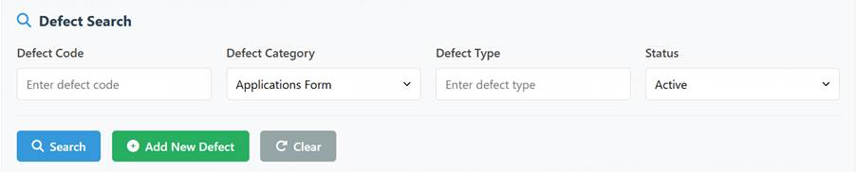
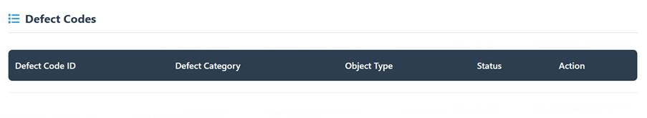
● Create Defect code
● Support modify and delete defect code

18.29. Email Notification for Additional Document Day Sequence
- Constant setting same as GST Tax Code
- Constant Code: NOTIFICATION_DAY_SEQUENCE
- Field
Field Name | Control Type | Input Field Format | M/N/C | Remarks
Description | Input | VARCHAR2(500) | M | Description of the Constant
Constant Value | Input | VARCHAR2(700) | M | Configurated in Constant  Days post-disbursement to trigger notifications  separated by “|”, e.g. 3|5|7

18.30. Admin fee amount
- Constant setting same as GST Tax Code
- Constant Code: ADM_FEE_AMOUNT
- Field
Field Name | Control Type | Input Field Format | M/N/C | Remarks
Description | Input | VARCHAR2(500) | M | Description of the Constant
Constant Value | Input | VARCHAR2(700) | M | Configurated in Constant  ADM_FEE_AMOUNT, used in CRA Expert Rule Validation.

18.31. MOF Upper Limit
- Constant setting same as GST Tax Code
- Constant Code: MOF_UPPER_LIMIT
- Field
Field Name | Control Type | Input Field Format | M/N/C | Remarks
Description | Input | VARCHAR2(500) | M | Description of the Constant
Constant Value | Input | VARCHAR2(700) | M | Configurated in Constant  MOF_UPPER_LIMIT, used in MOF validation.

18.32. FIS Auto Inquiry Span
- Constant setting same as GST Tax Code
- Constant Code: FIS_AUTO_INQUIRY_SPAN
- Field
Field Name | Control Type | Input Field Format | M/N/C | Remarks
Description | Input | VARCHAR2(500) | M | Description of the Constant
Constant Value | Input | VARCHAR2(700) | M | Configurated in Constant  FIS_AUTO_INQUIRY_SPAN, FIS automatic inquiry time span, used to control whether to query the latest result from FIS.

19.【Same as Batch2】Business Switch Maintenance

19.1. Expert Rule Switch
Expert Rule validation is provided to facilitate faster Case data entry and processing. The function is enabled by default and is not subject to parameter configuration or switch control.

19.2. E-Hakmilik Service Switch
● Switch parameter management follows General Constant Mode
● Constant setting same as GST Tax Code
● Constant Code: EHAK_LODGEMENT_SWITCH
● Field
Field Name | Control Type | Input Field Format | M/N/C | Remarks
Description | Input | VARCHAR2(500) | M | Description of the Constant
Constant Value | Input | VARCHAR2(700) | M | Input:  ON – lodgement service is online  OFF – lodgement service is offline

19.3. FIS Inquiry Switch
When FIS Inquiry service is out of service, calling this interface will generate cost without obtaining valid results, so the user needs to turn off this service if necessary
● Switch parameter management follows General Constant Mode
● Constant setting same as GST Tax Code
● Constant Code: FIS_INQUIRY_SWITCH
● Field
Field Name | Control Type | Input Field Format | M/N/C | Remarks
Description | Input | VARCHAR2(500) | M | Description of the Constant
Constant Value | Input | VARCHAR2(700) | M | Input:  ON – FIS inquiry service is online  OFF – FIS inquiry service is offline

19.4. STP SWITCH
CRA Team initialize and modify STP SWITCH
- Switch parameter management follows General Constant Mode
- Constant setting same as GST Tax Code
- Constant Code: STP_SWITCH
- Field
Field Name | Control Type | Input Field Format | M/N/C | Remarks
Description | Input | VARCHAR2(500) | M | Description of the Constant
Constant Value | Input | VARCHAR2(700) | M | Input:  ON – Apply STP  OFF – Do Not Apply STP
- Initialized to OFF as default

19.5. Hirer/Guarantor Document Generation Switch
● Switch parameter management follows General Constant Mode
● Constant setting same as GST Tax Code
● Constant Code: AGREEMENT_DOC_GEN_SWITCH
● Field
Field Name | Control Type | Input Field Format | M/N/C | Remarks
Description | Input | VARCHAR2(500) | M | Description of the Constant
Constant Value | Input | VARCHAR2(700) | M | Input:  ON – Generate document for emailing  OFF – Do Not Generate
● Initialized to ON as default

19.6. Hirer/Guarantor document Email Generation Switch

● Switch parameter management follows General Constant Mode
● Constant setting same as GST Tax Code
● Constant Code: AGREEMENT_EMAIL_GEN_SWITCH
● Field
Field Name | Control Type | Input Field Format | M/N/C | Remarks
Description | Input | VARCHAR2(500) | M | Description of the Constant
Constant Value | Input | VARCHAR2(700) | M | Input:  ON – Generate agreement email  OFF – Do Not Generate
● Initialized to ON as default

19.7. Hirer/Guarantor document Email Sending Switch

● Switch parameter management follows General Constant Mode
● Constant setting same as GST Tax Code
● Constant Code: AGREEMENT_EMAIL_SEND_SWITCH
● Field
Field Name | Control Type | Input Field Format | M/N/C | Remarks
Description | Input | VARCHAR2(500) | M | Description of the Constant
Constant Value | Input | VARCHAR2(700) | M | Input:  ON – Send agreement email  OFF – Do Not send
● Initialized to OFF as default

19.8. Disbursement Slip Email Sending Switch
● Switch parameter management follows General Constant Mode
● Constant setting same as GST Tax Code
● Constant Code: DISBSLP_EMAIL_SEND_SWITCH
● Field
Field Name | Control Type | Input Field Format | M/N/C | Remarks
Description | Input | VARCHAR2(500) | M | Description of the Constant
Constant Value | Input | VARCHAR2(700) | M | Input:  ON – Send disbursement slip email  OFF – Do Not send
● Initialized to OFF as default

19.9. E-hakmilik Slip Email Sending Switch
● Switch parameter management follows General Constant Mode
● Constant setting same as GST Tax Code
● Constant Code: EHAKSLIP_EMAIL_SEND_SWITCH
● Field
Field Name | Control Type | Input Field Format | M/N/C | Remarks
Description | Input | VARCHAR2(500) | M | Description of the Constant
Constant Value | Input | VARCHAR2(700) | M | Input:  ON – Send e-haklimik slip email  OFF – Do Not Send
● Initialized to OFF as default

20. Report
The user selects the report type, sets the filter criteria for the report, clicks submit to generate the report, and downloads it upon completion.

20.1. 【Same as Batch2】Report Downloading User Page
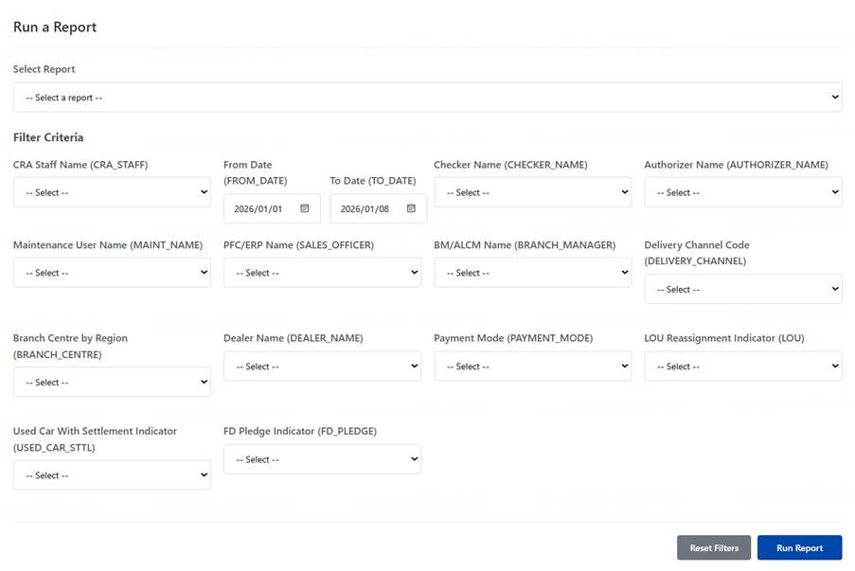
1. All filter conditions displayed in above picture should list in one column, the above display is only a demo.
2. Support select output file formats which is not displayed in above demo, include excel and csv
3. Business Rule
● User first check available report and select the report to be downloaded
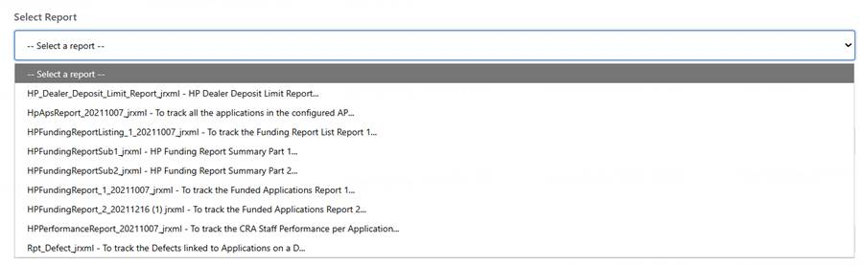
● User set Filter Condition, then click “Run” to trigger report generation
● All Report[h12] Filter Conditions except FROM DATE and TO DATE are optional, include:

Field Name (Variable) | Field Label / Description |  | Selection Type | Multiple selection | Notes
CRA_STAFF | CRA Staff Name |  | Multiple selection dropdown | Y | Select one or more CRA staff members
FROM_DATE | From Date |  | Date picker |  | Start date for filtering records
TO_DATE | To Date |  | Date picker |  | End date for filtering records
CHECKER_NAME | Checker Name |  | Multiple selection dropdown | Y | Select one or more checkers
AUTHORIZER_NAME | Authorizer Name |  | Multiple selection dropdown | Y | Select one or more authorizers
MAINT_NAME | Maintenance User Name |  | Multiple selection dropdown | Y | Select the maintenance user
SALES_OFFICER | PFC/ERP Name (SALES_OFFICER) |  | Multiple selection dropdown | Y | Select the sales officer
BRANCH_MANAGER | BM/ALCM Name (BRANCH_MANAGER) |  | Multiple selection dropdown | Y | Select the branch manager
DELIVERY_CHANNEL | Delivery Channel Code |  | Multiple selection dropdown | Y | Select the delivery channel code
BRANCH_CENTRE | Branch Centre by Region |  | Multiple selection dropdown | Y | Select branch centre by region
DEALER_NAME | Dealer Name |  | Multiple selection dropdown | Y | Select the dealer name
PAYMENT_MODE | Payment Mode |  | Multiple selection dropdown | Y | Select the payment method
LOU | LOU Reassignment Indicator |  | Single selection dropdown |  | Yes/No indicator for LOU reassignment
USED_CAR_STTL | Used Car With Settlement Indicator |  | Single selection dropdown |  | Yes/No indicator for used car with settlement
FD_PLEDGE | FD Pledge Indicator |  | Single selection dropdown |  | Yes/No indicator for FD pledge
Hold handling fee | Hold handling fee Indicator |  | Single selection dropdown |  | Yes/No
Product Type |  |  | Multiple selection dropdown[h13] | Y
REFUND_DEPOSIT | Refund Deposit |  | Single selection dropdown |  | Yes/No indicator for refund deposit status
AP_INDICATOR | AP Indicator |  | Single selection dropdown |  | Yes/No indicator for AP status
FBR | FBR |  | Single selection dropdown |  | Yes/No indicator for FBR indicator
FBT | FBT |  | Single selection dropdown |  | Yes/No indicator for FBT indicator
SI | Standing Instruction Indicator |  | Single selection dropdown |  | Yes/No indicator for SI indicator
Manual Process Indicator | Manual Process Indicator |  | Single selection dropdown |  | Yes/No indicator for selecting Manual Processed application.
STP Application indicator | STP Application indicator |  | Single selection dropdown |  | Yes/No indicator for STP processed application
 |  | Output option
Output file format | Excel  CSV |  | Single selection dropdown

20.2. 【Same as Batch2】Funding Report1
1. Business Rule
● Support user to generate at the end of each working day, to obtain a funding report of current working day.
● The User hope to use a single report for daily reconciliation and operational monitoring, in this report there is only one field (Vehicle registration number) that may change during the process. User will use vehicle registration number as a Primary Key to retrieve in the HOST.
● The report fields follow the existing rpt_hp_funding 1
● Supports selecting filter criteria to export and download detailed and summary data that meets the conditions from the complete report.
● The report filter criteria follow existing fields.
a) Date : compare with funding date
● If the application has been processed by several personnel, e.g. processed by more than 1 CRA Maintenance, only to show the last one in Funding Report.
● Description for other fields[h14] :

Topic / Field | Discussion / Suggestion
Agreement Date | Follow the agreement date from the latest copy of the HP (Hire-Purchase) Agreement.
PFC/EHP | Refers to "loan proposal"
BM/ALCM | Refers to the branch manager.
On The Road Price / Price List | Change field name to "On The Road Price / Total Price".
Deposit Amount | Defined as: down payment (cash) + down payment (trade-in).
Interest Rate | Should be the Approved Interest Rate.
MOF | Formula: Loan Amount / OTR (On The Road Price).
Handling Fee | Equals to "Net handling fee - GST"
Data Maintenance User Name, Checker's Name, Authoriser's Name | All should be the last person in each role who handled the application.
Exception Code | This code is input by CED
● Payment related fields
Payment Mode | Beneficiary Bank | Beneficiary Account Number
IBG | Retrieval from application | Retrieval from application
Transfer | Empty | Retrieval from application
Suspense | Empty | Empty
Advice | Empty | Empty

● Explanation for summary section:
It is calculated based on all funded applications. For example, sum retention together and count all applications that have retention.
“Hold handling Fee” and “Promo Package” depend on the indicator ticked by user.
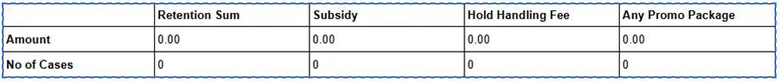
Reference: rpt_hp_funding 1 in the file Sample CRA report.xls.

20.3. 【Same as Batch2】Funding Report2
1. Business Rule, same as Funding Report1
● The report filter criteria follows existing fields.
a) Date : Compared with funding date
2. The user hope to keep current format in which all hirer and guarantor are arranged in a single record. There are at most 5 hirer and guarantors in total in an application.
3. If the application has been processed by several personnel, e.g. processed by more than 1 CRA Maintenance, only to show the last one in Funding Report.
4. Description of Special[h15] fields
Topic / Field | Discussion / Suggestion
Biometric (When to flag "Y") | Scenario 1: Identity Verification (E) = Matched.
 | Scenario 2: Verified fingerprint or uploaded biometric verification document, when Customer Biometric (NON-E) is ticked.
Customer Agree to Receive e- | Refers to: Customer agrees to receive the agreement file via email.
e-Agreement Status | Refers to the status of CrediOS pushing the email to Infobip.
e-Agreement Date/Time | Refers to the datetime when CrediOS pushes the email to Infobip.
Infobip Log Date | The date User upload the Infobip report into LOS System
Infobip MessageId | "Message Id" in Infobip Report
Infobip Communication Name | "Communication Name" in Infobip Report
Infobip Status | "Status" in Infobip Report
Infobip Done At | "Done At" in Infobip Report
Infobip Reason | "Reason" in Infobip Report

5. Infobip Email Report Column and Parameter in LOADS mapping refers to :
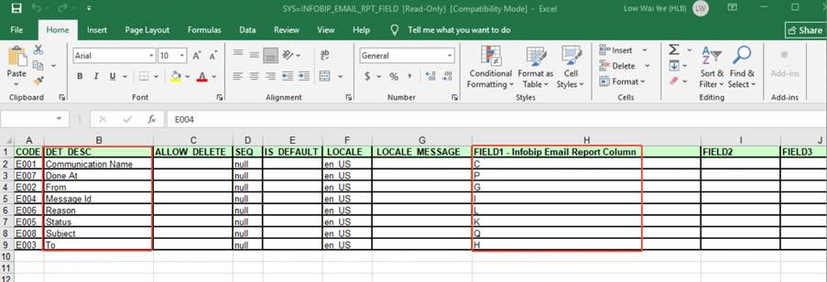
Reference: rpt_hp_funding 2 in the file Sample CRA report.xls.

20.4. 【2 More Filters】Defect Report
1. Business Rule, same as Funding Report1
● The report filter criteria follow existing fields.
a) Date : compare with Defect creation date
● Other detailed description[h16] .
Field Name | Meaning / Logic
Date and Time CRA Completed​ | The timestamp when the "CRA Completed" checkbox is ticked and saved.
Guarantor's Name (multiple)​ | Display all guarantor names within the same cell when there is more than one.
Checker Name​ | Refers to the person who checks/verifies the application. Not the person who ticks "rectified".
Dealer Name​ | In a seller scenario, this field displays the seller's name.
Date and Time Defect Rectified​ & Date and Time Fully Rectified​ | Can be split into two separate reports.  One is on defect level, in which only keep ”Date and Time Rectified”; the other is on application level, in which only keep “Date and Time Fully Rectified”.  Both should be completed at the end of the day, trigger generation by user.
Date and Time Defect Verified​ & Date and Time Fully Verified​ | Same as previous line.
Ageing Calculation​ | Calculated as: Date and Time Defect Rectified – Date and Time Initiated.
Reference: Defect_rpt in the file Sample CRA report.xls.

20.5. HP performance report
1. Business Rule, same as Funding Report1
a. Statistics at both application-level (detailed list) and summary-level (aggregated data).
b. Duration = Time transferred to next stage - Time of auto-assignment or pickup
c. Key performance indicator:
Stage/Person | Received Time Field | Completed Time Field | Duration Field
Checker & Maintenance | Date and Time Received (Checker Stage) | Date and Time Completed (Checker Stage) | Duration Time (Checker Stage)
Authoriser | Date and Time Authoriser Received | Date and Time Authoriser Completed | Duration Time (Authoriser)
Post Maintenance | Date and Time Received Post Maintenance | Date and Time Completed Post Maintenance | Duration Time (Post Maintenance)
Post Authoriser | Date and Time Received Post Authoriser | Date and Time Completed Post Authoriser | Duration Time (Post Authoriser)

Reference: rpt_hp_performance in the file Sample CRA report.xls.

21. 【Same as Batch2】Requirement Rely on HOST Capability
- Suspense reversal – No available interface from HOST
- Dealer available limit confirmation via interface – No available interface from HOST

22. Document storage
Permanent Validity: All files are stored permanently on the EIWS.
Retention Period Parameter Configuration: Follow EIWS current retention rules.

23. 【Same as Batch2】URS Requirements Traceability Matrix

NO | Section | Source Text | FSD Coverage Status | Progress/Note
815 | 7.8.1 Contract Signing | "System generate Company/Partnership resolution based on information in the LOS System." | Will not cover | Confirmed OK  Dependency on new letter template.
816 | 7.8.1 Contract Signing | "System generate Delivery Order Request and send via SMS/In-App (similar to eConsent concept) for Sales Team to submit to customer to confirm the car delivery." | Will not cover | Confirmed OK  DO e-consent already confirmed removal from URS.
823 | 7.9.3 Sales End Loan Application Submission | "System integrates with HOST System to perform dealer inquiry, retrieve and display dealer's information (i.e.: Dealer status, Dealer Remark, Funding Before Register (FBR) & Funding Before Transfer (FBT) limit and utilization, and balance, etc.) from the HOST system." | Will be partially covered | Confirmed OK  No interface to query real time FBR/FBT available limit.
824 | 7.9.3 Sales End Loan Application Submission | "*System to prompt User to submit for loan disbursement when insufficient balance limit (FBR/FBT)." | Will not cover | Confirmed OK  No interface to query real time FBR/FBT available limit.
833 | 7.9.4 Disbursement Data Structuring and OCR Verification | "Straight Thru Process (STP) application: Pass all AIOCR rules, extract data and input back into CrediOS. Based on a certain percentage indicator, the system auto proceeds for payment to the Dealer." | Will be partially covered | Confirmed OK  Partial Scenario supported, e.g. STP, new car, individual.
856 | 7.9.5 CRA Approval Workflow (Data Maintenance & Verification) | "Allow user to perform Loan Suspense reversal and perform payment to Dealer/Customer. (ie : Deposit amount)." | Will not cover | Confirmed OK  No interface to support suspense reversal
858 | 7.9.5 CRA Approval Workflow (Data Maintenance & Verification) | "System indicator to indicate number of Days from 1st approval date. (On Screen and CRA Report)." | Will be partially covered | Confirmed OK  Prompt in My task and Queue Query.
867 | 7.9.6 Defect Process | "System to perform dealer inquiry, retrieve and display dealer's information (i.e.: Dealer status, Dealer Remark, Funding Before Register (FBR) & Funding Before Transfer (FBT) limit utilization, and balance, etc.) from the HOST system." | Will be partially covered | Confirmed OK  No interface to query real time FBR/FBT available limit.
868 | 7.9.6 Defect Process | "System to prompt or Stop User to submit for loan disbursement when insufficient balance limit (FBR/FBT)." | Will not cover | Confirmed OK  No interface to query real time FBR/FBT available limit.
878 | 7.9.6 Defect Process | "System auto add defect item if 'Agreement Date' exceeds 5 days." | Will be partially covered | Confirmed OK  In the My Task and Queue Query lists, it indicates parameter configuration is supported, but it will not be tracked as a defect.
913 | 7.9.8 Fund Transfer Processing | "Allow payment to Virtual Account." | Will not cover | Confirmed OK  Not used in production currently.
922 | 7.9.9 CRA Post Maintenance | "New LOS to perform dealer Inquiry (Retrieve and display dealer's information ie : Dealer status, Dealer Remark, FBR / FBT limit utilization and balance & etc)." | Will be partially covered | Confirmed OK  No interface to query real time FBR/FBT available limit.
951 | 7.9.11 System Validation and Prompters | "System able to validate mandatory funding attachments, is parameterized." | Will be partially covered | Confirmed OK  Based on our earlier discussions:  1. Mandatory checks for common required documents must be in place.  2. If a specific scenario is identified (e.g., SI), the system must enforce the corresponding scenario-specific required documents.  3. For highly exceptional scenarios, documents will not be strictly enforced.
993 | 7.9.16 RPA for E-Stamping Process | "The system supports Robotic Process Automation (RPA) to download E-Stamp Certificates from the LHDN website. These certificates are then uploaded as attachments to their respective Loan Applications within CrediOS." | Will not cover | Confirmed OK  Depending on the HLB IT team to modify the current RPA solution.
995 | 7.9.16 RPA for E-Stamping Process | "The system supports Robotic Process Automation (RPA) to download E-Stamp Certificates from the LHDN website." | Will not cover | Confirmed OK  Depending on the HLB IT team to modify the current RPA solution.
1009 | 7.9.17 Role and Access Management | "For Defect role - System will only auto round robin for weight or percentage >0.01%" | Will be partially covered | Confirmed OK  Based on previous discussion, set role weightage to 0 to fulfill this requirement.
1013 | 7.9.19 Disbursement For Floor Stock Application. | "System allows to create Loan Application for disbursement." | Will not cover | Confirmed OK  Out of scope
1014 | 7.9.19 Disbursement For Floor Stock Application. | "System able interface the Loan applications details and disbursement details to HOST." | Will not cover | Confirmed OK  Out of scope
1015 | 7.9.19 Disbursement For Floor Stock Application. | "System allows to perform payment to Car Dealer / Distributor." | Will not cover | Confirmed OK  Out of scope
1016 | 7.9.19 Disbursement For Floor Stock Application. | "System able to generate floor stock funding report" | Will not cover | Confirmed OK  Out of scope
1020 | 7.9.19 Disbursement For Floor Stock Application. | "System able interface the Loan applications details and disbursement details to HOST." (implies real-time or near-real-time interface requirement) | Will not cover | Confirmed OK  Out of scope
1021 | 7.9.19 Disbursement For Floor Stock Application. | "System allows to perform payment to Car Dealer / Distributor." (implies audit and security requirements) | Will not cover | Confirmed OK  Out of scope
1152 | 7.11.2 CRA Reports Generations | "Error Correction Report" | Will not cover | Rarely happens. Low priority.
1431 | 10 Requirement - Overview on Main System Interface | "1. Vehicle eHakmilik Lodgement 2. Vehicle eHakmilik Discharge 3. FIS Inquiry on Vehicle (Ownership, Double Financing, Total Loss, Stolen Car, etc) 4. Update Collateral info for FIS Secondhand Car Price Listing (import & export or API integration), can be from other vendor as well" | Will be partially covered | ITEM 1. Covered  ITEM 2. In 3rd party website, not in LOS currently  ITEM 3. Covered  ITEM 4. Refer to CED
 | Proposed in discussion. | Normal application(non FBR/FBT) is allowed to modify the Collateral section after disbursement and before e-stamping. | Will not covered | Not an existing feature.  Not included in URS.  Low frequency scenario.

24. Appendix

Appendix 1. CRA Business Rules & Defect Code

Appendix 2. E-mail Template（gurantor）---need to update

Appendix 3. Disbursement Slip Email Template（dealer）---need to update

Appendix 4 Disbursement (Batch 3)-Prototype Walkthrough

Appendix 5. Sync From OCR Fields ---need to update by WT

