Antonio Rosado

Prof. Chien

IOOP Section #4

PreLab #5

**By submitting this work, I certify that this assignment is my own work, and that I have not copied in part or whole from online sources or plagiarized the work of other students.**

**Class Diagram**

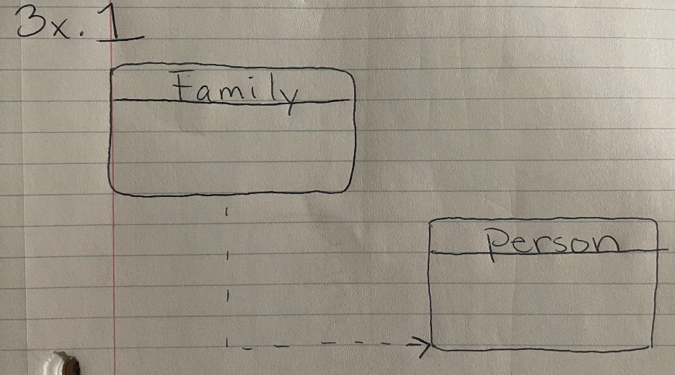

**Object Diagram**

