1. Go on Microsoft Edge.
2. Go on any website you want to inspect, look at the bar that looks like this on the top.
3. Click on the three dots on the right corner of the tab, which look like this (…)
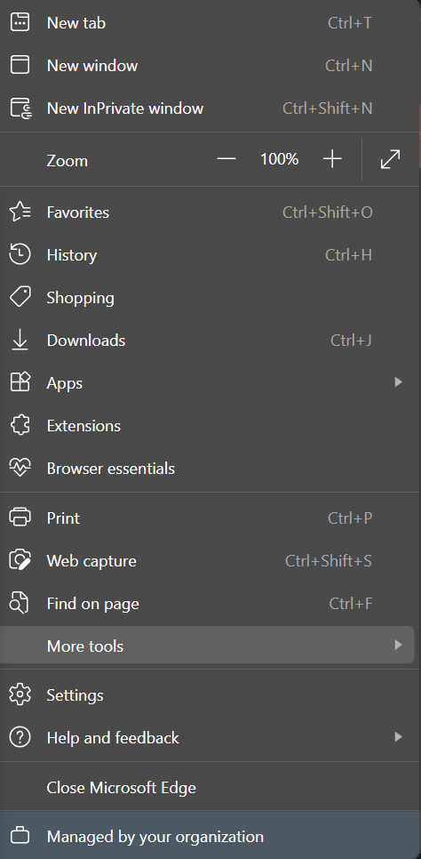
4. Once you get a tab that looks like this find the tab called more tools.
5. Click on it.
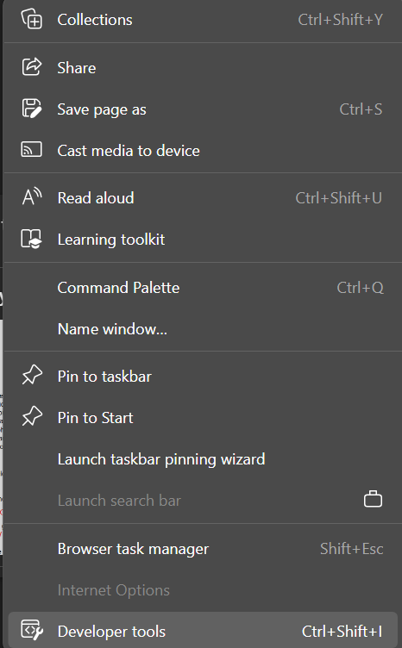
6. Once you click on more tools you should see this tab.
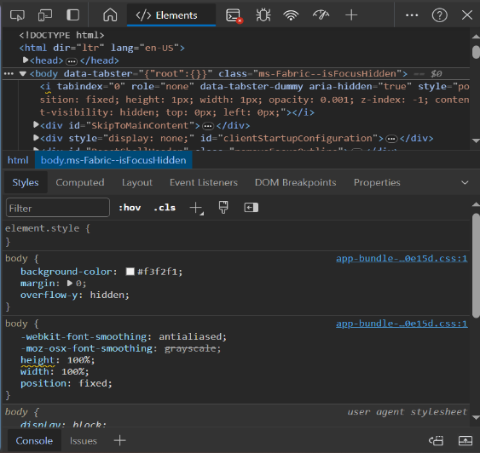
7. At the very bottom of this tab, you will see the developers tools, click on it.

8. once you get to something that look like the picture on the right, click on the 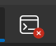 Console button, this will take you to a console which you can edit.
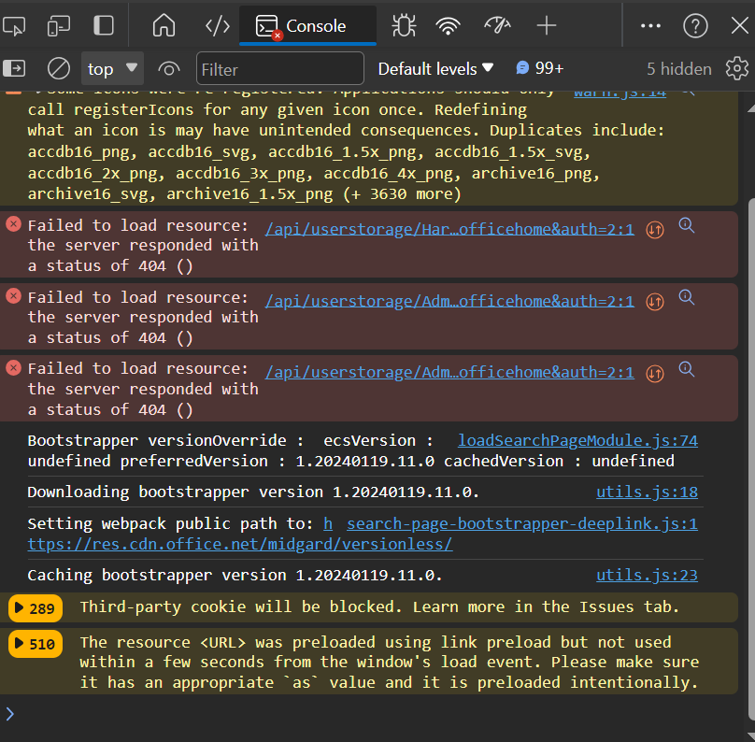
9. Once you click on the Console button it will take you to a console, look at the very button, you will see a small >_ , put anything you want to put in there, you can also copy paste any commands you want in here.
10. Press enter, and it should work.
Reminder: Once you click the restart button, click out of the window, click out of your browser, the code will not save, and you will have to go back in and put any code you want to put in the console, also sometimes some codes won’t even work if the site is ultra secured.

