**P1 unit 1 class02: beauty of geometry**

**Course project:** this lesson mainly uses the instruction to realize the drawing of the shell figure (the shell is mainly composed of gradually larger or smaller circles)

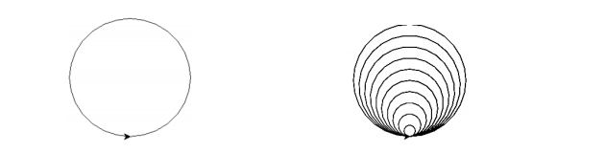

**Course objectives:**

1. Learn to change the appearance of brush

2. Learn to draw circles of different sizes

3. Learn to set brush speed

1. Understand radius knowledge

**Analysis of knowledge points:**

1. Appearance styles that can be set by shape() instruction

turtle：海龟

triangle：三角形

square：正方形

circle：圆

arrow：箭头

classic：经典的

2. Radius

Any line segment from the center of a circle to its periphery is called a radius. The larger the radius, the larger the circle. The radius can control the size of the circle

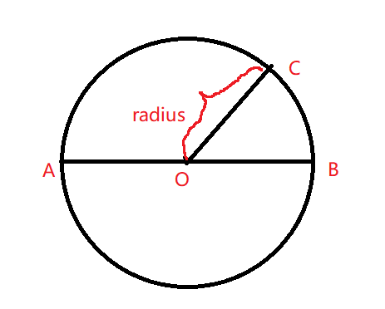

**key word:**

1. Change brush appearance command: shape ()

2. Circle instruction: circle ()

3. Acceleration instruction: speed ()

**Homework:**

Use the instructions learned in class to achieve the following graphics:

