**P1 unit 1 class03: Sunshine smile**

**Course project: This lesson is a creation lesson,mainly using instructions that we learned before to achieve the drawing of hydrogen balloon,expression graphics and other graphics.To improve students’ comprehensive application ability and creativity,and consolidate their mastery of knowledge points.**



**Course objectives:**

1. Learn to change the thickness of the pen

2. Learn to take up and put down the pen

3. Learn to fill in graphic colors

1. Understand the concept of coordinate and apply it in the program

**Analysis of knowledge points:**

1. **Coordinates.**

Coordinates are used to represent the plane position of a point and are called plane coordinates. It is composed of x-axis and y-axis. When the two axis intersect at a point, it is called the origin. The plane coordinates of the point are (x, y)

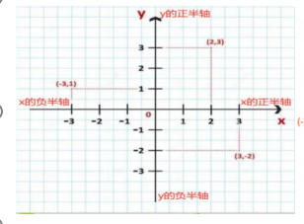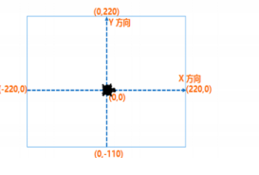

**key word:**

1. Two data types: string(字符串数据类型) and number(数字数据类型)

2. Assignment comparison operator:=

3. Define variable: variable name = value

4. Output instruction: Print ()

1. For loop instruction: for x in range

**Homework:**

Use the instruction learned in class to realize the following figure: (Regular hexagon spiral)

