**PUBLIC TRANSPORT OPTIMIZATION**

**OBJECTIVE:**

The objective is to create a comprehensive and technologically advanced transit system that improves the overall experience for commuters and provides numerous benefits to both passengers and transportation authorities.

* **Real-Time Transit Information:**To develop a system that offers up-to-the-minute information on the status and location of public transportation vehicles, allowing passengers to make informed decisions about their travel plans.
* **Arrival Time Prediction**: To implement predictive algorithms and data analytics to accurately estimate arrival times for buses, trains, and other modes of public transportation, reducing waiting times and increasing convenience for commuters.
* **Ridership Monitoring:** To collect and analyze data on passenger volumes, routes, and preferences to optimize transit routes and schedules, ensuring efficient resource allocation and improved service quality.
* **Enhanced Public Transportation Services**: To add some innovative features such as Wi-Fi, digital ticketing, and real-time service alerts to enhance the overall passenger experience and attract more riders to public transportation.  
    
  **IoT SENSOR DESIGN:**

Public transportation users face many problems, the most important of which is the long wait at the bus stops.

* The proposed system helps users of public transportation to find public transportation, arrival times, and other information from any place and at any time using a mobile application.
* To reduce the wait time at the bus stops by knowing the nearest buses to a user, the real-time location of buses, the arrival time of buses, and speed.
* The system is an IoT-based, real-time, and easy-to-use system. It consists of a GPS module and an ESP32 (microcontroller & Wi-Fi module) that will be installed inside the buses.
* The system includes an ESP32 with a Wi-Fi built-in module, a GPS module, and an Android app connected to the server.
* The system is operated by GPS and ESP32, which are installed in each bus with a power supply that may be obtained from the bus. GPS receives the satellite signals and then the position coordinates with latitude, longitude and speed are determined for moving buses. After receiving the data, the tracking data can be transmitted using wireless communications systems.

**ESP32 Microcontroller:**

The ESP32 is a microcontroller with a Wi-Fi module, an open-source IoT platform that is characterized by low-cost and low-power system-on-a-chip (SOC). An ESP32 has a dual-core structure and internal modules such as Wi-Fi, Bluetooth, and many Peripheral Interfaces such as IR, SPI, CAN, Ethernet, and temperature sensors.

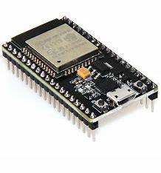

**GPS MODULE:**

GPS (Global Position System) used for positioning and tracking buses based on

satellite communication. GPS satellites cover the entire earth at all times. To get

accurate GPS location data, there should be a minimum of three satellites. The

NEO-6M GPS module used in the proposed system is small and works on very

low power, making it ideal for tracking applications. The GPS module operates

at 3.3 V, as a result, powered by connecting the GPS module to the 3.3 V pin of

the ESP32.

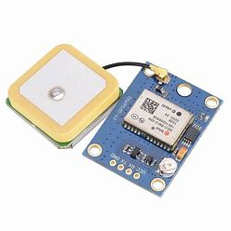

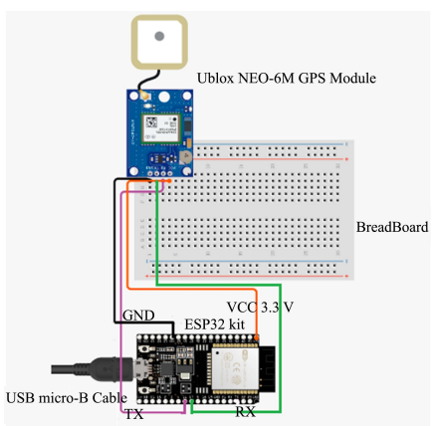

**REAL-TIME TRANSIT INFORMATION PLATFORM:**

* GPS is used to obtain a real-time bus location, as well as speed, direction, etc. All data collected by ESP32 will be transferred to the Blynk server through Wi-Fi, then displayed on the mobile application. The system aims to reduce the wait time at the bus station.

Ø The system consists of an Android application designed for users who want real-time information about the buses. The app will display information about buses such as real-time location on Google Maps, speed, distance, and arrival time of each bus.

* The android application gets data from the Blynk server and provides the required data to the user based on the information provided in the android application.The Android application is critical to this system’s success. It assists passengers by providing information about the bus they need to take. It works as a link between the user and the server.
* In this system, the android application is designed by using the Blynk platform. The Blynk platform is an IoT platform, offering a way to design wonderful applications in minutes for Android and iOS smartphones. It can be used to manage different controllers, such as Raspberry Pi, ESP8266, ESP32, etc. The Blynk platform’s architecture includes Blynk libraries, Blynk server, and Blynk apps .
* The Android app includes a map that will show the passenger’s location, as well as track the present location of the bus. It also provides the estimated time for the bus to arrive, the speed of the moving bus, and displays the nearest bus to the user by calculating the distance between the passenger and the bus location.

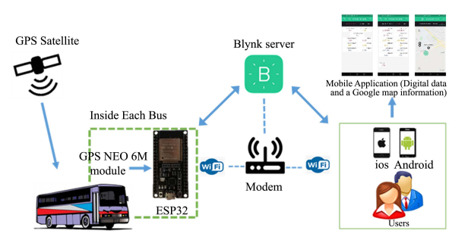

**INTEGRATION APPROACH:**

* First, the user must determine his location by activating the location feature in smartphone. To get the information entered the application will provide the details about buses, bus location, bus speed, bus arrival time, nearest bus from a user by offering the distance between user location and bus. This information will assist the passenger to select their suitable bus.
* When the power supply is on, the GPS module communicates continuously with the satellite to get coordinates. The GPS module will initialize itself, then the module will get the coordinates, but if the coordinates are not received, then the module will initialize again.
* Once the GPS obtains the coordinates, it sends the data, including latitude and longitude, and speed to the IoT Blynk server through the ESP32. At the Blynk server, the latitude and longitude are extracted and used on the visual map in the Blynk application.
* The live location of the bus can be seen on the Google map. Continuous data digital updates such as speed, distance, and the arrival time of the bus are displayed on the mobile application

