**NAME: CLASS: DATE:**

**(一)阅读下面短文，根据短文内容从后面各题所给的A、B、C三个选项中选出最佳选项。**

I opened my eyes. It was the first day at my new middle school—the day I didn’t look forward to...

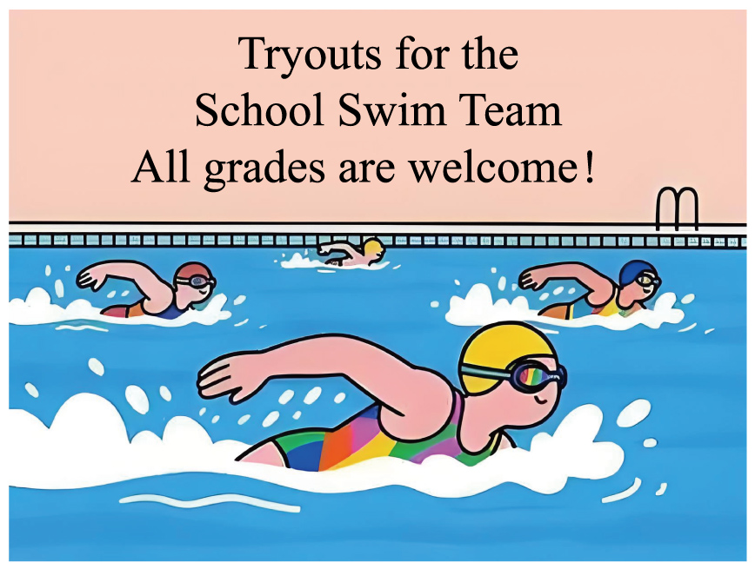“Max,” Mom called, “breakfast is ready.”

I pulled on my new jeans and ____15____ moved my feet down to the kitchen.

Mom put her hand on my shoulder, “I know you feel sad, Max. But we’re starting a new life here. There’ll be more chances for you.”

I knew Mom was trying to ____16____ me, but it didn’t help much. All I could think of was my old friends and how I wouldn’t be seeing them anymore.

When I arrived at the new school, I kept thinking of my old friends. At this moment, they must be enjoying themselves together. But I was just a ____17____ boy sitting at the back of the classroom, with no one to talk to. For the whole day, I spent most of my time alone, feeling like an island.

After school, I was walking by myself in the hallway when a bright blue poster caught my eye, “Tryouts (选拔赛) for the School Swim Team. All grades are welcome” My heart ____18____. Maybe this was my chance I was excited because I used to be the fastest swimmer in my old school. But I also felt a bit nervous. “What if I am not as good as others here?” After thinking it over, I made up my mind to give it a try.

A few days later, it was time for the tryouts. Standing at the side of the pool, I took a deep breath and then jumped into the water, I swam like a fish—getting back into the ____19____ felt so good. Finally, the coach read out the team list—I was on it

Our team’s first task was to prepare for the upcoming sports meet. We trained very hard every day. And when I won my first race in the sports meet, my teammates cheered for me and even lifted me up on their shoulders. At that moment, I realized I found my ____20____.

Mom was right. I was starting a new life here.

15. A. slowly B. excitedly C. carefully

16. A. join B. surprise C. encourage

17. A. brave B. quiet C. lazy

18. A. raced B. ached C. sank

19. A. team B. class C. pool

20. A. place B. hobby C. model

You might think studying is something you should do alone. However, does it mean you should never try studying with someone? Actually, having a study buddy, a friend who studies with you and makes you stay excited about learning, can really help you learn better

One of the best things about having a study buddy is that you get to **collaborate**. When you put two minds together, problem-solving becomes faster and more creative. Imagine you both want to improve your writing. Your friend might be able to see words you’ve misspelt, and you could help correct your friend’s grammar mistakes. Then, you could discuss and add finishing touches to your written work.

What’s more, problems become opportunities. Maybe your buddy is good at English but finds math difficult, while it’s the other way around for you. When you teach your friend how to solve a math problem, you start understanding it better. Scientists call this the “protégé effect”. It means one can get smarter by helping someone else learn.

With a study buddy, it’s easier to stay motivated (有驱动力的). By asking questions like, “Did you finish the reading?” or “Ready to quiz each other?”, you are holding each other accountable (负有责任的). This makes sure that both of you have your goals in mind and are doing your best.

The benefits of having a study buddy don’t end here. If you’re ready to give it a try, here’s how to start:

Choosing the right partner (同伴) matters. Look for someone who balances your strengths and weaknesses. If you are a creative thinker but poor at making plans, team up with a buddy who’s good at planning and managing (管理) time. Set achievable goals, such as learning 10 new words daily or reading one book every month. Set clear rules, like meeting weekly and never putting tasks off until the last minute. Don’t forget to celebrate small wins. Treat yourselves if both of you do well on an exam.

Remember, a study buddy isn’t just a homework helper—they are your partner in growth. By working together, you can get through challenges and discover the joy of learning as a team. So, pair up, and get ready to level up your grades—and your friendship!

28. According to the passage, a study buddy ________.

A. helps you to improve your study B. does all of the difficult work for you

C. stays more excited about learning than you

29. The underlined word “collaborate” in Paragraph 2 probably means ________.

A. challenge someone B. chat with others C. work with each other

30. What can we learn from Paragraph 3 about the “protégé effect”?

A. Teaching others makes you a better learner. B. Helping others learn brings you more friends.

C. Solving math problems improves your memory.

31. Which of the following would the writer most probably agree with?

A. You’re more likely to put tasks off with a study buddy.

B. People with the same study habits make great study buddies.

C. A good study buddy not only helps you but also lets you help them.