Student Attendance Management System Specification

I. Introducing the Student Attendance Management System
In modern education, applying information technology to academic management is essential. Traditional paper-based attendance is time-consuming, error-prone, and difficult to manage. Therefore, the university develops an online Student Attendance System to improve accuracy, efficiency, and transparency in tracking student attendance.
The system supports lecturers, students, and administrators in managing attendance records, handling leave requests, and generating reports. To further explore the system, the main functions are described in the following sections.

1. Functional Requirements
-Attendance Monitoring:
+ Lecturers can view the list of students in the course sections they are responsible for in the current semester. This list is organized by course section, helping lecturers easily select and manage.
+ The instructor can create a attendance session for each lesson. When creating a session, the instructor selects the class/course to be attended, and determines the start and end times of the session.
During the attendance check, the system displays a list of students for the instructor to take attendance.
+ For each class session, lecturers will take attendance. The system allows recording attendance statuses including: Present, Absent, or Late.
+ Attendance results are stored for each session and each student, supporting future lookup and reporting.
+ In case of errors, lecturers can edit the attendance status of students after completing attendance (e.g., a student arrives late or a wrong status was selected).
− View History and Absence Reports:
+ For students: Students can view their personal attendance history by subject or course section. The system displays aggregated information such as total sessions, number of absences, and absence rate, and provides warnings when students are at risk of exceeding the allowed absence limit.
+ For lecturers: Lecturers can view overall statistics of student participation in a course section. The system supports tracking the number of absences, attendance rate of each student, and provides a list of students who exceed the allowed absence limit.
− Leave Request:
+ Students can submit online leave requests for one or multiple specific class sessions. When submitting, students must provide a reason and may attach supporting documents if necessary.
+ Leave requests will be sent to the responsible lecturer or academic office for review. They can approve or reject the request. If approved, the attendance status of the corresponding session will be updated to “Excused Absence”; if rejected, the attendance status remains unchanged.
− System Administration:
+ User Management: Administrators can create student and lecturer accounts, update user information, and lock or unlock accounts when necessary.
+ Course Section/Subject Management: Administrators can create course sections for each semester, assign lecturers, and import student lists into each course section.
+ Timetable Management: Administrators can set schedules for each course section, manage classrooms and class times, and define the start and end time of the semester.
− Business Processes:
+ Attendance Process: Lecturers log into the system, select a course section and the session to take attendance. The system displays the student list, lecturers select attendance status for each student (Present, Absent, Late) and save the results. After completion, lecturers can edit attendance information if there are errors.
+ Leave Request Process: Students log into the system, select the session they want to request leave for, enter the reason, and submit the request with supporting documents (if any). The system records the request and forwards it to the lecturer or academic office for processing. The reviewer evaluates the request and decides to approve or reject it. The result is updated in the system and notified to the student; if approved, the attendance status will be changed to “Excused Absence.”

2. Non-Functional Requirements

- Usability:
The web interface must be responsive and adapt to various screen sizes, especially on mobile devices, so lecturers can take attendance directly in class.
The system supports multiple languages (Vietnamese and English).
The time required for a new user to learn and use basic features should not exceed 10 minutes.

- Performance:
The system must be able to handle 500 – 1,000 students accessing the attendance history simultaneously at the end of the semester.
Response time when scanning attendance codes or saving data must not exceed 2 seconds.
The system should be capable of storing data for at least 10,000 students and attendance history for up to 5 years.

- Supportability:
The source code must be well-structured and clearly documented to facilitate maintenance or future feature upgrades (such as facial recognition).

- Security:
Strict access control must be enforced so that students absolutely do not have permission to modify attendance data.
Prevent common security vulnerabilities such as SQL Injection and Cross-Site Scripting (XSS).
Use Session/Token mechanisms (JWT) to manage login sessions, with automatic logout after 30 minutes of inactivity.

- Design Constraints:
Platform: Simple application (desktop/mobile app).
Programming languages: C#, Jave or Python
Database management system: MySQL or PostgreSQL.
Deployment environment: Runs well on Windows or Android/iOS

II. DFD Diagrams

1. DFD Level 0
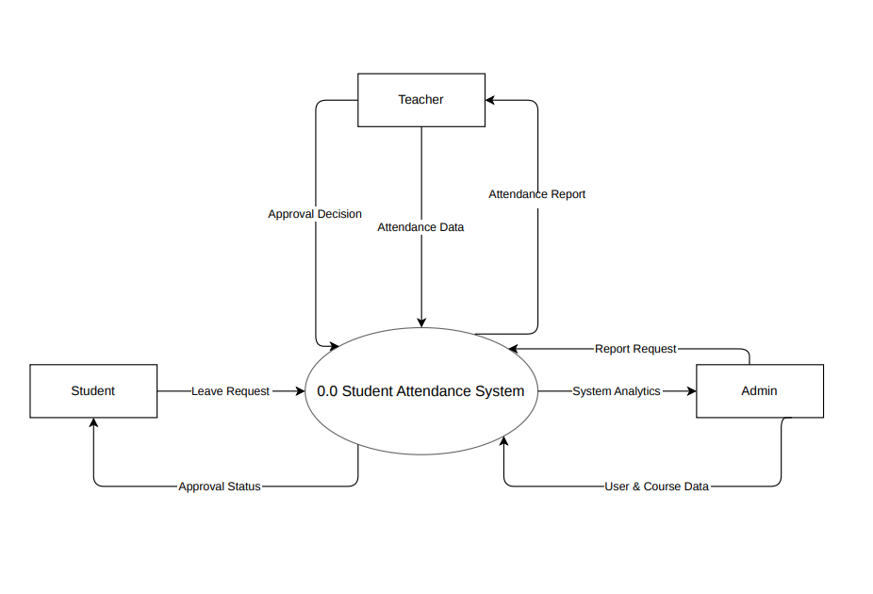

2. DFD Level 1

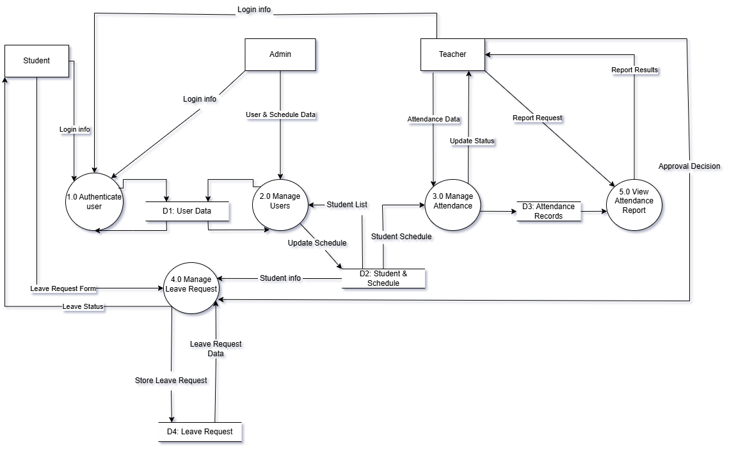

III. Use Case Diagrams

Overall Diagram

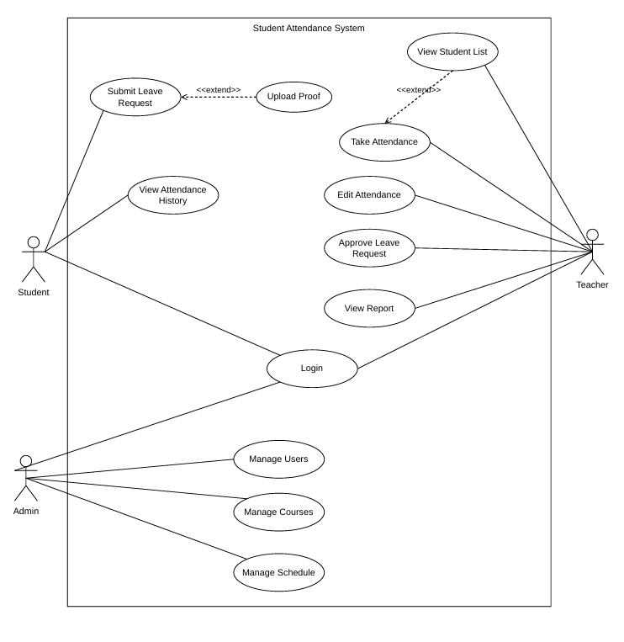

Actor List

STT | Use-case | Description
1 | Student | A participant in the class who needs to view attendance history and submit leave requests.
2 | Teacher | The person responsible for teaching, who has permission to take attendance, view reports, and approve leave requests.
3 | Admin | The system administrator who manages the entire system, responsible for initializing data related to users, courses, and schedules.

1.2. Use Case List

Use-case | Description | Notes
Login | Allows users to authenticate and log into the system. | General
Submit Leave Request | Allows students to submit a leave request for a specific class session. | Student
Approve Leave Request | Allows lecturers to review and decide to approve or reject students' leave requests. | Teacher
View Attendance History | Allows students to review their own attendance/absence history. | Student
Upload Proof | Allows students to upload supporting documents (e.g., medical certificates) attached to the leave request. | Student
View Student List | Allows lecturers to view the list of students in a specific class. | Teacher
Take Attendance | Allows lecturers to record attendance status (present, absent, late) for the class. | Teacher
Edit Attendance | Allows lecturers to modify previously recorded attendance statuses if there are errors. | Teacher
View Report | Allows lecturers to view attendance statistics and reports for the class. | Teacher
Manage Users | Allows Admin to add, update, or delete user account information. | Admin
Manage Courses | Allows Admin to manage the list of courses and subjects in the institution. | Admin
Manage Schedule | Allows Admin to create and manage class schedules and assign lecturers to classes. | Admin

2. Use Case: Login

2.1. Summary

This use case allows actors (Student, Teacher, Admin) to access the system using their personal accounts in order to perform functions according to their roles and permissions.

2.2. Event Flow

2.2.1. Main Flow
1. The user enters User ID and Password.
2. The system checks the login information in the database (User DB).
3. The system successfully authenticates the information.
4. The system redirects the user to the Dashboard corresponding to their role (Admin/Teacher/Student)

2.2.2. Alternative Flows
Invalid credentials: At step 2, if the ID or password is incorrect, the system displays the message: "Invalid user ID or password. Please try again."

2.3. Special Requirements
The password must be masked with * characters when the user enters it.

2.4. Pre-conditions
The user account has already been created in the system by the Admin.

2.5. Post-conditions
A login session is created to maintain the user's active state.

2.6. Extensions
None

3. Use Case: Submit Leave Request

3.1. Summary

Allows students to submit a leave request for a specific class session along with a reason and supporting documents for the lecturer to review.

3.2. Event Flow

3.2.1. Main Flow
1 The student selects the "Submit Leave Request" function.
2 The system displays a form including: Date of leave and Reason
3 The student enters the reason for absence.
4 The student chooses to upload supporting documents (medical proof, related documents).
5 The student clicks the "Submit" button.
6 The system saves the leave request with the initial status "Pending" and displays a success notification.

3.2.2. Alternative Flows
1 If the student leaves required fields empty, the system shows an error and requests completion.
2 If the attached file format is invalid, the system requests another file.

3.3. Special Requirements

The attachment file size must not exceed 5MB.

3.4. Pre-conditions
The student has successfully logged into the system.

3.5. Post-conditions
The leave request data is stored in the database.

3.6. Extensions

Use Case: Upload Proof – If the student attaches supporting documents, the system invokes this use case to store the file on the server.

4. Use-case Approve Leave Request

4.1. Summary

This use case allows lecturers to review and decide whether to approve or reject students' leave requests.

4.2. Event Flow

4.2.1. Main Flow
1. The lecturer accesses the list of pending leave requests.
2. The lecturer selects a specific request to view details.
3. The system displays the reason and attached files (if any).
4. The lecturer selects "Approve" or "Reject".
5. The system updates the request status accordingly.

4.2.2. Alternative Flows
None.

4.3. Special Requirements
None.

4.4. Pre-conditions
1. The lecturer has successfully logged in.
2. There is at least one leave request in "Pending" status.

4.5. Post-conditions
The leave request status is updated to "Approved" or "Rejected" in the database..

4.6. Extensions
None.

5. Use-case View Attendance History

5.1. Summary

This use case allows students to review their attendance history, including presence, absence, and lateness for each course, in order to monitor their attendance status.

5.2. Event Flow

5.2.1. Main Flow
1. The student selects the "View Attendance History" function.
2. The system displays a list of courses the student is enrolled in.
3. The student selects a specific course.
4. The system retrieves and displays detailed attendance history (date, time, and corresponding attendance status).

5.2.2. Alternative Flows
If the student has no attendance data for the selected course, the system displays the message: "No attendance data available for this course."

5.3. Special Requirements
None.

5.4. Pre-conditions
The student has logged into the system.

5.5. Post-conditions
No change.

5.6. Extensions
None.

6. Use-case Upload Proof

6.1. Summary

This use case allows students to upload supporting documents (medical certificates, leave requests, etc.) to attach to a leave request. This is an extension (extend) of the Submit Leave Request use case

6.2. Event Flow

6.2.1. Main Flow
1. On the leave request screen, the student clicks the "Upload Proof" button.
2. The system opens a file selection dialog from the device.
3. The student selects a file and confirms.
4. The system checks the file format and size.
5. The system uploads the file to the server and displays the uploaded file name on the interface.

6.2.2. Alternative Flows
Invalid format or file size: At step 4, if the file is not in the allowed formats (PNG, JPG, PDF) or exceeds 5MB, the system displays an error message and requests the user to select another file.

6.3. Special Requirements
Supported file formats: .png, .jpg, .pdf. Maximum size: 5MB.

6.4. Pre-conditions
The student is on the "Submit Leave Request" screen.

6.5. Post-conditions
The file is temporarily stored on the server, waiting to be attached when the student submits the request.

6.6. Extensions.
None.

7. Use-case View Student List

7.1. Summary

This use case allows lecturers to view the full list of students in a specific class. This use case is included (include) in the attendance process

7.2. Event Flow

7.2.1. Main Flow
1. The lecturer selects a class to view the student list.
2. The system retrieves data from the database (Course DB, Student DB).
3. The system displays the student list including: Student ID, Full Name, Class.

7.2.2. Alternative Flows
Empty class: If no students have been added to the class by the Admin, the system displays the message: "Student list is empty."

7.3. Special Requirements
The list can be sorted by Student ID or Full Name in alphabetical order.

7.4. Pre-conditions
The lecturer has successfully logged in.

7.5. Post-conditions
No change.

7.6. Extensions
None.

8. Use-case Take Attendance

8.1. Summary

This use case allows lecturers to record students' attendance status (present, absent, late) for a specific class session and store it in the system.

8.2. Event Flow

8.2.1. Main Flow
1. The lecturer selects the "Take Attendance" function for a specific session.
2. The system invokes the View Student List use case to retrieve and display the class list. By default, all students are marked as "Present".
3. The lecturer updates the status for students who are absent or late.
4. The lecturer clicks "Save".
5. The system updates the data in the Attendance DB and displays a success message.

8.2.2. Alternative Flows
Cancel operation: At step 4, if the lecturer clicks "Cancel", the system discards all changes and returns to the previous screen.

8.3. Special Requirements
None.

8.4. Pre-conditions
The class has been created and contains a valid student list.

8.5. Post-conditions
The attendance status of the session is stored in the system.

8.6. Extensions
None.

9. Use-case Edit Attendance

9.1. Summary

This use case allows lecturers to update attendance status for a previously recorded session in case of errors.

9.2. Event Flow

9.2.1 Main Flow
1. The lecturer selects a past session that has already been recorded.
2. The lecturer selects the "Edit Attendance" function.
3. The system displays the student list with the previous attendance statuses.
4. The lecturer modifies the statuses as needed.
5. The lecturer clicks "Update".
6. The system saves the changes (overwriting old data) and displays a success message.

9.2.2. Alternative Flows

None.

9.3. Special Requirements
All modifications must be logged by the system to ensure transparency.

9.4. Pre-conditions
The session must be in "Recorded" status.

9.5. Post-conditions
The attendance data for the session is updated.

9.6. Extensions
None.

10. Use-case View Report

10.1. Summary

This use case allows lecturers to view statistical tables and overall reports on attendance (presence and absence rates) for the entire class or individual students.

10.2. Event Flow

10.2.1. Main Flow
1. The lecturer selects the "View Report" function.
2. The system prompts the lecturer to select a class and a time range for reporting (e.g., weekly, monthly, or full semester).
3. The lecturer sets filters and clicks "View Report".
4. The system retrieves and aggregates data from the database (Attendance DB).
5. The system displays the report in the form of tables and visual charts..

10.2.2. Alternative Flows

No data: At step 4, if there are no attendance records for the selected time range, the system displays the message: "No data available for this period."

10.3. Special Requirements
The report must support export functionality (Export to Excel/PDF) so lecturers can save it.

10.4. Pre-conditions
The lecturer has logged into the system.

10.5. Post-conditions
No change to the system state.

10.6. Extensions
None.

11. Use-case Manage Users

11.1. Summary

This use case allows the Administrator (Admin) to create, update, or delete user accounts (including lecturers and students) in the system.

11.2. Event Flow

11.2.1. Main Flow
1. The Admin selects the "Manage Users" function.
2. The system displays a list of all existing users.
3. The Admin chooses one of the actions: Add, Update, or Delete a user.
4. The Admin enters/edits necessary information (ID, Full Name, Email, Role, Password, Class, etc.)
5. The Admin clicks the "Save" button.
6. The system validates the data, stores it in the User DB, and displays a success message.

11.2.2. Alternative Flows

1. Duplicate data: At step 6, if the User ID (Student ID/Lecturer ID) or Email already exists, the system displays an error message "Account already exists" and requests re-entry.
2. Cancel operation: The Admin can click "Cancel" at any time to return to the list without saving changes.

11.3. Special Requirements
When deleting an account, the system must display a confirmation dialog to prevent accidental deletion.

11.4. Pre-conditions
The Admin has successfully logged in with administrative privileges.

11.5. Post-conditions
User data (Student, Teacher) is updated in the database.

11.6. Extensions
None.

12. Use-case Manage Courses

12.1. Summary

This use case allows the Admin to create, update, or delete information about courses and subjects offered in the institution.

12.2. Event Flow

12.2.1. Main Flow
1. The Admin selects the "Manage Courses" function.
2. The system displays a list of existing courses/subjects.
3. The Admin performs Add, Edit, or Delete operations on a course.
4. For Add/Edit, the Admin enters information such as Course ID and Course Name.
5. The Admin clicks the "Save" button.
6. The system saves changes to the Course DB and displays a success message.

12.2.2. Alternative Flows

Missing information: If required fields (such as Course ID or Course Name) are left empty, the system highlights them and prevents saving..

12.3. Special Requirements
None.

12.4. Pre-conditions
The Admin has logged into the system.

12.5. Post-conditions
Course data is updated in the system.

12.6. Điểm mở rộng
None.

13. Use-case Manage Schedule

13.1. Summary

This use case allows the Admin to create schedules, assign classrooms, set time slots, and assign lecturers to specific classes..

13.2. Event Flow

13.2.1. Main Flow
1. The Admin selects the "Manage Schedule" function.
2. The system displays the schedule management interface.
3. The Admin selects the option to create a new schedule for a course.
4. The Admin selects the course, assigns a lecturer, enters the time (date, start time, end time), and classroom.
5. The Admin clicks the "Save" button.
6. The system validates the data, saves it to the Schedule DB, and displays a success message.

13.2.2. Alternative Flows

Schedule conflict: At step 6, if the classroom is already in use or the lecturer has another class at the same time, the system prevents saving and displays the warning: "Schedule conflict for classroom or lecturer. Please reschedule !."

13.3. Special Requirements
The schedule interface should be displayed in a calendar format (weekly/monthly view) for better overview.

13.4. Pre-conditions
Data for lecturers (User DB) and courses (Course DB) already exists in the system.

13.5. Post-conditions
A new schedule is created and can be viewed by the relevant lecturers/students.

13.6. Extensions
None.

IV. Class Diagram

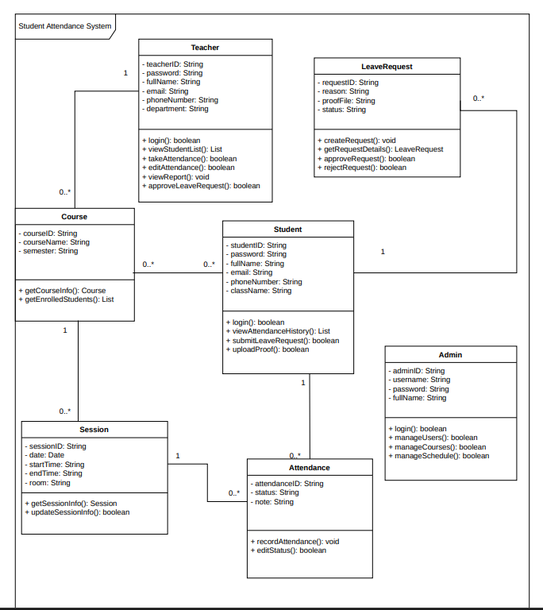

V. ERD Diagram

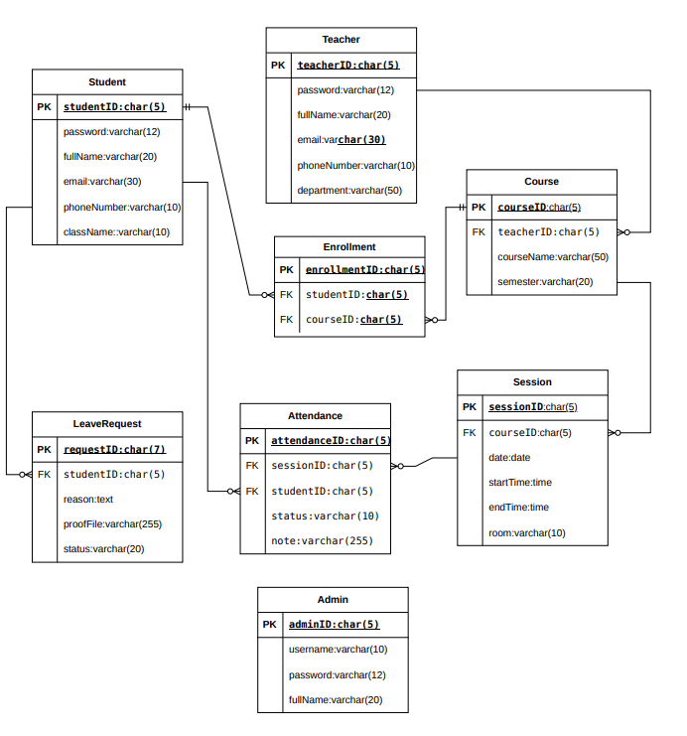

Class-to-Table Mapping

Teacher
teacherID
password
fullName
email
phoneNumber
department

Teacher_ID | Password | Full_Name | Email | Phone | Department

Attendance
attendanceID
status
note

Attendance_ID | Session_ID(FK) | Student_ID(FK) | Status | Note

Session
sessionID
courseID
date
startTime
endTime
room

Session_ID | Course_ID(FK) | Date | Start_Time | End_Time | Room

LeaveRequest
requestID
studentID
reason
proofFile
status

Request_ID | Student_ID(FK) | Reason | Proof_File | Status

Admin
adminID
username
password
fullName

Admin_ID | User_Name | Password | Full_Name

Intermediate table

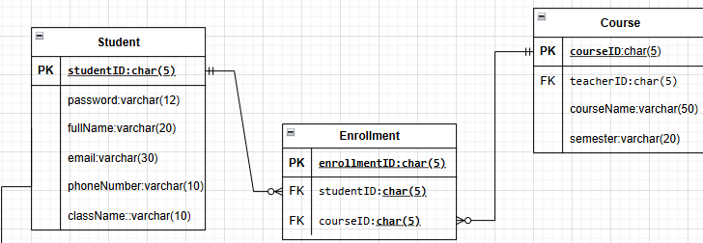

Student_ID | Password | Full_Name | Email | Phone | Class_Name
Student table:

Enrollment_ID | Student_ID (FK) | Course_ID (FK)

Enrollment.

Course_ID | Teacher_ID (FK) | Course_Name | Semester
Course table:

VI. User Interface Design (Text Description)
The system is designed as a simple application (desktop/mobile) with an intuitive and easy-to-use interface for three main user groups: Students, Faculty, and Administrators.

1. Login Screen
Users enter their User ID and Password to log in.
If the information is incorrect, the system will display an error message.
After successfully logging in, users are redirected to the main interface corresponding to their role.
2. Student interface
After logging in, students can:
View attendance history: Select a subject/class to view attendance details (date, status: Present, Absent, Late) and overall attendance rate.
Submitting a leave of absence request: Fill out a form with the date and reason for leave, which can be attached as proof, then submit the request online.
3. Instructor interface
After logging in, instructors can:
Create attendance sessions and attendance checks: Select a course, create an attendance session (determine the start/end times), then mark the status for each student (Ambient, Absent, Late) and save the results.
Reviewing leave applications: View the list of student leave applications and select approve or reject.
View attendance reports: Check student attendance statistics in the course.
4. Administrator interface
Administrators can:
User management: Add, edit, delete, or lock/unlock student and faculty accounts.
Course/Subject Management: Create semester-based course classes, assign instructors, and import student lists.
Schedule management: Setting up class schedules, classrooms, study times, and determining the start/end times of the semester.
5. General features
The application works well on both computers and mobile devices.
The interface is simple, easy to understand, and supports quick operation.
Display basic feedback messages (success or error).
Supports multiple languages (Vietnamese and English).

