Figures and Figure Legends
Figure 1. Cohort flow diagram
From 10,871 unique research IDs in the institutional thyroid surgical warehouse, 3,375 patients met inclusion criteria for the patient-level primary analysis. The pre-specified strict-ACR-eligible nodule subset of 3,687 nodules from 1,668 patients was used for the nodule-level sister analysis. Exclusion arms quantify dropouts at each gate.
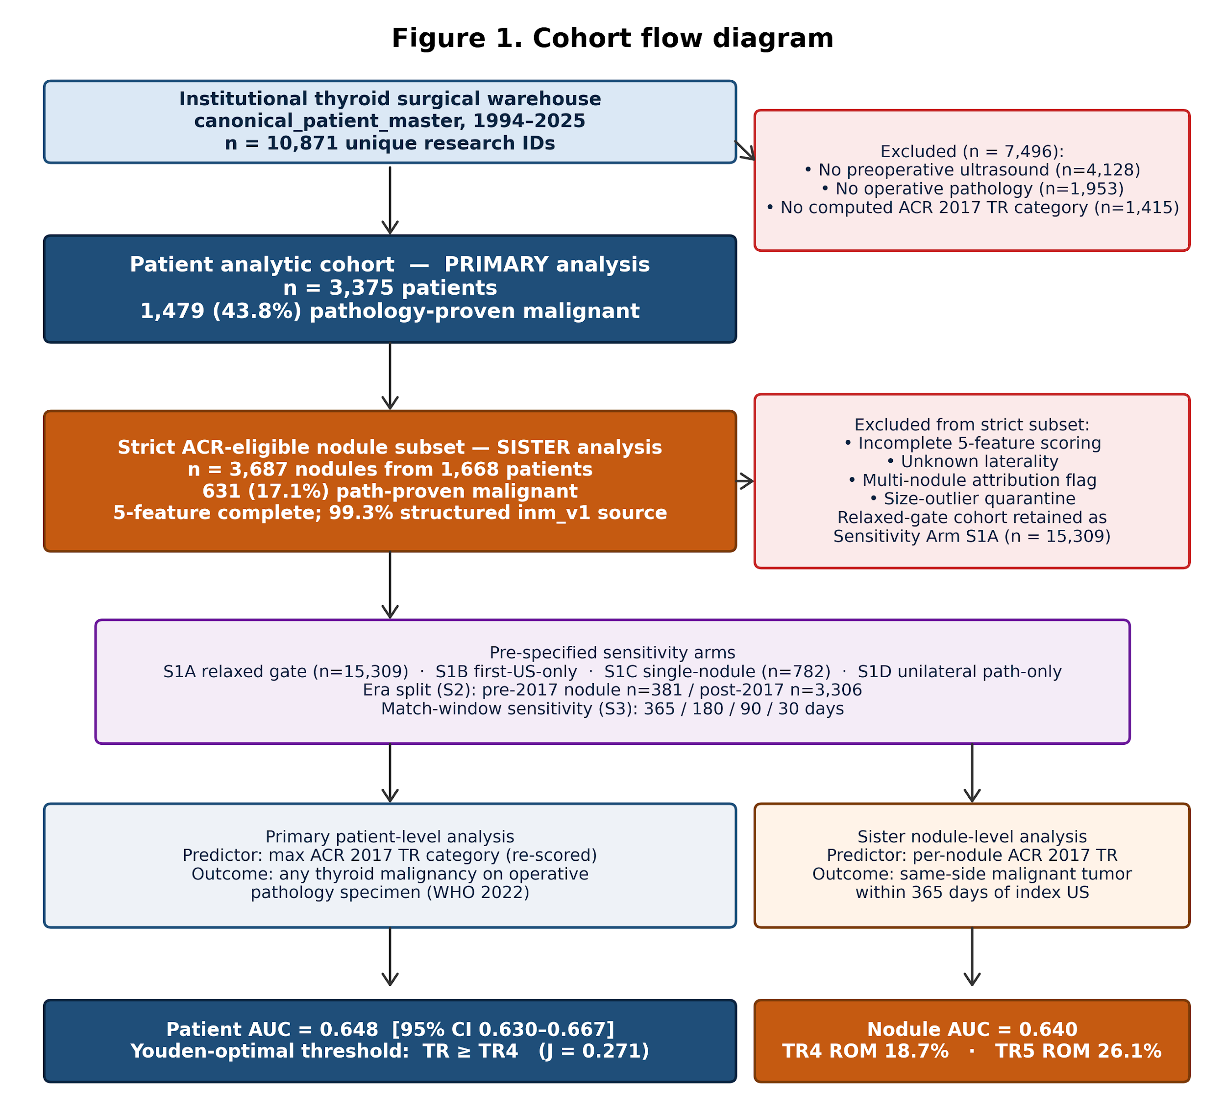

Figure 2. Patient-level receiver-operating-characteristic curve
ROC for ACR TI-RADS in the 3,375-patient operative cohort. AUC 0.648 (95% CI 0.630–0.667). Three pre-specified threshold operating points (TR≥TR3, TR≥TR4, TR≥TR5) are annotated; the Youden-optimal threshold TR≥TR4 (J = 0.271; sensitivity 71.3%, specificity 55.9%) is circled.
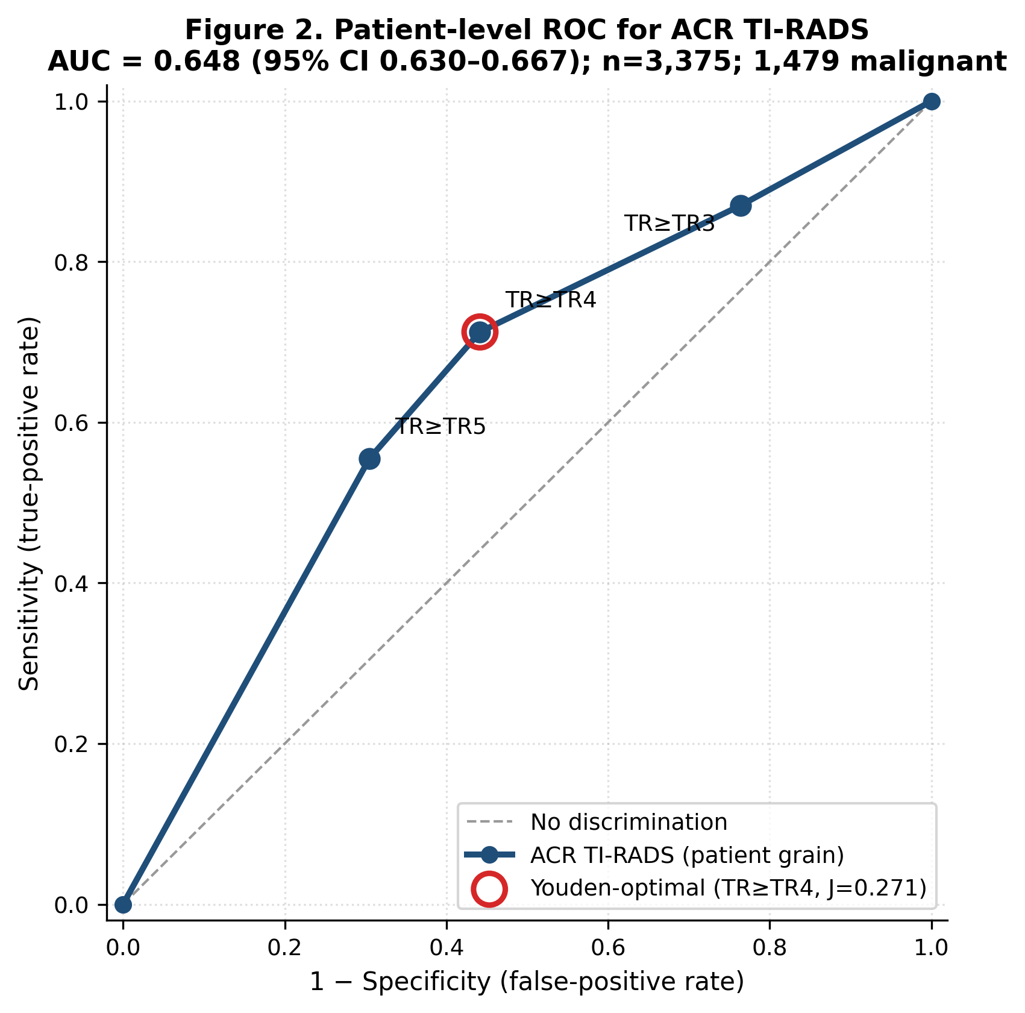

Figure 3. Patient-level per-category risk of malignancy
Patient-level ROM by ACR TI-RADS category with Wilson 95% CIs and overlay of ACR 2017 expected ranges (TR1 <2%; TR2 <2%; TR3 <5%; TR4 5–20%; TR5 >20%). Patient ROM exceeds expected bands at TR1–TR4; only TR5 falls within the expected band.
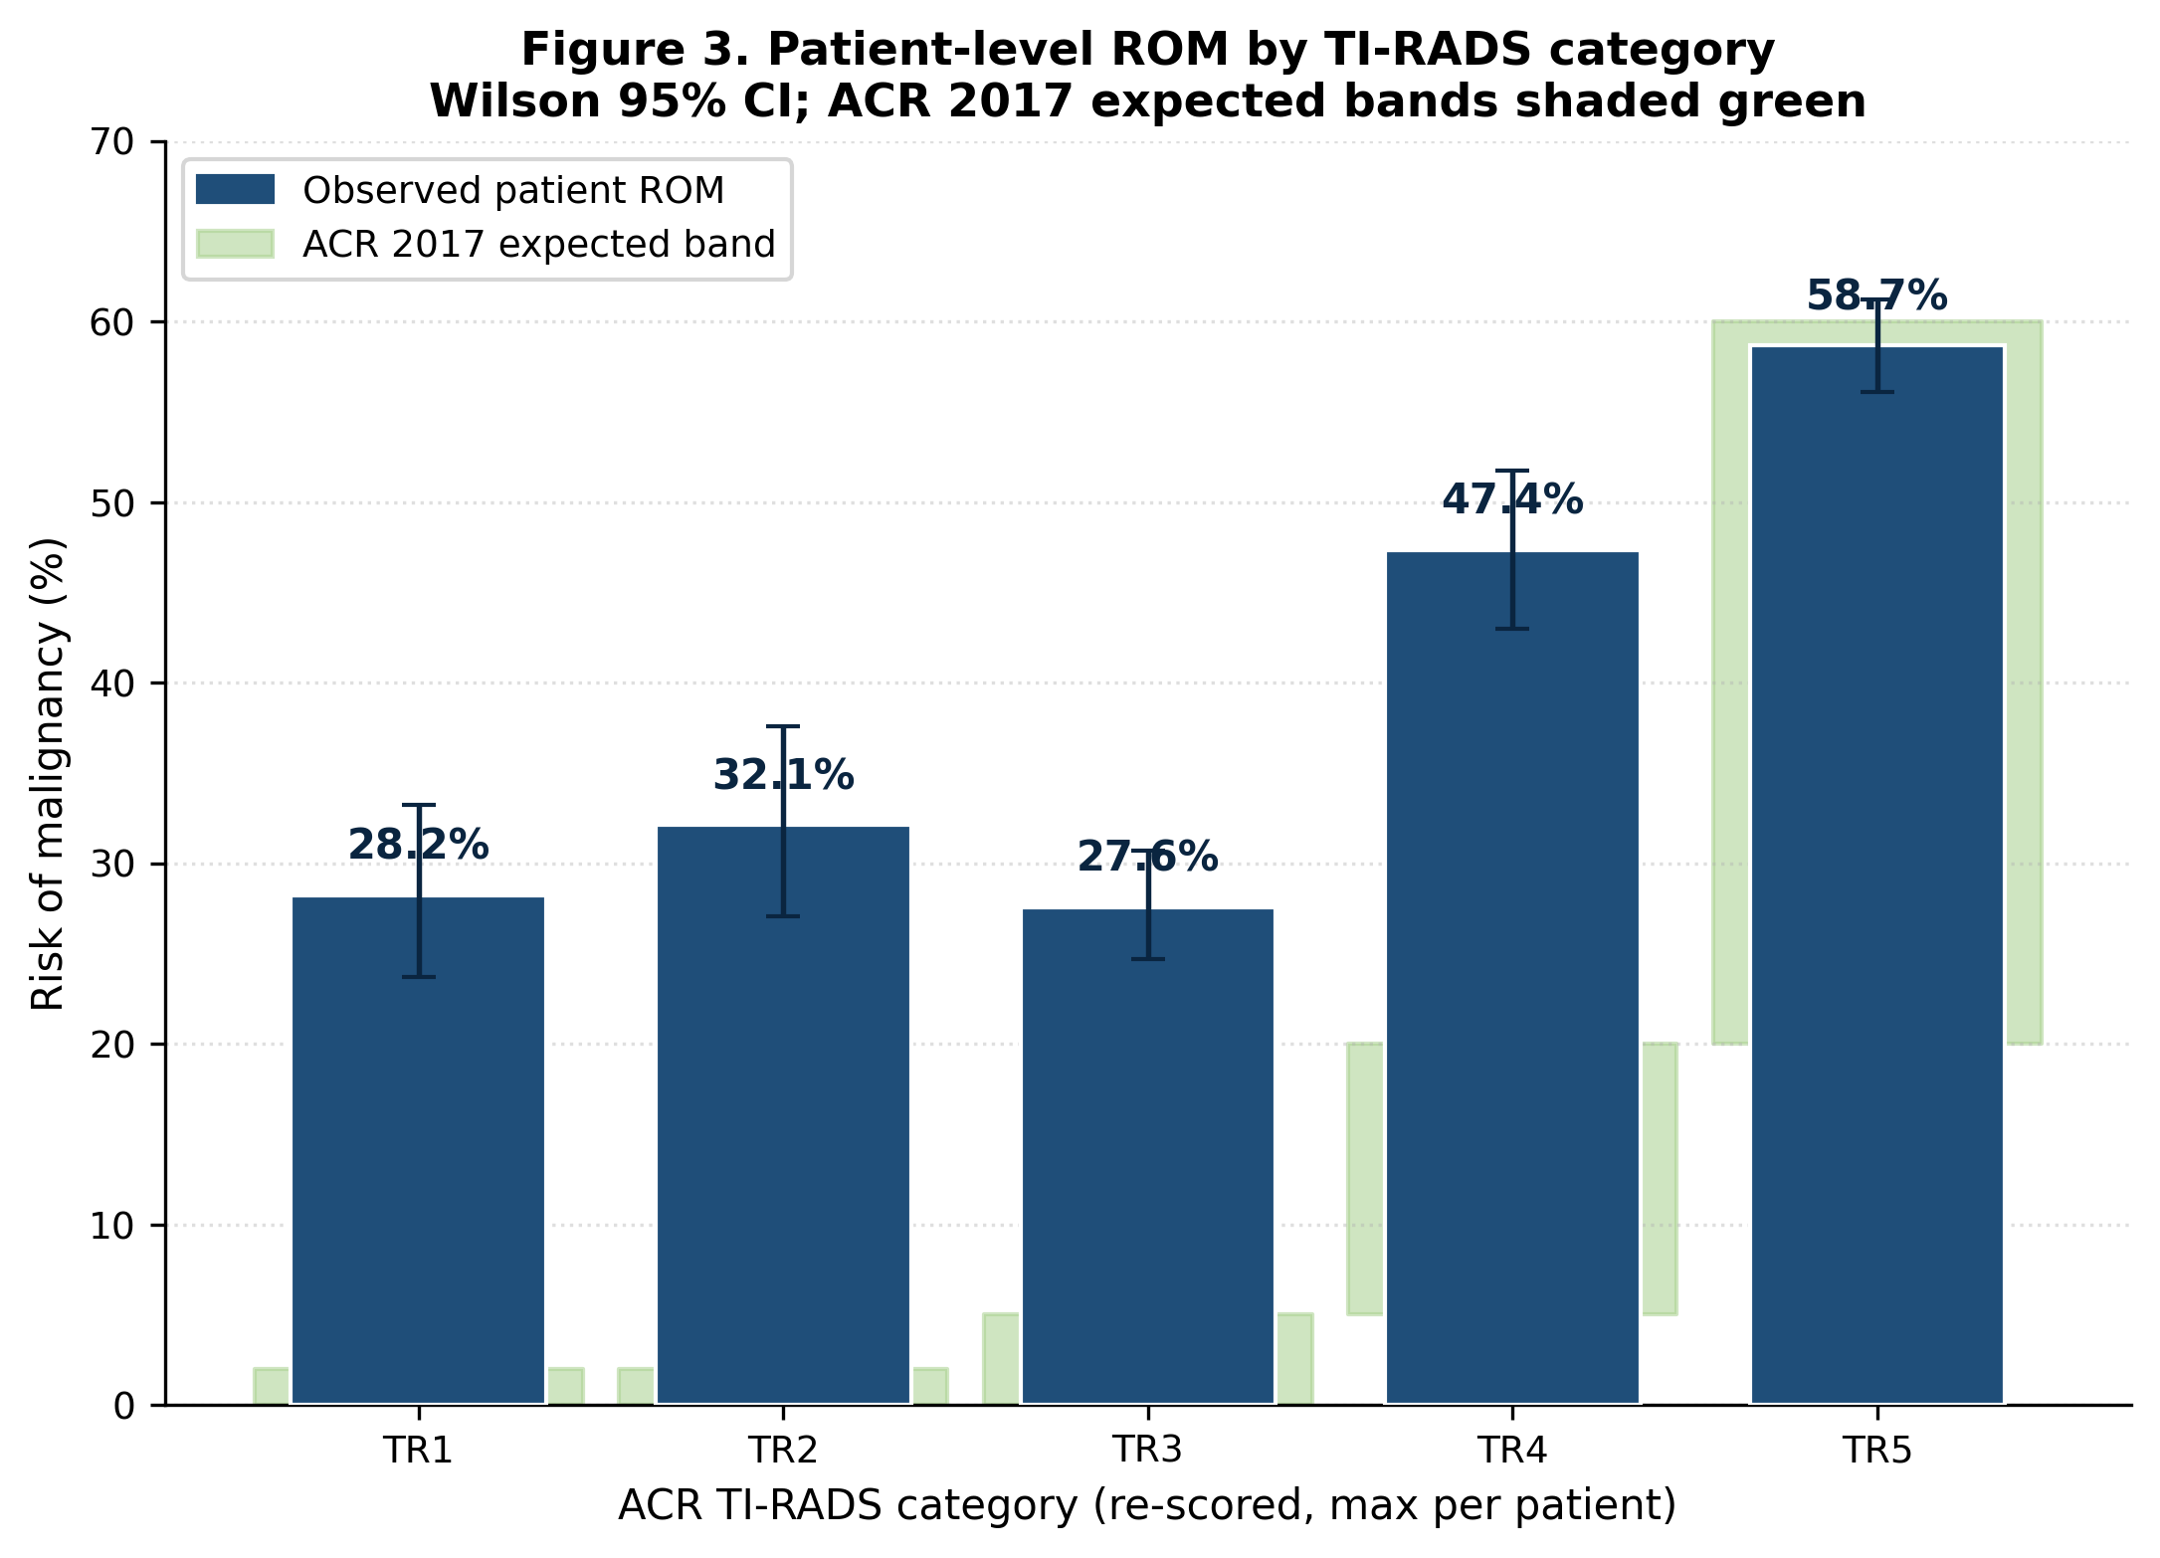

Figure 3b. Patient- vs nodule-grain ROM with ACR-expected bands
Paired patient and nodule per-category ROM with Wilson 95% CIs and ACR 2017 expected bands. Per-nodule TR4 (18.7%) and TR5 (26.1%) recover within-band calibration. Patient-versus-nodule inflation at TR4 and TR5 is +28.6 and +32.6 percentage points, quantifying multinodular attribution error.
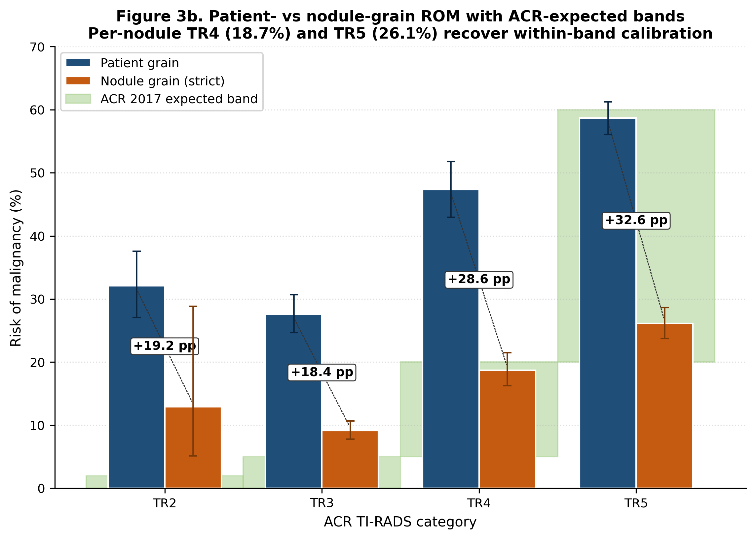

Figure 4. Diagnostic confusion at TR≥TR4 and ACR FNA-eligibility audit
Patient-level confusion matrix at the Youden-optimal TR≥TR4 threshold (TP 1,054; FP 837; FN 425; TN 1,059) and ACR 2017 FNA-eligibility stacked chart. Retrospective rule application flagged 1,553 below-threshold cases (46.0% of the 3,375-patient cohort) and 472 malignant patients below the ACR FNA threshold (31.9% of 1,479 malignancies; 14.0% of cohort).
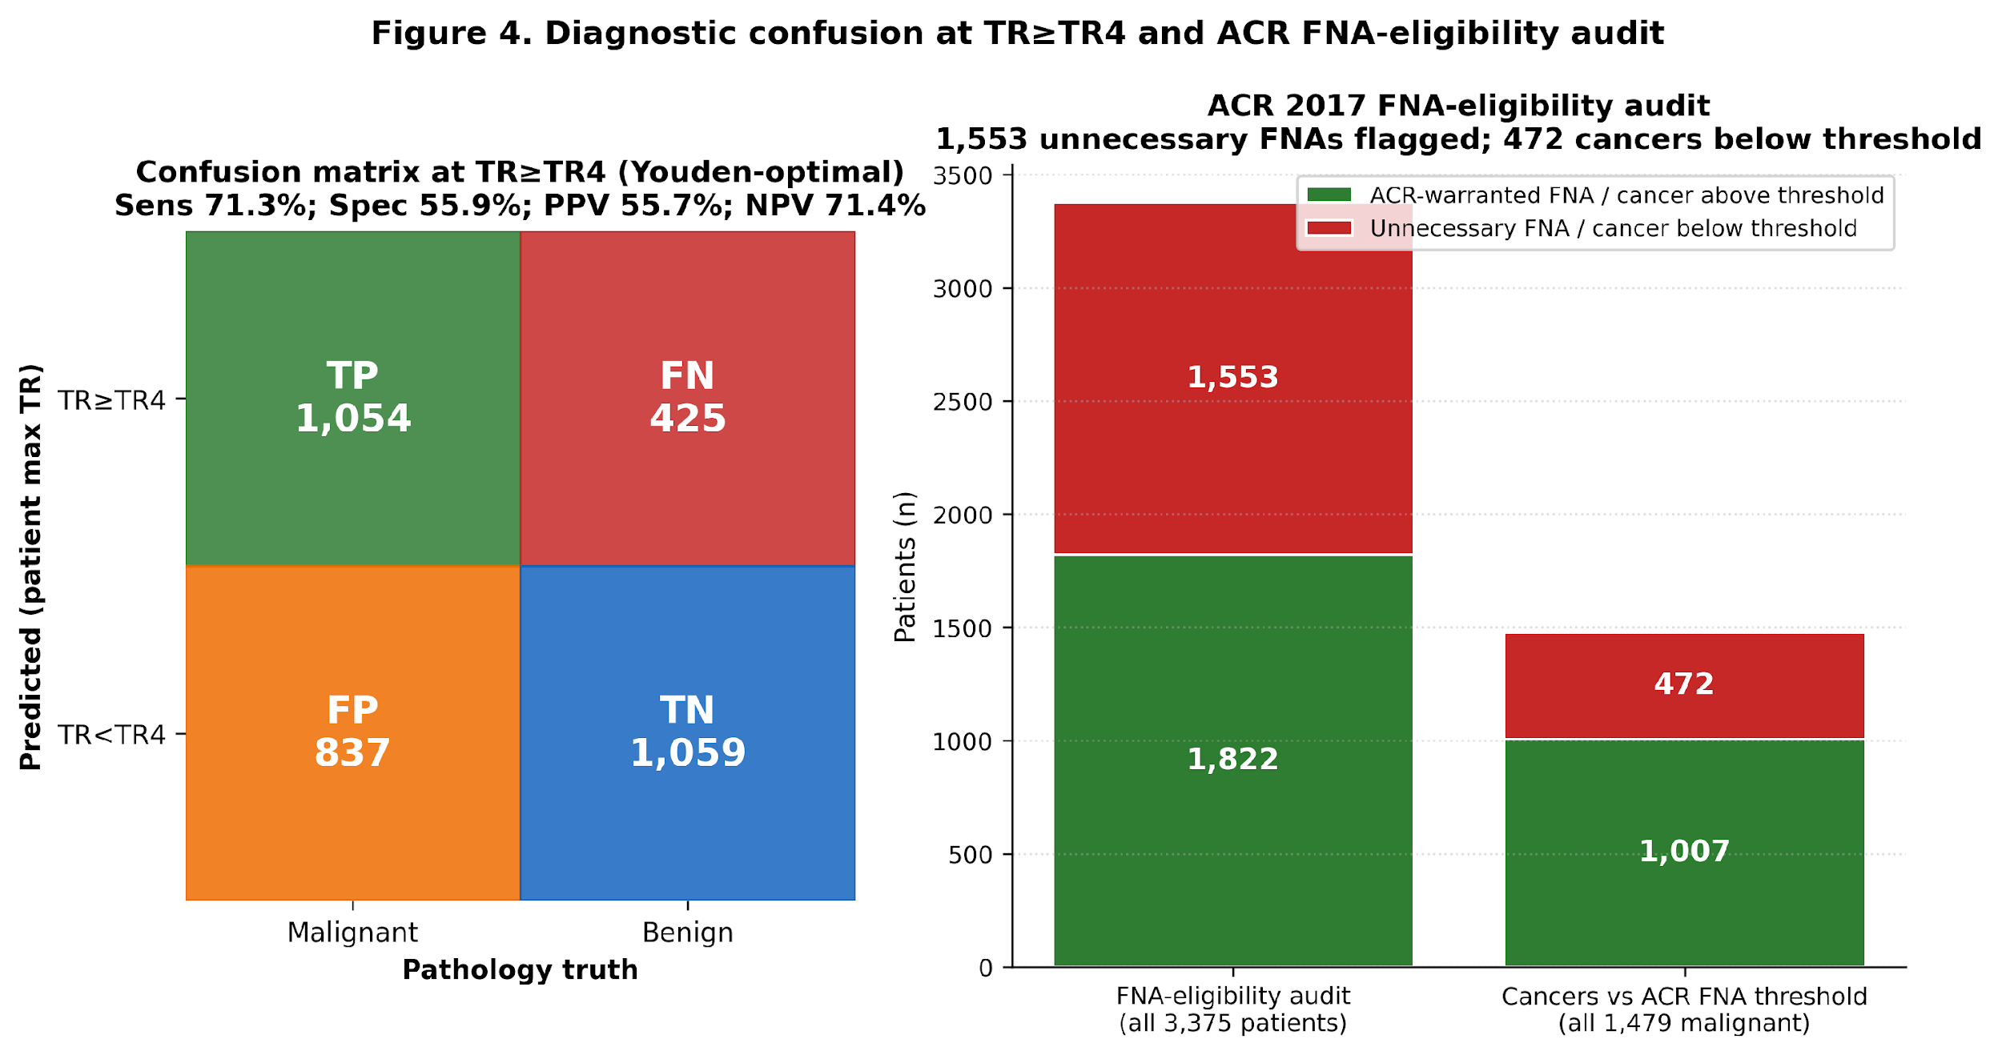

Figure 5. Subgroup forest plot — AUC by demographic stratum
AUC stratified by sex, age band (<40, 40–54, 55–69, ≥70 years), and surgery era (pre-2017 / post-2017). Discrimination (modest) is preserved across all strata; the cohort overall AUC of 0.648 is shown as a reference.
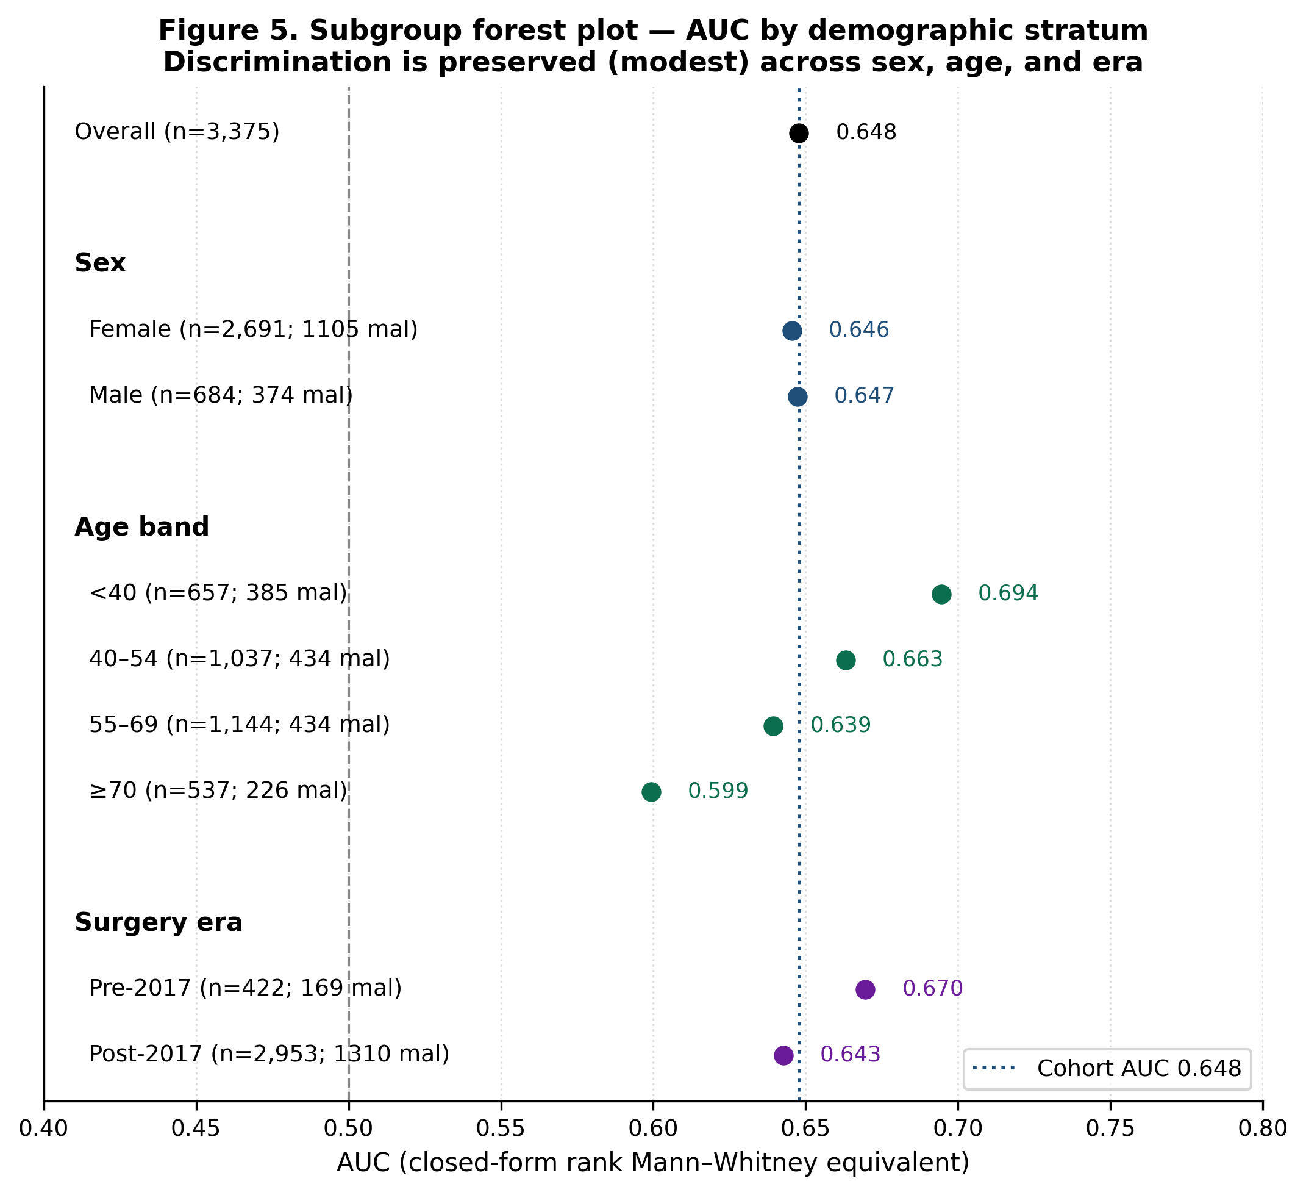

Supplementary Figure S1. Bethesda × TI-RADS heatmap (strict-eligible nodule level)
Heatmap of Bethesda × TI-RADS contingency at the strict-eligible nodule level (n = 3,687 nodules). 495 (13.4%) of strict-eligible nodules had a bridged Bethesda value; the dominant 'Missing' row reflects the FNA-linkage carry-forward limitation (CF-FNA-SIZE-CM-NULL).
