1. Report your opinion on the classification displayed in the bottom drawing in the document "Linear Models and Least Squares"?

Answer: I am sorry for that I was not sure if the “bottom drawing” is shown as Figure 1. In my opinion, the result is not classified so well by using Liner models and least squares. According to the distribution of sample data, red points and black points are distributed mixed. We should use a nonlinear model to fit the data and use the least square method to improve the accuracy of fit result.

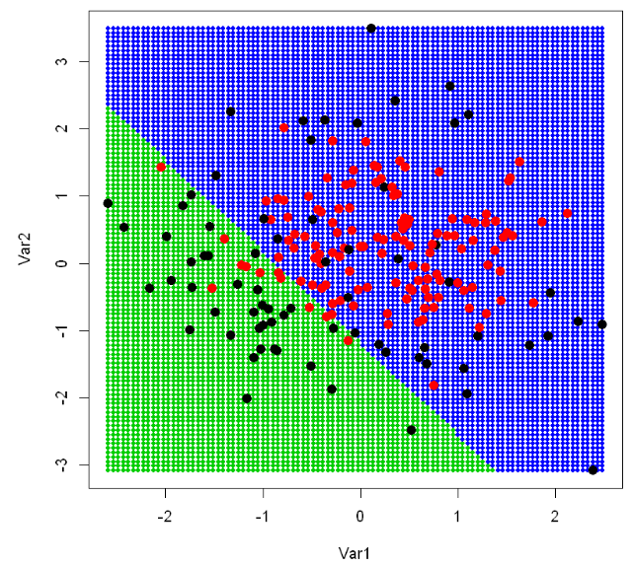

Figure 1

1. Describe the top formula in the document "k-Nearest Neighbor Method" in your mother tongue language as if you describe it to the friends who are not familiar with math.

Answer: This formula is used to calculate the average distance of k sample points with the closest distances of prediction point and other points of test sample.

In Chinese: 计算待测点的k个最短距离点的平均距离。

1. Describe the bottom 9 panels in the document "k-Nearest Neighbor Method" on the change in the regions along the parameter values of k.

Answer: According to the 9 figures, it is easily to find out that classify result of odd number k is better than when k is an even number. Besides, big k value will not mean the classify result is better. In my opinion, when k is 3, the classify result is the best one, though there are two red points near the bottom are not classified correctly. Because, we cannot be sure that if the two red points are outliers without any other sample near this two points.