question:write an explanation on bias and variance and their tradeoff in machine learning to somebody who are new to machine learning.

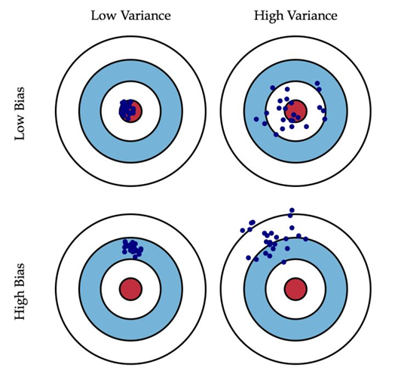[1]

1.bias and variance

In statistics，we usually want to make the deviation between the true values and the results we get as little as possible.

The bias means that the measuring method(algorithm) may have some questions which causes the error.

Then the variance means the sensitivity to small fluctuations in the training set.

For example, when a person is taking practice shooting(the picture above),the high bias means that the person maybe aiming the target inclined(method cause the error).Then variance means that the person’s hands shakes very strongly,or the winds are blowing very strong,then causes the error.

2.their trade-off

Unfortunately, the bias and variance in the same system cannot be 0 in the same time, so it is necessary to find their trade-off in the statistics.

[1]where the picture from: http://scott.fortmann-roe.com/docs/BiasVariance.html