Student:呂　楚陽　Student number：1030-30-1544 工学研究科電子工学山田研

We discussed on three panels of beta coefficients of three methods, stepwise, Lasso and Ridge.

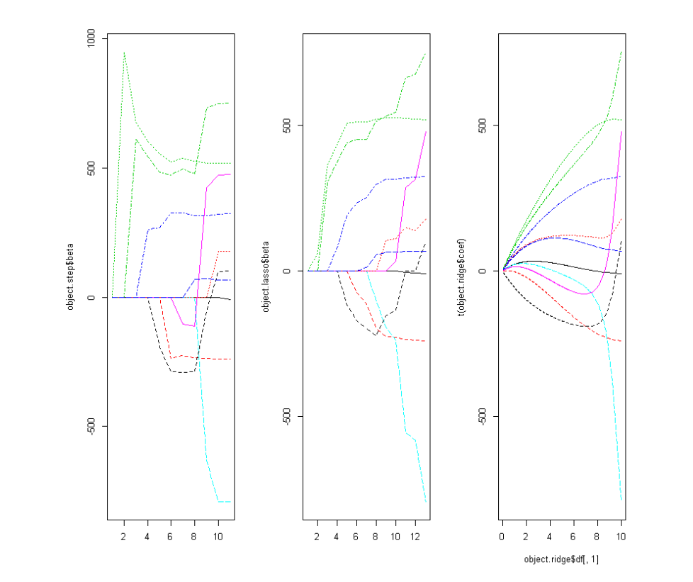

The regression $\hat{Y}$　　 = X $\hat{β}$

In Stepwise

$\hat{β}$ = argminβ(||y-Xβ||2)

We are supposed to minimize the sum of squares ||y-||2,increase the elements of the subset to make the ||y-||2 become smallest.

In LASSO

= argminβ(||y-Xβ||2+λ||β||)

minimizing the sum of squares ||y-||2with the regulation of the λ||β||. When the λ=0, takes the same result with the least square method.When λ>0， $\hat{β}$ will be smaller than the result of the least square method.

In ridge

$\hat{β}$ = argminβ(||y-Xβ||2+λ||β||2)

A little same with the LASSO method,We minimize the sum of squares ||y-||2with the regulation of the λ||β||. When the λ=0, takes the same result with the least square method. When λ>0， will be smaller than the result of the least square method.