When we use liner regression method to analyses data, we may face the situation of multiple explanatory variables. It is very difficult to make sure which part of variables should be selected to do the analyse.

We have three methods in total named stepwise regression, LASSO regression and Rouge regression.

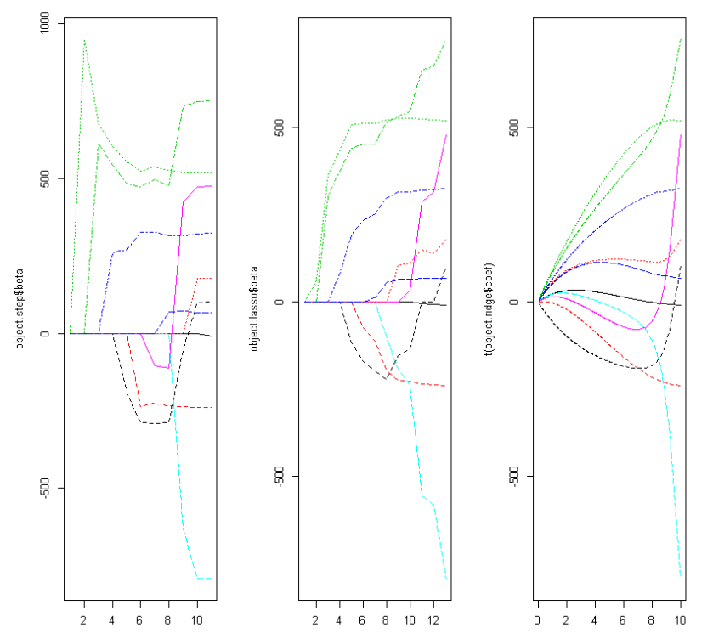

Figure 1

As shown as the Figure 1, the result of stepwise is similar as the result of LASSO. When the variable is put into the model one by one, the result became larger from zero. But in the result of Rouge, the line is different from the two others. But the trends of the three are similarity.