**Question:**

**Read the review https://www.ncbi.nlm.nih.gov/pmc/articles/PMC5721660/ .**

**Is there any improvement in your skills to grab the content of the review?**

**If any, describe what they are and how they worked?**

**If no, describe how the lectures should be improved.**

Answer:

After reading the paper, I realize that it’s too late for me to read the paper. If I can get it before I starting analyze my Natech events data, I think it will be a very efficient work.

Natural hazard triggered hazardous material (hazmat) release accidents (Natech events) have caused economic loss and impacted on our environment in the past 30 years. Many studies show that Natech events will increase the risks to regions that are not prepared for them. Learning from the historical records about Natech events can be considered as an effective method for Natech risk prevention and preparedness. Therefore, all hazmat release accidents recorded in the National Response Center (NRC) database in the United States were analyzed in my study. However, because there is no clear standard reporting of hazmat release accidents, I cannot identify and retrieve Natech events directly. With the aim of solving the problem, Deep Learning Methods were used to analyze the field of “Description of Incident” to identify and retrieve Natech events.

In the process of analyzing data, I faced at least 3 tips were mentioned in the paper which is tip 1, tip 4 and tip 8. First of all, because there is no standard for reporting Natech events and the data was already reported for 28 years (from 1990 to 2017) in USA, even the field of “Description of Incident” is full of uncertainty. As a result, cleaning data should be done after my several failure analyzing based on deep learning methods. After that, the problem of which deep learning method I should use to analyze the cleaned data was appeared. I select LSTM, CNN, Classify tree, KNN, SVM and sample BP method. However, only LSTM, CNN and Classify tree give some good result. Especially, for the KNN method, because there are over 820,000 hazmat release accidents in the NRC database from 1990 to 2017 need to be analyzed, even I established cluster services, I didn’t get a satisfied result. After read this paper, I find that, the KNN method might be not suitable to analyze so large number of the data. At last, how to estimate the deep learning method I chose is another appeared problem. I just used F1 and accuracy index to estimate the methods and got the result shown in Figure 1.

I retrieved and classified the Natech data according to the triggering natural hazard using the Long Short-Term Memory (LSTM) method and the Convolutional Neural Network (CNN) method. The high accuracy values of LSTM (0.9428) and CNN (0.8564) methods show that Deep Learning methods are suitable to extract and analyze historical hazmat release accidents. By comparing the result of LSTM with the result of the CNN method and combining them with the Keyword search method, we were able to identify 33,226 Natech events. The results showed that Natech events were triggered by hurricane (24.4%), storm (16.1%), heavy rains (17.0%) and other natural hazards (28.8%, including extreme temperature, flooding, lightning and snow etc.). However, because of the uncertainty of the data, there are 4,561 (13.7%) Natech events where the natural hazard triggering event was unknown. Overall, similar to previous studies, the results suggest that the number of Natech events have an increasing trend in the study period (from 1990 to 2017).

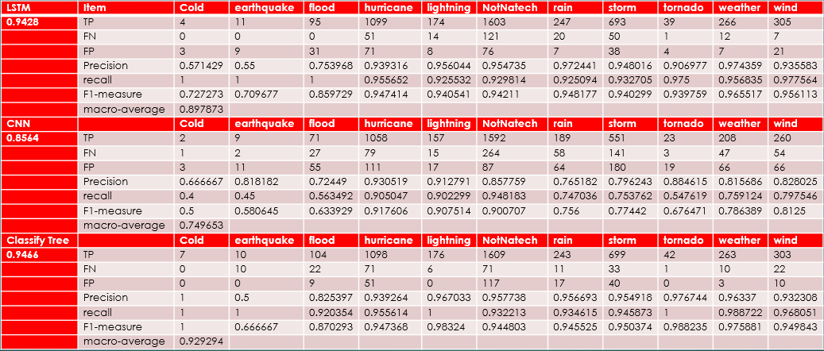

Figure 1 Estimation of different deep learning methods.