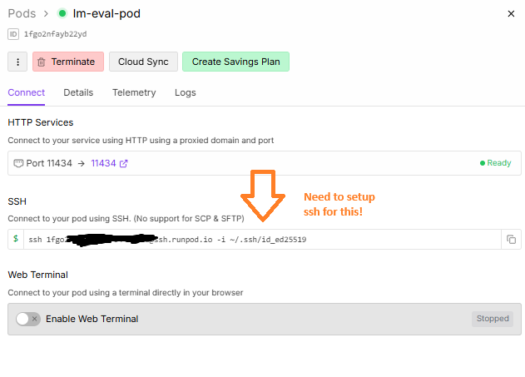
When you run the ssh-keygen command and it asks for a passphrase, you can simply press Enter (twice) to skip setting one.
That way there’s no password prompt every time you connect.
Here’s a step-by-step you can literally copy–paste:

1. Generate a key without passphrase
Open a terminal on the machine where you’ll run your Python script and type:
ssh-keygen -t ed25519 -C "your_email@example.com"
When it shows:
Enter file in which to save the key (/home/you/.ssh/id_ed25519):
just press Enter.
When it shows:
Enter passphrase (empty for no passphrase):
press Enter again.
And again for:
Enter same passphrase again:
press Enter.
You’ll see something like:
Your identification has been saved in /home/you/.ssh/id_ed25519.
Your public key has been saved in /home/you/.ssh/id_ed25519.pub.
This gives you a key with no passphrase.

2. Copy the public key to RunPod
Print it:
cat ~/.ssh/id_ed25519.pub
Copy the entire line starting with ssh-ed25519 and paste it into the SSH public key box in the RunPod pod page (as shown in your screenshot).
Click Save.

3. Test manually (optional)
Once the pod is running and shows a public IP, try:
ssh -i ~/.ssh/id_ed25519 runpod@<pod_public_ip>
You should go straight in without any password prompt.

4. Use in Python
In your Python script, just point paramiko (or any SSH library) to ~/.ssh/id_ed25519:
ssh.connect(public_ip, username="runpod", key_filename=os.path.expanduser("~/.ssh/id_ed25519"))
No passphrase is needed.

