**Capstone Research Project**

This project studies how training language models on a variety of languages affects racial and gender bias in in these models. Specifically, I ask how the choice of languages used in training different versions of a model impacts the racial and gender biases presented within these NLP models? Does the inclusion of other languages, and therefore the inclusion of the societal norms and customs that come from the cultures who speak and write in these languages have any impact on the potential biases these models may show to a certain ethnic group or gender? To answer this I examine the shifts in racial and gender bias across BERT models trained for a variety of languages.

While language models, such as BERT, have revolutionized NLP tasks, there are concerns that these models are trained to exhibit bias unintentionally. In a study done by Caliskan et al. (2017), the authors evaluated the cosine similarity between a subset of words pertaining to a variety of categories. Their tests discovered the model’s racial and gender biases. Through this study, the authors showed not only that the GloVe model exhibits these commonly held biases, but also that these biases could lead to disproportionate representation in automated decision-making processes.

I propose a similar design to Caliskan et al. in which I evaluate the cosine similarity of a subset of target words and concepts to determine if the selected models exhibit bias. All the models evaluated will be trained in both English and in at least one other language. This ensures that when running the tests for cosine similarity, no translation will be needed. The models being evaluated are available from Hugging Face. The data I will evaluate these models on will change depending on the kind of bias I want to look at.

To measure bias in these models, I test how similar a set of words is to another. For example, in the test for gender bias, I evaluate the cosine similarity between two sets of the most popular names for both men and women respectively and two sets of job labels, one consisting of STEM-related jobs and one of non-STEM-related fields. In doing so, I compare how closely related these sets of words are to each other, and whether one set of names is more closely linked to one of the two sets of job labels.

To test for biases, I will create a set of both target words and a set of concepts in my evaluations of cosine similarity. The set of target words used in each test will be consistent throughout to keep results consistent. These two sets will consist of words which are considered Pleasant (e.g. happy, kind, enjoyable) and Unpleasant (e.g. sad, angry, disgusting). I will first test for race using subsets of names that are commonly classified as European/English-American, African-American, Chinese-American, and Latin-American, and evaluating the cosine similarity of these subsets with both the group of Pleasant and Unpleasant words. I will then test for gender bias following a similar format, in which I will gather two sets of the most common names in the US for both men and women respectively, and evaluate the cosine similarity between each set and the set of target words. With regards to gender bias, I will also evaluate the cosine similarity between these sets of names and two sets of job labels. These two sets of labels will consist of labels pertaining to STEM careers, such as engineer or data scientist, and non-STEM fields, such as journalist or teacher.

The models I will be testing are outlined in the List_of_Models.csv file. This csv file contains a list of 9 models, 3 of which are trained only in English and 6 multilingual models. The three English models are as follows: bert-base-cased, roberta-base, and distilbert-base-cased. These three models will serve as the control group in this experiment, as these are some of the most used variations of the BERT model, and the majority of the models I will be testing are derived from these base models. The other 6 models are: bert-base-cased-multilingual, bert-base-uncased-multilingual, xlm-roberta-base, ernie-2.0-base-en, distilbert-base-multilingual-cased, and stsb-xlm-r-multilingual.

To organize these models, I’ve constructed a dataset of a variety of one-hot encoded variables outlining the languages they’ve been trained in, training data, and the uses of these models, as well as if the models have been finetuned. The variables outlining the language the model was trained in are: English, Chinese, Spanish, German, French, and Multi. The Multi variable in this case represents that a model was trained in more than one language, whether that be 2 or more of the five previously listed languages, or that the model was trained in more languages than just the five listed ones. I’ve also included another variable, Number_of_Languages, which as the name suggests, contains the total number of languages the model was trained in through training and finetuning.

The next group of variables represents the training data that was used to train the model, or the underlying model each variation was built from. The variables are as follows: Wikipedia, BookCorpus, CommonCrawl, CC100, Ted2020, and Other. The Wikipedia variable represents the Wikipedia datasets, a collection of cleaned Wikipedia articles written in every available language. The BookCorpus variable represents the BookCorpus dataset, a collection of text from over 11,000 unpublished books scraped from the internet. The CommonCrawl dataset represents the CommonCrawl dataset, a collection of 3.15 billion webpages scraped from the internet, 46% of which are in English, with the rest being in a variety of other languages. The CC100 variable represents the CC100 corpus which was used to train XLM-R. This corpus contains data for 116 languages from the 2018 CommonCrawl snapshot. The Ted2020 variable represents the Ted2020 corpus, a collection of transcripts from nearly 4000 TED talks in 2020. Finally, the OtherData variable represents if were any other datasets used to train the model.

The intended uses of each model are also outlined in the List_of_Models dataset. The MLM variable represents if one of the primary uses of the model is for Masked Language Modeling, where the model is able to predict missing words in a sentence by looking at the context of the rest of the words in the sentence. The NSP variable represents the model’s ability to perform Next Sentence Prediction, where the model is given two sentences and is tasked with determining if the two sentences were following one another in whatever text they were taken from. The Sequence_Classification variable represents if the model is capable of sequence classification, where the model is fed a sequence of data and is tasked with predicting a category for the sequence of data. The Token_Classification variable represents if the model is capable of token classification, where the model is given a string of text and is tasked with assigning each token, in this case each word, to a category. The QnA variable represents if the model can provide a response to a question posed by a human. Lastly, the NLI variable represents if the model is capable of Natural Language Inference, in that when presented with a hypothesis, the model can determine if the hypothesis is true, false, or undetermined. If there are any other primary uses for the model which do not require finetuning, the Other_Uses variable is used.

The next set of variables focuses on if a model was finetuned for some task(s), and the datasets that were used in the process of doing so. In the case of many of these models, they were finetuned to complete certain tasks or to be able to understand and communicate in more than one language. The finetuning variables used in this dataset represent the names of different finetuning datasets that a model uses. The variables in this section are as follows: XNLI, XQuAD, GLUE, SuperGLUE, MNLI, and OtherFT. All of these variables, apart from OtherFT, represent a specific well-known and trusted dataset used in finetuning language models. The OtherFT variable represents if the model was finetuned on any other dataset not listed previously.

Finally, the last section of variables focuses on the structure of each model. The first two columns indicate if the model is either an encoder or a decoder model, or both. For a model to be an encoder, it must take in an input, in this case, strings of text, and maps the data into a more compact representation that focuses on the specific patterns and features of this input data. On the other hand, a decoder model takes this compact representation of the data and turns it back into the original form of the data. In the case of these 12 models, only 1 is capable of being considered both an encoder and a decoder model, that being the mDeBERTA v3 model that was finetuned on the XNLI and MNLI datasets. The rest of these models are all considered to be encoder models. The final two variables, named Attention_Heads and Layers, describe how many attention heads each neural network has, as well as the number of layers each network has. The number of attention heads reflects ow many different mechanisms that capture different aspects of the input data in the model, and discern the patterns present in the data. As for the layers in a model, each layer focuses on a specific operation performed on the data, and produces an output that is passed down to the next layer.

Moving forward, the focus of this project will be on testing each model for cosine similarity. As discussed, there will be 3 separate tests performed on each model. The first of these tests will focus on testing for cosine similarity between 20 of the most popular baby names, according to Names.org, of both African American, Latin American, Asian American and European/English American origin against two lists of words similar to Pleasant and Unpleasant. These cosine similarity values will be used to determine the amount of underlying racial biases each of these models may hold. The list of African American baby names will consist of the 10 most popular male names (Reginald, Kameron, Kendrick, Javon, Tyrell, Jamar, Camron, Tyree, Jamari, and Reggie) and the 10 most popular female names (Jada, Latoya, Jayla, Tamika, Latoyna, Journey, Tameka, Journee, Lawanda, and Janiya). Similarly, each list will follow a similar structure as the African American list. The list of European/English American names is as follows: James, John, Robert, Michael, William, David, Joseph, Richard, Charles, and Thomas for the males, and Mary, Elizabeth, Patricia, Jennifer, Linda, Barbara, Margaret, Susan, Sarah, and Jessica for the females. For the list of Latin American names, the 10 most popular male names are Paul, Vincent, Victor, Adrian, Marcus, Leo, Miles, Roman, Sergio, and Felix, with the 10 most popular female names being Patricia, Laura, Amanda, Victoria, Julia, Gloria, Diana, Clara, Paula, and Norma. Finally, the list of the most popular Chinese American names is as follows: Lian, Shan, Lew, Long, Quan, Jun, Tou, Jin, Cai, and Chan for the males, and Lue, China, Lu, Maylee, Tennie, Maylin, Chynna, Jia, Mei, and Tylee for the females. For each of these lists, the names are in order of their popularity, with the first name being the most popular and the last beign the 10th most popular name. As for the lists of words similar to Pleasant and Unpleasant these names will be compared too, the lists were chosen on a more subjective approach. I’ve chosen 10 words for each category that I believe will give both a broad range of results as well as covering a variety of different characteristics. It is also important to note these lists will also be used in the second round of testing I will complete for each of these models involving gender biases. The list of “pleasant” words I’ve chosen are Happy, Agreeable, Polite, Civil, Charming, Gracious, Gentle, Approachable, Love, and Cool. As for the “unpleasant” words, I’ve chosen to include the words Rude, Lazy, Disagreeable, Lousy, Sad, Hate, Violent, Bitter, Harsh, and Angry.

When moving to the second and third rounds of testing, the focus of these tests will be on the potential gender biases within these models. The list of male and female names used in these two rounds of testing will be the top 20 male and female baby names in the US according to Names.org. To note, for both lists of names, as well as the previously discussed lists of names, these baby names are the most popular names in the US from 1880 to the present. The list of male names I will use in these tests will be: James, John, Robert, Michael, William, David, Joseph, Richard, Charles, Thomas, Christopher, Daniel, Matthew, George, Anthony, Donald, Paul, Mark, Andrew, and Edward. As for the list of female names I will use, they are: Mary, Elizabeth, Patricia, Jennifer, Linda, Barbara, Margaret, Susan, Dorothy, Sarah, Jessica, Helen, Nancy, Betty, Karen, Lisa, Anna, Sandra, Emily, and Ashley. The first of these two tests for cosine similarity will follow almost the exact same format as the test for racial bias, in that this group of commonly male and female names will be compared with the same list of “pleasant” and “unpleasant” words that I’ve outlined previously.

However, the second test for gender bias will follow a slightly different design, in that rather than comparing the cosine similarity between the two groups of names and the groups of pleasant and unpleasant words, this test will compare each group of names to two sets of professions, namely those that are STEM-related careers and those that are not. The reason for this specific test is to not only determine the potential biases held by these models of the characteristics of men and women, but also to test the biases these models may possess regarding what roles men and women have in the workforce. There has been a strong emphasis in recent years on improving gender relations in the STEM fields and reform to help these fields become more inclusive, however certain training data that these models are trained on are full of older material from times where it was uncommon for women to work in these professions. It is also important to note that the training and/or finetuning data for the multilingual models possess texts from a variety of different cultures and languages, where it may be more commonplace that women are not to be working in specific fields (let alone at all), as these cultures and their teachings put the focus on the men to earn for the family and for women to take care of the home. To test for these potential biases, we need to first identify the STEM and non-STEM careers we will use to compare with the lists of male and female names. For STEM careers, the list will consist of 10 of the best jobs in the field according to US News’s best jobs in STEM in 2023: Software Developer, Nurse Practitioner, Health Services Manager, Physicians Assistant, Security Analyst, IT Manager, Web Developer, Dentist, Orthodontist, and Computer Systems Analyst. For the list of non-STEM careers, the list of 10 professions is selected from Indeed’s list of best paying non-STEM careers: Artist, Marketing Manager, Social Worker, Attorney, Journalist, Musician, Teacher, Media Manager, Graphic Designer, and Judge. The reason that the list of non-STEM professions was selected through a more subjective process is that there is an extremely wide range of professions that are not in the STEM fields, and as such are much more difficult to narrow down into a list of the 10 most popular jobs. As such, I chose what I believe to be the most diverse and appropriate professions to include in the list.

Test 1 consisted of testing the names commonly associated with the 4 previously outlined ethnic groups (European/English Americans, African Americans, Chinese Americans, and Latinx Americans) against both lists of Pleasant and Unpleasant words. After calculating the cosine similarity values between each of the 80 names and 20 target words, I was left with a dataset consisting of 1600 observations for each of the 9 models, each with the name, the word, and the cosine similarity value of those two words. I have also included the name of the model as another column to be used in the cross-model analysis portion of my results, as well as two columns with the ethnic group the name in question is commonly associated with and whether the word it was being compared to was a Pleasant or Unpleasant word.

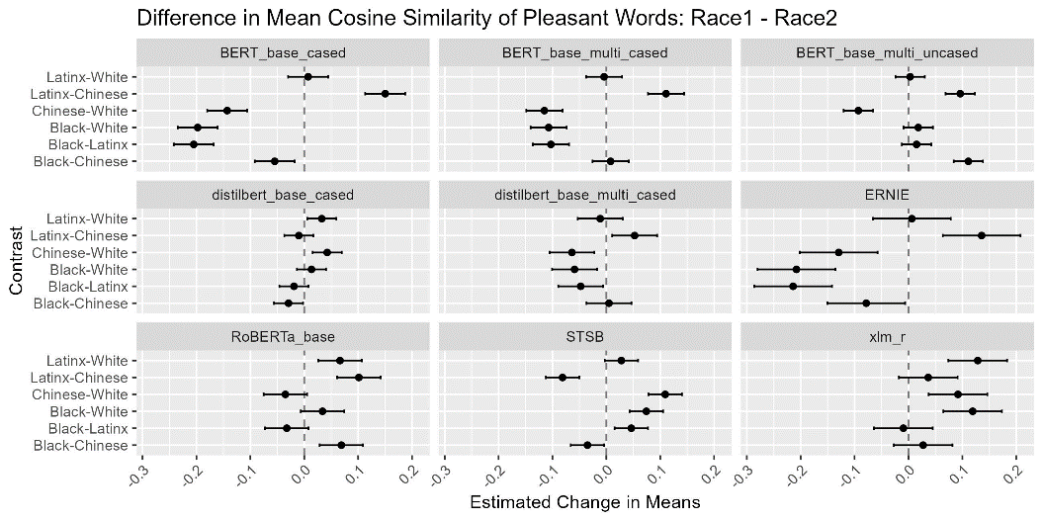After gathering this data from all models, I first began with a simple analysis of variance test on the cosine similarity values for each of the 4 ethnic groups, as well as a complementary post-hoc Tukey test. In performing these tests, we can decern graph the differences in mean cosine similarities of two ethnic groups to help visualize the potential biases these models may hold against certain ethnic groups. Shown to the right is a graph displaying the change in means of the cosine similarities for a pair of ethnicities and the group of Pleasant words for each model, accompanied by an error bar showing a confidence interval with which the true difference in means is most likely to be found.

Going in the order of the models of the graph, we can see for the BERT-base-cased model there are some clear patterns in the biases it shows. When looking at the differences in the means between the cosine similarities for African American names and all three other ethnic groups, the estimated difference is less than 1, suggesting there is bias against names of African American origin overall for the model. However, we can also see there is a negative difference in means for Chinese American and White (European/English) American names, suggesting there is also some level of bias that favors White American names over both Chinese and African American names. However, there is a positive difference in means for Latinx American names and both Chinese and White American names, indicating that the model may actually be biased more for those with commonly Latinx American names over the rest of the ethnic groups being studied.

When moving to BERT-base-multilingual-cased, we can see that the same relationship for the difference in means hold for Black and White names, Chinese and White names, and Black and Latinx names, however, there seems to be a positive difference in means for Black and Chinese names, and a very slight negative difference in Latinx and White names. (Find better way to sum up results cause this is way too wordy)

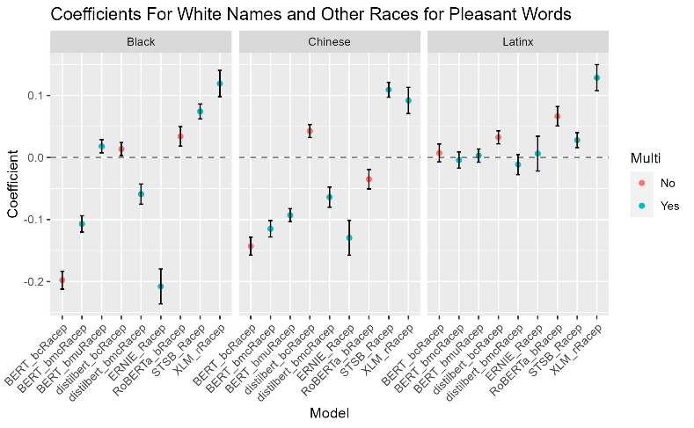Following these analysis of variance tests and the associated post-hoc Tukey Honest Significant Difference tests for each model, the challenge of comparing the potential biases shown in these models must be tackled. To start, I began by normalizing the cosine similarity values for each model using min-max normalization. To perform min-max normalization, the lowest cosine similarity value from all three rounds of testing is subtracted from the value being normalized, which then get divided by the largest possible cosine similarity value minus the smallest possible cosine similarity value. By using this min-max normalization technique, I could run a linear regression model for each of the 9 model that would determine the change in cosine similarity when moving from one ethnic group to another. Before creating the model however, the Race attribute, which states what ethnic group/race the name in the observation is commonly associated with is, needed to have a reference factor set. I chose to set the reference factor to “White”, as one of my original hypotheses was that these NLP models would show biases for European/English names. In doing so, the linear model that will be produced will display the coefficients for the change in cosine similarity when moving from the group of White names to any of the other three ethnic groups. After running these models for both the dataset for Pleasant and Unpleasant words, I was able to derive these two graphs:

These graphs show the coefficients of cosine similarity when moving from the group of White names to Black, Chinese, and Latinx names for each other 9 models. A negative coefficient suggests that the regression model predicts the cosine similarity value for a Pleasant/Unpleasant word to decrease when moving from comparing the word to a commonly associated White (European/English) name to an African/Chinese/Latinx American name, whereas a positive coefficient suggests the model predicts the cosine similarity value for a Pleasant/Unpleasant word to increase when moving from comparing the word to a White name to comparing the same word to an African/Chinese/Latinx American name. In the case of a negative coefficient, we can interpret that as the NLP model in question is more likely to associate the word in question with a White name rather than a name associated with a different ethnic group, and a positive coefficient shows that the NLP model is more likely to associate the word in question with a name from one of the other ethnic groups rather than a White name.

The first graph looks at the relationship between White names and the other three ethnic groups and how their cosine similarity values with Pleasant words changes. We can see that there are a multitude of models which show a clear bias for White names compared to Black and Chinese names, while there surprisingly seems to be a bias against White names when compared to Latinx names. The BERT-base-cased, BERT-base-multilingual-cased, distilbert-base-multilingual-cased, and ERNIE models all have negative coefficients for Black names, indicating the cosine similarity value decreases when moving from the group of White names to the group of Black names. This negative coefficient shows there is a clear bias in these four models against names which are more commonly associated with African Americans when comparing them to Pleasant words. We can also see that all three base BERT models (base-cased, base-multilingual-cased, and base-multilingual-uncased), distilbert-base-multilingual-cased, ERNIE, and RoBERTa-base all have negative coefficients for Chinese names, suggesting that there is a bias towards White names when comparing their cosine similarities to Pleasant words to Chinese names’ cosine similarities. However, when looking at the coefficients for Latinx names, not a single one of the 9 models has a negative coefficient. This is to say that when looking at the cosine similarity values for Pleasant words and White names and Pleasant words and Latinx names, each of these models is more likely to associate a Pleasant word with a Latinx name than a White name.

The second of these two graphs is set up in a similar fashion, as this graph shows the coefficients of cosine similarities when comparing a White name and an Unpleasant word and a name associated with one of the other three ethnic groups in this study and an Unpleasant word. We can see in this graph a similar pattern of bias against Black and Chinese names and a bias for Latinx names. Only three models, BERT-base-cased, BERT-base-multilingual-cased, and ERNIE, have a negative coefficient for Black names, suggesting that the other 6 models are likely to associate and Unpleasant word with a Black name rather than a White name. We can also see that the same three models, BERT-base-cased, BERT-base-multilingual-cased, and ERNIE, as well as RoBERTa-base, all have negative coefficients for Chinese names, suggesting that the other 5 models are more likely to associate an Unpleasant word with a Chinese name than a White name. Finally, we can see that BERT-base-multilingual-cased and uncased models, distilbert-base-multilingual-cased, and stsb-xlm-r-multilingual all have very slightly negative coefficients for Latinx names, indicating these 4 models are more likely to associate White names with an Unpleasant word than Latinx names.

There are a few strange and concerning patterns we can see in these graphs however. First, looking at Black names specifically, all three models which possessed negative coefficients of cosine similarity for Unpleasant words (BERT-base-cased, BERT-base-multilingual-cased, and ERNIE) also had negative coefficients for Pleasant words. We can also see this same pattern within the both graph for our Chinese name coefficients, as these same three models have negative coefficients for both Pleasant and Unpleasant words. This doesn’t necessarily rule out that these models might not possess any biases one way or another towards Black and Chinese names, but rather these models may not have enough training data including uses of the names in our Black names or Chinese names lists relative to our White names list. From the results of our regression models, there are only 5 instances where a coefficient appears to not be statistically significant to a p-value < 0.05 for Black names and Chinese names; BERT-base-multilingual-uncased’s coefficient for Black names and Unpleasant words (p-value of 0.087) and coefficient for Chinese names and Unpleasant words (0.547), both of distilbert-base-multilingual-cased’s coefficients for Black names (p-values of 0.197 and 0.255 for Pleasant and Unpleasant words respectively) , and RoBERTa-base’s coefficient for Chinese names and Unpleasant words. In the case of BERT-base-multilingual-cased specifically, the combination of having only negative coefficients for both Black names and Chinese names and having not statistically significant coefficients for both sets of names for Unpleasant words suggests that there may be discernable pattern of bias within this model, and that there may not have been enough training data included in this model to account for the specific names and words chosen to compare. This same conclusion is also the most likely suitable conclusion for the other two models in question (BERT-base-cased and ERNIE), as even though the coefficients may be statistically significant, the appearance of a negative coefficients for both Pleasant and Unpleasant words for both Black names and Chinese names is likely due to a smaller number of appearances of these names in their training data, as BERT-base-cased is an English only model, and ERNIE is only trained in English and Chinese.

Sources

Caliskan, Aylin, et al. “Semantics Derived Automatically from Language Corpora Contain Human-like Biases.” *Papers With Code*, 25 Aug. 2016, paperswithcode.com/paper/semantics-derived-automatically-from-language.

“Bert-Base-Uncased · Hugging Face.” *Bert-Base-Uncased · Hugging Face*, huggingface.co/bert-base-uncased. Accessed 17 May 2023.

“Best Stem Jobs | Best Jobs Rankings | US News Careers.” *US News World Report*, 2023, money.usnews.com/careers/best-jobs/rankings/best-stem-jobs.

“Best Non-STEM Majors with High-Paying Salaries | Indeed.Com.” *Indeed*, 27 Oct. 2022, www.indeed.com/career-advice/finding-a-job/highest-paying-non-stem-majors.

“Most Popular African American Baby Names - the Meaning of Names.” *Names.Org*, www.names.org/lists/by-origin/african-american/. Accessed 17 July 2023.

“Most Popular Baby Names in the United States.” *Names.Org*, www.names.org/lists/most-popular/all-time/. Accessed 17 July 2023.

“Most Popular Chinese Baby Names - the Meaning of Names.” *Names.Org*, www.names.org/lists/by-origin/chinese/. Accessed 17 July 2023.

“Most Popular English Baby Names - the Meaning of Names.” *Names.Org*, www.names.org/lists/by-origin/english/. Accessed 17 July 2023.

“Most Popular Latin Baby Names - the Meaning of Names.” *Names.Org*, www.names.org/lists/by-origin/latin/. Accessed 17 July 2023.