MIS381N (Fall 2018) Homework1

Ryan Borthwick Hoff

September 13, 2018

1. Three limitations with Capital360’s database that stand out immediately:

* Since there appears to be no relation between the P_ , M_ and S_ variables they should be separate tables. Keeping these variables together would limit querying capabilities due to the varying row counts for each column.
* Additionally, if a supplier can carry multiple products in its inventory there is no way currently to convey that besides a duplicate product entry. This is detrimental to both querying and data entry.
* Another limitation is that inventory is not linked to product within the database. This is a confusing syntax and could easily cause errors.

1. (1) The first step in the process of updating Capital360’s database is analyzing your database needs and conceptualizing a model around them. I’d recommend theorizing how the database’s variables are related to one another and how you would like to enter and query for said variables during the store’s typical operations. Pose hypotheticals such as “If I needed to order more of a certain item, what information would I use how to find the manufacturer information?” or “When a product is purchased, where would an associate go to update the inventory?” These questions will should make clearer how to define keys and which variables in the database, forming an entity relationship diagram for the process.

(2) The second step is to use the conceptual model to generate a logical model. Using the relationships outlined by the conceptual questions and required keys, begin to form the tables. Here you want to ensure that your database can grow with your business and that it will function during day-to-day operations. After forming the logical model, it is good to poise the same hypotheticals from step (1) to test it and ensure it will work with the uses demanded of it.

(3) After forming the logical model, the next step is to define the physical design of your database. Ask yourself if a cloud-based solution or an in-house hardware solution would be better for your business. From there determine size and form of storage and how to keep backups and redundancies.

(4) The Final step is implementation, installing the hardware if it’s an in-house solution or setting up the cloud-based solution. Then we’d transfer all of Capital360’s old data onto the new database. We’d also work with the business employees ensuring they know the ins and outs of the new database and check-in periodically to ensure it functions as intended.

Other Rules

1. IDs (which we’ll use as primary keys) must be unique and cannot be null. To ensure uniqueness, instead of using an integer we can use a composite of other pertinent variables
2. Inventory and Min age cannot be 0 or lower
3. If a qualitative variable is missing the space should be filled with an “n/a”

3. Here are the new tables for Capitol360’s database:

1 NF Table



3 NF Table







We now separate the manufacturer and supplier information from the product information. The database now uses P_ID as the primary key, which can be used to look up information on the product, its manufacturer and which suppliers carry that product. Supplier information can now be found using the S_ID key listed with the product information.

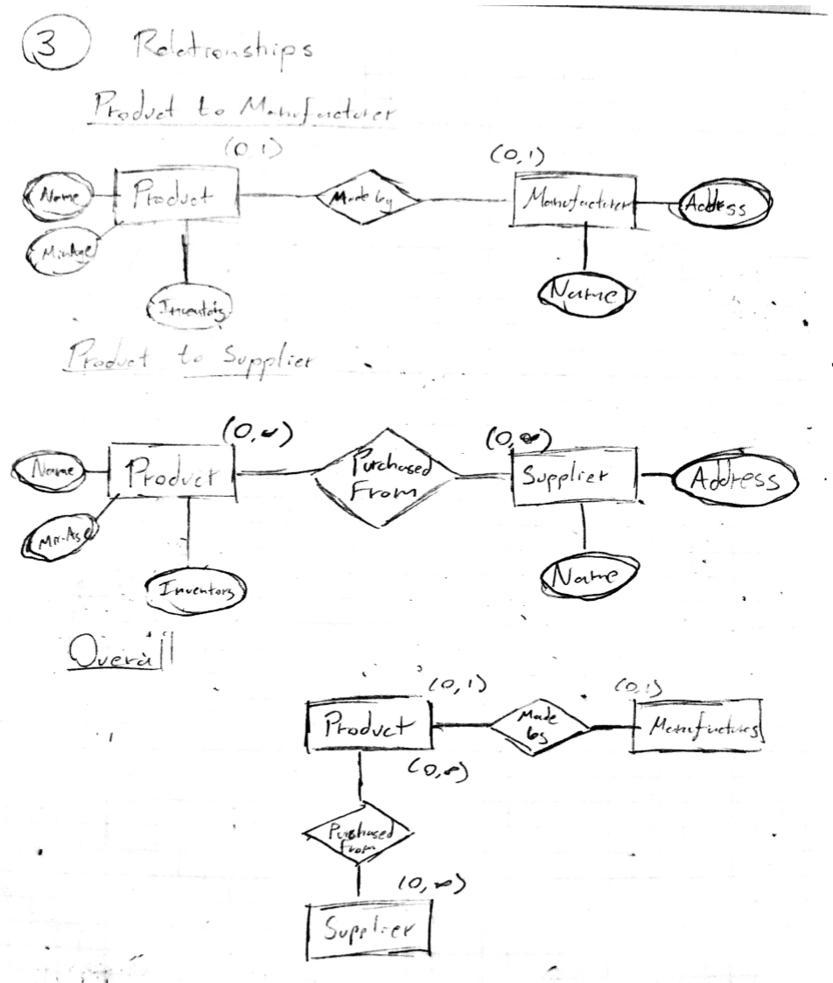

(0,1)

(0,1)

(0,N)

(0,N)