**PART A: Coffee database**

**Question 1** - Identify various functional dependencies. Using functional dependencies, evaluate the normal form of the table (Excel spreadsheet)? Justify.

From the table, the primary key is a composite of, Product ID, Area Code and Date

Therefore, the functional relationships are as follows

1.ProductID links to the Product which in turn links to Product Line, Type and Product Type.

2.Area Code links to the State, Market and Market Size

3.The combination primary key (Product ID, Area Code, Date) links to all other database information, Profit, Margin, Sales, COGS, Total Expenses, Marketing, Inventory, Budget Profit, Budget Margin, Budget Sales, and Budget COGS.

These dependencies prove that the table as given is in 1NF form.

**Question 2** - Normalize the database into 3rd normal form using functional dependencies identified above. Identify the various tables including primary keys and foreign keys. (Feel free to create unique keys when you have composite primary keys)

**Entities**





|  |  |
| --- | --- |
| *Table 3: Transactions* | Product ID (FK) |
| Area Code (FK) |
| Date (PK) |
| Sales(Monthly) |
| Profit (Monthly) |
| Margin (Monthly) |
| Inventory |
| Total Expenses (Other than Product Cost) |
| Marketing Expenses |
| COGS |
| Budget Profit |
| Budget Margin |
| Budget Sales |
| Budget COGS |

**Entities and Keys Chart**

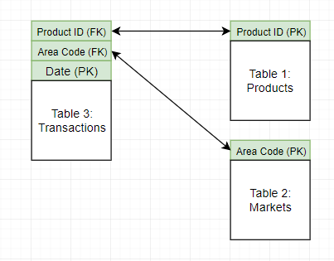

**Question 3** - Now, identify various entities and relationship types (1-1; 1-M; M-N), draw the E-R diagram. Convert the logical schema into actual table structure. Clearly identify PKs and FKs in the table structure.

1. Each product may be sold in multiple markets, but for any sale we can only have one market and product. So, the relationship of Markets to Sales is one to many (1,N) and Products to Sales is one to many (1,N)
2. Each market may sell multiple products, so the relationship of Products to Markets is Many to Many (N,N)

**E-R Diagram**

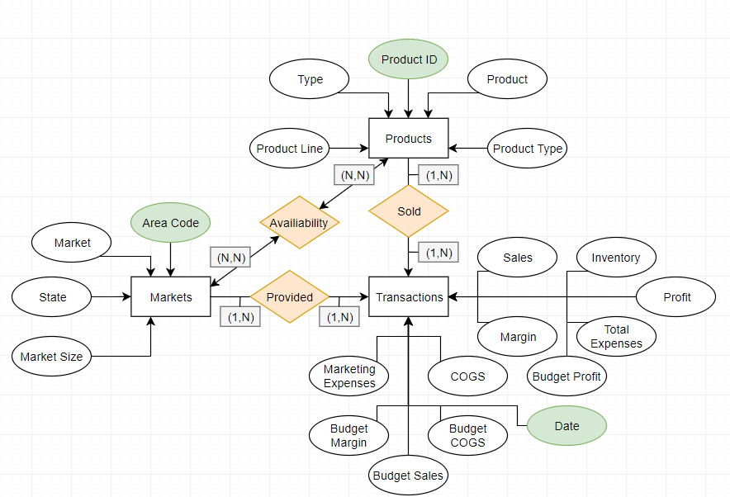

SQL Code

**CREATE** **TABLE** Products**(**

ProductId **integer** **not** **null,**

"Product" **CHAR(**25**)** **not** **null,**

"Product Line" **CHAR(**25**)** **not** **null,**

"Type" **CHAR(**25**)** **not** **null,**

"Product Type" **CHAR(**25**)** **not** **null,**

**PRIMARY** **KEY(**ProductId**),**

**CONSTRAINT** Check_Prod_Type **CHECK(**"Product Type" **IN** **(**'Coffee'**,** 'Espresso'**,** 'Herbal Tea'**,** 'Tea'**)),**

**CONSTRAINT** Check_Line **CHECK(**"Product Line" **IN**

**(**'Beans'**,** 'Leaves'**)),**

**CONSTRAINT** Check_Type **CHECK(**"Type" **IN**

**(**'Regular'**,** 'Decaf'**)));**

**CREATE** **TABLE** Markets**(**

"Area Code" **INTEGER** **not** **null,**

"State" **CHAR(**25**)** **not** **null,**

"Market" **CHAR(**25**)** **not** **null,**

"Market Size" **CHAR(**25**)** **not** **null,**

**PRIMARY** **KEY(**"Area Code"**),**

**CONSTRAINT** Check_Market_Size **CHECK(**'Market Size' **IN**

**(**'Major Market'**,** 'Small Market'**)),**

**CONSTRAINT** Check_Market **CHECK(**'Market' **IN**

**(**'West'**,** 'East'**,** 'South'**,** 'Central'**))**

**);**

**CREATE** **TABLE** Sales**(**

ProductId **INTEGER** **not** **null,**

"Area Code" **INTEGER** **not** **null,**

"Date" **DATE** **not** **null,**

Profit **REAL** **not** **null,**

Sales **REAL** **not** **null,**

COGS **REAL** **not** **null,**

"Total Expenses" **REAL,**

Marketing **REAL,**

Inventory **REAL,**

"Budget Profit" **CHAR(**10**)** **REAL,**

"Budget Margin" **CHAR(**10**)** **REAL,**

"Budget Sales" **CHAR(**10**)** **REAL,**

"Budget COGS" **CHAR(**10**)** **REAL,**

**PRIMARY** **KEY(**ProductID**,** "Area Code"**,** "Date"**),**

**FOREIGN** **KEY(**ProductID**)** **REFERENCES** Products**(**ProductID**),**

**FOREIGN** **KEY(**"Area Code"**)** **REFERENCES** Markets**(**"Area Code"**)**

**);**

**PART B: Tommy and Tom (TT)**

**Question 1** - Identify various entities and the relationships and draw the E-R diagram. Convert the E-R diagram into tables (relational model).

TT have 100s of products each with more than 10,000 components. For each of their products they have a bill of materials(components) and each of their components should be linked to supplier information. The supplier information which is pertinent is price, quality and reliability for each of the components they supply. TT also have a system which maintains order information which includes the date the order was place, expected delivery date, the actual delivery date (if delivered) and the shipment certification.

**Entities**













**E-R Diagram**

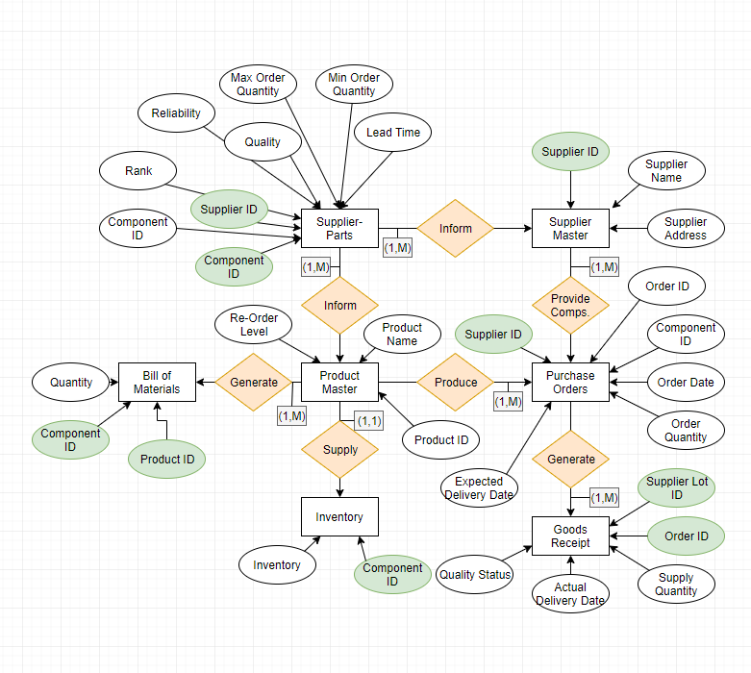

**SQL**

**CREATE** **TABLE** Products**(**

ProductId **NUMBER** **not** **null,**

"Product Name" **char(**25**)** **not** **null,**

“ReOrder **Level**” **NUMBER** **not** **null,**

**PRIMARY** **KEY(**ProductId**)**

**);**

**CREATE** **TABLE** BOM**(**

ProductId **NUMBER** **not** **null,**

ComponentId **NUMBER** **not** **null,**

Quantity **NUMBER** **not** **null,**

**PRIMARY** **KEY(**ProductId**,** ComponentId**),**

**FOREIGN** **KEY(**ProductId**)** **REFERENCES** Products**(**ProductId**),**

**FOREIGN** **KEY(**ComponentId**)** **REFERENCES** Products**(**ProductId**)**

**);**

**CREATE** **TABLE** Inventory**(**

ComponentId **NUMBER** **not** **null,**

Inventory **NUMBER** **not** **null,**

**PRIMARY** **KEY(**ComponentId**),**

**FOREIGN** **KEY(**ComponentId**)** **REFERENCES** Products**(**ProductId**)**

**);**

**CREATE** **TABLE** SupplierMaster**(**

SupplierId **NUMBER** **not** **null,**

SupplierName **char(**25**)** **not** **null,**

SupplierAddress **char(**50**)** **not** **null,**

**PRIMARY** **KEY(**SupplierId**)**

**);**

**CREATE** **TABLE** SupplierParts**(**

SupplierId **NUMBER** **not** **null,**

ComponentId **NUMBER** **not** **null,**

“Unit Price” **REAL** **not** **null,**

Quality **REAL** **not** **null,**

Reliability **REAL** **not** **null,**

**Rank** **REAL** **not** **null,**

"Lead Time" **REAL** **not** **null,**

"Min Order Quantity" **REAL** **not** **null,**

"Max Order Quantity" **REAL** **not** **null,**

**PRIMARY** **KEY(**SupplierId**,** ComponentId**),**

**FOREIGN** **KEY(**SupplierId**)** **REFERENCES** SupplierMaster**(**SupplierId**),**

**FOREIGN** **KEY(**ComponentId**)** **REFERENCES** Products**(**ProductId**)**

**);**

**CREATE** **TABLE** OrderInformation**(**

OrderId **NUMBER** **not** **null,**

SupplierId **NUMBER** **not** **null,**

ComponentId **NUMBER** **not** **null,**

"Order Date" **DATE** **not** **null,**

"Order Quantity" **NUMBER** **not** **null,**

"Expected Delivery Date" **DATE** **not** **null,**

**PRIMARY** **KEY(**OrderId**),**

**FOREIGN** **KEY(**SupplierId**)** **REFERENCES** SupplierMaster**(**SupplierId**),**

**FOREIGN** **KEY(**ComponentId**)** **REFERENCES** Products**(**ProductId**)**

**);**

**CREATE** **TABLE** GoodsReceipt**(**

OrderId **NUMBER** **not** **null,**

"Supply Lot Id" **NUMBER** **not** **null,**

"Supply Quantity" **NUMBER** **not** **null,**

"Actual Delivery Date" **DATE** **not** **null,**

"Quality Status" **char(**25**)** **not** **null,**

**PRIMARY** **KEY(**OrderId**,** "Supply Lot Id"**),**

**FOREIGN** **KEY(**OrderId**)** **REFERENCES** OrderInformation**(**OrderId**),**

**CONSTRAINT** Check_Quality **CHECK** **(**“Quality Status” **IN**

‘SATISFACTORY’**,** ‘UNSATISFACTORY’**))**

**);**

**Question 2** - What if an order can be supplied in small quantities at various times (that is, a large order can be split into many small orders). How does your E-R diagram and table structure change?

The overall structure will not change. Each individual ‘Part’ or smaller portion of the order can just be logged under a different Supplier Lot ID. The table entries may still be used in the same fashion, but supply quantity will represent the smaller order portions. The orders can be placed until the full order is fulfilled and quality status can be used to determine whether or not the order is completed. An additional determinant variable may be added to the Goods Receipt table called “Order Status” if need be, but the “Quality Status” should work.