MIS381N (Fall 2018) Homework1

Due on 10/08 before 12 pm

**NOTE**: To complete this homework, you will need to really step back and ask what problem you are trying to address and how to break the bigger problem into smaller questions to solve using SQL. Given the nature of questions, there will be subjectivity and variance in the answers.

Please submit SQL statement (well formatted) with results in a Word document. Whenever there are more than 10 records in the result, please copy and paste the first 10 records.

The data files are available on Canvas. Here are the tables you need to create; Note: PK is primary key and FK is the foreign key.

**TABLE: MANAGERS (REGID is the PK)**

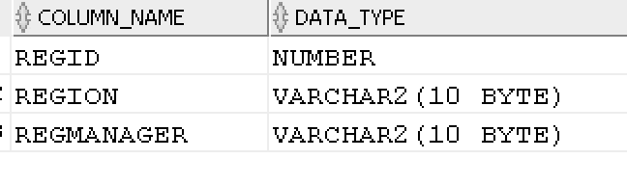

CONSTRAINT:

REGION can be only ‘East’, ‘South’, ‘Central’, ‘West’.

**TABLE: PRODUCTS (ProdID is the PK)**

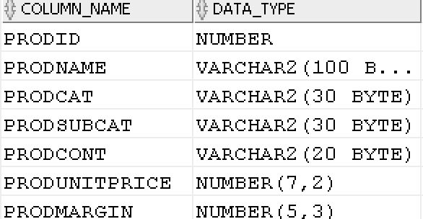

CONSTRAINTS:

PRODCAT can only be ‘Technology’ ‘Furniture’ or ‘Office Supplies’

PRODCONT take on only ‘Jumbo Drum’, ‘Medium Box’, ‘Jumbo Box’, ‘Wrap Bag’, ‘Large Box’, ‘Small Box’, ‘Small Pack’

**TABLE: ORDERS (OrderID is the PK)**

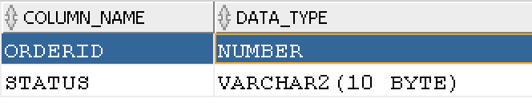

**TABLE: CUSTOMERS (CustID is the PK; CustReg is the FK on delete cascade)**

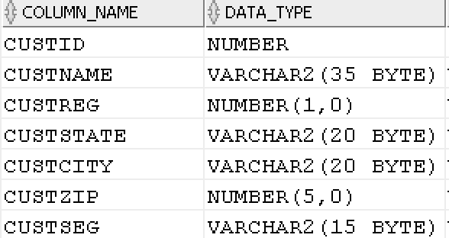

CONSTRAINT:

CUSTSEG can be only Home Office ‘Corporate’, ‘Small Business’, ‘Consumer’.

**TABLE: ORDERDET (OrderID (FK), CustID (FK), ProdID (FK) are together a PK; All FK are on delete restrict)**

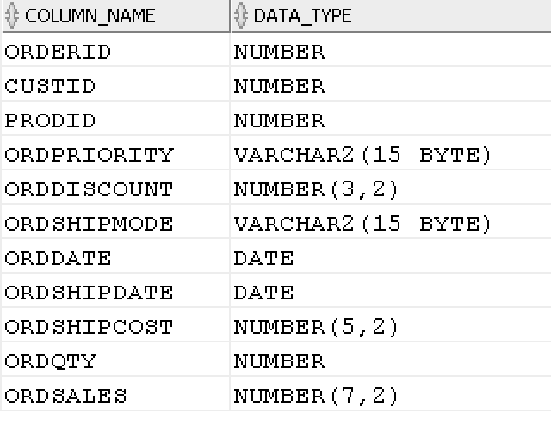

CONSTRAINTS

ORDPRIORITY can be ‘Low’, ‘Medium’, ‘High’, ‘Critical’, ‘Not Specified’

ORDSHIPMODE can be ‘Regular Air’, ‘Delivery Truck’, ‘Express Air’

**TASKS:**

Do the following and copy into Word document the DDL, DML, results, and any errors. Like in Part A, please copy and paste the first 10 rows if there are more than 10 rows in the answer.

**QUESTION 1: Create the 5 tables given above. You should define primary keys, foreign keys, and other CHECK constraints. And, load the data from Excel spreadsheet.**

CREATE TABLE MANAGERS(

Regid Number PRIMARY KEY NOT NULL,

REGION VARCHAR2(10) CONSTRAINT Chk_Region CHECK (REGION IN ('East', 'Central', 'West', 'South')),

REGMANAGER VARCHAR2(10)

);

CREATE TABLE PRODUCTS(

PRODID NUMBER PRIMARY KEY NOT NULL,

PRODNAME VARCHAR2(100) NOT NULL,

PRODCAT VARCHAR2(30) NOT NULL CONSTRAINT Chk_prodcat CHECK(PRODCAT IN ('Technology', 'Furniture', 'Office Supplies')),

PRODSUBCAT VARCHAR2(30) NOT NULL,

PRODCONT VARCHAR2(20)NOT NULL CONSTRAINT Chk_prodcont CHECK(PRODCONT IN ('Jumbo Drum', 'Medium Box', 'Jumbo Box', 'Wrap Bag', 'Large Box', 'Small Box', 'Small Pack')),

PRODUNITPRICE NUMBER(7,2),

PRODMARGIN NUMBER(5,3)

);

CREATE TABLE ORDERS(

ORDERID NUMBER PRIMARY KEY NOT NULL,

STATUS VARCHAR2(10)

);

CREATE TABLE CUSTOMERS(

CUSTID NUMBER PRIMARY KEY NOT NULL,

CUSTNAME VARCHAR2(35),

CUSTREG NUMBER(1,0) REFERENCES MANAGERS(Regid) ON DELETE CASCADE,

CUSTSTATE VARCHAR2(20),

CUSTCITY VARCHAR2(20),

CUSTZIP NUMBER(5,0),

CUSTSEG VARCHAR2(15) CONSTRAINT Chk_custseg CHECK (CUSTSEG IN ('Home Office', 'Corporate', 'Small Business', 'Consumer'))

);

CREATE TABLE ORDERDET(

ORDERID NUMBER NOT NULL REFERENCES ORDERS(ORDERID),

CUSTID NUMBER NOT NULL REFERENCES CUSTOMERS(CUSTID),

PRODID NUMBER NOT NULL REFERENCES PRODUCTS(PRODID),

ORDPRIORITY VARCHAR2(15) CONSTRAINT Chk_priority CHECK (ORDPRIORITY IN ('Low', 'Medium', 'High', 'Critical', 'Not Specified')),

ORDDISCOUNT NUMBER(3,2),

ORDSHIPMODE VARCHAR2(15) CONSTRAINT Chk_ship CHECK (ORDSHIPMODE IN ('Regular Air', 'Delivery Truck', 'Express Air')),

ORDDATE DATE,

ORDSHIPDATE DATE,

ORDSHIPCOST NUMBER(5,2),

ORDQTY NUMBER,

ORDSALES NUMBER(8,2),

PRIMARY KEY(ORDERID, CUSTID, PRODID)

);

**QUESTION 2: ORDER Cancellations**

1. **What fraction of the orders was cancelled?**

SELECT ROUND((SELECT COUNT(*) FROM ORDERS WHERE STATUS = 'Returned')/

(SELECT COUNT(*)FROM ORDERS),5) AS Prop_Returned_Orders

FROM DUAL;

Answer:0.00933

1. **What were the sales from cancelled orders?**

SELECT SUM(ORDSALES) AS Sales_By_Returned

FROM

ORDERS A

INNER JOIN

ORDERDET B

ON A.ORDERID = B.ORDERID and status = 'Returned';

Answer: 308,455.12

1. **Who are the top five customers in terms of cancelled orders?**

SELECT C.CUSTID, D.CUSTNAME, C.Count_Returned

FROM

( (SELECT B.CUSTID, COUNT(A.ORDERID) AS Count_Returned

FROM

(

ORDERS A

INNER JOIN

ORDERDET B

ON A.ORDERID = B.ORDERID AND STATUS = 'Returned'

)

GROUP BY CUSTID

ORDER BY COUNT(A.ORDERID) DESC ) C

INNER JOIN

CUSTOMERS D

ON C.CUSTID = D.CUSTID

)

WHERE ROWNUM < 6;

Answer:

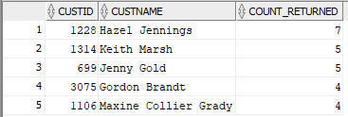

**QUESTION 3: CUSTOMER related:**

1. **Who are the top 10 customers in terms of revenues generated?**

SELECT C.CUSTID, D.CUSTNAME, C.TOT_REVENUE

FROM

( (SELECT A.CUSTID, SUM(A.ORDSALES) AS Tot_Revenue

FROM

(

ORDERDET A

INNER JOIN

ORDERS B

ON A.ORDERID = B.ORDERID

)

WHERE STATUS IS null

GROUP BY A.CUSTID

ORDER BY SUM(A.ORDSALES) DESC) C

INNER JOIN

CUSTOMERS D

ON C.CUSTID = D.CUSTID

)

WHERE ROWNUM < 11;

Answer:

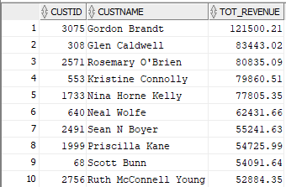

1. **Are there customers who buy mostly some categories of products and there is a potential for them to buy other product categories?**

SELECT C.CUSTID, D.CUSTNAME, D.CUSTSEG, COUNT(DISTINCT C.PRODCAT) AS Categories_Purchased, SUM(C.ORDQTY) as Qty_Purchased

FROM

((SELECT *

FROM(

ORDERDET A

INNER JOIN

PRODUCTS B

ON A.PRODID = B.PRODID

)) C

INNER JOIN

CUSTOMERS D

ON C.CUSTID = D.CUSTID

)

GROUP BY C.CUSTID, D.CUSTNAME, D.CUSTSEG

HAVING SUM(C.ORDQTY) > 80 AND COUNT(DISTINCT C.PRODCAT) <>3 AND CUSTSEG IN ('Corporate', 'Small Business')

ORDER BY Categories_Purchased ASC, Qty_Purchased DESC;

Answer:

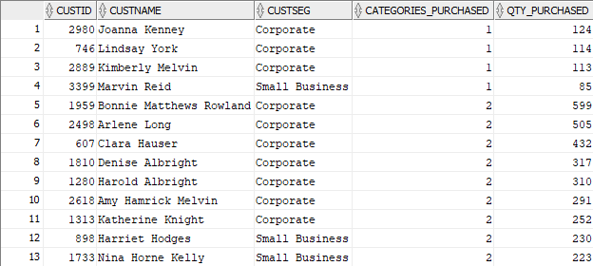

This query generated a table showing customers who have purchased from more than one category. Using ‘Small Business’ and ‘Corporate’ as examples, there does appear to be potential for other category purchases.

**QUESTION 4: There are differences in the actual (theoretical) price ((unit price * number of units*(1-discount) + shipping cost) and the actual sales for all products. There are some discounts and shipping costs. Yet, there are discrepancies in the theoretical sales and actual sales.**

1. **How much more or less are the actual sales value compared to the theoretical sales value?**

SELECT E.ORDERID, E.ORDDISCOUNT, E.ORDSHIPCOST, E.ORDQTY, E.ORDSALES, E.PRODUNITPRICE, E.PRODMARGIN, F.REGION, F.REGMANAGER,

(E.PRODUNITPRICE*E.ORDQTY*(1-E.ORDDISCOUNT) + E.ORDSHIPCOST) AS Theoretical_Price,

(E.ORDSALES - (E.PRODUNITPRICE*E.ORDQTY*(1-E.ORDDISCOUNT) + E.ORDSHIPCOST)) AS Difference

FROM(

(SELECT *

FROM(

(SELECT * FROM(

ORDERDET A

INNER JOIN

PRODUCTS B

ON A.PRODID = B.PRODID

)) C

INNER JOIN

CUSTOMERS D

ON C.CUSTID = D.CUSTID

)

) E

INNER JOIN

MANAGERS F

ON F.REGID = E.CUSTREG

);

Answer:

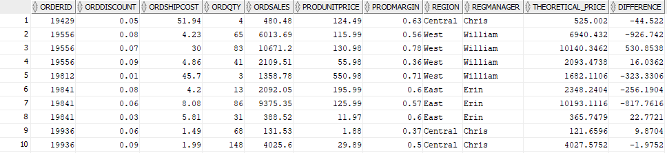

The difference column in the difference between the actual and theoretical sales for each Order. The overall difference is -21,791, so the actual sales is less than the theoretical.

1. **Are certain managers generally pricing more or less than theoretical sales? Analyze the differences based on the regions/managers.**

SELECT *

FROM(

(SELECT REGMANAGER, REGION, PRODCAT, SUM(DIFFERENCE) as Overall_Gap

FROM TEMP1

GROUP BY REGMANAGER, REGION, PRODCAT)

PIVOT

(

SUM(Overall_Gap)

FOR PRODCAT

IN ('Technology', 'Furniture', 'Office Supplies')

)

);

Answer:

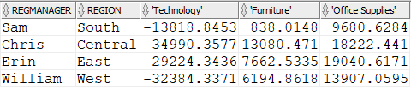

From the above table it appears that Technology is given at steep discounts by most managers, which should be investigated. While, furniture and office supplies are sold for profits.