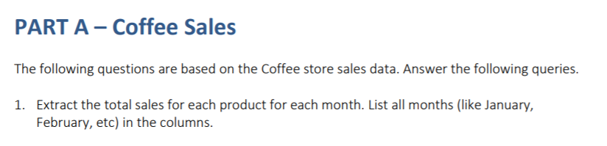Ryan Hoff



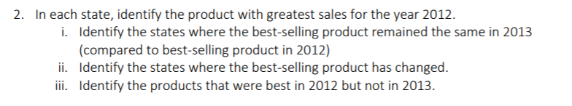







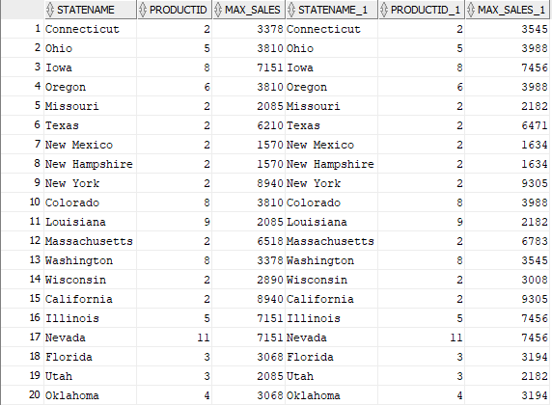

--Part II

There are no states where the best selling product has changed

--Part III

There are no products better in 2013 than 2012

https://i.gyazo.com/38c4ab8fa860f6d05d6cd49d5af6efbb.png



https://i.gyazo.com/a46ccbf6bbb27d24f09465cb1db6e8b6.png

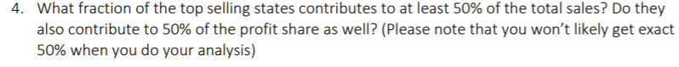



The top 7 of 20 states account for 50% of the sales

https://i.gyazo.com/4c362b37aff0f3d0146f1fb0b0f5dffc.png



Assuming all the costs of production are alike, Id recommend dropping Regular Expresso. From the previous graphs you can see it is not a preferred product in any state and it has the lowest sales numbers.

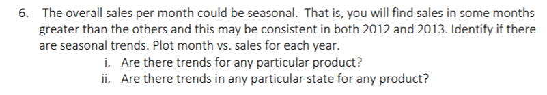



Graphing from excel gives…



The Trends are more easily visible in the high-selling products, one more noticeable trend is how Coloumbian coffee “fall”s off it popularity during the fall. Lemon gains popularity throughout the year with a small dip at the start of the fall.

One trend is that California doesn’t appear to adhere to the macro-trends of product sales.

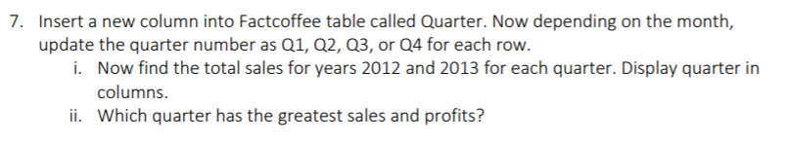



https://i.gyazo.com/1056ad1020a9378460b643a5d36022e9.png

--Part ii. The best quarter was Q3 for both years.

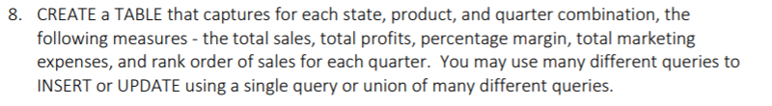



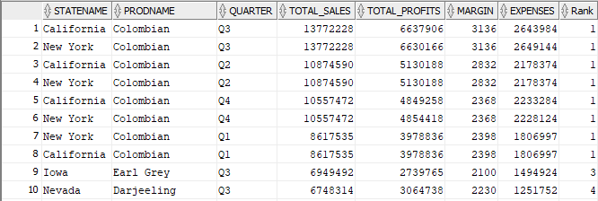

…





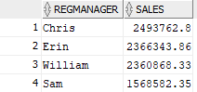

https://i.gyazo.com/04c7e8eec862b335128fce318f73c6ec.png



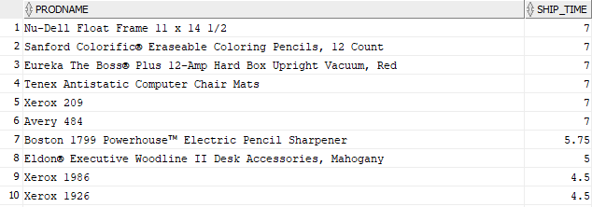

…

https://i.gyazo.com/114317cfe8015013d0517e5f8778bd0a.png



https://i.gyazo.com/83a5e291e6dc7b5d87271740ff610d2e.png



https://i.gyazo.com/cba49095114b794d945e26ecf1df3dc4.png



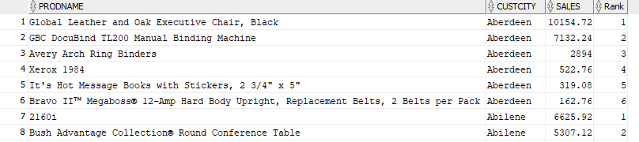

…





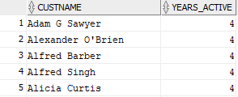

…



https://i.gyazo.com/69fa4a5031ed4cc83e020f0bbbb432da.png



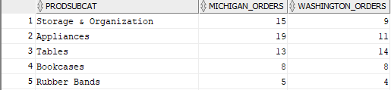

…

https://i.gyazo.com/48a9df6759239562adf3fa0b05b3729c.png

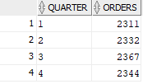

https://i.gyazo.com/0cab84c54b76925936906796302f7934.png



