CS566

An Examination of Lattice-based Cryptography through the Kyber Algorithm

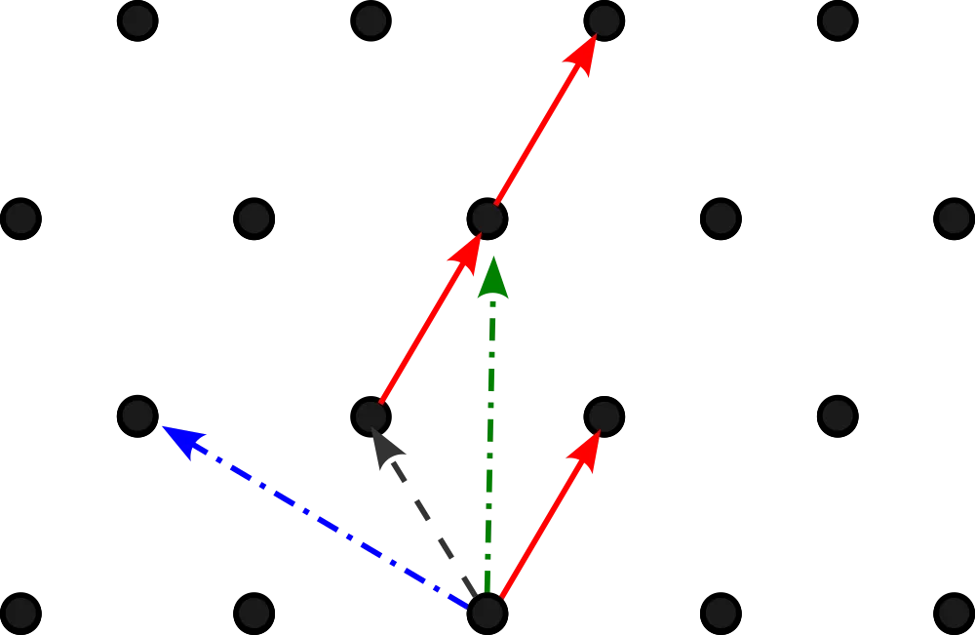

Ryan Christopher
Table of Contents:

3 Abstract

3 Lattice-based cryptography and how it differs from existing public key cryptography

4 Post-Quantum Cryptography and NIST

4 CRYSTALS, Kyber, ML-KEM, and FIPS 203

5 Pseudocode for Kyber KEM

6 Comparing the performance of Kyber to RSA

11 References

Abstract
The Kyber Algorithm became one of the first post-quantum cryptographic methods to be standardized as ML-KEM by NIST as a result of their competition to find cryptographic methods that are resistant to quantum computers. This paper will provide a brief background to the type of cryptography that is used in Kyber, how it is useful in a situation where adversaries posses quantum machines, an examination of the pseudocode, and a comparison of how Kyber can perform compared to RSA as a public-key algorithm.

Lattice-based cryptography and how it differs from existing public key cryptography
Much of our public key cryptographic systems rely on one-way functions. These are mathematical functions which are easy to compute in one direction, yet very difficult to perform the inverse. In particular, prime factorization and solving the discrete logarithm problem are both one-way functions by which RSA and ECC – two dominant asymmetric-key encryption algorithms - generate public/private key pairs. In particular, these two methods for generating public/private keys were able to be computed with relative ease on most systems while maintaining computational infeasibility to attacks.
In 1994, Peter Shor, a mathematician and computer scientist developed an quantum algorithm that could easily compute prime factors for a given integer which was previously impossible for any classical computer [1]. This led cryptographers to pursue other potential forms of cryptography, and in the late 1990s lattice-based cryptography began to take form. Relying on the computational hardness of lattice problems, lattice-based cryptography employs the use of vectors to be used within cryptographic functions as there are concepts such as the "Shortest Vector Problem" that drastically increase the computational hardness of the cryptographic methods as compared to the prior mentioned one-way functions.

Post-Quantum Cryptography and NIST
Shor's algorithm provided compelling evidence that quantum computers, once equipped with enough qubits and proper error correction, are particularly capable of solving prime factorization and discrete logarithm problems - the same two that make up much of our existing public key cryptographic systems. As such, there has been substantial effort placed into developing new cryptographic systems that are resistant to the capabilities of quantum computers. Post-Quantum Cryptography, or PQC, uses methods such as lattice-based cryptography which employs a different form of one-way functions.
The National Institute for Standards and Technology, NIST, deemed the need for standardization of post-quantum cryptography was necessary in 2017 [2], and announced their "Call for Proposals for Post-Quantum Cryptography Standardization." The competition involved mathematicians and cryptographers submitting their ideas for quantum-resistant cryptography, and if their proposed method was selected they had to implement improvements for the next round. What originated as 69 submissions became 4 standards announced in 2022 – one for key encapsulation and three for digitally signing.

Crystals, Kyber, ML-KEM, and FIPS 203
The Cryptographic Suite for Algebraic Lattices, known as CRYSTALS, was submitted to NIST's competition, and contains the Kyber algorithm for key encapsulation. Kyber combines the concept of vectors from lattice-based cryptography and obfuscates the vectors into a list of polynomial equations containing purposeful errors. These purposeful errors make a shard secret extremely computationally hard for both classical machines and quantum machines, as the equations could be unsolvable without knowing the errors. This is the basis of the Learning With Errors (LWE) problem. Kyber generates private and public vector pairs that can share a secret key that is directly generated through mutual computations. By utilizing lattice-based cryptography with LWE, the algorithm is quantum resistant and serves as a viable means for securely generating a shared secret key.
After multiple rounds and revisions, Kyber was selected as the finalist for key encapsulation and was renamed to the Module-Lattice-Based Key-Encapsulation Mechanism (ML-KEM) Standard in the Federal Information Processing Standards publication series (FIPS). FIPS-203 states that at present, "ML-KEM is believed to be secure, even against adversaries who posses a quantum computer" [3].

Pseudocode for Kyber KEM
At its core, Kyber consists of three methods as a key-encapsulation mechanism: KeyGen, Encaps, and Decaps. Each step involves the use of internal algorithms for encryption, decryption, and formatting the polynomials used as vectors with a Number Theoretic Transform (NTT), however we will only take a look at the initial three methods for use of Kyber as a KEM. Once the shared key K is established, a method such as AES can be used for symmetric encryption.

Method 1: KeyGen
Input: none
Output: encapsulation key and decapsulation key
1. generate 32 random bytes for two variables d and z
2. call internal key generation with randomness (d and z) as input
3. return ek (encapsulation key), dk (decapsulation key)
Method 2: Encaps
Input: ek (encapsulation key)
Output: shared secret key (K) and ciphertext (c)
1. generate 32 random bytes for variable m
2. call internal encapsulation algorithm with randomness and encryption key as input (m, ek)
3. return shared secret key (K) and ciphertext (c)

Method 3: Decaps
Input: dk (decapsulation key) and ciphertext generated from Encapsulate method (c)
Output: shared secret key K
1. call internal decapsulate method with dk and c
2. return generated shared key K

Comparing the performance of Kyber to RSA
Kyber (later named ML-KEM) and RSA were implemented and are now maintained in Rust Crypto, a collection of “pure Rust implementations of cryptographic algorithms.” To compare the performance of Kyber compared to an commonly used public key algorithm like RSA, a text file containing random quotes was generated and both algorithms were assigned to a function.

Below is the code for Kyber:
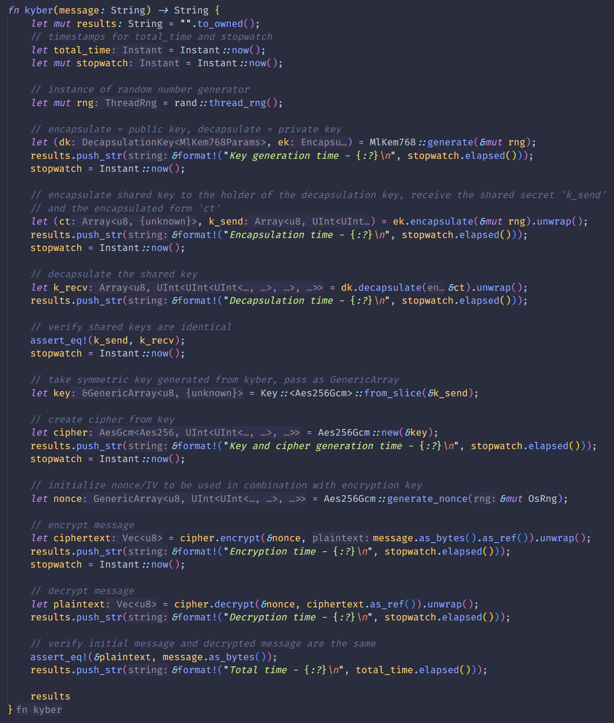

Below is the code for RSA:
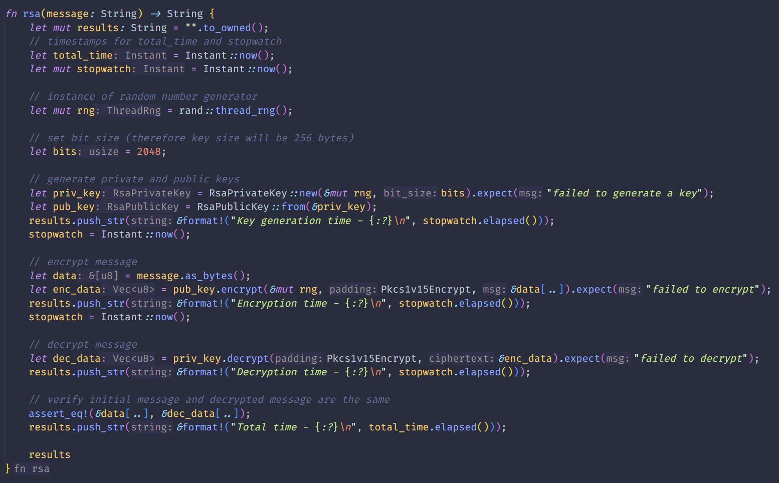

The algorithms were then used to take each line of the text file, generate keys, encrypt, and decrypt the message back to the original text. Then, the timestamps for each function were recorded and written to two text files (one for Kyber, one for RSA).
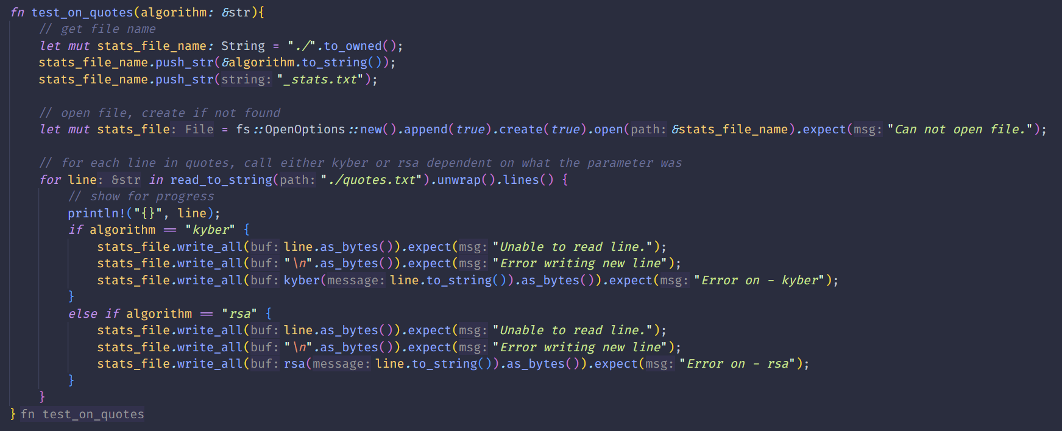
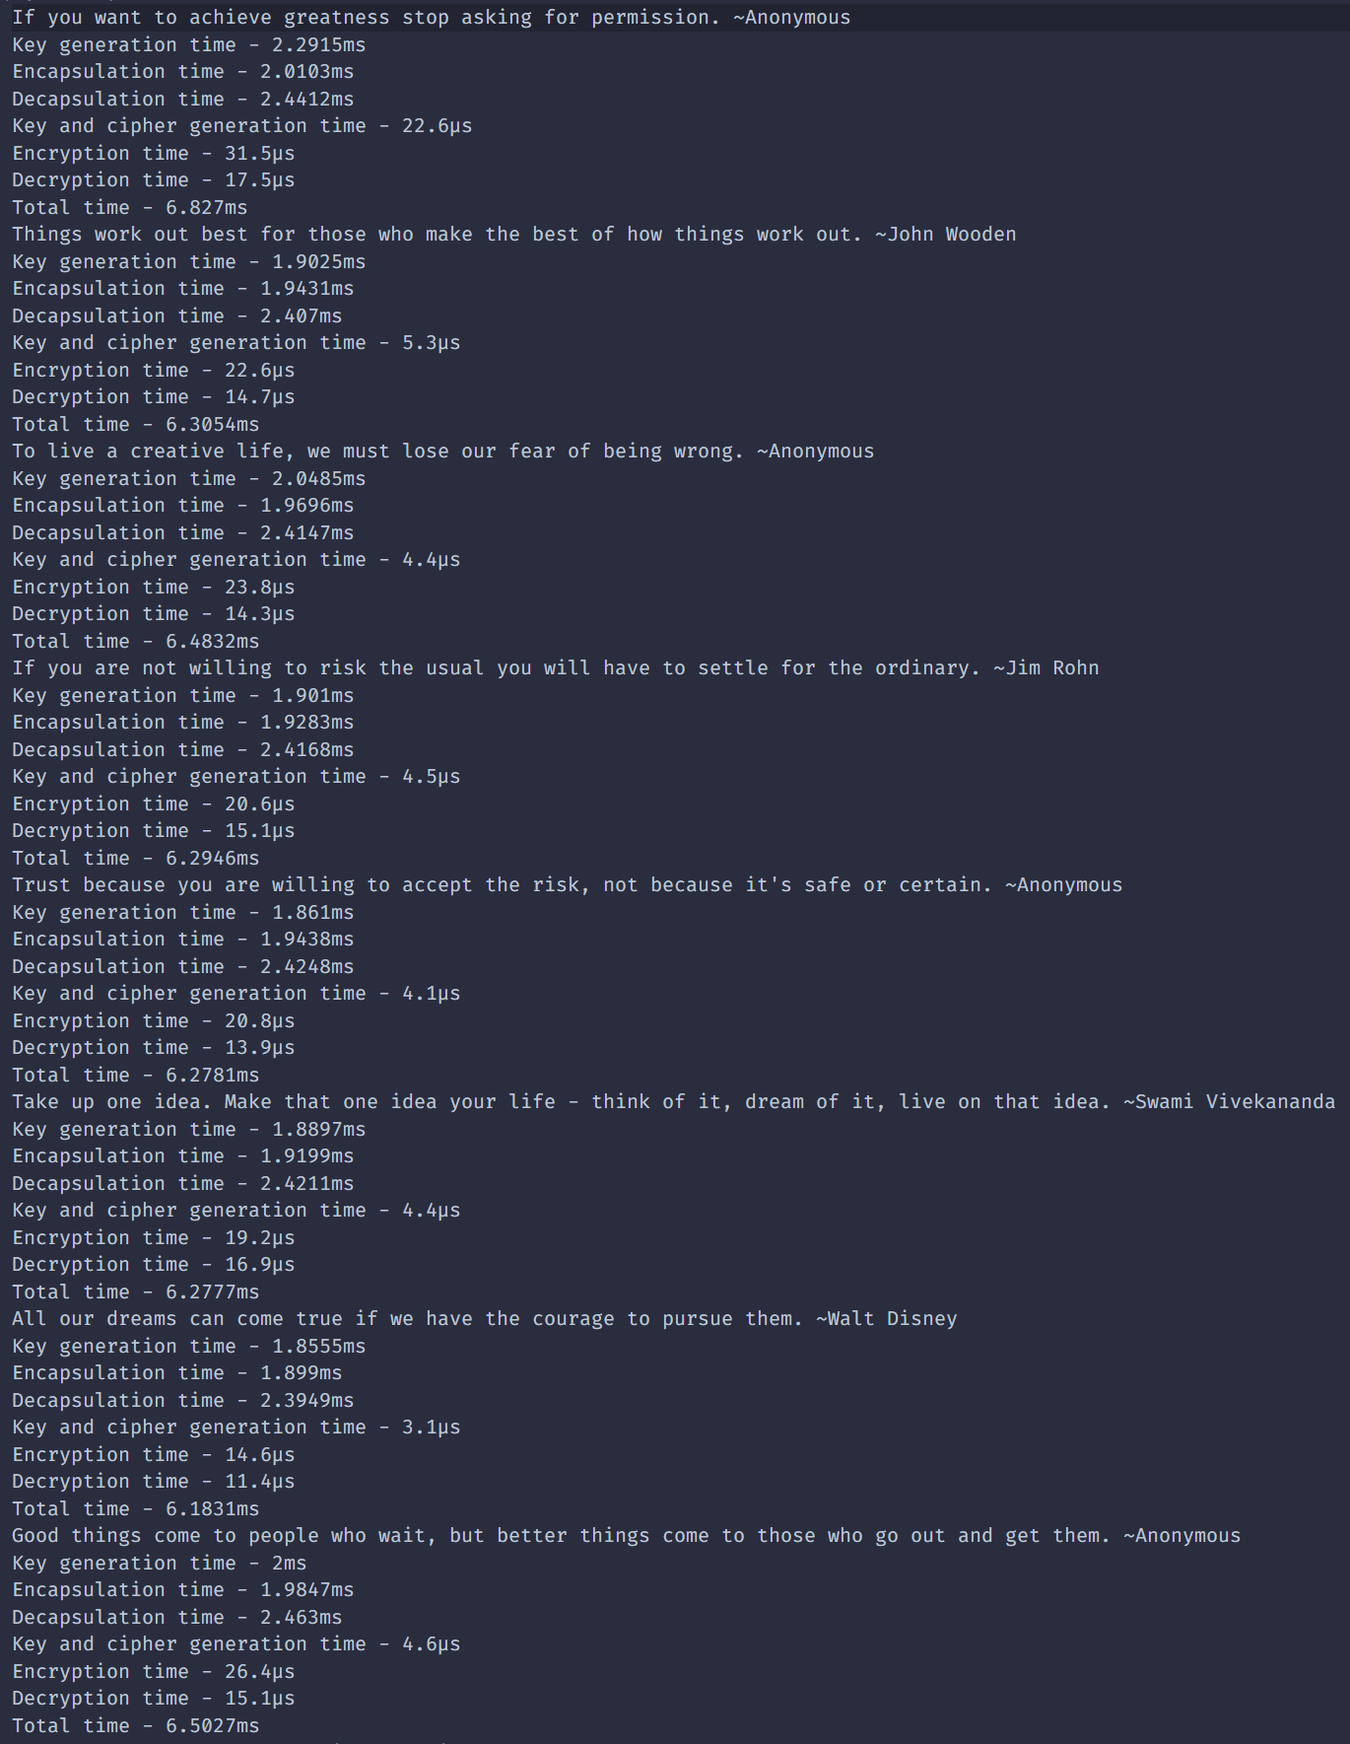
Kyber test results:

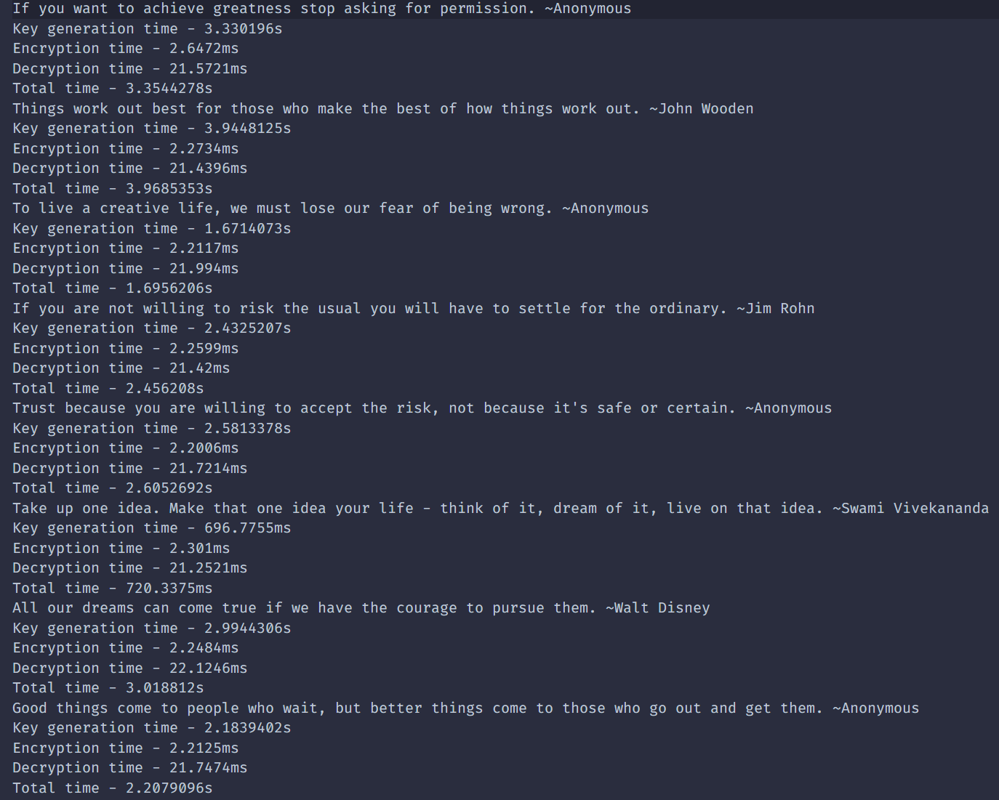
RSA test results:

The two resulting files yield promising results, as Kyber was far faster in key generation and total time required for the initial message to be received from decryption. The messages with Kyber required a total time of roughly 6.5ms, whereas the same messages using RSA required a total time of 720ms up to 3.3 seconds. It is worth noting that the key size for Kyber is larger than RSA, however the efficiency and security gained provides a compelling argument for the adoption of ML-KEM.

References
[1] Ugwuishiwu, C. H., et al. "An overview of quantum cryptography and shor’s algorithm." Int. J. Adv. Trends Comput. Sci. Eng 9.5 (2020).

[2] “Call for Proposals - Post-Quantum Cryptography: CSRC.” NIST Computer Security Resource Center, csrc.nist.gov/Projects/Post-Quantum-C ryptography/Post-Quantum-Cryptography-Standardization/Call-for- Proposals. Accessed 21 Apr. 2025.

[3] Module-Lattice-Based Key-Encapsulation Mechanism Standard, 13 Aug. 2024, https://doi.org/10.6028/nist.fips.203.

