Ryan Christopher
MET CS566
Assignment 3

1. Design a stack that supports push, pop, and retrieving the minimum element in
constant time.

The folder “stack” contains mod.rs with the Stack struct. Tests are called in main.rs
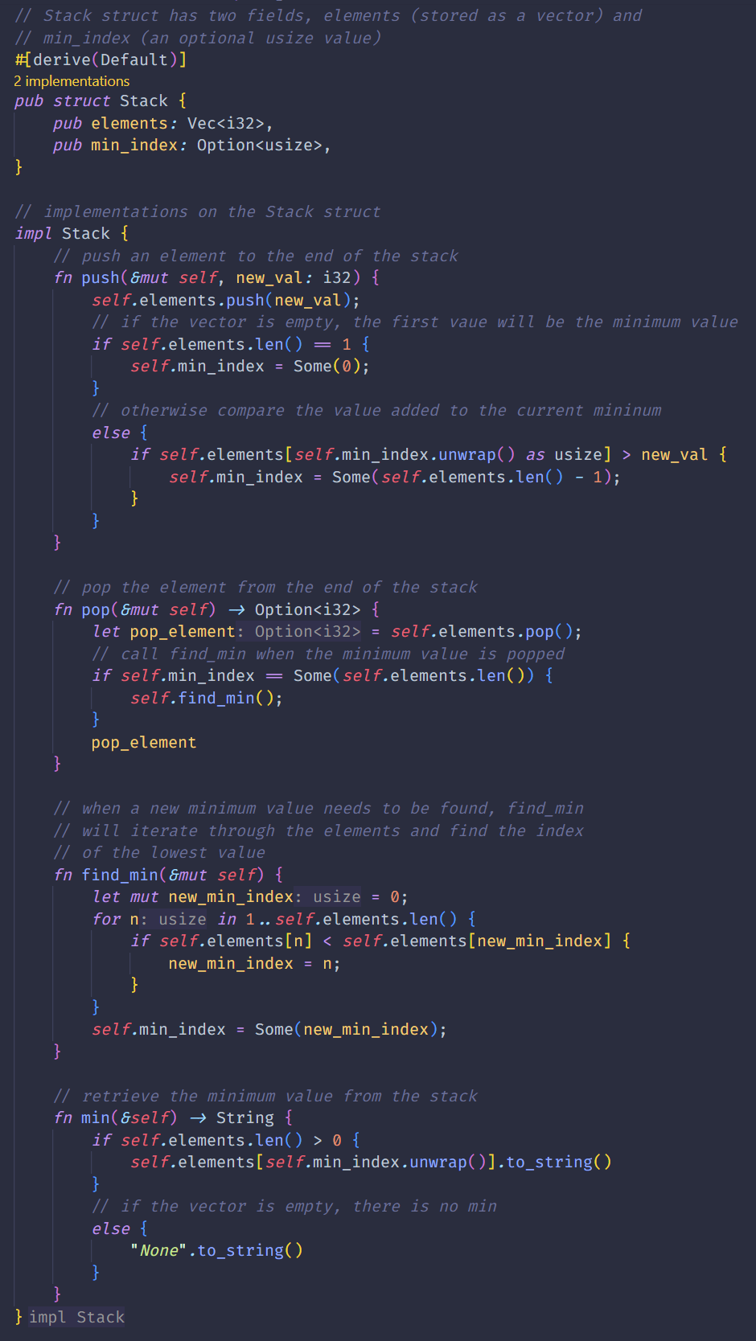
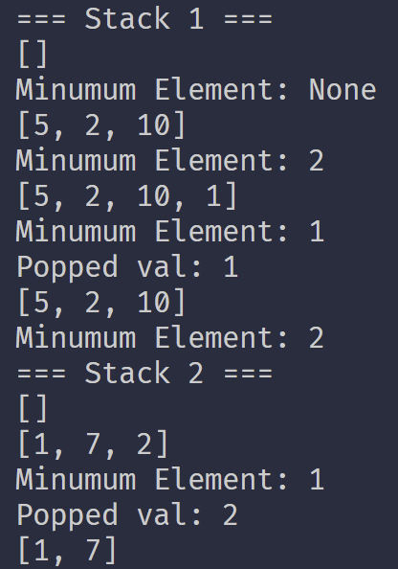
2. You wish to store a set of n numbers in either a max-heap or a sorted array. For each
application below, state which data structure is better, or if it does not matter.
Explain you answers.

a) Want to find the maximum element quickly.

To find the maximum element quickly, it does not matter if you use a max-heap or
a sorted array. The max heap would have the maximum element at the root of the
tree, and the sorted array would have the maximum element at the end of the
array. In this case, retrieving the element from either data structure would be O(1).

b) Want to be able to delete an element quickly.

To delete an element quickly, it would be better to store a set of n numbers as a
sorted array. This is because a sorted array can quickly shift the position of all
elements by one to accommodate the deleted element, whereas a max-heap
could potentially require reheaping the entire set.

c) Want to find the median element quickly.

To find the median element quickly, it would be better to store a set of n numbers
as a sorted array. Since the index value of an element is directly tied to its size,
the median element can quickly be found by dividing the length of the array by 2
and finding the value at that index.

3. Implement an external sort, which uses intermediate files to sort files bigger than
main memory. What is the fastest external sort algorithm? What about mergesort,
heapsort, quicksort, and B-tree based sort algorithms for external sort? Test your
algorithm within the limits of time / power, RAM of your computer.

The folder “external_sort” contains mod.rs with the sort function. Tests are called in
main.rs.
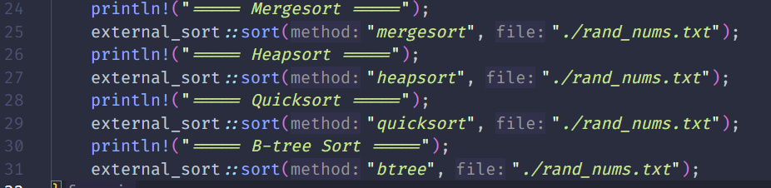

For this problem, I have a loop that is in main.rs that generates a sequence of 12.5
million integers between 1 and 25 million.
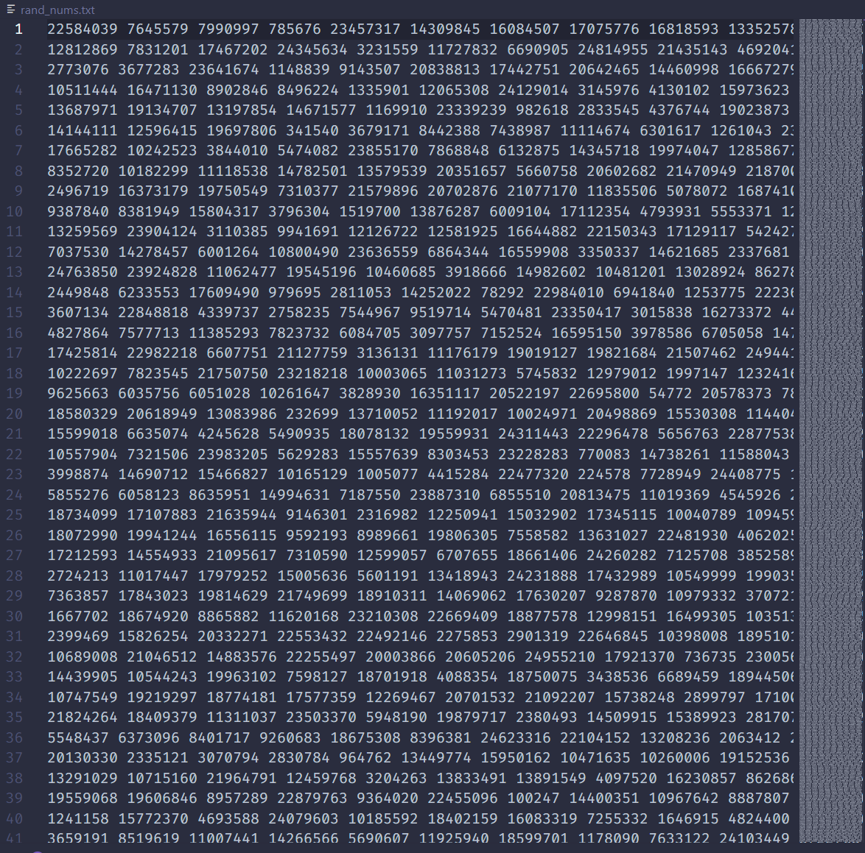

The file is approximately 100mb:

My algorithm then splits the large file into chunks and writes each chunk to a txt file,
where each intermediate file is roughly 10mb. This is done with two groupings of \
intermediate files. One directory is created for the unsorted chunks, and another is
created for the chunks once they become sorted.

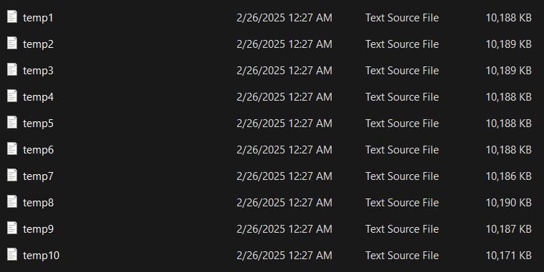
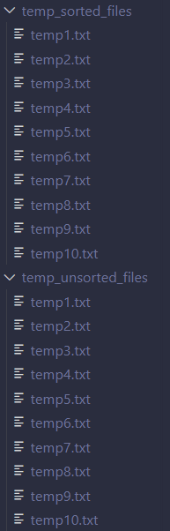

Here is what the unsorted temp files look like:

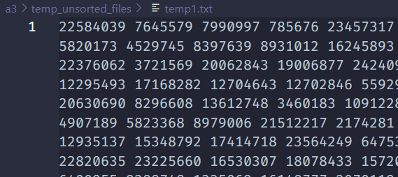

And here is what the sorted temp files look like:
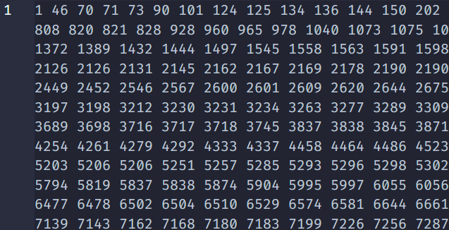

Once the chunks are combined, an output file is generated with the sorted values.
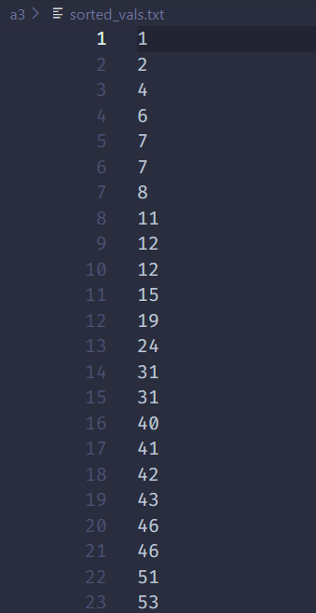
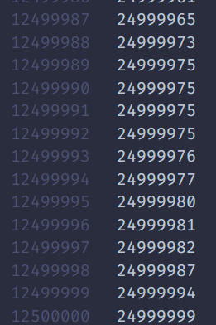
For each of the sorting algorithms, here was the time required to complete sorting:

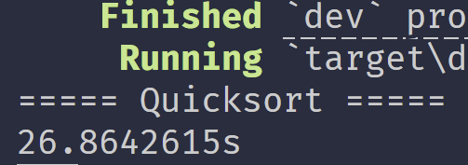
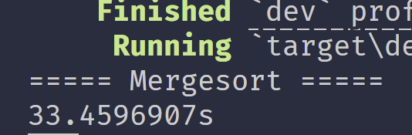

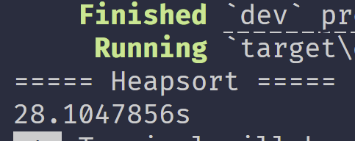
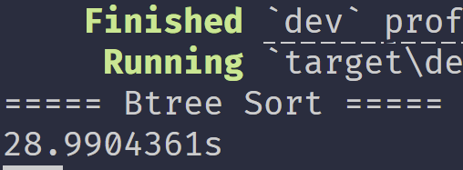

While the four of them were fairly close in running time, quicksort finished the
fastest at 26.86 seconds, roughly 1.3 seconds ahead of heapsort.

4. Given the following array:
26, 5, 77, 1, 61, 11, 59, 15, 48, 19, 81
Sort this array by hand using heapsort and answer the following questions:

a) Draw the initial complete tree representation of the file before the heap is
created.
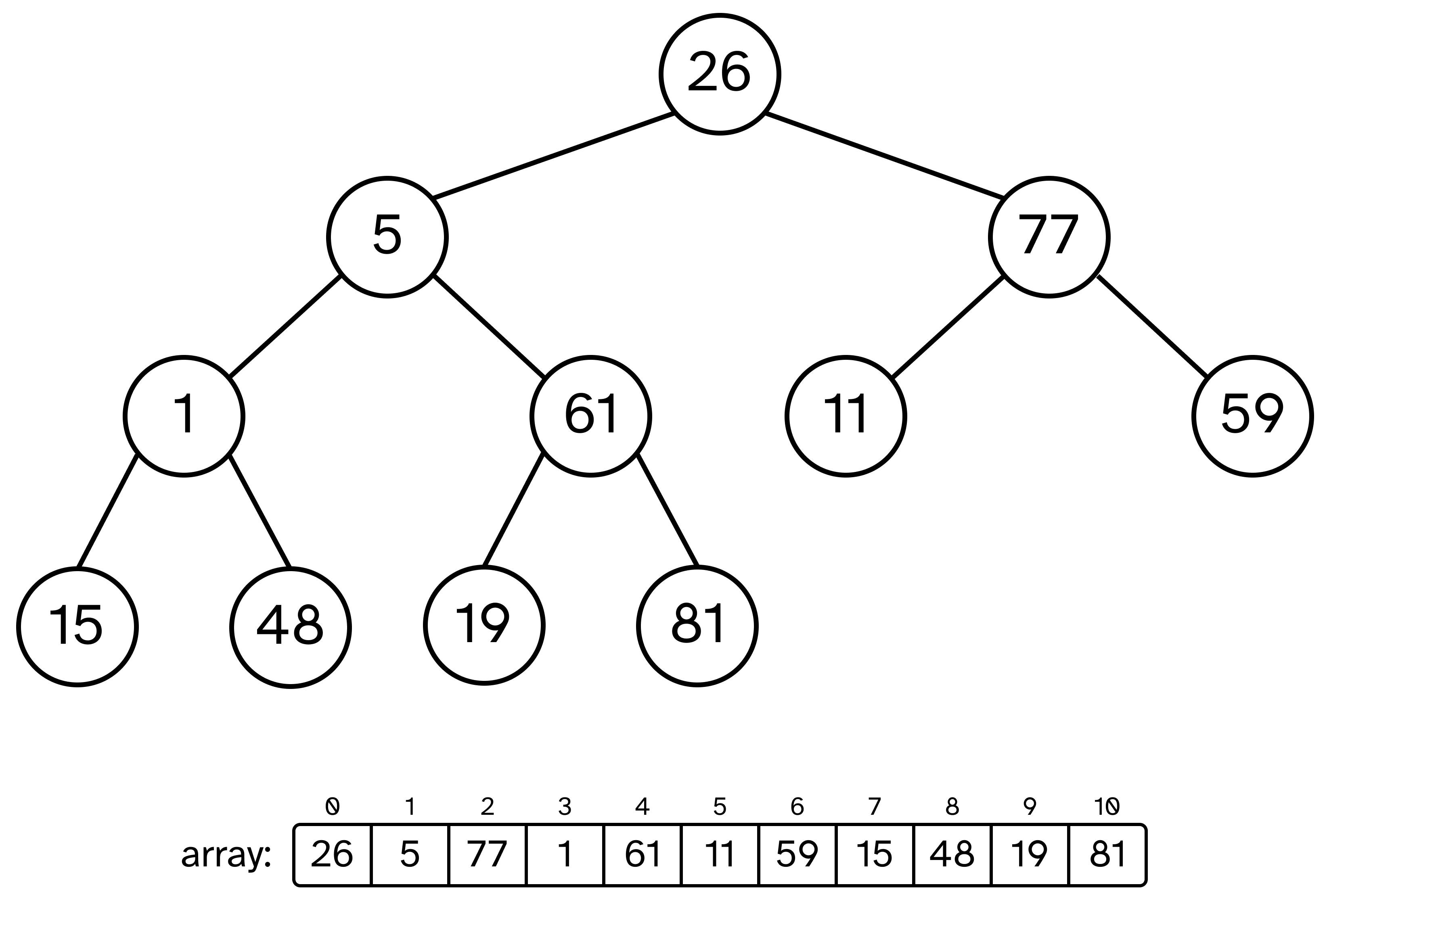
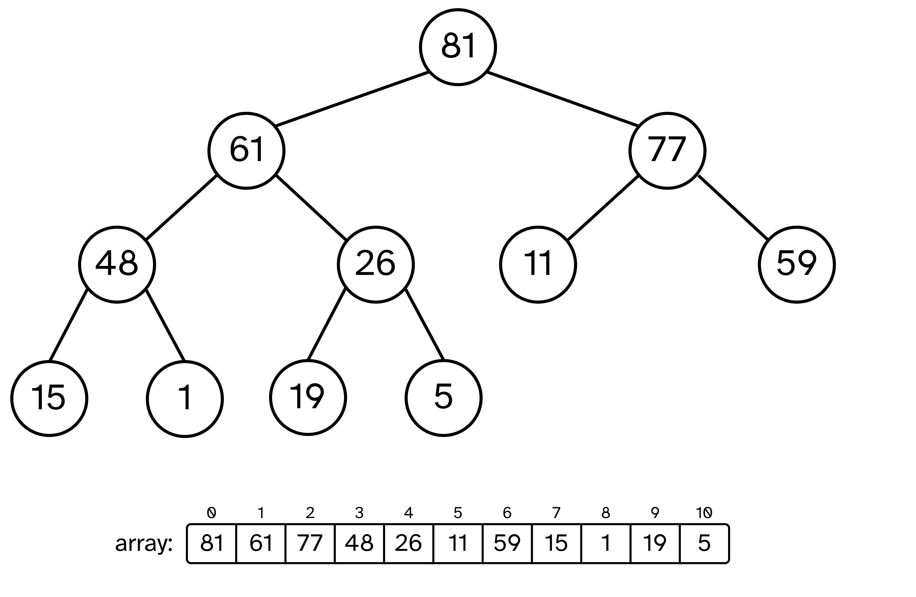
b) Draw the initial heap.

c) Continue with the sort for two iterations past the initial heap. What does the heap
look like?

The first iteration, where 81 is removed and placed as a sorted value:
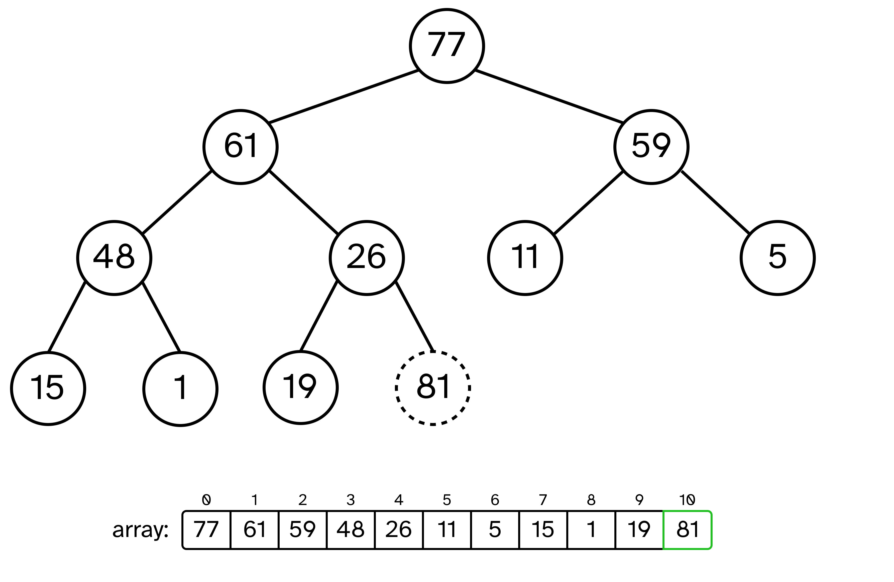
The second iteration, where 77 is removed and placed as a sorted value:
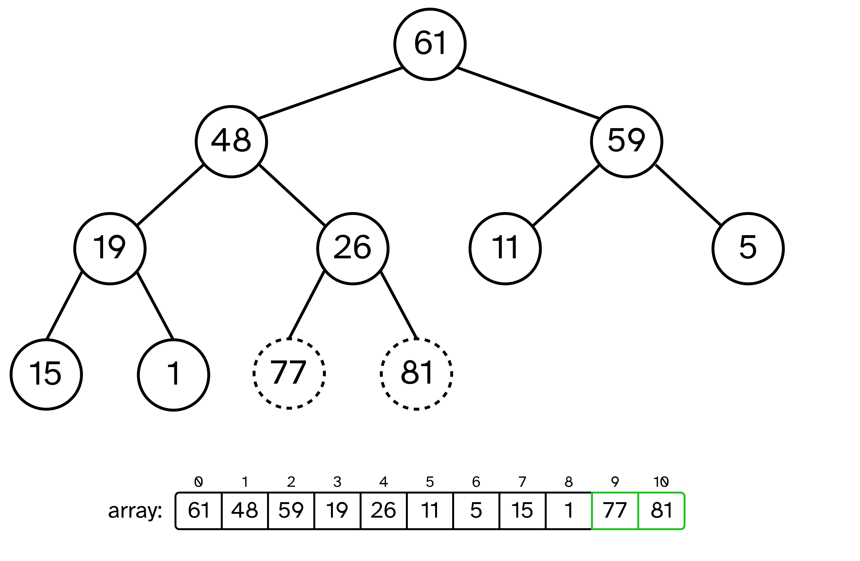

5. Use quicksort to sort the following array using the first element as the pivot
element:
72, 20, 73, 42, 11, 80, 39, 30, 100, 46, 88, 32, 21, 1, 13

a) Continue sorting the entire array until totally sorted. During the entire sort – what
was the maximum number of inversions removed by a single comparison and
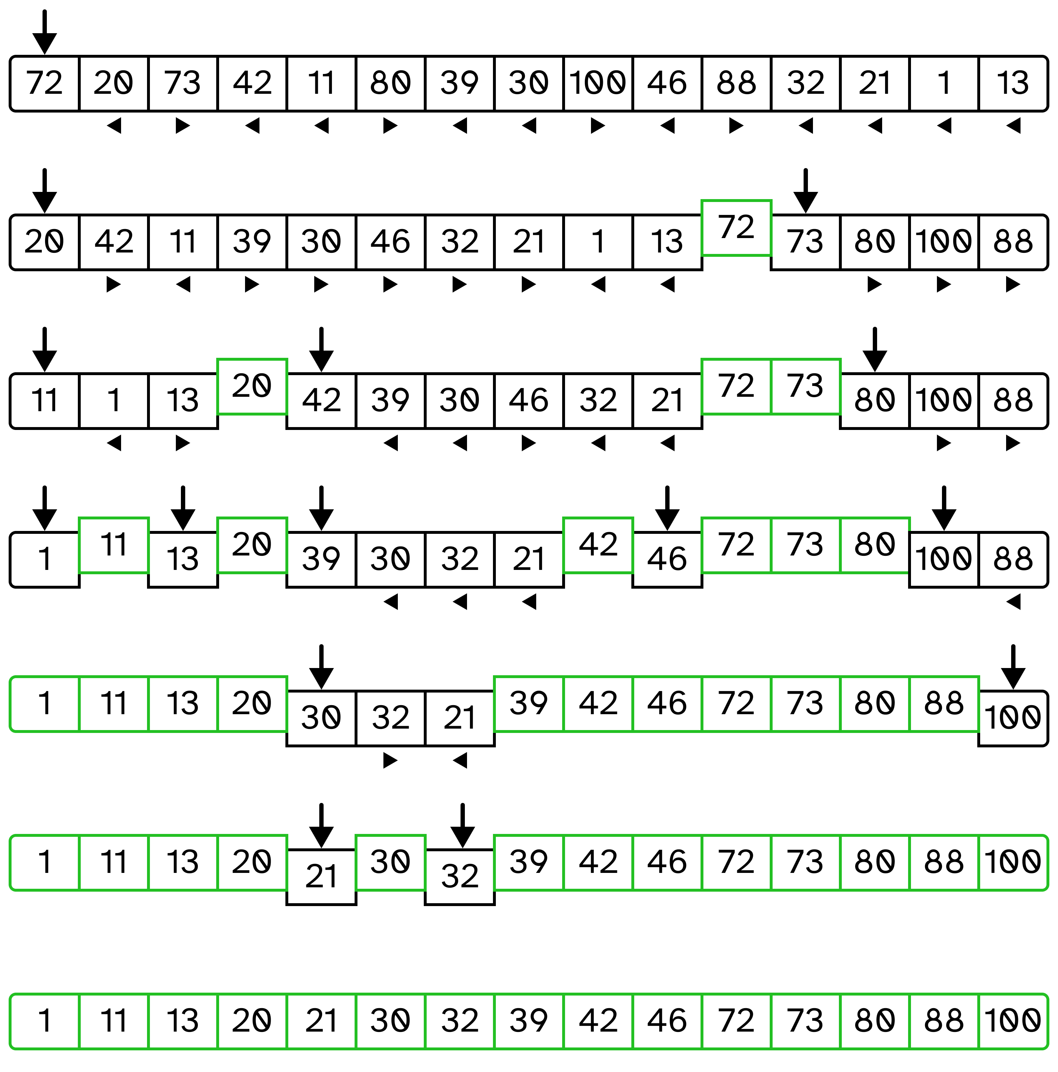
swap?

The maximum number of inversions were removed on the first swap, where 10
inversions were removed by placing 72 in the fifth to last spot.

b) What would be the sequence of the “best” pivot elements for this particular case?

The sequence of pivot elements 39, 20, 73, 11, 30, 46, 88 would be the best for
this particular case as it would most efficiently split the list in half each iteration.
As a result, the least number of iterations would need to occur to sort all the
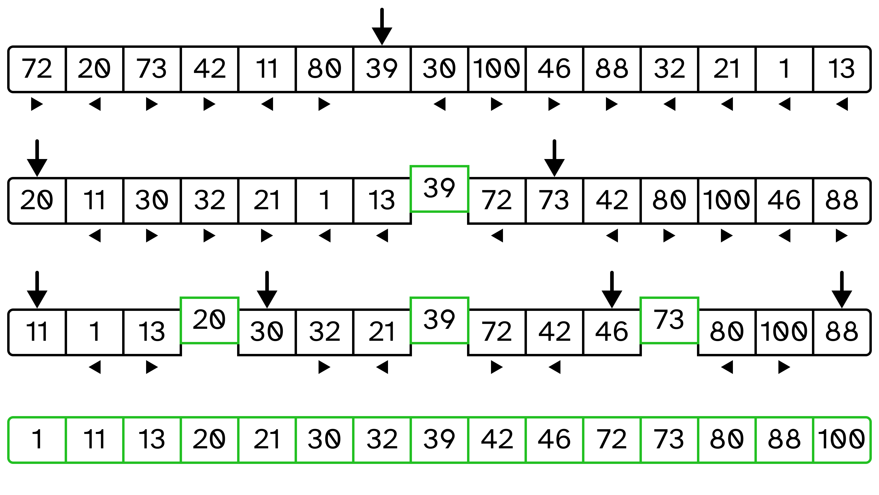
elements.

c) Does a balanced Binary Search Tree help?

Yes, because an in-order traversal of a Binary Search Tree yields the sorted order
of the list, the binary tree would be able to produce the sorted array after the
fifteen elements are added to the tree. This would be more efficient than the array
using quicksort to produce the sorted list.

