CS695 – Lab 2

Probing and Vulnerability Scanning

Ryan Christopher
Table of Contents:

1 Title Page

2 Table of Contents

3 Lab Preparation – Load Metasploitable 2 Linux into VM

4 Part 1 – Using Nmap to Probe

8 Part 1 – Questions

10 Part 2 – Using Nessus to Scan Vulnerabilities

19 Part 2 – Questions

20 Reflection

Lab Preparation – Load Metasploitable 2
Linux into VM
7)
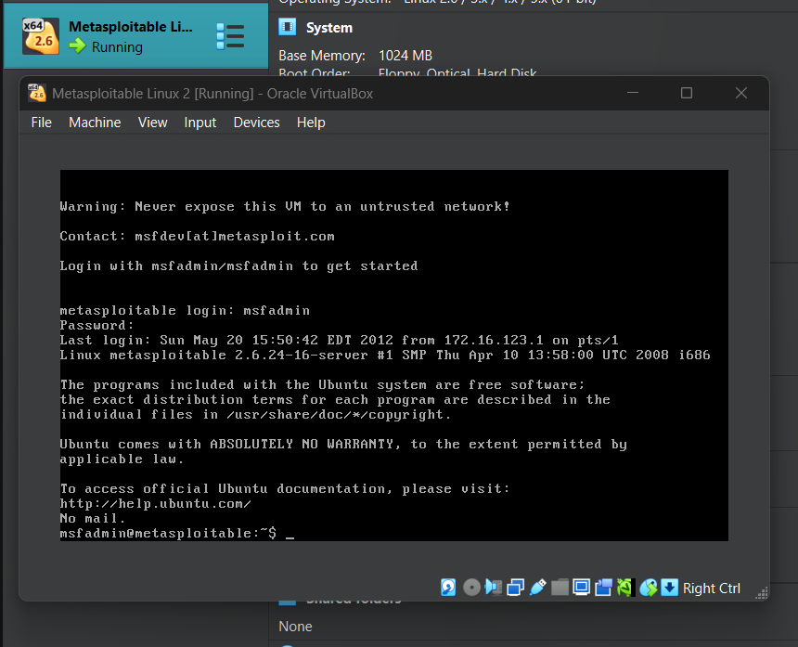
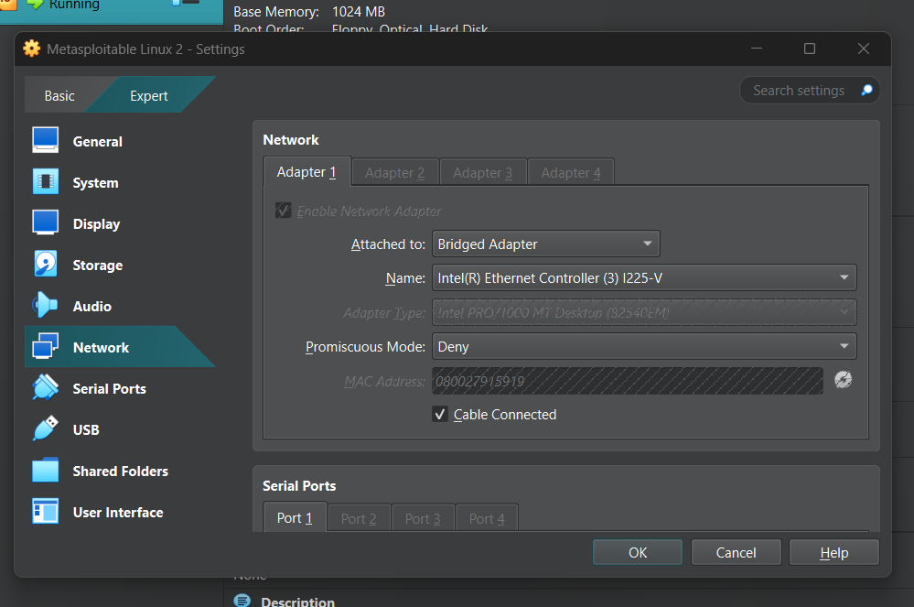
8)

9) The IP for Metasploitable 2 is 192.168.1.125 and the IP for Kali is 192.168.1.126:
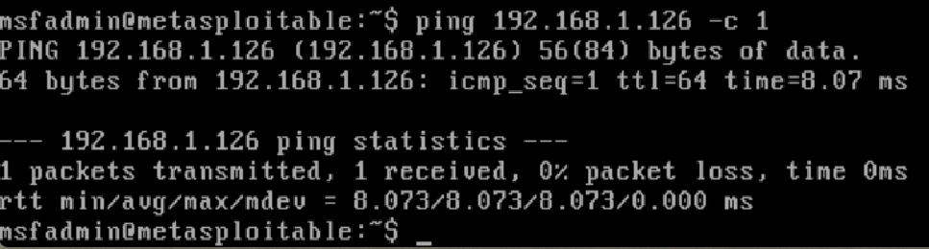
Part 1 – Using Nmap to Probe
1)
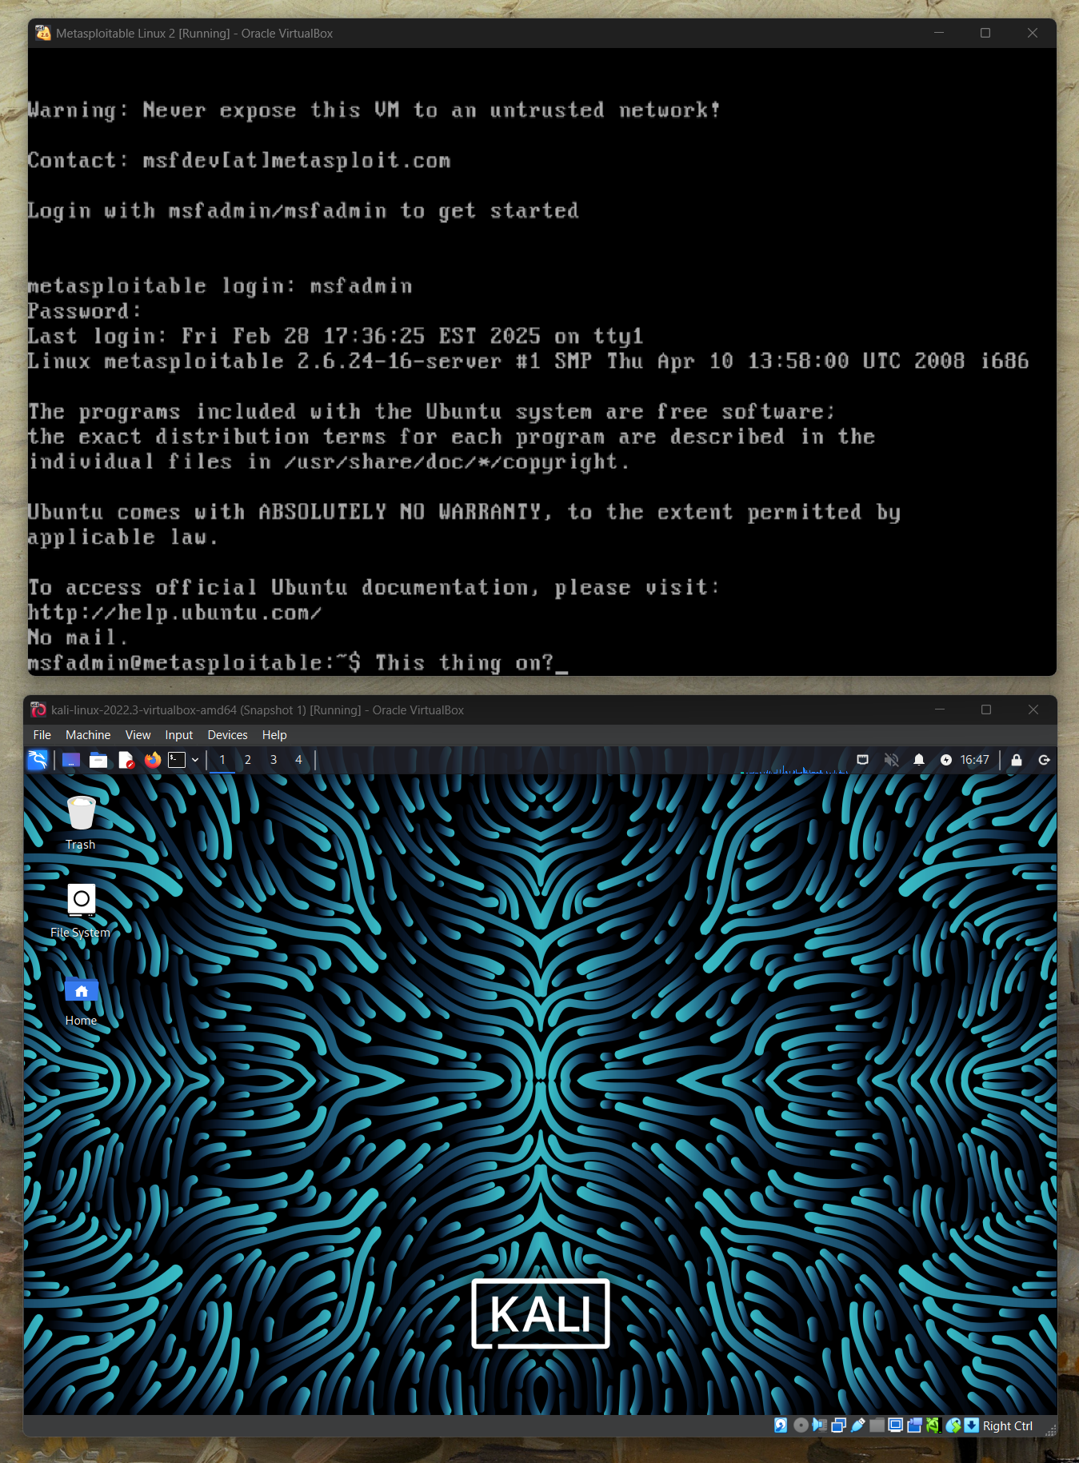

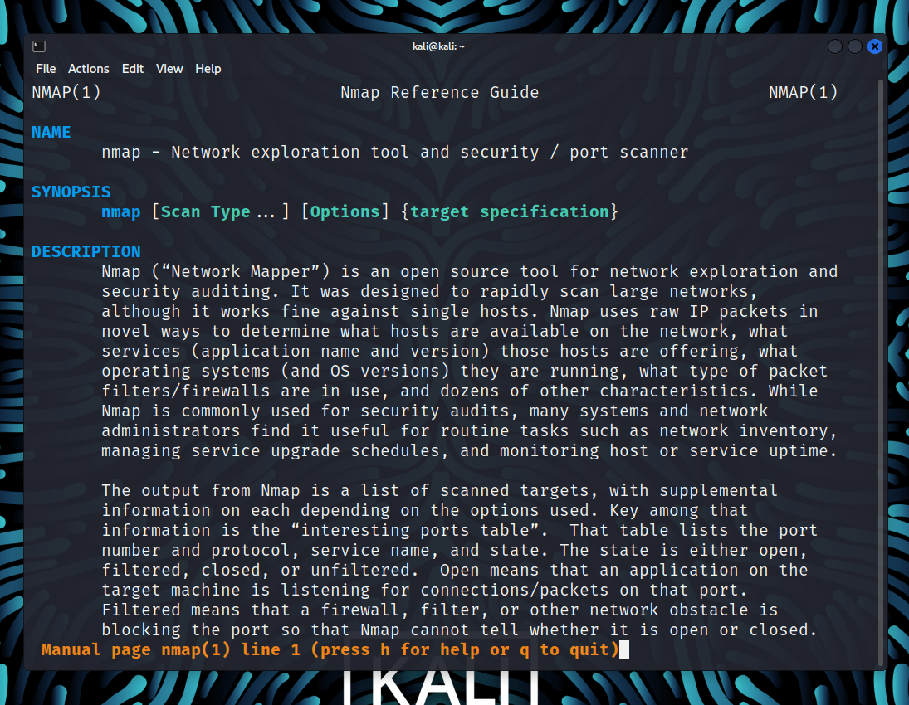
2)
3)
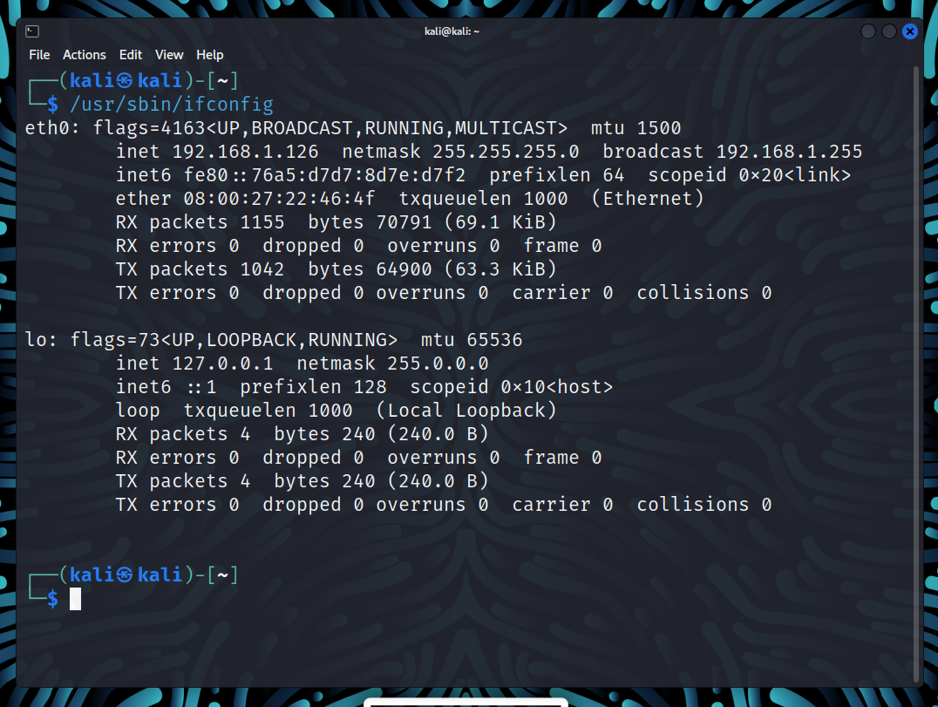
4)
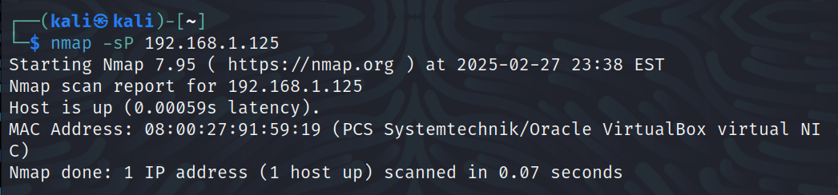

5)
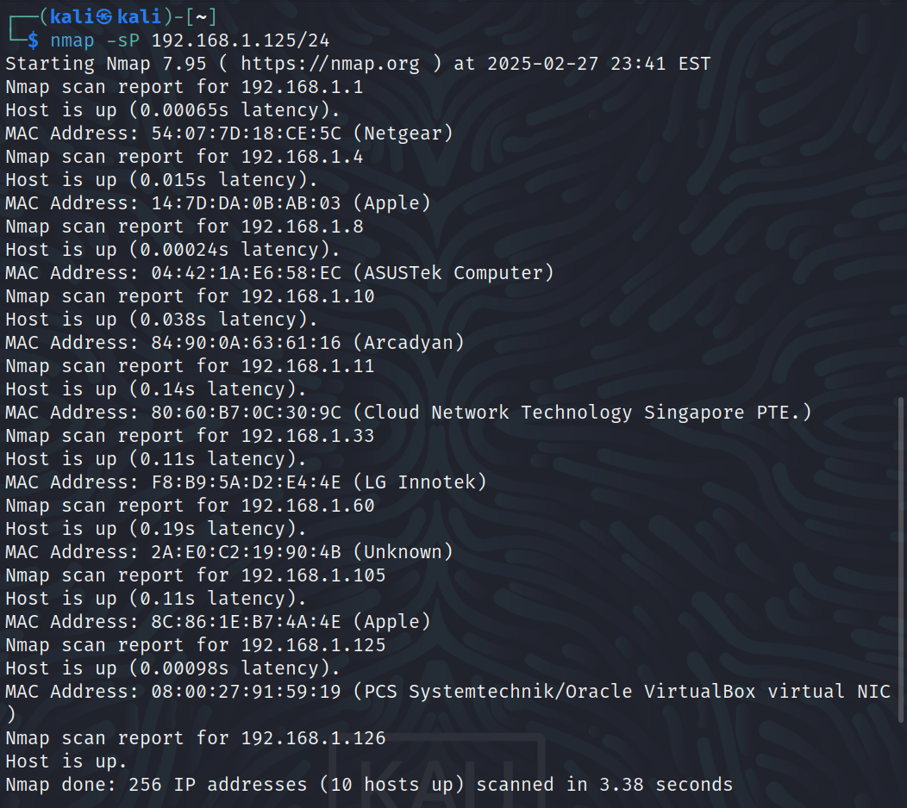
6)
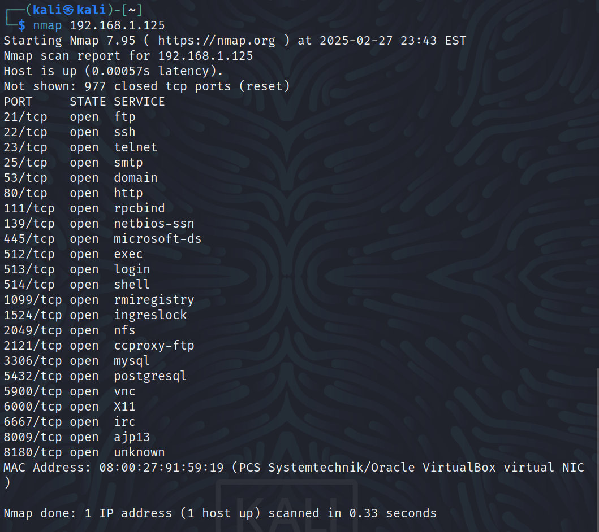
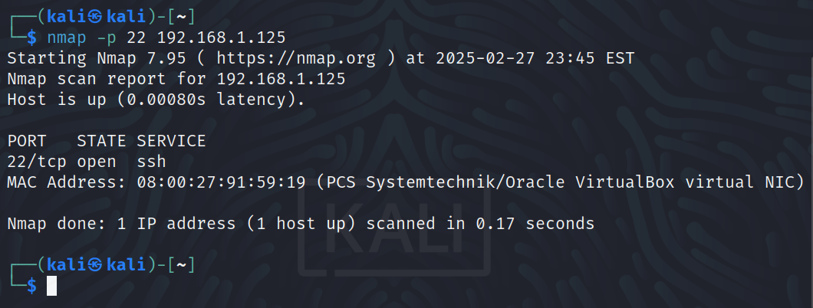

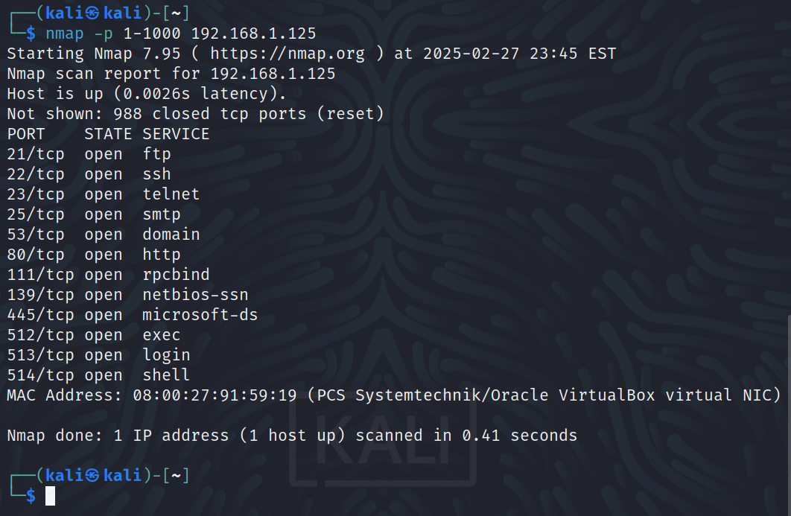

7)
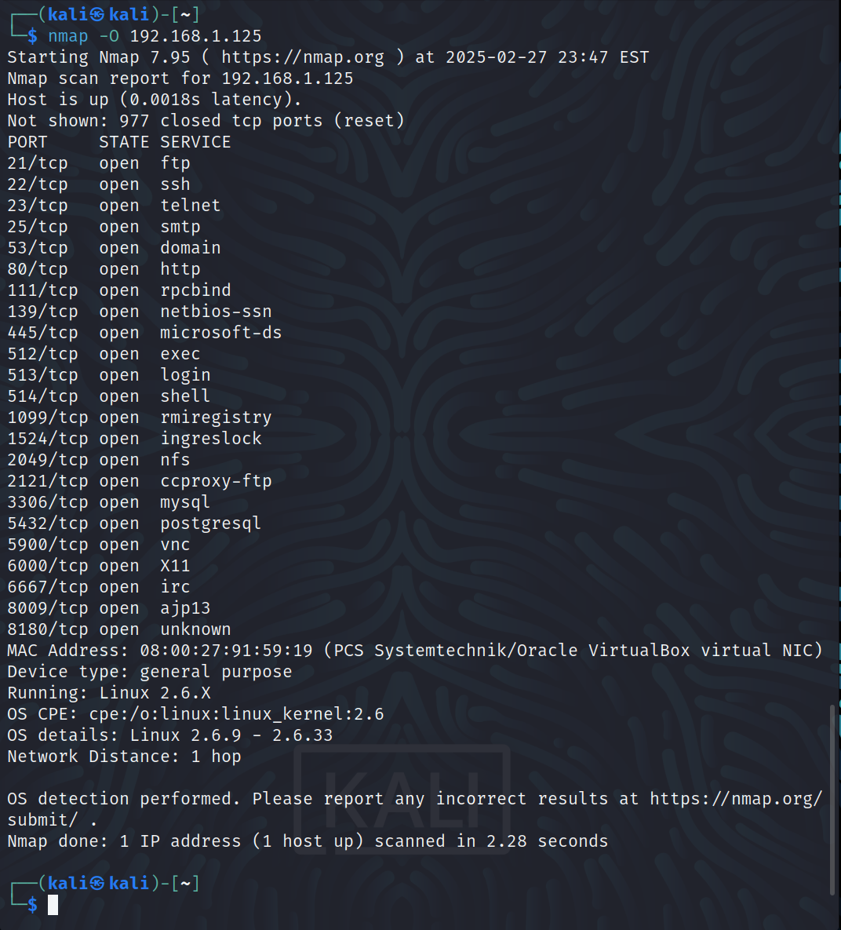
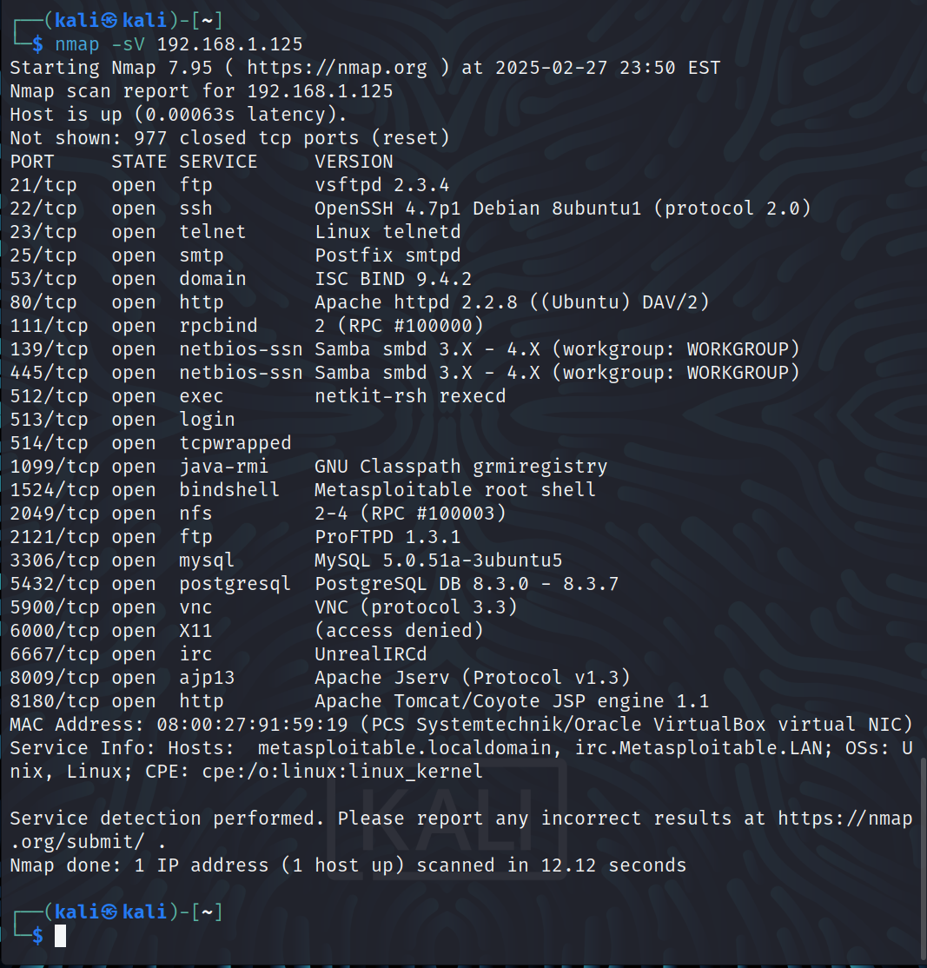
8)
Part 1 Questions:
1) What is a network mask? How do you use it to determine the IP address range of your LAN?

A network mask is a 32-bit digits in the form of 4 octets that identifies the network address
and the host address of an IP address. This is done by converting the IP address and the
netmask into their binary octets. The section of the binary representation of the IP address
shares the same position as the 1’s in the netmask is the network address, whereas the
section that overlaps with 0’s is the host address. With this, the range of a LAN can be
determined by setting the host binary values to 0 to find the first possible address and all of
the host binary values to 1 to find the last possible address.

2) 3 vulnerabilities rated as “high” for Linux 2.6.9 – 2.6.33:

1: Return value not checked – “artswrapper in aRts, when running setuid root on Linux 2.6.0 or later versions, does not check the return value of the setuid function call, which allows local users to gain root privileges by causing setuid to fail, which prevents artsd from dropping privileges.”

If a bad actor knows that a return value is not checked, they can write malicious code that forces setuid to fail and gain root privileges for an unsuspecting user or for their own user if they are able to remotely control the device. This would then make the bad actor able to have a higher level of control and access to the system than the system intended.
2: Linux kernel does not properly handle page faults – “The Linux kernel 2.6.9 before 2.6.9-67 in Red Hat Enterprise Linux (RHEL) 4 on Itanium (ia64) does not properly handle page faults during NUMA memory access, which allows local users to cause a denial of sevice (panic) via invalid arguments to set_mempolicy in an MPOL_BIND operation.”

If a user downloads malware that knows of this vulnerability, their system could held ransom and be made unusable through panic that would be forced through page faults on NUMA memory access.

3: Vulnerability in apk-tools that can result in Remote Code Execution – “Alpine Linux versions prior to 2.6.10, 2.7.6, and 2.10.1 contains a Other/Unknown vulnerability in apk-tools (Alpine Linux’s package manager) that can result in Remote Code Execution. This attack appears to be exploitable via a specially crafted APK-file that can cause apk to write arbitrary data to an attacker-specified file, due to bus in handling long link target name and the way a regular file is extracted.”

By allowing remote code execution to occur, this vulnerability has a strong ability to compromise the security of the system. If an APK-file that appears legitimate contains the instructions needed to write to another file on the targeted system.

3) 3 Vulnerabilities rated as “high” for MySQL 5.0.51a:

1: Backdoor in vsftpd 2.3.4 – “vsftpd 2.3.4 downloaded between 20110630 and 20110703 contains a backdoor which opens a shell on port 6200/tcp.”

This vulnerability was listed as “high” in CVSS 2.0 and “critical” in CVSS 3.x, and is due to the nature of a backdoor allowing unauthorized access to a system through the port that is opened by vsftpd.

2: SQL injection vulnerability in ProFTPD 1.3.1 – “SQL injection vulnerability in ProFTPD Server 1.3.1 through 1.3.2rc2 allows remote attackers to execute arbitrary SQL commands via a “%” (percent) character in the username, which introduces a “” (single quote) character during variable substitution by mod_sql.”

A SQL injection vulnerability when exploited can result in important/sensitive data being accessed and modified on the target system.

3: Linux telnetd allows remote attackers to bypass authentication – “telnet daemon (telnetd) from the Linux netkit package before netkit-telnet-0.16 allows remote attackers to bypass authentication when telnetd is running with the -L command line option.”

If authentication is bypassed, a remote attacker that successfully exploits this vulnerability would gain immediate access to the target system, making the data that is normally protected fully accessible.

Part 2 – Using Nessus to Scan Vulnerabilities
1)

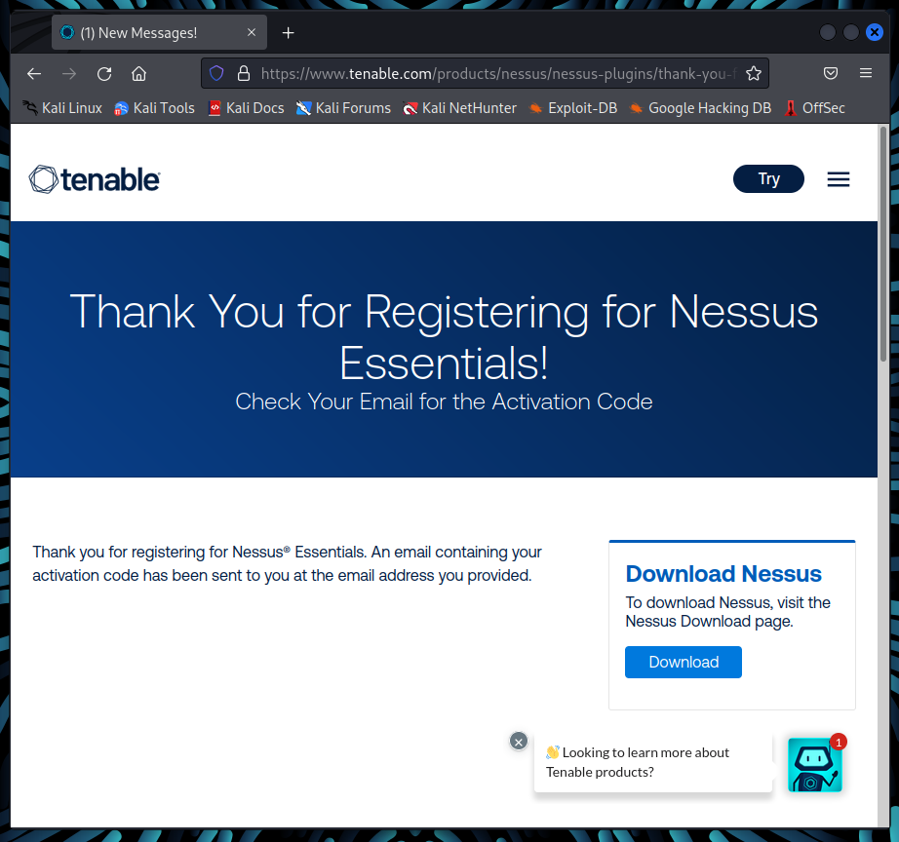
2)
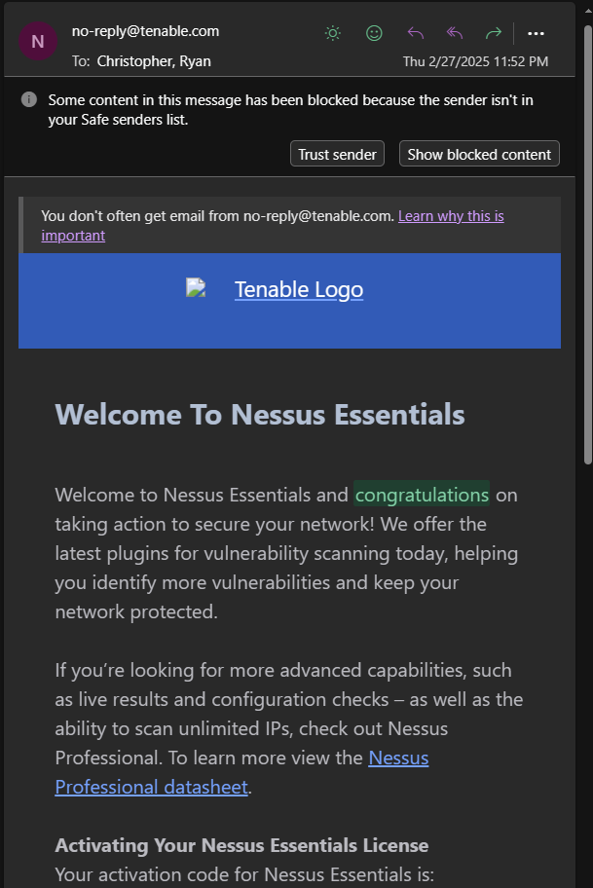
3)
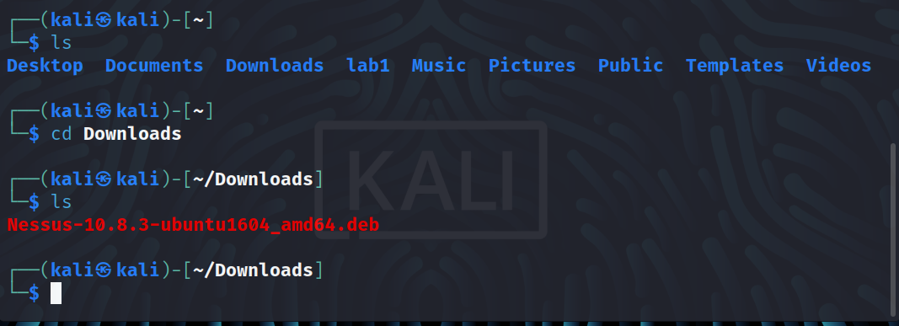
4)
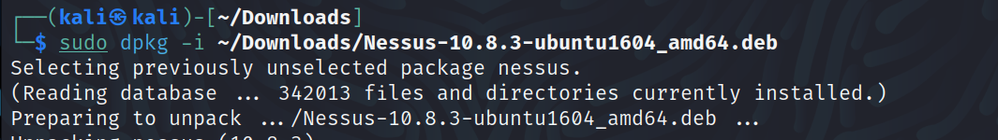
5)

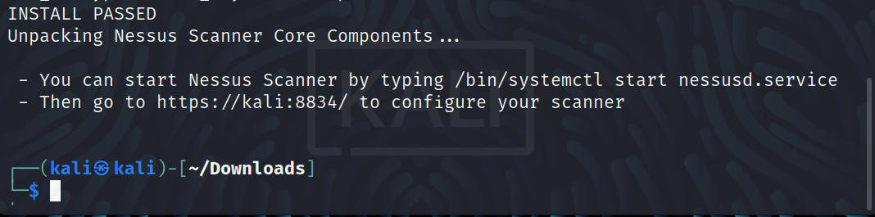
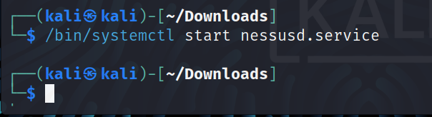
6-12)
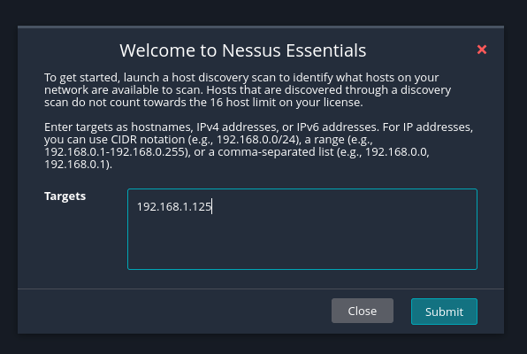

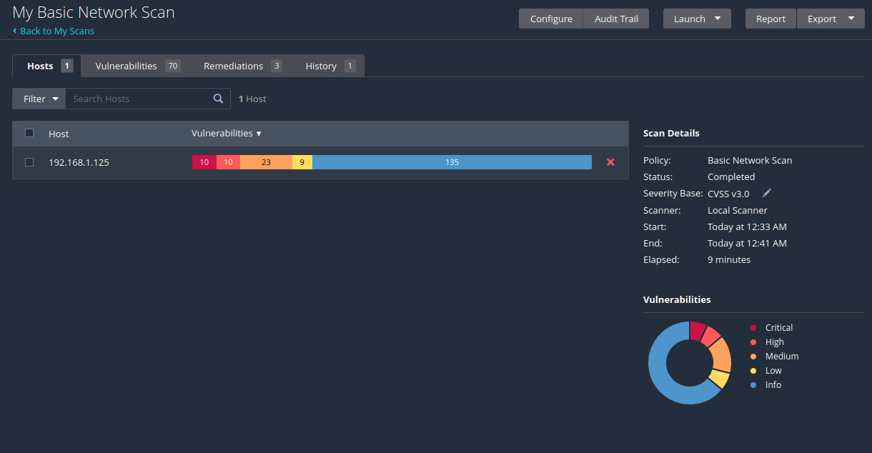
13)
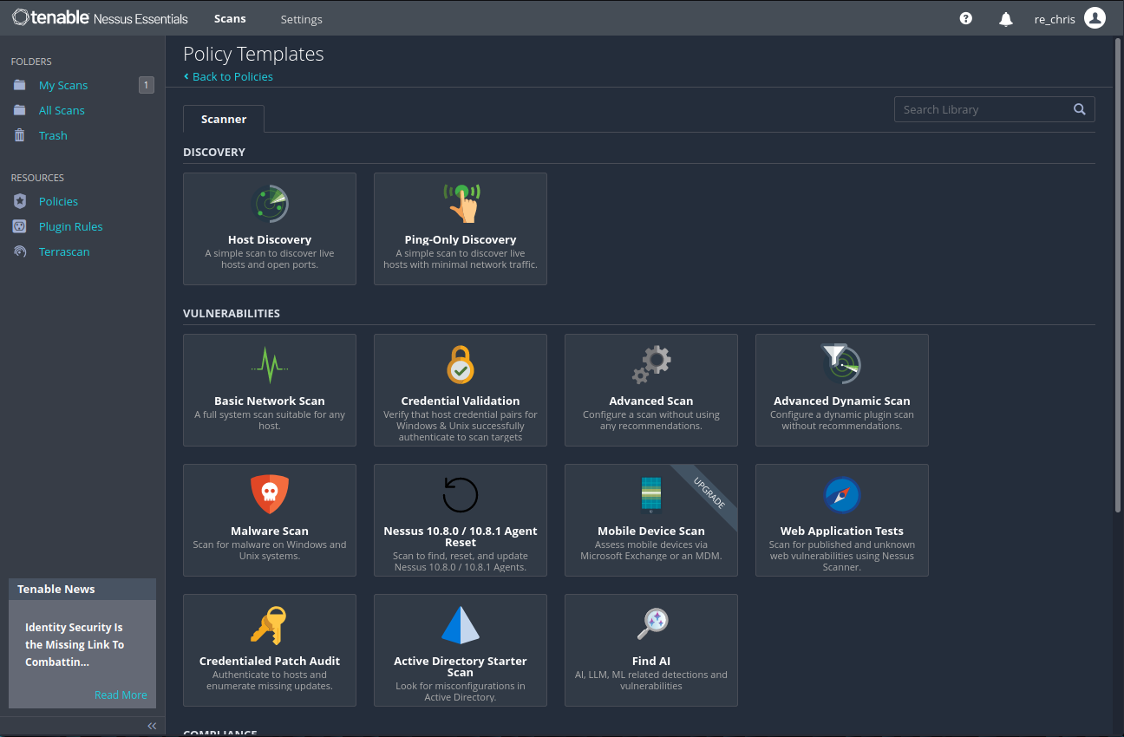
14)

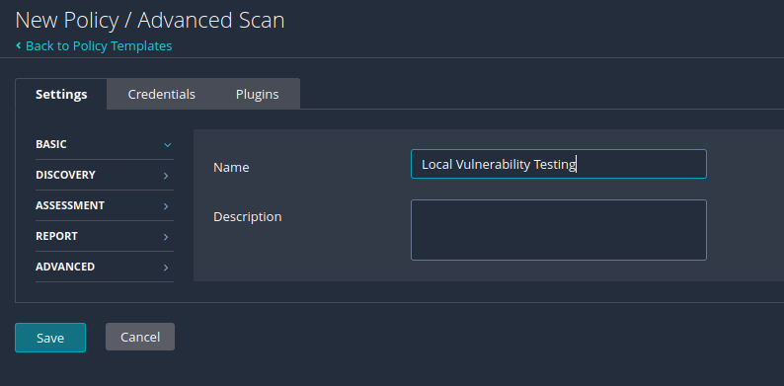

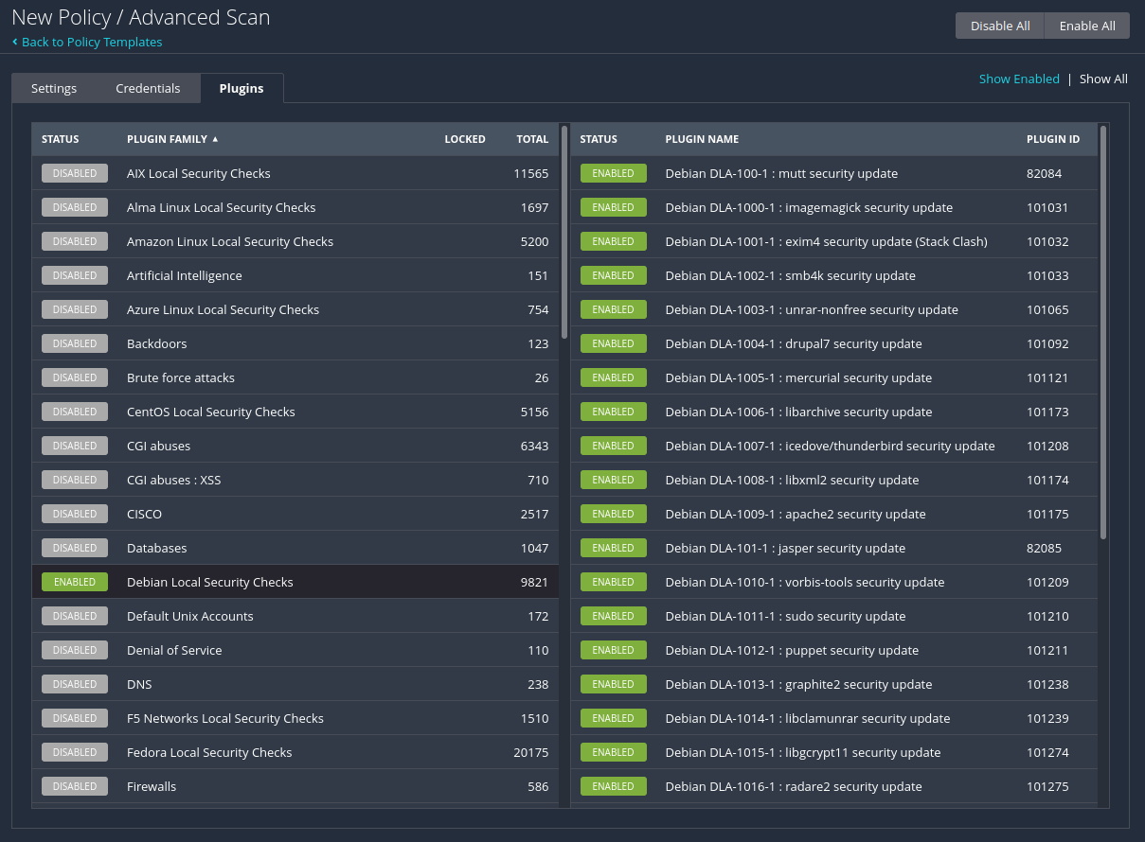
15)

16)
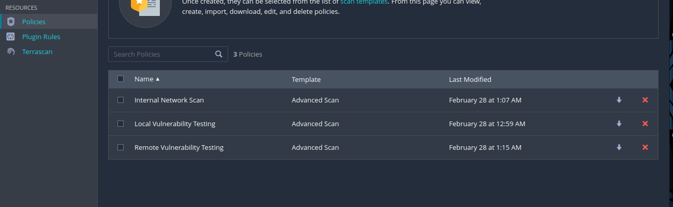
17)
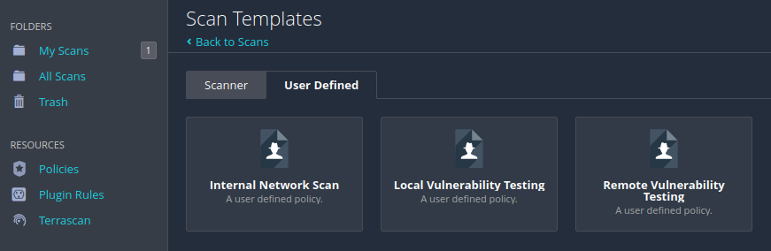

18)

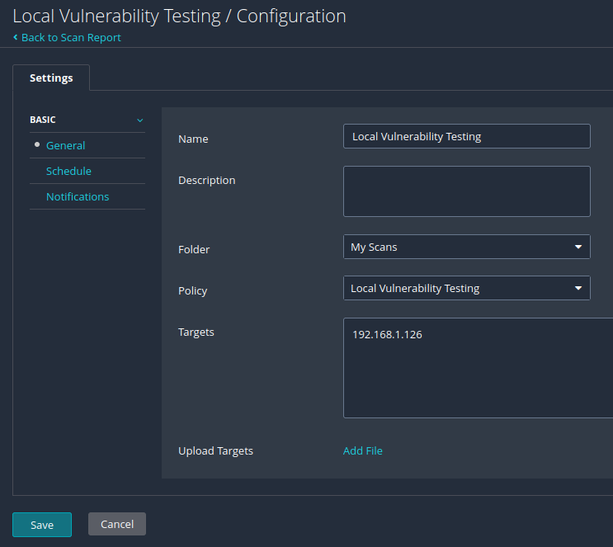
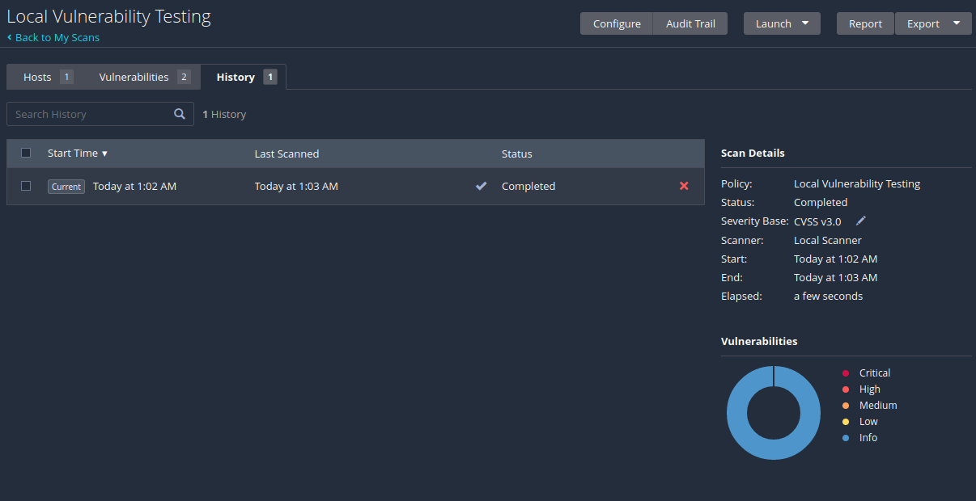

19)

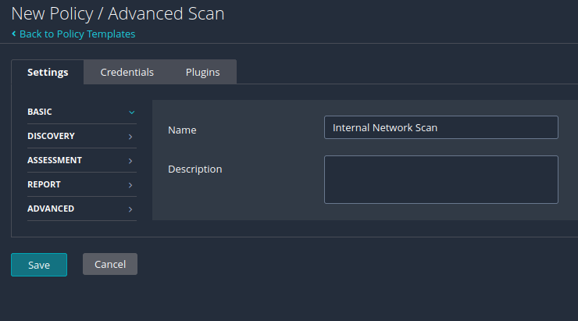
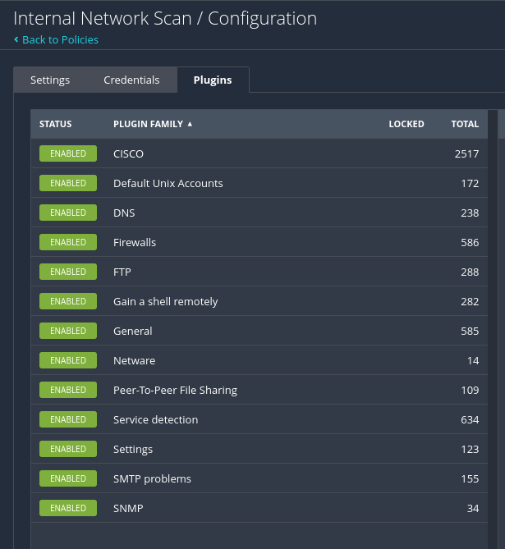

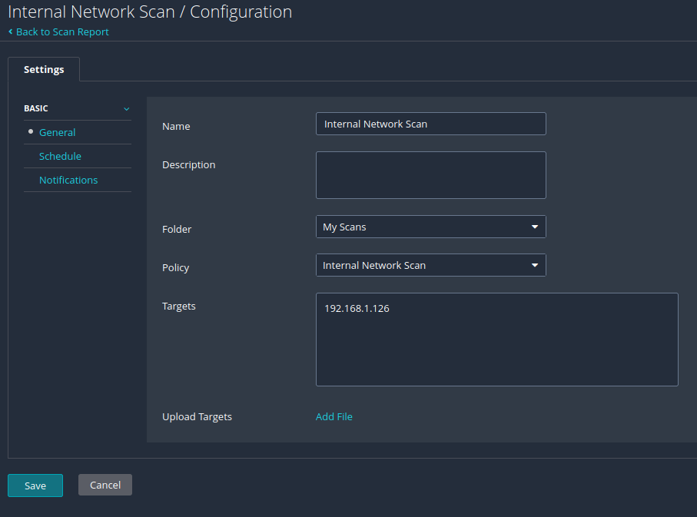

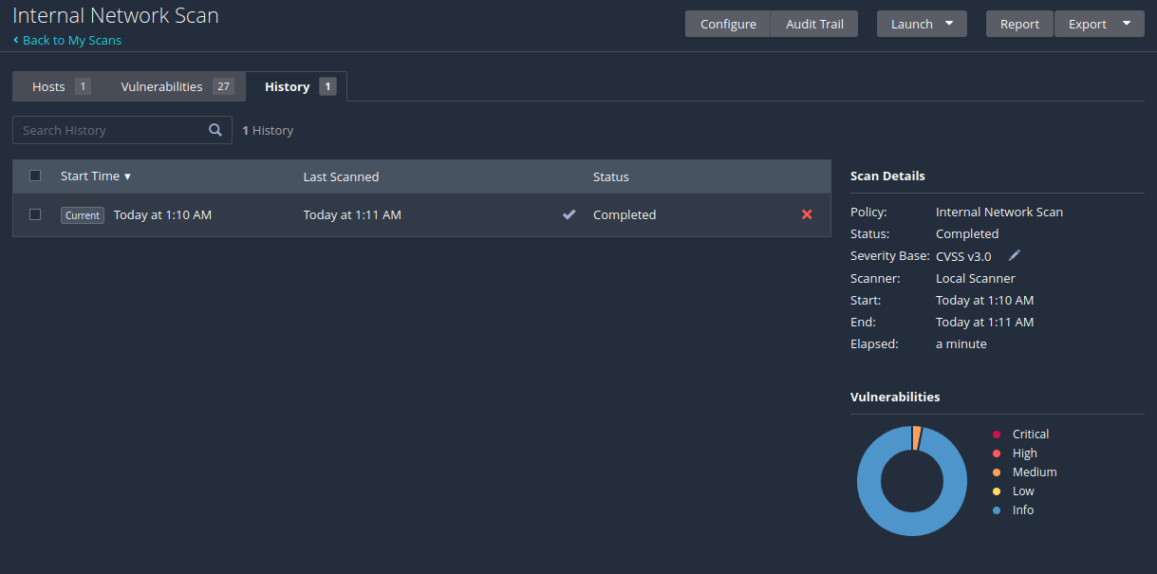

20)

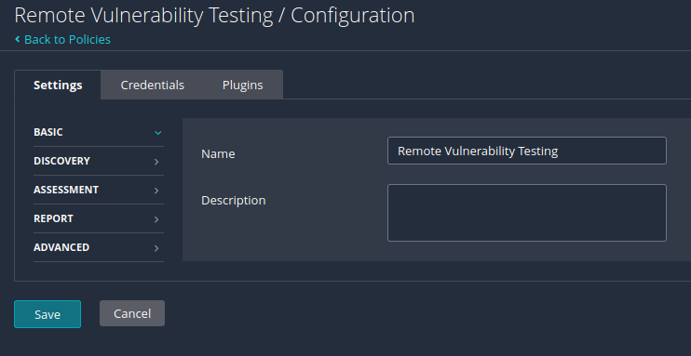

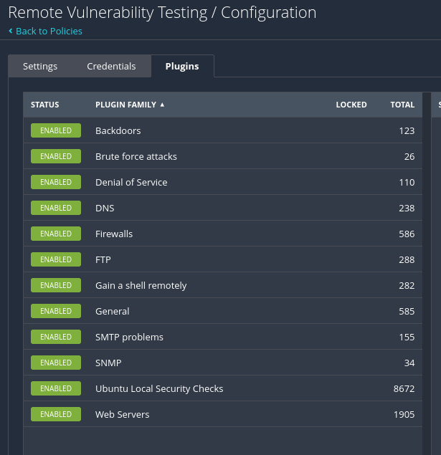

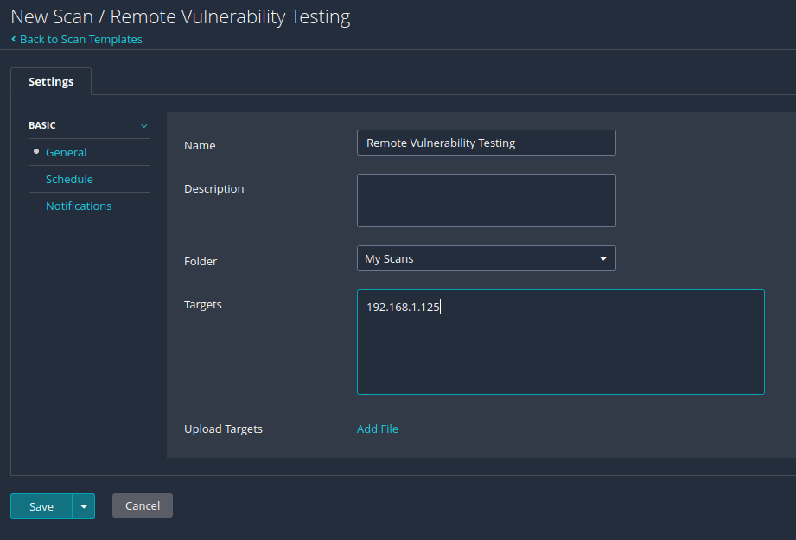
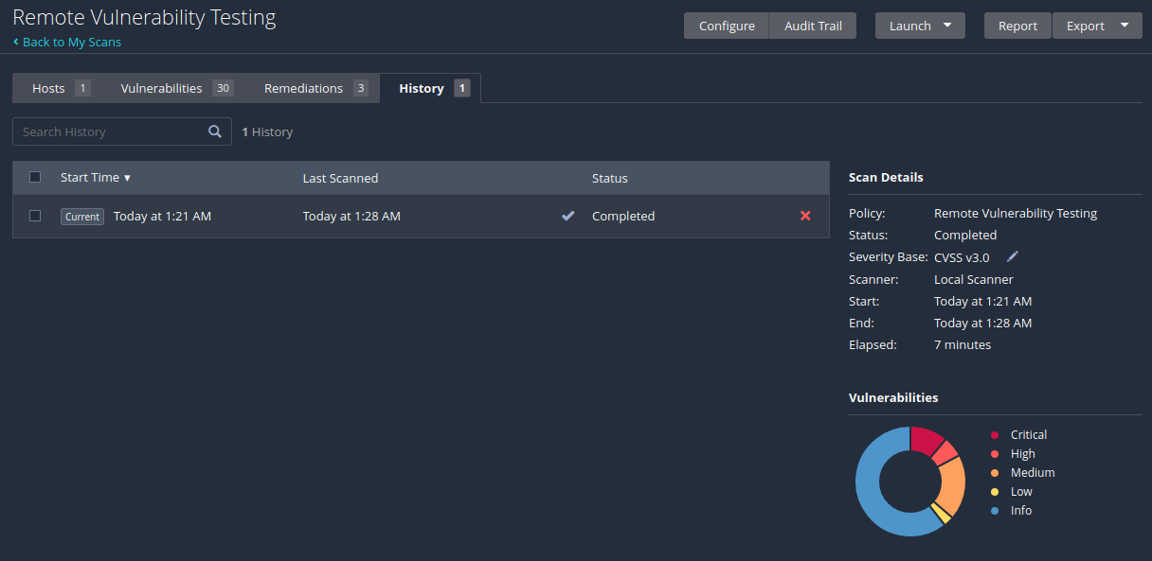

Part 2 Questions
1) Compare the reports from step 12 and step 20, and state your findings.

The “Basic Network Scan” from step 12 shows a total of 120 vulnerabilities. Of the 120 vulnerabilities, 8 are critical, 8 are high, and 18 are medium. The “Remote Vulnerability Testing” scan from step 20 shows a total of 63 vulnerabilities, of which there are 7 critical, 4 high, and 12 medium. From these two reports, it seems that Metasploitable 2 Linux is especially vulnerable when it comes to remote access, as the only critical vulnerability found in the “Basic Network Scan” and not in the “Remote Vulnerability Testing” is “SSL Version 2 and 3 Protocol Detection.” While I was initially surprised by this overlap, it began to make sense as Metasploitable 2 Linux is purposefully designed to be vulnerable to attacks and most attacks have to occur over a network.

2) Compare the reports from step 18 and step 19, and state your findings.

From the “Local Vulnerability Testing” and “Internal Network Scan” results, it is not surprising to see that Kali Linux has no critical or high vulnerabilities, and only 1 medium in the “Internal Network Scan” report which is “SSL Certificate Cannot Be Trusted.” Since Kali Linux has such an emphasis on security, the lack of vulnerabilities is expected. In the “Internal Network Scan” report, the other 35 vulnerabilities are all in the “info” severity which seems unavoidable as a device connected to a network. Most of the “info” vulnerabilities seem related to accessible information like the device type, hostname, running processes information, and connection information.

Reflection
a) What is the purpose of the lab in your own words?

To me, this lab was meant for us to become exposed to the practice of fingerprinting and
scanning devices other than our own on a network. While we had 2 virtual machines running,
almost all of the information for both machines was done on Kali using the IP address of
Metasploitable 2. The interactions we did with Nmap got us information via fingerprinting on
the Metasploitable 2 machine such as it’s operating system, the versions of different
software it has, and the ports it has open, while our use of Nessus gave us full reports on the
vulnerabilities each of the two systems had.

b) What did you learn? Did you achieve the objectives?

In full honesty, I did not realize you could run multiple virtual machines at the same time. So
at the very beginning I learned that you can run Metasploitable 2 and Kali at the same time!
In terms of network mapping and scanning, I learned how to fingerprint devices on a
network using Nmap along with what kind of information is available when you are
fingerprinting a device. I was aware that the operating system is available to see, however
what surprised me was seeing a full list of the ports that are open along with what specific
version of software a device on the network is running, such as ssh, telnet, and MySQL. I also
learned how to use Nessus for performing scans and generating a report of vulnerabilities
found on a target IP address. I believe that I achieved the objectives of the lab, and am
already planning on running scans on some of my personal devices to see what kinds of
information I can now gather.

c) From the defense point of view, why is it important to close unused services/ports and
patch your system/software in a timely manner?

Unused services and ports along with unpatched systems and software pose as a massive
threat to the security of a device. Ports that are open serve as a potential way into the
system from an outside device on the network that can easily be avoided by closing the
services and/or ports when not being used. Out of date systems and software serve as
possibilities for a system to become compromised as time goes on since bad actors will
work with outdated or unpatched software to discover vulnerabilities and develop methods to
exploit said vulnerabilities. By updating your operating system and applications regularly, the
identified vulnerabilities are fixed, lowering the risk of your system being compromised.

d) Is this lab hard or easy? Are the lab instructions clear?

While time consuming, this lab was not overly difficult due to the instructions being clear and
concise. There was a slight learning curve to using Nessus as I had never used the software
before, however once I became familiar with the UI and the different menus presented I was
able to run the scans fairly easily.

e) What do you think about the tools used? What worked? What didn’t? Are there other better
alternatives?

What surprised me the most was how not technically demanding the tools used in this lab
are. Nmap required using the terminal, but it’s commands are not overly difficult and we are
able to gain more information that I though with few to none additional parameters. The
same goes for Nessus, where the only information needed was the IP address of a target
system. I had always assumed these tools would have a high barrier to entry, but to my
surprise they all worked as intended with a lower learning curve than expected. From what I
have seen, there are alternatives to both Nmap and Nessus, however I don’t see a particular
reason to use the alternatives as they don’t appear to offer “better” results, just different
methods to gain the same information.

f) Other feedback

I very much enjoyed this lab, it seemed to be a well thought out introduction to what
Metasploitable 2 Linux, Nmap, and Nessus are as well as how to start using Nmap and
Nessus as the tools they are. I am hoping that we get to use Nmap and Nessus more in
depth as I’m guessing we have only scratched the surface of their functionality.

