CS695 – Lab 3

Encryption with GPG



Ryan Christopher
Table of Contents:

1 Title Page

2 Table of Contents

3 Part 1 – Symmetric Encryption

12 Part 1 – Questions

14 Part 2 – Asymmetric Encryption

16 Part 2 – Questions

18 Reflection

Part 1 – Symmetric Encryption
1)
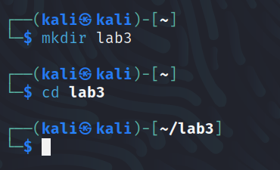

2)
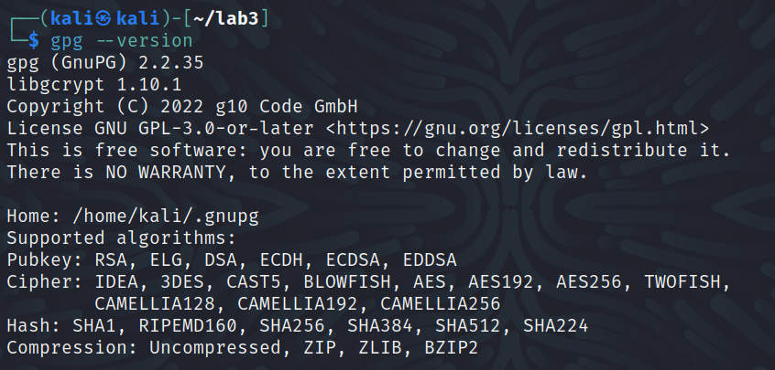

3)
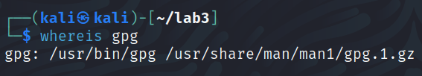

4)
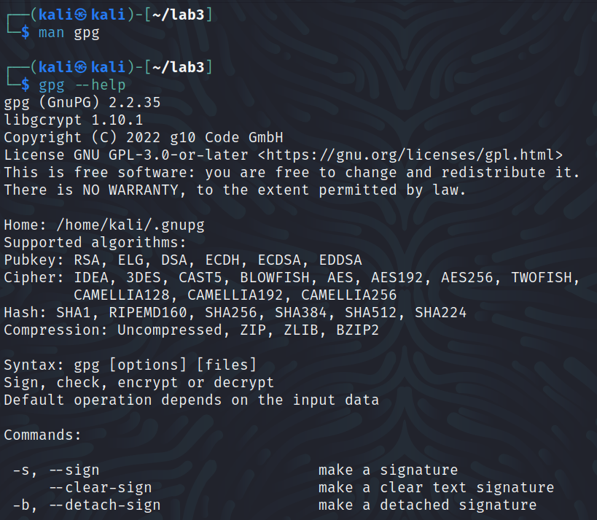
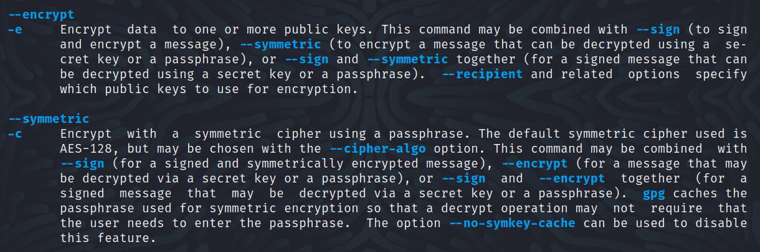
a) The option used to encrypt using a symmetric algorithm is “—symmetric”.

b) The option used to specify different encryption algorithms is “—cipher-algo”.

5)
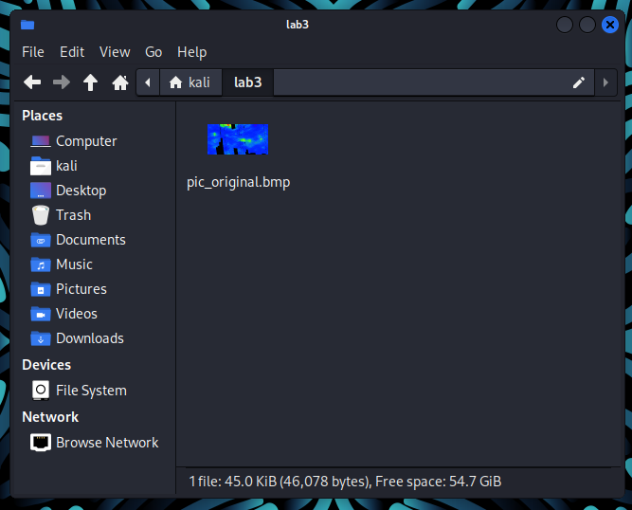
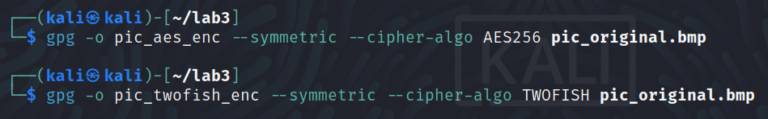
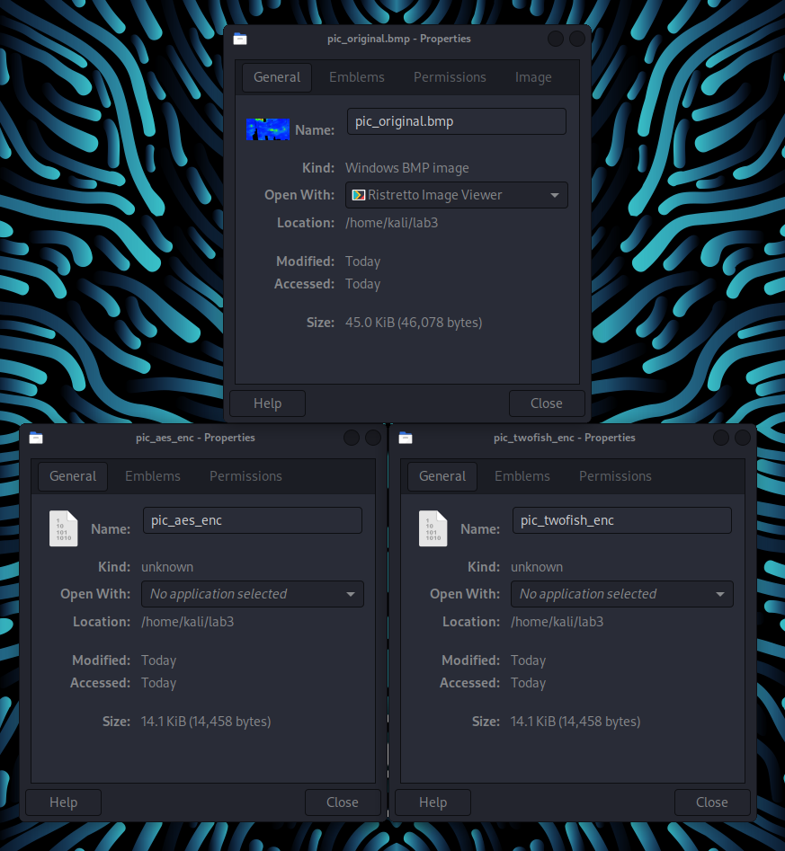
6)
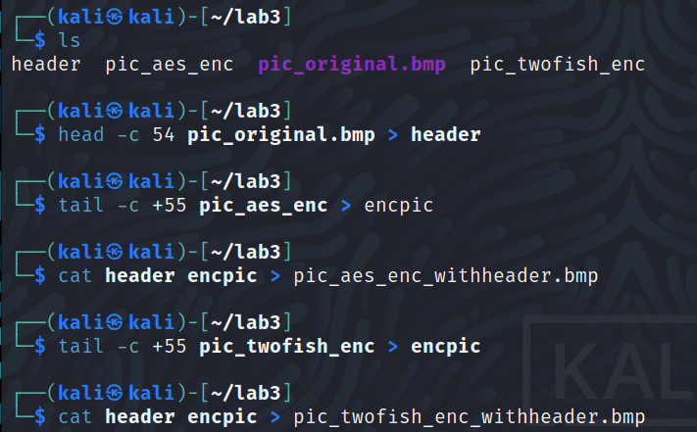

7)
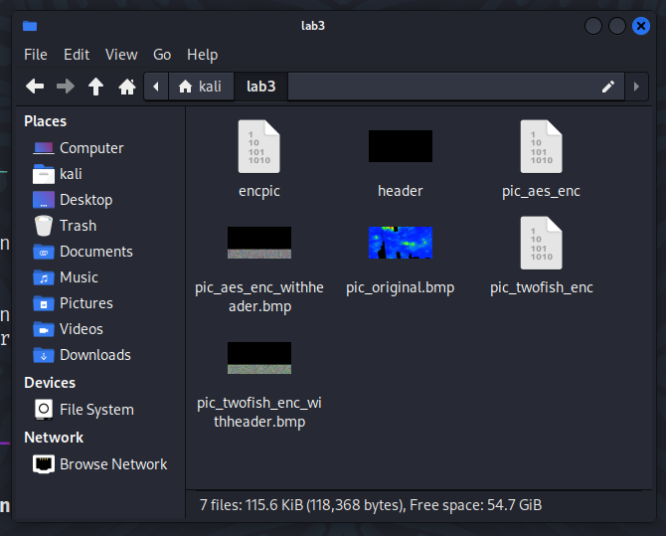
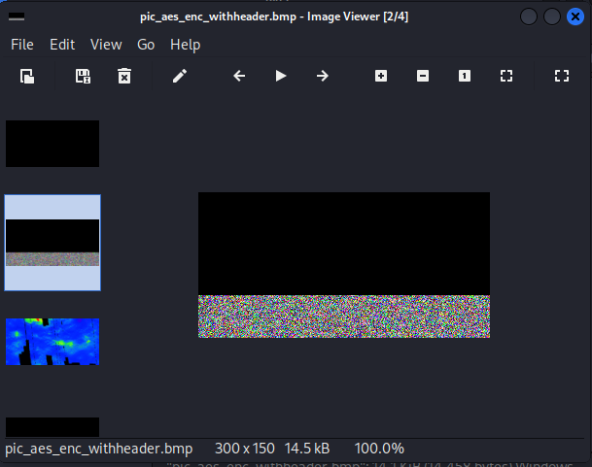
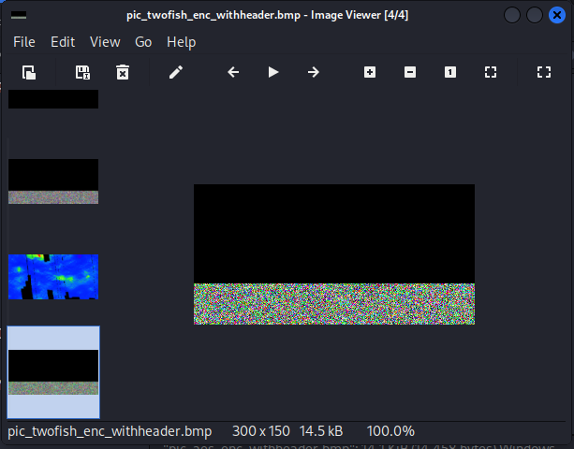

8)
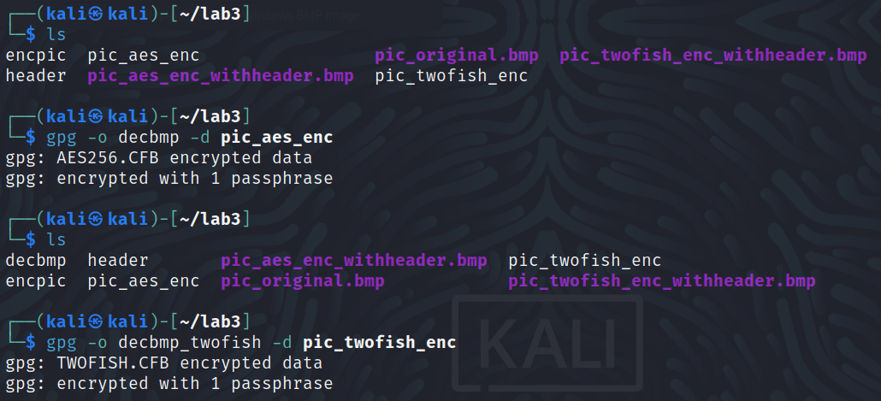

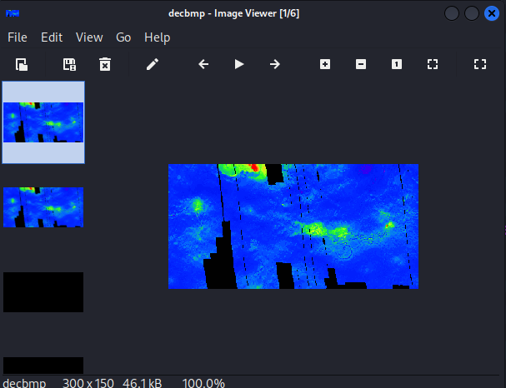

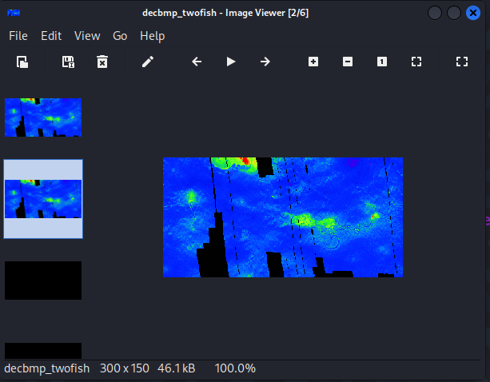

9)
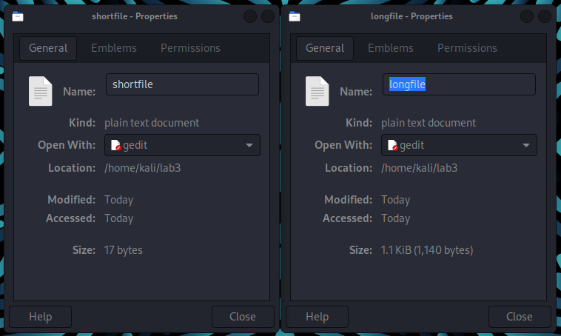

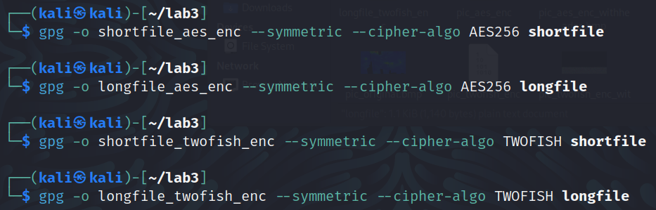
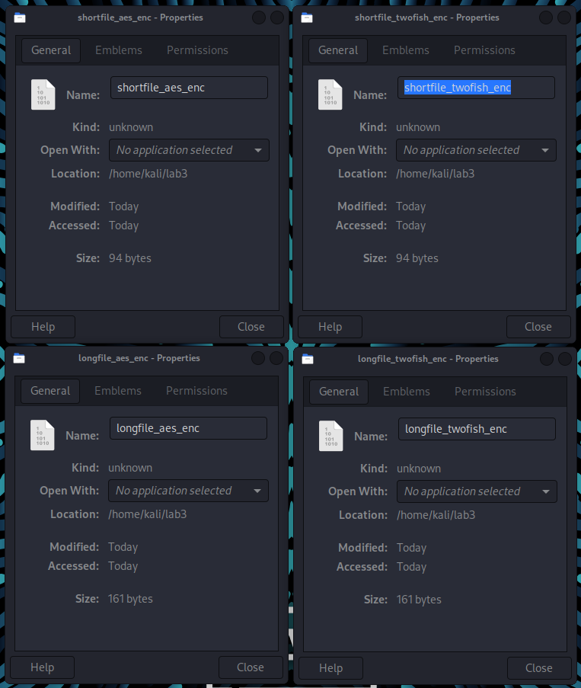

10)
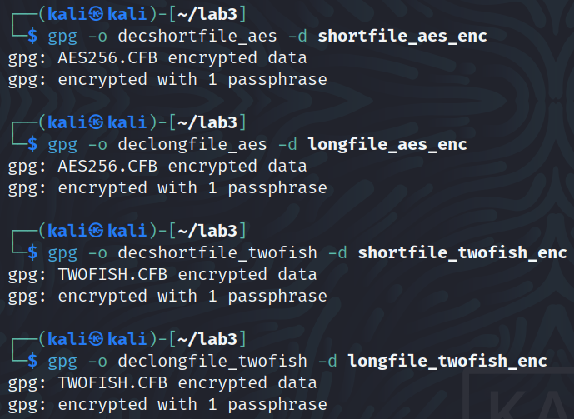
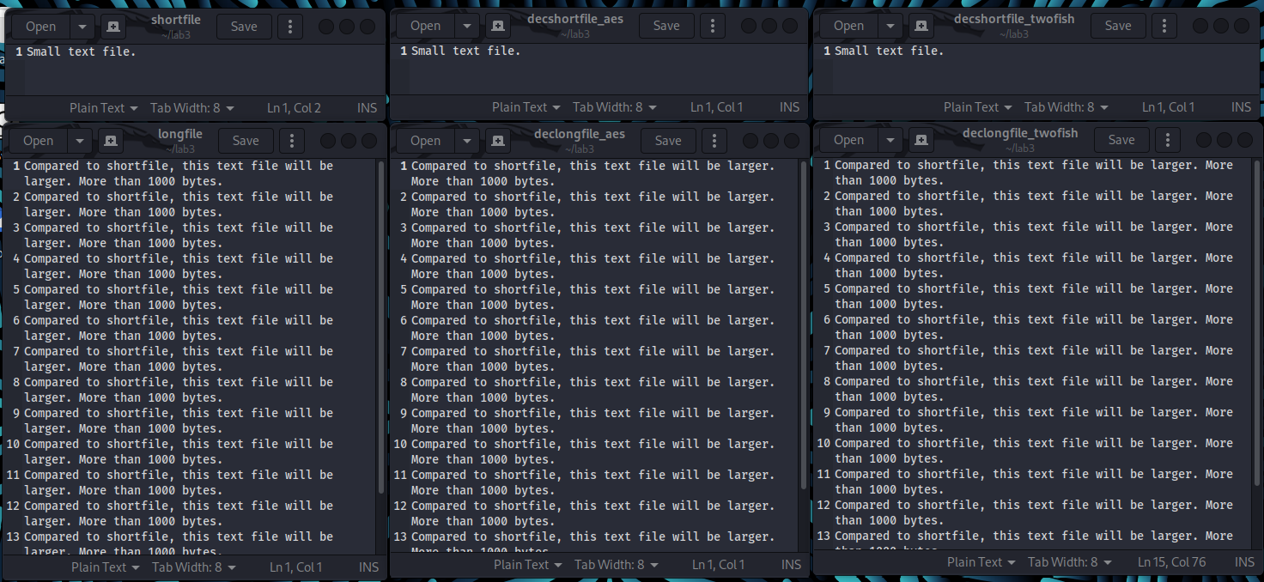

Part 1 Questions:
1) Please describe the differences between symmetric encryption, asymmetric encryption, and cryptographic hash algorithms. List at least three of each supported by the gpg tool in Kali Linux.

Symmetric encryption and asymmetric encryption are means of sending a message between two parties that is unreadable to outside groups, whereas cryptographic hash algorithms are a one-way operation that acts as a signature that proves the integrity of a message. Symmetric encryption uses the same key for both encryption and decryption, however asymmetric encryption uses one key for encrypting the data and a different key for decryption the data. The gpg tool in Kali Linux supports (but is not limited to) 3DES, AES256, and TWOFISH for symmetric encryption, RSA, ELG, and DSA for asymmetric encryption, and SHA1, SHA256, and SHA512 for cryptographic hashing.

2) When you encrypt the bmp file, what is the size of the encrypted files using AES256 and using TWOFISH? Are they the same? Are they larger or smaller than the original file? Why?

AES256 and TWOFISH both are 14.5kB in size after the header is added (14.1kiB before), and significantly smaller than the original 45kiB file. however the images are mostly black, with what looks like static on the lower third of the image. AES256 shows more of a rainbow pattern, whereas TWOFISH has more green in the picture. The files are smaller because they no longer contain the individual pixels of color and are just a string of binary data that can be decrypted into an image file.
When viewed in the File Manager, the encrypted files have an icon showing binary, which I'm guessing means the file is only binary data, however when the header is added then the preview of the mostly black image with static at the bottom is seen.

3) When you encrypt the text file, what is the size of the encrypted file using AES256 and using TWOFISH respectively? Are they the same? Are they larger or smaller than the original file?

When the text files are encrypted, the small file that is originally 17 bytes becomes 94 bytes when encrypted with AES256 and with TWOFISH and the encrypted files are larger than the original. The long file that is originally 1.1kiB, however, becomes 161 bytes when encrypted with AES256 and TWOFISH and is smaller once encrypted.

4) Briefly describe the differences between AES256 and TWOFISH. Which one do you think is more secure based on your experimental results?

While both AES256 and TWOFISH are symmetric key encryption algorithms that operate on fixed-size blocks as they work, they differ in the number of rounds that they perform when encrypting the data. AES256 performs 10 rounds for a 128 bit key, 12 rounds for a 192 bit key, and 14 rounds for a 256 bit key, whereas TWOFISH performs 16 rounds for a 128 bit key, 16 or 20 rounds for a 192 bit key, and 16, 20, or 24 rounds for a 256 bit key. I think that TWOFISH is a more secure algorithm due to the higher number of rounds that it can perform on the data that is being encrypted.

5) You will need to use a passphrase to generate a symmetric key for the encryption and decryption. Compare different passphrases (e.g. shorter and weaker vs longer and more complex) and state your findings.

When testing two passwords, one shorter and weaker and another longer and more complex, the resulted encrypted file did not appear to change the outcome of the encrypted file. On the long text file, both the short password and long password encryptions are 161 bytes in size, despite one of them having a password more than twice as long and with special characters.

Part 2 – Asymmetric Encryption
1)
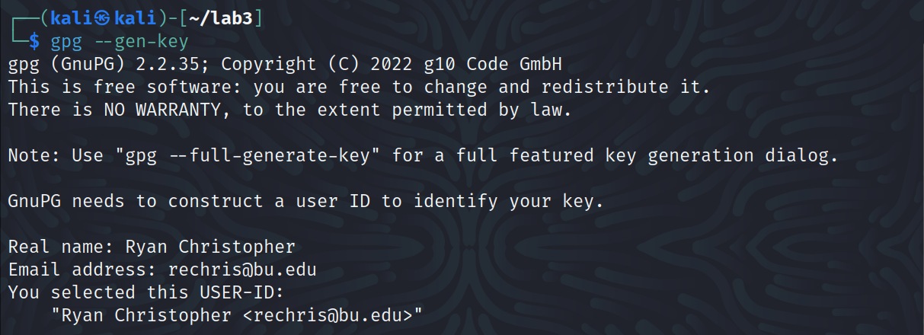
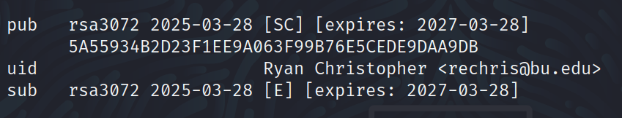

2)
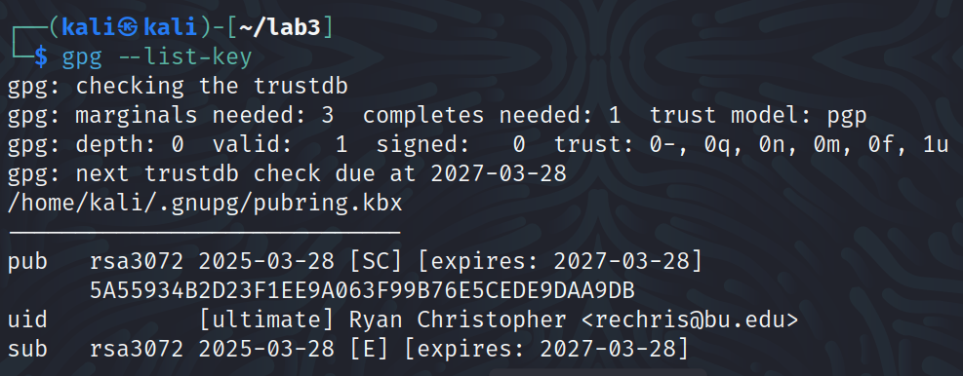

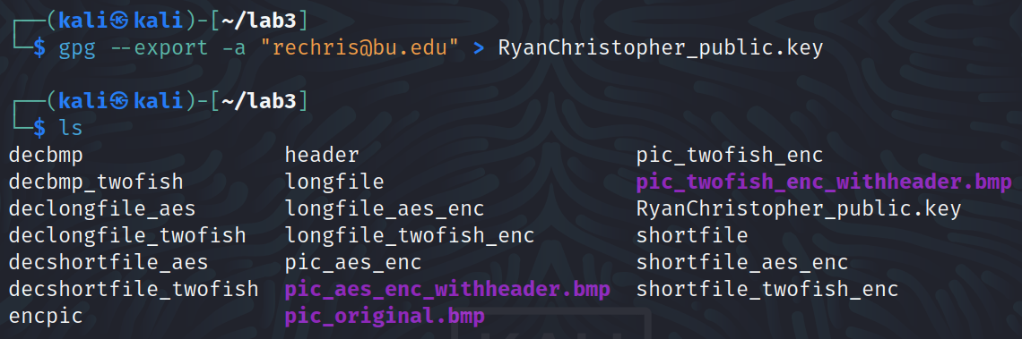
3)

4)
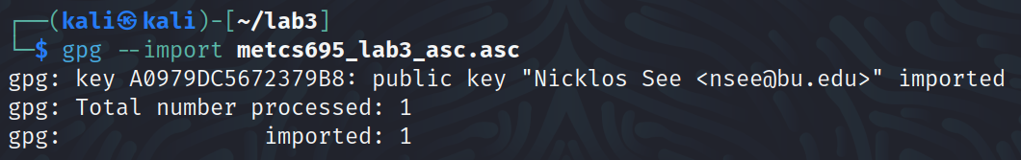

5)
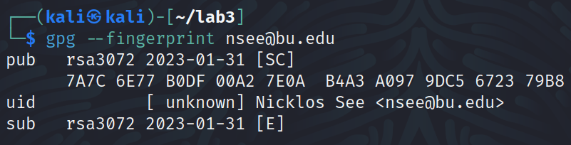

6) I did not receive an encrypted message. :(

7)
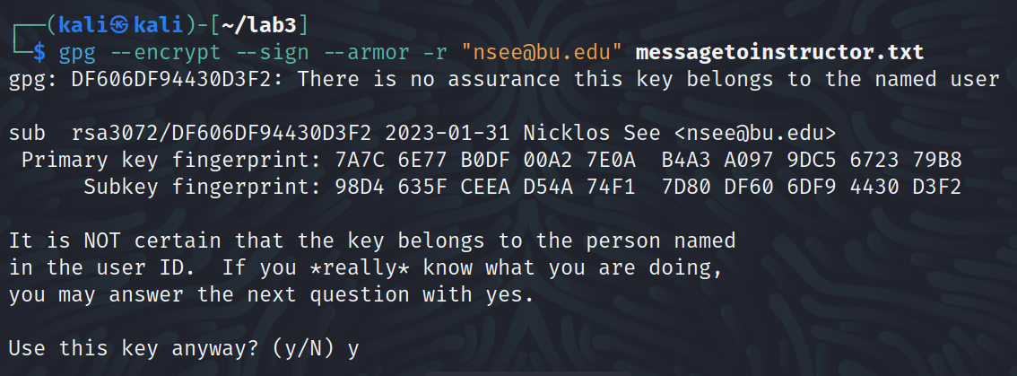

8)
9)
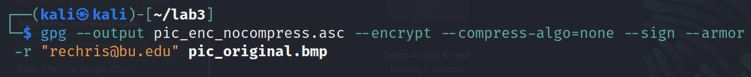

Part 2 Questions
1) Check the manual of the gpg command using either the man command or the
“--help” option and explain the following options:
a) --encrypt
encrypts the input data specified

b) --decrypt
decrypts the input data specified with a default method

c) --sign
creates a signature on the input data specified with a cryptographic hash function

d) --armor
creates an ascii armored output (a non-binary encoding)

e) --output
write the output to a specified file

f) -r
specifies the recipient USER-ID when encrypting input data

2) Gpg uses a hybrid approach to encrypt the message, which uses the public key to encrypt a session key and uses the session key to encrypt the message. Explain this in more detail about how the message you want to send to the instructor is encrypted and signed as well as the decryption process.

When you send an encrypted message, the random number is generated and used as the session key for this specific message only and encrypted using the recipients public key. Once the session key is encrypted and placed at the beginning of the message, the session key is used to encrypt the message. Then, when the recipient goes to decrypt the message, their private key decrypts the session key and uses the decrypted session key to decrypt the message.

3) Compare the size of the original text message and the encrypted & signed message, and state your findings and reasoning.

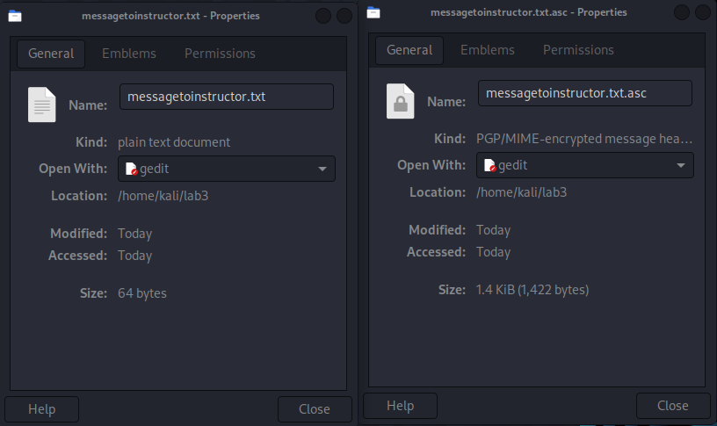
The original text message is 64 bytes and the encrypted and signed message is 1.4kiB, the file is large due to the larger size of the message once it is encrypted as well as the signature being included in the file.

4) Compare the file size of the original bmp file and encrypted bmp file with and without compression respectively, state your findings and reasoning.
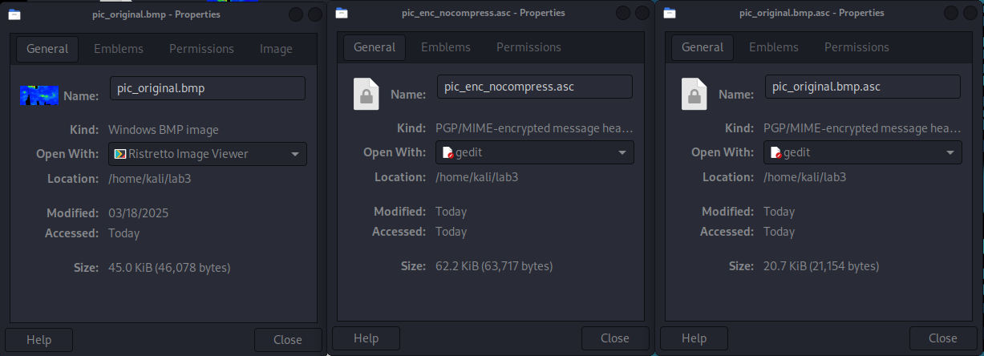
The original bmp file is 45kiB, whereas the encrypted bmp file with compression is 20.7kiB and the encrypted bmp file without compression is 62.2kiB. The file with compression is logically smaller than the original, however without compression and the signature, the uncompressed file is about 50% larger as a result.

Reflection
a) What is the purpose of the lab in your own words?

The purpose of this lab is to gain experience with encrypting different types of files (image and text) with symmetric and asymmetric encryption methods, as well as decrypting files with symmetric and asymmetric keys to gain the original.

b) What did you learn? Did you achieve the objectives?

I learned how to generate a private/public key, as well as how to use gpg in order to encrypt files with different methods. I would say that I achieved all of the objectives except for decrypting the instructor message as I did not receive one.

c) Is this lab hard or easy? Are the lab instructions clear?

This lab was fairly straightforward, and this is mostly due to the clear instructions in the lab. Without the instructions I would have guessed this lab to be much more difficult, however with the explanations of each step I was able to follow along fairly easily.

d) What do you think about the tools used? What worked? What didn’t? Are there other better alternatives?

I am particularly interested in gpg now, as I did not realize that encrypting files and generating private/public keys were performed so simply. I did not encounter any issues, so I would say that everything worked as expected. My guess is that there are more modern alternatives to encryption methods, as the list of “supported” algorithms on gpg did not include ones that I have seen in more recent discussions, however I am guessing that they can accomplish essentially the same result as gpg does.

e) Other feedback

Getting more exposure to the process of encrypting and decrypting data was, in my opinion, a valuable lab as we discuss these actions heavily in classes but I myself have not had much experience doing so. After this lab, I am curious to start experimenting with other methods of encryption, and especially seeing what parts of the processes in this lab have correlation with my project topic.

