Ryan Christopher
CS695 – Lab 4

Password Cracking

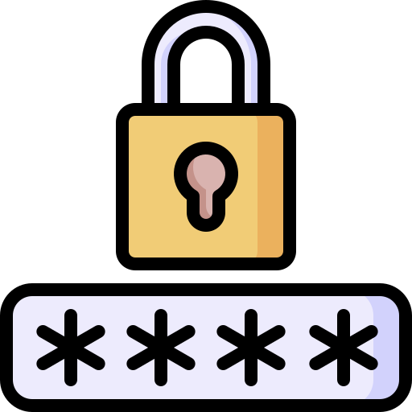

Table of Contents:

1 Title Page

2 Table of Contents

3 Part 1 – Using hydra-graphical for Online Password Cracking

10 Part 1 – Questions

13 Part 2 – Using John the Ripper for Offline Password Cracking

20 Part 2 – Questions

22 Reflection

Part 1 – Using hydra-graphical for Online
Password Cracking
1)
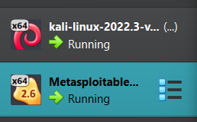

2)

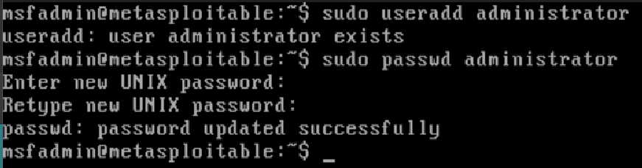

3)
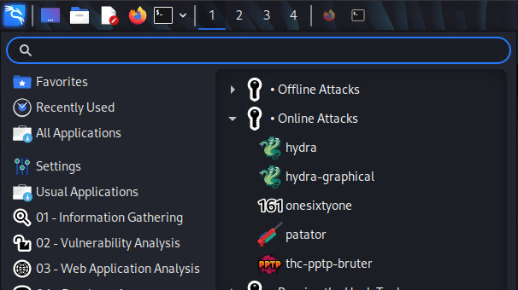

4)
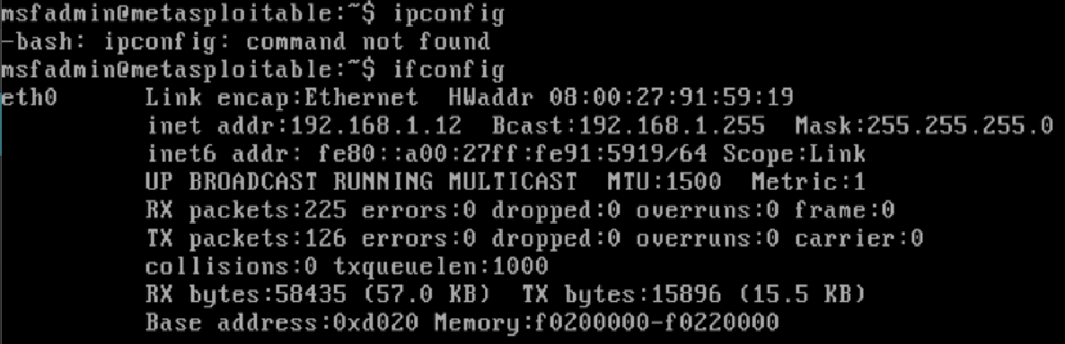
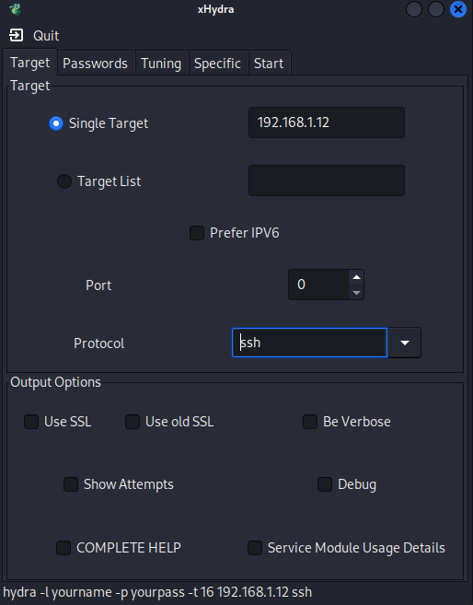

5)
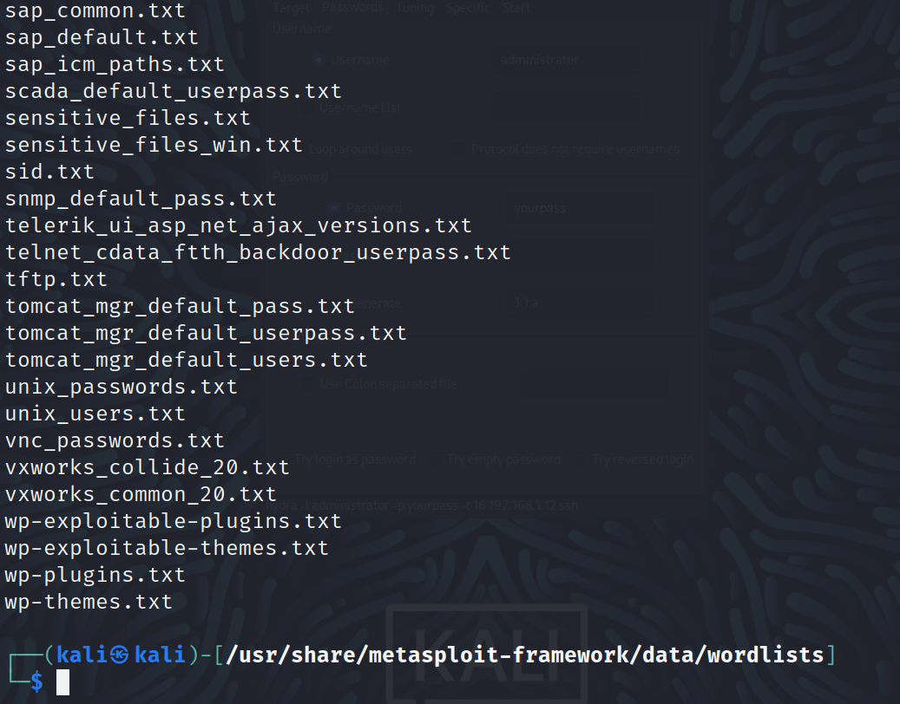
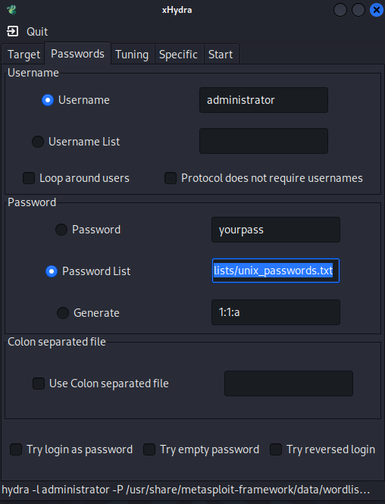
6)
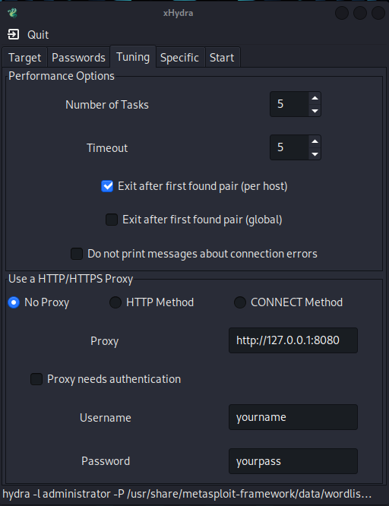

7)
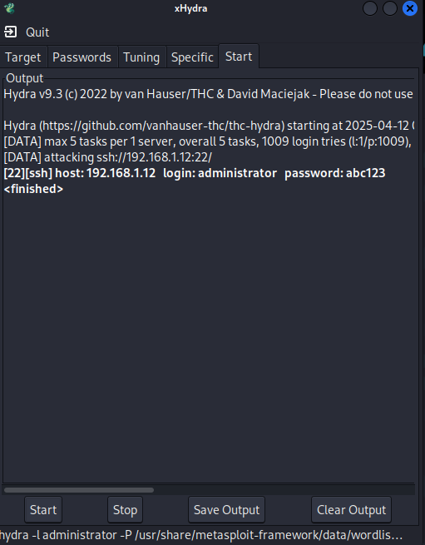

8)
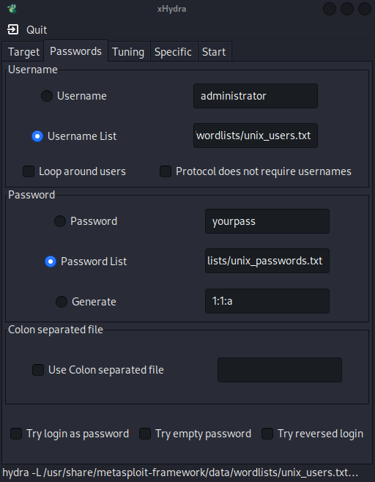
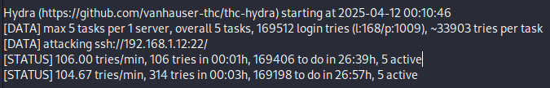
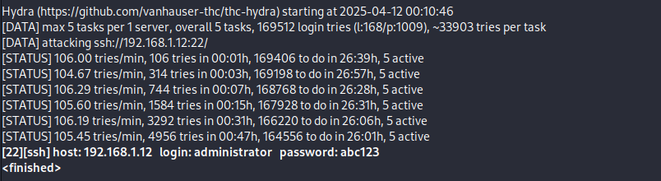

9)
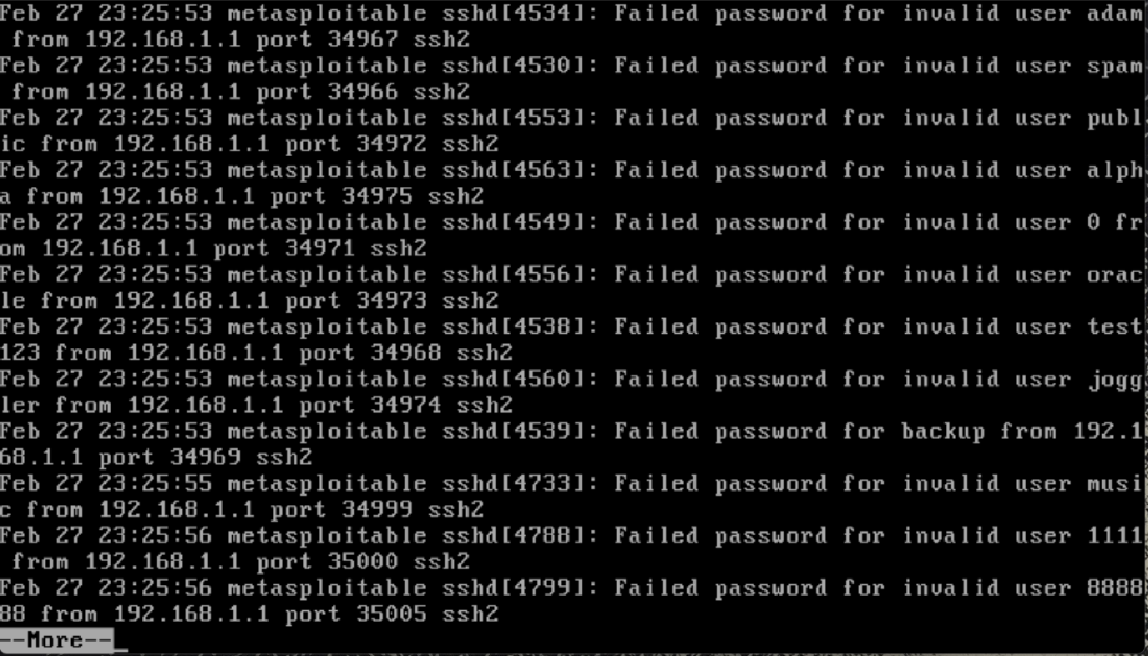
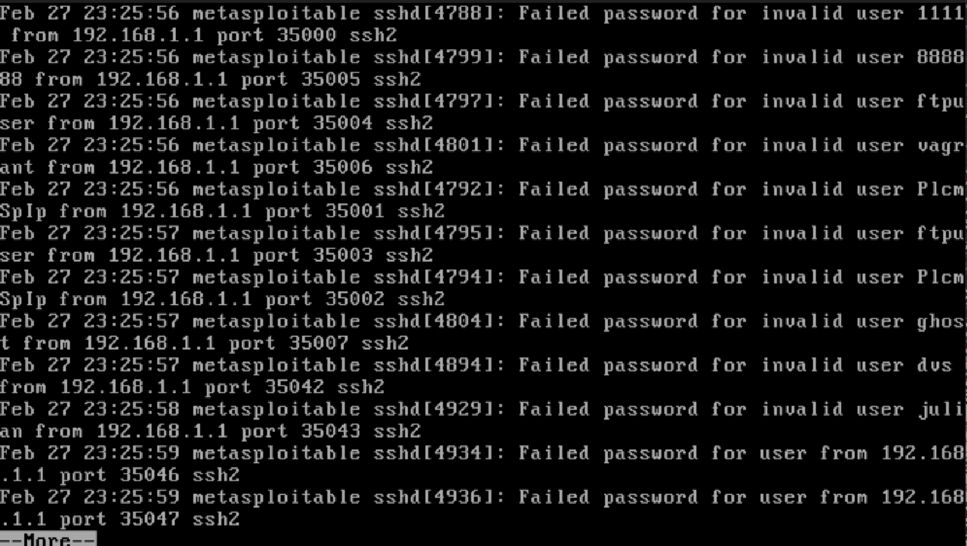

Part 1 Questions:
1) As you expect, the success of password cracking highly depends on the dictionary used. Generally, a larger and more comprehensive dictionary produces a higher success rate. We used unix_passwords.txt, 7,833 bytes, which contains commonly used account passwords for unix/linux users. In the same directory (/usr/share/metasploit-framework/data/wordlists), the file password.lst is much larger, 820,321 bytes, which is more general for different scenarios. In case that using unix_passwords.txt didn’t give a success, we can try password.lst. Take a look at other files in the same directory (wordlists). From their names, you can infer which scenarios they are used for, e.g., oracle_default_userpass.txt contains the frequently used passwords for an oracle database. Find three password dictionaries used in different scenarios in the wordlist directory, and compare them. What are your findings and conclusion?
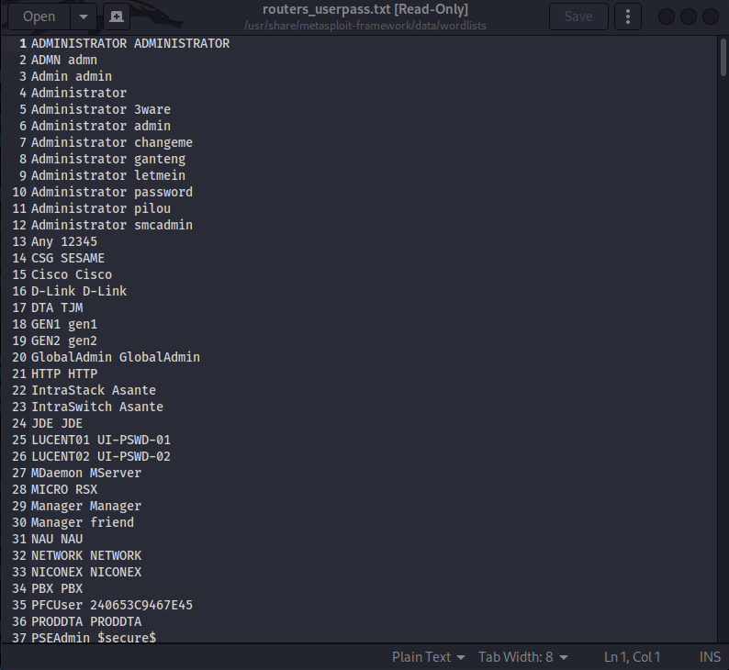
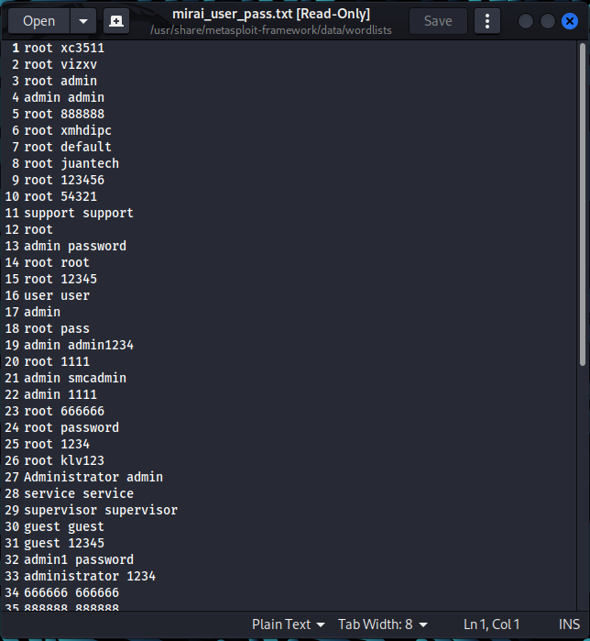
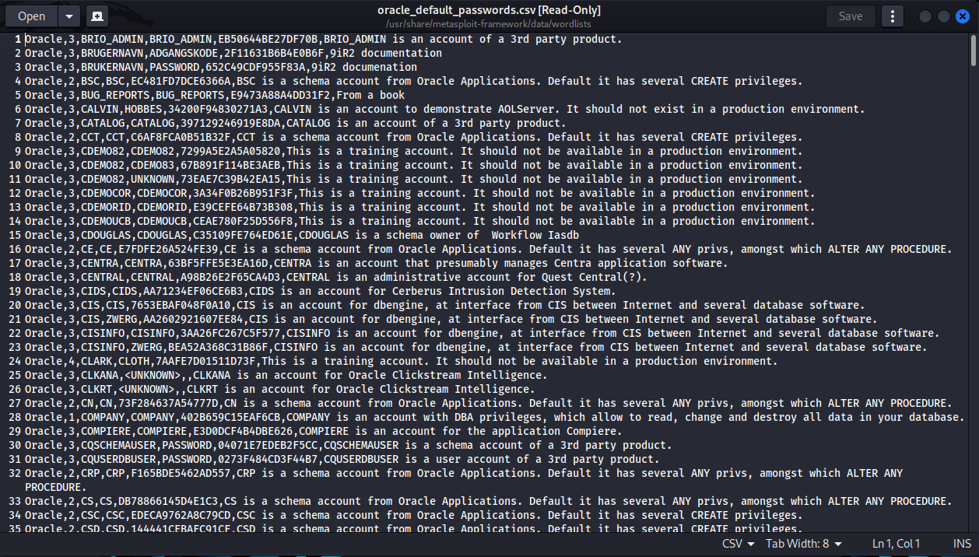

The three password dictionaries I decided to look at are routers_userpass.txt, mirai_user_pass.txt, and oracle_default_passwords.csv. Despite having different use cases, the three lists share quite a few similarities in the patterns they have for username/password combinations. All three of them contain examples of default username and password combinations that are meant to be changed by the user after setup. For example, “Administrator : changeme” for routers, “admin : admin” for mirai, and “COMPANY : COMPANY” for oracle are all default account setups that are intended to be changed after first login by the user. It appears that these lists are designed to target accounts in which the user did not go through proper security measures and left the default service account passwords unchanged after initial setup.

2) What countermeasures (list at least 3) did we study in class or you are aware of to deal with such online password cracking? Think about when you entered wrong passwords several times on your phone, email accounts, etc., what will happen typically?

Multi-factor authentication, automatic account locking, and using complex passwords not containing personal information are all viable countermeasures to deal with online password cracking. With multi-factor authentication, even if an account password is uncovered access would not be granted unless approved on the next means of authentication, automatic account locking will notify the targeted user if their account is attempted to be accessed too many times in a short span of time, and using complex passwords will reduce the likelihood of the bad actor’s dictionary containing the targeted account password.

3) Perform online research if necessary. What is stored in the auth.log file? Search for the failed login from administer by replacing ‘Failed password’ with ‘Failed password for administrator’, and keep the other parts of the command unchanged in Step 9. From the output of Step 9, identify the IP address that the login requests come from. Compare it with the IP address of your Kali Linux. Then take a look at the ports from the output of Step 9. Are they the source ports (used on Kali) or destination ports (on Metasploitable)?
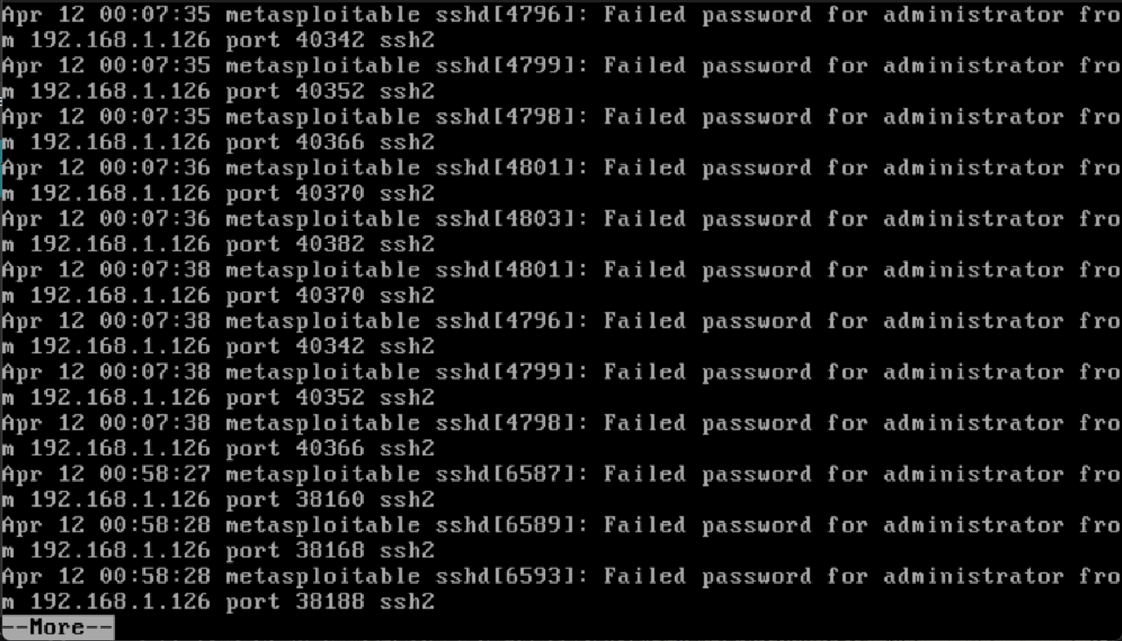
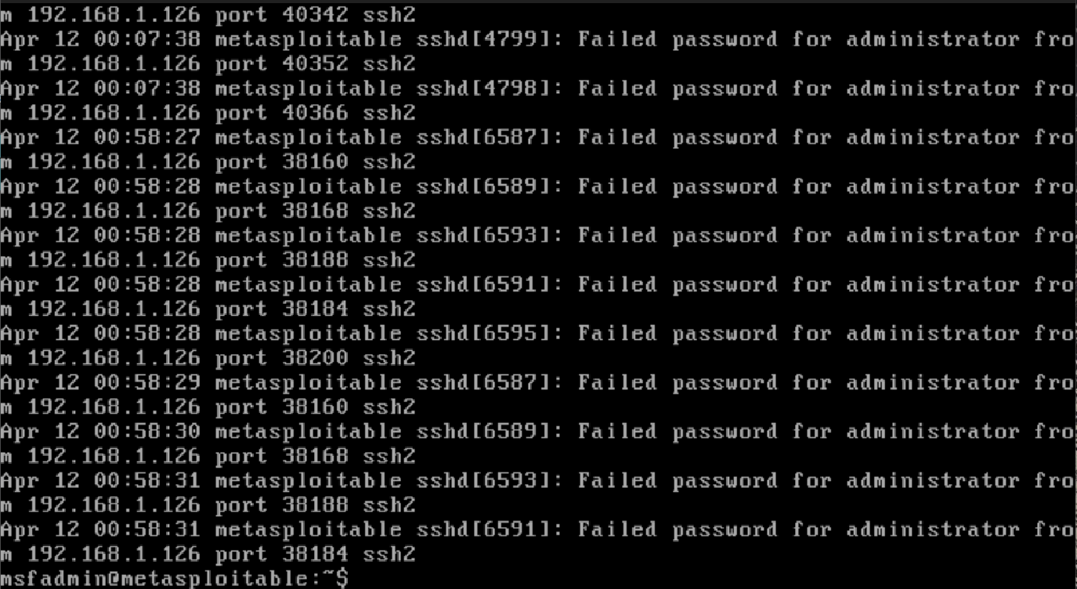
The auth.log file contains the history of all attempted logins, successful logins, and logouts that occur in the operating system. Using ‘Failed password for administrator’ only shows the instances in which hydra-graphical attempted to log into the administrator password compared to step 9 which shows multiple accounts attempting to be accessed. The IP address from the login requests is also the IP address of the Kali Linux machine (192.168.1.126), indicating in the logs that the requested logins and ports being used were not coming from the Metasploitable machine.

Part 2 – Using John the Ripper for Offline
Password Cracking
1)
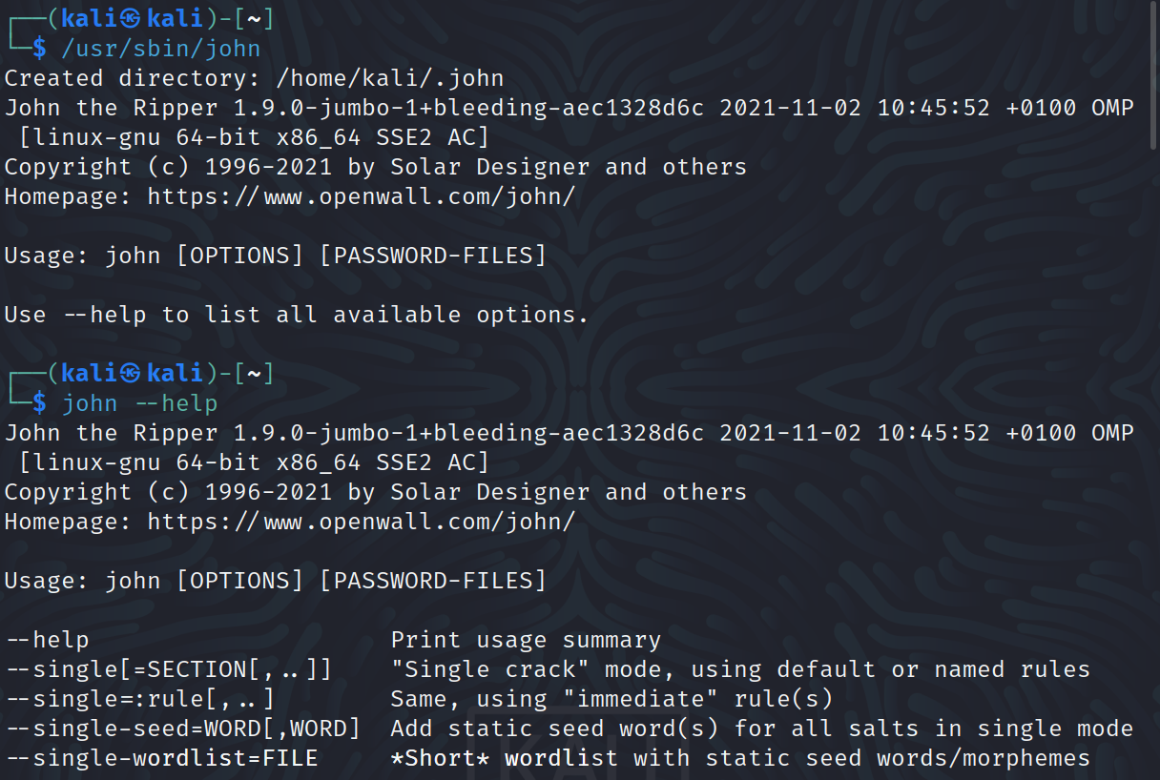

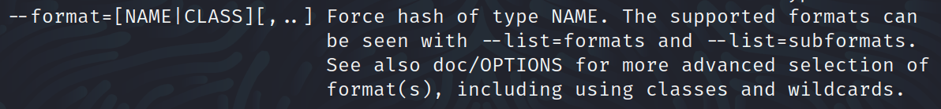

2)
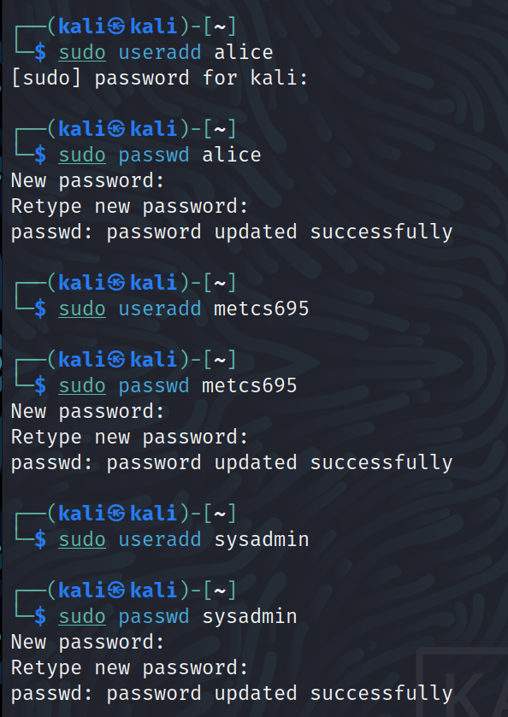

3)
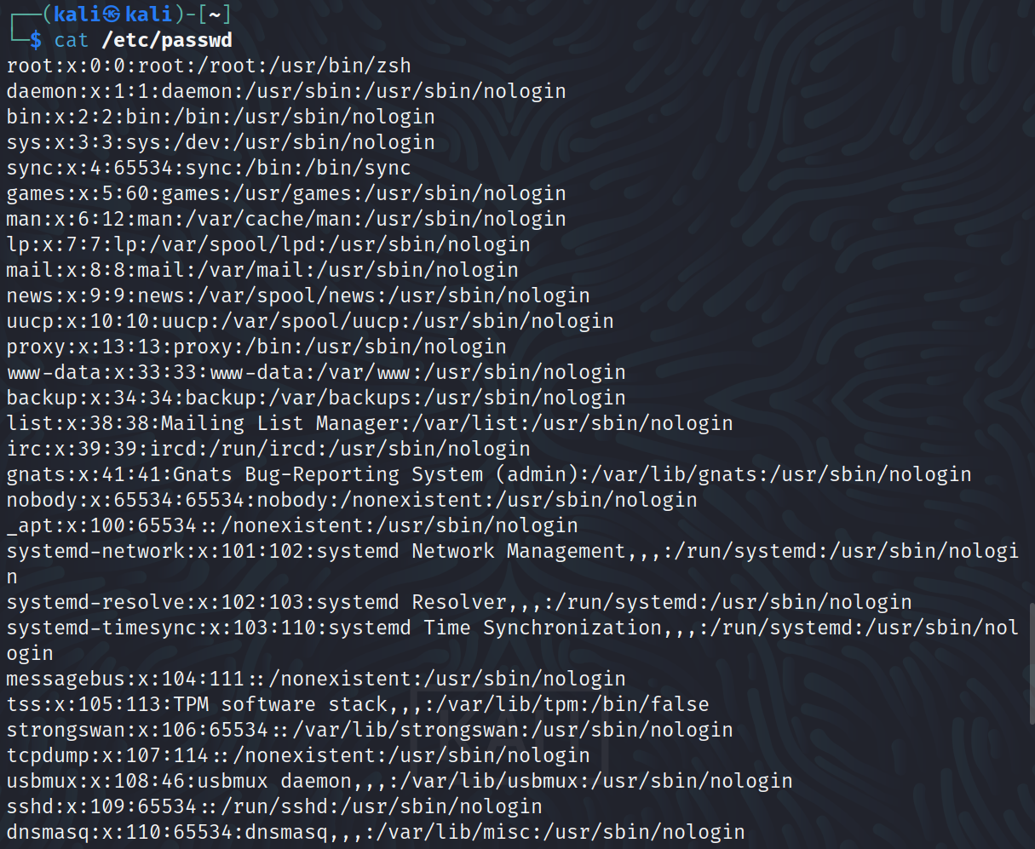
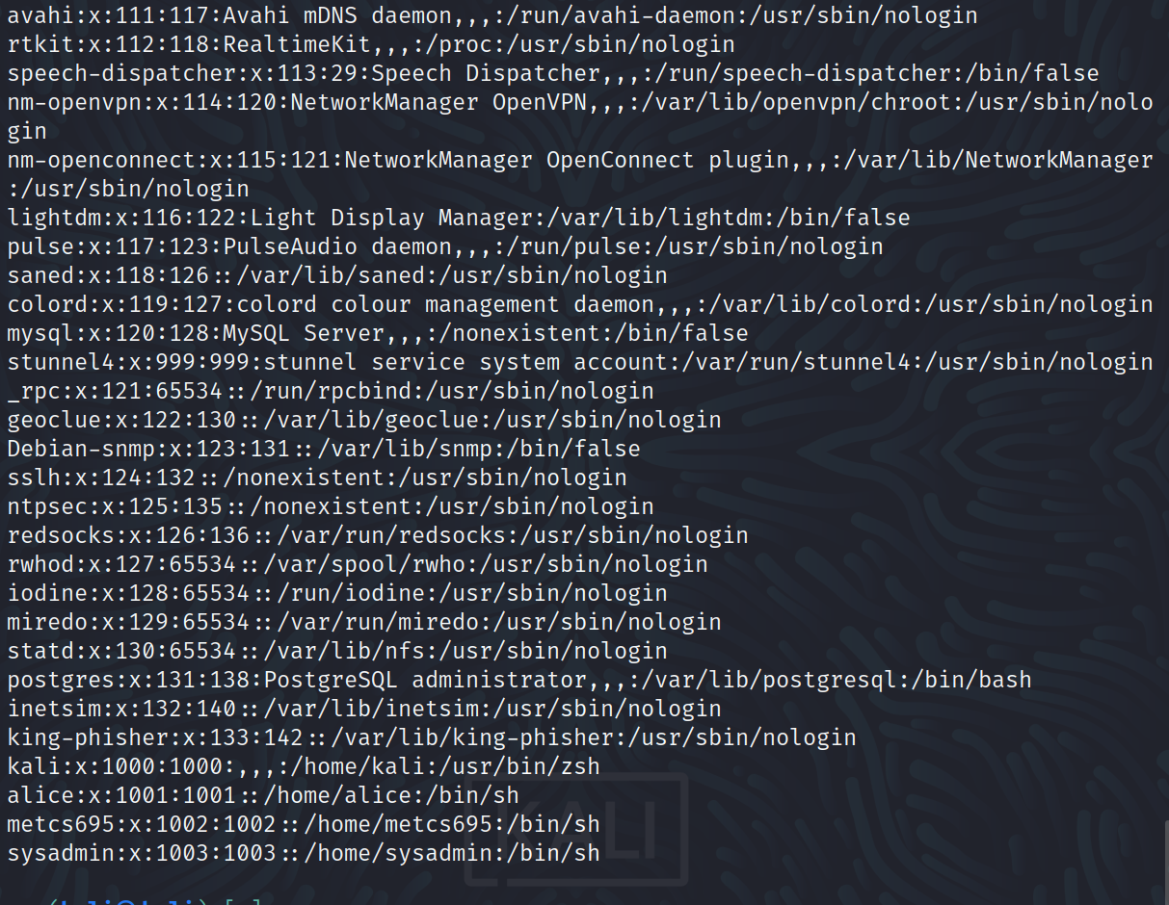

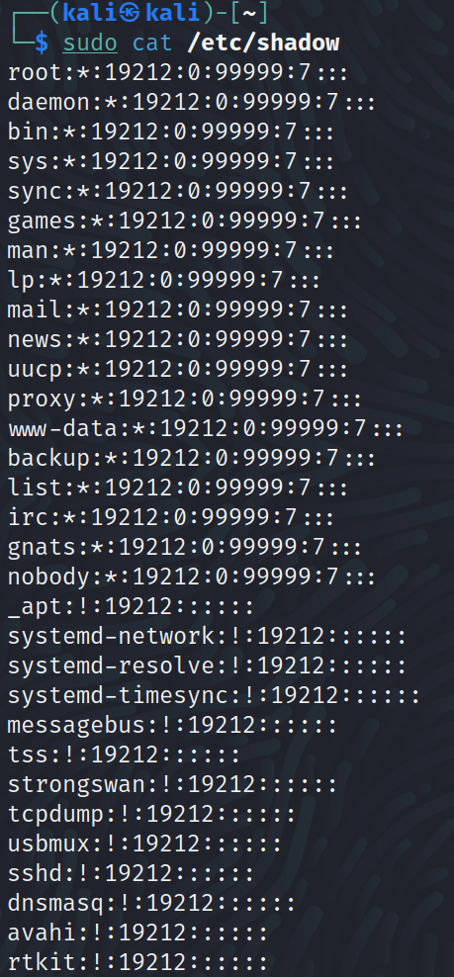

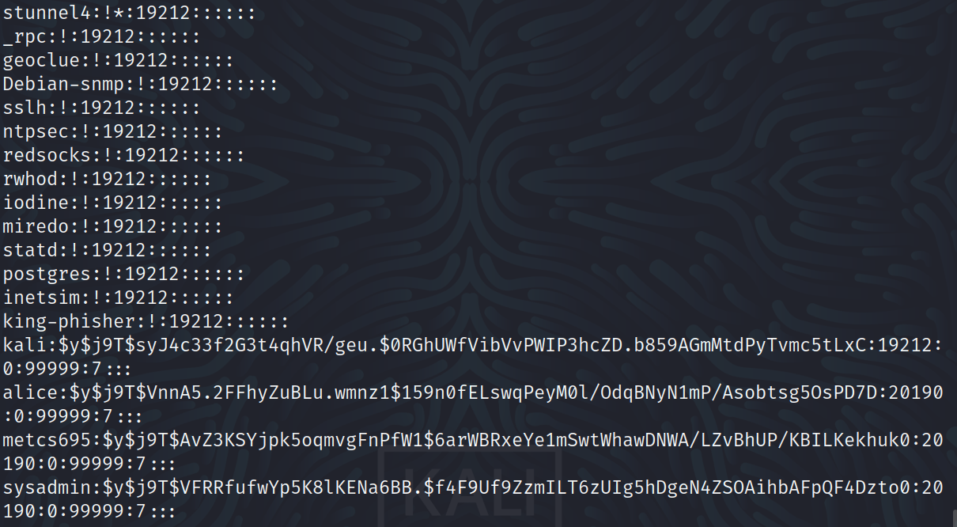

4)

5)
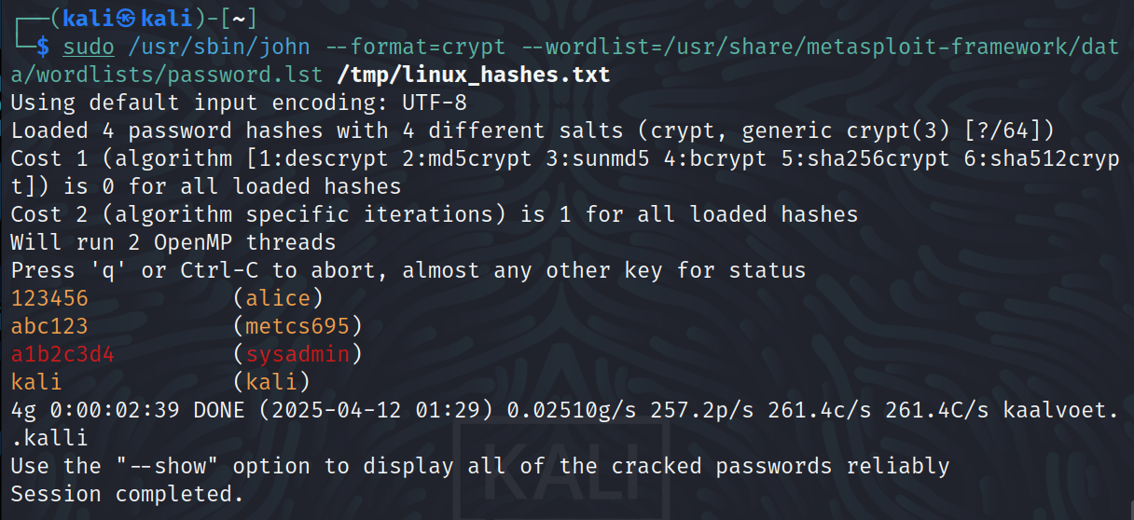

6)
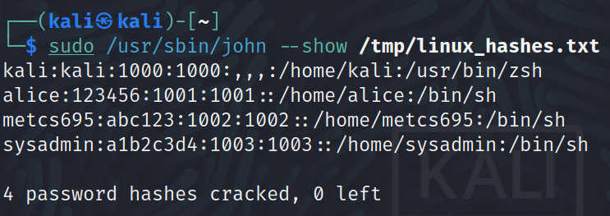
7)
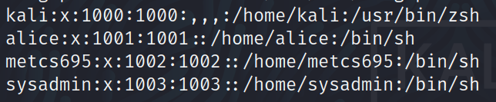

8)
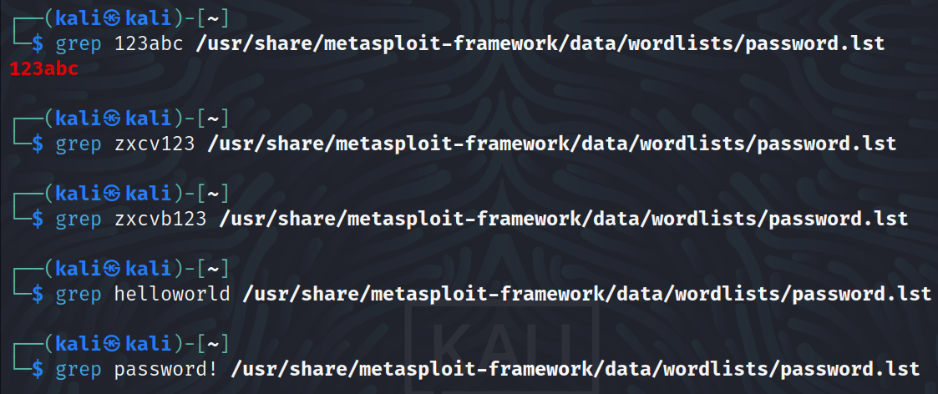

9)
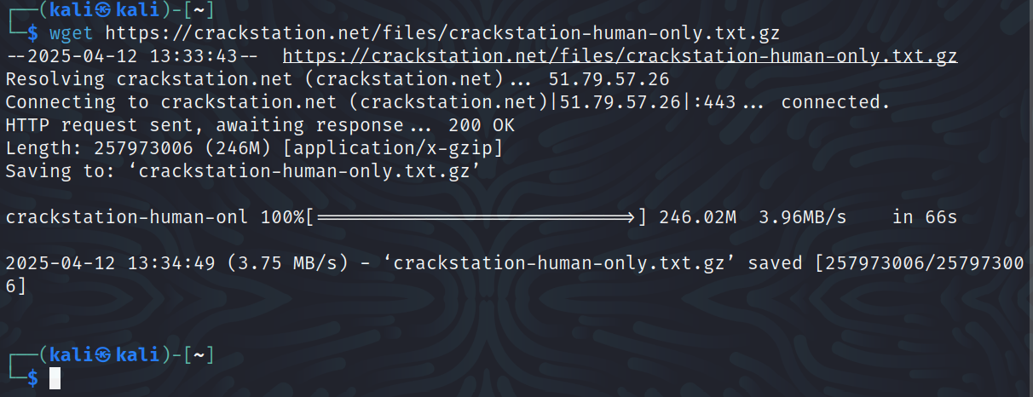

10)
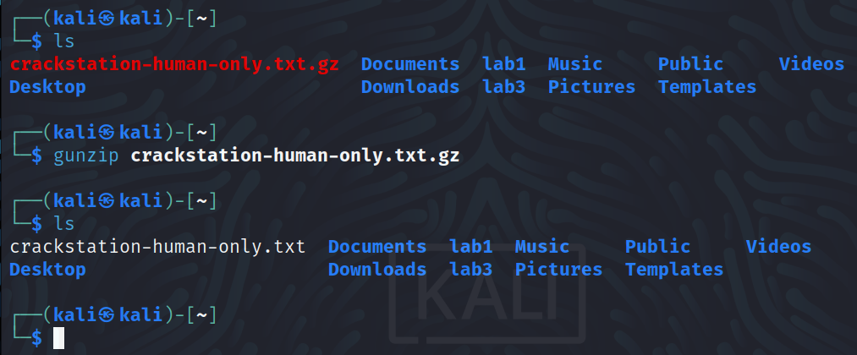

11)
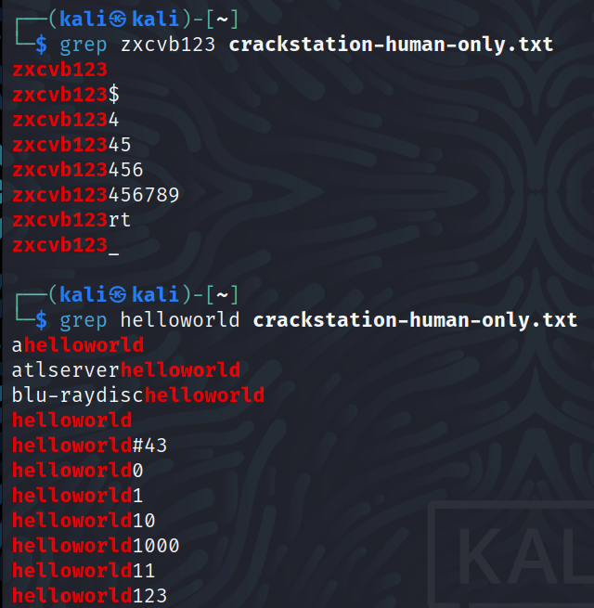

Part 2 Questions
1) From step 3, from both files of /etc/passwd and /etc/shadow, you can find entries for our just created users alice, metcs695, and sysadmin. For instance, below is the entry in /etc/passwd created for alice:

alice:x:1001:1001::/home/alice:/bin/sh

Refer to webpages (https://www.cyberciti.biz/faq/understanding-etcpasswd-file-format/
and https://www.cyberciti.biz/faq/understanding-etcshadow-file/) for explanation of the meaning of each field in the entry. Describe the meaning of each field for the entries you created.

In etc/passwd the accounts are stored with the following entries:
alice:x:1001:1001::/home/alice:/bin/sh
metcs695:x:1002:1002::/home/metcs695:/bin/sh
sysadmin:x:1003:1003::/home/sysadmin:/bin/sh

The fields are separated by the colon character and occur in the order:
1. username [alice]
2. password (shown as an x if encrypted and stored in /shadow) [x]
3. user ID [1001]
4. group ID [1001]
5. home directory [/home/alice]
6. command/shell [/bin/sh]

In /etc/shadow the accounts are stored with the following entries:
alice:$y$[hash]:20190:0:99999:7:::
metcs695:$y$[hash]:20190:0:99999:7:::
sysadmin:$y$[hash]:20190:0:99999:7:::

The fields are also separated by the colon character and occur in the order:
1. username [alice]
2. password [$y$ indicates encryption with yescrypt, followed by the hash]
3. last password change shown as days since unix time (1/1/1970) [20190]
4. minimum days required between password changes [0]
5. maximum number of days password is valid [99999]
6. number of days before password expires the user is warned to change password [7]

2) From the defense point of view, why is it important to enforce password complexity policy? List at least 5 password complexity policies you have seen before.

Enforcing password complexity reduces the likelihood that a password can be cracked, as both methods that we have used in the lab employ the use of a dictionary of known common passwords that exploit patterns most users choose when making a basic password. Patterns such as a list of letters in alphabetic order (abc), order they appear on the keyboard (qwerty), and numeric increments (123) are all included in the dictionaries. 5 password complexity policies that I have seen before include:

- using at least 15 characters
- including uppercase and lowercase letters
- including numbers in a non-sequential manner
- using at least one special character (!?.#*)
- not using common keywords (such as your name, sports teams, city, etc)

Reflection
a) What is the purpose of the lab in your own words?

This lab is meant for us to gain an understanding of how passwords are cracked both online and offline. Through the use of password cracking software and dictionaries containing common credentials, we performed a combination of password attacks on both local accounts and online accounts.

b) What did you learn? Did you achieve the objectives?

I believe that I achieved the objectives for the lab, and I learned a good amount on password attacks that I did not prior to this lab. In terms of online attacks, I learned that most attacks contain the use of a password dictionary, as well as how online password attacks occur by specifying a target IP address as well as a desired username and list of passwords. With offline attacks, I learned how passwords are stored in a system, as well as how bad actors could attempt to gain access to the accounts of a system by their stored hashes.

c) Is this lab hard or easy? Are the lab instructions clear?

Due to the easy to understand instructions, this lab was manageable despite using software I had never worked with before. The instructions were clear and concise, making each step easy to follow.

d) What do you think about the tools used? What worked? What didn’t? Are there other better alternatives?

Both hydra-graphical and John the Ripper worked without any errors for me, and I am surprised how easy passwords can be broken by both tools. I am sure there are more modern alternatives that attempt to circumvent things like account locks and multi-factor authentication, but I’m guessing they would be more complicated to use. I am interested in seeing what types of modern software for password cracking exist, and how they differ from the ones we used in this lab.

e) Other feedback

I think that this lab served as a great introduction to the software used in password cracking and made both the concept and practice easy to digest. Something I would like to see in the future are attacks on outdated versions of MacOS or Windows to see how a real-world attack might occur.

